**ONLINE SHOPPING SYSTEM**

*Submitted in partial fulfillment of the requirements for the award of the degree of*

### Master of Computer Application (MCA)

*to*

Guru Gobind Singh Indraprastha University, Delhi

## Supervisor: Submitted by:

DR VANDANNA SHARMA VIBHOR JAIN

Designation Roll No.:01511104420



Banarsidas Chandiwala Institute of Information Technology, New Delhi – 110019 Batch ( 2020-2022 )

MCA-169

CONTENTS

|  |  |  |
| --- | --- | --- |
| **S No** | **Topic** | **Page No** |
| 1 | Certificate (s) | II |
| 2 | Acknowledgement | III |
| 3 | Preface | IV |
| 4 | Synopsis | V |
| 5 | **Chapter-1: Introduction**   * 1. : Brief Description of the Organization   2. : General Description of the System under Study   3. : The Need of the New System   4. : Objectives of the proposed System   5. : Methodology   6. : Data required & data collection method |  |
| 6 | **Chapter-2: System Analysis of existing System 2.1:** Existing System along with limitations   * 1. **:** Proposed System along with intended objectives   2. **:** Feasibility study |  |
|  | **Chapter-3: System requirement analysis 3.1**: Requirement Analysis  **3.2**: Specific Requirements |  |
| 8 | **Chapter-4: System Design 4.1:** Work Flow diagram   * 1. **:** Data flow diagrams   2. **:** Entity-Relationship diagram   3. **:** Use case diagram**s**   4. **:** Class Diagram |  |

|  |  |  |
| --- | --- | --- |
|  | **4.6:** Database & file design |  |

|  |  |  |
| --- | --- | --- |
| 9 | **Chapter-5: System Development**   * 1. **:** Program Development   2. **:** Programming Platform   3. **:** Programming Language   4. : Query Language |  |
| 10 | **Chapter-6: Systems Testing** |  |
| 11 | **Chapter-7: Systems Implementation** |  |
| 12 | **Summary/Conclusion** |  |
| 13 | **Limitations Of the Project** |  |
| 14 | **Future Directions** |  |
| 15 | **References** |  |

### Certificate

I, Mr./Ms. _ , Roll No.

certify that the Project Report/Dissertation (MCA-170) entitled “ ” is done by me and it is an authentic work carried out by me at (Name of the organisation or of the Institute). The matter embodied in this project work has not been submitted earlier for the award of any degree or diploma to the best of my knowledge and belief.

Signature of the Student Date:

Certified that the Project Report/Dissertation (MCA-170) entitled ” Done by Mr./Ms. , Roll No. , is completed under my guidance.

### Signature of the Guide

Date:

### Name of the Guide:

**Countersigned** Designation:

### Address:

Banarsidas Chandiwala Institute of Information Technology, Kalkaji, New Delhi-110019

### Director / HOD

**ACKNOWLEDGEMENT**

In the “Acknowledgements” page, the writer recognizes his indebtedness for guidance and assistance of the thesis adviser and other members of the faculty. Courtesy demands that he also recognize specific contributions by other persons or institutions such as libraries and research foundations. Acknowledgements should be expressed simply, tastefully, and tactfully **duly singed above the name.**

(Signature) Student Name: Student Roll No:

### Director / HOD

**SYNOPSIS ON**

## "ONLINE SHOPPING SYSTEM"

**Submitted by:**

## Mr. Vibhor Jain MCA



**Guru Gobind Singh Indraprastha University**

**UNIVERSITY SCHOOL OF INFORMATION AND COMMUNICATION TECHNOLOGY**

**Sector 16 C, Dwarka, New Delhi, Delhi 110078**

**TITLE OF THE PROJECT**

“ONLINE SHOPPING SYSTEM"

**INTRODUCTION**

**PC assumes a significant part in our day by day life. Anything we need we can get just in one mouse click. Speed, dependability and exactness of the PC make it an incredible asset for various purposes. A vital and essential need of the present current business world is the speedy accessibility and preparing of data utilizing PC. One can undoubtedly get the sort of required data inside a small portion of a second. The task that I have taken is additionally in this classification which is utilized in our every day life at whatever point we need to buy a few things we can without much of a stretch get them at our home.**

**Problem Definition**

**One should understand what the issue is before it very well may be settled. The reason for the web based shopping entryway is to purchase items on the web and save the circumstance.**

**An Online shopping entrance, who need to purchase any result of their need, needs to contact various Shoppers, prior to choosing a specific Product that best suit his necessities, prerequisites and fulfillment. Besides, the vast majority of the work associated with this advancement interaction must be done physically which is tedious and lumbering and furthermore, it lessens the effectiveness, precision To know current realities and comprehension of the issue in detail, System Analysis is completed. It is the way toward examining the business cycles and methodology, by and large alluded to as business frameworks, to perceive how they can work and whether improvement is required.**

**Objectives & Scope**

**The target of venture on Online Shopping system is to building up a GUI based computerized framework, which will cover all the data Related to the all items which is utilized in our day by day life. For instance – Mobiles Phones, Laptops, Clothes, Books, Electronic Items and some more. So by this GUI based robotized framework a client need to buy something then it just a mouse click away to buy these items. according the current need in different Fields. This is online shopping Website which provides facility for purchasing Mobiles, Laptops, Camera and many more items. So by using this Online Shopping system users which want to purchase some products will first Register an account on this portal then Login through their Username and Password, and then Select items which they want to purchase and add them to cart and finally checkout by giving payment details. So by using this portal users can easily purchase products from their home.**

### METHODOLOGY

**TOOLS AND PLATFORM**

**Hardware Requirement:**

**Processor: intel CORE i5 RAM: 2GB or more**

**HD: 500 GB**

**Software Requirement: Operating System : Windows 7 Database : Mysql**

**PHP,HTML,CSS using xampp server etc .**

**Modules**

* Before Login
  + Login
  + Register
  + Forget Password
  + Administrator Login
  + About Us
  + Contact Us
* After Administrator Login
  + Edit Website Details
  + Add Brands
  + Add Category
  + Add Items
  + Delete Brands
  + Delete Category
  + Delete Items
  + Manage User
    - * See Users
      * Users Shopping
      * Add Users
      * Delete Users
  + Logout
* After User Login
  + My Profile
    - * Edit Profile
      * Change Password
  + Buy Products
    - * Categories (Controlled by Admin. Which can be add it dynamically according to their needs)
  + My Cart
  + My Shopping’s
  + Checkout
  + Logout

### Chapter-1: Introduction/Problem Definition

* 1. **: Brief Description of the Organization**

**PC assumes a significant part in our day by day life. Anything we need we can get just in one mouse click. Speed, dependability and exactness of the PC make it an amazing asset for various purposes. A vital and fundamental need of the present current business world is the fast accessibility and handling of data utilizing PC. One can undoubtedly get the kind of required data inside a small part of a second. The venture that I have taken is likewise in this class which is utilized in our day by day life at whatever point we need to buy a few things we can without much of a stretch get them at our home.**

1.2 : **General Description of the System under Study**

##### 

**The "Web based SHOPPING SYSTEM" is created agreeing the current need in various Fields. This is web based shopping Website which gives office to buying Mobiles, Laptops, Camera and a lot more things. So by utilizing this Online Shopping system clients which need to buy a few items will initially Register a record on this entry then Login through their Username and Password, and afterward Select things which they need to buy and add them to truck lastly checkout by giving installment subtleties. So by utilizing this entryway clients can without much of a stretch buy items from their home.**

1.3. : **The Need of the New System**

**The target of undertaking on Online Shopping Portal is to fostering a GUI based robotized framework, which will cover all the data Related to the all items which is utilized in our every day life. For instance – Mobiles Phones, Laptops, Clothes, Books, Electronic Items and some more. So by this GUI based robotized framework a client need to buy something then it just a mouse click away to buy these items.**

**1.4 Objectives of the proposed System**

**This activity is also known as the feasibility study. It begins with a request from the user for a new system. It involves the following:**

* **Identify the responsible user for a new system**
* **Clarify the user request**
* **Identify deficiencies in the current system**
* **Establish goals and objectives for the new system**
* **Determine the feasibility for the new system**
* **Prepare a project charter that will be used to guide the remainder of the Project**

**1.5: Methodology**

**Internet online Shopping System is a mechanized, online answer for the different issues looked by the Product purchaser and dealer wishing to reevaluate their product improvement work to a Provider at a conservative expense, hence accomplishing superior, precision, dependability and rapid of information recovery. In this framework, there is an enlistment cycle each for the Product purchaser and dealer. The Administrator of the site confirms the Provider after his enlistment and whenever fulfilled, doles out him a client name and secret phrase. Our site can be utilized by any individual who is looking for Products whether he/she is first time visiting our site. Our site additionally gives some limited Products as same u get on any shop.**

* 1. **: Data required & data collection method**

Information must be gathered from fitting sources. The advertising group can direct different information assortment exercises, for example, online reviews or center gatherings. For instance, leading polls and

reviews would require the least assets while center gatherings require reasonably high assets.

### Chapter-2: System Analysisof existing System

**2.1:** Existing System along with limitations

* + 1. This project is online shopping system
    2. This system hence reduces the manual labor.
    3. Manually it is difficult to upload all records time to time and there will be a chances of mistakes in management system .So this create a huge problem for the customers and this mistake affect the reputation of the company.
  1. **:** Proposed System along with intended objectives

Feasibility is determination of whether or not project is worth doing i.e the system which is going to develop will be useful to the organization. The process followed in the making the determination is called feasibility study.

The five import tests are described below.

* Operational Feasibility
* Technical Feasibility
* Economical Feasibility
* Time Feasibility
* Legal Feasibility

**Operational Feasibility-** Proposed project is a which can be turned into information system that will meet the operation requirements of the user.

**Technical Feasibility**:-Technical feasibility is concerned with specifying equipments and software that will successfully satisfy the user. Some import techs are: **XAMPP, Mysql.**

**Economical Feasibility:-** It looks at the financial aspects of the project.

**Software cost:-**

|  |  |
| --- | --- |
| **Xampp** | **Free** |
| **Mysql** | **Free** |

**Manpower cost:-**

|  |  |
| --- | --- |
| **Team cost** | **0** |
| **System cost** | **65000** |

**Total cost:-**

|  |  |
| --- | --- |
| **Total cost** | **65000** |

**Time Feasibility:-** We examine whether our proposed can be completed in specified time frame or not .

**Duration of Project**

|  |  |
| --- | --- |
| **Time Duration** | |
| **For study** | **19 days** |
| **Designing** | **18 days** |
| **For development** | **21 days** |
| **Testing** | **18 days** |

|  |  |
| --- | --- |
| **Total time** | **76 days** |

**Chapter-3: System requirement analysis 3.1:Requirement analysis**

We should need to analyze for the online shopping system the following things—

Draw context

Diagram

Draw Prototypes

Model The Requirement

Requirement

Finalize The Requirement

Requirement

**Draw Context Diagrams** – The context diagram is a simple model that defines the boundaries and interfaces of the proposed system with the external world. It identifies the entities outside the proposed system that interact with the system

**Development Of Prototype** – One effective way to find out what the customer really wants is to construct a prototype, something that looks and preferably acts like a part of the system they want.

**Model The Requirement** – This process really consist of various graphical representations of functions, data entities, external entities and the relationship between them. The graphical view may help to find incorrect, inconsistent, missing and superfluous requirement.

**Finalize The Requirements** – After modeling the requirements we will have better understanding of the system behavior. The inconsistencies and ambiguities have been identified and corrected.

**FUNCTIONAL REQUIREMENTS**

Functional requirements define the fundamental actions that must take place in the software in accepting the inputs and in processing and generating the outputs. These are listed as “shall” statements starting with “The system shall….

**Login Module** – This module is provided for administrator and users such as Product buyer and seller who have registered themselves in the system. These login are provided according to the need of the systems.

* + - **Input –** User id and password
    - **Process** – After entering user id and password by user process of validation occur to identify whether user id and password is available in database or not.
    - **Output** – Registered user can access website and can use the services.

Administrator Module – The administrator is provided with password and login-id with which he/she can access the system. Administrator is provided right of maintaining the database, verifies registered users.

* + - Input – Login id and password.
    - Process – Process of validation will occur.
    - Output – Administrator will maintain the database and will perform Product seller process.

Search Module – In this module we are going to provide facility for Product buyer to search for Products according to their specified categories so that users can search for Products easily.

* + - Input- Initial letter of Product, with the help of keywords and with the help of Brand name.
    - Output- Information about Products.

User Module – As users are the main visitor of site, the following facilities are available through this module.

Can search the Products according to their need

Can order online books and pay via credit or atm card or PayPal.

Can get information about Products.

* + - Input – User Id and password
    - Process – Process of validation will occur.
    - Output – Only genuine user can access services provided by website.

**NON FUNCTIONAL REQUIREMENT**

## **Performance Requirement**

The performance of the product mainly depends on the speed of Internet connection. If the user wants hard real time response, then this is definitely not the product to go for.

## **Safety Requirements**

The electrical connection to the devices is critical and should be done according to the standards to avoid any short circuits.

**Security Requirements**

We aim to provide high security features like encryption to the user accounts to provide security from illegal hacking and gaining access to the system.

**Chapter-4: System Design**

**4.**1 Data flow diagrams

**DFD-0 FOR user side(**Before Login

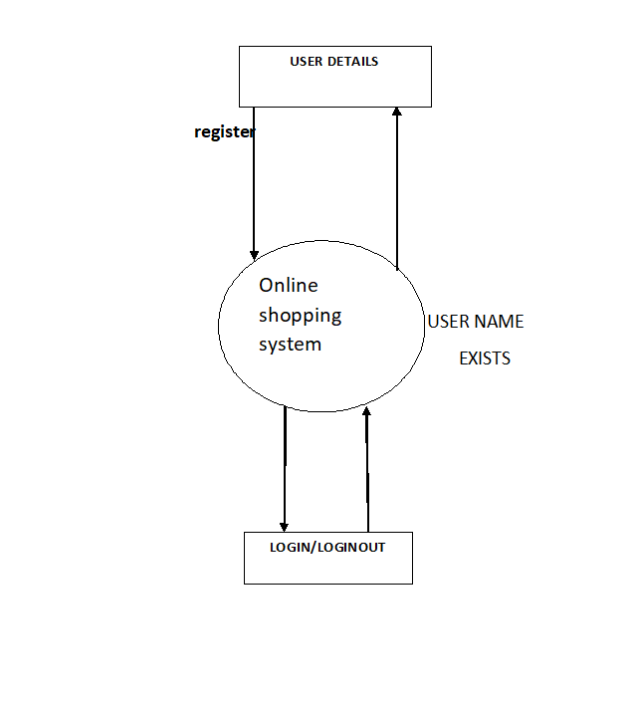

**DFD FOR admin**

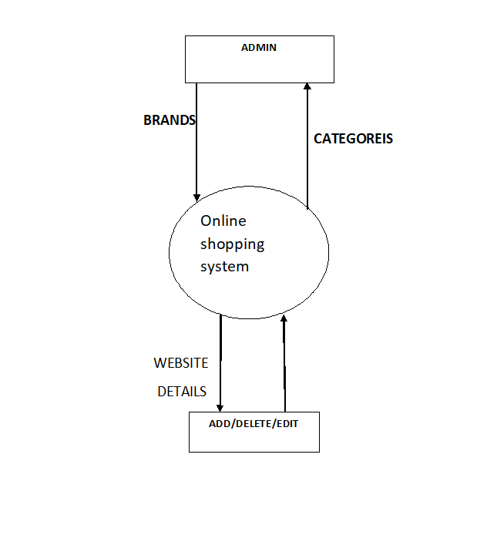

4.2 : Entity-Relationship diagram

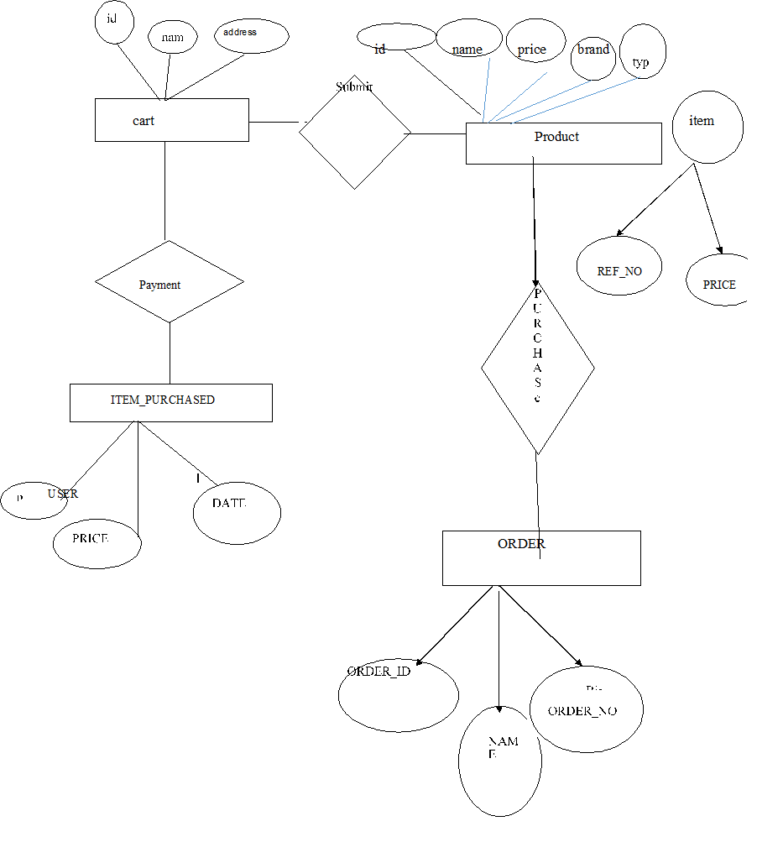

4.3: Use case diagrams

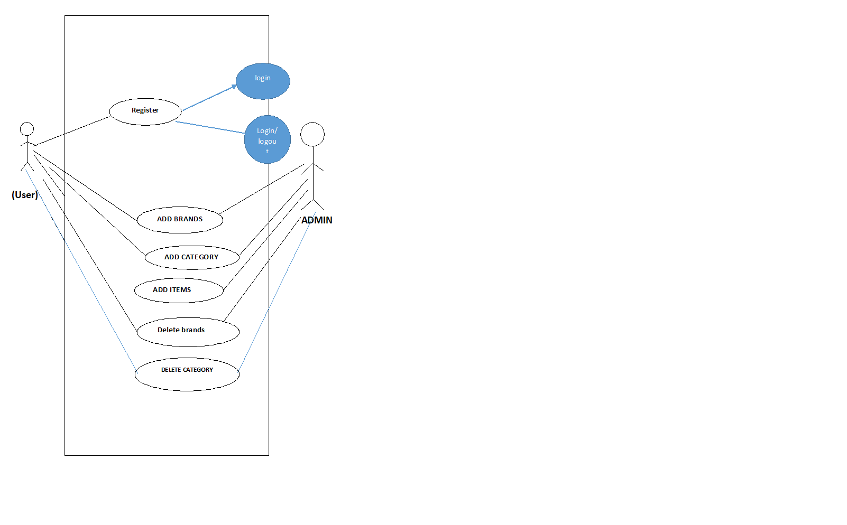

4.4: Database & file design

fname varchar

mname varchar

lname varchar

phone int

userid varchar

pwd varchar

**Chapter-5: System Development**

5.1: Program Development

### 5.1: Program Development

**Programming Improvement Life Cycle is the utilization of standard strategic policies to building programming applications. It's regularly isolated into six to eight stages: Arranging, Prerequisites, Plan, Fabricate, Record, Test, Convey, Keep up. Some venture directors will consolidate, split, or discard steps, contingent upon the undertaking's extension. These are the center parts suggested for all product improvement projects.**

**SDLC is an approach to quantify and improve the advancement cycle. It permits a fine-grain examination of each progression of the interaction. This, thus, assists organizations with boosting proficiency at each stage. As figuring power builds, it puts a more appeal on programming and designers. Organizations should lessen costs, convey programming quicker, and address or surpass their clients' issues.**

**SDLC accomplishes these objectives by distinguishing shortcomings and greater expenses and fixing them to run easily.**

* 1. **: Programming Platform**

XAMPP is a free, open source, integrated development environment (IDE) that enables you to develop desktop, mobile and web applications. They supports application development in various languages, including CSS, HTML, PHP .. The IDE provides integrated support for the complete development cycle, from project creation through debugging, profiling and deployment. They runs on Windows, Linux, Mac OS X, and other UNIX-based systems.

### : Query language

MySQL is the world's most popular open source database. With its proven performance, reliability and ease-of-use, MySQL has become the leading database choice for web-based applications, used by high profile web properties including Facebook, Twitter, YouTube, Yahoo! and many more.

Oracle drives MySQL innovation, delivering new capabilities to power next generation web, cloud, mobile and embedded applications.

### Chapter-6: System Testing

Here the entire software system is tested. The reference document for this process is the requirements document and goal is to see if software meets its requirements.

### Testing Techniques

Two Category of Software Testing

* + - Black Box Testing
    - White Box Testing

**Black box testing** :System test falls under the **black box testing** category of software testing. This is applied during the later stage of testing. It enables the software developer to derive a set of input conditions that will

fully exercise the functional requirements of a program.

**White Box Testing**: This method also knows as glass box testing, is performed early in the testing process. Using the software engineer can derive a test that guarantees that all independent paths within the module have been exercised at lest once.

### Chapter-7: Systems Implementation

##### Implementation (Techniques)

**Structured Programming**

In the process of coding, the lines of code keep multiplying, thus, size of the software increases. Gradually, it becomes next to impossible to remember the flow of program. Structured programming states how the program shall be coded. Structured programming uses three main concepts:

* **Top-down analysis** - A software is always made to perform some rational work. This rational work is known as problem in the software parlance. Thus it is very important that we understand how to solve the problem.
* **Modular Programming** - While programming, the code is broken down into smaller group of instructions. These groups are known as modules, subprograms or subroutines. Modular programming based on the understanding of top-down analysis.
* **Structured Coding** - In reference with top-down analysis, structured coding sub-divides the modules into further smaller units of code in the order of their execution.

### Functional Programming

Functional programming is style of programming language, which uses the concepts of mathematical functions. A function in mathematics should always produce the same result on receiving the same argument. While control flow is transferring from one procedure to another, the program changes its state.

Functional programming provides means of computation as mathematical functions, which produces results irrespective of program state. This makes it possible to predict the behavior of the program.

Functional programming uses the following concepts:

* **First class and High-order functions** - These functions have capability to accept another function as argument or they return other functions as results.
* **Pure functions** - These functions do not include destructive updates, that is, they do not affect any I/O or memory and if they are not in use, they can easily be removed without hampering the rest of the program.
* **Recursion** - Recursion is a programming technique where a function calls itself and repeats the program code in it unless some pre-defined condition matches. Recursion is the way of creating loops in functional programming.
* **Strict evaluation** - It is a method of evaluating the expression passed to a function as an argument. Functional programming has two types of evaluation methods, strict (eager) or non-strict (lazy). Strict evaluation always evaluates the expression before invoking the function. Non-strict evaluation does not evaluate the expression unless it is needed.
* **λ-calculus** - Most functional programming languages use λ-calculus as their type systems. λ- expressions are executed by evaluating them as they occur.

Common Lisp, Scala, Haskell, Erlang and F# are some examples of functional programming languages.

* 1. Programming style

Programming style is set of coding rules followed by all the programmers to write the code. When multiple programmers work on the same software project, they frequently need to work with the program code written by some other developer. This becomes tedious or at times impossible, if all developers do not follow some standard programming style to code the program.

##### Coding Guidelines

Practice of coding style varies with organizations, operating systems and language of coding itself. The following coding elements may be defined under coding guidelines of an organization:

* + - **Naming conventions** - This section defines how to name functions, variables, constants and global variables.
    - **Indenting** - This is the space left at the beginning of line, usually 2-8 whitespace or single tab.
    - **Whitespace** - It is generally omitted at the end of line.
    - **Operators** - Defines the rules of writing mathematical, assignment and logical operators. For example, assignment operator ‘=’ should have space before and after it, as in “x = 2”.
    - **Control Structures** - The rules of writing if-then-else, case-switch, while-until and for control flow statements solely and in nested fashion.
    - **Line length and wrapping** - Defines how many characters should be there in one line, mostly a line is 80 characters long. Wrapping defines how a line should be wrapped, if is too long.
    - **Functions** - This defines how functions should be declared and invoked, with and without parameters.
    - **Variables** - This mentions how variables of different data types are declared and defined.
    - **Comments** - This is one of the important coding components, as the comments included in the code describe what the code actually does and all other associated descriptions. This section also helps creating help documentations for other developers.

### Software documentation

Software documentation is an important part of software process. A well written document provides a great tool and means of information repository necessary to know about software process. Software documentation also provides information about how to use the product.

A well-maintained documentation should involve the following documents:

* + - **Requirement documentation** - This documentation works as key tool for software designer, developer and the test team to carry out their respective tasks. This document contains all the functional, non-functional and behavioural description of the intended software.
    - **Software Design documentation** - These documentations contain all the necessary information, which are needed to build the software. It contains: High-level software architecture, Software design details, Data flow diagrams,
    - **Technical documentation** - These documentations are maintained by the developers and actual coders. These documents, as a whole, represent information about the code. While writing the code, the programmers also mention objective of the code, who wrote it, where will it be required, what it does and how it does, what other resources the code uses, etc.

There are various automated tools available and some comes with the programming language itself. For example java comes JavaDoc tool to generate technical documentation of code.

* + - **User documentation** - This documentation is different from all the above explained. All previous documentations are maintained to provide information about the software and its development process.

##### Software Implementation Challenges

There are some challenges faced by the development team while implementing the software. Some of them are mentioned below:

* + - **Code-reuse** - Programming interfaces of present-day languages are very sophisticated and are equipped huge library functions. Still, to bring the cost down of end product, the organization management prefers to re-use the code, which was created earlier for some other software. There are huge issues faced by programmers for compatibility checks and deciding how much code to re-use.
    - **Version Management** - Every time a new software is issued to the customer, developers have to maintain version and configuration related documentation. This documentation needs to be highly accurate and available on time.
    - **Target-Host** - The software program, which is being developed in the organization, needs to be designed for host machines at the customers end. But at times, it is impossible to design a software that works on the target machines.

### Post Implementation (Implementation)

PIER is a tool or standard approach for evaluating the outcome of the project and determine whether the project is producing the expected benefits to the processes, products or services. It enables the user to verify that the project or system has achieved its desired outcome within specified time period and planned cost.

PIER ensures that the project has met its goals by evaluating the development and management processes of the project.

The objectives of having a PIER are as follows −

* + - To determine the success of a project against the projected costs, benefits, and timelines.
    - To identify the opportunities to add additional value to the project.
    - To determine strengths and weaknesses of the project for future reference and appropriate action.
    - To make recommendations on the future of the project by refining cost estimating techniques.
    - Project team and Management
    - User staff
    - Strategic Management Staff
    - External users

### System Maintenance / Enhancement

Maintenance means restoring something to its original conditions. Enhancement means adding, modifying the code to support the changes in the user specification. System maintenance conforms the system to its original requirements and enhancement adds to system capability by incorporating new requirements.

Thus, maintenance changes the existing system, enhancement adds features to the existing system, and development replaces the existing system. It is an important part of system development that includes the activities which corrects errors in system design and implementation, updates the documents, and tests the data.

##### 

System maintenance can be classified into three types −

* + - **Corrective Maintenance** − Enables user to carry out the repairing and correcting leftover problems.
    - **Adaptive Maintenance** − Enables user to replace the functions of the programs.
    - **Perfective Maintenance** − Enables user to modify or enhance the programs according to the users’ requirements and changing needs.

**Summary/Conclusion**

The online shopping systemis looking to a more efficient and streamlined processing system and better coordination between customer and online shopping which shop and see products easily.

**Limitations Of the Project**

Although I have tried to do the best and try to do all the things that are possible in an

Online System, but still the system contains some of the limitations.

The reason of these limitations is the time constraints. Time is the major problem. I

Have to deliver the project in a particular time period. That’s way I have to leave

Some of the topics that actually I want to cover, I am still working on this software

And my next goal is to remove these limitations and develop a more efficient and

Elegant system.

1. This project does not give the information about the stock (quantity) present within the shop.
2. This project does not create monthly, yearly Reports.

After removing these and other minor limitations I hope this project will very efficient and effective.

**Future Directions**

1. **The scope of this project is to provide an easy option for the customer who is willing to check online.**
2. **It saves time and labor.**
3. **Such that labor of staff is reduced. Project is flexible enough to meet the requirements of the customer.**
4. **This system can be accessed anywhere who has net connection at any time of day or night, thus providing customer’s comfort.**

### References

**Google Search Engine for various searching**

### ONLINE REFRENCES

[**www.w3schools.com**](http://www.w3schools.com/) **www.tutorialspoint** [**www.google.com**](http://www.google.com/)

.