# SYNOPSIS

**on**

## "online shopping system"

**Submitted by:**

## Mr. Vibhor Jain MCA



**Guru Gobind Singh Indraprastha University**

**UNIVERSITY SCHOOL OF INFORMATION AND COMMUNICATION TECHNOLOGY**

**Sector 16 C, Dwarka, New Delhi, Delhi 110078**

Online shopping system

**INTRODUCTION**

PC assumes a significant part in our day by day life. Anything we need we can get just in one mouse click. Speed, dependability and exactness of the PC make it an incredible asset for various purposes. A vital and essential need of the present current business world is the speedy accessibility and preparing of data utilizing PC. One can undoubtedly get the sort of required data inside a small portion of a second. The task that I have taken is additionally in this classification which is utilized in our every day life at whatever point we need to buy a few things we can without much of a stretch get them at our home.

Problem Definition:

One should understand what the issue is before it very well may be settled. The reason for the web based shopping entryway is to purchase items on the web and save the circumstance.

An Online shopping entrance, who need to purchase any result of their need, needs to contact various Shoppers, prior to choosing a specific Product that best suit his necessities, prerequisites and fulfillment. Besides, the vast majority of the work associated with this advancement interaction must be done physically which is tedious and lumbering and furthermore, it lessens the effectiveness, precision.

To know current realities and comprehension of the issue in detail, System Analysis is completed. It is the way toward examining the business cycles and methodology, by and large alluded to as business frameworks, to perceive how they can work and whether improvement is required.

Objectives & Scope

The target of venture on Online Shopping system is to building up a GUI based computerized framework, which will cover all the data Related to the all items which is utilized in our day by day life. For instance – Mobiles Phones, Laptops, Clothes, Books, Electronic Items and some more. So by this GUI based robotized framework a client need to buy something then it just a mouse click away to buy these items.

according the current need in different Fields. This is online shopping Website which provides facility for purchasing Mobiles, Laptops, Camera and many more items. So by using this Online Shopping Portal users which want to purchase some products will first Register an account on this portal then Login through their Username and Password, and then Select items which they want to purchase and add them to cart and finally checkout by giving payment details. So by using this portal users can easily purchase products from their home.

### **METHODOLOGY**

**TOOLS AND PLATFORM**

**Hardware Requirement:**

**Processor: intel CORE i5 RAM: 2GB or more**

**HD: 500 GB**

**Software Requirement: Operating System : Windows 7 Database : Mysql**

**PHP,HTML,CSS using xampp server etc .**

**Modules**

* Before Login
  + Login
  + Register
  + Forget Password
  + Administrator Login
  + About Us
  + Contact Us
* After Administrator Login
  + Edit Website Details
  + Add Brands
  + Add Category
  + Add Items
  + Delete Brands
  + Delete Category
  + Delete Items
  + Manage User
    - * See Users
      * Users Shopping
      * Add Users
      * Delete Users
  + Logout
* After User Login
  + My Profile
    - * Edit Profile
      * Change Password
  + Buy Products
    - * Categories (Controlled by Admin. Which can be add it dynamically according to their needs)
  + My Cart
  + My Shopping’s
  + Checkout
  + Logout

DFD-0

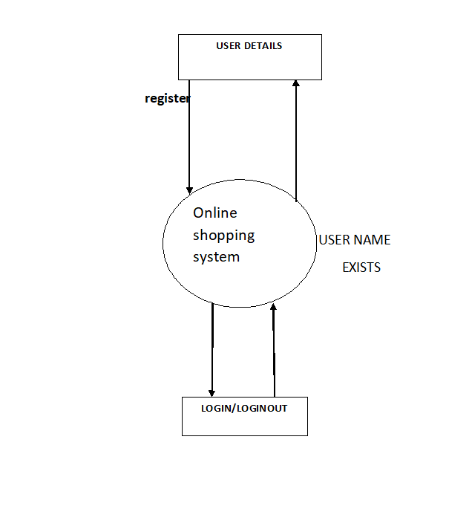

DFD FOR admin

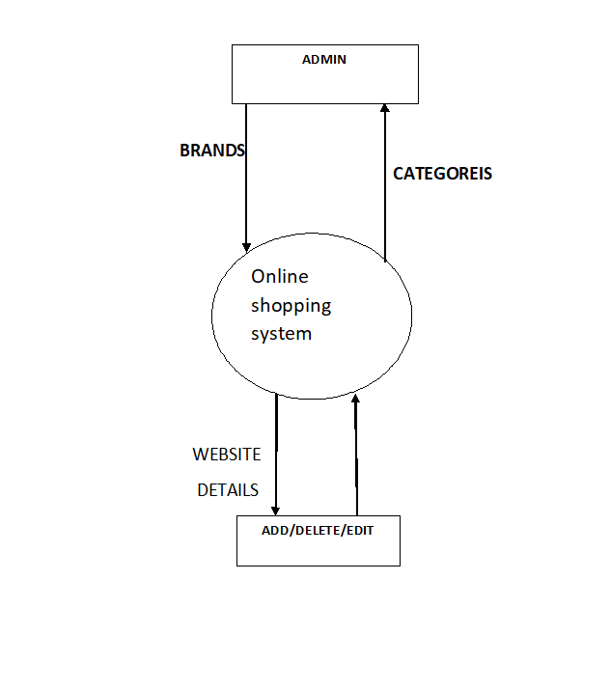

DFD-1

**Login**

**to System**

**Check**

**Access**

**Admin**

VIBHOR JAIN Page 13

**Manage**

**Modules**

**Manage product**

**Details**

**Manage brands Details**

**Manage website details**

**Manage customer Details**

USE CASE DIAGRAM

