K
K E-Commerce
App Flow Document
Field | Value
Document type | Personal research
Author | Vibol Khan
Version | 1.0 (Draft)
Date | 22 October 2026
Based on | K E-Commerce PRD v1.0 (incl. answered open questions Q1–Q9)
Status | Research draft

Contents

1. Introduction

1.1 Purpose
This document describes how every user moves through the K E-Commerce app: which screens they see, what they do on each screen and how the system responds. It turns the requirements in the PRD into concrete flows for UI design, Flutter routing (go_router) and backend work (Supabase).

1.2 How to read the diagrams
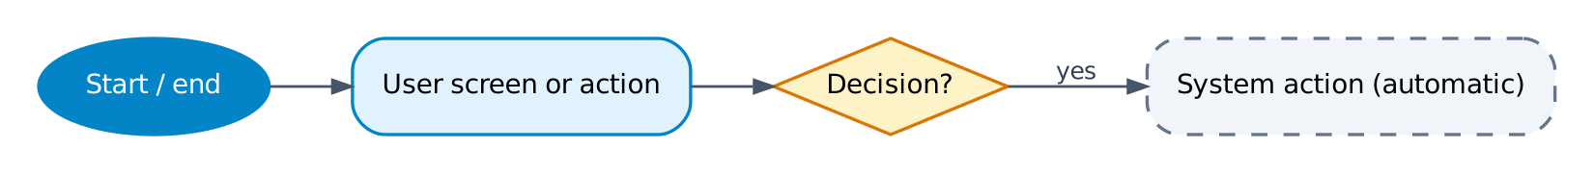
- Dark blue ellipse — start or end point of a flow (often a link to another flow, e.g. "F5").
- Light blue box — a screen the user sees or an action the user takes.
- Yellow diamond — a decision or check.
- Grey dashed box — an automatic system action (Supabase / Edge Function / push).

1.3 Decisions confirmed for this flow
These decisions come from the PRD open questions (section 12.3) and the follow-up confirmation. Where they differ from the original PRD text, the flows below follow these decisions.
Topic | Decision | Effect on flows
Market | Cambodia only (Q1, Q2). No country selector. | No country step at launch. Prices in USD with KHR shown; one tax setup.
App structure | One app with role-based entry, published to App Store and Google Play, plus web (Q4). | After sign-in the app routes to Customer, Business buyer, Rider or Admin home.
Admin access | Admin uses the same app on mobile and web. | Admin screens are responsive; admin can work from a phone.
State / routing | Riverpod + go_router (Q3). | Each screen ID in section 3 maps to a go_router route with role guards.
Sign-in | Guest can browse; sign-in at checkout or protected actions. | Sign-in flow returns the user to the action that triggered it.
B2B buying | Business buyers see only quote prices (Q8) and buy through RFQ only. | No prices and no cart for business buyers; "Request quote" instead.
B2B payment | KHQR, COD or bank transfer (Q6). | Bank transfer adds slip upload and admin confirmation.
Retail payment | Bakong KHQR and COD. ABA PayWay is next phase. | Payment step shows KHQR and COD only.
Delivery promise | Same day, cut-off 3 PM (Q7). | Orders after 3 PM are scheduled for next day.
Returns | 3-day window; customer pays return delivery (Q5). | Return button only within 3 days of delivery; fee deducted or collected.
Brand | Name "K", main colour sky blue, logo is a refined letter K (Q9). | Splash, app icon and theme use the K mark and sky blue.

2. App structure and role routing
One Flutter app serves four roles. The role is stored in the user profile and checked by go_router guards and by Supabase Row-Level Security, so a user can never open screens of another role.
Role | Home screen | Bottom navigation (mobile) / side menu (web)
Guest | Customer Home | Home · Categories · Cart · Account (sign in)
Customer (B2C) | Customer Home | Home · Categories · Cart · Orders · Account
Business buyer (B2B) | Customer Home (no prices) | Home · Categories · Quote list · Orders & Quotes · Account
Rider | Rider Home | Jobs · History · COD summary · Account
Admin / staff | Admin Dashboard | Dashboard · Orders · RFQs · Catalog · Inventory · Customers · Riders · Returns · Reviews · Chat · Content · Reports · Settings (menu items shown by staff permission)

2.1 Launch and routing flow (F0)
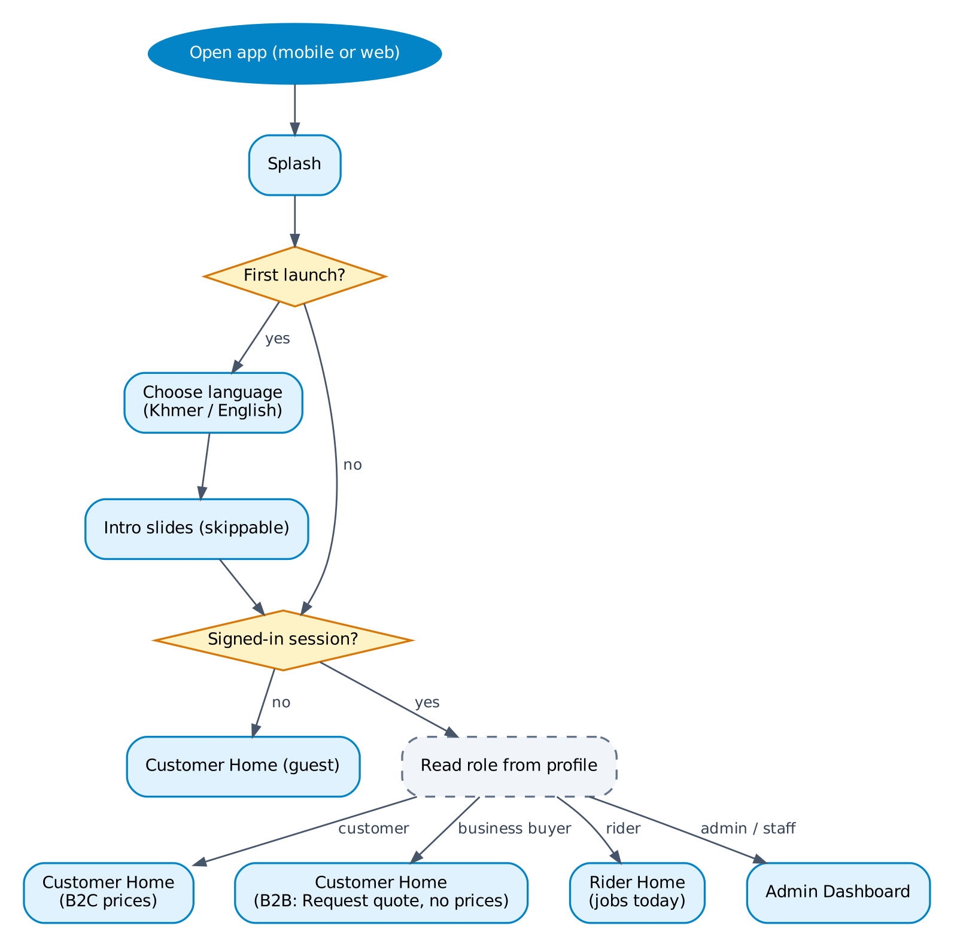
Figure F0 — App launch and role routing
# | Screen | User action | System response / rule
1 | Splash | Opens the app. | Shows the K logo on sky blue. Loads saved language and Supabase session.
2 | Language select | First launch only: picks Khmer or English. | Saved on device; can be changed later in Account > Language.
3 | Intro slides | Swipes or taps Skip. | First launch only. 3 slides: shop, pay with KHQR/COD, same-day delivery.
4 | — | — | If there is a valid session, read role from profiles and route to that role's home. Otherwise open Customer Home as guest.

3. Screen inventory
Screen IDs are used as go_router route names. "All" means guest, customer and business buyer.

3.1 Shared and onboarding
ID | Screen | Purpose | Flow
S-01 | Splash | Logo, session and language load | F0
S-02 | Language select | Khmer / English (first launch) | F0
S-03 | Intro slides | Short value introduction, skippable | F0
S-04 | Sign-in | Phone, email, Google, Apple options | F1
S-05 | OTP verify | 6-digit code, resend timer | F1
S-06 | Complete profile | Name and optional email for new users | F1
S-07 | Notifications inbox | List of push notifications, mark as read | F10
S-08 | Account | Profile, addresses, language, notification settings, delete account, sign out | —

3.2 Customer and business buyer
ID | Screen | Purpose | Flow
C-01 | Home | Banners, collections, categories shortcut, search bar | F3
C-02 | Categories | Category tree | F3
C-03 | Product list | Products of a category or collection, filters and sort | F3
C-04 | Search | Search input, recent searches, results with filters | F3
C-05 | Product detail | Images, variants, stock, reviews; price + Add to cart (B2C) or Request quote (B2B) | F3
C-06 | Cart | Items, quantities, subtotal (B2C only) | F4
C-07 | Checkout | Address, delivery date, payment method, note, summary | F4
C-08 | Address list / editor | Saved addresses, map pin, set default | F4
C-09 | KHQR payment | QR code, amount, 15-min timer, save/share | F5
C-10 | Order success | Order number, delivery date, track button | F4
C-11 | Orders list | Active and past orders | F6
C-12 | Order detail / tracking | Status timeline, live map, invoice, cancel, return, review, reorder | F6
C-13 | Cancel order | Reason and confirm | F6
C-14 | Return request | Items, quantity, reason, photos, fee notice | F7
C-15 | Write review | Stars, text, photos | F9
C-16 | Wishlist | Saved products, move to cart | F9
C-17 | Support chat | Conversation with support, optional order link | F10
B-01 | Business upgrade form | Company, VAT TIN, address, licence upload, status | F2
B-02 | Quote request list | Items to quote (acts like a cart) | F8
B-03 | Submit RFQ | Delivery address, required date, notes, attachments | F8
B-04 | Quotes list | RFQs and quotes with status | F8
B-05 | Quote detail | Quoted prices, validity, terms, PDF, accept/reject/revise | F8
B-06 | Bank transfer | Bank account details, amount, upload slip | F8

3.3 Rider
ID | Screen | Purpose | Flow
R-01 | Rider home / jobs | On-duty toggle, today's assigned deliveries and return pickups | F11
R-02 | Job detail | Address, map, contact, items, COD amount | F11
R-03 | Proof of delivery | Photo, recipient name, COD collected | F11
R-04 | Failed delivery | Reason and photo | F11
R-05 | History | Completed jobs by date | F11
R-06 | COD summary | Cash collected today, hand-over status | F11

3.4 Admin and staff
ID | Screen | Purpose | Flow
A-01 | Dashboard | Sales today, orders by status, open RFQs, low stock, pending items | F14
A-02 | Orders list / detail | Filter, status actions, packing slip, assign rider, refund | F12
A-03 | Bank transfer review | View slip, confirm or reject | F8, F12
A-04 | RFQ list / quote editor | Review RFQ, set prices, send quote | F13
A-05 | Catalog | Products, variants, prices, images, CSV import/export | F14
A-06 | Inventory | Stock, adjustments, low-stock alerts | F14
A-07 | Customers | Profiles, B2B verification, block | F2, F14
A-08 | Riders | Rider accounts, zones, availability, COD reconciliation | F14
A-09 | Returns | Approve/reject, schedule pickup, inspect, refund | F7
A-10 | Reviews | Moderate and reply | F9
A-11 | Support chat | Queue, assign, reply, resolve | F10
A-12 | Content | Banners, collections, static pages | F14
A-13 | Reports | Sales, payments, COD, stock, RFQ conversion | F14
A-14 | Settings | Delivery zones & fees, COD limit, cut-off time, KHR rate, bank account, staff roles | F14

F1 Sign-in and registration
Actor | Trigger / entry | PRD refs
Guest | Taps a protected action (checkout, RFQ, wishlist, review, chat) or Account > Sign in. | AUTH-01 to AUTH-04, AUTH-06

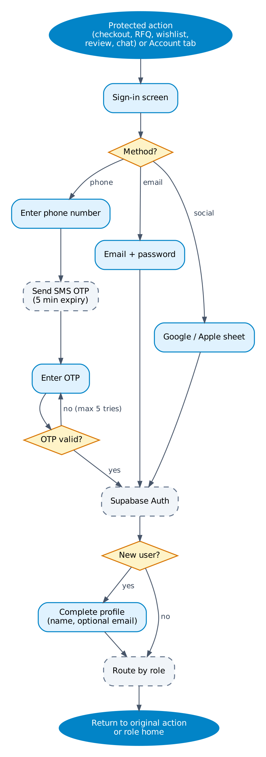
Figure F1 — Sign-in and registration

Steps
# | Screen | User action | System response / rule
1 | S-04 Sign-in | Chooses phone, email, Google or Apple. | Phone is the default option.
2 | S-04 | Enters phone number (+855 pre-filled). | Supabase Auth sends SMS OTP; code valid 5 minutes; resend after 60 s.
3 | S-05 OTP verify | Enters 6-digit code. | Wrong code: error, max 5 tries then wait 15 minutes.
4 | S-06 Complete profile | New users only: enters name, optional email. | Creates profiles row with role = customer.
5 | — | — | Routes by role. If sign-in was triggered by an action, return to that action with state kept (e.g. cart).

Rules and edge cases
- Riders and staff accounts are created by an admin; they sign in with the same screen and are routed to their home.
- A blocked user sees a "Contact support" message and cannot continue.
- Google/Apple sign-in for a phone-registered user links accounts only after OTP confirmation.

F2 Upgrade to business buyer
Actor | Trigger / entry | PRD refs
Customer, Admin | Account > Become a business buyer. | AUTH-05, ADM-06

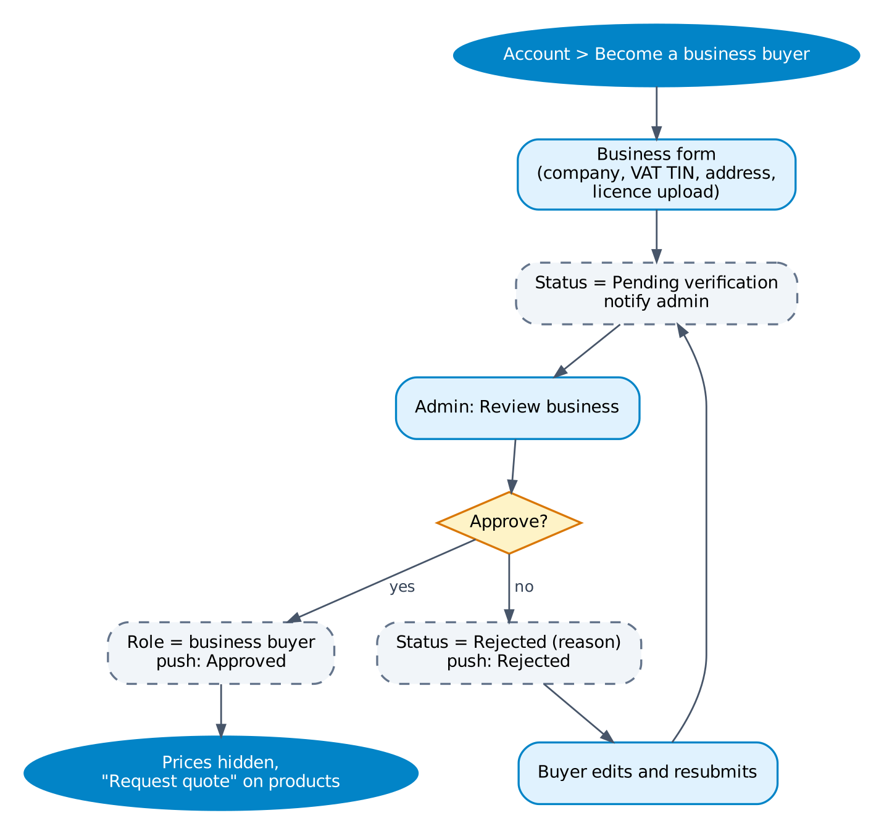
Figure F2 — Upgrade to business buyer

Steps
# | Screen | User action | System response / rule
1 | B-01 Business form | Enters company name, VAT TIN, business address; uploads business licence. | Validates TIN format; files stored in Supabase Storage (private).
2 | B-01 (status) | Submits. | Status = Pending verification; push to admins with Customers permission.
3 | A-07 Customers | Admin reviews documents; approves or rejects with reason. | Approved: role = business buyer, push "Your business account is active". Rejected: push with reason.
4 | C-01 Home | Business buyer browses. | Prices and cart are hidden; products show "Request quote".

Rules and edge cases
- While pending, the user keeps shopping as a normal customer.
- Any items in the retail cart stay; after approval the cart tab is replaced by the Quote list, and the old cart is cleared with a notice.

F3 Browse, search and product detail
Actor | Trigger / entry | PRD refs
Guest, Customer, Business buyer | Customer Home. | CAT-01 to CAT-07

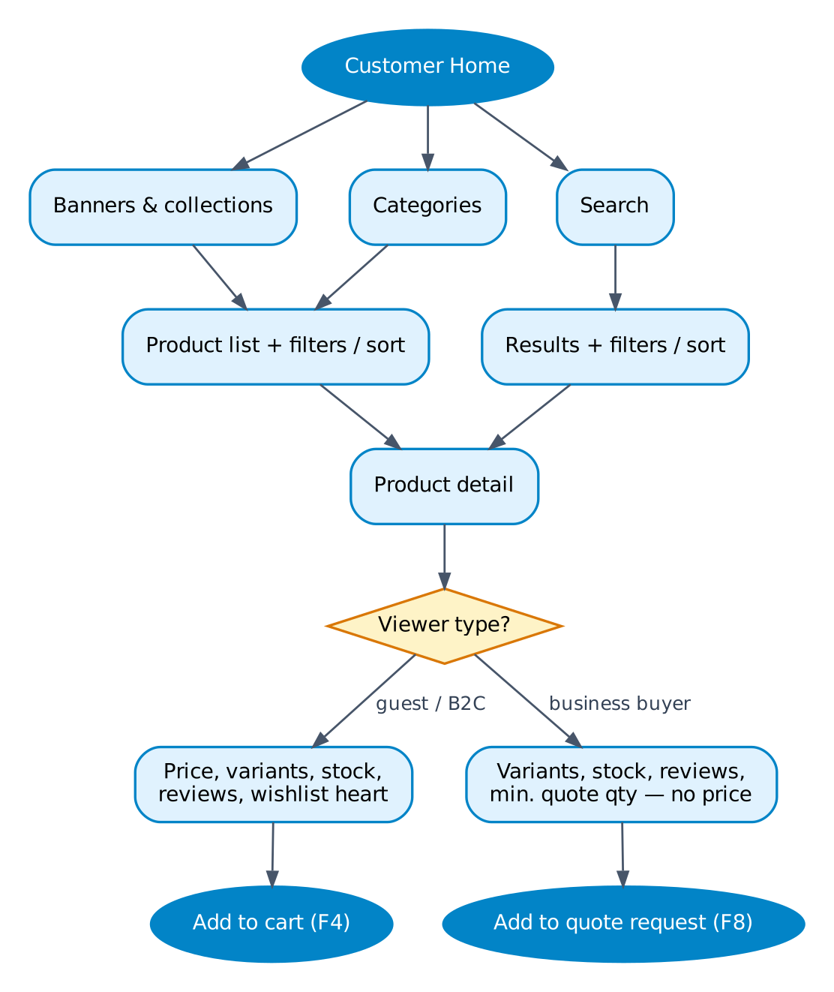
Figure F3 — Browse, search and product detail

Steps
# | Screen | User action | System response / rule
1 | C-01 Home | Scrolls banners, collections, categories. | Content managed in A-12; cached for fast load.
2 | C-04 Search | Types in Khmer or English. | Suggestions after 2 characters; typo-tolerant results.
3 | C-03 Product list | Filters (price, category, brand, rating, in stock) and sorts. | B2B viewers cannot filter or sort by price.
4 | C-05 Product detail | Selects variant, views images and reviews. | Out-of-stock variants are disabled.
5 | C-05 | B2C: taps Add to cart. B2B: taps Add to quote request. | B2C → F4. B2B → F8. Guest adding to cart is allowed; sign-in comes at checkout.

Rules and edge cases
- Prices are shown in USD with the KHR equivalent underneath (rate from Settings).

F4 Cart and checkout (B2C)
Actor | Trigger / entry | PRD refs
Customer | Cart tab > Checkout. | CHK-01 to CHK-05, PAY-03

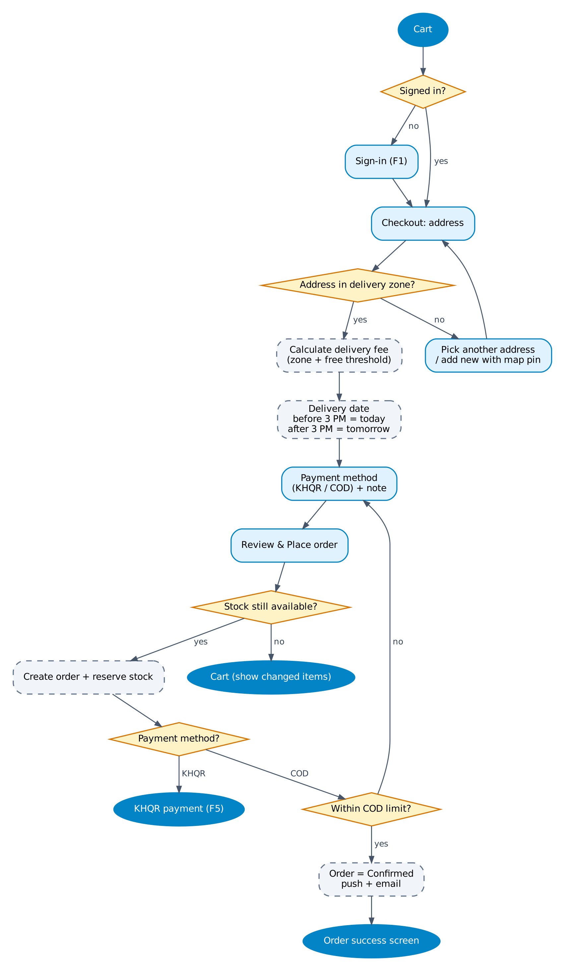
Figure F4 — Cart and checkout (B2C)

Steps
# | Screen | User action | System response / rule
1 | C-06 Cart | Changes quantities, removes items, taps Checkout. | Guest is sent to F1 first, then back to checkout.
2 | C-07 Checkout | Chooses saved address or adds one with map pin (C-08). | Checks the pin is inside a delivery zone. Outside: "We don't deliver here yet".
3 | C-07 | — | Calculates delivery fee from zone and free-delivery threshold.
4 | C-07 | Sees delivery date. | Before 3:00 PM: "Today". After 3:00 PM: "Tomorrow". Optional time slot.
5 | C-07 | Chooses KHQR or COD, adds a note. | COD hidden if the total is above the zone's COD limit.
6 | C-07 | Taps Place order. | Re-checks stock. Creates order and reserves stock for 15 minutes.
7 | C-09 / C-10 | — | KHQR → F5. COD → order Confirmed, push + email, C-10 Order success.

Rules and edge cases
- If stock changed, the user is returned to the cart with changed items highlighted.
- The cut-off is based on Cambodia time (UTC+7) on the server, not the device clock.
- Orders placed on a day with no delivery (e.g. public holiday set in Settings) roll to the next delivery day.

F5 KHQR payment
Actor | Trigger / entry | PRD refs
Customer, Business buyer | Order placed with KHQR. | PAY-01, PAY-04, CHK-04

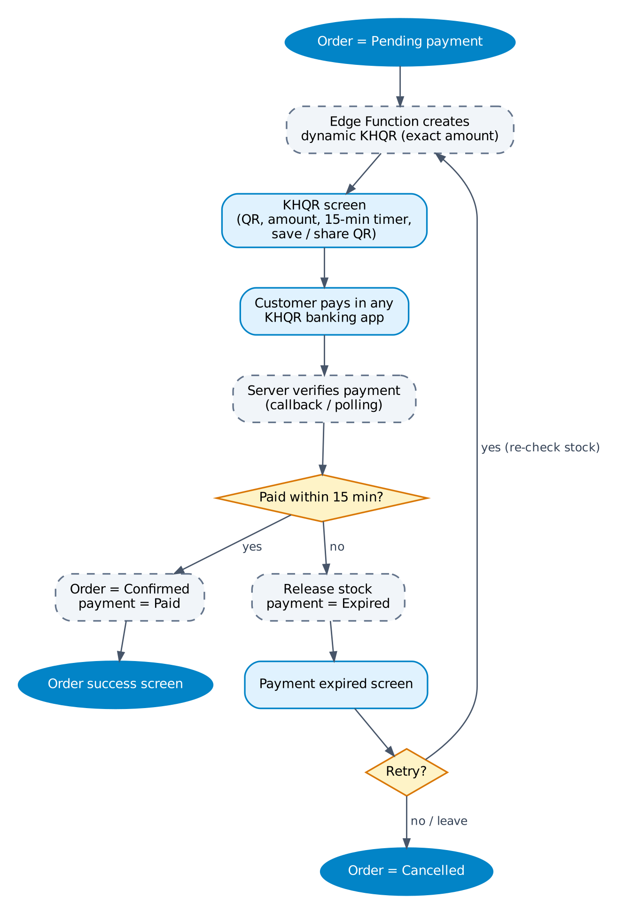
Figure F5 — KHQR payment

Steps
# | Screen | User action | System response / rule
1 | C-09 KHQR | Sees QR with exact amount and a 15-minute timer. | Edge Function generates a dynamic KHQR; order = Pending payment.
2 | C-09 | Pays from any KHQR banking app (scan, or save/share QR on same phone). | —
3 | C-09 | Waits on the screen. | Server confirms payment (callback or polling every few seconds). Client never marks paid.
4 | C-10 | — | Paid: order = Confirmed, push + email, success screen.
5 | C-09 (expired) | Taps Retry or leaves. | Expired: stock released. Retry re-checks stock and creates a new QR; leaving cancels the order.

Rules and edge cases
- If the app is closed during payment, the order still confirms when payment arrives and a push is sent.
- Amount mismatch or duplicate payment is flagged on the order for admin refund.

F6 Order tracking and cancellation
Actor | Trigger / entry | PRD refs
Customer, Business buyer | Orders tab or a push notification. | ORD-01 to ORD-04, ORD-06, CHT-03

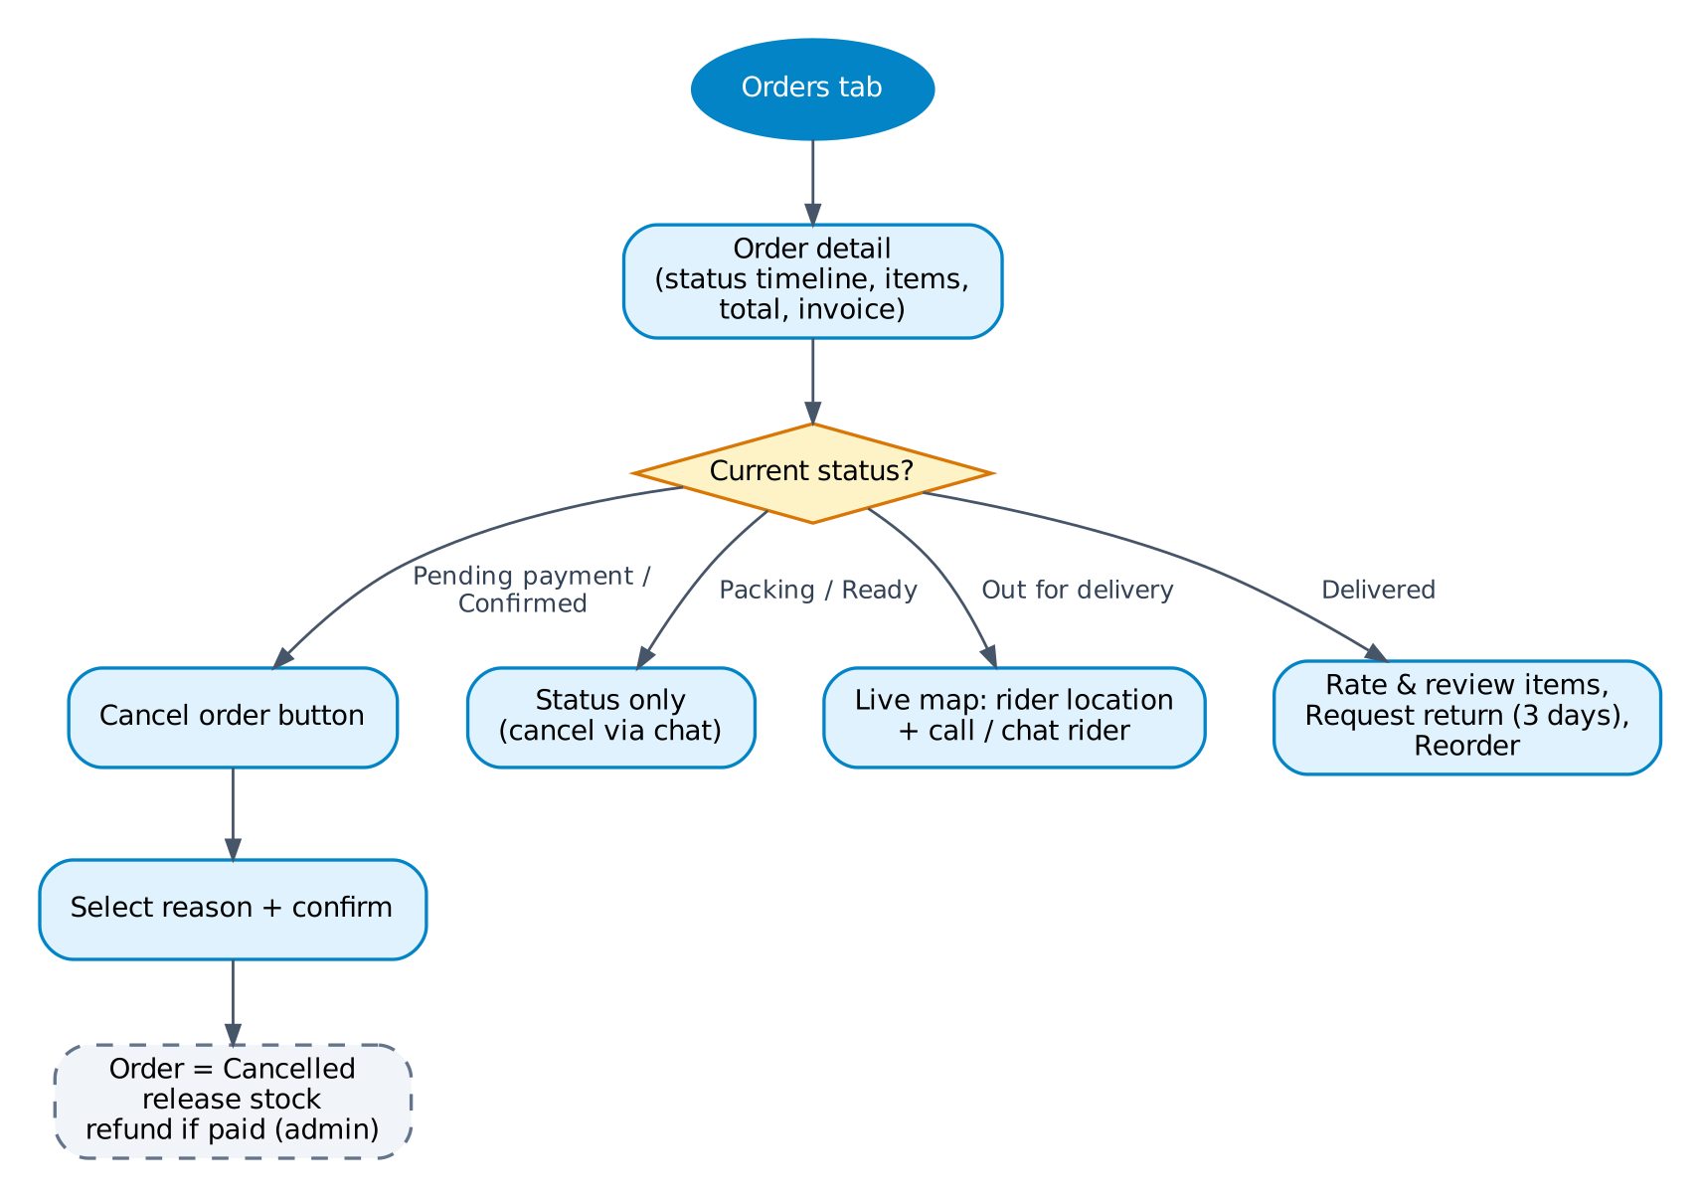
Figure F6 — Order tracking and cancellation

Steps
# | Screen | User action | System response / rule
1 | C-11 Orders | Opens an order. | Active orders on top.
2 | C-12 Order detail | Views status timeline, items, total, invoice PDF. | Status updates in real time (Supabase Realtime).
3 | C-13 Cancel | Pending payment or Confirmed only: picks reason, confirms. | Order = Cancelled, stock released; if paid by KHQR/bank, admin refund task created.
4 | C-12 (live map) | Out for delivery: sees rider on map; can call or chat rider. | Rider location updated about every 15 s.
5 | C-12 | Delivered: reviews items (F9), requests return (F7) or reorders. | Reorder adds available items to cart at current prices (B2C only).

Rules and edge cases
- From Packing onward, cancellation is only possible through support chat.

F7 Return request
Actor | Trigger / entry | PRD refs
Customer, Admin, Rider | Delivered order, within 3 days. | ORD-05, PAY-06

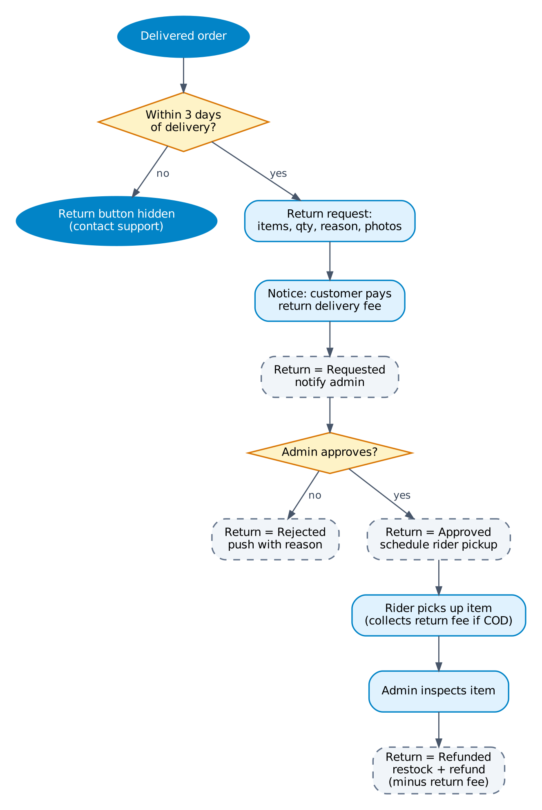
Figure F7 — Return request

Steps
# | Screen | User action | System response / rule
1 | C-12 | Taps Request return. | Visible only within 3 days (72 h) of the Delivered time.
2 | C-14 Return request | Selects items and quantity, reason, adds photos. | Shows notice: return delivery fee is paid by the customer.
3 | A-09 Returns | Admin approves or rejects. | Rejected: push with reason. Approved: pickup job created for a rider.
4 | R-01 / R-02 | Rider collects the item. | If the order was COD, rider collects the return fee in cash; otherwise it is deducted from the refund.
5 | A-09 | Admin inspects and refunds. | Return = Refunded, stock added back, refund recorded (KHQR/bank refund done manually by admin).

Rules and edge cases
- Damaged-by-user items can be rejected after inspection; item is sent back at customer cost.

F8 B2B quote request (RFQ) to order
Actor | Trigger / entry | PRD refs
Business buyer | Product detail > Add to quote request. | RFQ-01 to RFQ-06, Q6, Q8

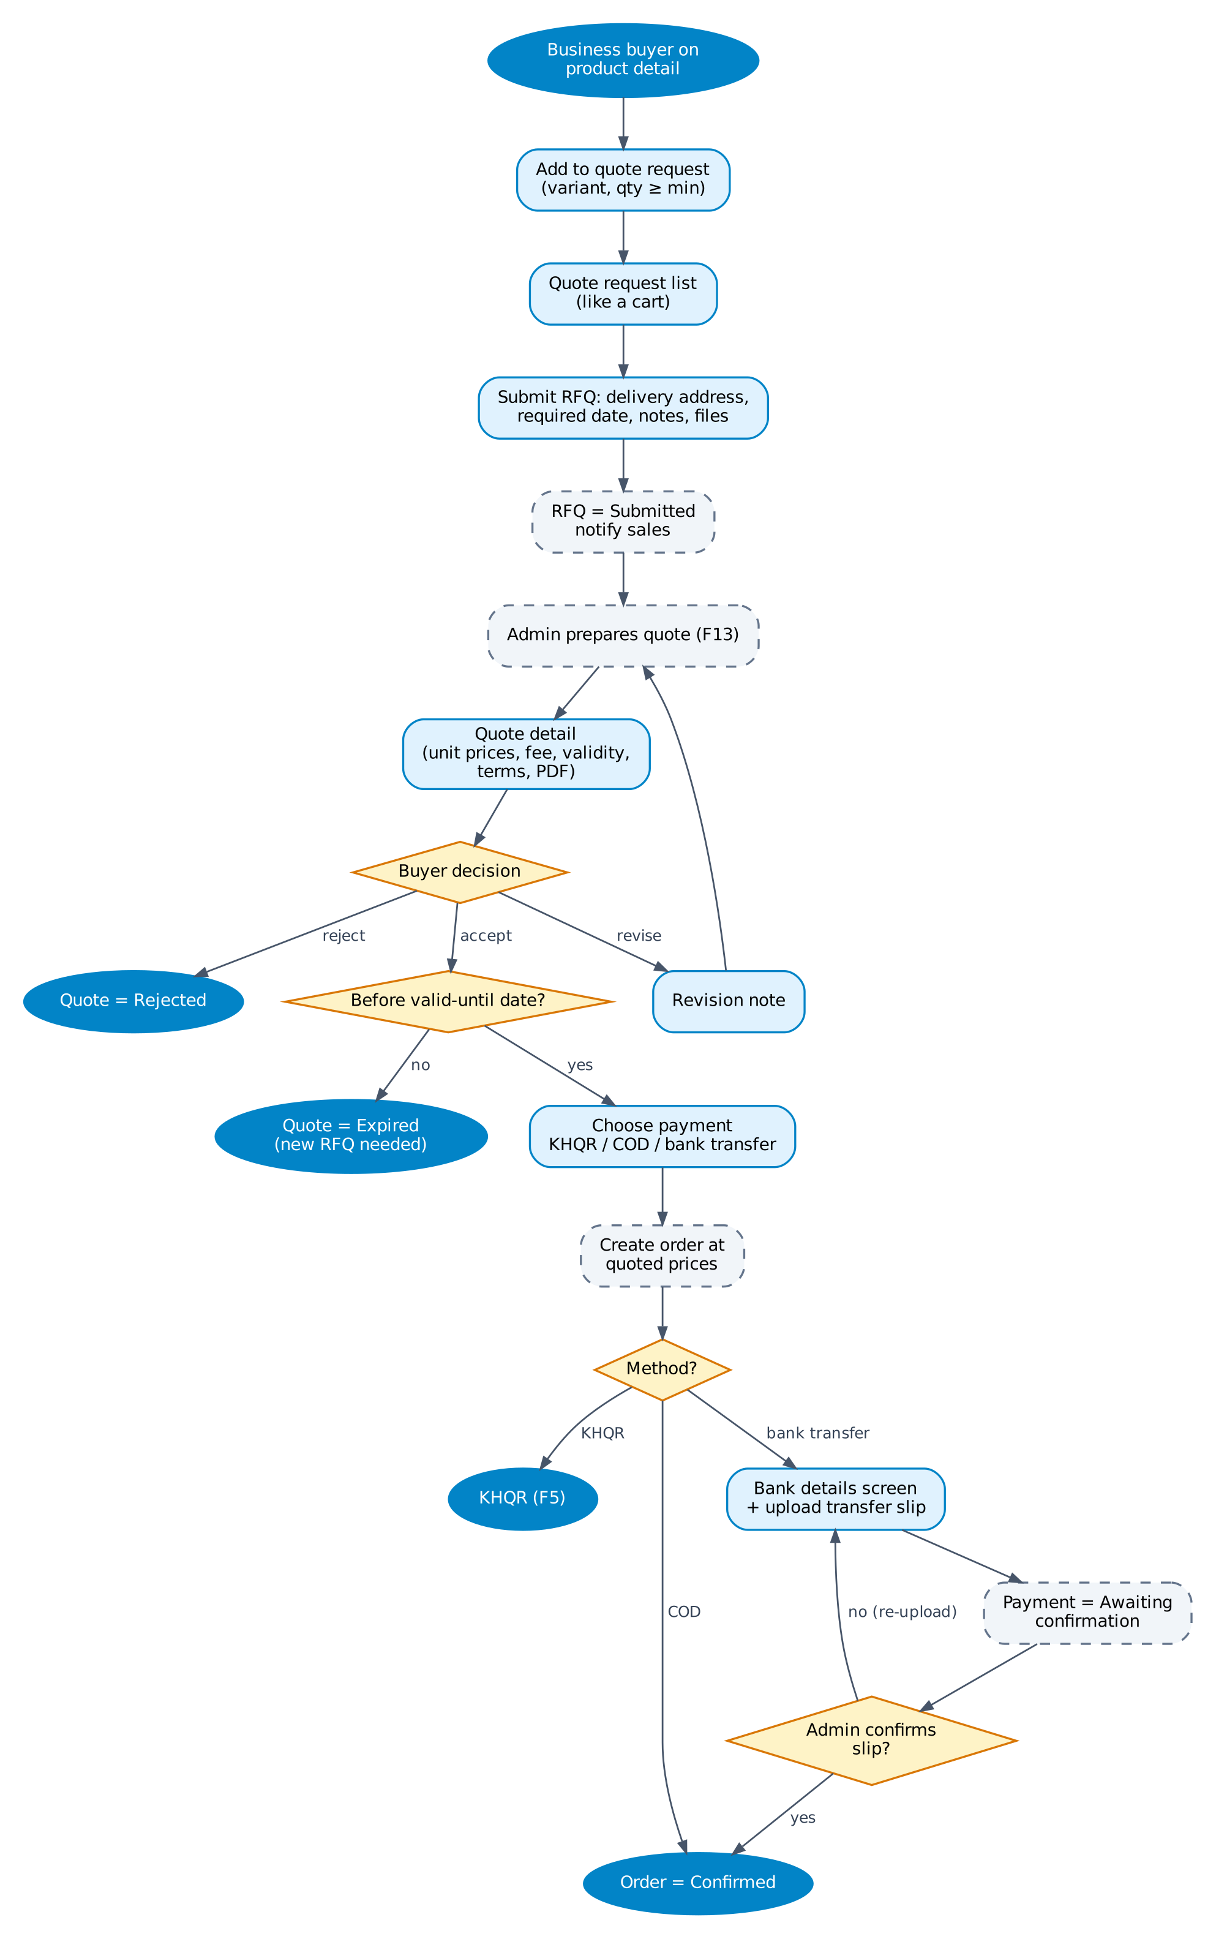
Figure F8 — B2B quote request (RFQ) to order

Steps
# | Screen | User action | System response / rule
1 | C-05 | Selects variant and quantity (at least the minimum quote quantity). | Item added to the quote request list (B-02).
2 | B-02 Quote list | Reviews items, edits quantities, taps Submit. | —
3 | B-03 Submit RFQ | Chooses delivery address, required date, adds notes and files. | RFQ = Submitted; sales staff notified.
4 | B-04 / B-05 | Receives push when the quote is ready; opens it. | Quote shows unit prices, delivery fee, total, valid-until date, terms, PDF.
5 | B-05 | Accepts, rejects, or requests revision with a note. | Revision returns to admin (F13). Expired quotes cannot be accepted.
6 | B-05 | On accept: chooses KHQR, COD or bank transfer. | Order created at quoted prices with quote_id.
7 | C-09 / B-06 | KHQR → F5. COD → Confirmed. Bank transfer → sees bank details and uploads slip. | Bank: payment = Awaiting confirmation; admin confirms in A-03 → order Confirmed.

Rules and edge cases
- Business buyers never see retail prices; the only prices they see are on their own quotes.
- Delivery date for RFQ orders is the agreed required date, not the 3 PM rule.
- Bank transfer must be confirmed before the quote expiry date + 3 days, otherwise the order is cancelled.
- Buyer and sales can message on the RFQ thread (RFQ-06) from B-05.

F9 Wishlist and reviews
Actor | Trigger / entry | PRD refs
Customer, Business buyer, Admin | Product detail heart icon; or a delivered order. | WSH-01, REV-01 to REV-03

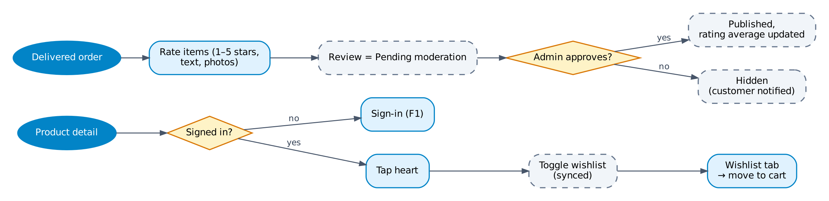
Figure F9 — Wishlist and reviews

Steps
# | Screen | User action | System response / rule
1 | C-05 | Taps the heart. | Guest → F1 first. Toggles wishlist; syncs across devices.
2 | C-16 Wishlist | Moves item to cart (B2C) or to quote list (B2B). | —
3 | C-15 Write review | From a delivered order: stars, text, photos. | One review per product per order. Status = Pending moderation.
4 | A-10 Reviews | Admin approves, hides, or replies. | Approved review is published and the product rating is recalculated.

Rules and edge cases
- Push reminder to review is sent 2 days after delivery.

F10 Support chat and notifications
Actor | Trigger / entry | PRD refs
Customer, Business buyer, Support staff | Account > Help & Support, or Order detail > Chat. | CHT-01, CHT-02, NOT-01, NOT-02

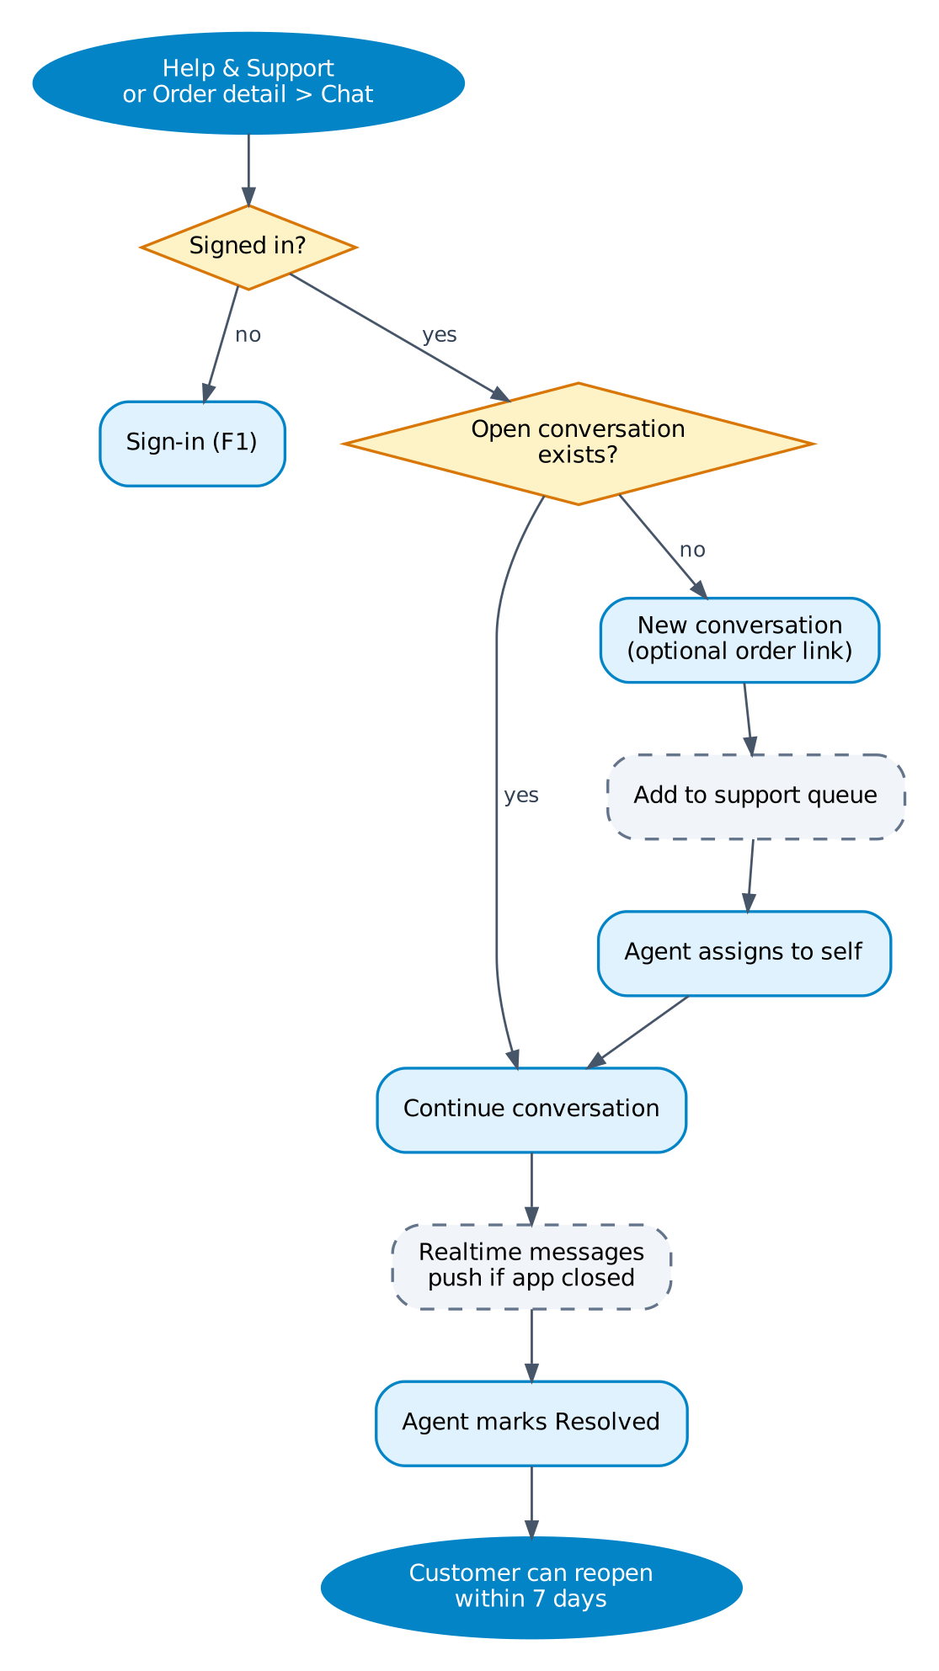
Figure F10 — Support chat and notifications

Steps
# | Screen | User action | System response / rule
1 | C-17 Support chat | Opens chat (optionally from an order). | Reuses an open conversation if one exists.
2 | C-17 | Sends a message or image. | Conversation enters the support queue (A-11).
3 | A-11 Support chat | Agent takes the conversation and replies. | Realtime delivery; push when the app is closed.
4 | A-11 | Agent marks Resolved. | Customer can reopen within 7 days; after that a new conversation starts.
5 | S-07 Inbox | Opens a notification. | Deep link to the related order, quote or chat.

F11 Rider delivery
Actor | Trigger / entry | PRD refs
Rider | Rider signs in. | RID-01 to RID-07

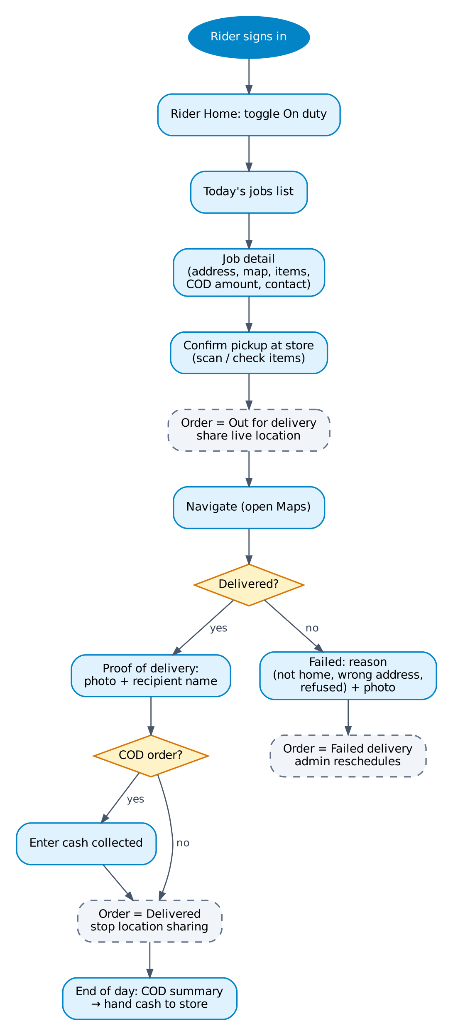
Figure F11 — Rider delivery

Steps
# | Screen | User action | System response / rule
1 | R-01 Jobs | Turns On duty. | Only on-duty riders can be assigned.
2 | R-01 | Sees assigned deliveries and return pickups for today. | New job → push + sound.
3 | R-02 Job detail | Checks items at the store and confirms pickup. | Order = Out for delivery; live location sharing starts.
4 | R-02 | Navigates (opens Google Maps), calls or chats customer. | —
5 | R-03 Proof of delivery | Takes photo, enters recipient name, enters cash collected (COD). | Order = Delivered; location sharing stops; customer push.
6 | R-04 Failed delivery | Selects reason and takes photo. | Order = Failed delivery; admin reschedules or cancels.
7 | R-06 COD summary | End of day: reviews cash total and hands it to the store. | Admin confirms hand-over in A-08 (COD reconciliation).

Rules and edge cases
- Status updates made without signal are queued on the device and synced when online.
- COD amount entered must match the order total; a mismatch requires a note.

F12 Admin order fulfilment
Actor | Trigger / entry | PRD refs
Admin / staff | Dashboard or Orders list. | ADM-04, ADM-07, PAY-06

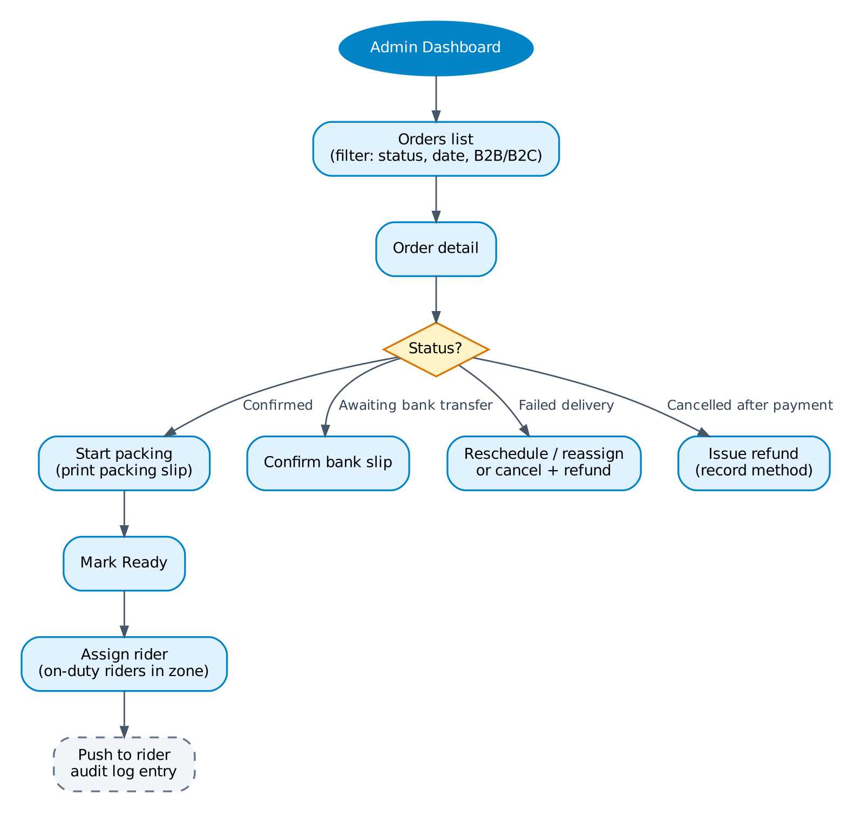
Figure F12 — Admin order fulfilment

Steps
# | Screen | User action | System response / rule
1 | A-02 Orders | Filters by status, date, B2B/B2C. | Default view: Confirmed orders for today.
2 | A-02 Detail | Starts packing and prints the packing slip. | Order = Packing; customer cannot self-cancel any more.
3 | A-02 | Marks Ready and assigns an on-duty rider in the zone. | Rider push; audit log entry.
4 | A-03 | Confirms or rejects a bank transfer slip. | Confirmed → order Confirmed. Rejected → buyer asked to re-upload.
5 | A-02 | Handles failed deliveries: reschedule, reassign, or cancel and refund. | —

F13 Admin RFQ handling
Actor | Trigger / entry | PRD refs
Admin (sales) | New RFQ push or RFQ list. | RFQ-02 to RFQ-05

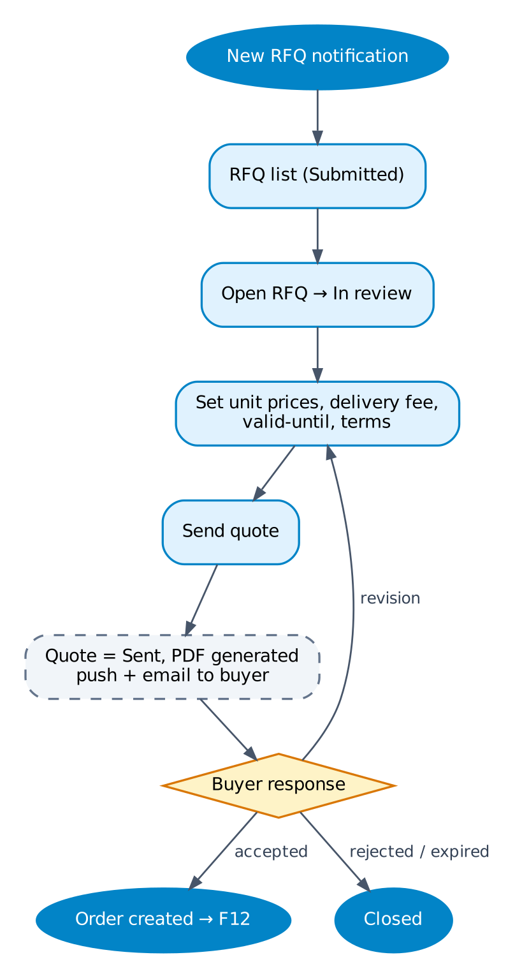
Figure F13 — Admin RFQ handling

Steps
# | Screen | User action | System response / rule
1 | A-04 RFQ list | Opens a Submitted RFQ. | RFQ = In review.
2 | A-04 Quote editor | Sets unit prices, delivery fee, valid-until date, terms. | Shows cost and stock for reference.
3 | A-04 | Sends quote. | Quote PDF generated; push + email to buyer; RFQ = Quoted.
4 | A-04 | Handles revision requests by editing and re-sending. | Previous quote versions kept.

Rules and edge cases
- Target response time: within 1 business day (PRD KPI).

F14 Admin back-office map
Actor | Trigger / entry | PRD refs
Admin / staff | Admin Dashboard. | ADM-01 to ADM-11

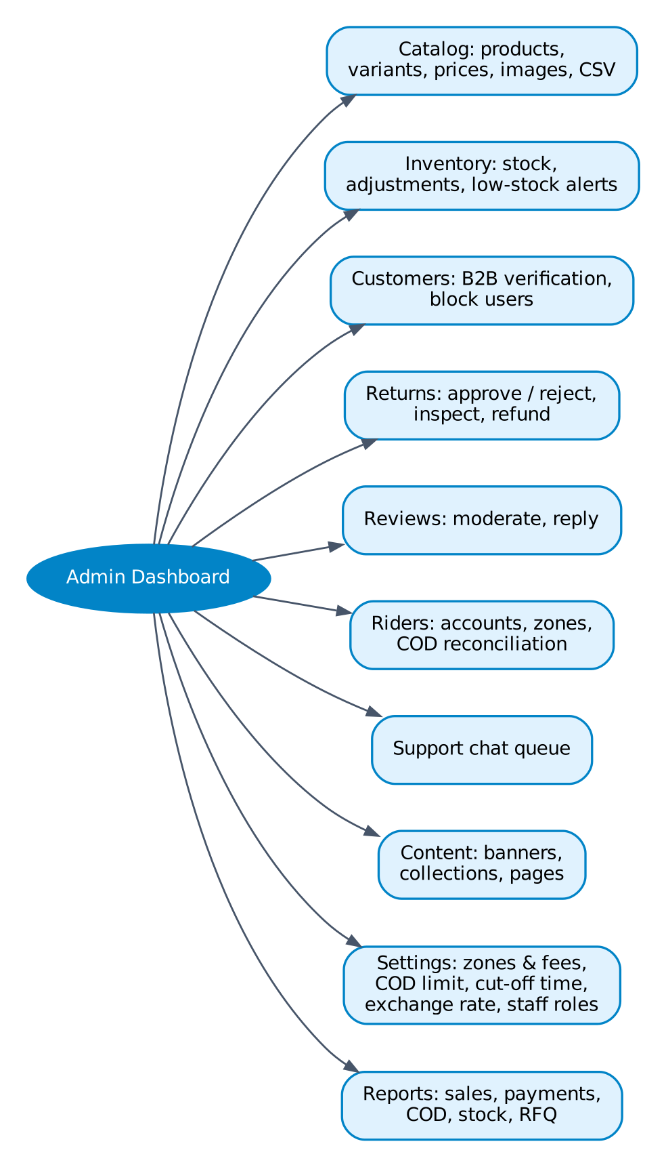
Figure F14 — Admin back-office map

Steps
# | Screen | User action | System response / rule
1 | A-01 Dashboard | Sees today's sales, orders by status, open RFQs, pending B2B verifications, returns, low stock. | Each tile links to the filtered list.
2 | A-05 / A-06 | Manages products, prices, images and stock. | Low-stock alert when stock is below the set level.
3 | A-08 Riders | Creates rider accounts, sets zones, confirms COD hand-over. | —
4 | A-14 Settings | Sets zones and fees, COD limit, 3 PM cut-off, KHR rate, bank account, staff roles. | Changes recorded in the audit log.

Rules and edge cases
- Menu items are shown according to staff permission (super admin, catalog, sales, support).

5. Status state diagrams
Blue boxes are final states. These states drive the screens and push notifications in the flows above.

5.1 Order status
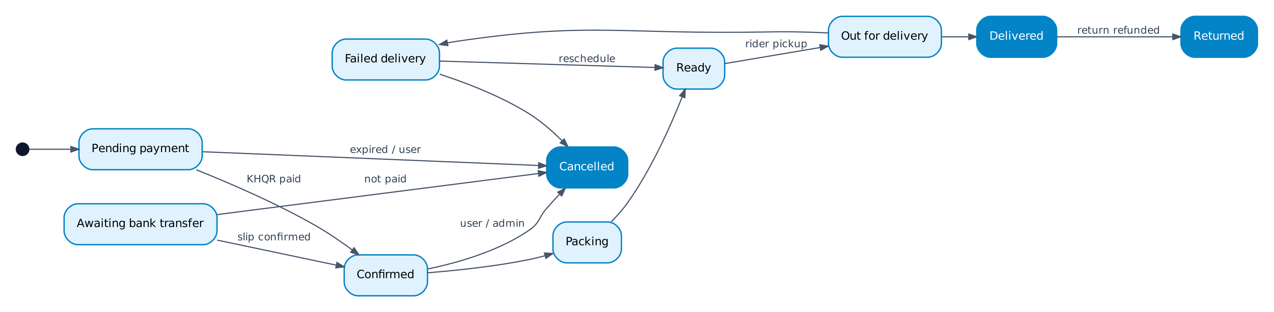
Retail and KHQR/COD orders start at Pending payment (COD moves straight to Confirmed). B2B bank-transfer orders start at Awaiting bank transfer.

5.2 Payment status
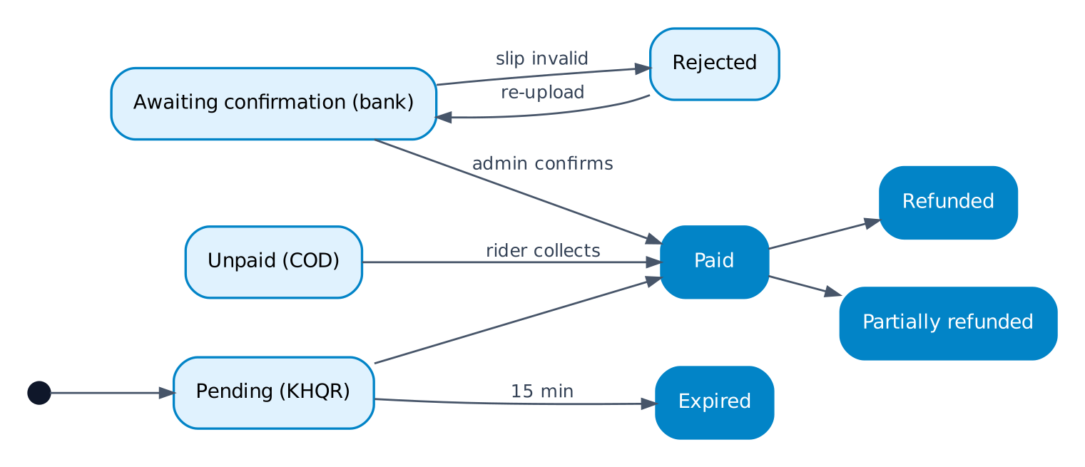

5.3 RFQ / quote status
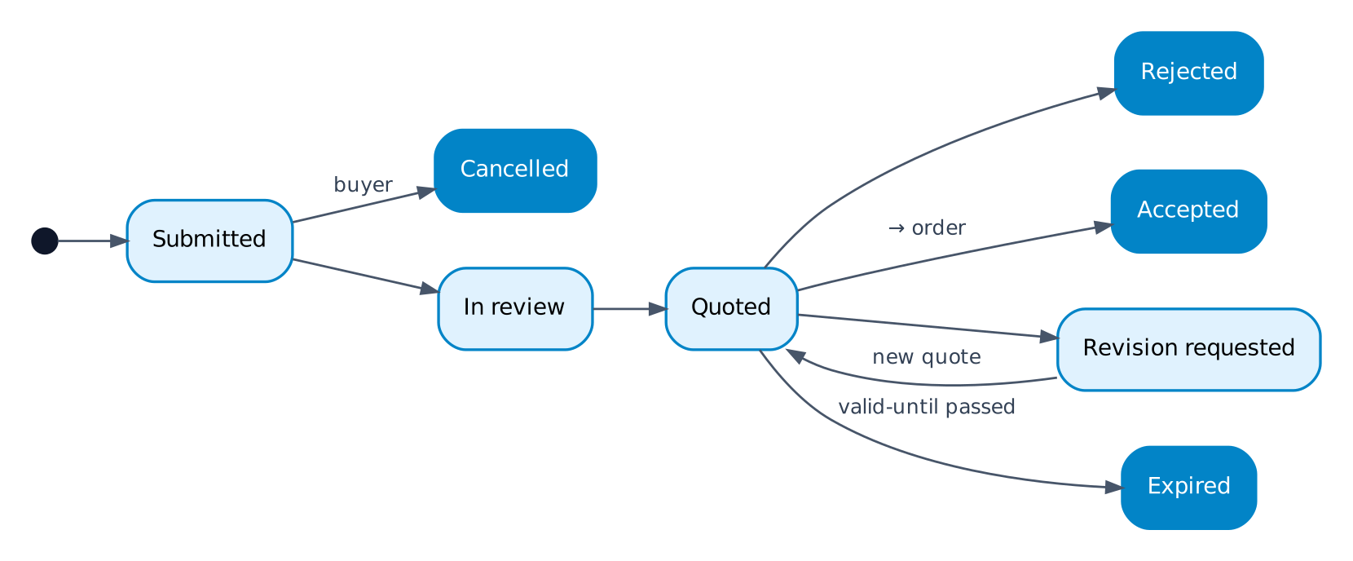

5.4 Delivery status
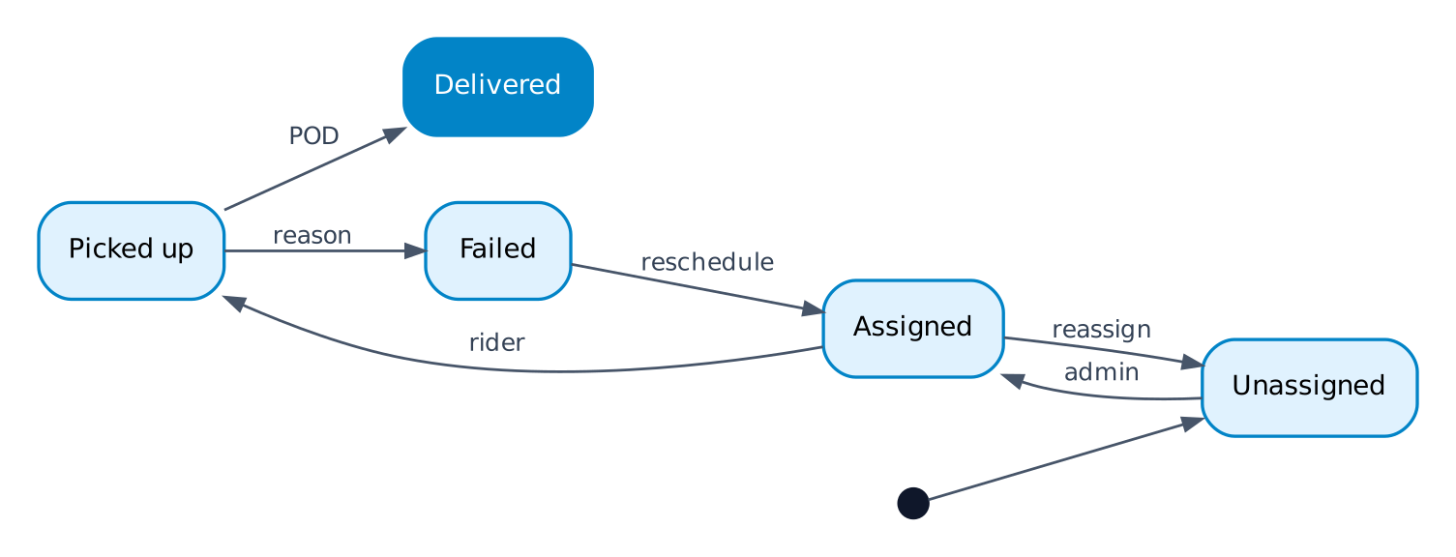

5.5 Return status
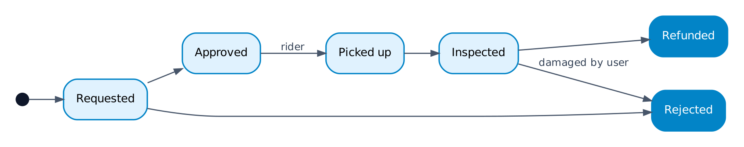

6. Notification matrix
Event | Recipient | Channel | Opens
Order confirmed / paid | Customer | Push, email | C-12
KHQR payment expired | Customer | Push | C-12
Order packing / out for delivery | Customer | Push | C-12 (live map)
Order delivered | Customer | Push | C-12
Delivery failed | Customer, Admin | Push | C-12 / A-02
Review reminder (2 days after delivery) | Customer | Push | C-15
Return approved / rejected / refunded | Customer | Push | C-12
Business account approved / rejected | Customer | Push, email | B-01
Quote ready / revised | Business buyer | Push, email | B-05
Quote expiring in 24 h | Business buyer | Push | B-05
Bank slip confirmed / rejected | Business buyer | Push | C-12 / B-06
New chat message | Customer or agent | Push (if app closed) | C-17 / A-11
New job assigned | Rider | Push + sound | R-02
New order, RFQ, return, B2B request, bank slip | Admin (by permission) | Push, dashboard badge | A-01 lists
Low stock | Admin (catalog) | Dashboard | A-06

7. Global business rules
Rule | Value | Where used
Market and currency | Cambodia; prices in USD with KHR shown | All price displays
Same-day cut-off | 3:00 PM Cambodia time; later orders → next day | F4
Stock reservation | 15 minutes for unpaid KHQR orders | F4, F5
KHQR validity | 15 minutes per QR | F5
OTP | 5-minute expiry, 5 attempts, resend after 60 s | F1
Customer cancellation | Allowed until Packing starts | F6
Return window | 3 days after delivery; customer pays return delivery | F7
B2B pricing | Only quote prices visible; purchase only via RFQ | F3, F8
B2B payment | KHQR, COD or bank transfer (slip + admin confirm) | F8
Retail payment | KHQR, COD (ABA PayWay next phase) | F4
COD limit | Per delivery zone, set in Settings | F4
Rider location updates | About every 15 s, only while out for delivery | F6, F11
Chat reopen window | 7 days after resolved | F10

7.1 Items to update in the PRD
These flow decisions change or add to PRD v1.0 and should be reflected in the next PRD version:
- Multi-country (INT-01, INT-02, PAY-07) moves out of v1: Cambodia only.
- Business buyers purchase through RFQ only and never see retail prices (CAT, CHK sections).
- Bank transfer with slip upload is added as a B2B payment method.
- Admin back-office runs in the same app on mobile and web (not web-only).
- Return window is 3 days; return delivery is paid by the customer.
- Same-day delivery with a 3 PM cut-off.

