**Ideas and Benefits**

The primary objective of this paper is to conceptualize and outline a strategic approach for developing a pharmaceutical molecule that effectively reverses aging by extending telomeres. This endeavor is not merely a significant step, but a definitive plan aimed at curing aging and achieving negligible senescence. The approach envisions administering the molecule sublingually or orally via a capsule, ensuring ease of delivery and maximizing bioavailability.

Holistic Approach: While telomere shortening is a primary cause of aging, addressing other factors holistically is essential. A balanced diet, supplements, and lifestyle changes are necessary to support cellular and mitochondrial health, DNA repair mechanisms, and oxidative stress reduction.

### Reasoning: Why Telomeres?

Telomeres are pivotal in the aging process, serving as the primary regulators of cellular aging and longevity. Addressing telomere length and integrity is crucial for several reasons:

* **Kingpin of Aging:** Telomeres act as the central axis influencing various aging factors. Their shortening is intricately linked with the aging process, and by extending them, we can modulate and potentially reverse other aging factors to youthful levels.
* **Primordial Germ Cells (PGCs):** PGCs are essentially immortal, maintaining their functionality and vitality over time. However, their gene expression and DNA stability alter with age. This alteration is not intrinsic to PGCs but is influenced by the surrounding cells with short telomeres. This is based on studies that human cells/skin when their telomeres are lengthened, all possible biomarkers of aging become youthful, in every way imaginable, including expression patterns and so on. By targeting telomere length in these regulatory cells, we can indirectly preserve the integrity and functionality of PGCs, thereby contributing to longevity and health.
* **Reversal of Aging Biomarkers:** Studies on mice have shown that induced aging through telomere shortening can be reversed. Mice that underwent premature aging due to telomere shortening experienced a reversal in all aging biomarkers once their telomeres were re-lengthened. Organs that had atrophied, like the brain, regained their normal size and functionality, providing compelling evidence of the regenerative potential of telomere extension.
* **Epigenetic Rejuvenation:** There is strong indication that the reversal of telomere shortening can restore the epigenetic profile of cells to a youthful state. This is crucial as epigenetic alterations are significant contributors to the aging process.
* **Addressing Cellular Damage:** While there is concern regarding the accumulation of DNA damage over time, evidence suggests that telomere extension can effectively rejuvenate cells, making them indistinguishable from their younger counterparts. For instance, skin cells from 80-year-old individuals, when subjected to telomere extension, mirrored the characteristics of cells from much younger individuals.
* **Long-Term Viability:** Given the evidence, it is plausible to assume that addressing telomere shortening can yield long-lasting results, potentially extending health and vitality for tens of thousands of years. The risk of mutations accumulating over such extended periods is acknowledged but is deemed manageable with the advent of technologies like CRISPR and anticipated advancements in medical technology.

(*Image Reversed Aging in Human Cells in Vitro, Reversed Aging in Human Skin (80 year old skin to become identical to young skin in every measure, by the extent of telomere elongation) on Mice, Reversed Aging in Engineered Mice, Nothing Else has even Done Any of these Things, and it is not just talking about a couple biomarkers, it is about every possible measurable biomarker became youthful again, according to Bill Andrews (watch his youtube videos)*)

(*Image Hallmarks of Aging, Loss of Proteostasis, Epigenetic Alterations, Telomere Attrition, Genomic Instability, Cellular Senescence, Mitochondrial Dysfunction, Deregulated Nutrient Sensing, Altered Intercellular Communication, Stem Cell exhaustion)

**Hallmarks of Aging,**

**Loss of Proteostasis** - Proteostasis will return to normal by epigenetic resetting or telomere elongation and telomere elongation can activate epigenetic resetting, making this hallmark of aging become youthful again, as in the studies. There may be bad protein buildup, but these can be cleared by the cell becoming younger.

**Epigenetic Alterations** - Controls the expression of genes, telomere relengthening controls this. However modern "age reversal studies" decide that this is the main cause when it is not, because it doesn't extend telomeres.

**Telomere Attrition** - Main cause of aging. Relatively simple to relengthen in humans.

**Genomic Instability** - Instability arises because of telomere shortening and it can be promptly reversed

**Cellular Senescence** - Cells become senescent because there telomeres reach 5000 base pairs

**Mitochondrial Dysfunction** - Returns to normal, we don't age by oxidative stress, but by telomere decline. A study on human skin in a petri dish showed that antioxidants did not cause the cells to exceed the hayflick limit, but telomere elongation did, showing that antioxidants are of little concern, as the body can produce more than enough already. However, mice already have long telomeres and constantly produce it, but they age by oxidative stress and mitochondrial dysfunction, so adding antioxidants to the mice cells made them exceed the hayflick limit.

**Deregulated Nutrient Sensing** - Nutrient sensing, blood health levels and such return to normal.

**Altered Intercellular Communication** - The intercellular communication returns to normal.

**Stem Cell Exhaustion** - Stem cells are harbored in special niches where they are exposed to little damage, but they are not able to divide anymore because telomeres shorten.

**Extracellular matrix Dysregulation** - As seen in the human skin and mouse models, the extracellular matrix becomes normal.

(*Image What We Lose With Age a single celled human has 15,000 base pairs of telomerase, a newborn has 10,000 base pairs, when telomeres get to 5000 base pairs they stop dividing)

Telomeres are crucial components in the aging process, serving as protective caps at the ends of chromosomes. They are sequences of repetitive nucleotide bases (TTAGGG in humans) that prevent chromosomes from deteriorating or fusing with each other. As cells divide, telomeres gradually shorten, and this shortening process is closely associated with aging, cellular dysfunction, and the onset of various age-related diseases.

Understanding Telomeres:

* **Telomere Basics:** Telomeres consist of repetitive DNA sequences and associated proteins that protect the ends of chromosomes from degradation and fusion. They are essential for maintaining genomic stability and integrity.
* **Shortening Mechanism:** With each cell division, telomeres shorten due to the inability of DNA polymerase to fully replicate the ends of linear DNA molecules. This process eventually leads to cellular senescence or apoptosis when telomeres reach a critical length.

Telomere Length Dynamics:

* **Initial Length:** In the earliest stage of human development, as a single cell, individuals possess approximately 15,000 base pairs of telomeres.
* **At Birth:** By the time of birth, due to cell divisions during embryonic development, the telomere length decreases to around 10,000 base pairs.
* **Critical Length:** When telomeres shorten to approximately 5,000 base pairs, cells enter a state of dysfunction, senescence, or programmed cell death (apoptosis). This critical length triggers a cellular crisis, contributing to aging and age-related diseases.

Significance in Aging:

* **Aging Marker:** Telomere length serves as a biological clock, marking cellular age and functionality. Shortened telomeres are indicators of aged, dysfunctional cells.
* **Health Implications:** Short telomeres are associated with a higher risk of chronic diseases, including cardiovascular diseases, diabetes, and neurodegenerative disorders.

Why Target Telomeres?

* **Reversing Aging:** By addressing telomere shortening, we aim to reverse cellular aging, restore cell functionality, and promote health and longevity.
* **Holistic Approach:** Extending telomeres offers a comprehensive strategy to modulate all other aging factors, providing a holistic approach to health and anti-aging interventions.

How can Targeting Telomeres Reverse all Aging Factors? Well basically like this.

**Why can we become biologically immortal?**

Take the primordial germ cells, they are immortal, however they still age.

Primordial germ cells (PGCs) are the precursors of sperm and eggs. They undergo extensive epigenetic reprogramming, including DNA methylation changes, to ensure the transmission of genetic information across generations. There is also a decrease in DNA stability. DNA methylation in PGCs is dynamic and is carefully regulated during their development. The process is crucial for the stability and integrity of these cells.

The surrounding somatic cells, also known as supporting cells, play a significant role in this regulation. These supporting cells create a microenvironment that influences the epigenetic state and stability of PGCs, guiding their development and differentiation. The interaction between PGCs and their surrounding cells is complex and crucial for the proper functioning and maintenance of germ cells.

Also, given that there were mice that were made to age because of telomere shortening, and their telomeres were relengthened, they gained a reversal in all possible biomarkers. Their brains that were 75% of the normal size because 100% again, and similarly could be said for every other organ, if this can happen to something as complex as the organ. And because Bill Andrews said that every possible biomarker of aging became indistinguishable from a younger cell, we could also assume that the epigenetic changes would return to a youthful state. And this is not to mention that mice do not even age by telomere shortening, but humans do.

And with this we have proved that telomere shortening is the cause of aging and reversing telomere shortening can make you become younger and youthful again. We have also addressed the issue of cellular damage over time, taking the primordial germ cells for account. However, there is still the slight issue of accumulation of dna damage over time, but even still 80-year-old skin when having the telomeres relengthened became identical to younger cells in every way imaginable. So assuming this, it would take a really long time like 10's of thousands of years before there may signs of aging even if this is taken care of. There is also the issue of mutations piling up over time, but it really shouldn't be an issue, as we have crispr and technology will become more advanced.

Finally,

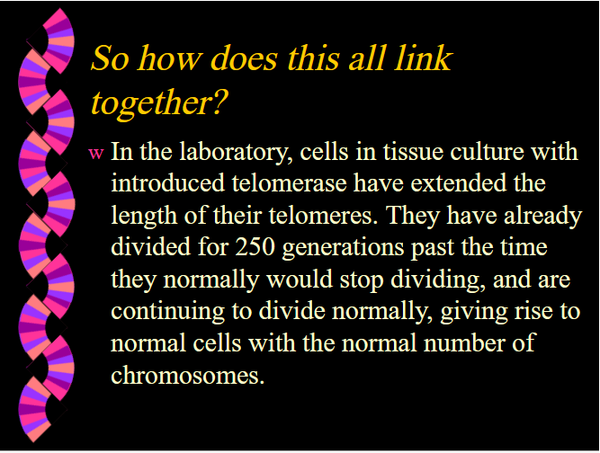

(*Image In the laboratory, human cells in tissue culture with introduced telomerase have extended the length of their telomeres. They have already divided for 250 generations past the time they normally would stop dividing and are continuing to divide normally, giving rise to normal cells with the normal number of chromosomes.)

So, we could live at least 5 times longer without issue.

### Future Considerations and Theory

While the focus is on telomere extension, it is crucial to consider and monitor potential risks and challenges. Telomere extension can be done by expressing telomerase.

Theory

We need to lengthen telomerase in all our cells, not just our stem cells. Lenghtening telomeres will make senescent cells regain their functionality again.

What is telomerase?

The telomerase enzyme is primarily composed of two core components: the telomerase RNA component (TERC or hTR) and the telomerase reverse transcriptase (hTERT). hTERT is the catalytic subunit of telomerase and is crucial for its activity. While TERC is usually present in cells, the expression of hTERT is tightly regulated. In many somatic (non-germline) cells, hTERT expression is turned off, but it needs to be activated for telomerase to function.

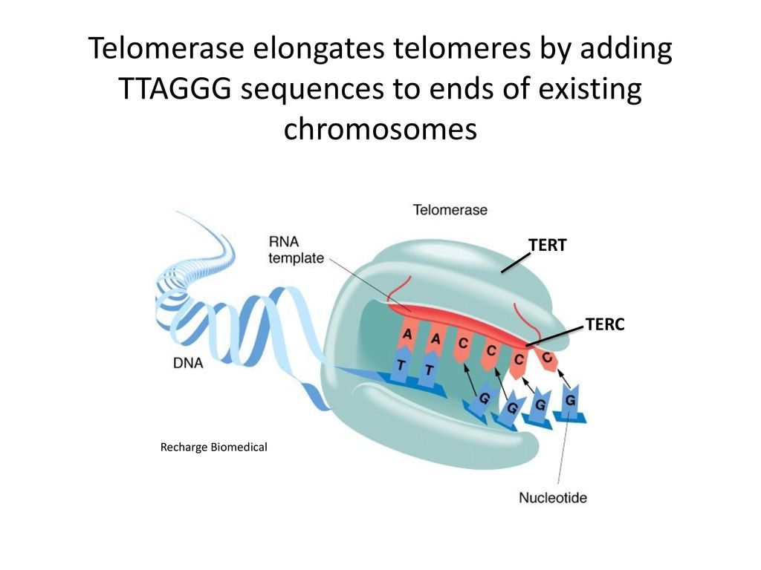

(*image Telomerase enzyme with TERT and TERC)

To get "full telomerase activity", Bill Andrews said that he mixed the protein component and the rna component in vitro and he got full telomerase activity. The cells stopped aging. Aging was reversed by every method of measurement because of this according to bill andrews. This experiment demonstrates that TERT and TERC are the minimal components necessary for telomerase activity.

Thus, we need to focus on enhancing TERT and TERC maximally to get full telomerase activation safely and effectively.

For TERT

The goal is to inhibit a repressor protein, to activate TERT and get near full expression safely.

A method to do so, is the inhibition of 2 repressor proteins F13 and F13H.

" the specific TERT repressor proteins

are the human f13 TERT repressor protein and the human f13h repressor protein

the subject repressor proteins inhibit expression of TERT, where-by inhibit expression is meant that expression of TERT is reduced by at least about 50%, usually at least about 75% and more usually at least about 90% as compared to a control system where TERT expression occurs and that is identical but for the absence of the subject repressor protein.

Therefore, if we completely repress these proteins we can have 90% activation of TERT. The risks for side effects are also minimal as Sierra Sciences is targeting these proteins and they have very little side effects so far. Though more research is needed to put it here concisely. We also need the protein structure and the exact name. There is no apparent side effects to this protein being inhibited in reproductive cells. And Sierra Sciences focus based on this/these proteins has shown no/very minor side effects.

"https://patents.justia.com/patent/7211435

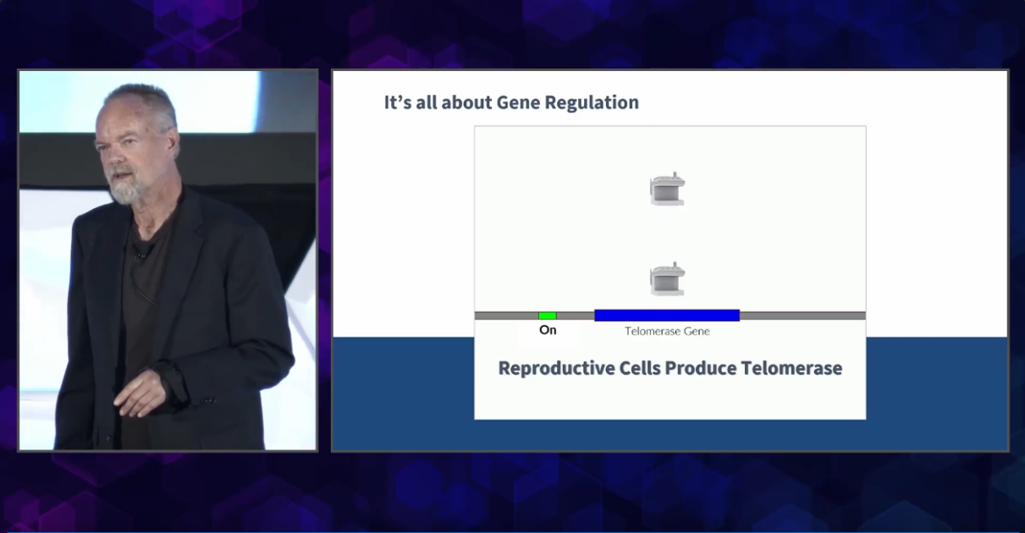

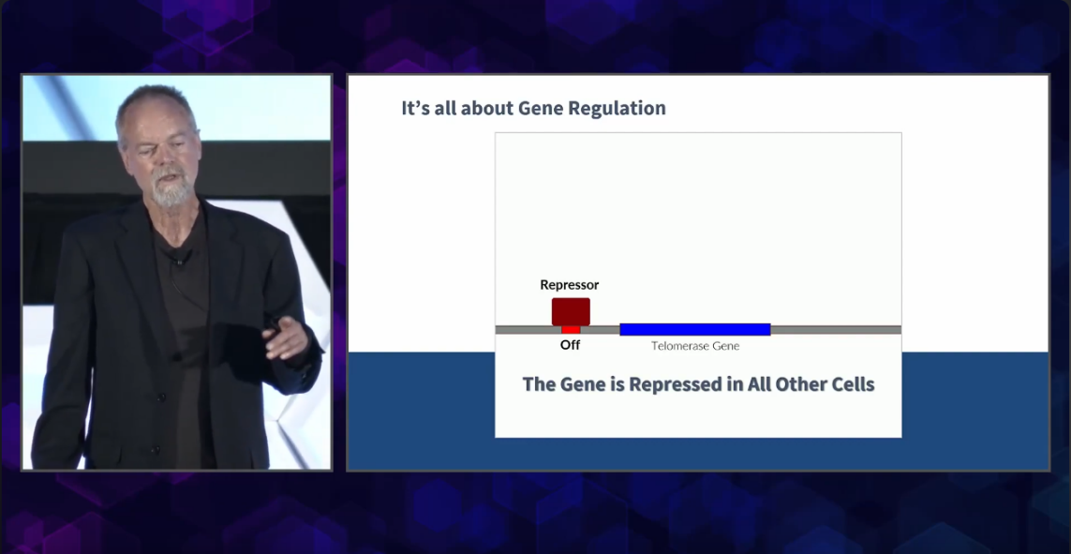

(*Image of chromosome line with red protein on regulator site of the telomerase gene, and on the right is no telomerase production. Image on the bottom is the same, but there is a green chemical that binds to the repressor protein to lift it and enable telomerase production.)

**F13:**

* **TERT Repressor:** F13 is described as a protein that inhibits the expression of TERT. TERT is an enzyme that plays a crucial role in maintaining the length of telomeres, which are structures at the ends of chromosomes.
* **Amino Acid Sequence:** The patent provides the amino acid sequence of F13 (SEQ ID NO:09), which can be used for further identification and study of this protein.

MEVNCLTLKDLISPRQPRLDFAVEDGENAQKENIFVDRSRMAPKTPIKNE PIDLSKQKKFTPERNPITPVKLVDRQQAEPWTPTANLKMLISAASPDIRD REKKKGLFRPIENKDDAFTDSLQLDVVGDSAVDEFEKQRPSRKQKSLGLL CQKFLARYPSYPLSTEKTTISLDEVAVSLGVERRRIYDIVNVLESLHLVS RVAKNQYGWHGRHSLPKTLRNLQRLGEEQKYEEQMAYLQQKELDLIDYKF GERKKDGDPDSQEQQLLDFSEPDCPSSSANSRKDKSLRIMSQKFVMLFLV SKTKIVTLDVAAKILIEESQDAPDHSKFKTKVRRLYDIANVLTSLALIKK VHVTEERGRKPAFKWIGPVDFSSSDEELVDVSASVLPELKRETYGQIQVC AKQKLARHGSFNTVQASERIQRKVNSEPSSPYREEQGSGGYSLEIGSLAA VYRQKIEDNSQGKAFASKRVVPPSSSLDPVAPFPVLSVDPEYCVNPLAHP VFSVAQTDLQAFSMQNGLNGQVDVSLASAASAVESLKPALLAGQPLVYVP SASLFMLYGSLQEGPASGSGSERDDRSSEAPATVELSSAPSAQKRLCEER KPQEEDEPATKRQSREYEDGPLSLVMPKKPSDSTDLASPKTMGNRASIPL KDIHVNGQLPAAEEISGKATANSLVSSEWGNPSRNTDVEKPSKENESTKE PSLLQYLCVQSPAVTSSSDPQEHPTHTS

* **Function:** The inhibition of TERT expression by F13 and F13H can be significant, with the patent noting reductions of at least about 50%, usually at least about 75%, and more usually at least about 90% compared to controls.
* To look at the F13 protein and download https://www.ebi.ac.uk/thornton-srv/databases/cgi-bin/pdbsum/GetPage.pl?pdbcode=A4sc
* This protein was obtained by using alphafold to get a 99.9% percentage identity accuracy accuracy via going to a web server that offers AlphaFold predictions. [AlphaFold at EMBL-EBI](https://www.ebi.ac.uk/thornton-srv/databases/cgi-bin/pdbsum/GetPage.pl?pdbcode=index.html&template=alphafold.html)
* For example, if you have two protein sequences:

Sequence 1: AGTCAGTC

Sequence 2: AGTCCGTC

There are 6 identical positions out of 8, so the percentage identity is (6/8)*100 = 75%.

**F13H:**

* **Homolog of F13:** F13H is described as a homolog of F13. In biology, "homolog" refers to a gene or protein that shares a common evolutionary ancestor. Homologs typically have similar sequences and may have similar functions.
* **TERT Repressor:** Like F13, F13H also acts as a repressor of TERT expression.
* **Amino Acid Sequence:** The amino acid sequence of F13H is provided as SEQ ID NO:11 in Figure 3 of the patent (not accessible in the text).
* **Function:** It is implied that F13H has a similar function to F13 in inhibiting TERT expression, though the exact degree of inhibition is not specified for F13H in the text.

**Relationship Between F13 and F13H:**

* **Similar Function:** Both F13 and F13H are described as TERT repressor proteins, suggesting they have similar functions in inhibiting TERT expression.
* **Sequence Similarity:** As F13H is a homolog of F13, they share sequence similarity, though the exact degree of similarity is not specified in the text.
* **Potential for Homologs in Various Species:** The patent notes that homologs of these proteins, with significant sequence identity, can be found in various species, including mammals.

**For TERC**

TERC is thought to be abundant and ubiquitously expressed

1. **Ubiquitous Expression of TERC**: TERC, as the RNA component of telomerase, is ubiquitously expressed across various cell types throughout the body. This widespread expression ensures that TERC is available in cells when needed.
2. **Functional Dependency on TERT**: Despite its ubiquitous presence, TERC requires the protein component, TERT, for telomerase to be functionally active. Most somatic cells have TERC but lack TERT expression, rendering telomerase inactive. Therefore, enhancing TERT activation becomes the primary target to activate telomerase.
3. **Empirical Evidence from Cellular Studies**: Studies on human cells in vitro have demonstrated that introducing telomerase (via TERT) can extend telomere length, resulting in extended cellular lifespan. This shows that as long as TERT is available and active, it can utilize the ubiquitously present TERC to function.
4. **Comparative Analysis with Germ Cells**: Germ cells, which include egg and sperm cells, have active telomerase throughout life. These cells have both TERC and TERT, with TERT being the differentiating factor that allows telomerase activity. This showcases that even in nature, where TERC is consistently available, TERT becomes the determining factor for telomerase activity.
5. **Final Thoughts**: Given the consistent and ubiquitous expression of TERC, the focus should be on optimizing TERT activation. Achieving 90% TERT activation would ensure telomerase activity is sufficiently high to halt or even reverse aging processes at the cellular level. The presence of TERC in cells, coupled with enhanced TERT activity, provides a promising avenue for anti-aging interventions.

TERC is sufficiently abundant thus the section for TERC is solved.

**Risks**

Cancer activation - however telomerase does not cause cancer, rather cancer activates telomerase to be immortal. It is irrelevant for cancer to have long telomeres as long as the immune system is healthy because it can eliminate those cells. We have remedies and treatments for cancer already. The issue with cancer activation is that if do not properly identify the repressor protein for the telomerase gene and mistakenly target another protein. Or we cause off-target effects.

hTERT elongates short telomeres and shortens long telomeres.

**The scale for effectiveness**

When human cells inside the body become negligibly senescent like Hela cells because telomeres growth outpaces telomere shortening. Also, we can compare it to the hela scale, because that is an immortal cell line that produces the least amount of telomerase to be immortal, however we may need even less telomerase than that, as Hela cells are immortal and in a dish.

**Theoretically**

If repressor proteins can activate telomerase to 90%, it could be sufficient to significantly extend the lifespan of cells, making them "immortal" in terms of their ability to divide. Germ cells and some stem cells have active telomerase to maintain their telomeres. However, achieving 90% activation doesn't guarantee full immortality, as other factors can influence cellular lifespan. While targeting TERT directly might further increase telomerase activity, it's uncertain if going beyond 90% would offer additional benefits for cellular immortality.

### Methods for Telomere Resetting

The strategic approach to developing a molecule for reversing aging through telomere extension involves a systematic and phased methodology. This section outlines the steps and considerations in the process:

#### 1. **Understanding Telomerase Activation:**

* **Biology of Telomerase:** Delve deep into the biology of telomerase, understanding its activation mechanisms, structure, function, and associated proteins.
* **Regulatory Pathways:** Investigate the pathways that regulate telomerase activity, identifying potential leverage points for intervention.

#### 2. **Target Identification:**

* **Drug Targets:** Identify potential targets within the telomerase pathway that are amenable to drug intervention.
* **Critical Proteins:** Focus on proteins or domains crucial for telomerase activation, serving as potential drug targets.

#### 3. **In Silico Drug Design:**

* **Computational Design:** Utilize computational methods to design molecules capable of interacting with identified targets effectively.
* **SBDD & LBDD Techniques:** Employ Structure-Based Drug Design (SBDD) and Ligand-Based Drug Design (LBDD) techniques for precise molecular design.
* **Molecular Docking:** Predict the interaction between designed molecules and targets using molecular docking techniques.

#### 4. **ADME/Tox Prediction:**

* **Pharmacokinetics Prediction:** Estimate the Absorption, Distribution, Metabolism, Excretion, and Toxicity (ADME/Tox) properties of designed molecules using in silico tools.
* **Toxicity Assessment:** Evaluate potential toxicity early in the design phase to ensure safety and efficacy.

#### 5. **In Vitro Testing:**

* **Molecule Synthesis:** Synthesize designed molecules and evaluate their activity through cell-based assays.
* **Telomerase Activation Assessment:** Test the molecules’ ability to activate telomerase in relevant cell lines and assess toxicity.

#### 6. **In Vivo Testing:**

* **Animal Model Testing:** Evaluate the efficacy and toxicity of promising candidates in animal models to understand their physiological impacts.

#### 7. **Optimization:**

* **Molecule Refinement:** Based on testing results, optimize the molecules to enhance their activity while minimizing toxicity.

### Tools and Software Utilized:

* **Molecular Modeling Software:** MOE, Schrodinger Suite, Discovery Studio.
* **ADME/Tox Prediction Tools:** ADMET Predictor, PreADMET, SwissADME.
* **Molecular Docking Software:** AutoDock, DOCK, Glide.

### Considerations:

* **High-Throughput Screening:** Lower cost per compound, uses existing compound libraries, bulk purchases.

But most existing compounds have already been tested?

* **Custom Synthesis:** Higher cost, creating new molecules not available in libraries, specialized process chatgpt gave numbers of $2000-20,000 for the synthesis of new molecules. However, if the new molecule is able to achieve the object then Bill Andrews says he could mass produce it for less than $1 per person.
* **To do**

Longecity forum, put this paper there

Find the protein structure for F13H

* (this is where I left off. What I am thinking is that because the patent describes F13H )

The F13H protein, is a variant or homolog of the F13 protein, so it may indeed have a similar amino acid sequence to F13. Proteins that are variants, isoforms, or members of the same family often share sequence similarities due to their related functions and evolutionary origins. However, the degree of similarity can vary widely, from almost identical sequences to only sharing conserved domains or motifs.

If F13H is closely related to F13, it might be among the 98 results you obtained when searching for sequences with high identity to F13. To confirm this, you would need to analyze the sequences of the results and compare them to the known sequence of F13H (if available). You can use bioinformatics tools and databases to perform sequence alignment and comparison to quantify the degree of similarity and identity between the sequences.

I just happened to leave off here, so I am not burdening you with a hard task, it just would require me some hours to find the protein structure.

Open F13 and F13H in molecular docking software and locate the optimal binding sites

Maximize the inhibition and use AI to help / open source initiative. Bionemo?

Regarding funding and testing molecules, we can all collectively donate to Bill Andrews of Sierra Sciences to get the molecule and test it/ fund his research. Bill Andrews, can have a website showing the top donors and such so we actually know where the money is going

Regarding epitalon - it doesn't increase telomerase expression

Bill Andrews said in 2019 that there were only three known telomerase inducers that he knew of ta-65, Isagenix isagenesis(?), tam818? Everything else is a lie and if there is anyone that would know it would be him.

Bill Andrews always says to watch out for the "charlattans" and greedy people. Most pubmed articles are SH#T and state false facts. ALWAYS investigate into the background of people. Just because an entire research team is working on it, even if Harvard works on it, does not mean it is reliable.

BASICALLY, YOU CAN USE http://clab.labshare.cn/cb-dock/php/index.php AND PUT THE F13 PROTEIN THERE, THEN EXPERIMENT WITH A NEW COMPOUND THAT YOU CREATE USING SWISSDOCK, THEN OPTIMIZE THE BINDING. SIMILARLY FOR F13H. THE GOAL IS TO INHIBIT THESE PROTEINS, NOT ACTIVATE THEM.

TO GET AN EXAMPLE OF HOW TO USE CB-DOCK, GO TO THE LINK, THEN PRESS "RESULTS" A PROTEIN AND LIGAND WILL SHOW UP. THE LOWER THE VINA SCORE, THE HIGHER THE BINDING AFFINITY.

YOU CAN SEE THE DIFFERENT "CRATERS" AND THIS IS VERY IMPORTANT BECAUSE SOME OF THESE CRATERS ARE THE IDEAL TARGETS, WHOM YOU WANT TO IDENTIFY AND FIND THE PERFECT MOLECULE TO FIT IN THIS CRATER. YOU DON'T HAVE TO TARGET ALL CRATERS (MAYBE) IT IS USUALLY A FEW OR EVEN ONE, TO "INHIBIT".

**Hallmarks of Aging,**

**Loss of Proteostasis** - Proteostasis will return to normal by epigenetic resetting or telomere elongation and telomere elongation can activate epigenetic resetting, making this hallmark of aging become youthful again, as in the studies. There may be bad protein buildup, but these can be cleared by the cell becoming younger.

**Epigenetic Alterations** - Controls the expression of genes, telomere relengthening controls this. However modern "age reversal studies" decide that this is the main cause when it is not, because it doesn't extend telomeres.

**Telomere Attrition** - Main cause of aging. Relatively simple to relengthen in humans.

**Genomic Instability** - Instability arises because of telomere shortening and it can be promptly reversed. Especially in the primordial germ cells, whose maintenance is affected by the surrounding somatic cells.

**Cellular Senescence** - Cells become senescent because there telomeres reach 5000 base pairs. Killing senescent cells via senolytics is bad, especially if you are older, because those cells aren't "dead" they just don't divide, this is why senolytics is bad, according to bill Andrews. This is why senolytics targeting isn't an option. Telomere relengthening can make senescent cells become normal again.

**Mitochondrial Dysfunction** - Returns to normal, we don't age by oxidative stress, but by telomere decline. A study on human skin in a petri dish showed that antioxidants did not cause the cells to exceed the hayflick limit, but telomere elongation did, showing that antioxidants are of little concern, as the body can produce more than enough already. However, mice already have long telomeres and constantly produce it, but they age by oxidative stress and mitochondrial dysfunction, so adding antioxidants to the mice cells made them exceed the hayflick limit.

**Deregulated Nutrient Sensing** - Nutrient sensing, blood health levels and such return to normal.

**Altered Intercellular Communication** - The intercellular communication returns to normal following telomere reextension

**Stem Cell Exhaustion** - Stem cells are harbored in special niches where they are exposed to little damage, but they are not able to divide anymore because telomeres shorten.

**Extracellular matrix Dysregulation** - As seen in the human skin and mouse models, the extracellular matrix becomes normal following telomere re-extension.

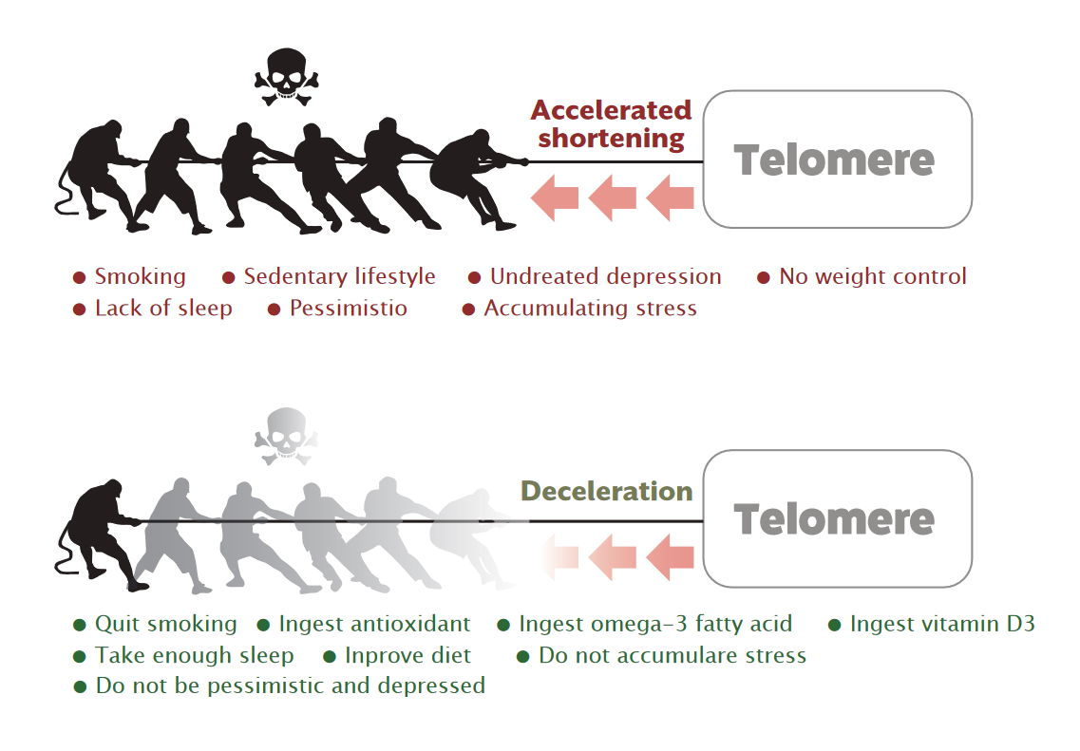

How can these beneficial things reduce telomere shortening? They reduce the oxidative damage to telomeres, rather than activating telomerase or anything, and actually the antioxidant buildup is much greater when you do these things rather than stay stagnant, because you build even more antioxidants than when you stay still.

When you do long distance running, you may get sore at first, because you have lots of inflammation in your body, but your body gets used to this. It produces much more antioxidants, and this is why there are still 80 and 90 year olds that can run marathons.

Extreme muscle building is bad, because you overexhaust your muscle stem cells to produce more muscle cells.

Sorry if the grammar is bad, I wanted to put this paper on longecity as soon as possible. And It should be fine, because there is still lots of work to do. I just worked on the base.