**COMS4111-Introduction to Databases**

**Project 1, Part 1**

Xiyan Liu (xl2672)

Jun Hu (jh3846)

**Proposal Approved By: YU GU**

**Comments by Yu:**

1. Add constraints to owner
2. Redraw weak entity & relationship

**Our Solutions:**

Fixed all mentioned problems

**Description**

Property management database is a web-based real estate database that provides information and service for homebuyers, home sellers and real estate agents to exchange property information more efficiently among them. This database stores information about property details, building neighborhood, school, transportation, lists of price, etc. related to property and agents who holds the source of property.

A homebuyer could utilize the database to look for their likely interesting home by zip code, address, price, property type (condo, house, apartment), school district and other specific condition. Real estate agents can widely publicize their listings and get contacted by potential homebuyers. Homeowners can hire the good performance agents depending on their past trading record.

**Design Specification**

**Properties**

A property has a unique property ID, address, a zip code, the number of bedroom and bathroom, the area of squire feet and a built date. One property lies in one block. The property has a list of price. The property is sold by an agent and belonged one owner.

**Sale States**

Sale state is the state to describe if the property is on sale right now. Sale state still shows what is the start sale date and end sale date.

**Prices**

The price is composed of listing price, maintenance fee and tax deduction. Each property has an evaluated price and a last time sold price.

**Blocks**

Block is the district where property belongs. Each block has a unique district ID. Some block locates at water front division. The block has its commute system such as bus and subway.

**School Districts**

School district has its unique district number. The public school including primary, middle and high school have scores rated by education system.

**Agents**

Sell agent has a unique register ID, first name, last name and telephone.

**Owners**

Owner has a unique SSN number, first name and last name.

**ER Diagram**

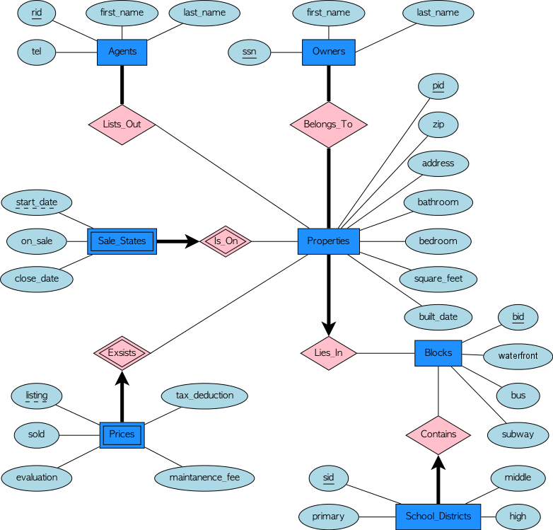

**Relational Schema**

CREATE TABLE Agents ( rid CHAR(15),

tel INTEGER,

first_name CHAR(25),

last_name CHAR(25),

PRIMARY KEY (rid) )

CREATE TABLE Sale_States ( start_date DATE,

on_sale CHAR(10),

close_date DATE,

pid CHAR(10),

PRIMARY KEY (start_date, pid),

FOREIGN KEY (pid) REFERENCES Properties

ON DELETE CASECADE )

CREATE TABLE Prices ( listing REAL,

sold REAL,

evaluation REAL,

tax_deduction REAL,

maintanece_fee REAL,

pid CHAR(10),

PRIMARY KEY (listing, pid),

FOREIGN KEY (pid) REFERENCES Properties

ON DELETE CASECADE )

CREATE TABLE Owners ( ssn CHAR(10),

first_name CHAR(25),

last_name CHAR(25),

PRIMARY KEY (ssn) )

CREATE TABLE Properties ( pid CHAR(10),

zip CHAR(10),

address CHAR(30),

bathroom INTEGER,

bedroom INTEGER,

square_feet REAL,

built_date DATE,

PRIMARY KEY (pid) )

CREATE TABLE Blocks ( bid CHAR(11),

waterfront BOOLEAN,

bus CHAR(20),

subway CHAR(20),

PRIMARY KEY (bid) )

CREATE TABLE School_Districts ( sid CHAR(30),

primary CHAR(30),

middle CHAR(30),

high CHAR(30),

PRIMARY KEY (sid) )

**Part 3 Choice:**

Web Front-End Option (Option 3.a).