FAQ accordion
Create an FAQ accordion so that each question can be clicked and expanded.

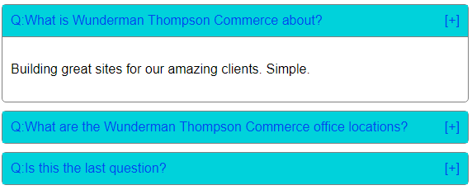

Pre-requisites:
- FAQs JSON - https://api.myjson.com/bins/jw3rg
- You can use a JavaScript library / framework of your choosing if preferable.

We are looking for:
- FAQ’s to be rendered dynamically and to look as per visual.
- Accordion to be functional i.e. click on question and answer should expand
- Clean code following DRY / Solid principle

Deliverables:
- Zip file containing application source files
- Readme file detailing
- steps to run the final solution
- your full name and email address, any other suitable information

