My table contains some identifiers, call them ID1 and ID2 and the records look like this:  
[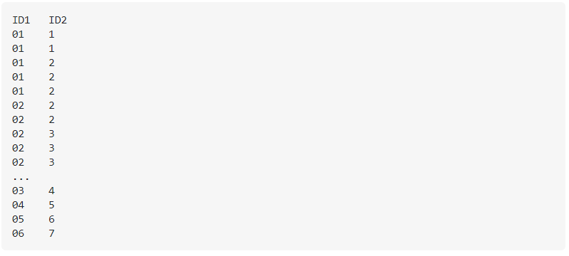](https://user-images.githubusercontent.com/49004578/103276549-28659e80-49c7-11eb-87a3-987cba4dc844.png)

Output of above will be like:

[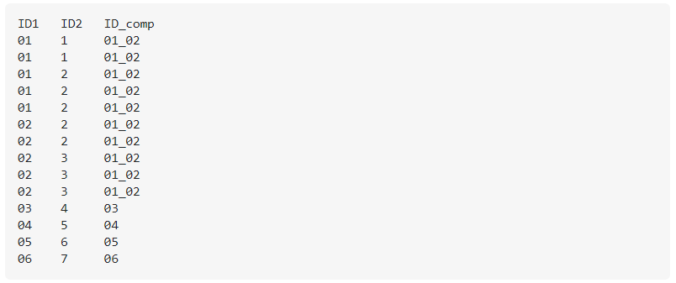](https://user-images.githubusercontent.com/49004578/103276616-564ae300-49c7-11eb-945d-6698ce876cdc.png)

Transformation Logic:

Link ID2 = 3 to ID2 = 2 via ID1 = 02 and then ID1 = 02 to ID2 = 01 via ID2 = 2 in the first part of the example table.  
Second part is single entry.