Input data :-

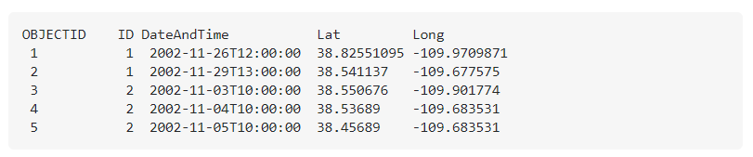

Requirement :- is to calculate the distance between sequential points and partitioned by the ID number in BigQuery.

Based on the above table, we want the query to calculate the distance between ObjectID 1 & 2, and then the distance between ObjectID 3 & 4 and then 4 & 5.

Expected Output:-

