UNIVERSITY OF IBADAN, IBADAN, NIGERIA

**DEPARTMENT OF COMPUTER SCIENCE**



**Prof. Solomon O. AKINOLA**

**CABLES & TELEGRAMS: UNIVERSITY OF IBADAN**

**TELEX 31128NG**

**E-mail:** [akinola.olalekan@dlc.ui.edu.ng](mailto:akinola.olalekan@dlc.ui.edu.ng)

**Phone: +2348169748281**

**1 March, 2025**

**The Hall Warden, Tedder Hall, University of Ibadan**

**Re: Obiezue Victor Chidera**

I write to confirm that Obiezue Victor Chidera (Matriculation Number 238022) is currently in 100 Level in my Department. He is a serious student. He came all the way from Kaduna State and he is in serious need of accommodation for next session.

I shall be very grateful if he could secure a bed space in your Hall against next session Best regards.

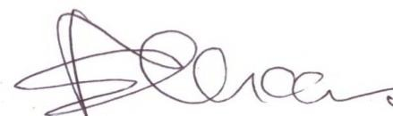

**Professor S. O. Akinola** 19/4/2024 <https://sci.ui.edu.ng/content/akinola-s-olalekan> Department of Computer Science,

University of Ibadan, Ibadan, Nigeria.