Sample IEEE Paper for A4 Page Size

Anonymous VCIP Submission
Paper ID:

Abstract— This document gives formatting instructions for authors preparing papers for publication in the Proceedings of an IEEE conference. The authors must follow the instructions given in the document for the papers to be published. You can use this document as both an instruction set and as a template into which you can type your own text.

Index Terms— Include at least 5 keywords or phrases
- Introduction
This document is a template. An electronic copy can be downloaded from the conference website. For questions on paper guidelines, please contact the conference publications committee as indicated on the conference website. Information about final paper submission is available from the conference website.
- Page Layout
An easy way to comply with the conference paper format-ting requirements is to use this document as a template and simply type your text into it.
- Page Layout
Your paper must use a page size corresponding to A4 which is 210mm (8.27") wide and 297mm (11.69") long. The margins must be set as follows:
- Top = 19mm (0.75")
- Bottom = 43mm (1.69")
- Left = Right = 14.32mm (0.56")
Your paper must be in two column format with a space of 4.22mm (0.17") between columns.
- Blind Review
Many authors misunderstand the concept of anonymizing for blind review. Blind review does not mean that one must remove citations to one's own work; in fact it is often impossible to review a paper unless the previous citations are known and available.
Blind review means that you do not use the words “my” or “our” when citing previous work. That is all. (But see below for techreports)

Saying “this builds on the work of Lucy Smith [1]” does not say that you are Lucy Smith, it says that you are building on her work. If you are Smith and Jones, do not say “as we show in [1]”, say “as Smith and Jones show in [1]” and at the end of the paper, include reference 1 as you would any other cited work.
An example of a bad paper:

An analysis of the frobnicatable foo filter.
In this paper we present a performance analysis of our previous paper [1], and show it to be inferior to all previously known methods. Why the previous paper was accepted without this analysis is beyond me.
[1] Removed for blind review

An example of an excellent paper:

An analysis of the frobnicatable foo filter.
In this paper we present a performance analysis of the paper of Smith et al. [1], and show it to be inferior to all previously known methods. Why the previous paper was accepted without this analysis is beyond me.
[1] Smith, L and Jones, C. “The frobnicatable foo filter, a fundamental contribution to human knowledge”. Nature 381(12), 1-213.

If you are making a submission to another conference at the same time, which covers similar or overlapping material, you may need to refer to that submission in order to explain the differences, just as you would if you had previously published related work. In such cases, include the anonymized parallel submission [1] as additional material and cite it as

[1] Authors, “The frobnicatable foo filter,” ACM MM 2011 Submission ID 324, Supplied as additional material acmmm11.pdf.

Finally, you may feel you need to tell the reader that more details can be found elsewhere, and refer them to a technical report. For conference submissions, the paper must stand on its own, and not require the reviewer to go to a techreport for further details. Thus, you may say in the body of the paper “further details may be found in [2]”. Then submit the techreport as additional material. Again, you may not assume the reviewers will read this material.
Sometimes your paper is about a problem which you tested using a tool which is widely known to be restricted to a single institution. For example, let’s say it’s 1969, you have solved a key problem on the Apollo lander, and you believe that the VCIP audience would like to hear about your solution. The work is a development of your celebrated 1968 paper entitled “Zero-g frobnication: How being the only people in the world with access to the Apollo lander source code makes us a wow at parties”, by Zeus et al.
You can handle this paper like any other. Don’t write
“We show how to improve our previous work [Anonymous, 1968]. This time we tested the algorithm on a lunar lander [name of lander removed for blind review]”. That would be silly, and would immediately identify the authors. Instead write the following:

We describe a system for zero-g frobnication. This system is new because it handles the following cases: A, B. Previous systems [Zeus et al. 1968] didn’t handle case B properly. Ours handles it by including a foo term in the bar integral.
...
The proposed system was integrated with the
Apollo lunar lander, and went all the way to the moon, don’t you know. It displayed the following behaviours which show how well we solved cases A and B: ...

As you can see, the above text follows standard scientific convention, reads better than the first version, and does not explicitly name you as the authors. A reviewer might think it likely that the new paper was written by Zeus et al., but cannot make any decision based on that guess. He or she would have to be sure that no other authors could have been contracted to solve problem B.
FAQ: Are acknowledgements OK? No. Please omit them in the review copy and leave them for the final copy.

- Paper ID and filenames
Authors should first submit the title, list of authors, topic/keywords, and abstract of paper. After that, a paper ID will be assigned. This should be entered in the paper ID field below the title, and used as the filename of the submitted paper (and any supplementary materials). This avoids revealing the authors' information in the filename.

- Page Style
All paragraphs must be indented. All paragraphs must be justified, i.e. both left-justified and right-justified.
- Text Font of Entire Document
The entire document should be in Times New Roman or Times font. Type 3 fonts must not be used. Other font types may be used if needed for special purposes.
Recommended font sizes are shown in Table 1.

- Title and Author Details
Title must be in 24 pt Regular font. Author name must be in 11 pt Regular font. Author affiliation must be in 10 pt Italic. Email address must be in 9 pt Courier Regular font.
TABLE I
Font Sizes for Papers
Font Size | Appearance (in Time New Roman or Times)
Font Size | Regular | Bold | Italic
8 | table caption (in Small Caps),  figure caption,  reference item |  | reference item (partial)
9 | author email address (in Courier),  cell in a table | abstract body | abstract heading (also in Bold)
10 | level-1 heading (in Small Caps),  paragraph |  | level-2 heading,  level-3 heading,  author affiliation
11 | author name
24 | title

All title and author details must be in single-column format and must be centered.
Every word in a title must be capitalized except for short minor words such as “a”, “an”, “and”, “as”, “at”, “by”, “for”, “from”, “if”, “in”, “into”, “on”, “or”, “of”, “the”, “to”, “with”.
Author details must not show any professional title (e.g. Managing Director), any academic title (e.g. Dr.) or any mem-bership of any professional organization (e.g. Senior Member IEEE).
To avoid confusion, the family name must be written as the last part of each author name (e.g. John A.K. Smith).
Each affiliation must include, at the very least, the name of the company and the name of the country where the author is based (e.g. Causal Productions Pty Ltd, Australia).
Email address is compulsory for the corresponding author.
- Section Headings
No more than 3 levels of headings should be used. All headings must be in 10pt font. Every word in a heading must be capitalized except for short minor words as listed in Section IV-B.
- Level-1 Heading: A level-1 heading must be in Small Caps, centered and numbered using uppercase Roman numerals. For example, see heading “III. Page Style” of this document. The two level-1 headings which must not be numbered are “Acknowledgment” and “References”.
- Level-2 Heading: A level-2 heading must be in Italic, left-justified and numbered using an uppercase alphabetic letter followed by a period. For example, see heading “C. Section Headings” above.
- Level-3 Heading: A level-3 heading must be indented, in Italic and numbered with an Arabic numeral followed by a right parenthesis. The level-3 heading must end with a colon. The body of the level-3 section immediately follows the level-3 heading in the same paragraph. For example, this paragraph begins with a level-3 heading.
- Figures and Tables
Figures and tables must be centered in the column. Large figures and tables may span across both columns. Any table or figure that takes up more than 1 column width must be positioned either at the top or at the bottom of the page.
Graphics may be full color. All colors will be retained on the CDROM. Graphics must not use stipple fill patterns because they may not be reproduced properly. Please use only SOLID FILL colors which contrast well both on screen and on a black-and-white hardcopy, as shown in Fig. 1.

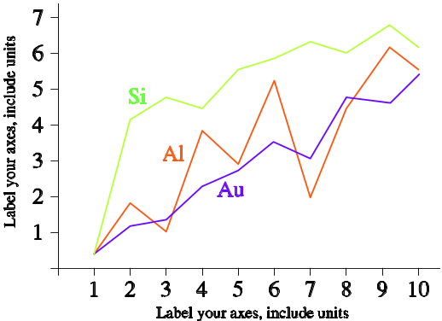
Fig. 1 A sample line graph using colors which contrast well both on screen and on a black-and-white hardcopy

Fig. 2 shows an example of a low-resolution image which would not be acceptable, whereas Fig. 3 shows an example of an image with adequate resolution. Check that the resolution is adequate to reveal the important detail in the figure.
Please check all figures in your paper both on screen and on a black-and-white hardcopy. When you check your paper on a black-and-white hardcopy, please ensure that:
- the colors used in each figure contrast well,
- the image used in each figure is clear,
- all text labels in each figure are legible.


Fig. 2 Example of an unacceptable low-resolution image

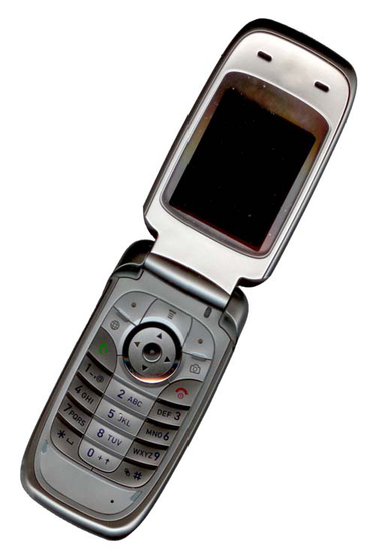
Fig. 3 Example of an image with acceptable resolution

- Figure Captions
Figures must be numbered using Arabic numerals. Figure captions must be in 8 pt Regular font. Captions of a single line (e.g. Fig. 2) must be centered whereas multi-line captions must be justified (e.g. Fig. 1). Captions with figure numbers must be placed after their associated figures, as shown in Fig. 1.
- Table Captions
Tables must be numbered using uppercase Roman numerals. Table captions must be centred and in 8 pt Regular font with Small Caps. Every word in a table caption must be capitalized except for short minor words as listed in Section IV-B. Captions with table numbers must be placed before their associated tables, as shown in Table 1.
- Page Numbers, Headers and Footers
Page numbers, headers and footers must not be used.
- Links and Bookmarks
All hypertext links and section bookmarks will be removed from papers during the processing of papers for publication. If you need to refer to an Internet email address or URL in your paper, you must type out the address or URL fully in Regular font.
- References
The heading of the References section must not be numbered. All reference items must be in 8 pt font. Please use Regular and Italic styles to distinguish different fields as shown in the References section. Number the reference items consecutively in square brackets (e.g. [1]).
When referring to a reference item, please simply use the reference number, as in [2]. Do not use “Ref. [3]” or “Reference [3]” except at the beginning of a sentence, e.g. “Reference [3] shows …”. Multiple references are each numbered with separate brackets (e.g. [2], [3], [4]–[6]).

Examples of reference items of different categories shown in the References section include:
- example of a book in [1]
- example of a book in a series in [2]
- example of a journal article in [3]
- example of a conference paper in [4]
- example of a patent in [5]
- example of a website in [6]
- example of a web page in [7]
- example of a databook as a manual in [8]
- example of a datasheet in [9]
- example of a master’s thesis in [10]
- example of a technical report in [11]
- example of a standard in [12]
- Conclusions
The version of this template is V2. Most of the formatting instructions in this document have been compiled by Causal Productions from the IEEE LaTeX style files. Causal Produc-tions offers both A4 templates and US Letter templates for LaTeX and Microsoft Word. The LaTeX templates depend on the official IEEEtran.cls and IEEEtran.bst files, whereas the Microsoft Word templates are self-contained. Causal Produc-tions has used its best efforts to ensure that the templates have the same appearance.
Causal Productions permits the distribution and revision of these templates on the condition that Causal Productions is credited in the revised template as follows: “original version of this template was provided by courtesy of Causal Productions (www.causalproductions.com)”.

Acknowledgment
The heading of the Acknowledgment section and the References section must not be numbered.
Causal Productions wishes to acknowledge Michael Shell and other contributors for developing and maintaining the IEEE LaTeX style files which have been used in the preparation of this template.
Are acknowledgements OK? No. Please omit them in the review copy and leave them for the final copy.
References
- S. M. Metev and V. P. Veiko, Laser Assisted Microtechnology, 2nd ed., R. M. Osgood, Jr., Ed. Berlin, Germany: Springer-Verlag, 1998.
- J. Breckling, Ed., The Analysis of Directional Time Series: Applications to Wind Speed and Direction, ser. Lecture Notes in Statistics. Berlin, Germany: Springer, 1989, vol. 61.
- S. Zhang, C. Zhu, J. K. O. Sin, and P. K. T. Mok, “A novel ultrathin elevated channel low-temperature poly-Si TFT,” IEEE Electron Device Lett., vol. 20, pp. 569–571, Nov. 1999.
- M. Wegmuller, J. P. von der Weid, P. Oberson, and N. Gisin, “High resolution fiber distributed measurements with coherent OFDR,” in Proc. ECOC’00, 2000, paper 11.3.4, p. 109.
- R. E. Sorace, V. S. Reinhardt, and S. A. Vaughn, “High-speed digital-to-RF converter,” U.S. Patent 5 668 842, Sept. 16, 1997.
- (2002) The IEEE website. [Online]. Available: http://www.ieee.org/
- M. Shell. (2002) IEEEtran homepage on CTAN. [Online]. Available: http://www.ctan.org/tex-archive/macros/latex/contrib/supported/IEEEtran/
- FLEXChip Signal Processor (MC68175/D), Motorola, 1996.
- “PDCA12-70 data sheet,” Opto Speed SA, Mezzovico, Switzerland.
- A. Karnik, “Performance of TCP congestion control with rate feedback: TCP/ABR and rate adaptive TCP/IP,” M. Eng. thesis, Indian Institute of Science, Bangalore, India, Jan. 1999.
- J. Padhye, V. Firoiu, and D. Towsley, “A stochastic model of TCP Reno congestion avoidance and control,” Univ. of Massachusetts, Amherst, MA, CMPSCI Tech. Rep. 99-02, 1999.
- Wireless LAN Medium Access Control (MAC) and Physical Layer (PHY) Specification, IEEE Std. 802.11, 1997.

