**Captain Gigi Great Escape**

Design document

Created for

By

TEAM_GG

High concept:

This is a procedurally generated 2d pirate endless runner with platforming and RPG elements.

**Blurb:**

A procedurally generated side-scrolling 2D endless runner. Collect coins and diamonds as you flee from the vengeful ghost of Dervy Jernz and his ghastly curse, avoiding his mutated crew and the cannons set up along the way. Collect temporary power-ups for your run: Double Jump, Ground Dash, and Air Dash to access higher areas, avoid enemies, and better escape Dervy, invest in those powerups to unlock them as base abilities. Just remember... There is no escape from the Curze of Dervy Jernz!

**Gameplay:**

* The player, Captain Gigi can run, jump, attack, and throw swords.
* Gigi is being constantly harassed by the ghost of Dervy Jernz, who forces him to never stop running for fear of a quick death
* The enemies attack Captain Gigi when he’s too close but can be stomped on or fought.
* The traps shoot at Gigi and cannot be stopped.
* The coins and diamonds can buy items in the shop.
* When Gigi loses all his hp or falls off the game level it’s game over.
* The potions grant Gigi special abilities like double jump and dash.

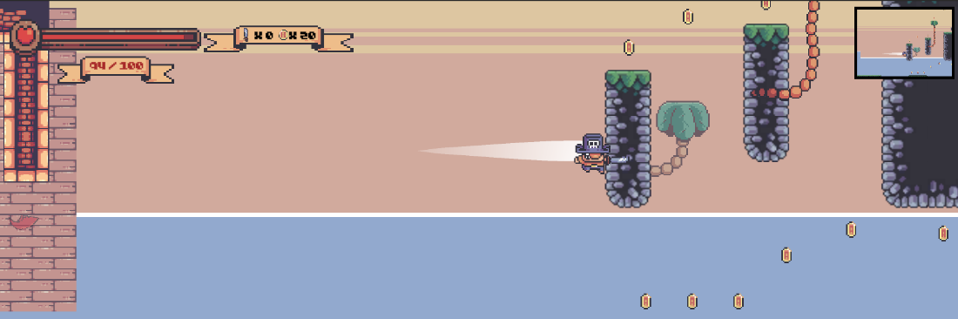

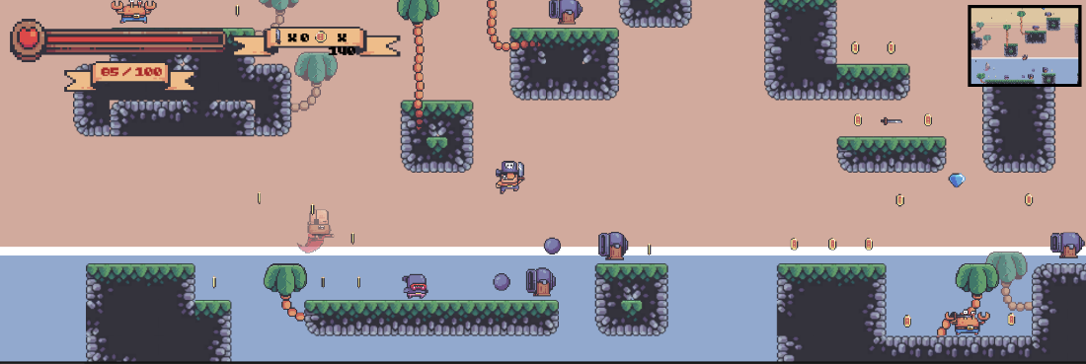

Features:

* Shop to buy items and abilities
* Abilities available as temporary items in your runs until they have been unlocked in the store
* Avoid the persistent AI chasing you, when in contact the pirate ghost deals a lot of damage
* A procedurally generated world composed of ~40 different ground and sky blocks
* A rewarding ability system, the game begins difficult, the player must work harder to escape Dervy and be creative in accessing higher areas. As their abilities grow avoiding Dervy becomes a much easier feat.

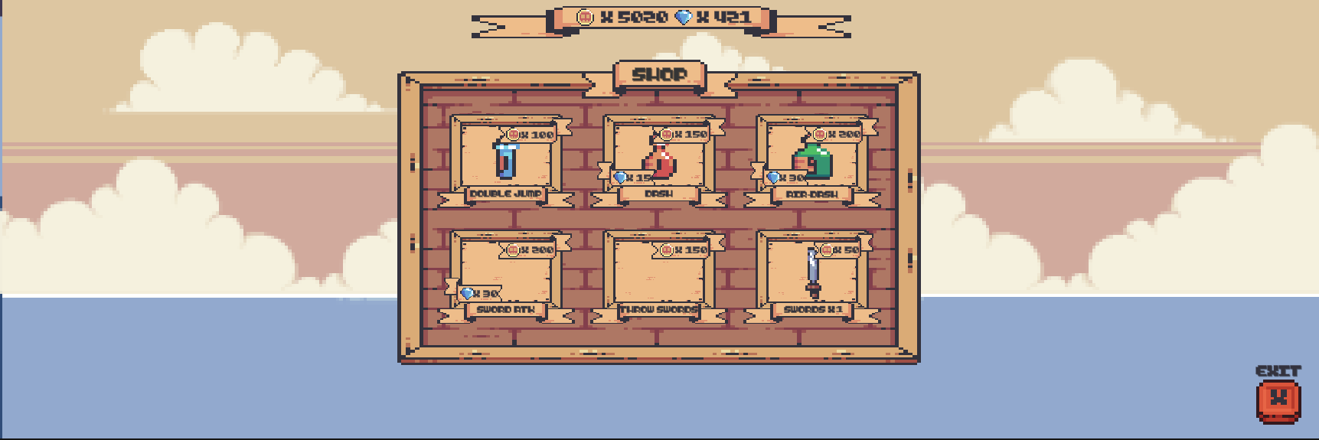

Sourcing:

* Sprites: Treasure hunters, Kings and Pigs, Pirate Bomb asset packs created by PixelFrog <https://pixelfrog-assets.itch.io/>
* Music: Not Jam music pack by Not Jam <https://not-jam.itch.io/not-jam-music-pack>
* Sound effects: Minifantasy - Dungeon Audio Pack