PACOIMA—2008 Tract Boundaries
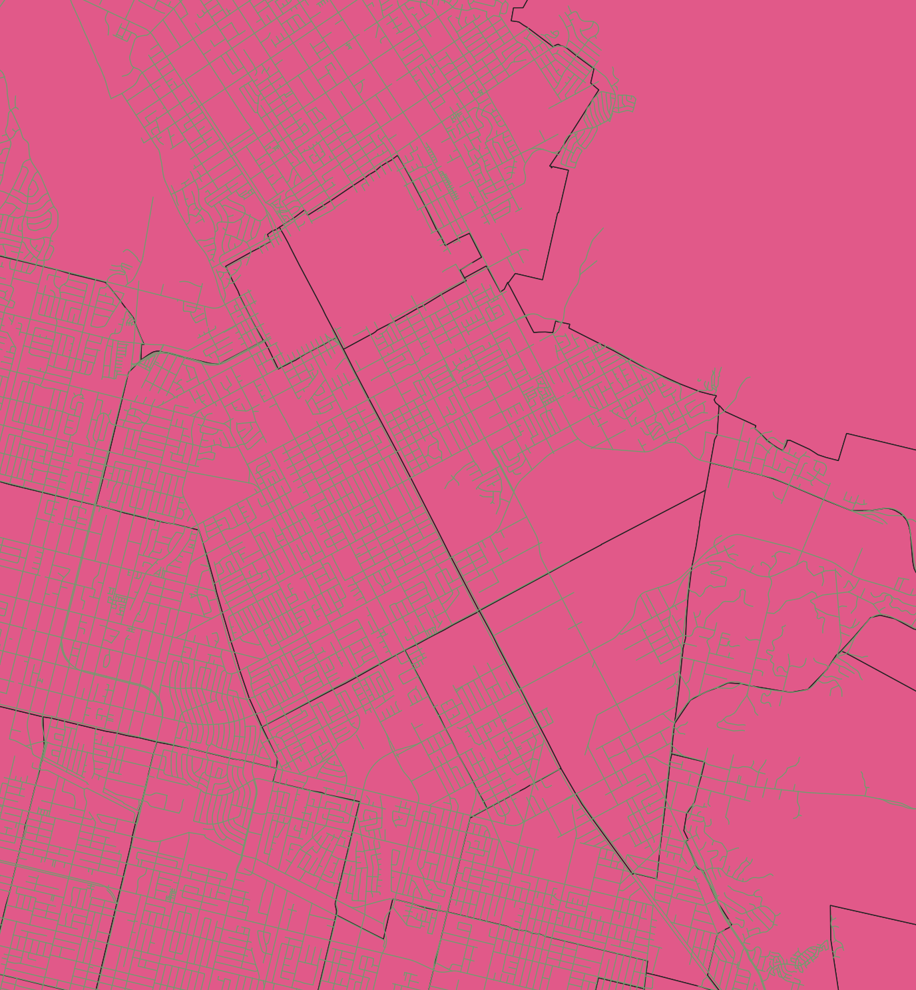

Overlay of contemporary map of Pacoima on 2008 Census GIS Tiger Shapefiles
