# App Structure

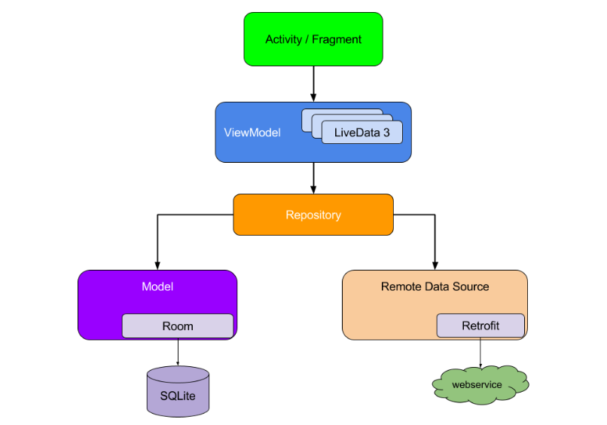

Debug SHA1 Key - A6:D5:92:68:2F:A5:60:D0:19:1E:CF:53:D8:C7:F6:EA:30:E0:64:9B

Release SHA1 key - 81:B2:A8:5F:02:7B:5A:54:47:24:CA:2B:41:3C:53:2E:A1:26:62:6D

Run terminal

keytool -list -v -keystore E:\Solution\QRTicket\documentation\key.jks -alias key0

# Installation