Wielders

Game Design Document

By: Recordamur Studios (Adamo)

Version: 1.0

### Change Log

1.0: Document created

### Table of Contents

Overview

Elevator Pitch

Game Overview

Setting Overview

Selling Points

Target Audience

Gameplay

Core Mechanics

Controls

Game Loops

Look & Feel

Mood Board

Art Influences

Audio Influences

Mechanic Influences

Scope and Resources

# Overview

|  |  |
| --- | --- |
| **Genre** | [Fill in GENRE here] |
| **Platform** | [Fill in PLATFORM here] |
| **Point of View** | [Fill in POINT OF VIEW here] |
| **Theme / Mood** | [Fill in THEME/MOOD here] |
| **Core Aesthetic** | [Fill in CORE AESTHETIC here] |
| **Target Audience** | [Fill in TARGET AUDIENCE here] |

## Elevator Pitch

[The Elevator Pitch should be catchy, evocative and only 1-3 short sentences that you should be able to easily memorize]

## Game Overview

[Short one paragraph description of the game, including a mock up screenshot to show main perspective and gameplay elements. For example, in Portal, you would state that the core gameplay revolves around first person physics puzzles using Portal guns that connect pairs of portals.]

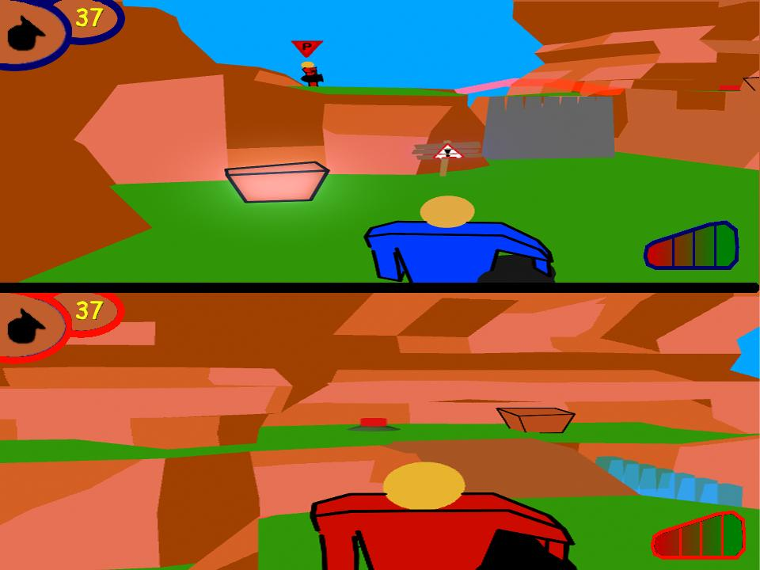

##### Optional Caption

## Setting Overview

[Briefly describe the setting and tone of the world. Don’t go into detail here. You can do that elsewhere. For example, for Portal, you would state that the game is set in a clean futuristic science laboratory setting, and relies on black humour to give it an interesting tone.]

## Selling Points

[Who is the target audience? Describe why this game will be fun and engaging to this player. What are its core selling points? Emphasise any unique hooks.]

## Target Audience

[What are the psychological drivers and desires of your target audience. How do the mechanics and features of your game aim to address these expectations?]

# Gameplay

## Core Mechanics

### Mechanic Name

[Describe a mechanic as clearly and succinctly as possible. Wherever possible, use simple diagrams, sketches, bullet points, tables, whatever is the best format to express the idea.]

### 

##### Optional Caption

[How does this impact other elements of the game? What benefit and/or tradeoff does this provide for the player? How does this inform the core aesthetic?]

### Mechanic Name

[Describe a mechanic as clearly and succinctly as possible. Wherever possible, use simple diagrams, sketches, bullet points, tables, whatever is the best format to express the idea.]

### 

##### Optional Caption

[How does this impact other elements of the game? What benefit and/or tradeoff does this provide for the player? How does this inform the core aesthetic?]

### Mechanic Name

[Describe a mechanic as clearly and succinctly as possible. Wherever possible, use simple diagrams, sketches, bullet points, tables, whatever is the best format to express the idea.]

### Image result for mechanics diagram

##### Optional Caption

[How does this impact other elements of the game? What benefit and/or tradeoff does this provide for the player? How does this inform the core aesthetic?]

## Controls

[Describe and illustrate the controls here as simply as possible.]

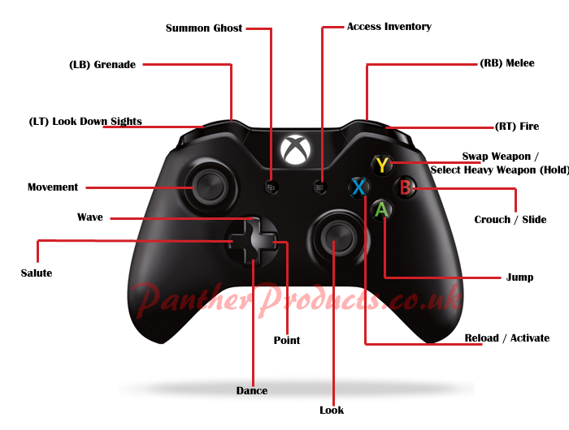

## Game Loops

### Moment to Moment Loops

[Describe the moment to moment gameplay loops.

Describe the intention, duration, and reward for these loops.]

### Level / Mission / Challenge Loops

[Describe the loops relating to levels, missions, or challenges.

Describe the intention, duration, and reward for these loops.]

### Gameplay Session Loop / Exit Points

[Describe the longer term gameplay loops.

Describe the intention, duration, and reward for these loops.]

### Expected Gameplay Scenario

[Illustrate how those loops will pace out in an average play session.]

[Show overlapping gameplay loops in a diagram of example gameplay loops & rewards.]

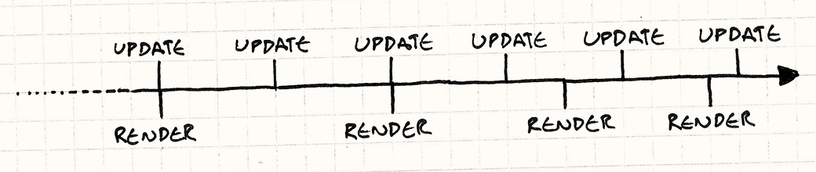

##### Optional Caption

# Look & Feel

## Mood Board

[Show a few choice reference images, that sum up the primary visual influences for the game. Don’t write any text in this section]

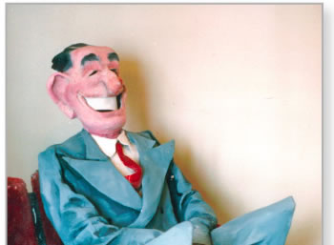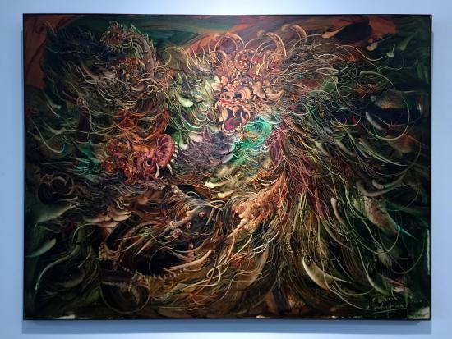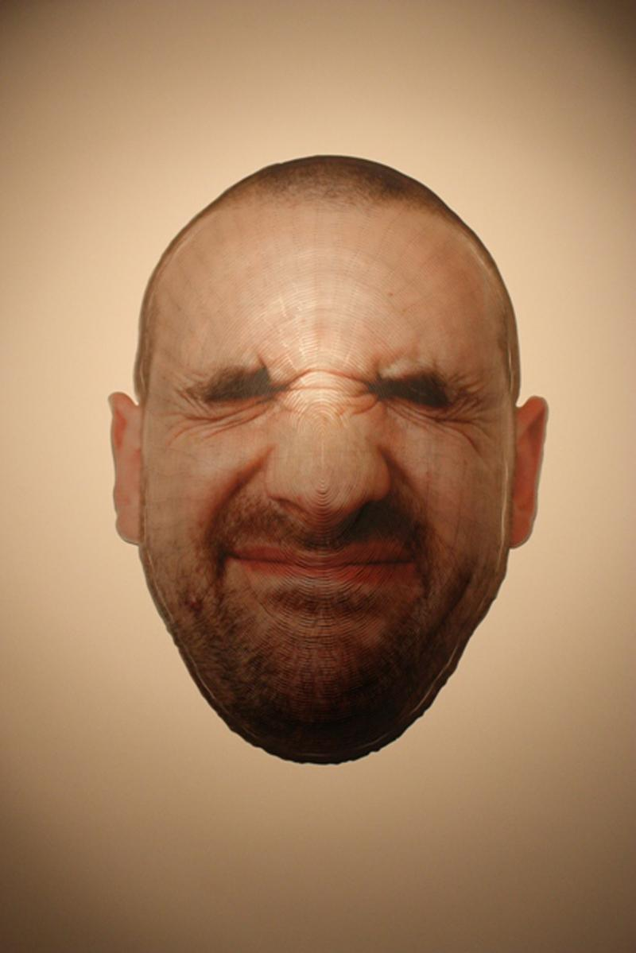

## Art Influences

### Art influence name

[Describe specifically what it is about this reference that informs your game. ie: the color pallette. Or, the environment design. Etc.]

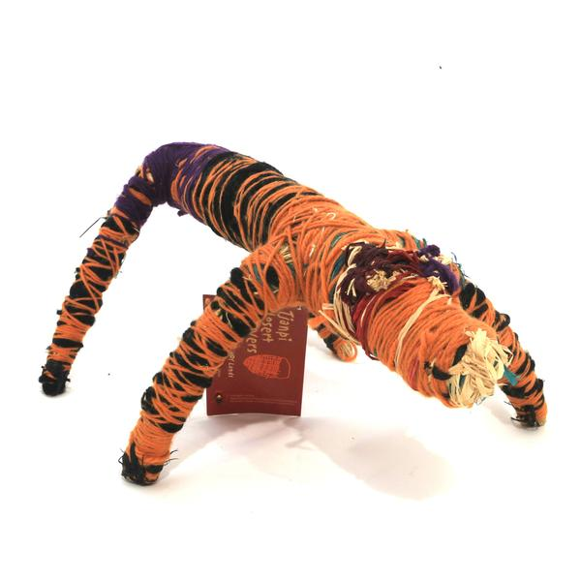

##### Optional Caption

### Art influence name

[Describe specifically what it is about this reference that informs your game. ie: the color pallette. Or, the environment design. Etc.]

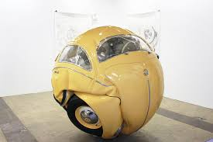

##### Optional Caption

### Art influence name

[Describe specifically what it is about this reference that informs your game. ie: the color pallette. Or, the environment design. Etc.]

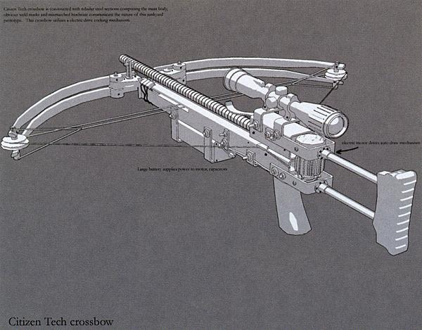

##### Optional Caption

# Audio Influences

[Describe the feel and tone of audio design in the game. Is it realistic, 8-bit, rich, simple, scary, cartoony?]

### Audio influence name

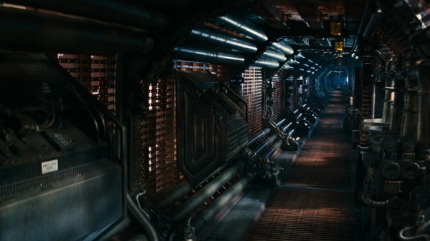

##### Optional Caption

[link to example](https://youtu.be/9CdVTCDdEwI)

###### [additional optional notes about what part/which section etc of the link is applicable]

###### [Eg: Skip to time 3:22 on linked track]

### Audio influence name

### Image result for Music band

##### Optional Caption

[link to example](https://youtu.be/9CdVTCDdEwI)

###### [additional optional notes about what part/which section etc of the link is applicable]

# Mechanic Influences

[Describe any influences on the mechanics of your game, this can include other video games, sports, board games, or day to day activities]

### Mechanic influence name

[If there is a mechanic, or control system, or camera system, that you want to copy or reference from another game, specify it here, and describe specifically what you **are** referencing from it, what you are **not** referencing from it, and any differences.]



##### Optional Caption

[link to example](https://youtu.be/9CdVTCDdEwI)

###### [additional optional notes about what part/which section etc of the link is applicable]

### Mechanic influence name

[If there is a mechanic, or control system, or camera system, that you want to copy or reference from another game, specify it here, and describe specifically what you **are** referencing from it, what you are **not** referencing from it, and any differences.]



##### Optional Caption

[link to example](https://youtu.be/9CdVTCDdEwI)

###### [additional optional notes about what part/which section etc of the link is applicable]

### Mechanic influence name

[If there is a mechanic, or control system, or camera system, that you want to copy or reference from another game, specify it here, and describe specifically what you **are** referencing from it, what you are **not** referencing from it, and any differences.]

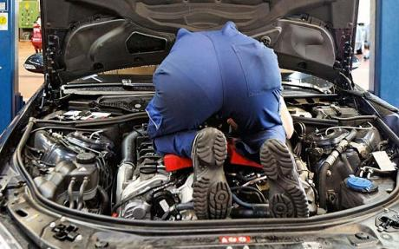

##### Optional Caption

[link to example](https://youtu.be/9CdVTCDdEwI)

###### [additional optional notes about what part/which section etc of the link is applicable]

# Scope and Resources

## Team Members

### Designer

* Designer Name

### Producer

* Producer Name

### Artists

* Artist Name 1
* Artist Name 2

### Programmers

* Programmer Name 1
* Programmer Name 2

## Scope Overview

[Give an overview of roughly how long the project is estimated to take for an example team size. Ie: “It is estimated that an 8 person team could make the game in 3 months.”]

[Link to a separate Scope Document.](https://www.google.com/)

## Milestones

[Link to a separate Scope Document.](https://www.google.com/)