Wielders
Game Design Document

By: Recordamur Studios (Adamo)
Version: 1.1

Change Log
1.0: Document created
1.1: Overview and Gameplay completed

Table of Contents

Overview
Elevator Pitch
Game Overview
Setting Overview
Selling Points
Target Audience

Gameplay
Core Mechanics
Controls
Game Loops

Look & Feel
Mood Board
Art Influences
Audio Influences
Mechanic Influences

Scope and Resources

Overview

Genre | Fantasy Deckbuilder
Platform | PC, Physical
Point of View | Second Person/Third Person Omniscient
Theme / Mood | Dystopian
Core Aesthetic | Overgrown Apocalyptic
Target Audience | 13+ Strategy Deckbuilding fans

Elevator Pitch
Wielders is a universe where thirty powers can be used by anyone in the world.
These Wielders must delve into Fissures, increasing the mastery of their power and finding loot to support them in their journey.
Will you be the last person standing, becoming the Sole Noble?
Or, will you band together and defeat the Nobles in the Final Fissure?

Game Overview
Players either pick or randomly pull a Power card which gives them an F-rank Mastery Power card and corresponding Skill cards. Players must increase their Mastery Rank in Fissures and grow more powerful to fight others and, at the end, survive the Apocalypse: Bloodbath or End of the World. Bloodbath consists of a free-for-all last man standing brawl, where the final player alive becomes the next Game Master. End of the World requires teamwork to attempt to defeat an endless wave of Nobles, boss monsters who have reached their species’ pinnacle, and the last person to live during this onslaught becomes the new Game Master.
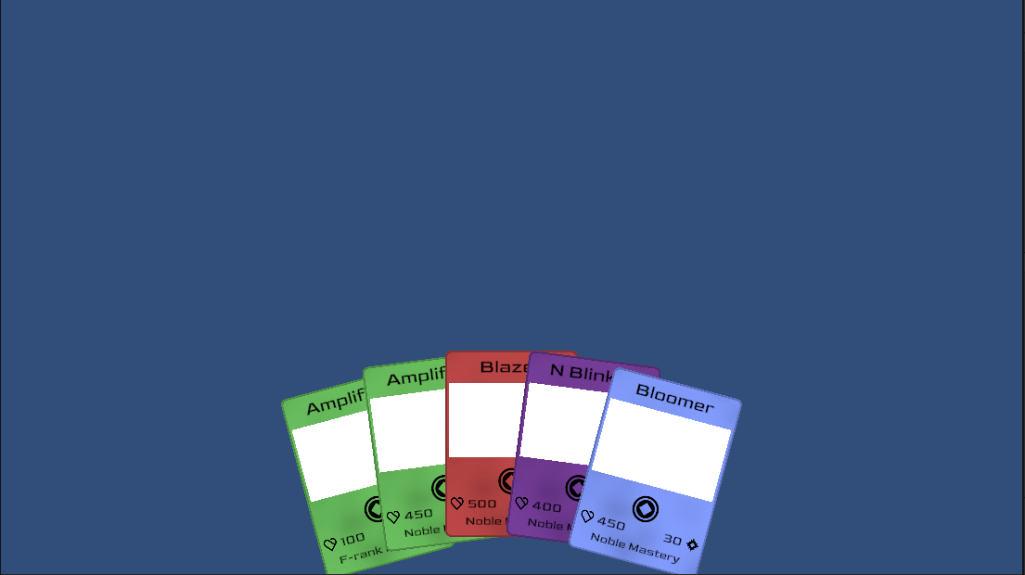

In-build screenshot with extra annotations

Setting Overview
A dystopian, overgrown city surrounded on all sides by mountainous walls of stone, with the only way out blocked by an ever-growing portal of sorts. Cracks of lightning shoot out and create Fissures, increasing in severity over time. This is the Battlefield of the Wielders. Modern-day chaos.

Selling Points
Unique mechanics, gamemodes to tailor to long and short games including many implementable optional rules for custom gamemodes.

Target Audience
13+, strategy, deckbuilding, TTRPG. Progression mechanic and collection, as well as the possibility of controlling the next Game, are hooks for players.

Gameplay

Core Mechanics

Mastery System

Your power evolves with you. Train to increase your Mastery, raising your stats and unlocking new skills. Fissures that spawn are the best way to increase your Mastery. Hitting certain levels increases your Mastery and grants you new skills and Expertise.

You must increase your Mastery if you wish to survive as a Wielder, as the power gap increases exponentially with higher Ranks. The difference between an F-rank Wielder and a Noble Wielder is unfathomable, with a single skill possibly eviscerating the F-rank immediately. The difficulty of Fissures also rises over time, and so if you do not rank up, you’ll hit a wall and inevitably lose.

Alter Ego

Your Alter Ego is you. Activate your Alter Ego to gain a completely new power with a new skillset that, at the discretion of the GM, either does not share experience or shares experience with your normal power.

The Alter Ego mechanic is an optional mechanic with its own rules that allows adaptability and strategy with Power usage, adding a completely new dynamic and difficulty curve to the game. Recommended for experienced parties, the Alter Ego mechanic can effectively double the lethality of any player, provided they know how to use it well.

The Seven Phases

The Seven Phases are the phases of the game. Technically, there are only six phases that affect the game in present time, but the seventh phase is a lore-implemented reset.

It gives structure to the game so players can understand and expect what will happen, although if this game is fleshed out further in the future, a gamemode could be added that removes the Phases to better mimic the unpredictability of an apocalyptic scenario.

Controls
Point-and-click.

Game Loops

Moment to Moment Loops

[Describe the moment to moment gameplay loops.
Describe the intention, duration, and reward for these loops.]

Level / Mission / Challenge Loops

[Describe the loops relating to levels, missions, or challenges.
Describe the intention, duration, and reward for these loops.]

Gameplay Session Loop / Exit Points

[Describe the longer term gameplay loops.
Describe the intention, duration, and reward for these loops.]

Expected Gameplay Scenario

[Illustrate how those loops will pace out in an average play session.]

[Show overlapping gameplay loops in a diagram of example gameplay loops & rewards.]

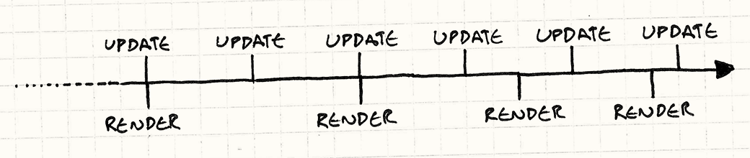

Optional Caption

Look & Feel

Mood Board
[Show a few choice reference images, that sum up the primary visual influences for the game. Don’t write any text in this section]

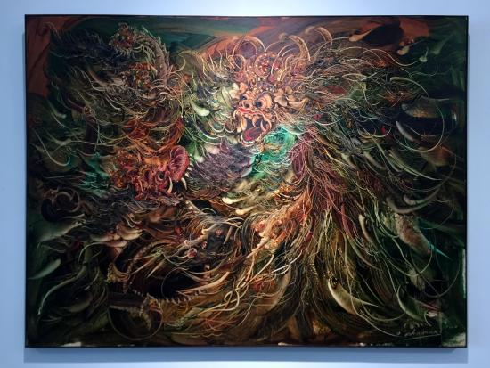



Art Influences

Art influence name
[Describe specifically what it is about this reference that informs your game. ie: the color pallette. Or, the environment design. Etc.]

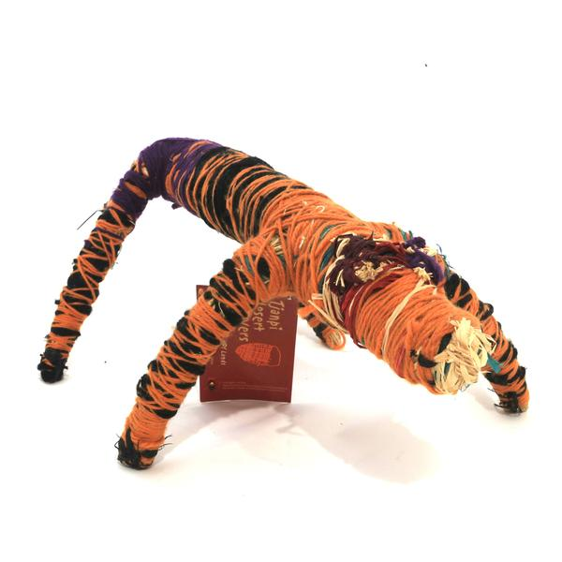

Optional Caption

Art influence name
[Describe specifically what it is about this reference that informs your game. ie: the color pallette. Or, the environment design. Etc.]

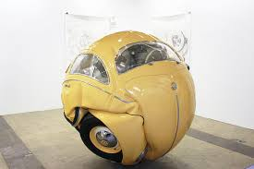

Optional Caption

Art influence name
[Describe specifically what it is about this reference that informs your game. ie: the color pallette. Or, the environment design. Etc.]

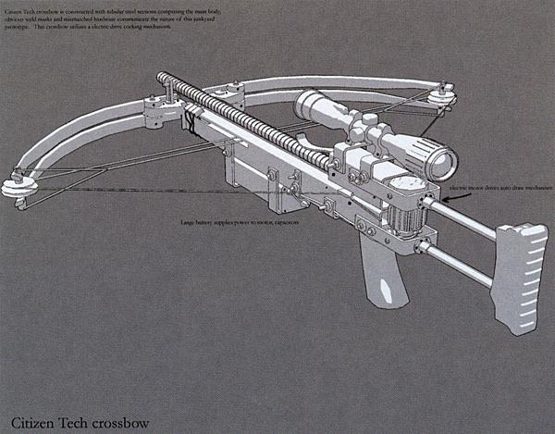

Optional Caption

Audio Influences

[Describe the feel and tone of audio design in the game. Is it realistic, 8-bit, rich, simple, scary, cartoony?]

Audio influence name

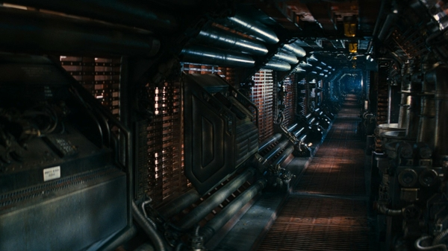

Optional Caption

link to example

[additional optional notes about what part/which section etc of the link is applicable]

[Eg: Skip to time 3:22 on linked track]

Audio influence name

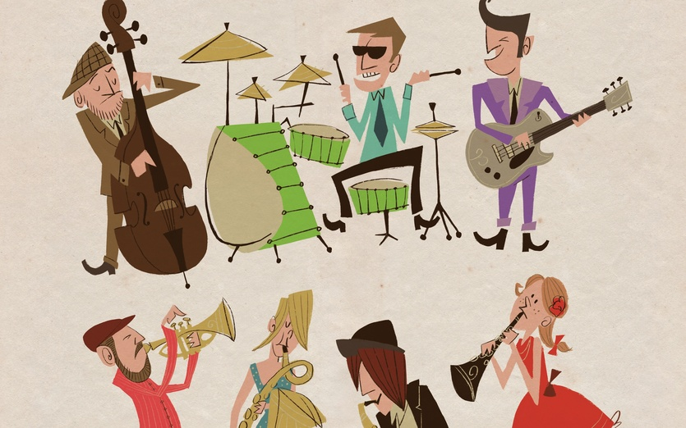

Optional Caption

link to example

[additional optional notes about what part/which section etc of the link is applicable]

Mechanic Influences

[Describe any influences on the mechanics of your game, this can include other video games, sports, board games, or day to day activities]

Mechanic influence name
[If there is a mechanic, or control system, or camera system, that you want to copy or reference from another game, specify it here, and describe specifically what you are referencing from it, what you are not referencing from it, and any differences.]



Optional Caption

link to example

[additional optional notes about what part/which section etc of the link is applicable]

Mechanic influence name
[If there is a mechanic, or control system, or camera system, that you want to copy or reference from another game, specify it here, and describe specifically what you are referencing from it, what you are not referencing from it, and any differences.]



Optional Caption

link to example

[additional optional notes about what part/which section etc of the link is applicable]

Mechanic influence name
[If there is a mechanic, or control system, or camera system, that you want to copy or reference from another game, specify it here, and describe specifically what you are referencing from it, what you are not referencing from it, and any differences.]



Optional Caption

link to example

[additional optional notes about what part/which section etc of the link is applicable]

Scope and Resources

Team Members

Designer
- Designer Name

Producer
- Producer Name

Artists
- Artist Name 1
- Artist Name 2

Programmers
- Programmer Name 1
- Programmer Name 2

Scope Overview
[Give an overview of roughly how long the project is estimated to take for an example team size. Ie: “It is estimated that an 8 person team could make the game in 3 months.”]

Link to a separate Scope Document.

Milestones

Link to a separate Scope Document.

