Model selection and applicability
Six models were selected to span a spectrum from fully interpretable linear baselines to non-linear kernel and tree-ensemble methods, implemented via src/models.py and tuned with GridSearchCV (exhaustive search over a fixed hyperparameter grid, using cross-validation exclusively within the training set).
Why GridSearchCV. The choice of hyperparameters is not free of consequence — an under-regularised model overfits the 594 training rows (Option A) or the training years (Option B), while an over-regularised one underfits determinants that genuinely matter. GridSearchCV was preferred over randomised or Bayesian search because every grid used here is small enough (24–36 combinations per model) to search exhaustively at negligible computational cost, which removes the additional source of variability a stochastic search would introduce — the same grid always produces the same selected combination, which matters for a result meant to be reproduced. Combined with cross-validation restricted to the training set (5-fold for Option A, a rolling TimeSeriesSplit for Option B, so no fold ever validates on years earlier than it trains on), it gives an estimate of each combination’s generalisation performance without ever touching the Test or Validation sets — the same discipline enforced everywhere else in this thesis.
Why these specific ranges. Each grid is centred on values reported as reasonable defaults in the literature for datasets of comparable size, then widened symmetrically enough to let the search itself decide rather than presupposing the answer. Ridge and Lasso’s alpha grids span three orders of magnitude (0.001–1000) because the right regularisation strength depends on a noise-to-signal ratio that is unknown a priori; log-spaced candidates cover very different regularisation regimes without needing an impractically large grid. SVR’s C and epsilon ranges bracket the target’s own scale (suicide rate spans roughly 3–40 per 100,000), and both a linear and an RBF kernel are tested since it is not known in advance whether the relationship is linear. Random Forest, XGBoost, and CatBoost all cap tree depth at modest values (5–15 for Random Forest, 2–4 for XGBoost, 3–5 for CatBoost) deliberately — with roughly 600 training rows for Option A and fewer for Option B, deep trees memorise rather than generalise, so the grids intentionally under-cover the “deeper is better” region rather than over-cover it. CatBoost’s l2_leaf_reg grid was extended to include 15 specifically to test whether the optimum lay beyond the originally narrower range — it did not (Section 3.6.4) — a case where the grid itself was revised in response to a result, rather than fixed once and left unquestioned.

Ridge Regression
Ridge Regression addresses overfitting in Ordinary Least Squares (OLS) by adding an L2 penalty on the magnitude of the coefficients. Its loss function is:
L(β) = ‖y - Xβ‖² + α‖β‖²₂
where α ≥ 0 is the regularisation strength and ‖β‖²₂ = Σⱼ βⱼ². The closed-form solution,
β̂ = (XᵀX + αI)⁻¹Xᵀy
adds αI to XᵀX, guaranteeing invertibility even under the moderate multicollinearity identified in Section 3.4.6. Grid: α ∈ {0.01, 0.1, 1, 10, 100, 1000}.

Lasso Regression
Lasso (Least Absolute Shrinkage and Selection Operator) replaces the L2 penalty with an L1 penalty:
L(β) = ‖y - Xβ‖² + α‖β‖₁ , ‖β‖₁ = Σⱼ |βⱼ|
The absolute value makes L(β) non-differentiable at βⱼ = 0, so there is no closed-form solution; scikit-learn's implementation uses coordinate descent, minimising with respect to one coefficient at a time. Unlike Ridge, the L1 penalty produces sparse solutions — some coefficients are driven exactly to zero, performing automatic feature selection, so the non-zero coefficients can be read as the determinants carrying independent predictive signal. Grid: α ∈ {0.001, 0.01, 0.1, 1, 10, 100}.

Support Vector Regression (SVR)
SVR finds a function f(x) that deviates from the true values yᵢ by at most ε, while staying as flat as possible — predictions within a tube of width 2ε incur zero loss. Its primal formulation is:
min(w,b,ξ,ξ*) ½‖w‖² + C·Σᵢ(ξᵢ + ξᵢ*)
subject to yᵢ - wᵀxᵢ - b ≤ ε + ξᵢ , wᵀxᵢ + b - yᵢ ≤ ε + ξᵢ* , ξᵢ, ξᵢ* ≥ 0. Solved in its dual form, where data enters only via inner products, replacing which with a kernel function implicitly maps the data into a higher-dimensional space:
f(x) = Σᵢ (αᵢ - αᵢ*) K(xᵢ, x) + b
The grid tests both a linear kernel and the RBF kernel, K(xᵢ,xⱼ) = exp(-γ‖xᵢ-xⱼ‖²). Grid: C ∈ {0.1, 1, 10, 100}, ε ∈ {0.1, 0.5, 1.0}, kernel ∈ {linear, rbf}.

Random Forest Regressor
Random Forest is a bagging ensemble: B trees, each fit on a bootstrap sample of the training data, with each split restricted to a random subset of m ≈ √p candidate features. Each split minimises the weighted variance of the child nodes:
MSE_split = (n_L/n)·Var(y_L) + (n_R/n)·Var(y_R)
and the final prediction averages every tree, ŷ = (1/B)·Σᵇ f_b(x). Restricting each split to a random feature subset decorrelates the trees, so averaging reduces variance without increasing bias. Grid: n_estimators ∈ {100, 200, 300}, max_depth ∈ {5, 10, 15, None}, min_samples_split ∈ {2, 5, 10}, max_features ∈ {sqrt, 0.5}.

XGBoost
XGBoost is a boosting ensemble: trees are built sequentially, each one fit to correct the residual error of the ensemble built so far. After t rounds, the prediction is ŷᵢ⁽ᵗ⁾ = Σₖ₌₁ᵗ fₖ(xᵢ), and each new tree minimises a regularised objective:
L⁽ᵗ⁾ = Σᵢ l(yᵢ, ŷᵢ⁽ᵗ⁻¹⁾ + fₜ(xᵢ)) + Ω(fₜ)
where Ω(fₜ) penalises the number of leaves and the magnitude of leaf weights — a built-in defence against overfitting on top of the hyperparameters below. The objective is optimised via a second-order Taylor expansion of the loss (both gradient and Hessian), which is what “gradient boosting” refers to. Grid: n_estimators ∈ {100, 200}, max_depth ∈ {2, 3, 4}, learning_rate ∈ {0.05, 0.1}, subsample ∈ {0.8, 1.0}, colsample_bytree ∈ {0.8, 1.0}.

CatBoost
CatBoost is also gradient-boosted, differing from XGBoost in two ways relevant to a dataset this size: ordered boosting and symmetric (oblivious) trees. Standard gradient boosting estimates each row's gradient using a model that has already seen that same row, introducing a target-leakage effect (prediction shift) that grows worse on small datasets; ordered boosting avoids this by computing each row's gradient from a model trained only on a random permutation of the other rows. Oblivious trees use the same split condition at every node of a given depth, acting as an additional regulariser at some cost in per-tree flexibility, compensated with more, shallower trees. Grid: iterations ∈ {200, 400}, depth ∈ {3, 4, 5}, learning_rate ∈ {0.05, 0.1}, l2_leaf_reg ∈ {3, 7, 15}.

Results comparison
Table 3.3 and Table 3.4 report Test and Validation RMSE, MAE, and R² for all six models under Option A; Table 3.5 and Table 3.6 report the same under Option B.
Model | CV RMSE | RMSE | MAE | R²
SVR | 5.23 | 9.11 | 6.27 | 0.444
XGBoost | 3.98 | 9.14 | 6.39 | 0.440
CatBoost | 4.01 | 9.45 | 5.82 | 0.402
Random Forest | 4.43 | 11.06 | 6.42 | 0.180
Ridge | 5.87 | 11.33 | 7.04 | 0.139
Lasso | 5.72 | 11.70 | 7.26 | 0.082

Table 3.3: Option A (geographical split), Test set.
Model | CV RMSE | RMSE | MAE | R²
SVR | 5.23 | 5.40 | 4.84 | 0.131
CatBoost | 4.01 | 6.11 | 5.14 | -0.112
Lasso | 5.72 | 6.52 | 5.12 | -0.267
Ridge | 5.87 | 6.83 | 5.52 | -0.391
Random Forest | 4.43 | 6.84 | 5.86 | -0.395
XGBoost | 3.98 | 7.38 | 6.08 | -0.624

Table 3.4: Option A (geographical split), Validation set.
Model | CV RMSE | RMSE | MAE | R²
CatBoost | 6.68 | 2.03 | 1.53 | 0.875
SVR | 6.54 | 2.12 | 1.60 | 0.864
Random Forest | 6.94 | 2.93 | 2.17 | 0.741
XGBoost | 6.71 | 3.28 | 2.46 | 0.675
Lasso | 7.55 | 4.81 | 3.89 | 0.301
Ridge | 7.84 | 5.21 | 4.08 | 0.182

Table 3.5: Option B (temporal split), Test set.
Model | CV RMSE | RMSE | MAE | R²
SVR | 6.54 | 2.87 | 2.18 | 0.628
CatBoost | 6.68 | 2.96 | 2.39 | 0.605
Random Forest | 6.94 | 3.31 | 2.61 | 0.505
Lasso | 7.55 | 4.21 | 3.50 | 0.202
Ridge | 7.84 | 4.50 | 3.58 | 0.085
XGBoost | 6.71 | 5.01 | 3.71 | -0.135

Table 3.6: Option B (temporal split), Validation set.
Two patterns stand out. First, Option A generalises poorly: every model reaches a positive Test R² (0.08–0.44), but five of six collapse to a negative Validation R² — worse than predicting the training mean — with only SVR holding up (0.44 → 0.13). This instability, rather than a uniform failure, suggests the positive Test score is highly sensitive to which specific countries land in the test split, not evidence of a model that generalises to genuinely unseen countries. Second, Option B is markedly more stable: Test R² ranges 0.18–0.88, Validation R² 0.09–0.63, with CatBoost and SVR the most consistent performers across both metrics. CatBoost (Option B) is the model persisted to outputs/models/catboost_option_b.joblib and used by prod/predict.py; the exact hyperparameters selected by GridSearchCV were depth=4, iterations=400, l2_leaf_reg=7, learning_rate=0.1.

Results diagnostics and interpretability
Beyond the aggregate metrics above, src/diagnostics.py provides actual-vs-predicted scatter plots, residual histograms, residuals-vs-predicted plots (a heteroscedasticity check), and mean absolute error broken down by year and by country, applied to the production CatBoost model on Option B's Validation set.
Error is not evenly distributed across years: mean absolute error rises from ≈2.0 (2018) to ≈2.9 (2021) — degradation concentrated specifically in the two COVID-19 years (2020–2021), which the training period (2000–2014) could not have anticipated. Part of the Test/Validation gap reported above is attributable to this structural shock rather than to generic time-distance decay.
SHAP (SHapley Additive exPlanations) was used to interpret the production CatBoost model, via TreeExplainer (exact for tree ensembles). SHAP assigns each feature a value derived from Shapley values in cooperative game theory: for a prediction f(x), the contribution of feature j is
φⱼ = Σ_(S⊆F\{j}) [|S|!(|F|-|S|-1)!]/|F|! · [f(S∪{j}) - f(S)]
averaged over every possible subset S of the other features — the only attribution method satisfying local accuracy (contributions sum exactly to the prediction) and consistency (a feature's attribution cannot decrease if its marginal contribution increases in the model). Alcohol use disorders emerged as by far the most influential predictor (mean |SHAP value| ≈ 2.9, roughly three times the next-ranked feature), with classical socioeconomic determinants (Unemployment rate, Health expenditure) ranking lowest. [Probable, no verificado más allá de esta observación:] this likely reflects that Option B only asks the model to explain variation over time within a fixed set of countries — a determinant that varies mostly across countries rather than within a country over time (unemployment, structurally, tends to be more of the former) contributes comparatively little to that specific task.

Model improvement experiments
Four hypotheses raised by the SHAP results were tested directly, in notebooks/03b_model_improvements.ipynb / prod/03_train.py. Only one held up — negative results are reported rather than discarded, so a suggestion that does not survive contact with the data is not attempted again without remembering why:
Hypothesis | Outcome
Hidden multicollinearity within the mental-health feature block | Not confirmed — max VIF 3.64 within the block
Test/Val gap is partly a COVID-period effect | Confirmed — Val R² 0.72 (pre-COVID) vs 0.47 (COVID years)
Dropping lowest-importance features improves generalisation | Not confirmed — Test and Val R² both dropped slightly
The CatBoost l2_leaf_reg optimum lies beyond the searched grid | Not confirmed — GridSearchCV re-selected the same value with an extended range

Clustering methods (Unsupervised learning)
The regional grouping used descriptively in Section 3.4.4 (Western Europe/Nordics, Mediterranean, Eastern Europe, Baltics) was an a priori decision, based on geographic and cultural criteria, not derived from the data. This section tests that assumption directly with unsupervised clustering, implemented in src/clustering.py / notebooks/04_clustering.ipynb. This is a standalone, descriptive analysis — its cluster labels are not fed into the supervised models of Section 3.6 as a feature. An earlier version of this pipeline did feed a (leakage-safe) cluster label back into the panel models, and it was reverted: even done without leaking the target, folding the two together blurs which result answers which question, and the two are cleaner read separately.

Country-level aggregation
Clustering country-year rows directly would let the same country land in different clusters across years, which does not make sense for validating a label (Region) that never changes. Each of the 27 countries is instead reduced to one row: the mean of every socioeconomic/mental-health predictor and of the target over 2000–2021, plus the linear trend of the target over time (slope from an OLS fit of target ~ year) — level alone would treat a country with a flat high suicide rate the same as one climbing rapidly toward it:
x̄ⱼ = (1/T)·Σₜ xⱼ,ₜ , trend = β̂₁ where yₜ = β₀ + β₁·t + εₜ
The resulting 27×20 feature matrix is scaled with the same RobustScaler used throughout (median/IQR), given the outliers already characterised in Section 3.4.2.

K-Means clustering
K-Means partitions the n=27 countries into k clusters by minimising the within-cluster sum of squares (WCSS, or inertia):
J = Σᵢ₌₁ᵏ Σ_(x∈Cᵢ) ‖x - μᵢ‖²
where μᵢ is the centroid of cluster Cᵢ. Lloyd's algorithm alternates two steps until convergence: assign each point to its nearest centroid, then recompute each centroid as the mean of its assigned points. J has no closed-form minimum and the algorithm can converge to a local optimum, so scikit-learn's implementation (n_init=10) restarts with different centroid initialisations and keeps the best result.

Choosing k: the elbow method and the silhouette score
Before comparing anything to the four-region assumption, the data itself was asked how many clusters it supports, via two complementary criteria over k ∈ {2, …, 8} (src/clustering.py::sweep_kmeans):
- Elbow method: plots inertia J against k. Inertia strictly decreases as k grows (more clusters can only reduce within-cluster variance), so the heuristic looks for the point where the marginal reduction sharply slows — an “elbow” — rather than the minimum itself.
- Silhouette score: for each point i, with a(i) the mean distance to other points in its own cluster and b(i) the mean distance to points in the nearest other cluster,
s(i) = [b(i) - a(i)] / max{a(i), b(i)}
averaged over all points; s ∈ [-1, 1], with values near 1 indicating well-separated clusters and values near 0 indicating overlapping ones. Unlike inertia, it does not automatically favour larger k.
The silhouette score peaks at k=2 (≈0.32), not at k=4 (≈0.20) — the four-region split is not what the data would choose unprompted. Inspecting the k=2 partition directly shows it groups Germany, France, Spain, and Italy — the EU's four largest economies by population and GDP — against the remaining 23 countries, tracking economic/population scale rather than geography or suicide rate. Both k=2 and the region-matched k=4 are examined further below.

Hierarchical clustering
As a cross-check against K-Means' sensitivity to initialisation, agglomerative hierarchical clustering (src/clustering.py::run_hierarchical) was run with Ward linkage, which merges the pair of clusters at each step that produces the smallest possible increase in total within-cluster variance:
ΔJ(A,B) = [|A||B| / (|A|+|B|)] · ‖μ_A - μ_B‖²
producing a dendrogram that is cut at k=4 for direct comparison with K-Means, without needing to specify k in advance the way K-Means does.

Agreement with the a priori EU_REGIONS grouping
Agreement between a clustering result and the a priori labels is measured with the Adjusted Rand Index (ARI) and Normalized Mutual Information (NMI), both invariant to how the cluster IDs happen to be numbered.
The Rand Index counts the fraction of point-pairs on which two partitions agree (both together or both apart); ARI corrects it for the agreement expected by chance:
ARI = (RI - E[RI]) / (max(RI) - E[RI])
NMI normalises the mutual information I(U,V) between two partitions U, V by their entropies:
NMI(U,V) = I(U,V) / √(H(U)·H(V))
Both range 0 (no agreement beyond chance) to 1 (perfect agreement); ARI penalises any disagreement more strictly, NMI is more forgiving of a cluster that splits one region into sub-groups without mixing different regions together.
Method | ARI | NMI
K-Means (k=4) | 0.573 | 0.721
Hierarchical (k=4) | 0.573 | 0.721

Table 3.7: Agreement between the k=4 data-driven clusters and the a priori EU_REGIONS grouping.
Both algorithms converge on the same agreement level independently — a property of the feature space, not one method's idiosyncrasy. Breaking the k=4 partition down by region shows the disagreement is not evenly spread: Baltics and Eastern Europe are recovered perfectly (every member country falls in its own cluster, mixed with no other region); the entire discrepancy concentrates at the Mediterranean / Western-Europe-Nordics boundary, which the algorithm does not treat as separate groups. Combined with the k=2 finding above, this supports treating the regional grouping as a partially, not fully, corroborated descriptive tool — defensible for the EDA in Section 3.4, but not an empirically “discovered” structure.

Temporal evolution: a priori regions vs data-driven clusters
As a direct visual counterpart to Table 3.7's summary numbers, the country-level cluster label is mapped back onto every year of df_development (a country's cluster is a fixed attribute, not something that varies year to year) and plotted against suicide rate over time, the same way EU_REGIONS already is in Section 3.4.4 (src/diagnostics.py::plot_suicide_trend_by_group). The two trend plots echo each other wherever Table 3.7 showed agreement (Baltics, Eastern Europe) and diverge where it did not (the Mediterranean / Western-Europe-Nordics boundary), consistent with the ARI/NMI figures rather than an independent finding.

Temporal persistence check
Section 3.6 establishes whether socioeconomic and mental-health determinants predict suicide rate. This section asks a related but different question, kept deliberately separate rather than folded into Section 3.6's comparison: how much of suicide rate is simply explained by itself — by its own persistence from one year to the next — independent of any determinant? Mixing the two would be misleading: a model with access to a country's own recent suicide rate looks strong almost for free, for reasons that have nothing to do with the determinants Section 3.6 tests. Implemented in src/timeseries_models.py / prod/05_temporal_persistence_check.py / notebooks/05_temporal_persistence_check.ipynb.
This section uses Option B (temporal split) exclusively. A per-country time-series model forecasts a country forward from its own history; Option A's Test/Validation countries have zero training rows, so there is no history to forecast from, regardless of which time-series method is chosen — this is not a limitation of implementation, it is what "time-series model" means.

Naive persistence baseline
Before any model, a trivial baseline was computed: predict every Validation-year row as that same country's last known training-period value, no fitting involved —
ŷ_(c,t) = y_(c, t_last_train) for every t in Test/Validation
This baseline is not a formality. Suicide rate's pooled year-over-year autocorrelation across the dataset is ≈0.99, so any model with access to a country's own recent value is expected to score well from persistence alone; the naive baseline is the number that separates "the model learned something" from "suicide rate does not change much year to year, which every model here can see." It scored Val R² = 0.62 — higher than every one of the six panel models in Section 3.6 under Option B (0.09–0.63) and close to, or above, the univariate time-series models below.

Endogenous vs exogenous variables
SARIMAX and Prophet, described below, are primarily endogenous models: next year's suicide rate is explained mainly by the same series' own past values. An exogenous variable is any other series supplied from outside the target's own history — here, one country's own value of a socioeconomic/mental-health indicator in the same year — that the model may additionally use.
Both models below default to zero exogenous variables, and this was checked directly rather than assumed. Fitting SARIMAX for a representative country (Germany) with all 17 available predictors as exogenous regressors technically converges, but drives the Akaike Information Criterion (AIC) to an implausible −235 — more free parameters than the ≈15 training observations per country, the textbook signature of overfitting rather than genuine explanatory power. A single, deliberately curated exogenous feature (Alcohol use disorders, the strongest SHAP-ranked determinant from Section 3.6.3) keeps the AIC in the same range as the univariate model (≈14 vs ≈13) and produces a materially better forecast, reported below.

SARIMAX
SARIMAX (Seasonal AutoRegressive Integrated Moving Average with eXogenous regressors) is fit once per country, on that country's own 2000–≈2014 training-period series. Dropping the seasonal term (annual data has no sub-annual seasonality to capture) and the constant, a non-seasonal ARIMA(p,d,q) model with exogenous regressors is:
(1 - Σᵢ₌₁ᵖ φᵢLⁱ)(1-L)ᵈ yₜ = (1 + Σⱼ₌₁ᵠ θⱼLʲ)εₜ + Σₖ βₖ xₖ,ₜ
where L is the lag operator (Lyₜ = yₜ₋₁), the AR(p) term models yₜ as a linear combination of its own past p values, the I(d) term differences the series d times to induce stationarity, the MA(q) term models the error as a linear combination of past q forecast errors, and the βₖ xₖ,ₜ term is the exogenous contribution — mechanically, ARIMA with an added linear regression on external covariates ("ARIMAX"). Order (p,d,q) = (1,1,0) was used throughout — deliberately low, given how few points each country provides (≈15) relative to how many parameters a richer order would add.

Prophet
Prophet (Meta/Facebook) decomposes a series additively into trend, seasonality, and holiday components plus regressors:
y(t) = g(t) + s(t) + h(t) + Σₖ βₖ xₖ(t) + εₜ
where g(t) is a piecewise-linear (or logistic) trend with automatically-detected changepoints, s(t) is a Fourier-series seasonal component, and h(t) captures holiday effects. Weekly, daily, and yearly seasonality were all disabled here — irrelevant for annual observations — reducing the model in practice to trend plus the same optional exogenous term as SARIMAX, added via add_regressor().

Results
Model | Variant | Test R² | Val R²
Naive persistence | no model | — | 0.62
SARIMAX | univariate | 0.91 | 0.60
SARIMAX | +1 exog (Alcohol use disorders) | 0.94 | 0.74
Prophet | univariate | 0.90 | 0.72
Prophet | +1 exog (Alcohol use disorders) | 0.91 | 0.69

Table 3.8: Temporal persistence check, Option B, pooled across all 27 countries.
Reading Table 3.8 against the naive baseline rather than in isolation: univariate SARIMAX (Val R² 0.60) does not even beat the naive baseline (0.62) — its apparent skill is entirely persistence, captured less well than simply repeating the last value. Univariate Prophet (0.72) beats the baseline, but by a modest margin relative to how strong 0.72 sounds on its own. SARIMAX with the single curated exogenous feature (0.74) is the strongest result in this section, and the only one that constitutes real evidence for Section 3.6's hypothesis specifically — the improvement is attributable to something concrete (Alcohol use disorders carrying information beyond persistence), not to the model having implicitly re-derived the country's own trend. Prophet with the same exogenous feature (0.69) unexpectedly underperforms its own univariate version — [Suposición, no investigado más allá de esta observación:] plausibly because Prophet's regressor-fitting procedure suits a single slow-moving covariate over ≈15 points less well than SARIMAX's exogenous-regression term does.
This section's result does not change Section 3.6's answer, and is not meant to: it demonstrates that, when a determinant is deliberately combined with a country's own persistence, it adds real, checkable value on top of it — corroborating evidence for Section 3.6's conclusion from a different angle, not a competing, better answer to the same question.

Production model and inference
The model persisted for inference (outputs/models/catboost_option_b.joblib, prod/predict.py) is CatBoost, Option B — not the highest-scoring model in this thesis overall (Section 3.8's SARIMAX + exog scores higher on both Test and Validation). This is a deliberate choice, not an oversight: SARIMAX/Prophet forecast a known country forward from its own history, and structurally cannot score a country with no training history, or an arbitrary new row of predictor values with no attached time series. predict.py is asked "what would this row's suicide rate be, given these determinants" — a question CatBoost is built to answer and the temporal models are not.

Inference architecture
predict.py loads the persisted CatBoost model and its fitted RobustScaler, accepts any DataFrame containing the same predictor columns used in training (src/features.py::build_predictor_list), scales it with the already-fitted scaler (never refit at inference time, to avoid a new dataset's distribution silently changing what "scaled" means), and returns the input with an added Predicted suicide rate column. Applied by default to df_real_world.parquet (2022–2023, the years for which WHO has not yet published suicide-rate figures).

Comparison against the temporal model
06_visualize_predictions.py / 06_visualize_predictions.ipynb plots CatBoost's 2022–2023 predictions against Section 3.8's SARIMAX + exog forecast extended to the same years, at both the individual-country and the EU_REGIONS-aggregated level. This is a secondary comparison, not a validation of either model against ground truth — 2022–2023 has no published WHO label to compare against. The SARIMAX + exog models are refit for this comparison (outputs/models/sarimax_exog_models.joblib) but are not an alternative inference path: the comparison exists to show, country by country and region by region, whether a model built purely from determinants and one built purely from persistence-plus-one-determinant tell a similar story or diverge — agreement is a mild corroborating signal, disagreement is not a defect in either model, only a reminder that they answer different questions.

Conclusions

Future lines of work

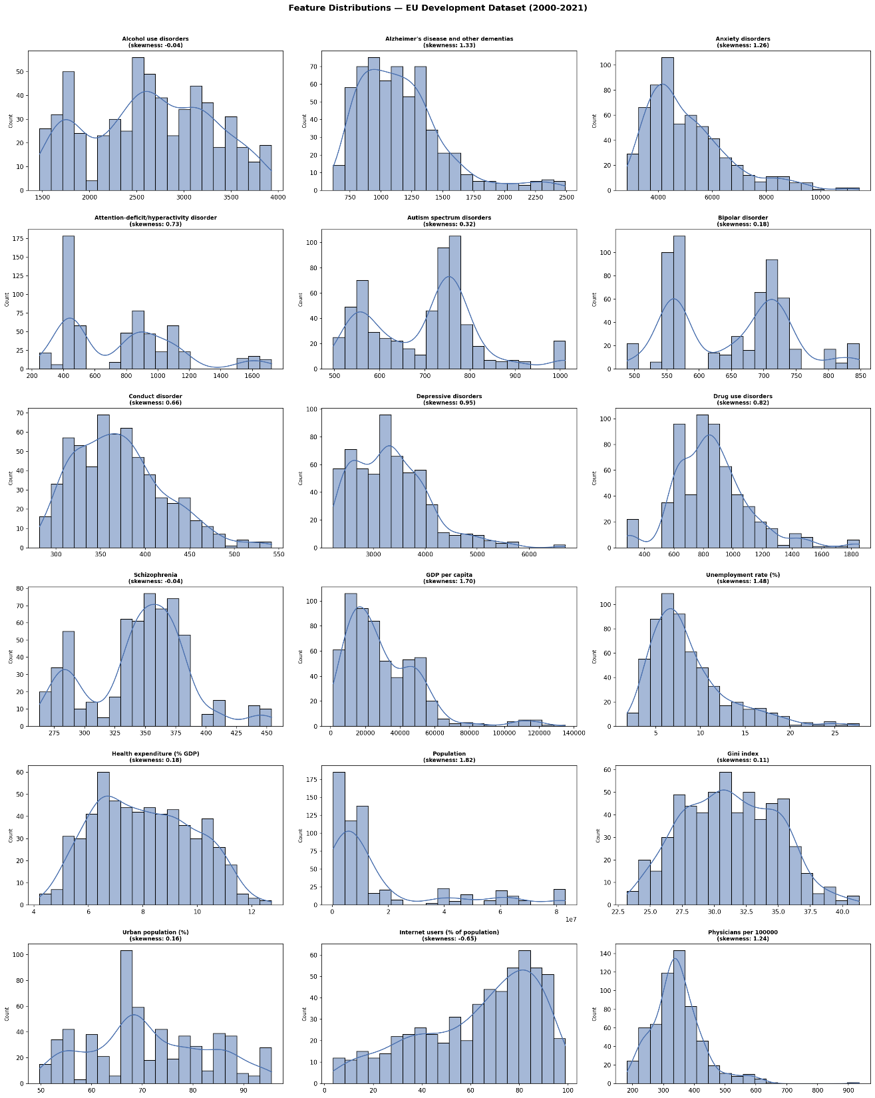
Appendix: full-page graphics
Figure 4.1: Distribution of numerical explanatory variables in the EU Development Dataset (2000–2021). Histograms and kernel density estimates (KDE) illustrate variability, skewness, and distributional patterns across socioeconomic, demographic, healthcare, and mental health indicators.

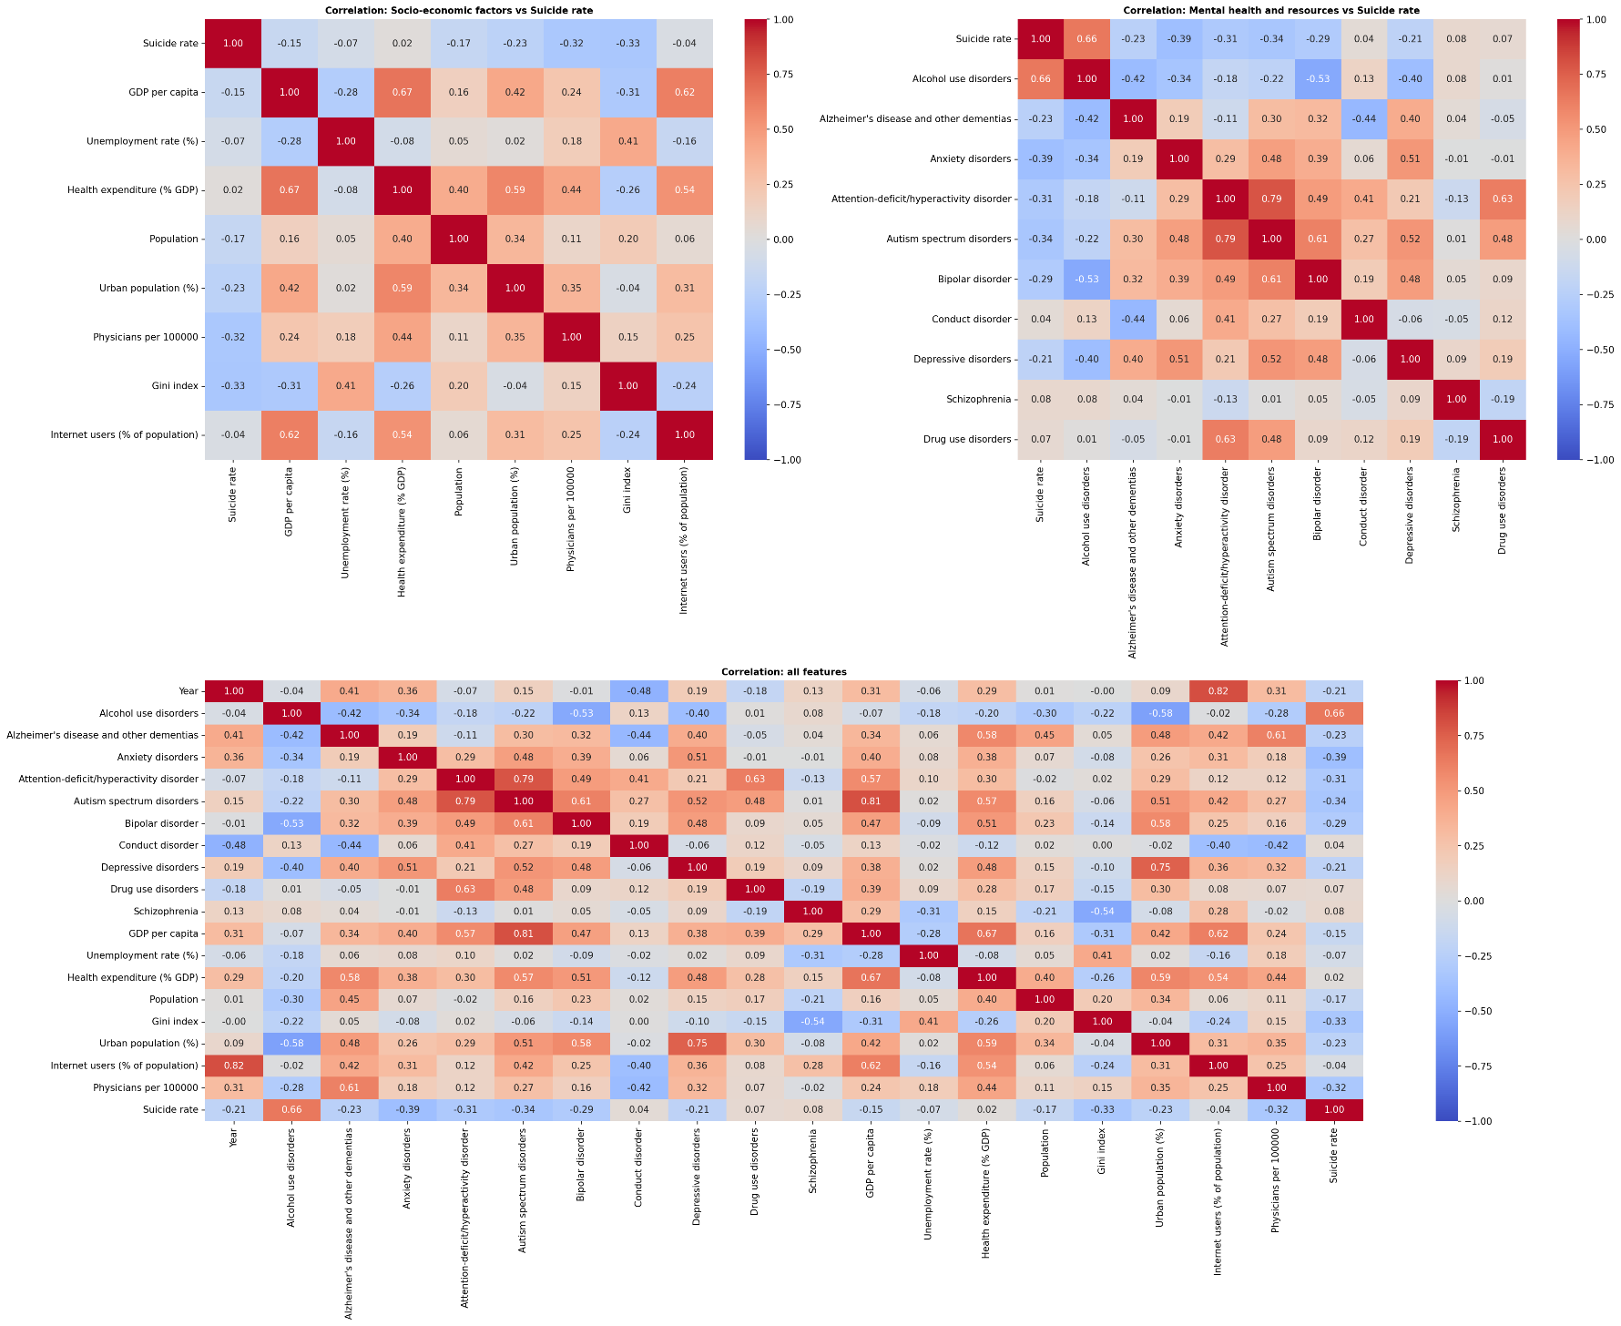
Figure 4.2: Correlation matrices showing the relationships between suicide rates, socio-economic factors, and mental health indicators across all variables included in the study in the geographical split.
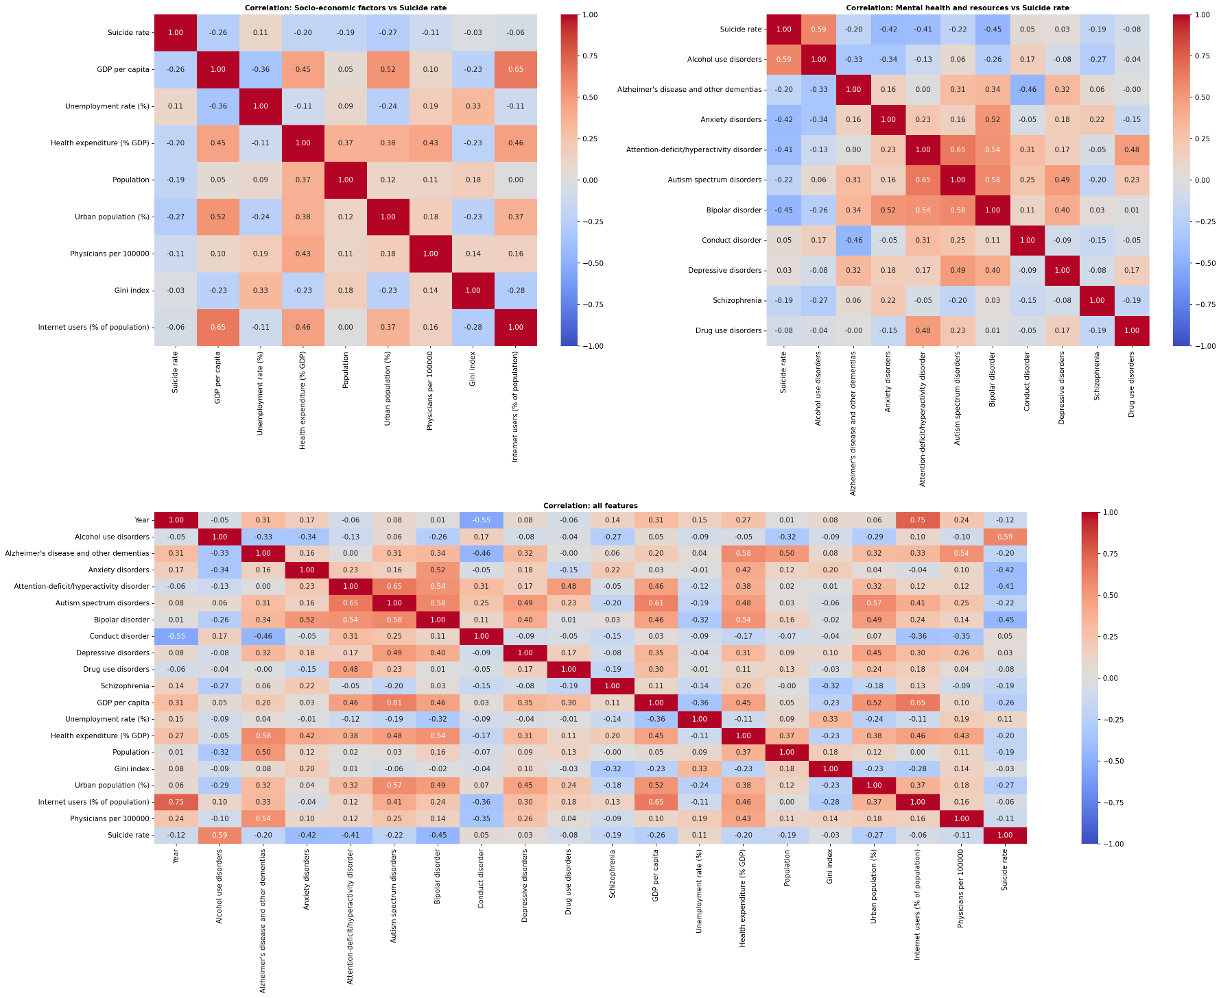
Figure 4.3: Correlation matrices showing the relationships between suicide rates, socio-economic factors, and mental health indicators across all variables included in the study in the temporal split.

BIBLIOGRAPHY
Biplob, K. B. B., Bijoy, Md. H. I., Bitto, A. K., Das, A., Chowdhury, A., & Hossain, S. Md. M. (2023). Suicidal Ratio Prediction Among the Continent of World: A Machine Learning Approach. 2023 International Conference on Artificial Intelligence and Applications (ICAIA) Alliance Technology Conference (ATCON-1), 1–6. https://doi.org/10.1109/ICAIA57370.2023.10169618
DeBeer, B., Mignogna, J., Talbot, M., Villarreal, E., Mohatt, N., Borah, E., Russell, P. D., Bryan, C. J., Monteith, L. L., Bongiovanni, K., Hoffmire, C., Peterson, A. L., Heise, J., Baack, S., Weinberg, K., Polk, M., & Benzer, J. K. (2024). Suicide Prevention Programming: Comparing Four Prominent Frameworks. Psychiatric Services, 75(8), 789–800. https://doi.org/10.1176/appi.ps.20230173
European Commission. (2023). European Health Union: A comprehensive approach to mental health (IP/23/3050). European Commission. https://ec.europa.eu/commission/presscorner/api/files/document/print/en/ip_23_3050/IP_23_3050_EN.pdf
Hawton, K., & Pirkis, J. (2024). Preventing suicide: A call to action. The Lancet Public Health, 9(10), e825–e830. https://doi.org/10.1016/S2468-2667(24)00159-2
Kleiman, E. M., Glenn, C. R., & Liu, R. T. (2023). The use of advanced technology and statistical methods to predict and prevent suicide. Nature Reviews Psychology, 2(6), 347–359. https://doi.org/10.1038/s44159-023-00175-y
Na, P. J., Shin, J., Kwak, H. R., Lee, J., Jester, D. J., Bandara, P., Kim, J. Y., Moutier, C. Y., Pietrzak, R. H., Oquendo, M. A., & Jeste, D. V. (2025). Social Determinants of Health and Suicide-Related Outcomes: A Review of Meta-Analyses. JAMA Psychiatry, 82(4), 337. https://doi.org/10.1001/jamapsychiatry.2024.4241
Nadeem Parpio, Y., Nuruddin, R., Ali, T. S., Mohammad, N., Khan, U. R., Shahzad, S., Khan, M. M., & Aslam, M. (2025). Suicide prevention program on suicidal behaviors and mental wellbeing among school aged adolescents: A scoping review. Frontiers in Public Health, 13, 1506321. https://doi.org/10.3389/fpubh.2025.1506321
O’Brien, R. M. (2007). A Caution Regarding Rules of Thumb for Variance Inflation Factors. Quality & Quantity, 41(5), 673–690. https://doi.org/10.1007/s11135-006-9018-6
O’Connor, R. C., Kirtley, O. J., & De Beurs, D. (2024). Preventing suicide: Understanding the complex interplay between individual and societal factors. The Lancet Public Health, 9(10), e714–e715. https://doi.org/10.1016/S2468-2667(24)00217-2
Pirkis, J., Dandona, R., Silverman, M., Khan, M., & Hawton, K. (2024). Preventing suicide: A public health approach to a global problem. The Lancet Public Health, 9(10), e787–e795. https://doi.org/10.1016/S2468-2667(24)00149-X
Pranckeviciene, E., & Kasperiuniene, J. (2024). Global Suicide Mortality Rates (2000–2019): Clustering, Themes, and Causes Analyzed through Machine Learning and Bibliographic Data. International Journal of Environmental Research and Public Health, 21(9), 1202. https://doi.org/10.3390/ijerph21091202
Rotejanaprasert, C., Thanutchapat, P., Phoncharoenwirot, C., Mekchaiporn, O., Chienwichai, P., & Maude, R. J. (2025). Global spatiotemporal analysis of suicide epidemiology and risk factor associations from 2000 to 2019 using Bayesian space time hierarchical modeling. Scientific Reports, 15(1), 12785. https://doi.org/10.1038/s41598-025-97064-6
Somé, N. H., Noormohammadpour, P., & Lange, S. (2024). The use of machine learning on administrative and survey data to predict suicidal thoughts and behaviors: A systematic review. Frontiers in Psychiatry, 15, 1291362. https://doi.org/10.3389/fpsyt.2024.1291362
Spittal, M. J., Guo, X. A., Kang, L., Kirtley, O. J., Clapperton, A., Hawton, K., Kapur, N., Pirkis, J., & Carter, G. (2025). Machine learning algorithms and their predictive accuracy for suicide and self-harm: Systematic review and meta-analysis. PLOS Medicine, 22(9), e1004581. https://doi.org/10.1371/journal.pmed.1004581
World Health Organization. (2019, September 9). Suicide: One person dies every 40 seconds. https://www.who.int/news/item/09-09-2019-suicide-one-person-dies-every-40-seconds
World Health Organization. (2021). Comprehensive Mental Health Action Plan 2013-2030 (1st ed). World Health Organization. https://www.who.int/publications/i/item/9789240031029
World Health Organization. (2022). World Mental Health Report: Transforming Mental Health for All. Executive Summary (1st ed). World Health Organization. https://www.who.int/publications/i/item/9789240050860
World Health Organization. (2025a). Suicide worldwide in 2021: Global health estimates (1st ed). World Health Organization. https://www.who.int/publications/i/item/9789240110069
World Health Organization. (2025b, September 2). Over a billion people living with mental health conditions – services require urgent scale-up. https://www.who.int/news/item/02-09-2025-over-a-billion-people-living-with-mental-health-conditions-services-require-urgent-scale-up

