Predictive analysis of suicide rates in the EU, based on socioeconomic determinants and mental health prevalence
Cazalla, Víctor, Corrales, Mario, Corredor, Laura.
MSc Data Science and Artificial Intelligence



CONTENT
1 Introduction and context 4
1.1 Global magnitude and impact of mental health 4
1.2 Suicide as the outcome of cumulative processes in mental health 5
1.3 Explanatory factors and determinants of suicide 5
1.4 Limitations of the current approach and the need for change 6
1.5 Application of Data Science: state of the art 6
2 Objectives of the thesis 7
3 Methodology 7
3.1 Databases and working tools 7
3.1.1 Description of data sources 7
3.1.2 Tools and working environment 8
3.2 Data acquisition and preprocessing 10
3.2.1 Data sources and access mechanisms 10
3.2.2 Data extraction and loading 11
3.2.3 Initial data homogenisation 11
3.3 Data integration and cleaning 12
3.3.1 Dataset integration 12
3.3.2 Dataset structuring 13
3.3.3 Initial dataset analysis 13
3.3.4 Detection and treatment of missing values 14
3.4 Exploratory Data Analysis (EDA) 15
3.4.1 Distribution of the suicide rate by country 15
3.4.2 Identification of extreme values 16
3.4.3 Temporal evolution of the suicide rate 18
3.4.4 Analysis of the distribution by region 19
3.4.5 Univariate analysis of explanatory variables 20
3.4.6 Multicollinearity and variable selection 20
3.5 Data preparation for modelling 22
3.5.1 Option A: geographical split 22
3.5.2 Option B: temporal split 23
3.5.3 Correlation study 23
3.5.4 Scaling of indicators 24
3.6 Model creation (Supervised learning) 25
3.6.1 Model selection and applicability 25
3.6.2 Evaluation metrics 31
3.7 Clustering methods (Unsupervised learning) 32
3.7.1 Country-level aggregation 32
3.7.2 K-Means clustering 33
3.7.3 Hierarchical clustering 34
3.7.4 Agreement with the a priori regions grouping 35
3.8 Temporal persistence check 35
3.8.1 Naive persistence baseline 36
3.8.2 Endogenous vs exogenous variables 36
3.8.3 SARIMAX 36
3.8.4 Prophet 37
3.9 Production model and inference 37
3.9.1 Inference architecture 37
3.9.2 Comparison against the temporal model 38
4 Results 38
4.1 Supervised learning 38
4.1.1 Results comparison 38
4.1.2 Results diagnostics and interpretability 40
4.1.3 Model improvement experiments 42
4.2 Unsupervised learning 43
4.3 Temporal persistence check 44
4.3.1 Results 45
4.4 CatBoost vs SARIMAX predictions 45
5 Conclusions 47
5.1 Research closure 47
5.1.1 Key findings 47
5.1.2 Interpretation of the results 47
5.1.3 Contributions of this study 48
5.1.4 Limitations 48
5.1.5 Practical implications 48
5.1.6 Conclusion 49
5.2 Future lines of work 49
6 Appendix: full-page graphics 50
7 Bibliography 53

Introduction and context

Global magnitude and impact of mental health
Over the past few decades, mental health has become one of the leading public health challenges at a global scale, owing to its high prevalence, its cross-cutting impact on quality of life, and its close relationship with social, economic, and cultural factors (European Commission, 2023; World Health Organization, 2022).
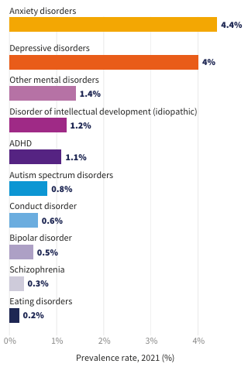
According to the latest data from the World Health Organization (WHO), approximately one in every eight people — more than 1, 000 million individuals— live with a mental disorder (World Health Organization, 2025b). Overall, mental disorders account for around 13 % of the global burden of disease and rank among the leading causes of disability worldwide, with depression and anxiety standing out as two of the most prevalent conditions (World Health Organization, 2021). In fact, anxiety alone accounts for around 4.4% of the global disease burden (Figure 1.1), making it one of the single most important causes of disability worldwide (World Health Organization, 2021).
Figure 1.1: Global prevalence of mental disorders in 2021, where “Prevalence” refers to the proportion of individuals in a population who have a particular disease or condition at a specific point in time or over a defined period.
From a socioeconomic perspective, mental illness not only affects the wellbeing and health of the population but also generates a significant economic impact. It is estimated, for example, that between 2011 and 2030 the productivity losses and other costs associated with mental disorders will reach around US$16.3 trillion globally (World Health Organization, 2025a). These numbers illustrate the enormous economic burden that poor mental health places on societies, driven mainly by reduced labour productivity, increased healthcare spending, and social benefit payments.

Suicide as the outcome of cumulative processes in mental health
This problem takes on an especially critical dimension when suicidal behaviour is examined, regarded as one of the most extreme manifestations of mental health deterioration.
Worldwide, an estimated 727,000 people die by suicide every year (Pirkis et al., 2024; World Health Organization, 2025a), equivalent to one death every 45 seconds (World Health Organization, 2019). Moreover, this figure should be interpreted as a conservative estimate, given that the quality and availability of registration systems vary significantly across countries, particularly in low- and middle-income regions (Pirkis et al., 2024).
Consequently, the actual number of suicide deaths could be higher than estimated, further reinforcing the severity of this phenomenon, which accounts for 1% of all deaths worldwide (World Health Organization, 2025a).
The impact of suicide is particularly alarming among young people. Several studies agree that it is one of the leading causes of death among people aged 15 to 29, and even the fourth leading cause of death among adolescents worldwide (Nadeem Parpio et al., 2025).
Adding to this reality is the fact that mortality represents only a fraction of the problem, since for every completed suicide there are an estimated 50 to 100 prior attempts, alongside a high prevalence of suicidal ideation in the population (Nadeem Parpio et al., 2025).

Explanatory factors and determinants of suicide
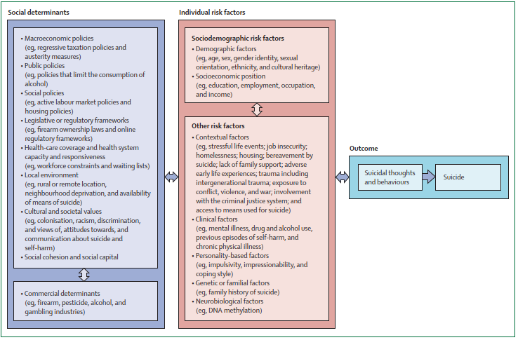
From an explanatory standpoint, the scientific literature has shown that suicide cannot be understood in isolation as an individual clinical problem, but rather as the multifactorial outcome of multiple psychological, social and economic determinants (Figure 1.2, (Pirkis et al., 2024)).
Figure 1.2: Public health model of suicide illustrating the multilevel interaction between social determinants, individual risk factors and its outcomes.
Experts stress that suicidal behaviour is the product of an intricate interaction between individuals' psychological vulnerability and adverse contextual conditions (Hawton & Pirkis, 2024; O’Connor et al., 2024). Factors such as income level, unemployment, violence, social isolation, substance abuse, and discrimination thus exert a decisive influence on the development of suicide risk (Hawton & Pirkis, 2024; O’Connor et al., 2024; Pirkis et al., 2024).
This integrative perspective holds that the social and economic determinants of health contribute substantially to the emergence of suicidal behaviour (Na et al., 2025).

Limitations of the current approach and the need for change
Given this complexity, the literature agrees that the institutional response to mental health and suicide prevention has historically been dominated by a reactive approach, focused on interventions targeting people who already exhibit suicidal behaviour or acute crises (Pirkis et al., 2024), owing to:
- Structural and operational limitations: preventive interventions face major challenges in terms of the difficulty of designing, implementing, and evaluating them.
- Traditional mental health systems organised around illness-centred care models, reinforcing action only once the problem has already manifested.
As a result, key structural factors, such as socioeconomic inequality or living conditions, receive limited attention within prevention strategies (DeBeer et al., 2024; Hawton & Pirkis, 2024; Nadeem Parpio et al., 2025; Pirkis et al., 2024).
The use of predictive analytical tools could help with the early detection of emerging patterns. Several authors already speak of a paradigm shift towards proactive, data-driven strategies based on multidimensional analysis that can anticipate trends and risk factors at the population level (Hawton & Pirkis, 2024; Na et al., 2025; Nadeem Parpio et al., 2025; Pirkis et al., 2024).
This paradigm shift would mean moving from a model centred on responding to individual crises to one oriented towards anticipating risk at the population level, enabling the design of more efficient and targeted policies.

Application of Data Science: state of the art
This problem is framed as a predictive question within the field of Data Science: is it possible to predict the global evolution of suicide rates using mental health indicators and socioeconomic variables?
The rise of large-scale data analytics has led numerous researchers, in recent years, to apply Data Science to the study of suicide rates. Advanced analytical techniques — ranging from machine learning models to spatiotemporal statistical modelling — have been applied to large international databases integrating mental health indicators and socioeconomic variables, with the aim of identifying complex patterns and anticipating trends (Somé et al., 2024; Spittal et al., 2025).
These efforts range from global-scale analyses — for instance, Bayesian models incorporating data from nearly every country in the world, or clustering algorithms grouping countries according to the evolution of their suicide rates — to work focused on specific contexts (practices at the level of continents, regions, or particular demographic groups) (Biplob et al., 2023; Pranckeviciene & Kasperiuniene, 2024; Rotejanaprasert et al., 2025).
Although these initiatives are still at an early stage of development, their sheer proliferation reflects a growing interest in leveraging data science to address suicide prevention at the population level in a more comprehensive way (Kleiman et al., 2023).

Objectives of the thesis
The main objective of this Master's Thesis is to predict the evolution of suicide rates at the European scale, based on the joint analysis of mental health indicators and some of the key socioeconomic variables described by the academic works cited above.
This approach integrates descriptive and predictive techniques in order to identify relationships between determining factors and trends in suicide rates, as well as to project their future behaviour. All of this aims to generate useful knowledge that contributes to risk anticipation and the design of proactive public health strategies, as well as to decision-making in the private healthcare sector.
This work aims to add value in both the academic and practical domains:
- Academic contribution:
To apply the knowledge acquired in the field of data science to address a complex problem of global relevance, helping to narrow the existing gap in the literature regarding the large-scale prediction of mental health phenomena through the integrated use of heterogeneous data from public sources.
- Practical contribution:
To develop an analytical approach with genuine real-world applicability, capable of providing strategic information to both public bodies and private-sector entities, facilitating intervention planning, resource allocation, and data-driven decision-making in the field of mental health.
To facilitate the readability of this thesis, any chart or image intended to occupy a full page will be included in the Appendix: full-page graphics section.

Methodology

Databases and working tools

Description of data sources
The initial step of this work consisted of building an integrated dataset combining health information and socioeconomic variables, with the aim of analysing and modelling the evolution of the suicide rate in European Union countries. Since no single source concentrates all the relevant variables, multiple official data sources widely used in the scientific literature were selected instead.
In this context, the sources have been structured according to their role within the analytical model, distinguishing between:
- the target variable,
- the explanatory indicators,
- the contextual indicators.
This classification allows the construction of the dataset to be aligned with the predictive approach of the work, facilitating both the interpretation of the results and the subsequent development of the models.
Table 1 presents a comparative summary of the main sources used:
Source | Indicator type | Content | Access | Role in the analysis | Description
WHO – World Health Organization | Target indicator | Suicide rate (per 100,000 inhabitants, age-standardised) | REST API (JSON) | Dependent indicator of the predictive model | Official, validated source; high international comparability; broad historical coverage
World Bank Open Data | Explanatory indicators | Socioeconomic indicators (GDP, GDP per capita, unemployment, inflation, health expenditure, etc.) | REST API (JSON) | Independent variables of the model | Broad temporal and geographical coverage; standardised and up-to-date data
IHME – Global Burden of Disease (GBD 2023) | Context indicators | Prevalence of mental disorders | Local CSV (downloaded from its website) | Support for exploratory analysis and contextualisation | High epidemiological quality; homogeneous and cross-country comparable methodologies
Table 1: Summary of data sources and index description.
Following this comparative analysis, it can be observed that the core of the model is built from the combination of the suicide rate (WHO) as the target variable and socioeconomic indicators (World Bank) as explanatory variables. In turn, data from the Global Burden of Disease (GBD - IHME) enriches the analysis from a health perspective.
Taken together, the integration of these sources allows the phenomenon of suicide to be addressed from a multicausal approach, consistent with the existing literature presented in the introduction, although it introduces relevant challenges in terms of data homogenisation, quality, and availability, which will be addressed in later sections.

Tools and working environment
This work was developed within the Visual Studio Code software ecosystem, entirely based on the Python language, with a structure that separates two complementary tracks: an exploratory one, based on interactive notebooks, and a production one, based on modular *.py scripts. This decision reflects the ease of project development and modularity of implementing the solution in notebooks, and its subsequent adaptation to a production environment. Both approaches are kept for visibility.

Tools
The tools include, most notably:
- Pandas and Numpy, for data manipulation, cleaning and integration.
- Requests, for extracting information from external APIs (World Bank and WHO).
- Scikit-learn, XGBoost and CatBoost, for the predictive modelling phase.
- SHAP, for model interpretability.
- Matplotlib and Seaborn, for visualisations generation.
- Joblib, for persisting trained models.
- Statsmodels, for SARIMAX time-series modelling.
- Prophet, for the second, independent time-series approach.
- SciPy, for hierarchical clustering.
- PyArrow, for reading and writing the intermediate datasets in Parquet format.
- OpenPyXL, for writing the PowerBI data workbook.
The combined use of these libraries makes it possible to implement an ETL-type workflow (extraction, transformation, and loading), necessary to integrate heterogeneous sources into a single coherent dataset.
Other complementary libraries will be introduced progressively in later sections (exploratory analysis and modelling), depending on their use within the pipeline.

Working environment
The working environment used was a version-control repository (Git/GitHub, repository URL listed in Section 5), with a local Python virtual environment and Visual Studio Code as the editor. The choice of this environment was based on:
- The ability to version the complete history of project changes, with traceability of every decision made.
- A clear, reproducible folder structure (data/, notebooks/, prod/, src/, outputs/), which separates reusable logic (src/) from its use in each notebook or script.
- A dependencies file (requirements.txt) that fixes the exact version of every library used, ensuring the reproducibility of the environment on any machine.
- The ability to run the complete pipeline both in notebooks (notebooks/, for the exploratory phase) and via independent production scripts (“prod/”), including an inference script (predict.py) that allows scoring new data without needing to retrain the model.
Taken together, this structure provides a reproducible, versioned, and modular basis for the development of the analysis, covering the complete cycle from data acquisition to inference on new data.
In addition to this repository, an interactive Power BI dashboard was developed from the same pipeline outputs (see prod/07_export_powerbi.py), covering everything this thesis discovers. It is intended primarily as a live, explorable complement for the oral defence rather than as a component of this written report, so it is referenced here rather than reproduced in full.

Data acquisition and preprocessing
The first step in building the analytical dataset begins with data acquisition and integration. As explained earlier, since the data come from different sources, they present differences in format, structure, and access mechanism. It was therefore necessary to design a process enabling their extraction, initial transformation, and integration into a single analytical framework.

Data sources and access mechanisms
Data acquisition was carried out using two main approaches: dynamic access through APIs and loading a local file format. This combination makes it possible, on the one hand, to ensure the pipeline's updatability and reproducibility in the case of APIs, and on the other, to incorporate specific datasets not available through code access.
- Target indicator (suicide rate) was obtained from the World Health Organization's (WHO) Global Health Observatory, via its public API. This API provides the data in JSON format, allowing its direct integration into the analysis environment.
The endpoint used is the following:
https://ghoapi.azureedge.net/api/SDGSUICIDE
- The socioeconomic explanatory variables were extracted from the World Bank Open Data portal, using its REST API.
General access to the indicators is carried out through:
https://api.worldbank.org/v2/country/ALL/indicator/
From this endpoint, specific queries are built for each indicator (GDP per capita, unemployment, health expenditure, among others), making it possible to obtain homogeneous time series for the countries analysed.
- Mental illness prevalence data comes from the Global Burden of Disease (GBD 2023) study by the Institute for Health Metrics and Evaluation (IHME). This data was obtained by downloading it in CSV format from the official IHME website:
https://gbd2023.healthdata.org/gbd-results/

Data extraction and loading
Once the sources had been identified, the data was extracted and loaded into the working environment.
For the APIs (WHO and World Bank), extraction is carried out via HTTP requests using the requests library. The responses obtained in JSON format are subsequently transformed into tabular structures using Pandas, enabling their manipulation and analysis.
- WHO API: a single query is made to the suicide rate indicator, extracting the relevant fields (country, year, and indicator value). Specific filters are then applied to select only the data corresponding to both sexes and the total age range, thereby ensuring comparability across countries.
- World Bank data: extraction is carried out iteratively for each of the selected indicators.
Each response is processed independently and subsequently transformed into a DataFrame, allowing its progressive integration into a master dataset.
- GBD 2023 data is loaded directly from a CSV file using Pandas read_csv function and incorporated into the environment as an additional DataFrame.

Initial data homogenisation
Since the sources present heterogeneous structures and formats, an initial homogenisation process is required to enable their subsequent integration. To this end, various transformations are applied aimed at unifying both the structure and the content of the data.
- First, the identifier variables are standardised, mainly country and year. For country, three-letter ISO codes are generated from the original name, which facilitates matching across the different data sources.
Likewise, the time variable is homogenised, ensuring its representation as a numeric value.
Additionally, the names of the key variables are unified to ensure consistency across datasets.
- Second, a selection of relevant variables is made within each source, removing those that are not needed for the analysis.
The following socioeconomic variables were selected from the World Bank data:
- GDP per capita (USD). As a measure of general economic development and financial security.
- Unemployment rate. Direct proxy for economic stress at individual level.
- Health expenditure per country (percentage of GDP). Investment in health care systems, including mental health services.
- Population per country. Scale and control variable.
- Gini index. Measures the income inequalities. A greater inequality correlates to a greater psychosocial stress.
- Urban population (%). Allows to analyse if the urban environment (isolation, low resources) affects the rate.
- Physicians per 100,000 inhabitants. Measures the health system capability. The lower the rate, the lower the access to psychiatrists.
- Digital connectivity. Internet access could either be an issue for mental health or a network for support.
- Finally, initial filters are applied to bound the scope of the study, both in temporal and geographical terms. In particular, the analysis is restricted to observations from the year 2000 onward, thereby ensuring temporal consistency across the different sources.
Smoking rate was considered as an additional indicator, given its independently critical risk factor for increase suicide mortality (Hughes, 2008; Park et al., 2024), but during the research for data, no trustable database was found and was therefore left for a future line of work (Section 5.1).
Consistency across sources is ensured using the ISO codes mentioned above, which enables their integration through join operations by country and year. This results in a homogeneous and consistent dataset, suitable for subsequent analysis.

Data integration and cleaning

Dataset integration
Once homogenised, the different datasets are integrated into a single dataset through join (merge) operations.
Integration is carried out using the country code (ISO) and the year as common keys, which allows the different variables to be aligned in a panel structure (country-year), which is the structure that matches how the three source questions in this thesis are asked: whether a determinant predicts suicide rate compares countries at a given time (a cross-sectional question), while the temporal persistence check compares a country against its own past (a within-country, longitudinal question).
First, a base dataset (df_base) is built from the health indicators from the GBD (IHME). Onto this base, the World Bank socioeconomic indicators are incorporated, building a dataset containing all the features (df_features).
Finally, the target variable (the suicide rate from the WHO) is incorporated through a join by country and year.
For all these joins, a left join operation is used, which preserves all the observations in the base dataset while incorporating the subsequent variables.
The result of this process is an integrated dataset (df_development) structured in panel format (country-year), containing the target variable and the selected explanatory variables, which will be used for data treatment as well as in the subsequent exploratory analysis and modelling phases.

Dataset structuring
Once the integration process across the different sources has been completed, the resulting dataset is structured with the aim of ensuring its coherence and suitability for subsequent analysis.
The dataset is then segmented into two distinct subsets based on the availability of the target variable (suicide rate).
- On one hand, the df_development set is defined, which includes observations up to the year 2021, for which complete information on the target variable is available. This set constitutes the main basis for the exploratory analysis and the development of the predictive models.
- On the other hand, the df_real_world set is built, containing the most recent observations (from 2022 onward), for which the target variable is not available. This subset is reserved solely for use with the inference script, as a demonstration of its use on a new, unseen year.
This split responds to the need to distinguish between complete historical data, used for training and analysis, and recent data, which makes it possible to validate the model's behaviour in a context closer to reality.
This results in an organised, coherent data structure that clearly distinguishes between the model's development and application phases, facilitating subsequent analysis and ensuring the methodological consistency of the work.

Initial dataset analysis
Once the final dataset has been structured, an initial descriptive analysis is carried out with the aim of obtaining an overall view of the variables and checking their consistency before proceeding to more advanced stages of analysis.
To this end, the main descriptive statistics of the df_development dataset are calculated, including measures of central tendency, dispersion, and range.
This analysis makes it possible to identify, on a preliminary basis, the distribution of the variables as well as possible extreme values or inconsistencies in the data. It also provides an initial approximation of the scale and variability of the different socioeconomic indicators and of the target variable. Furthermore, this step is key to detecting possible data-quality issues, such as the presence of outliers or anomalous distributions, which could affect subsequent analysis.
In this sense, the descriptive analysis acts as an intermediate stage between data preparation and in-depth exploratory analysis, making it possible to validate the correct construction of the dataset before continuing with the study.

Detection and treatment of missing values
Following the initial descriptive analysis, missing values in the dataset are identified, with the aim of assessing data quality and determining whether imputation techniques are needed. To this end, the number of null values per variable is calculated in the df_development dataset.
Overall, the constructed dataset is found to be consistent in terms of missing values. Gaps in information are only observed in the socioeconomic variables Gini index and number of Physicians per 100,000 inhabitants, with 54 and 4 missing records respectively.
The presence of these missing values is mainly due to limitations in data availability in the original sources, especially in international time series, where not all countries report information continuously.
To minimise these missing values, an imputation approach adapted to each country's temporal pattern is applied, distinguishing two cases:
- Interior gaps (missing years between two known values): standard linear interpolation is applied.
- Boundary gaps (missing years at the start or end of a country's series, where linear interpolation cannot be applied): a linear trend is fitted by ordinary least squares (OLS) over that country's known years and extrapolated – rather than filling in with the last known value, which would underestimate any genuine trend at the edges of the series.
This function is implemented in
src/data_loading.py::interpolate_with_trend_extrapolation
This approach has certain limitations, as it assumes a relatively smooth evolution between consecutive observations, which may not resemble the real-world context. However, it is considered the most suitable option in this context, and its choice is justified for several reasons:
- The number of missing values is small.
- It preserves the temporal continuity of the data series, since imputation is performed intra-country, respecting the heterogeneity between analysis units.
- It avoids introducing biases associated with global imputations, such as the mean or the median.
- Unlike simple linear interpolation, the specific treatment of boundary gaps avoids underestimating genuine trends in years with no subsequent known data.
Consequently, the potential impact of this simplification on the final results is considered limited and methodologically acceptable.
At this point, the dataset is considered ready for subsequent exploratory analysis and is stored in Parquet format as df_development.parquet, to support the scalability of the work and its use in both prod/02_eda.py and notebooks/02_eda.ipynb.
Parquet was chosen over CSV specifically for this handoff between pipeline stages: it preserves exact column dtypes across save/load, and its columnar, compressed storage is faster to read for the column-heavy operations most of this pipeline performs. With a dataset this size the performance difference is negligible, but the dtype-preservation guarantee is worth having regardless of scale.

Exploratory Data Analysis (EDA)

Distribution of the suicide rate by country
With the aim of obtaining an initial overall view of the distribution of the suicide rate across European Union countries, a country-level comparative analysis is carried out using the df_development dataset.
To this end, the distribution of the suicide rate is represented through a box plot, which allows both the median and the dispersion of values to be visualised for each country:
The chart reveals a high degree of heterogeneity across countries, both in terms of average level (median) and dispersion. Some countries display clearly higher medians, at times accompanied by greater variability, while others maintain lower, more stable levels.
The box plot also makes it possible to identify the presence of extreme values in certain countries, suggesting the existence of differentiated behaviours within the European Union, which leads us to the next step of the EDA.
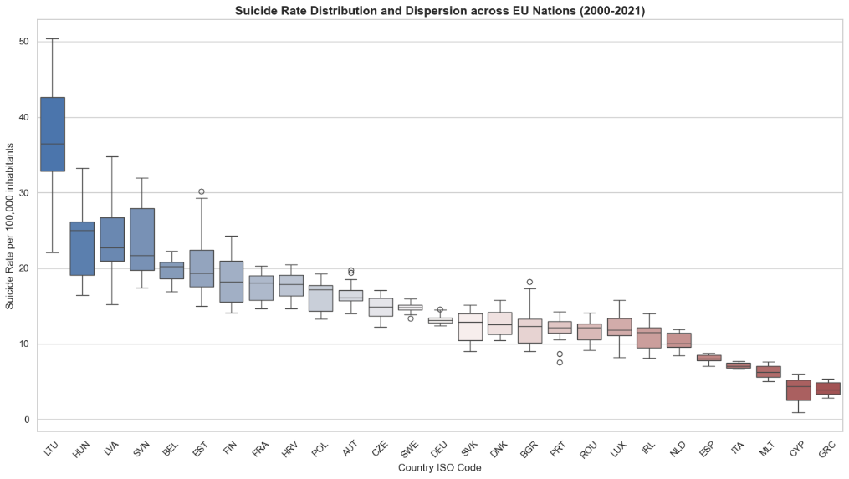
Figure 3.1: Distribution of suicide rates (per 100,000 inhabitants) across EU countries (2000–2021), highlighting cross-country variability and differences in dispersion patterns.

No categorical variable encoding was required, since every predictor used in the panel models is numeric by construction — socioeconomic indicators from the World Bank and mental-health prevalence rates from IHME — with Country/Code used only as row identifiers, never as a model feature.

Identification of extreme values
Following this initial overview, and with the aim of assessing the presence of atypical observations and their potential impact on the analysis, a specific outlier study is carried out.
To this end, a specific function based on the interquartile range (IQR), src/features.py::flag_outliers_iqr, is implemented, which systematically identifies values lying outside the lower and upper bounds defined for each variable. The 1.5 multiplier is Tukey's original convention (Tukey, 1977), not an arbitrary choice: for a normally distributed variable, fences set at $Q1-1.5·IQR$ and $Q3+1.5·IQR$ fall at approximately ±2.7 standard deviations from the mean, flagging roughly the most extreme 0.7% of values — strict enough to catch genuine anomalies without over-flagging on a dataset of this size. The stricter 3×IQR bound ($\sim ±4.7σ$) is reserved for what Tukey termed "far out" points, used here only as the optional stricter alternative noted in the function's own docstring.
This procedure is applied to the full set of variables in the dataset, yielding a quantitative summary of the number and percentage of outliers per variable (Table 2).

Feature | Outlier count | Outlier % | Lower bound | Upper bound
Population | 110 | 18.52 | -16125106.75 | 35771617.25
Unemployment rate (%) | 31 | 5.22 | -1.35 | 17.25
Physicians per 100000 | 26 | 4.38 | 163.24 | 517.34
Suicide rate | 23 | 3.87 | -2.05 | 30.30
GDP per capita | 18 | 3.03 | -28443.29 | 85443.25
Health expenditure (% GDP) | 0 | 0.00 | 2.28 | 13.70
Urban population (%) | 0 | 0.00 | 36.69 | 106.22
Gini index | 0 | 0.00 | 19.50 | 42.86
Internet users (% of population) | 0 | 0.00 | -13.00 | 140.16
Table 2: Summary statistics of outlier detection based on IQR thresholds for selected variables, including counts, percentages, and boundary limits
The results show an uneven presence of outliers across variables. In particular, the following stand out:
- Population, with 18.52% outliers, reflecting a high degree of structural heterogeneity across countries.
- Unemployment rate (%) (5.22%) and Physicians per 100,000 (4.38%), with moderate dispersion.
- Suicide rate, with 3.87% outliers, indicating the existence of isolated observations lying outside the usual range.
- Variables such as Health expenditure, Urban population, Gini index, and Internet users show no outliers, suggesting a more stable distribution.
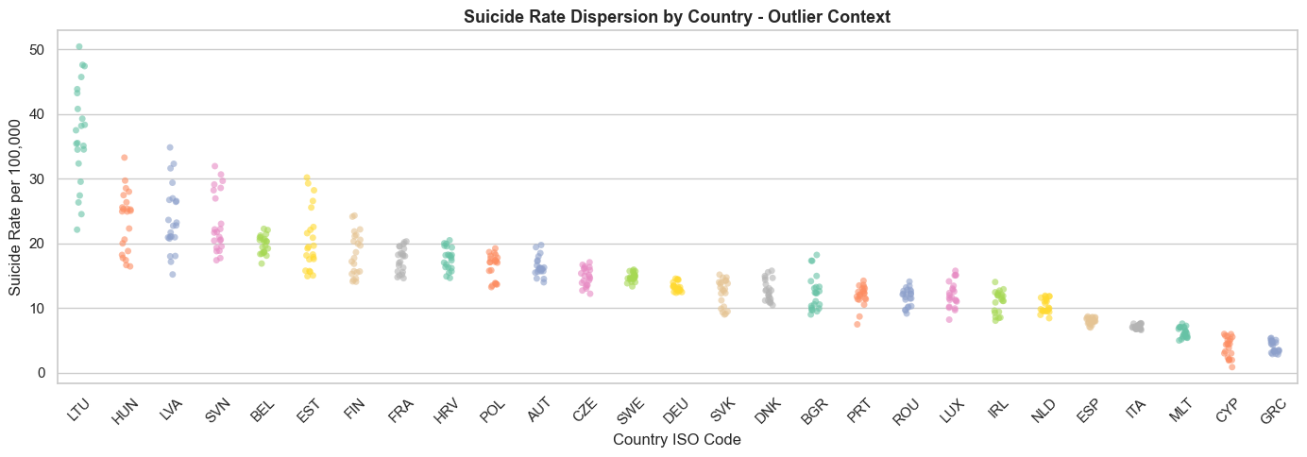
To put these results in context, the dispersion of the suicide rate by country is represented (Figure 3.3), showing variability both across and within countries.
Figure 3.2: Country-level distribution of suicide rates (per 100,000 inhabitants) as part of the outlier analysis, illustrating variability and potential extreme observations across EU countries (2000–2021).
The chart clearly shows the existence of countries with significantly elevated values, such as Lithuania (LTU), which reaches values above 40 suicides per 100,000 inhabitants in certain periods, compared to others such as Greece (GRC), with considerably lower levels.
It can also be seen that dispersion is not homogeneous, with some countries showing greater temporal variability and others exhibiting more stable behaviour, such as Sweden (SWE) or Germany (DEU).

Temporal evolution of the suicide rate
With the aim of analysing the evolution of the suicide rate over time, time series are plotted for a selected group of countries, making it possible to observe differentiated dynamics across national contexts.
Three countries representative of the distribution identified in the previous section are selected:
- Lithuania (LTU), as a case of high values,
- Greece (GRC), as case of low values,
- Germany (DEU), as an intermediate reference.
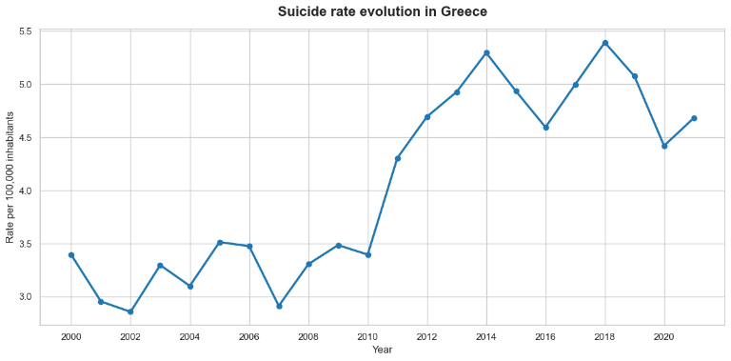
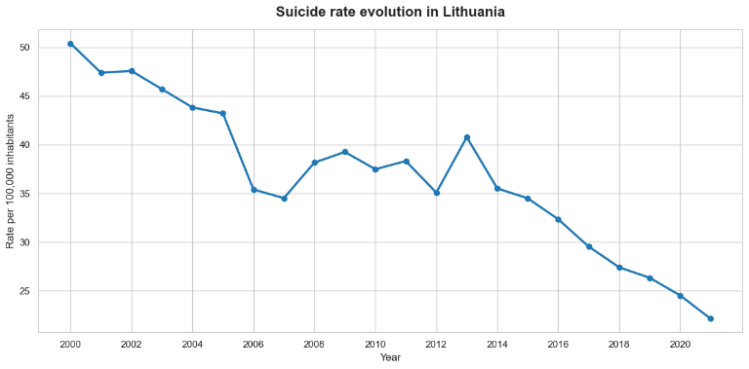
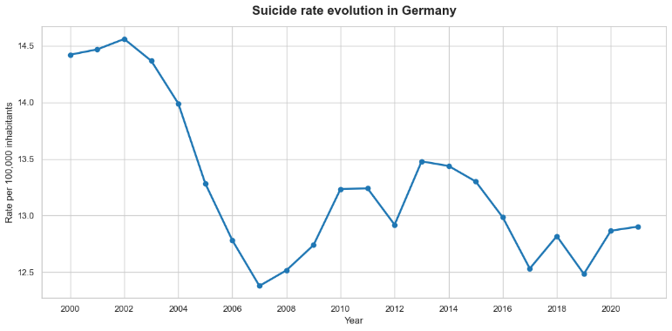
To this end, the function src/diagnostics.py::suicide_evolution_graph is used, developed specifically to visualise the temporal evolution of the suicide rate by country. (Figure 3.4). In simplified terms, the logic of the function is based on iterating over the selected countries and plotting the corresponding time series. This makes it possible to filter the dataset by any country and plot its evolution over time in a standardised way.
Figure 3.3: Temporal evolution of suicide rates (per 100,000 inhabitants) in selected EU countries (Lithuania, Greece, and Germany) over the period 2000–2021, illustrating contrasting trends and levels across high-, low-, and mid-range contexts.

Analysis of the distribution by region
With the aim of analysing the suicide rate from an aggregate perspective, an analysis by geographical region within the European Union is carried out, making it possible to identify structural patterns that are not evident at the country level.
The split by geographical and cultural region used in this analysis (Western Europe/Nordics, Mediterranean, Eastern Europe, Baltics) is an a priori decision, based on geographical and cultural criteria, not derived from the data (Figure 3.5). This assumption is empirically tested later, in the Unsupervised Modelling section (3.7), through a clustering analysis of each country's aggregated socioeconomic and mental health profile.
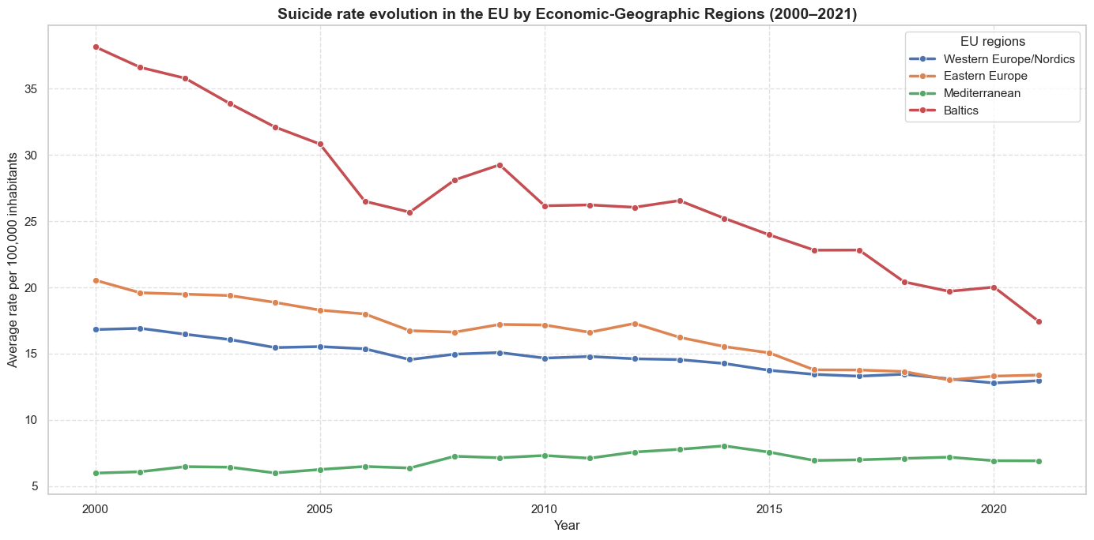
In this context, data aggregation is performed implicitly through the function lineplot, which computes the mean suicide rate for each region-year combination.
Figure 3.4: Temporal evolution of suicide rates (per 100,000 inhabitants) in EU Regions (over the period 2000–2021), showing marked regional disparities and a general downward trajectory over time.
The results show systematic differences between regions, with higher levels in the Baltic countries (group: Estonia, Latvia, and Lithuania) and lower values in the Mediterranean region. The Western Europe/Nordics and Eastern Europe regions sit at an intermediate position.
It can also be observed that, although all regions generally show a downward trend in the suicide rate between 2000 and 2021, the intensity of this decline is not homogeneous. In particular, the Eastern region shows a sharper decrease, while other regions show more gradual changes.
Taken together, the chart evidences the existence of differentiated geographical patterns, both in terms of level and temporal dynamics, suggesting that the suicide rate is influenced by structural factors shared at the regional level.

Univariate analysis of explanatory variables
With the aim of characterising the statistical behaviour of the explanatory variables, a univariate analysis based on the study of their distributions is carried out.
In particular, the procedure is implemented through a loop that iterates over each explanatory variable, allowing its distribution to be analysed individually. For each variable, non-null values are extracted, and their distribution is represented through histograms accompanied by kernel density estimates (KDE), which approximate the probability density function of each variable.
From the resulting plots (Figure 6.1), differentiated patterns can be observed in the shape of the explanatory variables' distributions.
On the one hand, some indicators show significant positive skewness (skewness > 0), especially GDP per capita and Population, whose distributions display long right-hand tails. This behaviour indicates the presence of a small number of countries with values far above the rest — that is, there are few very wealthy countries and few very populous countries, with most countries generally concentrated at the lower end of the distribution.
On the other hand, indicators such as Health expenditure (%GDP) or Gini index show more concentrated distributions closer to symmetry, with values spread across narrower ranges. This suggests lower relative heterogeneity across countries for these indicators.
Likewise, the Internet users (% of population) indicator shows significant negative skewness (skewness < 0), indicating that most countries are concentrated at high values, with a tail towards low values. This pattern is consistent with a context of high digital penetration in Europe, where most of the population has internet access, with only a few countries showing relatively lower levels.
This iterative approach makes it possible to systematically apply the same analysis to all explanatory variables, ensuring comparability across their distributions and facilitating the identification of common patterns or differentiated behaviours.

Multicollinearity and variable selection
Once the individual distribution of the variables has been analysed, the next step is to assess the possible existence of strong linear relationships between predictors, that is, the presence of multicollinearity. This phenomenon occurs when an explanatory variable can be largely explained by a combination of others, which hinders model interpretation and can generate instability in the estimates.
The VIF calculation is carried out over the full set of predictor variables, using the function src/features.py::compute_vif, which incorporates a constant in the model and evaluates each variable individually against the rest. To this end, the variance_inflation_factor implementation from the statsmodels library is used, applying the calculation to the dataset to compute the VIF for the entire set of explanatory variables.
The resulting values are sorted in descending order by VIF, making it possible to identify the variables with the highest degree of multicollinearity. Following common criteria, values above 5 are considered indicative of moderate multicollinearity. The conventional threshold of VIF > 10 is adopted (O’Brien, 2007), widely used in practice despite its limited formal statistical grounding; the decision is made to remove any indicator above this threshold, considering it reasonable under a conservative interpretation of the criterion.
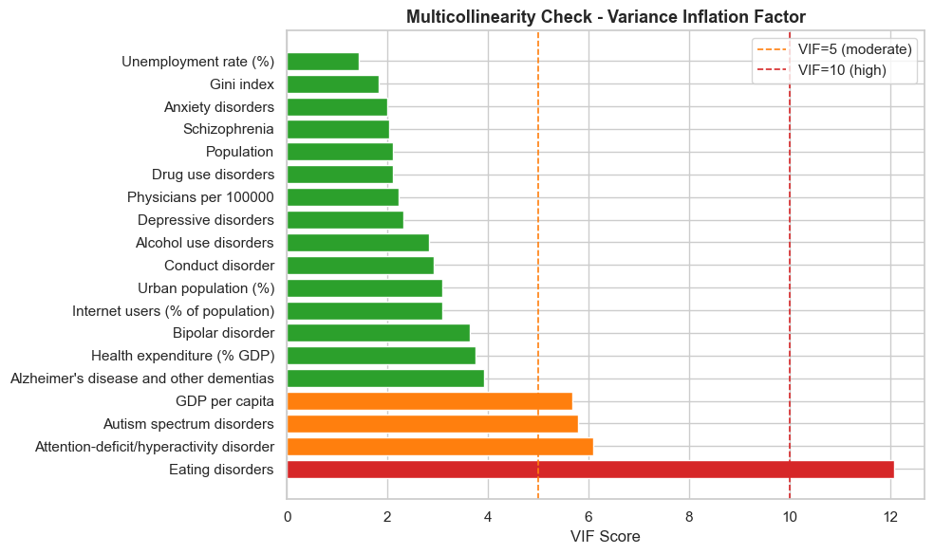
Figure 3.5: Preliminary multicollinearity assessment using Variance Inflation Factor (VIF). The indicator eating disorders shows severe multicollinearity (VIF > 10), indicating that it shares a large proportion of its variance with other predictors and contributes little unique information to the model.
Based on this analysis, the indicator Eating disorders is identified as the only one showing a high level of multicollinearity (VIF = 12.098; Figure 3.6), exceeding the established threshold.
The fact that this indicator’s VIF is so high shows that it can be largely explained by the other predictors, implying a redundancy of information. It is therefore removed from the set of predictor variables, with the aim of improving model stability, reducing noise, and avoiding duplicate information.
After this refinement, the set of explanatory variables is free of significant multicollinearity issues (Figure 3.7), allowing the work to move forward into the subsequent modelling phases with a more consistent and suitable dataset.
At this point, the df_development DataFrame is updated with the indicator removed and is saved as before, for subsequent use in both prod/03_train.py and notebooks/03_models.ipynb.

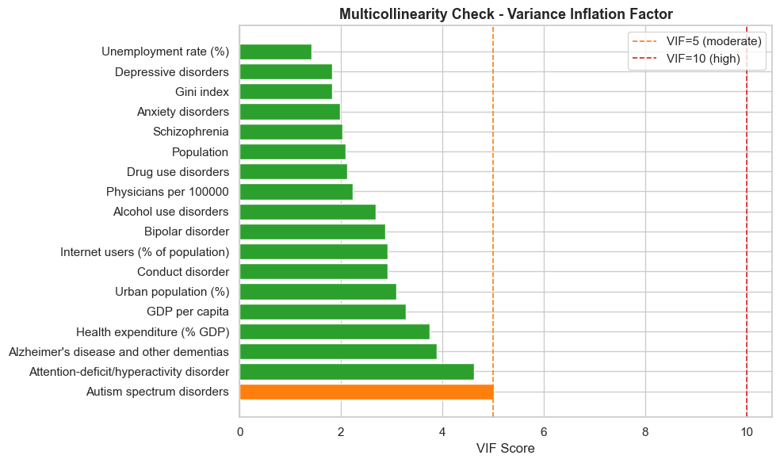
Figure 3.6: Final multicollinearity assessment using the Variance Inflation Factor (VIF). Following the removal of the eating disorders variable, all predictors exhibit acceptable VIF values, indicating a more stable and less collinear feature set.

Data preparation for modelling
Once the set of variables has been refined and multicollinearity analysed, the data is prepared for use in predictive models. At this stage, two dataset-splitting strategies are defined, with the aim of evaluating different forms of model generalisation.
- OPTION A: an approach based on a geographical split is proposed, with the aim of predicting the suicide rate in countries not observed during training. This approach makes it possible to evaluate the model's ability to generalise to new geographical contexts based on socioeconomic and health variables.
- OPTION B: a temporal split is considered, to predict the evolution of the suicide rate in subsequent years. This approach is oriented towards capturing temporal patterns and evaluating predictive capability in future scenarios.
In both cases, 70% of the development dataset corresponding to the 2000–2021 period is used. As noted earlier in this thesis, the years 2022 and 2023 are excluded from the analysis due to the lack of availability of official WHO suicide rate data for that period.

Option A: geographical split
With the aim of evaluating the model's ability to generalise to countries not observed during training, and using only socioeconomic and health variables, a geographical split is proposed. To this end, the available countries are randomly selected, assigning approximately 70% to the training set, 15% to test, and 15% to validation, with a fixed seed (random_state=42) to ensure the reproducibility of the split. The function is implemented in src/splits.py::geographical_split.
From this split, the data subsets train_countries, test_countries and val_countries are built accordingly, with the subsequent creation of the associated DataFrames df_train_A, df_test_A and df_val_A.

Option B: temporal split
With the aim of evaluating the model's ability to predict the future evolution of the suicide rate, a temporal split of the dataset is proposed. In this approach, the earliest 70% of the years available in the dataset is used for training, while the remaining years are reserved for test (15%) and validation (15%). In this way, the model is trained on past information and its ability to predict future years is evaluated. The function is implemented in src/splits.py::temporal_split.
From this split, the data subsets train_years, test_years, and val_years are built accordingly, with the subsequent creation of the associated DataFrames df_train_B, df_test_B, and df_val_B.

Correlation study
Once the training sets have been defined, a correlation analysis is carried out with the aim of exploring linear relationships between the variables. This analysis is carried out exclusively on the training set, thereby avoiding any possible data leakage.
To this end, three separate correlation matrices have been built to facilitate their reading: one for socioeconomic variables, another for mental-health-related variables, and a third including all the dataset's numerical variables. These matrices are visualised as heatmaps, with very similar results across both splits, albeit with very slight variations in the values (src/diagnostics.py::plot_correlation_heatmaps, Figure 6.2, Figure 6.3).
- Socioeconomic variables: generally moderate correlations are observed between the different indicators. The positive relationship between GDP per capita and the percentage of internet users stands out, as does its relationship with urban population, indicating that a higher level of economic development is also associated with a higher degree of digitalisation and urbanisation. Likewise, a moderate negative correlation is observed between GDP per capita and the unemployment rate, suggesting that countries with a higher economic level tend to show lower unemployment rates.
Related to the target variable, the suicide rate shows negative correlations with all variables, most notably with the number of physicians per 100,000 inhabitants, the Gini index, and urban population. This indicates a possible inverse relationship between certain structural factors and the phenomenon under study.
- Mental-health-related variables: positive correlations are identified between different disorders. For example, the positive correlation between depression and conduct disorders indicates that, in countries where the prevalence of one of these disorders increases, the other also tends to increase. A similar pattern occurs between autism spectrum disorders and anxiety disorders.
Related to the suicide rate, moderate positive correlations are observed with variables such as alcohol use disorders, indicating that an increase in this type of disorder is associated with an increase in the suicide rate. In contrast, other variables show negative or weak correlations, reflecting that the relationship with the target variable is not uniform within this group.
- All variables combined: the global matrix confirms the existence of multiple relationships between variables of different natures, both positive and negative. Positive correlations indicate that two variables tend to increase together, while negative ones reflect an inverse relationship, where an increase in one variable is associated with a decrease in the other.
In particular, the suicide rate shows moderate correlations with several variables, both socioeconomic and mental-health-related. Among these, alcohol use disorders stand out, showing one of the highest positive correlations. This result suggests that, as the prevalence of this type of disorder increases, the suicide rate also tends to increase.
Furthermore, no extremely high correlations are observed generally, which is consistent with the earlier multicollinearity analysis, in which only the eating disorders indicator showed significant issues. Taken together, these results reinforce the idea that the suicide rate is a multifactorial phenomenon, influenced by the interaction of different factors.

Scaling of indicators
With the aim of homogenising their range and facilitating the correct functioning of the machine learning models, the variables are scaled.
Since the dataset shows outliers, previously identified in the exploratory analysis, the RobustScaler method is chosen for both splits, which bases the transformation on the median and the interquartile range (IQR). Unlike other scaling methods, such as classic standardisation, this approach is less sensitive to extreme values found in Table 2, making it especially suitable for this case.
For each feature independently, RobustScaler transforms every value as
$$x_{scaled}=\frac{x-median\left(x\right)}{IQR\left(x\right)}$$
where
$$IQR\left(x\right)=Q_{3}\left(x\right)-Q_{1}(x)$$
being Q₁ the 25th percentile and Q₃ the 75th percentile.
First, the predictor variables (X) are separated from the target variable (y) for each of the training, test, and validation data subsets. The scaler is then fitted exclusively on the training set using the fit_transform function and applied to the remaining subsets using transform.
This procedure ensures that the data transformation is performed without incorporating information from the test and validation sets, thereby avoiding data leakage issues.
As a final safety check, it is verified that the medians of all scaled features are 0 and their interquartile ranges are 1, ensuring that all of them are centred around the median and scaled according to their dispersion. This improves the numerical stability of the models and ensures that no variable dominates the learning process due to its scale.

Model creation (Supervised learning)
This section showcases the six panel regression models used for the development of the Thesis, each trained under both Option A (geographical split) and Option B (temporal split). All six share the same predictor set – the socioeconomic and mental health indicators surviving the multicollinearity check in Section 3.4.6 – scaled with RobustScaler described in Section 3.5.4.

Model selection and applicability
Six models were selected to span a spectrum from fully interpretable linear baselines to non-linear kernel and tree-ensemble methos, implemented via src/models.py and tuned with GridSearchCV, which performs an exhaustive search over a fixed hyperparameter grid, using cross-validation exclusively within the training set.
The choice to span linear, kernel-based, and tree-ensemble families rather than committing to a single paradigm follows the comparative framework laid out in (Hastie et al., 2017), which characterises regularised linear methods as best suited to controlling variance under multicollinearity, margin-based methods as effective at capturing non-linear structure in continuous outcomes, and tree-ensemble methods as combining many weak learners to reduce either variance (bagging) or bias (boosting) — the same three families this section evaluates against each other. Including three distinct gradient-boosting and bagging implementations rather than one is supported by a comparative study (Bentéjac et al., 2021), which found XGBoost, Random Forest, and CatBoost to offer competitive, robust performance across varied prediction domains — motivating a direct comparison here to test whether either variance reduction (Random Forest) or sequential bias reduction (XGBoost, CatBoost) meaningfully improves on simpler linear baselines for this specific problem.

Cross-validation strategy
The two options require different validation strategies, since Option B rows are not exchangeable with the way Option A rows are:
Approach | Strategy | Justification
Option A (geographical split) | Standard 5-fold CV (cv_A = 5) | Countries are independent observations, so no temporal order needs to be preserved.
Option B (temporal split) | TimeSeriesSplit(n_splits=5) | Standard k-fold CV could leak temporal information by mixing future and past years within a fold; TimeSeriesSplit avoids this by always training on earlier data and validating on later data.
Table 3: Cross-validation strategy and justification
The choice of a rolling TimeSeriesSplit for Option B rather than standard k-fold follows the broader principle surveyed in (Arlot & Celisse, 2010): cross-validation schemes must respect whatever independence assumption the data actually satisfies, and standard k-fold's implicit assumption of exchangeable observations does not hold once rows are ordered in time — the same justification given above for using different CV strategies under Option A and Option B.
The choice of hyperparameters is not free of consequence — an under-regularised model overfits the 594 training rows (Option A) or the training years (Option B), while an over-regularised one underfits determinants that genuinely matter. GridSearchCV was preferred over randomised or Bayesian search because every grid used here is small enough (24–36 combinations per model) to search exhaustively at negligible computational cost, which removes the additional source of variability a stochastic search would introduce — the same grid always produces the same selected combination, which matters for a result meant to be reproduced. Combined with cross-validation restricted to the training set, it gives an estimate of each combination's generalisation performance without ever touching the Test or Validation sets — the same discipline enforced everywhere else in this thesis.
Each grid is centred on values reported as reasonable defaults in the literature for datasets of comparable size, then widened symmetrically enough to let the search itself decide rather than presupposing the answer — the per-parameter tables below each model give the specific reasoning; two points apply across all six. Regularisation-strength parameters ($α$ in Ridge/Lasso, l2_leaf_reg in CatBoost) are searched on a multiplicative/log scale rather than a linear one, since their effect on the loss is itself multiplicative — evenly-spaced linear candidates would waste most of the grid on regimes that behave almost identically. Tree-based models (Random Forest, XGBoost, CatBoost) all cap depth at modest values deliberately: with roughly 600 training rows for Option A and fewer for Option B, deep trees memorise rather than generalise, so the grids intentionally under-cover the "deeper is better" region rather than over-cover it. CatBoost's l2_leaf_reg grid was extended to include 15 specifically to test whether the optimum lay beyond the originally narrower range — it did not (Section 4.1.3).

Ridge Regression
Ridge Regression is a regularised extension of Ordinary Least Squares (OLS) that reduces overfitting by adding an L2 penalty on the magnitude of the coefficients to the loss function. It is a natural starting point for the analysis: an easily interpretable linear model, robust enough to moderate multicollinearity to be usable directly on the feature set.
Loss function:
$$L(β) = {\left\|y - Xβ\right\|}^{2} + α{\left\|β\right\|}_{2}^{2}$$
where $α≥0$ is the regularisation strength and $α{{\left\|β\right\|}_{2}}^{2}$ is the L2 penalty.
$${\left\|β\right\|}_{2}^{2}=\sum_{j=1}^{p}{β_{j}^{2}}$$
Or its closed-form solution:
$$β^{Ridge} = {\left(X^{T}X + αI\right)}^{-1}X^{T}y$$
Adding αI to $XᵀX$ guarantees the matrix is invertible even when correlated variables are present — one of the main reasons to include Ridge here, given the multicollinearity levels identified via VIF in Section 3.4.6.
Ridge Regression specifically addresses the instability of ordinary least squares under multicollinearity (Hoerl & Kennard, 1970) – the same condition, quantified via VIF in Section 3.4.6, that motivates its inclusion here as a model to evaluate.
- Coefficients shrink toward zero but never reach exactly zero.
- As $α→0$ the model converges to OLS; as $α→∞$ every coefficient tends to zero.
This shrinkage behavior is characterised more generally as a bias-variance trade-off (Hastie, 2020): shrinkage trades a small increase in bias for a larger reduction in variance, which is why Ridge remains a useful baseline even where OLS would already be unbiased.
- After RobustScaler, coefficients remain on a comparable scale, making them interpretable as each variable's relative contribution to the model.

Parameter | Values tested | Justification
alpha | [0.01, 0.1, 1, 10, 100, 1000] | Log-scale search from near-OLS (0.01) to strong regularisation (1000); a log scale suits the multiplicative effect of $α$ on the penalty.
Table 4: Ridge model hyperparameters

Lasso Regression
Lasso (Least Absolute Shrinkage and Selection Operator) is a regularised linear model that uses an L1 penalty instead of an L2 one. Unlike Ridge, the L1 penalty has the geometric property of producing sparse solutions — some coefficients are shrunk exactly to zero, giving automatic variable selection.
Lasso was introduced as an alternative to Ridge that performs continuous shrinkage and variable selection simultaneously, through this geometric property of the L1 penalty (Tibshirani, 1996) – the reason it is evaluated here specifically for its capacity to indicate which determinants carry independent predictive signal. Recent analysis of Lasso’s predictive performance under sparse regularisation confirms this sparsity property remains a genuine practical advantage for prediction (W. Chen et al., 2025), not only for interpretability, on datasets with a comparable ratio of observations to predictors to the one used here.
Loss function:
$$L(β) = {\left\|y - Xβ\right\|}^{2} + α{\left\|β\right\|}_{1}$$
where:
$${\left\|β\right\|}_{1} = \sum_{j=1}^{p}{\left|β_{j}\right|}$$
No closed-form solution: the absolute value in the L1 penalty makes the objective non-differentiable at $βⱼ = 0$, so there is no analytical solution. The implementation in scikit-learn uses coordinate descent — minimising with respect to one coefficient at a time while holding the others fixed, repeating until convergence. For this reason max_iter=10000 is set in make_models() (src/models.py): the default of 1,000 iterations does not always reach convergence on this dataset.
Why Lasso complements Ridge:
Property | Ridge | Lasso
Penalty | $${\left|β\right|}_{2}^{2}$$ | $${\left|β\right|}_{1}$$
Solution sparsity | Coefficients are never exactly zero | Some coefficients can shrink to exactly zero
Variable selection | Not automatic | Automatic
Closed-form solution | Yes | No
Table 5: Ridge vs Lasso comparisson
The comparison justifies including both: Ridge provides stability under multicollinearity, while Lasso identifies the most relevant variables directly — its non-zero coefficients show which socioeconomic and mental-health factors retain an independent predictive signal, speaking directly to the thesis's research question.
Parameter | Values tested | Justification
alpha | [0.001, 0.01, 0.1, 1, 10, 100] | The lower bound is extended to 0.001 relative to Ridge, since Lasso needs smaller alpha values to keep most variables at a non-zero coefficient on a standardised dataset.
Table 6: Lasso regression hyperparameters

Support Vector Regression (SVR)
SVR extends the Support Vector Machine framework to continuous targets, retaining the same margin-maximisation principle described below (Drucker et al., 1996). Rather than directly minimising prediction error, it finds a function $f(x)$ that deviates from the true values $y$ by at most $ε$ while staying as flat as possible to favour generalisation — predictions within a tube of width $2ε$ around the true value incur no loss.
Primal optimisation problem:
$$min \frac{1}{2}{\left\|w\right\|}^{2} + C·\sum_{i}^{n}{\left(ξ_{i} + ξ_{i}^{*}\right)}$$
subject to $y_{i}-wᵀx_{i}-b≤ε+ξ_{i}$, $wᵀx_{i}+b-y_{i}≤ε+ξ_{i}^{*}$, $ξ_{i}, ξ_{i}^{*}≥0$ — the slack variables $ξ_{i}$ and $ξ_{i}^{*}$ let some predictions fall outside the $ε$-tube, penalised via $C$.
The kernel trick: SVR is solved via its dual formulation (Smola & Schölkopf, 2004), where data enters only through inner products $(x_{i},x_{j})$; replacing these with a kernel function $K(x_{i},x_{j})$ implicitly maps the data into a higher-dimensional space without explicitly computing that mapping:
$$f(x) = \sum_{i}^{n}{\left(α_{i} - α_{i}^{*}\right)} K(x_{i}, x) + b$$
The grid tests both a linear kernel and the RBF (Radial Basis Function) kernel, which captures non-linear relationships by measuring similarity between observations via a Gaussian function of their Euclidean distance:
$$K(x_{i}, x_{j})=exp(-γ{\left\|x_{i} - x_{j}\right\|}^{2})$$
Parameter | Values tested | Justification
C | [0.1, 1, 10, 100] | Controls the trade-off between model flatness and error tolerance. Low values favour simpler models; high values can increase overfitting risk.
epsilon | [0.1, 0.5, 1.0] | Sets the width of the insensitivity tube, chosen relative to the target's own scale (suicide rate per 100,000 inhabitants): ε=0.1 sets a tight tolerance, ε=1.0 allows roughly one unit of error without penalty.
kernel | ['linear', 'rbf'] | Tests whether the relationship between variables is approximately linear or requires the non-linear modelling capacity of the RBF kernel.
Table 7: SVR hyperparameters

Random Forest Regressor
Random Forest is a bagging ensemble that combines bootstrap aggregation with random feature selection at each split specifically to decorrelate the individual trees (Breiman, 2001)– the mechanism described below as the reason averaging reduces variance without materially increasing bias.
For each of the $B$ trees in the forest:
- A bootstrap sample of size N is drawn from the training set, with replacement.
- At each node, only a random subset of m candidate features (out of p total) is considered for the split.
- The split minimising the weighted Mean Squared Error ($MSE$) of the child nodes is selected:
$${MSE}_{split} = \frac{n_{L}}{n}·Var(y_{L}) + \frac{n_{R}}{n}·Var(y_{R})$$
- The tree keeps growing until it reaches max_depth or the stopping criterion set by min_samples_split is met.
Prediction:
$$ŷ = \frac{1}{B}\sum_{b}^{B}{f_{b}(x)}$$
Decorrelating the trees. Restricting each tree to a random subset of features reduces correlation between them, so each tree makes different errors in different regions of the input space. Averaging their predictions then reduces the model's variance without materially increasing bias.
Variable importance. Random Forest computes feature importance from the total reduction in impurity — the decrease in mean squared error produced by splits on each variable, averaged across every tree in the forest. This gives a direct answer to this thesis's research question: which determinants contribute most to reducing prediction error.
Parameter | Values tested | Justification
n_estimators | [100, 200, 300] | More trees reduce variance; 300 is a practical ceiling for this dataset.
max_depth | [5, 10, 15, None] | Controls tree complexity and overfitting risk.
min_samples_split | [2, 5, 10] | Larger values produce more general splits and reduce overfitting.
max_features | ['sqrt', 0.5] | Controls how many features are evaluated at each split, increasing diversity between trees.
Table 8: Random Forest Regressor hyperparameters

XGBoost
XGBoost (Extreme Gradient Boosting) is a scalable implementation of gradient boosting, adding the explicit leaf-complexity regularisation term on top of the general gradient-boosting framework it extends (T. Chen & Guestrin, 2016). Unlike Random Forest, where trees are trained independently, XGBoost builds trees sequentially, so each new tree learns to correct the errors made by the ensemble built so far. Where Random Forest mainly reduces variance by averaging decorrelated trees, XGBoost reduces bias by iteratively focusing on residual errors.
The prediction after $t$ iterations is the sum of every tree's contribution built so far:
$$ŷ_{i}^{\left(t\right)}=\sum_{k=1}^{t}{f_{k}}(x_{i})$$
At each iteration, XGBoost adds a new tree fₜ that minimises a regularised objective:
$$L^{\left(t\right)}=\sum_{i}^{n}{l(}y_{i}, ŷ_{i}^{\left(t-1\right)}+f_{t}(x_{i}))+Ω(f_{t})$$
where $l$ is the loss function (squared error for regression) and $Ω(f_{t})$ is the regularisation term, penalising tree complexity (number of leaves and the magnitude of leaf weights) — an additional defence against overfitting on top of hyperparameter tuning. In practice, the objective is optimised via a second-order Taylor approximation around the current prediction, using both the gradient and the Hessian — the foundation of the gradient boosting algorithm.
Why it complements Random Forest: although both are tree-based ensemble methods, they behave differently. Random Forest reduces variance by averaging independently trained trees; XGBoost reduces bias by sequentially building trees that correct the ensemble's residual errors (Friedman, 2001). Comparing both on the same splits shows whether XGBoost sequential-correction strategy captures relationships Random Forest misses, or conversely, introduces a higher overfitting risk.
Parameter | Values tested | Justification
n_estimators | [100, 200] | Number of boosting rounds; kept lower than Random Forest since each tree corrects residual errors.
max_depth | [2, 3, 4] | Shallow trees act as weak learners, reducing overfitting.
learning_rate | [0.05, 0.1] | Controls each tree's contribution; smaller values tend to improve generalisation.
subsample | [0.8, 1.0] | Fraction of samples used per iteration; smaller values add randomness and reduce overfitting.
colsample_bytree | [0.8, 1.0] | Fraction of features used per tree; increases decorrelation between trees.
Table 9: XGBoost hyperparameters

CatBoost
CatBoost is also a gradient-boosted, tree-based model, but has two distinguishing features relative to XGBoost that are especially relevant for small, structured datasets (Prokhorenkova et al., 2017): ordered boosting and symmetric (oblivious) trees.
Ordered boosting. Traditional gradient boosting estimates each observation's gradient using a model that has already seen that same observation in earlier iterations, which can introduce a slight prediction shift resembling information leakage — more relevant on small datasets. CatBoost avoids this: for each observation, the gradient is computed using only a model trained on a random permutation of the other observations, so no observation influences the computation of its own gradient. This is the main reason to include CatBoost alongside XGBoost here, since df_development contains a limited number of observations, where this effect can matter.
Symmetric trees. While XGBoost trees can use different split rules at each node, CatBoost builds symmetric (oblivious) trees, where every node at the same depth uses the same split condition. This acts as an additional regulariser — reducing each tree's effective degrees of freedom and speeding up prediction — at the cost of less flexibility per tree, compensated with a larger number of shallower trees.

Parameter | Values tested | Justification
iterations | [200, 400] | Number of boosting rounds, controlling model complexity and learning capacity.
depth | [3, 4, 5] | Shallow symmetric trees were tested to balance learning complex patterns against overfitting risk on a small dataset.
learning_rate | [0.05, 0.1] | Controls each tree's contribution, helping regulate learning speed and generalisation.
l2_leaf_reg | [3, 7, 15] | L2 regularisation applied to leaf values, reducing overfitting by penalising large leaf weights.
Table 10: CatBoost hyperparameters

Evaluation metrics
Every result table from here on reports four numbers: CV RMSE, RMSE, MAE, and R². These four metrics follow standard practice for evaluating regression-based prediction models (Steyerberg et al., 2011), emphasizing reporting complementary error measures – one outlier-sensitive, one outlier-robust – alongside a normalised, baseline-relative score rather than relying on a single number.
RMSE (Root Mean Squared Error). The square root of the average squared prediction error:
$$RMSE = \sqrt{\frac{1}{n}}·\sqrt{\sum_{i}^{n}{{\left(y_{i} - ŷ_{i}\right)}^{2}}}$$
Expressed in the same units as the target (suicide rate per 100,000 inhabitants), which makes it directly interpretable — an RMSE of 2 means predictions are typically off by around 2 deaths per 100,000. Squaring the errors before averaging means RMSE penalises large errors disproportionately more than small ones, so it is sensitive to a handful of badly-predicted countries or years rather than reflecting typical performance alone.
MAE (Mean Absolute Error). The average absolute prediction error:
$$MAE = \frac{1}{n}·\sum_{i}^{n}{\left|y_{i} - ŷ_{i}\right|}$$
Also expressed in the target own units, but without RMSE squaring — every unit of error contributes proportionally, so MAE is more robust to a small number of outlier errors. Reporting both side by side is informative on its own: when RMSE is noticeably larger than MAE, the gap indicates a few large errors are pulling RMSE up, rather than error being spread evenly across every prediction.
R² (coefficient of determination). The proportion of the variance of the target explained by the model, relative to a naive baseline that always predicts the training mean ȳ:
$$R² = 1 - \frac{\sum_{i}{{\left(y_{i} - ŷ_{i}\right)}^{2}}}{\sum_{i}{{\left(y_{i} - ȳ\right)}^{2}}}$$
- R² = 1: perfect predictions.
- R² = 0: the model does exactly as well as always predicting the training mean — no better.
- R² < 0: the model does worse than that naive mean baseline — an active liability, not merely "low accuracy".
CV RMSE (cross-validation RMSE). The RMSE GridSearchCV itself computed on the training set alone (averaged across the 5 folds — plain K-fold for Option A, TimeSeriesSplit for Option B — see Section 3.6.1 cross-validation strategy table), used only to select the best hyperparameters for each model. It is reported alongside the Test/Val columns specifically so reader can compare it against them: a CV RMSE that looks reasonable but is followed by a much worse Test or Val RMSE is itself a diagnostic signal of overfitting to the training folds.

Clustering methods (Unsupervised learning)
The regional grouping used descriptively in Section 3.4.4 (Western Europe/Nordics, Mediterranean, Eastern Europe, Baltics) was an a priori decision, based on geographic and cultural criteria, not derived from the data. This section tests that assumption directly with unsupervised clustering, implemented in
src/clustering.py / notebooks/04_clustering.ipynb.
This is a standalone, descriptive analysis — its cluster labels are not fed into the supervised models of Section 3.6 as a feature. An earlier version of this pipeline did feed a (leakage-safe) cluster label back into the panel models, and it was reverted: even done without leaking the target, folding the two together blurs which result answers which question, and the two are cleaner read separately.

Country-level aggregation
Clustering country-year rows directly would let the same country land in different clusters across years, which does not make sense for validating a label (Region) that never changes. Each of the 27 countries is instead reduced to one row: the mean of every socioeconomic/mental-health predictor and of the target over 2000–2021, plus the linear trend of the target over time (slope from an OLS fit of target ~ year) — level alone would treat a country with a flat high suicide rate the same as one climbing rapidly toward it:
$$\overline{x}ⱼ = \frac{1}{T}\sum_{t}{x_{j, t}} , trend={\hat{β}}_{1} where yₜ=β₀+β₁·t+ε_{t}$$
Here, $ε_{t}$ is the ordinary least squares error term – the part of the target not explained by the linear trend at year $t$, assumed independent across years with mean zero.
The resulting 27×20 feature matrix is scaled with the same RobustScaler used throughout (median/IQR), given the outliers already characterised in Section 3.4.2.
Principal Component Analysis (PCA) was deliberately not used here to reduce this feature matrix before clustering, despite being a common preprocessing step for exactly this kind of high-dimensional aggregation. Components from PCA are linear combinations of every original variable, which would make this thesis lose traceability and interpretability over its features.

K-Means clustering
K-Means partitions the $n=27$ countries into $k$ clusters by minimising the within-cluster sum of squares (WCSS, or inertia):
$$J =\sum_{i=1}^{k}{\sum_{x∈Cᵢ}{‖x - μᵢ‖²}}$$
where $μ_{i}$ is the centroid of cluster $C_{i}$. Lloyd's algorithm (Lloyd, 1982) alternates two steps until convergence: assign each point to its nearest centroid, then recompute each centroid as the mean of its assigned points. $J$ has no closed-form minimum and the algorithm can converge to a local optimum, so scikit-learn's implementation (n_init=10) restarts with different centroid initialisations and keeps the best result.

Choosing k: the elbow method and the silhouette score
Before comparing anything to the four-region assumption, the data itself was asked how many clusters it supports, via two complementary criteria over $k∈\{2, …, 8\}$ (src/clustering.py::sweep_kmeans):
- Elbow method (Thorndike, 1953): plots inertia $J$ against $k$. Inertia strictly decreases as $k$ grows (more clusters can only reduce within-cluster variance), so the heuristic looks for the point where the marginal reduction sharply slows — an “elbow” — rather than the minimum itself.
- Silhouette score (Rousseeuw, 1987): for each point $i$, with $a(i)$ the mean distance to other points in its own cluster and $b(i)$ the mean distance to points in the nearest other cluster,
$$s\left(i\right)=\frac{b\left(i\right)- a\left(i\right)}{max\left\{a\left(i\right), b\left(i\right)\right\}}$$
averaged over all points; $s∈[-1, 1]$, with values near 1 indicating well-separated clusters and values near 0 indicating overlapping ones. Unlike inertia, it does not automatically favour larger $k$.
The silhouette score peaks at $k=2$ (≈0.32), not at $k=4$ (≈0.20) — the four-region split is not what the data would choose unprompted, although the elbow method would most likely choose $k=3$, given that no proper elbow is identified (Figure 3.8). Inspecting the $k=2$ partition directly shows Germany, France, Spain, and Italy — the EU's four largest economies by population and GDP — against the remaining 23 countries, tracking economic/population scale rather than geography or suicide rate. Both $k=2$ and the region-matched $k=4$ are examined further below.
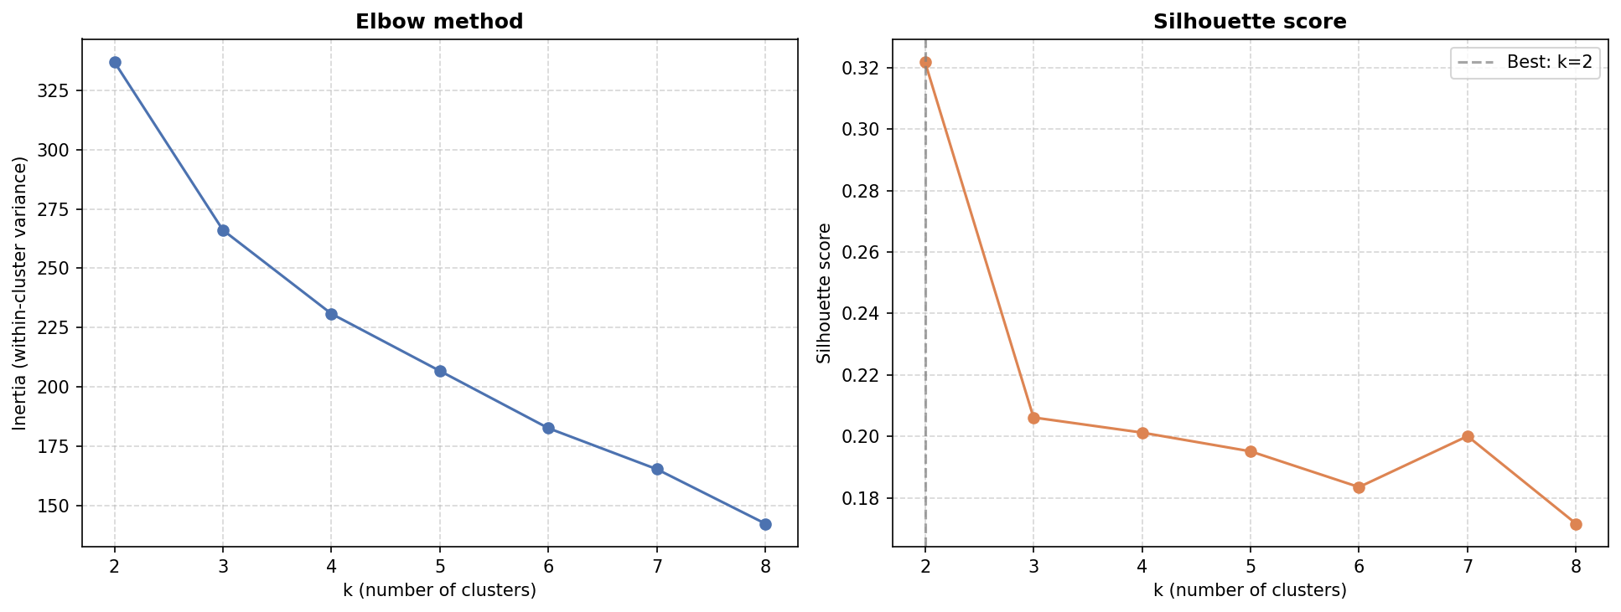
Figure 3.7: Clustering Elbow method and Silhouette score decision graphs

Hierarchical clustering
As a cross-check against K-Means' sensitivity to initialisation, agglomerative hierarchical clustering (src/clustering.py::run_hierarchical) was run with Ward linkage (Ward, 1963), which merges the pair of clusters at each step that produces the smallest possible increase in total within-cluster variance:
$$∆J(A,B) =\frac{\left|A\right|\left|B\right|}{\left|A\right|+\left|B\right|}‖μ_{A} - μ_{B}‖²$$
producing a dendrogram that is cut at $k=4$ for direct comparison with K-Means, without needing to specify $k$ in advance the way K-Means does.
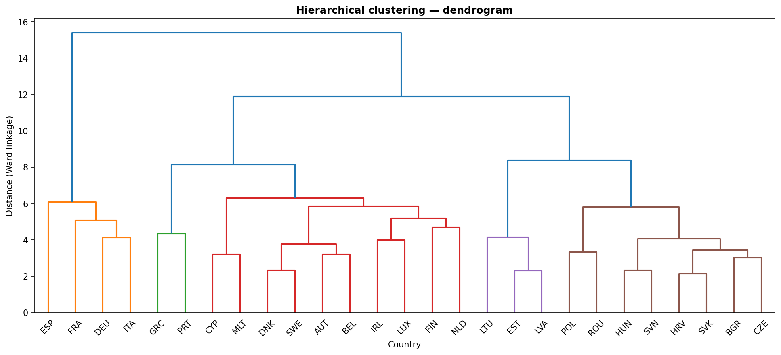
Figure 3.8: Hierarchical clustering dendogram
The dendrogram in Figure 3.9 itself makes this visible rather than only measurable: Lithuania, Estonia, and Latvia (purple) and the Eastern European bloc (brown) each merge into a single, self-contained branch well before joining anything else. Greece and Portugal (green), by contrast, merge into the large mixed branch containing most of Western Europe and the Nordics rather than forming their own clean Mediterranean group. The clustering also reproduces the $k=2$ split described earlier: Spain, France, Germany, and Italy (orange) split off from every other country at the very first branching point and do not rejoin the rest of the tree until the final merge at distance ≈15.4 — the widest gap in the whole dendrogram — reinforcing that this is a structurally distinct grouping, not a borderline case.

Agreement with the a priori regions grouping
Agreement between a clustering result and the a priori labels is measured with the Adjusted Rand Index (ARI) and Normalized Mutual Information (NMI), both invariant to how the cluster IDs happen to be numbered.
The Rand Index counts the fraction of point-pairs on which two partitions agree (both together or both apart); ARI corrects it for the agreement expected by chance (Hubert & Arabie, 1985):
$$ARI=\frac{RI-E\left[RI\right]}{max\left(RI\right)-E\left[RI\right]}$$
With RI being the Rand Index and E[RI] the expected value of RI
NMI (Vinh et al., 2010) normalises the mutual information $I(U,V)$ between two partitions $U$, $V$ by their entropies:
$$NMI(U,V)=\frac{I\left(U,V\right)}{\sqrt{H\left(U\right)·H\left(V\right)}}$$
Both range 0 (no agreement beyond chance) to 1 (perfect agreement); ARI penalises any disagreement more strictly, NMI is more forgiving of a cluster that splits one region into sub-groups without mixing different regions together.
Method | ARI | NMI
K-Means (k=4) | 0.573 | 0.721
Hierarchical (k=4) | 0.573 | 0.721
Table 11: Agreement between the k=4 data-driven clusters and the a priori grouping
Both algorithms converge on the same agreement level. Breaking the $k=4$ partition down by region shows the disagreement is not evenly spread: Baltics and Eastern Europe are recovered perfectly (every member country falls in its own cluster, mixed with no other region); the entire discrepancy concentrates at the Mediterranean / Western-Europe-Nordics boundary, which the algorithm does not treat as separate groups. Combined with the $k=2$ finding above, this supports treating the regional grouping as a partially, not fully, corroborated descriptive tool — defensible for the EDA in Section 3.4, but not an empirically discovered structure.

Temporal persistence check
Section 3.6 establishes whether socioeconomic and mental-health determinants predict suicide rate. This section asks a related but different question, kept deliberately separate rather than folded into Section 3.6 comparison: how much of suicide rate is simply explained by itself — by its own persistence from one year to the next — independent of any determinant? Mixing the two would be misleading: a model with access to a country's own recent suicide rate looks strong almost for free, for reasons that have nothing to do with the determinants Section 3.6 tests.
Implemented in src/timeseries_models.py, prod/05_temporal_persistence_check.py, notebooks/05_temporal_persistence_check.ipynb.
This section uses Option B (temporal split) exclusively. A per-country time-series model forecasts a country forward from its own history; Option A's Test/Validation countries have zero training rows, so there is no history to forecast from, regardless of which time-series method is chosen — this is not a limitation of implementation, it is what "time-series model" means.

Naive persistence baseline
Before any model, a trivial baseline – standard practice in forecasting evaluation (Hyndman & Athanasopoulos, 2021) – was computed: predict every Validation-year row as that same country's last known training-period value, no fitting involved
$$ŷ_{c,t} = y_{c, t_{last train}} for every t in Test/Validation$$
This baseline is not a formality. Suicide rate autocorrelation pooled year-over-year across the dataset is ≈0.99, so any model with access to a country's own recent value is expected to score well from persistence alone; the naive baseline is the number that separates "the model learned something" from "suicide rate does not change much year to year, which every model here can see". It scored Val R² = 0.62 — higher than every one of the six panel models in Section 3.6 under Option B (0.09–0.63) and close to, or above, the univariate time-series models below.

Endogenous vs exogenous variables
SARIMAX and Prophet, described below, are primarily endogenous models: suicide rate for next year is explained mainly by the past values of the same series. An exogenous variable is any other series supplied from outside the target's own history — here, the value of a socioeconomic/mental-health indicator from one country in the same year — that the model may additionally use.
Both models below default to zero exogenous variables, and this was checked directly rather than assumed. Fitting SARIMAX for a representative country (Germany) with all 17 available predictors as exogenous regressors technically converges but drives the Akaike Information Criterion (AIC) to an implausible −235 — more free parameters than the ≈15 training observations per country, the textbook signature of overfitting rather than genuine explanatory power. A single, deliberately curated exogenous feature (Alcohol use disorders, the strongest SHAP-ranked determinant from Section 4.1.2) keeps the AIC in the same range as the univariate model (≈14 vs ≈13) and produces a materially better forecast, reported below.

SARIMAX
SARIMAX (Seasonal AutoRegressive Integrated Moving Average with eXogenous regressors) (Box et al., 2016) is fit once per country, on that country's own 2000–2014 training-period series. Dropping the seasonal term (annual data has no sub-annual seasonality to capture) and the constant, a non-seasonal $ARIMA(p,d,q)$ model with exogenous regressors is:
$$\left(1 -\sum_{i=1}^{p}{φ_{i}L^{i}} \right){\left(1-L\right)}^{d} y_{t}=\left(1 + \sum_{j=1}^{q}{θ_{j}L^{j}}\right)ε_{t}+\sum_{k}{β_{k}x_{k, t}}$$
where $L$ is the lag operator $(Lyₜ = yₜ₋₁)$, the $AR(p)$ term models $yₜ$ as a linear combination of its own past $p$ values, the $I(d)$ term differences the series $d$ times to induce stationarity, the $MA(q)$ term models the error as a linear combination of past $q$ forecast errors, and the $βₖ xₖ,ₜ$ term is the exogenous contribution — mechanically, ARIMA with an added linear regression on external covariates ("ARIMAX"). Order $(p,d,q)=(1,1,1)$was used throughout — deliberately low, given how few points each country provides (≈15) relative to how many parameters a richer order would add. $(1,1,0)$ — with no moving-average term — was the original choice; a direct comparison against four alternative orders found the added $MA(1)$ term improves both Test and Validation R², so $(1,1,1)$ replaced it. Mechanically, $AR(1)$ alone models each country's year as depending only on its own previous level; adding $MA(1)$ lets the model also account for last period's forecast error, capturing the short-lived echo a one-off shock (a data revision, a genuinely unusual year) tends to leave in the following year — something a pure $AR$ term cannot represent. With a single covariate and ≈15 points per country, this is one extra parameter, not a materially larger search space.

Prophet
Prophet (Meta/Facebook) (Taylor & Letham, 2018) decomposes a series additively into trend, seasonality, and holiday components plus regressors:
$$y(t) = g(t) + s(t) + h(t) + \sum_{k}{β_{k}x_{k}(t)}+εₜ$$
where $g(t)$ is a piecewise-linear (or logistic) trend with automatically detected changepoints, $s(t)$ is a Fourier-series seasonal component, and $h(t)$ captures holiday effects. Weekly, daily, and yearly seasonality were all disabled here — irrelevant for annual observations — reducing the model in practice to trend plus the same optional exogenous term as SARIMAX, added via add_regressor().

Production model and inference
The model persisted for inference (outputs/models/catboost_option_b.joblib, prod/predict.py) is CatBoost, Option B — not the highest-scoring model in this thesis overall (Section 3.8 SARIMAX + exog scores higher on both Test and Validation). SARIMAX/Prophet forecast a known country forward from its own history and structurally cannot score a country with no training history, or an arbitrary new row of predictor values with no attached time series. predict.py is asked "what would this row's suicide rate be, given these determinants” a question CatBoost is built to answer and the temporal models are not.

Inference architecture
predict.py loads the persisted CatBoost model and its fitted RobustScaler, accepts any DataFrame containing the same predictor columns used in training (src/features.py::build_predictor_list), scales it with the already-fitted scaler (never refit at inference time, to avoid a distribution from a new dataset silently changing what "scaled" means), and returns the input with an added Predicted suicide rate column. Applied by default to df_real_world.parquet, which includes 2022 and 2023, the years for which WHO has not yet published suicide-rate figures.

Comparison against the temporal model
06_visualize_predictions.py / 06_visualize_predictions.ipynb plots CatBoost 2022–2023 predictions against Section 3.8 SARIMAX + exog forecast extended to the same years, at both the individual-country and the EU_REGIONS-aggregated level. This is a secondary comparison, not a validation of either model since 2022–2023 has no published WHO label to compare against. The SARIMAX + exog models are refit for this comparison (outputs/models/sarimax_exog_models.joblib) but are not an alternative inference path: the comparison exists to show, country by country and region by region, whether a model built purely from determinants and one built purely from persistence-plus-one-determinant tell a similar story or diverge — agreement is a mild corroborating signal, disagreement is not a defect in either model, only a reminder that they answer different questions.

Results

Supervised learning
This section presents the results obtained from the supervised learning models applied to predict suicide rates across the 27 countries in the EU. Model performance is evaluated using four standard metrics: CV RMSE, RMSE, MAE and R², defined in Section 3.6.2, allowing comparison between training behaviour, test performance and generalisation to validation data.

Results comparison
Table 12 and Table 13 summarise the performance of the six models under the two data partition strategies: Option A (geographical split) and Option B (temporal split).
Model | CV RMSE |  | RMSE |  | MAE |  | R²
 | Test | Validation | Test | Validation | Test | Validation | Test | Validation
SVR | 5.23 | 5.23 | 9.11 | 5.40 | 6.27 | 4.84 | 0.444 | 0.131
XGBoost | 3.98 | 3.98 | 9.14 | 7.38 | 6.39 | 6.08 | 0.440 | -0.624
CatBoost | 4.01 | 4.01 | 9.45 | 6.11 | 5.82 | 5.14 | 0.402 | -0.112
Random Forest | 4.43 | 4.43 | 11.06 | 6.84 | 6.42 | 5.86 | 0.180 | -0.395
Ridge | 5.87 | 5.87 | 11.33 | 6.83 | 7.04 | 5.52 | 0.139 | -0.391
Lasso | 5.72 | 5.72 | 11.70 | 6.52 | 7.26 | 5.12 | 0.082 | -0.267
Table 12: Option A (geographical split), test/validation comparison
In the geographical split (Table 12), all models achieve positive R² values in the test set (0.08–0.44), but only SVR maintains a positive value in validation (0.13). The remaining models collapse to negative validation R², indicating performance worse than predicting the training mean. This behaviour suggests that the apparent test performance is highly sensitive to the specific countries included in the split and therefore does not reflect true generalisation capability.
Option A generalises poorly: every model reaches a positive Test R² (0.08–0.44), but five of six collapse to a negative Validation R² — worse than predicting the training mean — with only SVR holding up (0.44 → 0.13). This instability, rather than a uniform failure, suggests the positive Test score is highly sensitive to which specific countries land in the test split, not evidence of a model that generalises to genuinely unseen countries.
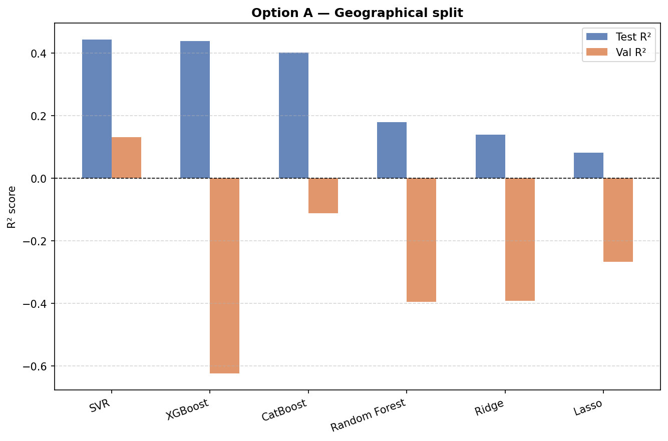
Figure 4.1: R² representation for the geographical split.
In contrast, the temporal split (Table 13) produces substantially more stable and consistent results. The four non-linear models (SVR, CatBoost, Random Forest and XGBoost) all achieve strong performance in both test and validation sets, with test R² values ranging from 0.81 to 0.92 and validation R² from approximately 0.53 to 0.65. Among them, SVR and CatBoost stand out as the best-performing models, showing both high predictive accuracy and relatively stable generalisation.
Model | CV RMSE |  | RMSE |  | MAE |  | R²
 | Test | Validation | Test | Validation | Test | Validation | Test | Validation
SVR | 1.75 | 1.75 | 1.68 | 2.89 | 1.33 | 2.21 | 0.915 | 0.624
CatBoost | 2.14 | 2.14 | 2.02 | 2.81 | 1.47 | 2.19 | 0.877 | 0.645
Random Forest | 2.54 | 2.54 | 2.32 | 3.22 | 1.72 | 2.53 | 0.837 | 0.531
XGBoost | 2.55 | 2.55 | 2.51 | 3.24 | 1.77 | 2.36 | 0.810 | 0.527
Ridge | 5.11 | 5.11 | 4.62 | 4.88 | 3.82 | 4.20 | 0.355 | -0.077
Lasso | 5.09 | 5.09 | 4.70 | 4.78 | 3.89 | 4.20 | 0.332 | -0.030
Table 13: Option B (temporal split), test/validation comparison
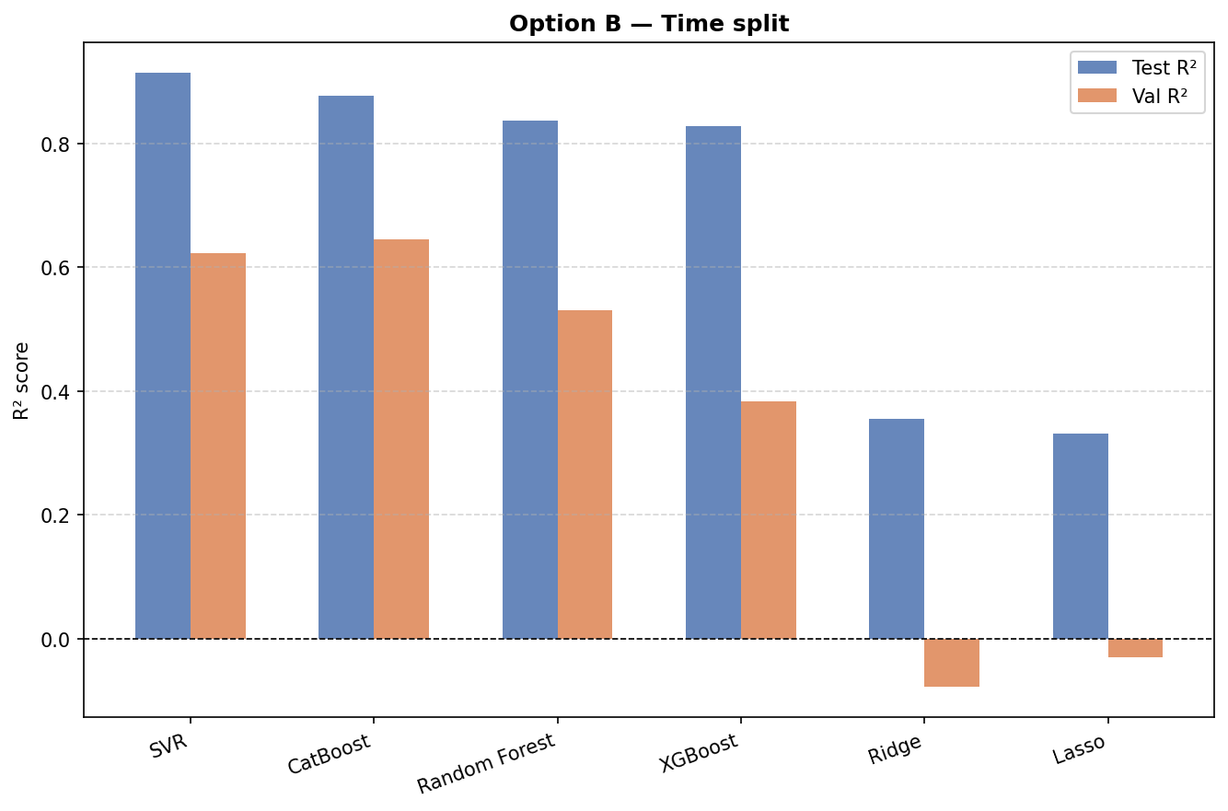
Figure 4.2: R² representation for the temporal split.
Option B is markedly more stable for the four non-linear models: Test R² ranges 0.33–0.92, Validation R² −0.08–0.65, with CatBoost and SVR the strongest and most consistent performers across both metrics — Ridge and Lasso, unlike under the four non-linear models, do drop to a slightly negative Validation R² here too. CatBoost (Option B) is the model persisted to outputs/models/catboost_option_b.joblib and used by prod/predict.py; the exact hyperparameters selected by GridSearchCV were depth=5, iterations=400, l2_leaf_reg=7, learning_rate=0.1.

Results diagnostics and interpretability
Beyond the aggregate metrics above, src/diagnostics.py provides actual-vs-predicted scatter plots, residual histograms, residuals-vs-predicted plots (a heteroscedasticity check), and mean absolute error broken down by year and by country, applied to the production CatBoost model on Option B's Validation set.
Each follows an established regression-diagnostics role: the actual-vs-predicted plot for assessing calibration and systematic bias (Kuhn & Johnson, 2016), the residual histogram for identifying skewness or heavy tails that would suggest departures from the roughly symmetric, homoscedastic error pattern regression diagnostics normally assume (Montgomery et al., 2007), and the residuals-vs-predicted plot for detecting heteroscedasticity, non-linearity, and model misspecification (Cook & Weisberg, 1995).
Error is not evenly distributed across years: mean absolute error rises from ≈1.8 (2018) to ≈2.6 (2021), with a visibly steeper climb on 2020 onward – plausibly a combination of combination of growing distance from the training period (2000-2014) and the onset of COVID-19 partway through the validation window. The COVID specific component is examined directly in Section 4.1.3.
The temporal distance component of that combination is visible on its own: the greater the distance from 2000-2014, the harder generalisation becomes for any model, regardless of any COVID-specific shock. Figure 4.3 shows how mean absolute error climbs in an almost linear progression across the whole period, with a bigger jump at the exact 2020 boundary.
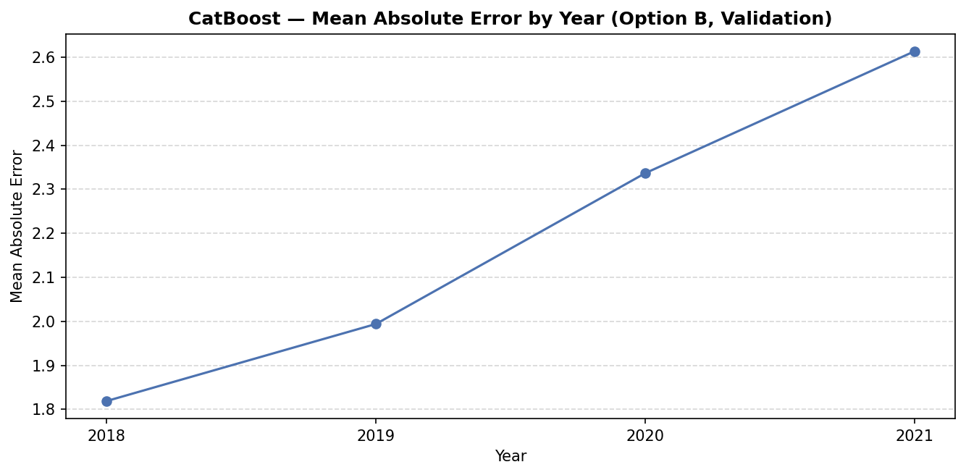
Figure 4.3. Mean Absolute Error (MAE) by year in the temporal solution
SHAP (SHapley Additive exPlanations) was used to interpret the production CatBoost model, via TreeExplainer (exact for tree ensembles). SHAP assigns each feature a value derived from Shapley values in cooperative game theory: for a prediction f(x), the contribution of feature $j$ is
$$φⱼ =\sum_{S⊆F\backslash \{j\}}{\frac{\left|S\right|!\left(\left|F\right|-\left|S\right|-1\right)!}{\left|F\right|!}}[f(S∪\{j\}) - f(S)]$$
averaged over every possible subset $S$ of the other features — the only attribution method satisfying local accuracy (contributions sum exactly to the prediction) and consistency (a feature's attribution cannot decrease if its marginal contribution increases in the model). Alcohol use disorders emerged as by far the most influential predictor (mean SHAP value ≈ 2.9, roughly three times the next-ranked feature), with classical socioeconomic determinants (Unemployment rate, Health expenditure) ranking lowest. These are two properties SHAP uniquely satisfies among attribution methods, which is the basis for using it here rather than a simpler importance measure (Lundberg & Lee, 2017).
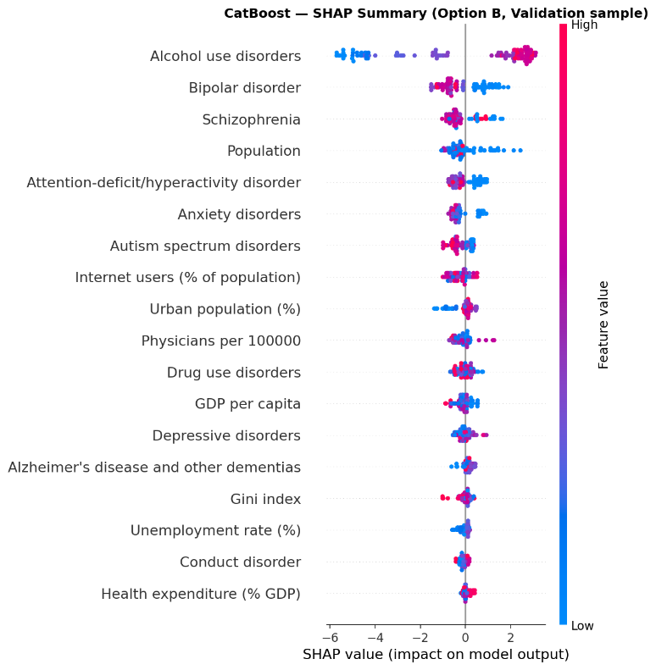
Figure 4.4: SHAP value impact on model output
Reading Figure 4.4 directly, not just the ranking: for Alcohol use disorders, high feature values (pink) sit almost entirely on the positive side of the SHAP axis, while low values (blue) sit on the negative side — a country with a higher prevalence of alcohol use disorders is predicted to have a meaningfully higher suicide rate, and this relationship holds consistently across the validation sample rather than only on average. Bipolar disorder and Schizophrenia repeat the same pattern at a smaller magnitude, keeping three of the four highest-ranked predictors within the mental-health block rather than the socioeconomic one. The bottom of the ranking is where this reverses: Unemployment rate and Health expenditure (% GDP) — the classical socioeconomic determinants — cluster tightly around zero impact, both in typical magnitude and in spread across countries, meaning the model finds almost nothing in them worth using once the mental-health indicators are already in play.

Model improvement experiments
Four hypotheses raised by the SHAP results were tested directly, in notebooks/03b_model_improvements.ipynb / prod/03_train.py. Only one held up — negative results are reported rather than discarded, so a suggestion that does not survive contact with the data is not attempted again without remembering why:
Hypothesis | Outcome
Hidden multicollinearity within the mental-health feature block | Not confirmed — max VIF 3.64 within the block
Test/Val gap is partly a COVID-period effect | Confirmed — Val R² 0.72 (pre-COVID) vs 0.47 (COVID years)
Dropping lowest-importance features improves generalisation | Not confirmed — Test and Val R² both dropped slightly
The CatBoost l2_leaf_reg optimum lies beyond the searched grid | Not confirmed — GridSearchCV re-selected the same value with an extended range
Table 14: Supervised models improvement hypothesis
Removing low importance features slightly reduced performance, and extending the hyperparameter search space did not yield better configurations.
The only confirmed effect relates to the impact of the COVID-19 period on model performance: validation R² drops from approximately 0.72 in pre-COVID years to 0.47 during the pandemic, confirming that part of the model error is driven by external shocks rather than model specification.
Both explanations are compatible rather than competing: growing temporal distance explains why error rises in an almost linear progression across all four years (Figure 4.3), while the COVID-19 effect explains why that rise accelerates specifically from 2019 onward. In other words, the model was already degrading gradually as it moved further from the training period, and COVID-19 added a further deterioration on top of that underlying trend, not explained by temporal distance alone.
These results reinforce the robustness of the selected CatBoost configuration while clarifying the limits of achievable performance given the available data.

Unsupervised learning
As a direct visual counterpart to Table 11 summary numbers, the country-level cluster label is mapped back onto every year of df_development (a country's cluster is a fixed attribute, not something that varies year to year) and plotted against suicide rate over time, Figure 4.5, the same way EU_REGIONS already is in Section 3.4.4. The two trend plots echo each other wherever Table 11 showed agreement (Baltics, Eastern Europe) and diverge where it did not (the Mediterranean / Western-Europe-Nordics boundary), consistent with the ARI/NMI figures rather than an independent finding.
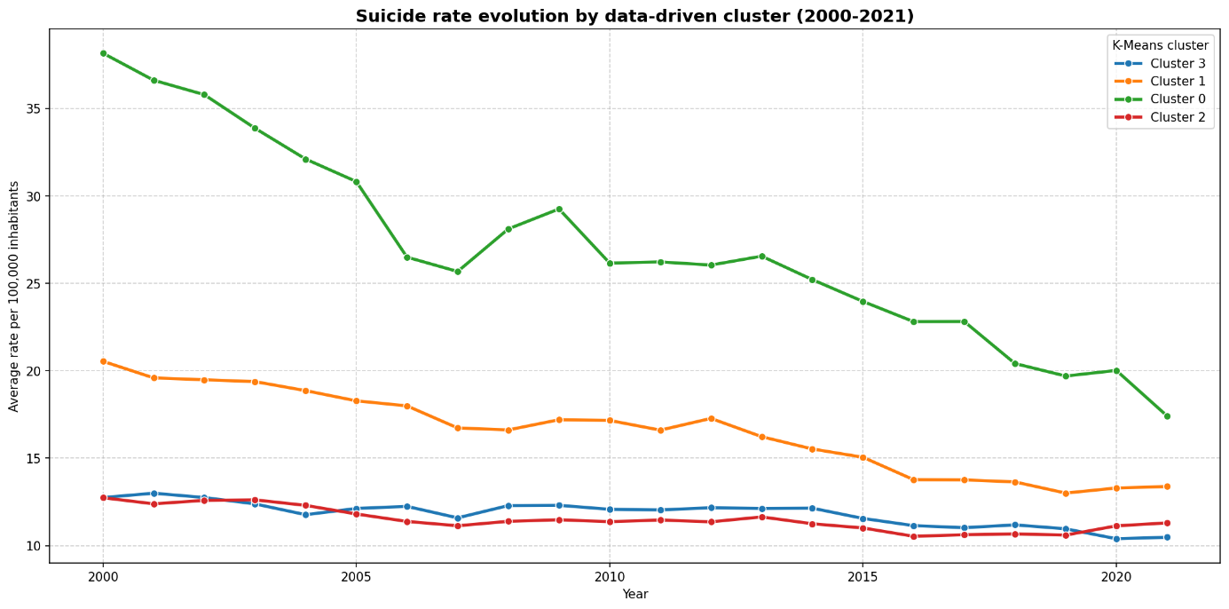
Figure 4.5: Temporal evolution of suicide rates (per 100,000 inhabitants) in the cluster decided regions (over the period 2000–2021).
Figure 4.6 shows where Table 11 agreement holds and where it breaks down: the Baltic cluster (0) and Eastern European cluster (1) overlay almost exactly onto their a priori regions, while cluster 3 absorbs nearly all of Western Europe/Nordics together with most of the Mediterranean group (Portugal, Greece) into a single undifferentiated block. Cluster 2 is the more striking result — it isolates Germany, France, Spain, and Italy specifically, cutting across both a priori regions rather than respecting either one, and visibly separated along PC1 from every other country. This is the $k=2$ partition described above reappearing inside the $k=4$ solution: the data's strongest split is economic scale, not geography, and it persists even when the clustering is forced to find four groups instead of two.
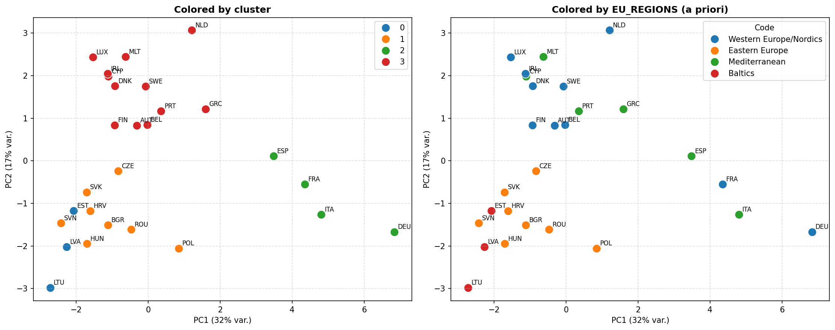
Figure 4.6: Cluster classified countries (left) vs a priori regions (right)
However, incorporating cluster labels into the supervised learning models did not lead to measurable improvements in predictive performance. For this reason, clustering is retained as a descriptive tool rather than as an input feature in the final models.
Overall, the unsupervised results confirm the structural coherence of the dataset, but do not alter the conclusions derived from the supervised learning approach.

Temporal persistence check
This section evaluates to what extent suicide rates can be explained by their own temporal persistence, independently of the socioeconomic and mental-health determinants analysed in Section 4.1. While the supervised models aim to capture cross-country relationships based on explanatory variables, the approach here focuses instead on within-country dynamics, using each country’s own historical trajectory as the primary source of information.
This distinction is important: models that have access to a country’s past suicide rate can achieve strong predictive performance purely through persistence, without necessarily learning meaningful relationships with external determinants. For this reason, results are interpreted relative to a naive persistence baseline.

Results
Model | Variant | Test R² | Val R²
Naive persistence | no model | — | 0.62
SARIMAX | univariate | 0.91 | 0.60
SARIMAX | +1 exog (Alcohol use disorders) | 0.94 | 0.77
Prophet | univariate | 0.90 | 0.72
Prophet | +1 exog (Alcohol use disorders) | 0.91 | 0.69
Table 15: Temporal persistence check, pooled across all 27 countries
Reading Table 15 against the naive baseline rather than in isolation: univariate SARIMAX (Val R² 0.60) does not even beat the naive baseline (0.62) — its apparent skill is entirely persistence, captured worse than simply repeating the last value. Univariate Prophet (0.72) beats the baseline, but by a modest margin relative to how strong 0.72 sounds on its own. SARIMAX with the single curated exogenous feature (0.77) is the strongest result in this section, and the only one that constitutes real evidence for Section 3.6 hypothesis specifically — the improvement is attributable to something concrete (Alcohol use disorders carrying information beyond persistence), not to the model having implicitly re-derived the country's own trend. Prophet with the same exogenous feature (0.69) unexpectedly underperforms its own univariate version.
The result of this section does not change the answer from Section 3.6: it demonstrates that, when a determinant is deliberately combined with a country's own persistence, it adds real, checkable value on top of it — corroborating evidence for Section 3.6 conclusion from a different angle, not a competing, better answer to the same question.
Overall, these findings highlight that temporal persistence alone explains a substantial proportion of the variation in suicide rates, as evidenced by the strong naive baseline. However, the inclusion of carefully selected exogenous variables can still provide additional explanatory power. Despite this, time-series models remain limited in their applicability, as they require historical data for each country and therefore cannot be used for prediction in contexts where such data is unavailable. This reinforces the choice of CatBoost as the final model for deployment, given its ability to generalise based solely on explanatory variables

CatBoost vs SARIMAX predictions
Once the results from both CatBoost and SARIMAX plus one exogenous indicator were obtained, they were tested against the years where WHO database did not provide suicide rate values yet, 2022 and 2023, for reference on how models worked, in the same countries that were plotted in Section 3.4.3, obtaining the below results:
Agreement varies with how strongly the recent trend of a country, and its determinant profile pull in the same direction, as the three Figures below show. This spread is itself the point made in Section 3.9: agreement (Germany) is a mild corroborating signal, and disagreement (Lithuania) is not a defect in either model, only a reminder that a determinant-based and a persistence-based prediction can genuinely diverge when the recent trajectory of a country and its socioeconomic/mental health profile are not pointing the same way.
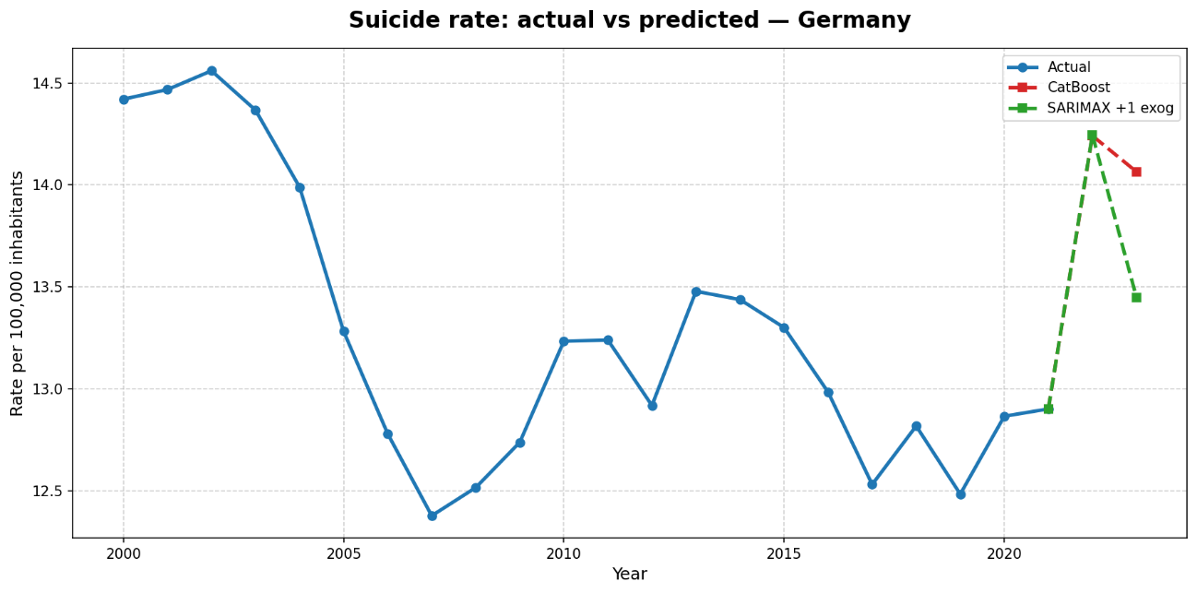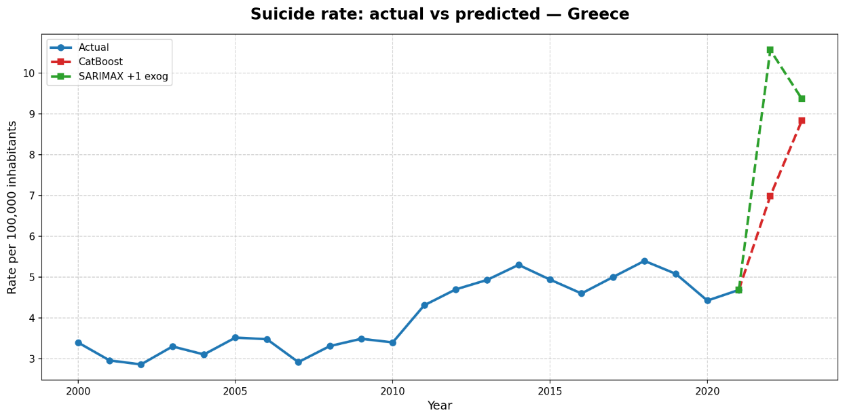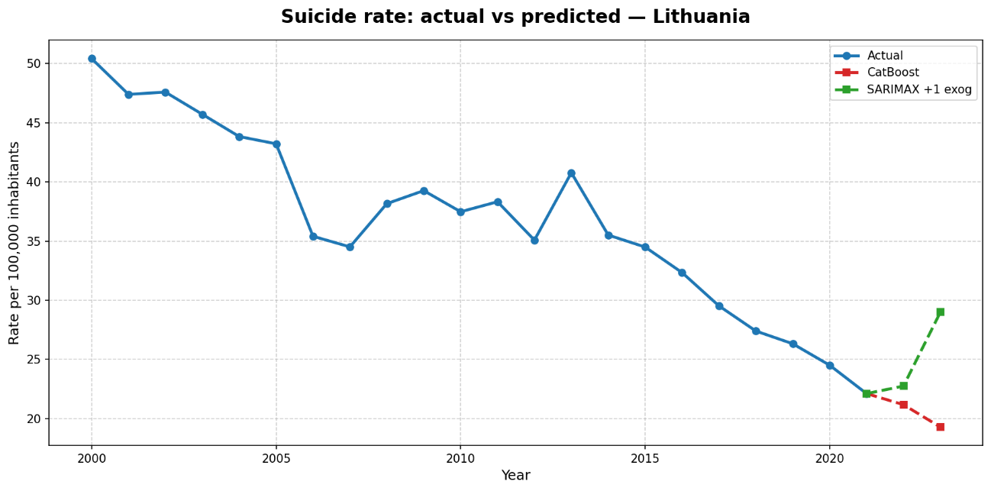
Figure 4.7: Suicide rate evolution with CastBoost and SARIMAX+exog predictions (2022-2023), for Lithuania, Greece and Germany

Conclusions

Research closure
This chapter closes the thesis: it summarises what the results in Chapter 4 support, states the contribution and limitations of this study, and turns those limitations into concrete next steps.
All code and findings are in the GitHub repository:
https://github.com/viccazjim/Predictive_analysis_of_suicide_rates_2026
The visual Power BI presentation of the study lays in:
https://app.powerbi.com/links/_vvIWkwJKZ?ctid=46bee415-cb49-4579-884e-0acbc7f2a82b&pbi_source=linkShare

Key findings
This study highlights the challenges of predicting suicide rates using socioeconomic, cultural, and mental-health-related variables. Among the evaluated models, CatBoost achieved the best predictive performance (Table 13, Option B), although its accuracy decreased as the forecasting horizon increased. In contrast, SARIMAX improved when Alcohol Use Disorders was included as an exogenous variable (Table 15). The comparison between both models (Figure 4.7) shows that their agreement reinforces the reliability of the predictions, while their differences reflect the complementary nature of machine learning and time-series forecasting approaches.

Interpretation of the results
The geographical split (Option A) revealed poor generalisation across countries. Although all models achieved positive test performance, only SVR maintained a positive validation R² (Table 12, Option A), indicating that predictive performance depends strongly on the countries included in the training set rather than reflecting robust generalisation to unseen populations (Figure 4.1).
In contrast, the temporal split (Option B) produced substantially more stable results. CatBoost achieved the best balance between predictive accuracy and generalisation, suggesting that suicide rates can be modelled more reliably over time than across different countries.
Among the predictors, Alcohol Use Disorders emerged as the most influential variable, consistently improving predictive performance and reinforcing its importance as a key predictor of suicide rates within the analysed dataset. The Eating Disorders indicator was excluded from the final models because preliminary VIF analysis revealed severe multicollinearity, indicating that it contributed little unique predictive information.
Crucially, temporal persistence explains a large share of the observed variation in these models. The naive baseline alone achieves a strong validation R² (0.62), demonstrating that suicide rates are highly autocorrelated over time. Consequently, while advanced models successfully capture this persistence, their predictive capacity must be interpreted relative to this robust baseline.
Time-series models, particularly SARIMAX with an exogenous variable, Alcohol use disorders, achieved strong predictive performance but rely on historical observations for each country. Consequently, they are useful for forecasting existing time series but cannot be readily applied to unseen countries or used to infer the underlying drivers of suicide rates.
Overall, the findings suggest that suicide rates are influenced by complex, non-linear relationships and strong temporal persistence. Model performance also deteriorated during the COVID-19 period and at longer forecasting horizons, highlighting the limitations of purely data-driven models when faced with structural shocks and long-term forecasting.

Contributions of this study
This study contributes to the understanding of suicide rate prediction through a comprehensive evaluation of different machine learning and time-series approaches using socioeconomic, cultural, and health-related indicators.
First, it provides a systematic comparison between multiple predictive models under different validation strategies, highlighting the importance of evaluating both geographical and temporal generalisation. The results show that models that perform well within known temporal contexts may not necessarily generalise to unseen countries.
Second, this work contributes to the identification of relevant predictive factors, with alcohol emerging as one of the most influential variables within the analysed dataset.
Finally, the proposed methodology offers a reproducible framework for applying machine learning techniques to population-level suicide rate modelling, while recognising the limitations associated with complex social and health-related phenomena.

Limitations
This study is subject to several limitations related to data availability and quality. First, suicide-related data may be affected by differences in reporting practices between countries. Some countries have limited mental-health monitoring systems or inconsistencies in suicide classification, which may introduce measurement bias. Additionally, relevant cultural factors associated with suicide risk are not fully captured by the available indicators.
Missing values were present for some variables, particularly the Gini index and the number of physicians per 100,000 inhabitants (54 and 4 missing records, respectively). These gaps were mainly caused by incomplete reporting in international databases. Although appropriate imputation methods were applied according to each country's temporal pattern, imputed values may introduce additional uncertainty into the models.
The analysis was restricted to 27 European countries with sufficiently reliable data coverage between 2000 and 2021. While this improves data consistency, it limits the generalisation of the findings to other geographical regions and different socioeconomic contexts.
Finally, some potentially relevant predictors, such as tobacco consumption, were not included due to data availability limitations. Previous meta-analyses have reported associations between smoking and different suicidal behaviours; however, these findings are based mainly on observational studies and cannot establish causal relationships. Furthermore, part of this association may be explained by confounding factors, including mental-health disorders, alcohol and substance use, and other risk behaviours (Poorolajal & Darvishi, 2016).

Practical implications
The findings of this study have potential applications in public health planning and policy design. At a country level, the identification of alcohol as a relevant predictor suggests that prevention and intervention strategies targeting alcohol-related problems may represent an important component of suicide prevention policies.
Furthermore, the clustering analysis reveals meaningful similarities between countries beyond geographical proximity. These groups can provide a benchmarking framework, allowing countries to compare their suicide rates and associated socioeconomic profiles with other countries facing similar structural conditions rather than relying only on geographical comparisons.
Finally, the predictive models developed in this study can support decision-making by helping identify temporal patterns and potential changes in suicide rates. However, these models should be considered as complementary analytical tools and not as substitutes for clinical assessment or causal analyses.

Conclusion
Among the evaluated approaches, CatBoost represents the most suitable model for predicting suicide rates within the scope of this study. Unlike time-series models, it can generate predictions based on explanatory variables without requiring historical observations for each country, making it more adaptable to new scenarios. Combined with its strong predictive performance and generalisation capabilities in the temporal evaluation, these characteristics support its selection as the final predictive model.
Overall, the results demonstrate that machine learning techniques provide a promising framework for modelling suicide rates using socioeconomic, cultural, and health-related indicators. Although limitations related to data availability, reporting consistency, and the complexity of suicide-related factors remain, this study shows that data-driven approaches can complement traditional statistical methods and contribute to improved research and decision-support tools in public health.

Future lines of work
Several research directions could extend the findings of this study. First, alternative validation strategies could be explored. Instead of allocating a fixed percentage of years for testing and validation, future studies could evaluate models using different country-based splits within the same temporal periods, allowing a more robust assessment of their ability to generalise across countries. Also, validating within countries laying within the same clusters, proven to have similar behaviours.
Second, more advanced machine learning approaches, such as neural networks or temporal deep learning architectures, could be investigated. These models may capture more complex non-linear interactions and temporal dependencies; however, their applicability would depend on the availability of larger and higher-quality datasets.
Third, future research should incorporate additional reliable predictors that may contribute to suicide risk modelling, including behavioural, health-related, and socioeconomic indicators such as tobacco consumption, economic insecurity, housing accessibility, and demographic structure.
Finally, this study focused on overall suicide rates per 100,000 inhabitants, without disaggregating by sex. Given the well-documented differences between male and female suicide rates in the broader literature (Barrigon & Cegla-Schvartzman, 2020), future research could investigate gender-specific prediction models to better understand whether the underlying factors and predictive patterns differ between populations.

Appendix: full-page graphics
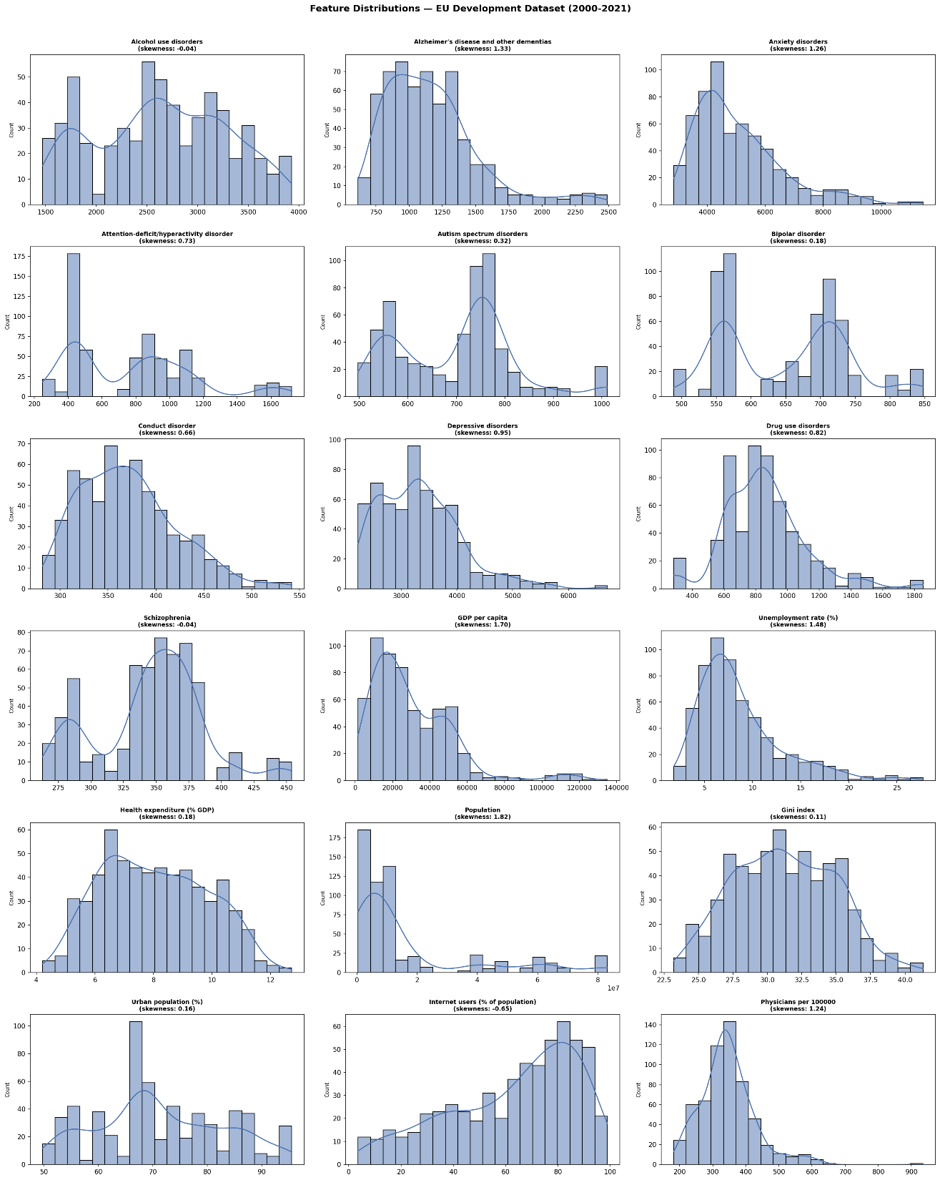
Figure 6.1: Distribution of numerical explanatory variables in the EU Development Dataset (2000–2021). Histograms and kernel density estimates (KDE) illustrate variability, skewness, and distributional patterns across socioeconomic, demographic, healthcare, and mental health indicators.
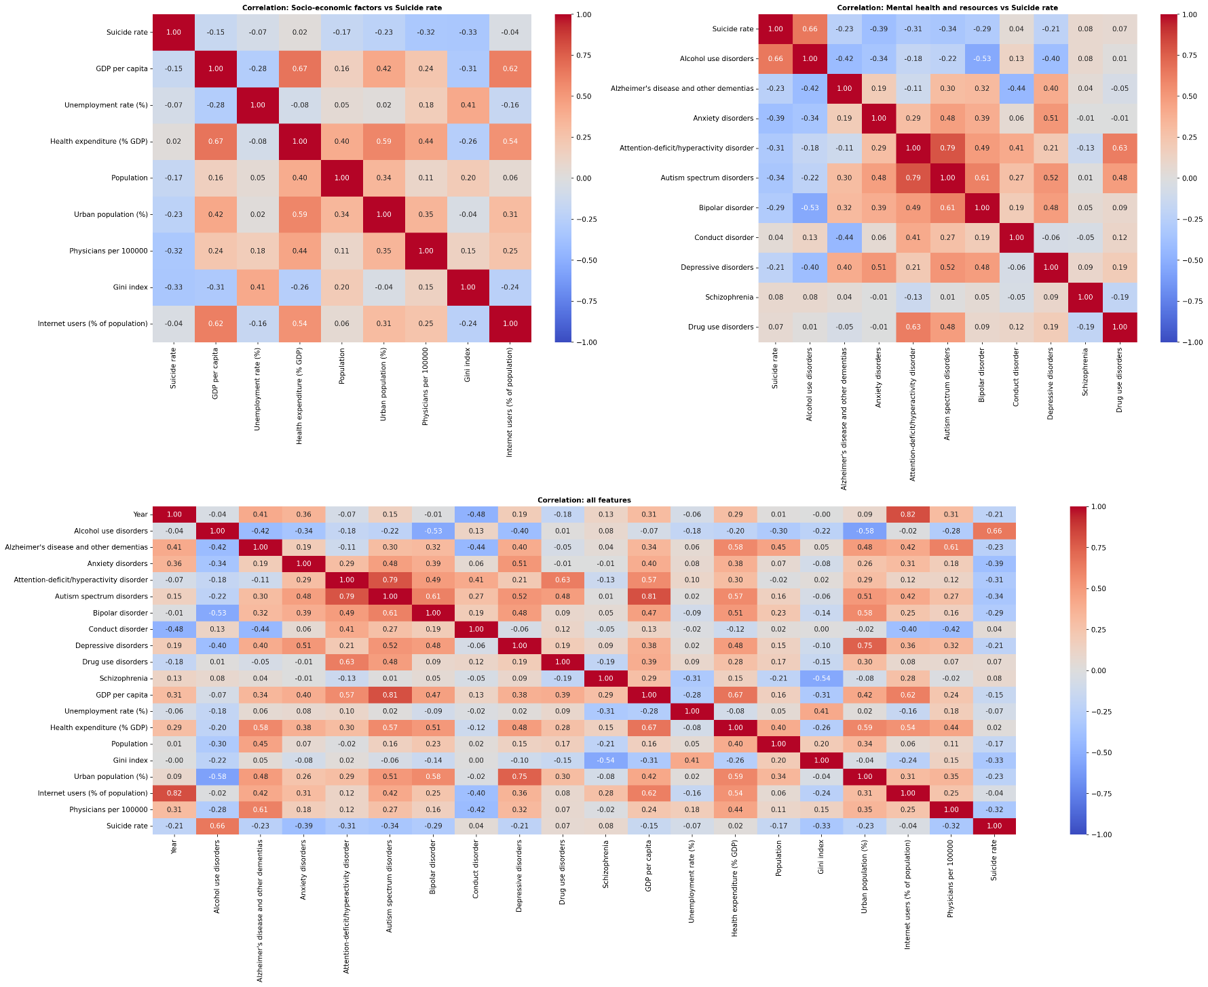
Figure 6.2: Correlation matrices showing the relationships between suicide rates, socio-economic factors, and mental health indicators across all variables included in the study in the geographical split.
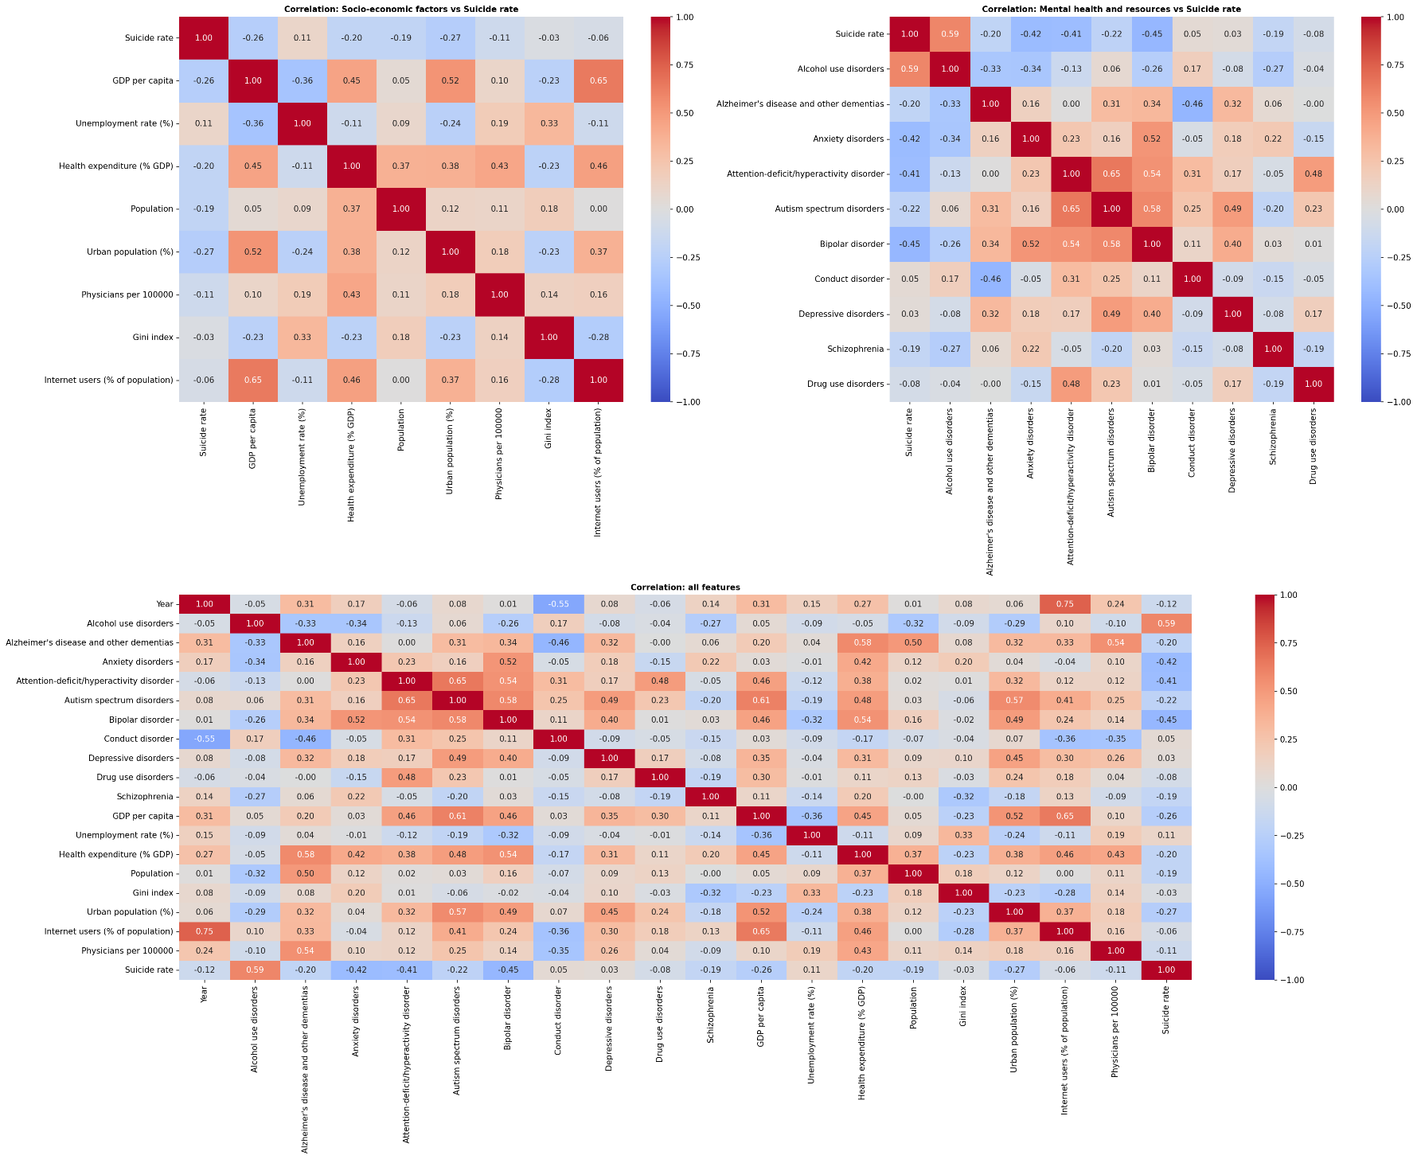
Figure 6.3: Correlation matrices showing the relationships between suicide rates, socio-economic factors, and mental health indicators across all variables included in the study in the temporal split.

Bibliography
Arlot, S., & Celisse, A. (2010). A survey of cross-validation procedures for model selection. Statistics Surveys, 4(none). https://doi.org/10.1214/09-SS054
Barrigon, M. L., & Cegla-Schvartzman, F. (2020). Sex, Gender, and Suicidal Behavior. In E. Baca-Garcia (Ed.), Behavioral Neurobiology of Suicide and Self Harm (Vol. 46, pp. 89–115). Springer International Publishing. https://doi.org/10.1007/7854_2020_165
Bentéjac, C., Csörgő, A., & Martínez-Muñoz, G. (2021). A comparative analysis of gradient boosting algorithms. Artificial Intelligence Review, 54(3), 1937–1967. https://doi.org/10.1007/s10462-020-09896-5
Biplob, K. B. B., Bijoy, Md. H. I., Bitto, A. K., Das, A., Chowdhury, A., & Hossain, S. Md. M. (2023). Suicidal Ratio Prediction Among the Continent of World: A Machine Learning Approach. 2023 International Conference on Artificial Intelligence and Applications (ICAIA) Alliance Technology Conference (ATCON-1), 1–6. https://doi.org/10.1109/ICAIA57370.2023.10169618
Box, G. E. P., Jenkins, G. M., Reinsel, G. C., & Ljung, G. M. (2016). Time series analysis: Forecasting and control (Fifth edition). Wiley.
Breiman, L. (2001). Random Forests. Machine Learning, 45(1), 5–32. https://doi.org/10.1023/A:1010933404324
Chen, T., & Guestrin, C. (2016). XGBoost: A Scalable Tree Boosting System. Proceedings of the 22nd ACM SIGKDD International Conference on Knowledge Discovery and Data Mining, 785–794. https://doi.org/10.1145/2939672.2939785
Chen, W., Liu, Q., Li, H., & Zou, J. (2025). The Prediction Performance Analysis of the Lasso Model with Convex Non-Convex Sparse Regularization. Algorithms, 18(4), 195. https://doi.org/10.3390/a18040195
Cook, R. D., & Weisberg, S. (1995). Residuals and influence in regression (Reprint). Chapman & Hall.
DeBeer, B., Mignogna, J., Talbot, M., Villarreal, E., Mohatt, N., Borah, E., Russell, P. D., Bryan, C. J., Monteith, L. L., Bongiovanni, K., Hoffmire, C., Peterson, A. L., Heise, J., Baack, S., Weinberg, K., Polk, M., & Benzer, J. K. (2024). Suicide Prevention Programming: Comparing Four Prominent Frameworks. Psychiatric Services, 75(8), 789–800. https://doi.org/10.1176/appi.ps.20230173
Drucker, H., Burges, C. J. C., Kaufman, L., Smola, A., & Vapnik, V. (1996). Support Vector Regression Machines. In M. C. Mozer, M. Jordan, & T. Petsche (Eds), Advances in Neural Information Processing Systems (Vol. 9). MIT Press. https://proceedings.neurips.cc/paper_files/paper/1996/file/d38901788c533e8286cb6400b40b386d-Paper.pdf
European Commission. (2023). European Health Union: A comprehensive approach to mental health (IP/23/3050). European Commission. https://ec.europa.eu/commission/presscorner/api/files/document/print/en/ip_23_3050/IP_23_3050_EN.pdf
Friedman, J. H. (2001). Greedy function approximation: A gradient boosting machine. The Annals of Statistics, 29(5). https://doi.org/10.1214/aos/1013203451
Hastie, T. (2020). Ridge Regularization: An Essential Concept in Data Science. Technometrics, 62(4), 426–433. https://doi.org/10.1080/00401706.2020.1791959
Hastie, T., Tibshirani, R., & Friedman, J. H. (2017). The elements of statistical learning: Data mining, inference, and prediction (Second edition). Springer.
Hawton, K., & Pirkis, J. (2024). Preventing suicide: A call to action. The Lancet Public Health, 9(10), e825–e830. https://doi.org/10.1016/S2468-2667(24)00159-2
Hoerl, A. E., & Kennard, R. W. (1970). Ridge Regression: Biased Estimation for Nonorthogonal Problems. Technometrics, 12(1), 55–67. https://doi.org/10.1080/00401706.1970.10488634
Hubert, L., & Arabie, P. (1985). Comparing partitions. Journal of Classification, 2(1), 193–218. https://doi.org/10.1007/BF01908075
Hughes, J. R. (2008). Smoking and suicide: A brief overview. Drug and Alcohol Dependence, 98(3), 169–178. https://doi.org/10.1016/j.drugalcdep.2008.06.003
Hyndman, R. J., & Athanasopoulos, G. (n.d.). Forecasting: Principles and Practice (3rd ed). OTexts. Retrieved 17 July 2026, from https://otexts.com/fpp3/ (Original work published 2021)
Kleiman, E. M., Glenn, C. R., & Liu, R. T. (2023). The use of advanced technology and statistical methods to predict and prevent suicide. Nature Reviews Psychology, 2(6), 347–359. https://doi.org/10.1038/s44159-023-00175-y
Kuhn, M., & Johnson, K. (2016). Applied predictive modeling (Corrected at 5th printing). Springer.
Lloyd, S. (1982). Least squares quantization in PCM. IEEE Transactions on Information Theory, 28(2), 129–137. https://doi.org/10.1109/TIT.1982.1056489
Lundberg, S., & Lee, S.-I. (2017). A Unified Approach to Interpreting Model Predictions (Version 2). arXiv. https://doi.org/10.48550/ARXIV.1705.07874
Montgomery, D. C., Peck, E. A., & Vining, G. G. (with Krueger, D.). (2007). Student solutions manual to accompany Introduction to linear regression analysis, fourth edition, Douglas C. Montgomery; Elizabeth A. Peck; G. Geoffrey Vining (Fourth Edition). Wiley-Interscience.
Na, P. J., Shin, J., Kwak, H. R., Lee, J., Jester, D. J., Bandara, P., Kim, J. Y., Moutier, C. Y., Pietrzak, R. H., Oquendo, M. A., & Jeste, D. V. (2025). Social Determinants of Health and Suicide-Related Outcomes: A Review of Meta-Analyses. JAMA Psychiatry, 82(4), 337. https://doi.org/10.1001/jamapsychiatry.2024.4241
Nadeem Parpio, Y., Nuruddin, R., Ali, T. S., Mohammad, N., Khan, U. R., Shahzad, S., Khan, M. M., & Aslam, M. (2025). Suicide prevention program on suicidal behaviors and mental wellbeing among school aged adolescents: A scoping review. Frontiers in Public Health, 13, 1506321. https://doi.org/10.3389/fpubh.2025.1506321
O’Brien, R. M. (2007). A Caution Regarding Rules of Thumb for Variance Inflation Factors. Quality & Quantity, 41(5), 673–690. https://doi.org/10.1007/s11135-006-9018-6
O’Connor, R. C., Kirtley, O. J., & De Beurs, D. (2024). Preventing suicide: Understanding the complex interplay between individual and societal factors. The Lancet Public Health, 9(10), e714–e715. https://doi.org/10.1016/S2468-2667(24)00217-2
Park, H. J., Han, B., Kim, B., Han, K., Kim, S., Kim, H., Youn, K., Park, H. J., Roh, Y., Choi, Y. S., Nam, G. E., & Kim, S. M. (2024). Relationship between smoking experience and risk of suicide mortality in South Korean adults: A nationwide population-based retrospective cohort study. Journal of Affective Disorders, 367, 67–74. https://doi.org/10.1016/j.jad.2024.08.211
Pirkis, J., Dandona, R., Silverman, M., Khan, M., & Hawton, K. (2024). Preventing suicide: A public health approach to a global problem. The Lancet Public Health, 9(10), e787–e795. https://doi.org/10.1016/S2468-2667(24)00149-X
Poorolajal, J., & Darvishi, N. (2016). Smoking and Suicide: A Meta-Analysis. PLOS ONE, 11(7), e0156348. https://doi.org/10.1371/journal.pone.0156348
Pranckeviciene, E., & Kasperiuniene, J. (2024). Global Suicide Mortality Rates (2000–2019): Clustering, Themes, and Causes Analyzed through Machine Learning and Bibliographic Data. International Journal of Environmental Research and Public Health, 21(9), 1202. https://doi.org/10.3390/ijerph21091202
Prokhorenkova, L., Gusev, G., Vorobev, A., Dorogush, A. V., & Gulin, A. (2017). CatBoost: Unbiased boosting with categorical features (Version 5). arXiv. https://doi.org/10.48550/ARXIV.1706.09516
Rotejanaprasert, C., Thanutchapat, P., Phoncharoenwirot, C., Mekchaiporn, O., Chienwichai, P., & Maude, R. J. (2025). Global spatiotemporal analysis of suicide epidemiology and risk factor associations from 2000 to 2019 using Bayesian space time hierarchical modeling. Scientific Reports, 15(1), 12785. https://doi.org/10.1038/s41598-025-97064-6
Rousseeuw, P. J. (1987). Silhouettes: A graphical aid to the interpretation and validation of cluster analysis. Journal of Computational and Applied Mathematics, 20, 53–65. https://doi.org/10.1016/0377-0427(87)90125-7
Smola, A. J., & Schölkopf, B. (2004). A tutorial on support vector regression. Statistics and Computing, 14(3), 199–222. https://doi.org/10.1023/B:STCO.0000035301.49549.88
Somé, N. H., Noormohammadpour, P., & Lange, S. (2024). The use of machine learning on administrative and survey data to predict suicidal thoughts and behaviors: A systematic review. Frontiers in Psychiatry, 15, 1291362. https://doi.org/10.3389/fpsyt.2024.1291362
Spittal, M. J., Guo, X. A., Kang, L., Kirtley, O. J., Clapperton, A., Hawton, K., Kapur, N., Pirkis, J., & Carter, G. (2025). Machine learning algorithms and their predictive accuracy for suicide and self-harm: Systematic review and meta-analysis. PLOS Medicine, 22(9), e1004581. https://doi.org/10.1371/journal.pmed.1004581
Steyerberg, E. W., Van Calster, B., & Pencina, M. J. (2011). Medidas del rendimiento de modelos de predicción y marcadores pronósticos: Evaluación de las predicciones y clasificaciones. Revista Española de Cardiología, 64(9), 788–794. https://doi.org/10.1016/j.recesp.2011.04.017
Taylor, S. J., & Letham, B. (2018). Forecasting at Scale. The American Statistician, 72(1), 37–45. https://doi.org/10.1080/00031305.2017.1380080
Thorndike, R. L. (1953). Who Belongs in the Family? Psychometrika, 18(4), 267–276. https://doi.org/10.1007/BF02289263
Tibshirani, R. (1996). Regression Shrinkage and Selection Via the Lasso. Journal of the Royal Statistical Society Series B: Statistical Methodology, 58(1), 267–288. https://doi.org/10.1111/j.2517-6161.1996.tb02080.x
Tukey, J. W. (1977). Exploratory data analysis (Repr.). Addison-Wesley.
Vinh, N. X., Epps, J., & Bailey, J. (2010). Information Theoretic Measures for Clusterings Comparison: Variants, Properties, Normalization and Correction for Chance. Journal of Machine Learning Research, 11(95), 2837–2854.
Ward, J. H. (1963). Hierarchical Grouping to Optimize an Objective Function. Journal of the American Statistical Association, 58(301), 236–244. https://doi.org/10.1080/01621459.1963.10500845
World Health Organization. (2019, September 9). Suicide: One person dies every 40 seconds. https://www.who.int/news/item/09-09-2019-suicide-one-person-dies-every-40-seconds
World Health Organization. (2021). Comprehensive Mental Health Action Plan 2013-2030 (1st ed). World Health Organization. https://www.who.int/publications/i/item/9789240031029
World Health Organization. (2022). World Mental Health Report: Transforming Mental Health for All. Executive Summary (1st ed). World Health Organization. https://www.who.int/publications/i/item/9789240050860
World Health Organization. (2025a). Suicide worldwide in 2021: Global health estimates (1st ed). World Health Organization. https://www.who.int/publications/i/item/9789240110069
World Health Organization. (2025b, September 2). Over a billion people living with mental health conditions – services require urgent scale-up. https://www.who.int/news/item/02-09-2025-over-a-billion-people-living-with-mental-health-conditions-services-require-urgent-scale-up

