What Happened to the US Car Industry 1970-1982?

Let’s begin with a little history. It all starts in 1965 when Arie Jan Haagen-Smith, a chemist working at California Institute of Technology, conducted research that concluded air pollution in Los Angeles was caused by vehicle gas exhaustion.[1] Due to the negative health effects by said pollution, Congress passed the Vehicle Air Pollution and Control Act which required tighter emission standard. This led to a trend of cars with less cylinders, lighter size, and less horsepower.[2] Pretty much anything one would do to improve MPG/fuel economy and decrease emission, or so one might think…

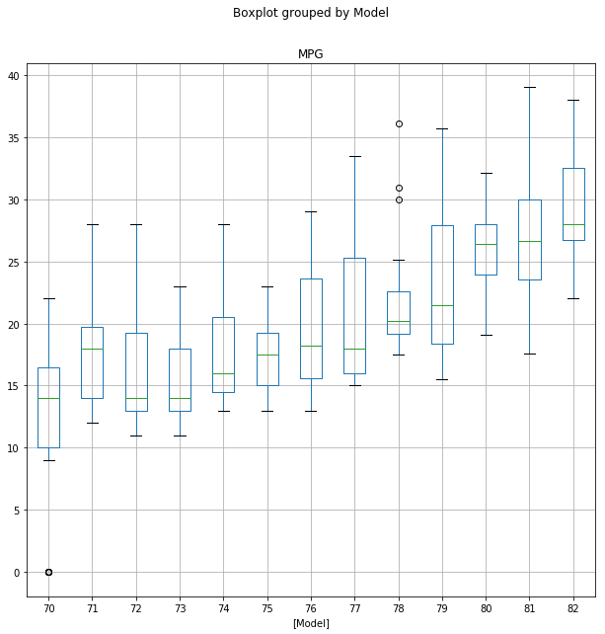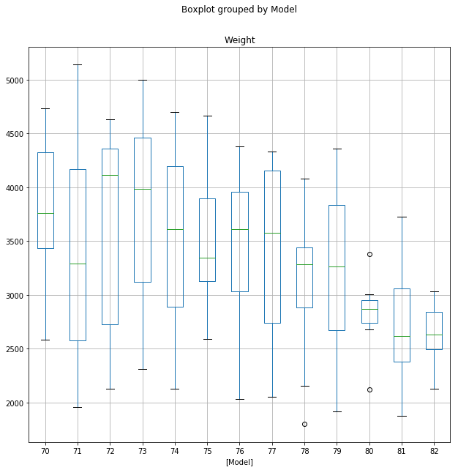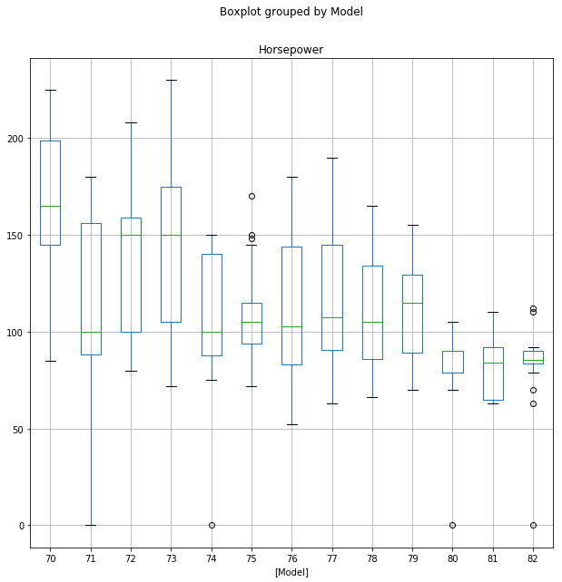[3]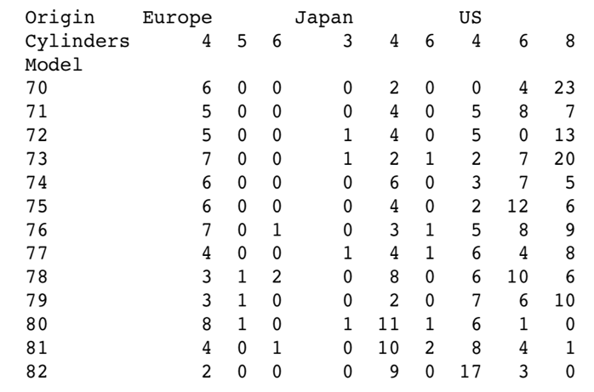

The first three graphs display data pertaining only to US cars regarding MPG, weight, and horsepower each grouped by model. The last table shows the data cross tabulated between Origin, Cylinders, and Model year.

As one can see from the box-and-whiskers plots, the averages of MPG, Weight, and Horsepower all fluctuated up and down until a steady increase in MPG and a steady decrease trend in the other two starting around 1978 and 1979. The last table allows us to see the number of cars produced by each country (Europe, Japan, and US) grouped into Cylinders and Model year. Once again fluctuations exist in the beginning 7 years of the 1970s until 1978 and 1979 when the all three countries start building cars with less cylinders. Why?

In 1973, Arab decided to enact an oil embargo towards all countries seemingly supporting Israel in what is known as the Yom Kippur War (also called the 1973 Arab-Israeli War).[4] The embargo led to what is known as the 1973 oil crisis, causing a major increase in oil prices throughout the world. However, the US refused to the downsizing due to lack of profits and the stubbornness of building luxury cars. This allowed foreign markets to profit more as they were already manufacturing cars with low cylinders and higher MPG.

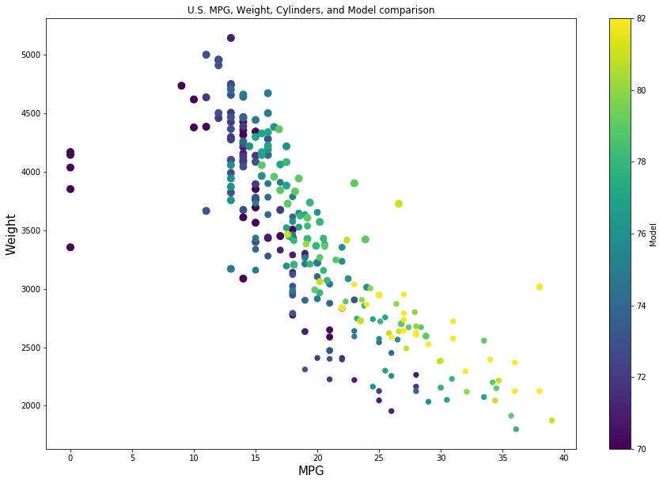

The above chart is meant to display the correlation between MPG, weight, and cylinders with model years represented by the color bar on the left and cylinders represented by size of the dot points. This is as expected due to smaller sizes and less cylinders leading to better fuel economy. I left out horsepower even though it was mentioned above due to scatter plot constraints, but the formula is simply more cylinders = more HP. The smaller the dots, the less cylinders the car was manufactured with. It was not until 1975 when the federal government pushed forward the Energy Policy and Conservation Act that fuel efficiency standards were enforced. Hence, US companies began improving car MPG more aggressively starting around 1978. In conclusion, these everlasting effects of historical factors and environmental concerns led to the trend of wanting better fuel economy/MPG and in turn smaller cars, fewer cylinders, and less HP.

1. [Anything About Cars, The 1970s Cars and Demands of the Times](https://www.anythingaboutcars.com/1970s-cars.html)
2. [Vroom Girls, What the Numbers Mean](https://www.vroomgirls.com/what-the-numbers-mean/)
3.
4. [Wikipedia, Automotive Industry in the United States 1970s](https://en.wikipedia.org/wiki/Automotive_industry_in_the_United_States#1970s)