Ready, Set, Apply

In this lab, we were supposed to analyze the website Indeed.com by parsing through all the information listed on the webpage and the backend. Looking at Figure 1, I see that the top three skills I should begin refreshing myself on are querying, statistics, and python. Unsurprisingly, every job posting mentioned querying one way or another as it is an important aspect of data science jobs. Parsing through the data yield a 100 percent outcome of number of pages which mentioned this skill.

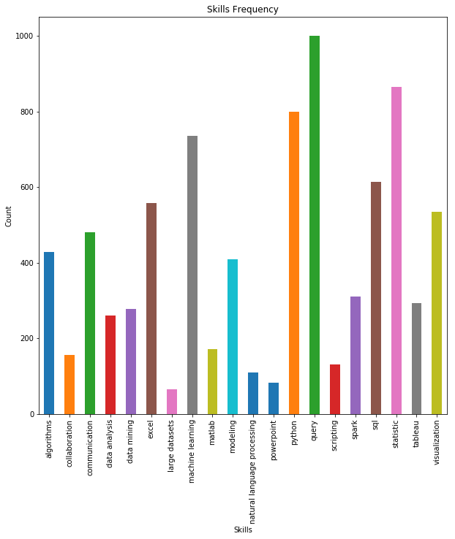

Figure 1. Frequency bar plot of 20 skills common to data scientists

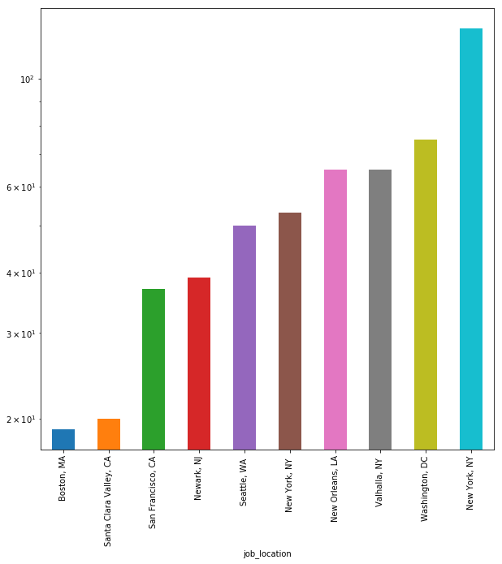

Figure 2. Frequency bar plot of the top 10 cities with most job advertisements.

Looking at Figure 2, I decided to also look up the distribution of employment within the U.S and found Figure 3.

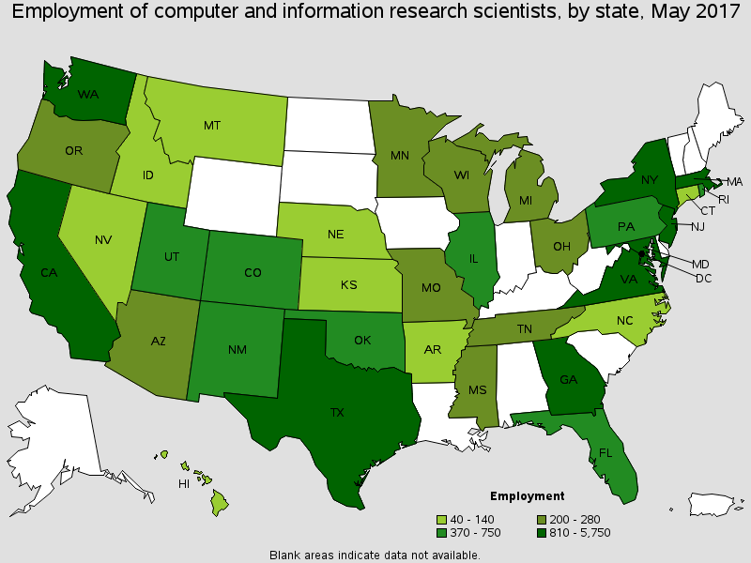

Figure 3. Map of employment rates throughout the U.S. in May 2017

Source: <https://www.bls.gov/oes/current/oes151111.htm#st>

Combining the visuals from Figures 2 and 3, I see that the highest employment rates lie within the coastal states and Texas back in 2017. However, with the recent ad postings on Indeed.com, there can be one of two things. Either the east coast is currently opening more tech branches leading to more opportunities for jobs in this field or Indeed.com is not a reliable source to base the current state of labor statistics on. The answer is pretty obvious considering how there is bias due to two things:

1. I only scraped 1000 job postings from the website, and a good number were repeats due to sponsorship
2. There are companies out there who do not wish to broadcast their job position opportunities on Indeed.com

Due to lack of evidence data scraped, I cannot really infer any ideas describing the map distribution of job opportunities of 2019 so far. What I can say, however, is that if someone would like to get a job in data science, they should begin honing their skills in querying, python, statistics, and machine learning. For those who would like to move to New York City, there are also many opportunities for them as most job postings are positioned at NYC.