Victor Chan

CIS 3715

Lab 8

Who is Leaving Verizon?

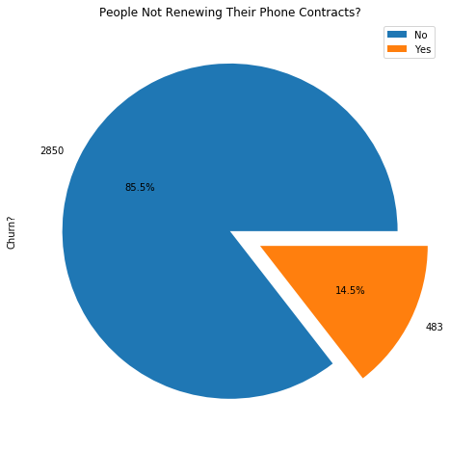When I first saw this, I just had to make fun of the fact it is data from a telecom company, and the one I like to make fun of the most is Verizon because of their outrageous prices (and sadly because I use them). First thing to look at is definitely the percentage and number of people who will be leaving Verizon (and going to T-Mobile, AT&T, or anything cheaper). As seen in *Figure 1*, there are around 483 people leaving which makes up around 14.5% of the total customers within this data set.

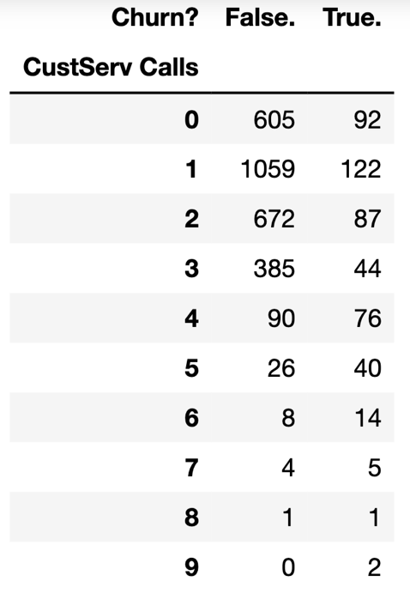Next, I would start to think about how many people are leaving because they are dissatisfied with the customer service. I look up the crosstab of the number of “Customer Service calls” and the “Churn” column. Seen in *Figure 2.* Clearly, there are less people leaving even though they’ve made several customer service calls so I would assume it is not due to poor customer service as they would have to deal with employees more often.

Figure 1. Pie Chart of the “Churn” column

Figure 2. Crosstab of Customer service calls and Churn?

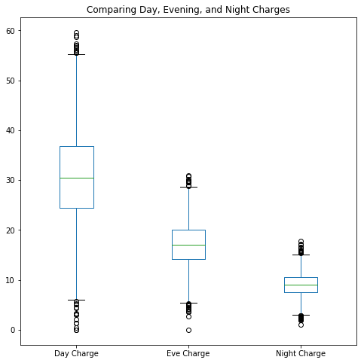

If customer service is seemingly not the main cause, I begin to think about pricing. Here is where it got a little interesting. In *Figure 3,* one can see the box-and-whisker plots of all customers saved onto this data set separated by their respective day, evening, and night charges. Surprisingly, the average of day charges is way more than the evening and night charges. I assume this is due to the telecom company knowing people would generally need more minutes during the day so they upcharge the daylight cost per minute. As one can see in the *Figure 3*, the average of day charges is around $30 while the highest charge one customer received was $55. Meanwhile evening charges has an average of around $17 or $18 with a max of $29. The max of the evening charge did not even reach the mean of the day charges, that is outrageous!

Therefore, I am not surprised that there is around 15% of their customers leaving this Verizon. Although I am shocked that people were tolerating their usually subpar customer service.