ICHNOS Dry Lab
Fisher Information and the Decoding Limits of the Tandem-Timer Biosensor
How precisely can (dose, time-since-onset) be recovered from two fluorescence channels — and how much of that precision is measured rather than assumed

What this report establishes.
Four claims about the device survive every perturbation we applied and are stated here as results: the two channels are not separable (ρ ≈ −0.9); the informative readout window is early, around 1–1.5 h rather than 3 h; the Cramér–Rao bound is not attainable from a single cell and describes a pooled measurement of ≥ 10 cells for timing and ≈ 300–1000 for dose; and the detection threshold can place the optimum out of reach.
What it does not establish. No absolute timing precision. σt depends on two quantities nobody has measured — the photon budget and the kinetic parameter dx — so it is given here as a scaling law with the placeholder visible, not as a number.
Contents

1. The decoding problem
The ICHNOS reporter is a tandem timer: a fast-maturing green fluorophore and a slow-maturing red one, expressed from the same stress-responsive promoter. A cell imaged once yields two numbers. From those two numbers the decoder must report two: how large the stress dose was, and how long ago it began.
That is an estimation problem, and estimation problems have a floor. The Cramér–Rao bound states the smallest covariance any unbiased estimator can achieve from a given observation model. It is the right primary metric for this device for three reasons. It is a bound rather than an estimate, so a statement like “this lesion costs a factor of 89 in timing resolution” is a statement about the device and not about our fitting software. It cannot be gamed by a dead circuit: as the response flattens the Fisher matrix becomes singular and the bound diverges, whereas shape metrics such as ratio spread are minimised by a circuit that does nothing. And because the dose parameter is taken in logarithm, dose error emerges as a relative error, which is the natural unit for a dose–response device.
This report sets out the mathematics, the implementation, two independent validations, a robustness test against the parameters the data cannot determine, and an explicit account of which conclusions are measured and which are conditional.

2. Mathematical framework

2.1 Observation model
The two channels are modelled as independent Poisson photon counts with means λg(θ) and λr(θ), where θ = (ln d, t) is the log-dose and the time since onset. Poisson is the correct noise law for photon counting, and using it directly on the channel counts avoids propagating an approximate first-order variance through a derived ratio.
For a single Poisson observation Y with mean λ(θ), the log-likelihood is ℓ = y ln λ − λ − ln y!, so the score and its second moment are:
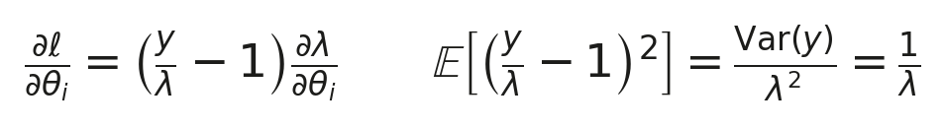
which gives the Fisher information for the two independent channels:
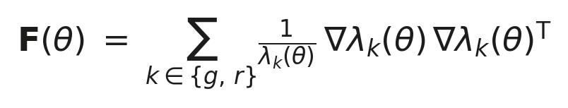
This is exact for the Poisson model; no delta-method approximation enters. The gradient is taken with respect to both parameters, so the result is a 2 × 2 matrix rather than a scalar for timing alone. That distinction matters: a scalar bound for t computed as though the dose were already known exactly would overstate the achievable precision, and the sensitivity analysis shows the measured ratio is not dose-invariant.

2.2 The bound and what is read off it
The off-diagonal element carries the finding that matters most. The dose–time correlation
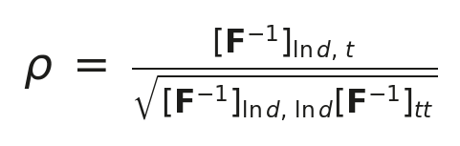
measures how far the two observables fail to separate the two parameters. A correlation approaching ±1 means the pair is only weakly identifiable — the quantitative form of the statement “we need both channels, and even then they overlap”.

2.3 Parameterisation
Dose is taken in logarithm throughout, so the dose error is relative and directly comparable with the ablation study's independent implementation, which uses the same parameterisation. The transformation from a raw-dose Fisher matrix is exact, because ∂/∂(ln d) = d · ∂/∂d:
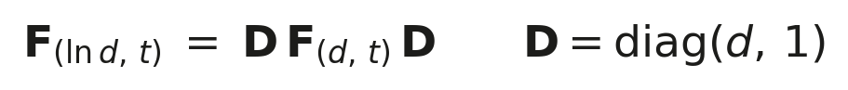
A useful consequence: the correlation ρ, and the marginal variance of each parameter, are invariant under a separate rescaling of either parameter. Comparisons of ρ between implementations that parameterise dose differently are therefore meaningful without any conversion.

2.4 Pooling cells
The decoder reads cultures, not single cells. Pooling N cells sums N independent Poisson draws, so the mean scales with N while the parameters do not:
Section 5 tests whether that scaling is matched by an actual estimator, which is a different question from whether it is written correctly.

2.5 Relation to the lognormal noise model
The ablation study's independent implementation assumes multiplicative lognormal measurement noise of coefficient of variation c, so that the log-observables carry additive noise of constant standard deviation and the information is F = JᵀΣ−1J. The two models differ only in the weight each attaches to a channel:
The two weights coincide at λ = c−2, which for c = 0.25 is 16 photons. At this circuit's operating point the channels carry roughly 20–40 photons, so the two noise models sit within a factor of about two of each other in weight — and indeed, measured directly on a common trajectory at a common time point, the two give σt within 8 % (ox) and 13 % (er). The noise model is not where the implementations disagree.

3. Implementation
The analysis does not reimplement the circuit. Both observables are read from the same merged SBML model used by the sensitivity and control-circuit analyses, through the existing Variant class, so that the Fisher analysis and the rest of the dry lab cannot silently diverge. A side effect is that the production rate is the real time-dependent one rather than a constant.
Four implementation choices are load-bearing and are therefore stated rather than buried.

3.1 Pre-equilibration
All species start at zero in the merged SBML. That is not a cell; it is an empty vessel. Without pre-equilibration the first hours of a trace are dominated by the filling of the reporter pools rather than by the stress response, and the two share a timescale, so they are not separable. The model is therefore integrated for 50 h at zero stress before the dose is applied.
The order is a trap worth naming. Once clearance is active the stress input obeys dS/dt = −k_clear·S, so pre-equilibrating with the dose already applied would decay it away before the run began — 50 h at 1.777 /h is roughly 128 half-lives. Pre-equilibration therefore runs at zero stress and zero clearance, with both set afterwards.
The 50 h horizon was verified for this model rather than inherited. Relative difference of the resulting trace against a 100 h horizon:
Pre-equilibration horizon | Max relative difference vs 100 h | Verdict
20 h | 5.931 × 10⁻⁴ | not converged
50 h | 1.243 × 10⁻⁸ | converged
The ablation study justifies 50 h with “already converged by 20 h”, which holds for its own model but not for the merged model with the clearance rate rule. The horizon was right; the stated reason was not transferable.

3.2 Parameter packages, not parameters
Clearance is not an independent knob. The fitted value k_clear = 1.969 /h belongs to a fit that also sets kon = 349.4, dx = 11.11, Kact = 158.1 and n = 4.801. Applying it on top of the committed SBML values (Kact,ox = 208, nox = 2.75, dx,ox = 0.5) mixes four parameters across two different fits — and the modelling repository already warns that doing so “is not neutral … they pull in opposite directions”.
Clearance is therefore reachable only as a member of a named package that is applied whole. There is deliberately no way to set it alone, and a package that moves K_act causes the code to warn that the reference dose is no longer the half-activation point.

3.3 Photon scale
An earlier version set the photon scale as 25 / max(trace), anchoring the absolute noise level to the maximum of whatever trace was being simulated. That makes the noise level a function of the protocol: enabling pre-equilibration raised the trace maximum from 10.70 to 13.96, dropped the conversion to 0.766 × and handed every time point fewer photons. Measured consequence: about 40 % of the apparent degradation from enabling pre-equilibration was this re-anchoring rather than physics (a factor of 1.431 × fell to 1.253 × when the scale was held fixed).
Worse, the scale was computed per branch, which is physically impossible: the same reporter, camera and microscope cannot yield different photons per reporter molecule. Normalising each branch to its own peak gave the dimmer branch a larger conversion factor and erased the difference between them. With one shared scale:
Branch | Peak green (model units) | Peak (photons) | Green rise above baseline | Red rise
ox | 27.85 | 65.06 | 50.02 | 41.16
er | 7.66 | 17.89 | 12.39 | 9.76
The er branch is 3.6 × dimmer, and its red channel rises 9.76 photons against a detection threshold of 10. The honest reading is not “er does not work”: a 2.4 % margin against a placeholder threshold means er sits exactly on the detection floor, and which side it falls on is decided by two unmeasured constants. That is a more useful statement than either verdict.
The scale is now an explicit constant. This removes the artifact; it calibrates nothing. The value in use is a placeholder awaiting the Photon Transfer Curve.

3.4 Detection threshold
A detection threshold was written to answer “is the response detectable?”. Applied as an absolute photon floor to a pre-equilibrated trace it answers a different question — “is baseline plus response detectable?” — because the pre-existing reporter pool already carries photons. Enabling pre-equilibration moved the first apparently valid point from 74.2 min to 28.8 min, and that earlier crossing was the red baseline reaching 10 photons, not the response becoming visible. The threshold is now measured above each channel's own baseline, which reduces exactly to the previous behaviour when there is no pre-equilibration.

4. Validation I — is the Fisher matrix correct?
A sign error or a mis-scaled derivative produces a confident, plausible, wrong number that nothing in the analysis can catch on its own. Two independent checks were applied.

4.1 Two differentiation routes
The attainment experiment of Section 5 needs λ at arbitrary (dose, t), which requires an interpolant over a grid of simulations. That gives a second, independent route to the Fisher matrix — finite differences on the interpolant — against the module's own route through the ODE solver's output. At the operating point, in the (ln d, t) parameterisation:
Element | Module (ODE output) | Surface (interpolant) | Relative difference
F[ln d, ln d] | 2.812041 | 2.830002 | 6.39 × 10⁻³
F[ln d, t] | 0.1333658 | 0.1333926 | 2.01 × 10⁻⁴
F[t, t] | 7.315921 × 10⁻³ | 7.282850 × 10⁻³ | 4.52 × 10⁻³
Worst case 0.64 %. The experiment aborts rather than report a ratio if this exceeds 5 %, because interpolation error must not be allowed to masquerade as a property of the estimator.

4.2 Independent agreement with a separate implementation
The ablation study computes the same bound from a separate codebase, with a different noise model (lognormal, CV = 0.25) and a different dose parameterisation. Run on a matched protocol, the two agree on the quantity that is invariant under rescaling:
Source | Branch | ρ(dose, t)
Ablation study, intact circuit | ox | −0.859
This implementation, ablation protocol | ox | −0.844
This implementation | er | −0.871
Two independent codebases, two noise models, agreement to 2 %.

5. Validation II — is the bound attainable?
A Cramér–Rao bound is a theorem about estimators, not a measurement. It says no unbiased estimator beats F⁻¹; it does not say any estimator achieves it. The bound is attained asymptotically, as information accumulates — and this decoder reads two Poisson counts to estimate two parameters, where there is no large-sample limit at all. Quoting F⁻¹ as “the decoder's precision” is therefore a claim that has to be earned.
Method: simulate synthetic measurements from the model at a known (dose, t), recover (dose, t) by maximum likelihood, repeat, and compare the empirical covariance of the estimates against F⁻¹. The operating point is t = 60 min at the reference dose — the readout time the project recommends, not the bound's own optimum, which would flatter the result. 600 replicates per N, fixed seed, multi-start optimisation because the likelihood has a near-degenerate ridge.
Channel means at the operating point: 40.70 photons green and 18.54 red, per cell. The bound at N = 1: σln d = 1.608 (161 % relative), σt = 31.7 min, ρ = −0.929.
N | σt emp (min) | σt CRLB | ratio | σlnd emp | σlnd CRLB | ratio | bias t (min) | ρ emp | pinned
1 | 145.04 | 31.70 | 4.58 | 0.978 | 1.608 | 0.61 | +29.83 | −0.327 | 42 %
3 | 27.47 | 18.30 | 1.50 | 0.855 | 0.928 | 0.92 | +6.08 | −0.495 | 36 %
10 | 9.02 | 10.02 | 0.90 | 0.693 | 0.508 | 1.36 | +1.26 | −0.775 | 24 %
30 | 5.36 | 5.79 | 0.93 | 0.466 | 0.294 | 1.59 | +0.61 | −0.798 | 8 %
100 | 3.23 | 3.17 | 1.02 | 0.243 | 0.161 | 1.51 | +0.08 | −0.835 | 1 %
300 | 1.82 | 1.83 | 0.99 | 0.105 | 0.093 | 1.13 | −0.21 | −0.905 | 0 %
1000 | 1.00 | 1.00 | 1.00 | 0.051 | 0.051 | 1.00 | −0.01 | −0.923 | 0 %
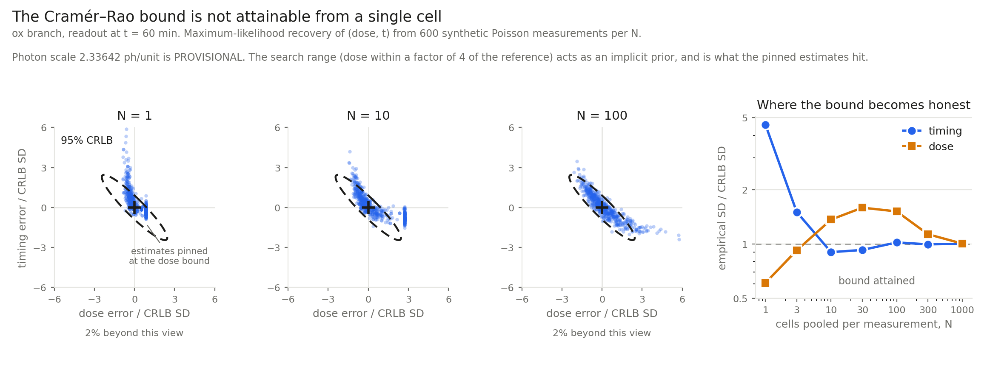
Figure 1. Estimate clouds against the 95 % CRLB ellipse, in units of the CRLB standard deviations so that the reference ellipse is identical in every panel (dividing a covariance by its marginal SDs leaves the correlation, which does not depend on N). Right: the ratio of empirical to bound standard deviation against pooled cell count. The vertical line of points is not an artifact — those are estimates that ran into the upper dose bound of the search range.

5.1 What the test shows
- The bound is not attainable from a single cell. The real timing error is 4.58 × the bound, and the estimator is biased by +29.8 min on a true value of 60 min — a 50 % bias. Since the CRLB assumes an unbiased estimator, at N = 1 it does not merely overstate the precision: it does not apply.
- Timing reaches the bound at about N = 10, after which the ratio stays within 10 % of unity and the bias falls below 1.3 min.
- Dose takes far longer — N ≈ 300 to 1000. The ratio is below 1 at N = 1 because a biased, boundary-pinned estimator has compressed scatter; beating a bound is a symptom, not an achievement.
- Four independent signatures agree on where the asymptotic regime begins: the standard-deviation ratio approaches 1, the bias decays to zero, the fraction of boundary-pinned estimates falls to zero, and the empirical correlation converges to the matrix's own prediction (−0.923 against −0.929).
Consequence. No σt from this analysis may be quoted as a single-cell figure. The bound describes a population measurement, and only above roughly 10 pooled cells for timing. Dose and timing claims require different cell counts, so quoting one N for both would be wrong in one direction or the other.
The search range — dose within a factor of four of the reference — acts as an implicit prior and is what the pinned estimates hit. A real decoder also knows roughly which dose range is physiological, so this is defensible, but it is doing real work in the N = 1 numbers and is stated rather than hidden.

6. Robustness — the parameters the data cannot determine
The modelling repository states the problem plainly: the ox kinetics are not reliable individually — koff and dx move by about 400 × between densitometry quantifications, and only the combination r is determined. So dx,ox does not exist as a measured quantity, and any value for it is a convention. The question a reviewer is entitled to ask is why anything computed with it should be believed.
The answer has to be a test, not a preference. Holding k_on and k_x fixed, r is invariant under a one-parameter family:
Moving along that family is, by construction, invisible to the quantifications that produced r. A negative control sweeps the same d_x range with k_off held fixed, which changes r and moves in a direction the data do constrain — so that a null result would mean the test is insensitive rather than the model robust.
Sanity check on the definition: scaling the committed pair (d_x = 0.5, k_off = 160) to d_x = 0.03 gives k_off = 9.6, and to d_x = 11.11 gives k_off = 3555. The values quoted by the team for those quantifications are about 5.3 and 1900 — the same order at both ends, so the family reproduces the observed candidate pairs.

6.1 Result
Scanning d_x,ox over 0.03 → 11.11, a 370 × range. Spread is max/min of each quantity over the sweep.
Quantity | Along the ridge (r fixed) | Across the ridge (control)
ρ(dose, t) | 1.06 × | 1.11 ×
readout point t* | 1.32 × | 1.11 ×
σt | 2.34 × | 1.01 ×
σ dose (%) | 1.94 × | 2.09 ×
- The correlation survives. ρ moves by 6 % across a 370 × change in a parameter nobody can measure. The claim that the channels are not separable — the one independently reproduced to 2 % — does not depend on the non-identifiable kinetics.
- The readout window survives qualitatively but not precisely. t* moves from 75.6 to 100.1 min. “Read early, around 1–1.5 h, not at 3 h” holds everywhere on the ridge; “the optimum is at 46 min” does not.
- σt does not survive. It moves 2.34 × along the direction the data cannot constrain, while moving only 1.01 × across the direction they do. That is the opposite of the reassuring pattern, and it is the finding.
- Whether a genuine interior optimum exists is itself parameter-dependent: the optimum flips between interior and boundary in both sweeps.
Consequence. σt is doubly unanchored — by the photon scale, and independently by dx,ox. Fixing the photon budget alone will not produce a defensible absolute timing precision; dx,ox has to be pinned experimentally too.

7. Results and design consequences

7.1 The channels are not separable
ρ ≈ −0.9 at every operating point and under every perturbation tested. This is a structural property of the tandem-timer motif: the two readouts carry nearly the same information, so dose and elapsed time are confounded. It is not a calibration problem and it does not go away with a better camera. The practical consequence is that both channels are necessary and still insufficient to separate the two quantities cleanly, which is what makes the joint 2 × 2 treatment — rather than a scalar bound on timing — the only honest formulation.

7.2 Read early
Three independent methods place the informative window in the same region: this Fisher analysis finds an interior CRLB minimum between 46 and 100 min depending on threshold and kinetics; the ablation study's age-resolution table is best at 1 h; the physics-informed analysis independently lands at 1 h. The calibration convention of reading at 3 h is a convention and not an operating point — at 3 h the dose error has plateaued while timing has degraded substantially.
This recommendation changed the experimental plan: the wet lab's H₂O₂ time points were chosen from it. The CuSO₄ recommendation was not model-derived — there is no copper branch in the model, only ox (H₂O₂) and er (DTT) — and the advice there (bracket the peak with 0.5 / 1 / 2 h) came from identifiability reasoning applied to the wet lab's own observation that the signal peaks near 1 h. The distinction is worth preserving: more time points were requested precisely where no model exists to interpolate between them.

7.3 It is a population instrument
Section 5 establishes this quantitatively: at least ~10 pooled cells before the bound describes timing honestly, and ~300 or more before it describes dose. The imaging protocol must specify a cell count, and a different one depending on which quantity is being claimed.

7.4 The detection threshold can hide the optimum
With a threshold of 10 photons on both channels, the first accessible time point falls at 74 min, while the interior CRLB minimum sits at 46 min. The choice of threshold therefore determines whether the optimal readout window is reachable at all — a design finding, not a technical detail, and one that makes the negative-control measurement that fixes the threshold a priority rather than a formality.

8. Limits, stated as scaling laws
Fisher information is linear in the photon count, so every absolute standard deviation carries the photon scale explicitly:
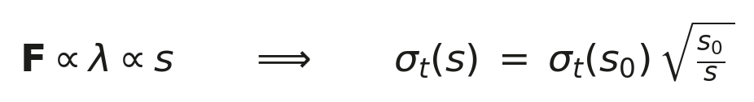
Rather than report a bare number, timing precision should be written with the placeholder visible — for example σt = 929 min × √(25 / λpeak), with λpeak = 25 photons provisional. When asked how the number is known, “we do not know it; we know how it scales, and this is the measurement that fixes it” is a stronger answer than a value, because it demonstrates which quantities are measured.

8.1 Open limitations
- Perfect crosstalk correction is assumed. Blind per-image crosstalk estimation is mathematically unidentifiable for a tandem-fusion reporter without a single-colour control per imaging session, because the true red signal is by construction proportional to the true green within every cell. Everything reported here is therefore a lower bound on a lower bound.
- Shot noise only. No camera read noise or gain, and no cell-to-cell biological variability. Real cells differ from one another, adding a variance floor that does not average away with N and can only make the true bound worse.
- No autofluorescence baseline and no proteasomal fragment-escape state.
- The camera is a cooled QImaging MicroPublisher 3.3 RTV (10-bit sensor, 8-bit saved, Image-Pro Plus), not the SC30 that earlier versions of this analysis named. The saved-file saturation value happens to remain correct; its stated justification did not.

8.2 The two measurements that close the gap
Measurement | What it fixes | Unblocks
Photon Transfer Curve + negative control | Photon scale and the detection floor | Every absolute σ; the threshold; whether the er branch is detectable
An experiment pinning d_x,ox | The 2.34 × ridge spread | Absolute timing precision
Single-fluorophore control strain | The perfect-crosstalk assumption | Turns a lower bound on a lower bound into a bound
These are independent of the modelling work and of each other. They should run in parallel with it rather than after it: nothing in the analysis depends on them, and everything in the analysis waits for them.

9. Corrections made during this analysis
Recorded because they bear on how the numbers should be read, and because the defects were present and invisible rather than introduced.
- The photon scale was a function of the protocol, and was computed per branch. This hid a 3.6 × brightness difference between ox and er, and accounted for about 40 % of an apparent degradation that was attributed to physics.
- A clearance value was applied without the four companion parameters from the same fit — the precise error the modelling repository warns against. Clearance is now reachable only as a whole package.
- The detection threshold silently changed meaning when pre-equilibration was introduced, testing baseline plus response rather than response.
- The pre-equilibration horizon was inherited from another model's justification. It was verified here and found correct, but 20 h — the horizon that justification quotes — would not have been.
- An earlier draft of the summary claimed the CuSO₄ time points were model-derived. They were not; there is no copper model.

10. Reproducibility
Every run prints a provenance header naming the parameter package, the pre-equilibration horizon, the photon scale and the detection mode. No number in this report should be quoted without it. The previous version's published figures remain reproducible exactly through explicit legacy modes, so that every change is opt-in and none moved a result silently.
Script | Produces
fisher_info_v3_1.py | The bound, with run provenance
scripts/crlb_attainment.py | Section 5: the attainment experiment
scripts/plot_attainment.py | Figure 1
scripts/ridge_stability.py | Section 6: the robustness sweep and its control
scripts/step1_factorial.py | Protocol one-variable-at-a-time comparison
scripts/unify_crlb.py | Poisson against lognormal on a common trajectory
The analysis imports the merged SBML model from the main modelling repository rather than vendoring it, so that the model cannot drift between analyses.

