

Development of model based on nearest neighbours with previous knowledge of signal propagation

**Vicenç Pio Badia**

Master ciència de dades

Area 4??

**Nom Consultor/a**

**Joaquín Torres-Sospedra**

Data Lliurament

Aquesta obra està subjecta a una llicència de [Reconeixement-NoComercial-SenseObraDerivada 3.0 Espanya de Creative Commons](http://creativecommons.org/licenses/by-nc-nd/3.0/es/)



**Llicències alternatives (triar alguna de les següents i substituir la de la pàgina anterior)**

**A) Creative Commons:**

Aquesta obra està subjecta a una llicència de [Reconeixement-NoComercial-SenseObraDerivada 3.0 Espanya de Creative Commons](http://creativecommons.org/licenses/by-nc-nd/3.0/es/)



Aquesta obra està subjecta a una llicència de [Reconeixement-NoComercial-CompartirIgual 3.0 Espanya de Creative Commons](http://creativecommons.org/licenses/by-nc-sa/3.0/es/)



Aquesta obra està subjecta a una llicència de [Reconeixement-NoComercial 3.0 Espanya de Creative Commons](http://creativecommons.org/licenses/by-nc/3.0/es/)



Aquesta obra està subjecta a una llicència de [Reconeixement-SenseObraDerivada 3.0 Espanya de Creative Commons](http://creativecommons.org/licenses/by-nd/3.0/es/)



Aquesta obra està subjecta a una llicència de [Reconeixement-CompartirIgual 3.0 Espanya de Creative Commons](http://creativecommons.org/licenses/by-sa/3.0/es/)



Aquesta obra està subjecta a una llicència de [Reconeixement 3.0 Espanya de Creative Commons](http://creativecommons.org/licenses/by/3.0/es/)



**B) GNU Free Documentation License (GNU FDL)**

Copyright © ANY EL-TEU-NOM.

Permission is granted to copy, distribute and/or modify this document under the terms of the GNU Free Documentation License, Version 1.3 or any later version published by the Free Software Foundation; with no Invariant Sections, no Front-Cover Texts, and no Back-Cover Texts.

A copy of the license is included in the section entitled "GNU Free Documentation License".

**C) Copyright**

© (l'autor/a)

Reservats tots els drets. Està prohibit la reproducció total o parcial d'aquesta obra per qualsevol mitjà o procediment, compresos la impressió, la reprografia, el microfilm, el tractament informàtic o qualsevol altre sistema, així com la distribució d'exemplars mitjançant lloguer i préstec, sense l'autorització escrita de l'autor o dels límits que autoritzi la Llei de Propietat Intel•lectual.

**FITXA DEL TREBALL FINAL**

|  |  |
| --- | --- |
| **Títol del treball:** | *Development of model based on nearest neighbours with previous knowledge of signal propagation* |
| **Nom de l’autor:** | *Vicenç Pio Badia* |
| **Nom del consultor/a:** | *Joaquín Torres-Sospedra* |
| **Nom del PRA:** |  |
| **Data de lliurament (mm/aaaa):** | *06/2022* |
| **Titulació o programa:** | *Màster ciència de dades* |
| **Àrea del Treball Final:** | *Àrea 4* |
| **Idioma del treball:** | *Anglès* |
| **Paraules clau** | *Wi-Fi Fingerprinting, indoor geolocation, k-NN* |
| **Resum del Treball (màxim 250 paraules):** *Amb la finalitat, context d’aplicació, metodologia, resultats i conclusions del treball* | |
| En aquest treball s’estudia el Wi-Fi Fingerprinting, que és una tècnica molt popular utilitzada en el geoposicionament en interiors. Està basada en la mesura de la senyal emesa pels punts d’accés Wi-Fi més propers i disponibles. El conjunt d’intensitats detectades pel dispositiu receptor es coneix com a empremta Wi-Fi (Wi-Fi fingerprint) i és molt útil a l’hora de calcular la posició d’aquest objecte. L’algorisme utilitzat per fer aquest càlcul és una adaptació del k-NN, el qual s’han fet diverses propostes de millora en els últims anys per augmentar-ne el rendiment. Per culpa de la pròpia naturalesa de la propagació de les senyals, apareixen problemes d’interferències provocats per obstacles de l’entorn, tant estàtics com mòbils. En el present treball es busca una implementació de l’algorisme que millori al màxim la precisió del posicionament amb el mínim cost computacional d’entrenament del model de predicció. També es busca el millor ajustament de dos paràmetres de l’algorisme k-NN: el valor de la k i la funció de distància. L’avaluació de l’algorisme es duu a terme utilitzant diverses bases de dades heterogènies amb dades d’entrenament i de test per determinar les millors mètriques de distància per a cada una d’elles. Per últim es proposa una solució que consisteix en fer un *ensemble* de les millors mètriques per obtenir la màxima precisió en els resultats. | |
| **Abstract (in English, 250 words or less):** | |
|  | |

**Índex**

1. Introducció 1

1.1 Context i justificació del Treball 1

1.2 Objectius del Treball 1

1.3 Enfocament i mètode seguit 2

1.4 Planificació del Treball 2

1.5 Breu sumari de productes obtinguts 2

1.6 Breu descripció dels altres capítols de la memòria 2

2. Resta de capítols 3

3. Conclusions 13

4. Glossari 14

5. Bibliografia 15

6. Annexos 16

**Llista de figures**

**¡Error! No se encuentran elementos de tabla de ilustraciones.**

# 1. Introducció

## 1.1 Context i justificació del Treball

Many applications need the exact position of users for proper working and companies require this technology more and more on its new products and services. The growing world of the Internet of Things is one of the sectors with the most demand. Geolocation in outdoor spaces is usually easy to resolve by using GPS systems embedded into all smartphones. However, geolocation in indoor environments comes with more limitations because GPS signals are not strong enough inside a building or in narrow spaces such a street with tall buildings surrounding. Another inconvenience is that GPS cannot distinguish at which floor is placed the device.

There are currently several indoor positioning techniques based on different technologies: Wi-Fi, BLE, RFID, etc. In our case of study, we focus on Wi-Fi fingerprinting with k-NN algorithm to create a prediction model using the measurements of the signals emitted by the near and available Wi-Fi access points. Related studies approaching the problem show results with some accuracy errors between the predicted location and the actual location of the device measured. The aim of this work is to implement a k-NN to improve the accuracy and reduce the computational cost when training the model. The focus is on the treatment of the signal propagation conditions and the handling of the errors caused by the present obstacles in the environment.

## 1.2 Objectius del Treball

The main objective of the project is to design and implement a predictive model based on the k-NN algorithm with previous knowledge of the signal propagation. The partial objectives are the following:

## Data cleaning, data filtering and identification of outliers.

## Select the signals from the most relevant access points.

## Select the best data representation to explain the conclusions.

## Select the best distance metric to optimize the results in this context.

## Implement and train the k-NN model with best accuracy and lowest computational cost.

1.3 Personal motivation

My interest in engineering and telecommunications comes from many years ago when studying at high school. The field of information technologies was my choice when starting the bachelor at university and for the jobs I’ve worked during the last years. The Master of Data Science opened a new window of knowledge for me, and I believe this topic is a good field of study to do a deeper insight. I have already worked in projects involving indoor positioning but using other technologies such as UWB, RFID and RF but never Wi-Fi. Because all this reasons I think this project is a good opportunity for me to finalize this master’s degree.

## 1.4 Enfocament i mètode seguit

The source of the data that will be used comes from a database filled with Wi-Fi signals collected from indoor spaces. That data includes the RSSI of each of the signals as well as other information. The first step will be to review the state of the art about Wi-Fi Fingerprinting and related recent studies. The next step is the design and implementation of the algorithm: the first stage will be the data preparation including data cleaning and selection of the interesting data from the training data base. Then the algorithm will be tested using different distance metrics to find the solution that fits best. The same process will be done with the data representation. The test data comes from a different source of the training data to simulate the real conditions and evaluate the algorithm. The development of the project will be coded in Python.

## 1.5 Planificació del Treball

The project is divided in seven stages to separate the main tasks:

* Definition and planification. From 16/02 to 27/02.
* State of the art revision. From 28/02 to 13/03.
* Design and implementation. From 14/03 to 15/05.
* Writing of the thesis (first delivery). From 16/05 to 29/05.
* Writing of the thesis (final delivery). From 30/05 to 05/06.
* Preparation of defense. From 06/06 to 12/06.
* Public defense. From 13/06 to 24/06.

## 

## 1.6 Breu sumari de productes obtinguts

No cal entrar en detall: la descripció detallada es farà en la resta de capítols.

## 1.7 Breu descripció dels altres capítols de la memòria

Explicació dels continguts de cada capítol i la seva relació amb el projecte global.

# 2. Related work

In this section, we first detail the different subareas contained within the scope of this work and the summary of the main tasks for each of them. Then we review several areas where this project could be applied and give value to possible applications. Finally, we present the state of the art of similar investigations.

## 2.1 Subareas within the scope of my work

The scope of the project includes several subareas that will be approached during the implementation of the algorithm. They can be divided as follows:

* Data cleaning: is the first step when working with large datasets. Includes the selection of the observations of interest and the possible transformations of some data if needed. A good process of data cleaning is fundamental for the performance of the algorithm because it helps to reduce the computational cost of the training.
* Algorithm implementation: consists of selecting the most relevant fingerprints focusing on the signal propagation. It is the main work of the project, and the goal is to implement an “improved” k-NN that predicts the position of the devices with the best accuracy.
* Train and test: a training database will be used to train the model with the best parameters to obtain the best results. The testing of the algorithm will be done with a separate database filled with testing data.

## 2.2 Possible applications in one area

In the recent years, indoor positioning has grown as one of the most demanded technologies by companies working in sectors such as IoT and Industry 4.0. We can find multiple examples of applications for indoor location, from the navigation of hospitals, airports, parking garages and shopping malls, for example, to navigational aids for the blind and visually impaired, targeted advertising, mining, and disaster response.

The use of Wi-Fi for the positioning comes with two main advantages: all these applications can be embedded in an average smartphone since all of them include Wi-Fi as standard. The other advantage is that most of the buildings have their own Wi-Fi access points so there is no need to install extra hardware to use these applications.

## 2.3 Similar investigations

The last part of this section is to present some of the most relevant works of the state of the art in relation with our field of study. All these articles will be useful to compare results with our own work at the end of the project.

Zhenghua Chen et al., (2019) present a local feature-based deep long short-term memory (LF-DLSTM) approach. The local feature extractor attempts to reduce the noise effect and extract robust local features. The DLSTM network is able to encode temporal dependencies and learn high-level representations for the extracted sequential local features.

Xudong Song et al., (2019) implement a novel classification model and a novel positioning model by combining a Stacked Auto-Encoder (SAE) with a one-dimensional Convolutional Neural Network (CNN). The SAE is utilized to precisely extract key features from sparse Received Signal Strength (RSS) data while the CNN is trained to effectively achieve high accuracy in the positioning phase.

Jianwei Niu et al., (2015) implement weighted KNN algorithm to assign different weights to APs and achieve room-level localization. To obtain the absolute coordinate of users, they design a novel MDS algorithm called MDS-C (Multi-Dimensional Scaling with Calibrations) to calculate coordinates of interested locations in the corridor and rooms, where anchor points are used to calibrate absolute coordinates of users.

Hurkan M. Aydin et al., (2021) propose to use feature selection methods along with the K-nearest neighbours (KNN) classification and regression algorithms in order to create a simple and swift location positioning system. The evaluation of various feature selection methods shows that computation times for positioning can be reduced by 75% using feature selection.

Jing, Hao et al., (2014) design a collaborative Wi-Fi fingerprint training (cWiDB) method that enables the system to perform inertial measurement based collaborative positioning or Wi-Fi fingerprinting alternatively according to the current situation. It also reduces the time required for training the fingerprint database. Different database training methods and different training data size are compared to demonstrate the time and data required for generating a reasonable database. Finally, the fingerprint positioning result is compared which indicates that the cWiDB is able to achieve the same positioning accuracy as conventional training methods but with less training time and a data adjustment option enabled.

Mok, Esmond and Cheung, Bernard K. S. (2013) propose a Wi-Fi positioning algorithm based on neural network modelling of Wi-Fi signal patterns. This algorithm is based on the correlation between the initial parameter setting for neural network training and output of the mean square error to obtain better modelling of the nonlinear highly complex Wi-Fi signal power propagation surface. The test results show that this neural network-based data processing algorithm can significantly improve the neural network training surface to achieve the highest possible accuracy of the Wi-Fi fingerprinting positioning method.

Finally, Rui Zhou et al., (2016) present a Wi-Fi fingerprinting algorithm based on Support Vector Machines (SVM), which combines SVM classification and regression to model the unknown relationship. During sampling and training, the indoor area is partitioned to subregions and the nonlinear relationship between signal fingerprints and locations as well as subregions are established. For positioning, SVM classifiers first determine the subregion that the mobile device is in, then SVM regression estimates the exact coordinate on the basis of classification result.

# 3. Materials and methods

3.1 Test environment

The data used in the experimentation comes from different areas of University Jaume I (València). It corresponds to several rooms of several floors and buildings and the area includes obstacles that can block or disturb the RSS signals. The infrastructure consists of X Wi-Fi Aps installed… +info

3.2 Data structure

The algorithm is tested on the following datasets in CSV format:

|  |  |  |  |
| --- | --- | --- | --- |
| **Filename** | **Train** | **Test** | **Total** |
| DSI1 | 1369 | 348 | 1717 |
| DSI2 | 576 | 348 | 924 |
| LIB1 | 576 | 3120 | 3696 |
| LIB2 | 576 | 3120 | 3696 |
| MAN1 | 14300 | 460 | 14760 |
| MAN2 | 1300 | 460 | 1760 |
| SIM0001 | 10710 | 1000 | 11710 |

Each dataset is divided in four separate CSV files following this structure:

* Training coordinates
* Training RSS
* Test coordinates
* Test RSS

On one hand, the coordinates files include: x, y, z, floor, building. For this work, to simplify the computation, the variables floor and building are avoided. On the other hand, the RSS files include the actual fingerprint, which is a vector of RSS. The vectors of RSS are represented in dB and the value 100 indicates signal not received. The length of the fingerprints varies from one dataset to another.

3.3 Methods

In this section we explain the methods implemented in this work:

* K-NN: is a supervised algorithm used for both classification and regression. In our case is used for regression and it consists basically of finding the average value of the k nearest neighbours for each fingerprint to obtain the estimated position coordinates.

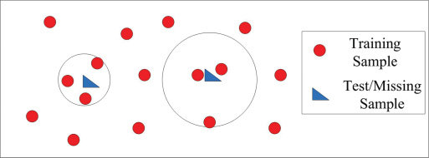

Scenario with 2 test samples and k=3

* Positioning error: it is the Euclidean distance between the estimated position and the real position of a sample. During the development of the project, the evaluation of the algorithm has been based on the average error of the predicted positions. The average error is calculated using the mean value of the positioning errors of all the positions estimated.
* Ensemble: is a technique used to improve the accuracy of the prediction once the k-NN has been executed. It consists of selecting the distance metrics with best accuracy results for one dataset and finding the centroid of the estimated position of each one of them. The output is the final predicted position.

# 4. Description of the proposed approach

The objective of the project is to find the best configuration of the k-NN algorithm to obtain a good accuracy and average error. To achieve that goal, I followed a methodology consisting of an incremental implementation of the algorithm. That means starting with a basic k-NN on the first tests and then adding several features to end up with the best results. In this chapter we explain this process and the detail of every step.

* Basic k-NN with Euclidean distance:
  + Get neighbours
* Predict positions
* Calculate error
  + Average error
* Distance metrics comparison
* Avoid errors:
  + Normalization
  + Absolute error
  + Increment by 100
* Ensemble

# 5. Experimental results and discussion

This chapter exposes the results obtained and gives interpretation and discussion on these.

As previously said, the k-NN algorithm has been tested on seven distinct datasets. The hyperparameters used to test the accuracy are the k value, the distance metric, and the transformation of the fingerprint (normalization, absolute value and increment).

When running the basic k-NN, errors appeared because of divisions by 0, sqrt and log of negative numbers. To avoid these errors, we tried different solutions:

* Min-max normalization:
* Absolute value:
* Increment by 100:

I ran several tests using the default configuration and the three solutions explained above, the best results are obtained with the following configuration:

* Dataset DSI1 average error with **absolute value**:

|  |  |  |  |
| --- | --- | --- | --- |
| **Distance metric** | **k=1** | **k=5** | **k=11** |
| **Euclidean** | 5.04 | 4.96 | 4.38 |
| **MinkowskiL1** | 4.95 | 4.72 | 4.42 |
| **MinkowskiL2** | 5.04 | 4.96 | 4.38 |
| **MinkowskiL3** | 5.58 | 5.35 | 4.58 |
| **MinkowskiL4** | 6.25 | 5.65 | 4.82 |
| **MinkowskiL5** | 6.62 | 5.86 | 5.01 |
| **City Block** | 4.95 | 4.72 | 4.42 |
| **Chebyshev** | 7.67 | 7.05 | 6.42 |
| **Sorensen** | 26.65 | 24.98 | 24.31 |
| **Gower** | 4.95 | 4.72 | 4.42 |
| **Soergel** | 4.99 | 4.72 | 4.43 |
| **Kulczynski d** | 4.99 | 4.72 | 4.43 |
| **Lorentzian** | 5.66 | 5.29 | 5.46 |
| **Canberra** | 4.8 | 4.48 | 4.32 |
| **Intersection** | 4.95 | 4.72 | 4.42 |
| **Wave Hedges** | 4.7 | 4.5 | 4.36 |
| **Czekanowski s** | 4.99 | 4.72 | 4.43 |
| **Czekanowski d** | 51.34 | 50.53 | 49.12 |
| **Motyka s** | 4.99 | 4.72 | 4.43 |
| **Motyka d** | 51.34 | 50.53 | 49.12 |
| **Kulczynski s** | 4.99 | 4.72 | 4.43 |
| **Ruzicka** | 4.99 | 4.72 | 4.43 |
| **Tanimoto** | 4.99 | 4.72 | 4.43 |
| **Inner Product** | 40.68 | 40.68 | 40.09 |
| **Harmonic** | 57.31 | 55.76 | 53.63 |
| **Cosine** | 5.06 | 4.98 | 4.47 |
| **Kumar-Hassebrook** | 5.1 | 4.98 | 4.39 |
| **Jaccard s** | 5.1 | 4.98 | 4.39 |
| **Jaccard d** | 46.01 | 45.74 | 44.01 |
| **Dice s** | 5.1 | 4.98 | 4.39 |
| **Dice d** | 46.01 | 45.74 | 44.01 |
| **Fidelity** | 40.68 | 40.68 | 38.41 |
| **Bhattacharrya** | 57.31 | 55.86 | 53.67 |
| **Hellinger** | 5.01 | 5.01 | 4.27 |
| **Matusita** | 5.01 | 5.01 | 4.27 |
| **Squared-chord** | 5.01 | 5.01 | 4.27 |
| **Squared Euclidean** | 5.04 | 4.96 | 4.38 |
| **Pearson** | 5.11 | 4.97 | 4.49 |
| **Neyman** | 4.87 | 4.78 | 4.28 |
| **Squared** | 5.01 | 4.99 | 4.29 |
| **Probabilistic Symmmetric** | 5.01 | 4.99 | 4.29 |
| **Divergence** | 4.77 | 4.74 | 4.22 |
| **Clark** | 4.77 | 4.74 | 4.22 |
| **Additive symmetric** | 4.99 | 4.99 | 4.31 |
| **Kullbac Leiber** | 57.31 | 55.77 | 53.63 |
| **Jeffreys** | 5.0 | 5.01 | 4.29 |
| **K Divergence** | 57.31 | 55.86 | 53.67 |
| **Topsoe** | 5.01 | 5.01 | 4.28 |
| **Jensen-Shannon** | 5.01 | 5.01 | 4.28 |
| **Jensen difference** | 5.01 | 5.01 | 4.28 |
| **Taneja** | 5.0 | 5.01 | 4.29 |
| **Kumar Johnson** | 4.98 | 5.01 | 4.32 |
| **AvgL** | 4.97 | 4.65 | 4.4 |
| **Vicis-Wave Hedges** | 4.76 | 4.45 | 4.27 |
| **Vicis Symmetric 1** | 4.9 | 4.94 | 4.37 |
| **Vicis Symmetric 2** | 4.91 | 4.96 | 4.29 |
| **Vicis Symmetric 3** | 5.02 | 4.95 | 4.27 |
| **Min-Symmetric** | 4.98 | 4.9 | 4.42 |
| **Max-Symmetric** | 5.02 | 4.98 | 4.31 |

From the results above, we can observe the lowest average error is when k=11. At this point I selected 3 of the best distance metrics to compare the results using an ECDF plot:

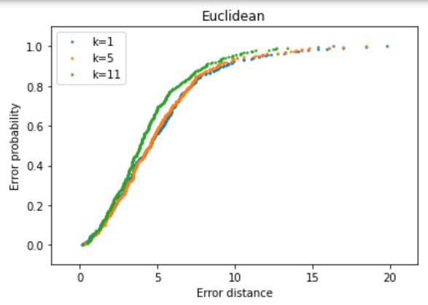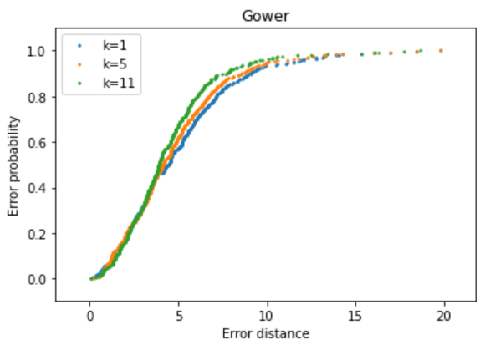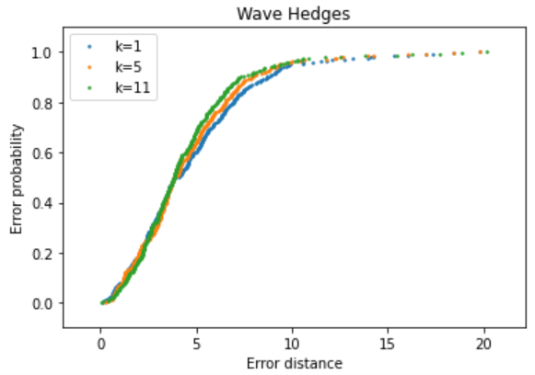

In ECDF plots, the most vertical line indicates the best results since the error distance is on the x axis. We can observe in all three plots that k=11 is the best option in this dataset. It is important to notice that the density of points of each dataset affects the election of the k, for dense datasets we will obtain better results with high k values.

**Ensemble**

The next step to improve the average error is to make an ensemble of the three previous distance metrics and evaluate the results. The following scatter plots show the comparison between the error of ensemble and the metric alone:

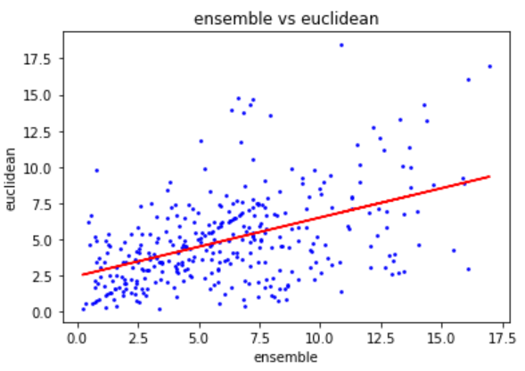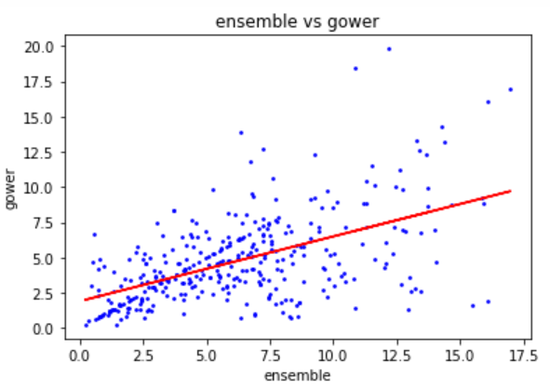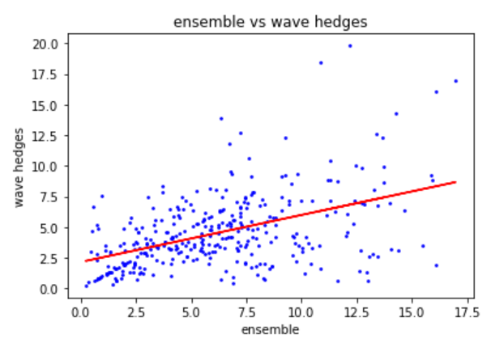

If the points on the scatter plot are very close to the regression line it means the error on both methods is very similar but, in this case, we can see a remarkable dispersion. The points over the line indicate a better performance of the ensemble and the ones under the line indicate better performance of the single metric.

I repeated the same test but instead of applying absolute value, I applied the min-max normalization. The results obtained are slightly different:

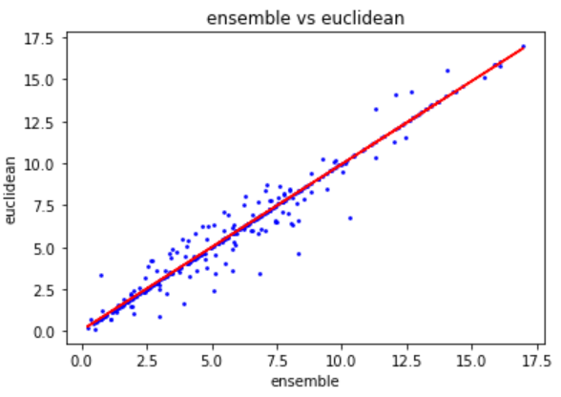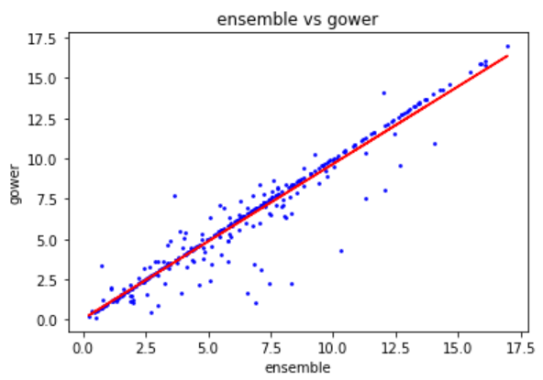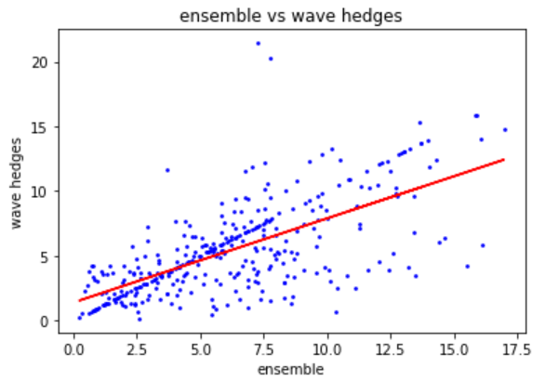

In the first two cases, the data points are closer to the line which means that the average error of the euclidean and gower distance is very similar to the ensemble.

# 6. Conclusions and future works

Aquest capítol ha d’incloure:

* Una descripció de les conclusions del treball: Quines lliçons s’han aprés del treball?.
* Una reflexió crítica sobre l’assoliment dels objectius plantejats inicialment: Hem assolit tots els objectius? Si la resposta és negativa, per quin motiu?
* Una anàlisi crítica del seguiment de la planificació i metodologia al llarg del producte: S’ha seguit la planificació? La metodologia prevista ha estat prou adequada? Ha calgut introduir canvis per garantir l’èxit del treball? Per què?
* Les línies de treball futur que no s’han pogut explorar en aquest treball i han quedat pendents.

# 7. Glossari

Definició dels termes i acrònims més rellevants utilitzats dins la Memòria.

# 8. Bibliografia

Llista numerada de les referències bibliogràfiques utilitzades dins la memòria. A cada lloc on s’utilitzi una referència dins el text, cal indicar-la citant el número de la referència, per exemple: [7].

És molt important incloure **totes** les referències utilitzades i citar-les apropiadament, és a dir, incloent tota la informació necessària per identificar la referència. La informació mínima que cal incloure segons el tipus de referència és:

* **Llibre:** Autors, Títol, Edició (si s’escau) Editorial, Ciutat, Any.
* **Article de revista:** Autors, Títol, Nom de la Revista, Número de Pàgina inicial i final, Número de la revista / Volum, Any.
* **Web:** URL i data en que s’ha visitat.

# 9. Annexos

Llistat d’apartats que són massa extensos per incloure dins la memòria i tenen un caràcter autocontingut (per exemple, manuals d’usuari, manuals d’instal·lació, etc.)

Depenent del tipus de treball, és possible que no calgui afegir cap annex.