Algonquin College Logo

# SCHOOL OF ADVANCED TECHNOLOGY

### ICT - Applications & Programming

### Computer Engineering Technology – Computing Science



A11

Computer Science Challenge

Lab Professor / Lab Session:

Paulo Sousa / 302

Team:

Vicente Mba Engung - Id: 041029226

CS Challenge 1: Cellular Automata

|  |  |
| --- | --- |
| **Part**  **1** | **Implementing CA** |

**Note 1: Read Specification**

*This is only a suggested template. Please check instructions in the A11 specification.*

* 1. **Example UC Solution**

**UC Diagram** (change this diagram to accommodate the actors and functionalities to be used):



**Actors table** (example):

|  |  |
| --- | --- |
| **Actors** |  |
| User | The primary actor who interacts with the CA, including initializing, defining rules, running, pausing, and resetting the automaton. |
| CA System | Represents the CA itself, responsible for executing the CA rules and managing its state. |

**UC table** (example):

|  |  |
| --- | --- |
| **Use Cases** |  |
| Initialize CA | This use case describes how the CA is initialized, including defining the grid size, setting initial states, and specifying boundary conditions. |
| Defined Rules | Users may need to define and update rules for the CA. |
| Run CA | Describes how the CA is started and runs over time, updating cell states according to the defined rules. |
| Pause/Resume CA | Allows users to pause and resume the CA's execution. |
| Reset CA | This use case resets the CA to its initial state. |
| User Interaction | Covers various user interactions like drawing on the grid, changing cell states, and adjusting visualization parameters. |

**Details**

*Functionalities such as the* ***rule definition*** *or* ***initial configuration,*** *are manually defined by the user while core components such as* ***local interaction*** *or* ***iteration*** *are automatic.*

*The relationship between actors and functionalities is the interaction with the CA to influence its behaviors.*

* 1. **Visual Components**

**Main Window / Basic interface**

* ***JFrame:*** *used for creating graphical user interfaces (GUIs).*
* ***JPanel:*** *used to organize and group components within a graphical user interface (GUI).*
* ***JLabel:*** *displays a static text or an image.*
* ***JComboBox:*** *shows a drop-down list of all labs.*
* ***JButton:*** *creates all required buttons.*

Example:

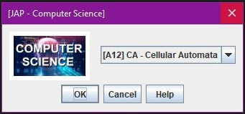

**CA Implementation**

*The following are the elements required to define a Cellular Automata (CA):*

* ***Grid:*** *The primary visual component is a grid, which represents the cells of the automaton.*
* ***Cell States:*** *Define the different states that each cell can be in.*
* ***Update Rules:*** *Define the rules that govern how the states of cells change over time.*
* ***Boundaries:*** *Decide how the grid behaves at its edges.*
* ***Initialization:*** *Determine how the initial state of the grid is set.*

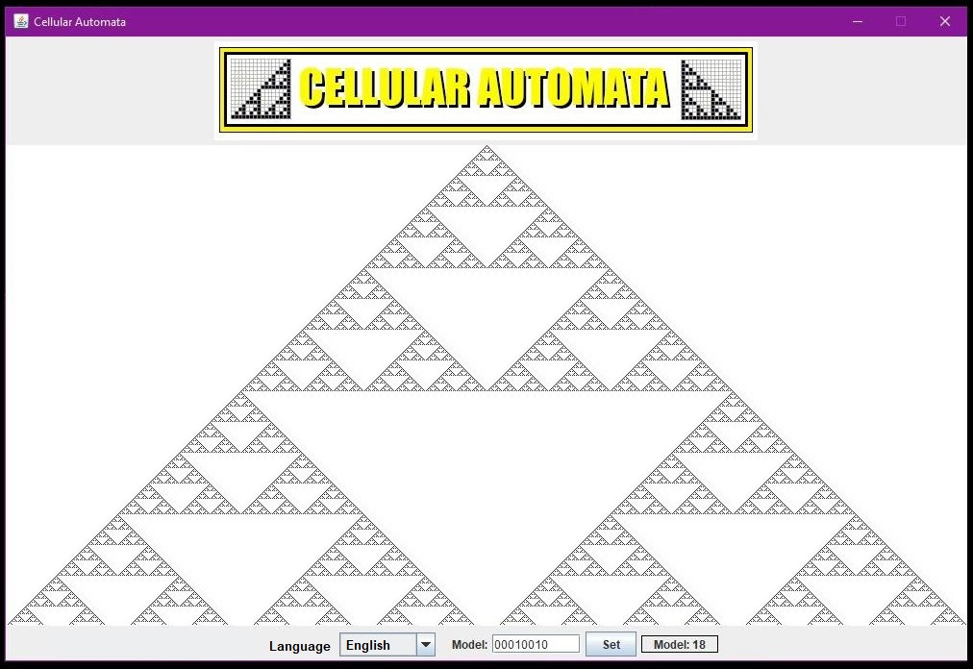

**Languages**

*The Cellular Automata will feature two languages:* ***English*** *as the default language for the program and* ***French*** *as the secondary language.*

**FINAL SUGGESTIONS**

**References**

|  |  |
| --- | --- |
| [1] | R. Awati, "TechTarget," [Online]. Available: https://www.techtarget.com/searchenterprisedesktop/definition/cellular-automaton#:~:text=A%20cellular%20automaton%20(CA)%20is,the%20states%20of%20neighboring%20cells.. [Accessed 13 09 2023]. |
| [2] | Wikipedia, "Cellular automaton," [Online]. Available: https://en.wikipedia.org/wiki/Cellular_automaton. [Accessed 13 09 2023]. |

|  |  |
| --- | --- |
|  | * ***NOTE****: Even if you use any AI tool (ex: ChatGPT), report here, including the references used.* |

Algonquin College

Fall, 2023