TaBle of Contents

General description 2
Specification 2
Installation, system requirements 2
Hardware settings 2
Development environment 3
Conventions 3
Source files 4
Class diagram 5
Realisation 6
Global variables 6
Path of the database file 6
Path of the result file 6
Name of table used by dataset 6
Informative string type variables 6
Int type variable which shows the current application 7
Bool type variable in charge of correctly filled fields 7
PictureBox type variable appearing for incorrectly filled fields 7
Constructor 8
Event handlers 9
Main application’s event handlers 9
Event handler located in the navigation bar 10
Validators 10
Event handlers assigned to keys 11
Other event handlers 12
Functions 14
setButtonsEnable() 14
Add() 14
AllControllsValidator() 14
Save() 15
Move() 15
Back() 15
Write() 15
AlphaPressed() 16
ExportData() 16
DeleteData() 16

General description

Specification

MSI is an application to help the survey of competitor stores’ prices, keeping record of each own stores inventory, price-labels, and recording of goods reception. Requirements:
- Simplify the process of data recording as far as possible, while exploiting the user interface of MS Windows.
- Both touch-screen and keyboard navigation must be possible.
- Make data recording and reloading possible.
- Make saving possible in a specific format that is compatible with SAP.

Installation, system requirements

Running of the application requires .NET Compact Framework that is contained by the operating system of the Symbol MC3090 device.
The application can be executed on Windows CE 5.0. There are no further hardware requirements that of the operating system.

Hardware settings

After navigating Device\SCANWEDGE\Config\Setup ScanWedge Example form can be seen. The following configurations are necessary

- allow escapes – not checked
- prefix to send – type ’z’
- send barcode – checked
- don’t treat- not checked
- suffix to send – empty
- send enter – checked
- send Tab – not checked
- send keys – not checked
Finally press button „Ok”.

Development environment
The application was developed in C#, using development environment Visual Studio .NET 2005 with compact framework, under operating system Windows XP.

Conventions

- The source code’s language is English.
- The name of the global variable is type_variablename, if it is necessary type_variableName.
- The name of the local variable is l_ variablename, if it is necessary l_variableName.
- The name of functions are Functionname(), or FunctionName().
- The name of the function’s parameters is p_ parametername, if it is necessary p_parameterName.
- The controlls name used on Form1 type_parentpanel_name.
- The name of event handlers are EventSender_name_Event().
- The interface’s language is Romanian.

Source files

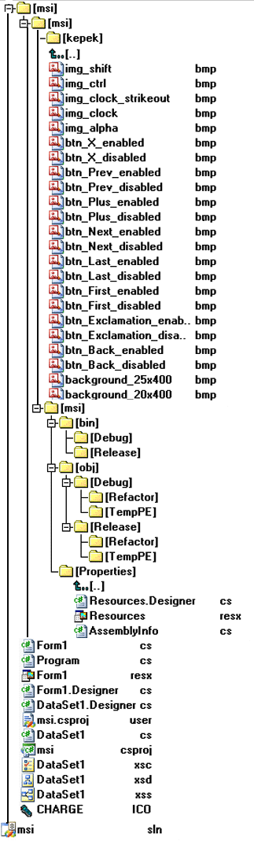

Class diagram
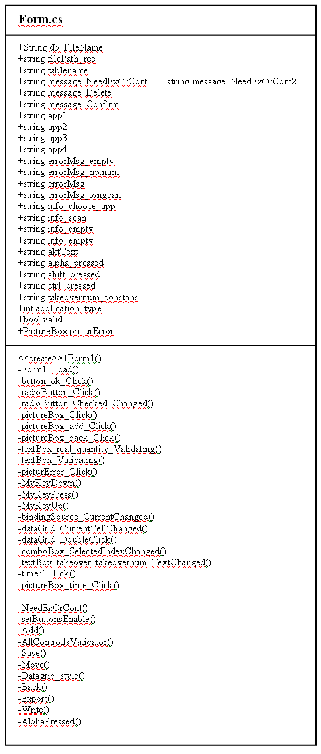

Realisation

Below is the introduction of realisation of the file Form1.cs, which contains the list and detailed description of the constructor, event handlers and functions.

Global variables

Path of the database file
String db_FileName = "Application/XMLdatabase.txt";

Path of the result file
string filePath_rec = "Application/recep.txt";

Name of table used by dataset
string tablename;

Informative string type variables
string message_NeedExOrCont = ""Exista deja date in optiunea "
string message_NeedExOrCont2 = "!";
string message_Delete = "Doriti sa stergeti toate datele?";
string message_AllDeleted = "Toate datele au fost sterse din MSI!";
string message_noexport = "Nu exista date, selectati o optiune!";

string app1 = "'Pret concurenta'";
string app2 = "'Stoc produse'";
string app3 = "'Pret etichete'";
string app4 = "'Receptie'";

string errorMsg_empty = "Completati toate campurile!";
string errorMsg_notnum = "Nu este un numar!";
string errorMsg = "";
string errorMsg_longean = "Atentie: max 13 cifre!";
string errorMsg_longprice = "Atentie: max 7.2 cifre!";
string errorMsg_longprice2 = "Atentie: max 4.3 cifre!";
string errorMsg_notdigit = "it can be between 0-9!";
string errorMsg_notpositiv = "Numai numere pozitive!";

string info_choose_app = "Alegeti o optiune!";
string info_scan = "In acest camp nu se scaneaza!";
string info_empty = "Inregistrare incompleta!! Doriti sa o corectati?";

string aktText = "";
string alpha_pressed = "Este apasat butonul ALPHA";
string shift_pressed = "Este apasat butonul SHIFT";
string ctrl_pressed = "Este apasat butonul CTRL";

Int type variable which shows the current application
int application_type = 0;

Bool type variable in charge of correctly filled fields
bool valid = false;

PictureBox type variable appearing for incorrectly filled fields
PictureBox picturError = new PictureBox();

Constructor

public Form1()
{
InitializeComponent();
picturError.Size = new Size(30, 30);
picturError.Image = imageList_buttons.Images[2];
picturError.Click += new System.EventHandler(this.picturError_Click);
}

pictureError variable is defined in constructor which is responsible for displaying a red exclamation mark behind incorrectly filled fields. Additional properties are granted in the validation functions (for example: location, parent component).

Event handlers

private void Form1_Load(object sender, EventArgs e)

Occurs whenever the user loads the form. Dataset is being filled by loading Form1 with the data previously stored in MSI which can be found in the file referred by db_FileName variable.
If the file referred by db_FileName variable does not exist the dataset scheme is written to the file.
Following this the dataset tables are examined by a condition consisting of five parts. If any of the tables is not empty, values of application_type and tablename global variables are set, and the radiobutton’s property corresponding to current application (mode) is set to true. If all of the tables are empty, application_type variable gets a zero value, which means that the user can choose from any appolication hereafter and the first radiobutton is also checked. At last the text and clock on status bar are set.

Main application’s event handlers

Occurs when the button_ok located in the panel_application is clicked. If the application_type global variable is not zero (which means that the there is some data in any of the tables in the dataset) and is not equal to the value of the radiobutton corresponding to this variable, an error message is displayed by calling NeedExOrCont() function. If this condition is not true and the radiobutton in charge of downloading is not focused, visibility properties of appropriate panels and the application_type variable are set. After this the enabled property of navigation buttons located at panel_navigator are set by calling the setButtonsEnable(bindingSource_...) function. Finally a new empty row is inserted in the actual binding source by calling the Add() function. If the last radiobutton is selected and there are data to download (radioButton_download) the panel_export controlls will be visible.

private void radioButton_Click(object sender, EventArgs e)
Occur when any radiobutton is clicked. The event handler’s only function is to give the focus back to the button_ok control located in panel_applicatin.

private void radioButton_Checked_Changed(object sender, EventArgs e)
Occur whenever any radiobutton’s ‘checked’ property changes value. The event handler’s only function is to give the focus back to the button_ok control located in panel_application.

Event handler located in the navigation bar

private void pictureBox_Click(object sender, EventArgs e)
The pictureBox_first, pictureBox_prev, pictureBox_next, pictureBox_last, and pictureBox_delete controls (located in panel_navigation) are assigned to this event handler, called by clicking the mentioned controls. Depending on actual application it calls the Move(1par, sender) function with the corresponding bindingSource parameter(1par), and with it’s own object type parameter.

private void pictureBox_add_Click(object sender, EventArgs e)
The pictureBox_add, located in panel_navigation is assigned to this event handler, called by clicking the control. Functions: checks if the controls of the actual panel contains correct data by calling AllControllsValidator() function, and then calls the Save(), and Add() functons.

private void pictureBox_back_Click(object sender, EventArgs e)
The pictureBox_back, located in panel_navigation is assigned to this event handler, called in the one hand by clicking the control, on the other hand by pressing button “Esc”. It has only one function: call the Back() function.

Validators

private void textBox_real_quantity_Validating(object sender, CancelEventArgs e)
Occur when the textBox_real_quantity control, located in panel_real, is being validated. The control is valid, if its text property value is less then 1’000’000 and it has a maximum of three decimals.

private void textBox_Validating(object sender, CancelEventArgs e)
Occur when the other textbox type controls (these are: texBox_con_ean, texBox_con_price, texBox_real_ean, texBox_label_ean, texBox_label_price, texBox_takeover_ean, texBox_takeover_price, texBox_takeover_takeovernum) are being validated. The control is valid, if its text property value is less then 10’000’000 and it has a maximum of two decimals.

private void picturError_Click(object sender, EventArgs e)
Occur whenever picture_Error control is clicked. The event handler has only one function: show an error message for the error made by the user.

Event handlers assigned to keys

private void MyKeyDown(object sender, KeyEventArgs e)
Occur when a key is first pressed. The button_ok, and all radiobuttons located in panel_application; and textBox and comboBox located in the panel_con, panel_label, panel_real or panel_takeover has this event handler. Function: checks whether the user pressed the „shift”, the „ctrl”, or the red(-) and green(-) keys. If the „shift”, or the „ctrl” key was used, an information message appears on the status bar. If the red(-) or green(-) keys were used the textBox text property value is saved to the akt_text string type global variable.

private void MyKeyPress(object sender, KeyPressEventArgs e)
Occur when the user is finished pressing a key. It has quite a wide range of functions.
If the sender is button_ok, located in panel_application: pressing keys „1-4” displays the panel that is assigned to the chosen application type. If the navigation (↓, ↑, ←, →) keys were used to choose the application, the same effect can be realized by pressing ”enter” key.
If the sender is a control which is located on any application panel (these are: panel_con, panel_label, panel_real, panel_takeover) and the pressed key is the “enter”, then the event handler’s function is to set the focus to the proper control, and save the data typed in by calling the Save() function.
If the pressed key is the “Esc” key and any application panel is visible, then the event handler navigates back to the main application (application_panel) by calling the Back() function.
The button_ok, and all of the radiobutton, located on panel_application; and all of the textbox and comboBox type control, located on any of application panel has this event handler.

private void MyKeyUp(object sender, KeyEventArgs e)
Occur when a key is released. The button_ok, and all of the radiobutton, located on panel_application; and all of the textbox and comboBox type control, located on any application panel has this event handler. Functions: on the one hand it checks whether the user pressed the „shift”, or the „ctrl” keys once again (released, deactivated), on the other hand if the red or green key was released, the actual textbox text property get the akt_text value, which was saved by the MyKeyDown(…) event handler. It is also responsible for the correct behaviour of navigation keys (these are ↓: the next radioButton will selected, if it the last radioButton, then the first radioButton will be selected; ↑: the previously radioButton will be selected, if it is the first radioButton , then the last radioButton will be selected; ←: the first radioButton will be selected; finally →: the last radiobutton will be selected).

Other event handlers

private void dataGrid_CurrentCellChanged(object sender, EventArgs e)
Event raised when the value of the currentcell property is changed on the datagrid. It has only one function: calling Datagrid_style(datagrid). The dataGrid_con, dataGrid_label, dataGrid_real, dataGrid_takeover has this event handler.

private void dataGrid_GotFocus(object sender, EventArgs e)
This event handler is being called when the focus is set on the datagrid. It is responsible for the correct editing of the bindingsource linked to the actual datagrid. When incorrect data is entered, the whole line is deleted. The dataGrid_con, dataGrid_label, dataGrid_real, dataGrid_takeover has this event handler.

private void dataGrid_real_Click(object sender, EventArgs e)
Clicking on control dataGrid_real calls this event handler. If the click was carried out on the second column of the datagrid, the control comboBox_real_devalution’s text property will get the value of the actual datagrid cell.

private void dataGrid_takeover_Click(object sender, EventArgs e)
Clicking on control dataGrid_takeover calls this event handler. A dataGrid_real kontrolra való kattintás hatására hívódó eseménykezelő. If the click was carried out on the first column of the datagrid, the control textBox_takeover_takeovernum will be visible, otherwise invisible.

private void dataGrid_DoubleClick(object sender, EventArgs e)
Occur when the control is double-clicked. Its function is to set the focus to the control of which text property contains the data that the current cell has. The dataGrid_con, dataGrid_label, dataGrid_real, dataGrid_takeover has this event handler.

private void comboBox_SelectedIndexChanged(object sender, EventArgs e)
Occur whenever the “SelectedIndex” property of the comboBox_con_storecode, located on panel_con, and the comboBox_real_devaluation, located on panel_real changes. The event handler’s function is to save the selected item values to the text property of right label.

private void textBox_takeover_takeovernum_TextChanged(object sender, EventArgs e)
Event raised when the value of the Text property is changed on textBox_takeover_takeovernum control, located on panel_takeover. The event handler’s function is to save the controls text property values, and overwrite all rows’ first cell with this value in the takeover table of dataset.

private void timer1_Tick(object sender, EventArgs e)
Occur in every minute, and it overwrites the label_time text property’s value to the correct system time.
The label_time is located in the status bar)

private void pictureBox_time_Click(object sender, EventArgs e)
Occur when pictureBox_time controls, located on the status bar is clicked; on the first click it stops the timer and show on the status bar that the timer is not running. On the second click it starts the timer again, and shows it on the status bar.

Functions

setButtonsEnable()
private void setButtonsEnable(BindingSource p_bindingSource_akt)
This function is in charge of enabling all the navigation buttons (first, previous, next, last, delete) properly. The enable property of these buttons depends on the item count in the dataset:
- first is active, if the selected item is not the first one
- previous is active, if the selected item is not the first one
- next is active, if the selected item is not the last one
- last is active, if the selected item is not the last one
- delete is active, if the actual data table has more than one items
- the label_count controls, showing the position of current item, its text is: „current position” of „all items”
This function can be called from the button_ok_Click(…), bindingSource_CurrentChanged(…) event handlers and from the Add() and Move() functions.

Add()
private void Add()
Depending on which application is being used (shown by value of application_type) it gives a new empty row to the actual bindingsource, then recounts the height and width of the actual datagrid by calling the Datagrid_style(datagrid_...) function, and finally calls the setButtonsEnabled(bindingSource_...) function to correct the navigation buttons’ enable property.
This function can be called from the button_ok_Click(…), pictureBox_add_Click(…), and the MyKeyPress(…) event handlers.

AllControllsValidator()
private bool AllControllsValidator()
This function is responsible for populating all controls of the actual panel correctly. It calls the actual control’s Validating(…) event handler by changing the focus. If any error was found, an error message would be sent about it, and the user gets two options: correct the data or delete the current row. If the correction option is chosen, the control to be modified would be selected. For the other choice the current row would be deleted and the Datagrid_style(datagrid_...) function would be called.
This function is called from the pictureBox_add_Click(…) event handler, and from the Move() and the Back() functions.

Save()
private void Save()
This function is in charge of saving one row. Calling from the pictureBox_add_Click(…), textBox_takeover_takeovernum_TextChanged(…), and the MyKeyPress(…) event handlers, and the Move(…) and the Back() functions.

Move()
private void Move(BindingSource p_bindingSource_akt, object p_sender)
The function is in charge of the correct behaviour of buttons, located in panel_navigation. If the sender is the delete button (pictureBox_delete), and deletion is allowed, then it will delete the current row, and then calls the Datagrid_style(datagrid_...) and setButtonsEnable() function. If the sender is not the delete button, then it checks by calling the AllControllsValidator() function if all controls of the actual application panel were filled correctly. If everything is ok then the the first, previous, next, or last row would be selected depending on which button was used. This function can be called from pictureBox_Click(…) event handler.

Back()
private void Back()
This function is in charge of navigation back to the main application (panel_application). It checks by calling the AllControllsValidator() function if all controls of the actual application panel were filled correctly, then saves the data. After all, it sets the panels visibility settings, and if it is neccesary (the actual table of the datasaet is empty) corrects the application_type global variable value.
This function is called from the pictureBox_back_Click(…), and the MyKeyPress(…) event handlers.

Write()
private void Write()
This function is in charge of writing the result file with the correct format depending on the application. This function is called only from the ExportData() function.

AlphaPressed()
private bool AlphaPressed(int p_key_char)
This function is in charge of checking if the „alpha” key was pressed on the keypad of the PDA. It has a string type local variable called prev_text, in which the text of the status bar is saved. If the “alpha” key is pressed again, then the text of the status bar gets the prev_text value. The key pressing can not be handled directly, because the .NET does not know the keyChar value of this key! Accordingly it is handled by checking the keyChar of the other keys.
This function is called from the MyKeyPress(…) event handler.

ExportData()
private void ExportData()
This function is responsible for the exportation of recorded data. It can only be called by clicking on button button_export_ok after selecting control radioButton_export_export placed on panel export_panel. First, the function prepares the appropriate result file by calling the Write() function. If it was successful, it creates the file written.txt. After this it sends a message about successful download, then calls the DeleteData() function, that is responsible for data deletion.

DeleteData()
private void DeleteData()
This function is responsible for the deletion of recorded data. It can be called by two means: 1. clicking on button button_export_ok after selecting control radioButton_export_export placed on panel export_panel, 2. fuction ExportData(). First it sends a confirmation message to the user, if he really wants to delete recorded data. If the answer is “No”, then the program navigates back to the main application. Otherwise the program deletes the contents of the dataset, sets the value of variable application_type to nil, and navigates back to the main application.

