**echaurren**

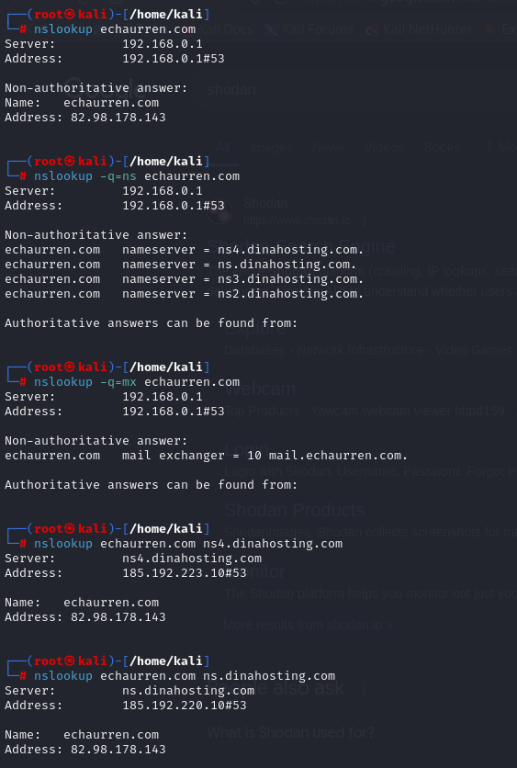

Whois

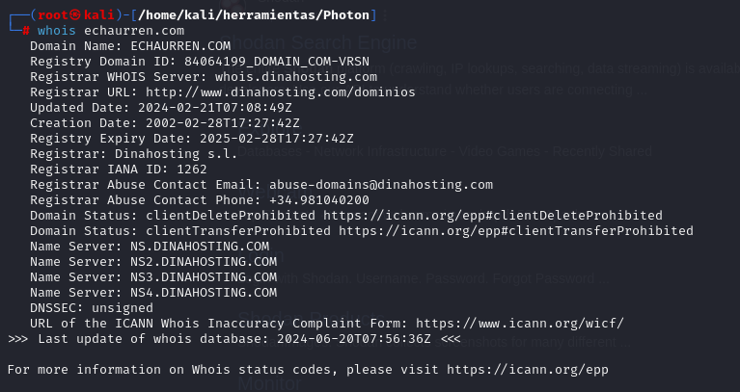

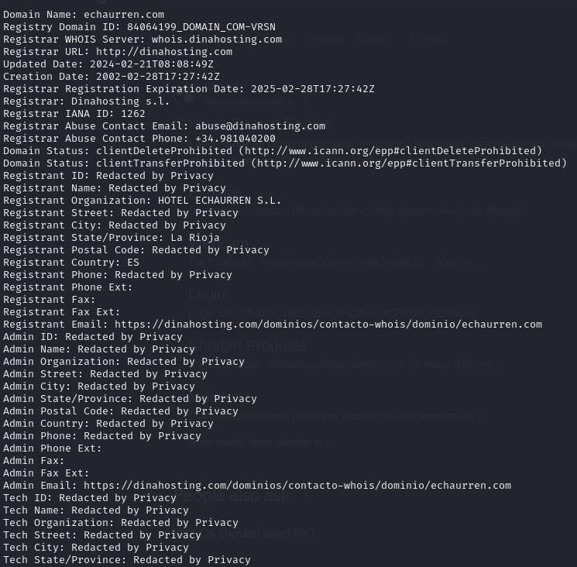

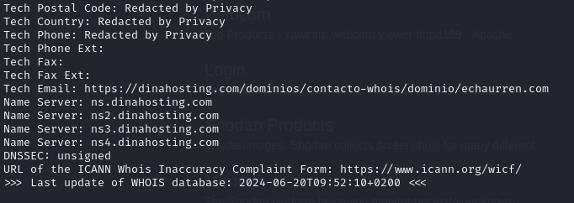

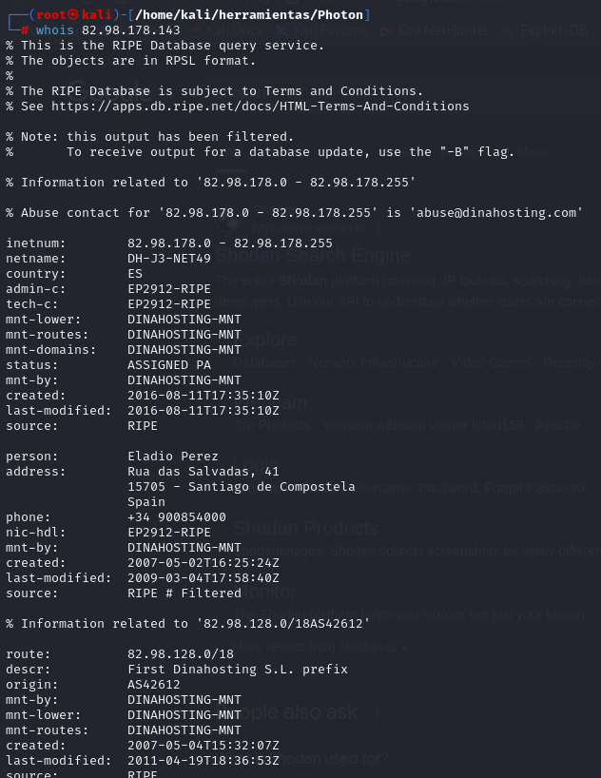

Photo

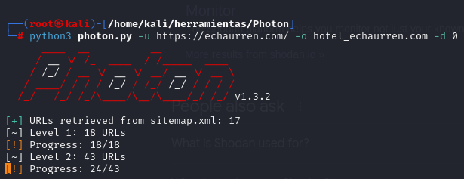

https://cookiedatabase.org/tcf/purposes/

https://c809f281.sibforms.com/serve/MUIEAGVaNaYwHc8XmKl4iZHKfr4XULeLOzL9NQlujHfmebwBopSF1PHu5KILwZLaZDIeRl-UbiA44gCaMTMzHqKhK3-SS4xGrsBb_BOZI7E9qBueHzvLIOvjh6nBRiCBRls86MPcgrDa_EAAoc1rfZxbNN0cYCeo4bwj8Fd-FRkp_uI0aehI7dClznL5kykAJo3-UndKCKxREUNV

http://open.spotify.com/user/ulb82urhfgvsfmu8ts1n76mmd

http://sedeagpd.gob.es/sede-electronica-web/

https://support.mozilla.org/en-US/kb/cookies-information-websites-store-on-your-computer

http://goo.gl/maps/JGEvUsnybTH6c4q28

https://support.apple.com/en-ie/guide/safari/sfri11471/mac

https://support.microsoft.com/en-us/windows/delete-and-manage-cookies-168dab11-0753-043d-7c16-ede5947fc64d

https://support.microsoft.com/en-us/microsoft-edge/delete-cookies-in-microsoft-edge-63947406-40ac-c3b8-57b9-2a946a29ae09

https://support.google.com/chrome/answer/95647?hl=en&amp;co=GENIE.Platform%3DDesktop

https://echaurren.com/wp-content/uploads/4.-SteakTartar_EchaurrenTraidicon.jpg

/pdfs/cartas/tradicion_menu_degustacion_frances.pdf

https://echaurren.com/wp-content/uploads/el_portal_menu_degustacion_frances-1.pdf

https://echaurren.com/wp-content/uploads/5.desayuno.jpg

https://echaurren.com/wp-content/uploads/5.ElPortaldeEchaurren.jpg

https://echaurren.com/wp-content/uploads/5.Helado_ElPortaldeEchaurren.jpg

https://echaurren.com/wp-content/uploads/5._HZM0641.jpg

/pdfs/cartas/el_cuartito_ingles_frances.pdf

https://echaurren.com/producto/experiencia-gastronomica-echaurren-tradicion/?add-to-cart=2909

https://echaurren.com/producto/experiencia-escapada-tradicion/?add-to-cart=2907

https://echaurren.com/producto/experiencia-gastronomica-el-portal-de-echaurren/?add-to-cart=2916

https://echaurren.com/producto/experiencia-escapada-el-portal-de-echaurren/?add-to-cart=2907

https://echaurren.com/producto/experiencia-gastronomica-echaurren-tradicion/?add-to-cart=6209

https://echaurren.com/producto/experiencia-gastronomica-el-portal-de-echaurren/?add-to-cart=2907

https://echaurren.com/producto/experiencia-escapada-el-portal-de-echaurren/?add-to-cart=2909

https://echaurren.com/producto/experiencia-dos-dias-gastronomicos/?add-to-cart=2917

https://echaurren.com/producto/experiencia-gastronomica-echaurren-tradicion/?add-to-cart=2914

https://echaurren.com/producto/experiencia-gastronomica-echaurren-tradicion/?add-to-cart=2907

https://echaurren.com/producto/experiencia-escapada-el-portal-de-echaurren/?add-to-cart=6209

https://echaurren.com/producto/experiencia-dos-dias-gastronomicos/?add-to-cart=2919

https://echaurren.com/producto/experiencia-escapada-tradicion/?add-to-cart=2919

https://echaurren.com/producto/experiencia-gastronomica-el-portal-de-echaurren/?add-to-cart=2917

https://echaurren.com/producto/experiencia-escapada-tradicion/?add-to-cart=2911

https://echaurren.com/producto/experiencia-escapada-el-portal-de-echaurren/?add-to-cart=2917

https://echaurren.com/producto/experiencia-gastronomica-el-portal-de-echaurren/?add-to-cart=2909

https://echaurren.com/producto/experiencia-escapada-tradicion/?add-to-cart=2916

https://echaurren.com/producto/experiencia-dos-dias-gastronomicos/?add-to-cart=2916

https://echaurren.com/producto/experiencia-dos-dias-gastronomicos/?add-to-cart=2907

https://echaurren.com/experiencias//producto/experiencia-gastronomica-el-portal-de-echaurren/

https://echaurren.com/producto/experiencia-gastronomica-echaurren-tradicion/?add-to-cart=2909

https://echaurren.com/trabaja-con-nosotros/

https://echaurren.com/producto/experiencia-gastronomica-echaurren-tradicion/?add-to-cart=6209

https://echaurren.com/a-casa//contacto/

https://echaurren.com/politica-de-privacidad/tel:941354047

https://echaurren.com/en/work-with-us/

https://echaurren.com/en//en/contact/

https://echaurren.com/en/contact/tel:+34941354047

https://echaurren.com/producto/experiencia-gastronomica-echaurren-tradicion/?add-to-cart=2907

https://echaurren.com/en/gastronomy//en/a-casa/

https://echaurren.com/experiencias/

https://echaurren.com/en/a-casa//en/contact/

https://echaurren.com/trabaja-con-nosotros/tel:941354047

https://echaurren.com/mailto:

https://echaurren.com/producto/ambientador-para-casa/

https://echaurren.com/a-casa/tel:941

https://echaurren.com/a-casa.html

https://echaurren.com/tapas.html

https://echaurren.com/restaurante-bistro-el-cuartito/

https://echaurren.com/gastronomia//contacto/

https://echaurren.com/a-casa/tel:941354047

https://echaurren.com/ezcaray-2/

https://echaurren.com/producto/experiencia-gastronomica-el-portal-de-echaurren/?add-to-cart=2916

https://echaurren.com/restaurante-bistro-el-cuartito//contacto/

https://echaurren.com/gastronomia.html

https://echaurren.com/en/a-casa/tel:941

https://echaurren.com/producto/experiencia-gastronomica-echaurren-tradicion/tel:941354047

https://echaurren.com/producto/experiencia-escapada-el-portal-de-echaurren/?add-to-cart=2909

https://echaurren.com/tel:+34

https://echaurren.com/politica-de-privacidad/

https://echaurren.com/en/product/el-portal-de-echaurren-gastronomic-experience/

https://echaurren.com/en/experiencies//en/contact/

https://echaurren.com/producto/kit-regalo-echaurren/

https://echaurren.com/producto/experiencia-dos-dias-gastronomicos/?add-to-cart=2919

https://echaurren.com/en/contact/tel:+34

https://echaurren.com/producto/experiencia-escapada-tradicion/?add-to-cart=2911

https://echaurren.com/experiencias//producto/experiencia-escapada-tradicion/

https://echaurren.com/experiencias//contacto/

https://echaurren.com/en/contact//en/contact/

https://echaurren.com/producto/experiencia-gastronomica-el-portal-de-echaurren/?add-to-cart=2909

https://echaurren.com/en/the-echaurren-family//en/contact/

https://echaurren.com/producto/experiencia-dos-dias-gastronomicos/?add-to-cart=2907

https://echaurren.com/en/the-echaurren-family/tel:+34941354047

https://echaurren.com/en/contact/mailto:

https://echaurren.com/producto/libro-hecho-en-casa/

https://echaurren.com/en/gastronomy/tel:+34941354047

https://echaurren.com/en/experiencies//en/product/tradicion-getaway-experience/

https://echaurren.com/producto/experiencia-escapada-el-portal-de-echaurren/?add-to-cart=2907

https://echaurren.com/producto/delantal-echaurren/

https://echaurren.com/boutique/

https://echaurren.com/producto/pol-contreras-chocolates/

https://echaurren.com//ezcaray-2//contacto/

https://echaurren.com/en/legal-warning/tel:+34941354047

https://echaurren.com/ezcaray//contacto/

https://echaurren.com/a-casa/mailto:**info@echaurren.com**

https://echaurren.com/en/cookies-policy/

https://echaurren.com/en/legal-warning//en/contact/

https://echaurren.com/en/gastronomy/

https://echaurren.com/producto/experiencia-gastronomica-el-portal-de-echaurren/

https://echaurren.com/producto/experiencia-escapada-tradicion/tel:941354047

https://echaurren.com/producto/experiencia-escapada-tradicion/?add-to-cart=2919

https://echaurren.com/mailto:susana@echaurren.com

https://echaurren.com/producto/experiencia-gastronomica-el-portal-de-echaurren/?add-to-cart=2917

https://echaurren.com/en/experiencies//en/product/el-portal-de-echaurren-gastronomic-experience/

https://echaurren.com/tel:941354047

https://echaurren.com/en//en/the-echaurren-family/

https://echaurren.com//ezcaray-2/

https://echaurren.com/en/echaurren-tradicion-restaurant/tel:+34941354047

https://echaurren.com/en/privacy-policy/

https://echaurren.com/en/el-portal-de-echaurren-restaurant/

https://echaurren.com/125aniversario.html

https://echaurren.com/en/

https://echaurren.com/el-portal.html

https://echaurren.com/carrito/tel:941354047

https://echaurren.com/gastronomia/tel:941354047

https://echaurren.com/contacto//contacto/

https://echaurren.com/gastronomia/

https://echaurren.com/en/ezcaray/tel:+34941354047

https://echaurren.com/producto/experiencia-dos-dias-gastronomicos/

https://echaurren.com//contacto//contacto/

https://echaurren.com/en/product/echaurren-tradicion-gastronomic-experience/

https://echaurren.com/producto/experiencia-escapada-el-portal-de-echaurren/?add-to-cart=6209

https://echaurren.com/en/legal-warning/

https://echaurren.com//contacto//politica-de-privacidad/

https://echaurren.com/en/product/tradicion-getaway-experience/

https://echaurren.com/a-casa/

https://echaurren.com/en/echaurren-tradicion-restaurant/

https://echaurren.com//contacto/tel:+34

https://echaurren.com/producto/experiencia-escapada-tradicion/?add-to-cart=2916

https://echaurren.com/producto/experiencia-dos-dias-gastronomicos/?add-to-cart=2916

https://echaurren.com/restaurante-el-portal-de-echaurren//contacto/

https://echaurren.com/carrito//contacto/

https://echaurren.com/restaurante-echaurren-tradicion/tel:941354047

https://echaurren.com/aviso-legal/tel:941354047

https://echaurren.com/en/product/the-two-days-of-gastronomy-experience/

https://echaurren.com/experiencias//producto/experiencia-escapada-el-portal-de-echaurren/

https://echaurren.com/producto/cuchillo-de-cocina-echaurren/

https://echaurren.com/trabaja-con-nosotros.html

https://echaurren.com/en/bistro-el-cuartito-restaurant/

https://echaurren.com/bistro.html

https://echaurren.com/condiciones-generales-de-compra/

https://echaurren.com/trabaja-con-nosotros//contacto/

https://echaurren.com/en/legal-warning/tel:941354047

https://echaurren.com/tradicion.html

https://echaurren.com/producto/experiencia-escapada-el-portal-de-echaurren/

https://echaurren.com/

https://echaurren.com

https://echaurren.com/en/contact/

https://echaurren.com/producto/experiencia-escapada-el-portal-de-echaurren/tel:941354047

https://echaurren.com/en//en/ezcaray/

https://echaurren.com/trabaja-con-nosotros/mailto:**susana@echaurren.com**

https://echaurren.com/la-arboleda.html

https://echaurren.com//familia-echaurren/tel:941354047

https://echaurren.com/politica-de-cookies/tel:941354047

https://echaurren.com/contacto//politica-de-privacidad/

https://echaurren.com/contacto/tel:+34

https://echaurren.com/producto/historia-de-ezcaray-cuaderno/

https://echaurren.com/en/general-conditions-of-sale/

https://echaurren.com/en/tel**:+34941354047**

https://echaurren.com/contacto.html

https://echaurren.com/restaurante-el-portal-de-echaurren/tel:941354047

https://echaurren.com//contacto/

https://echaurren.com/carrito/

https://echaurren.com/en/work-with-us/mailto:**susana@echaurren.com**

https://echaurren.com/experiencias//producto/experiencia-dos-dias-gastronomicos/

https://echaurren.com/politica-de-cookies/

https://echaurren.com/gastronomia//a-casa/

https://echaurren.com/restaurante-echaurren-tradicion/

https://echaurren.com/producto/experiencia-dos-dias-gastronomicos/?add-to-cart=2917

https://echaurren.com/en/the-echaurren-family/

https://echaurren.com/en/cookies-policy//en/contact/

https://echaurren.com/politica-de-cookies//contacto/

https://echaurren.com/producto/experiencia-gastronomica-el-portal-de-echaurren/tel:941354047

https://echaurren.com/aviso-legal.html

https://echaurren.com/en/gastronomy//en/contact/

https://echaurren.com/en/cart/

https://echaurren.com/familia-echaurren/tel:941354047

https://echaurren.com/producto/experiencia-escapada-el-portal-de-echaurren/?add-to-cart=2917

https://echaurren.com/en/product/el-portal-de-echaurren-giveaway-experience/

https://echaurren.com/ezcaray/tel:941354047

https://echaurren.com/restaurante-echaurren-tradicion//contacto/

https://echaurren.com//contacto/tel:941354047

https://echaurren.com/ezcaray-2/tel:941354047

https://echaurren.com/politica-de-privacidad//contacto/

https://echaurren.com/contacto/mailto:

https://echaurren.com//ezcaray-2/tel:941354047

https://echaurren.com/en/experiencies//en/product/the-two-days-of-gastronomy-experience/

https://echaurren.com/aviso-legal//contacto/

https://echaurren.com/producto/cena-jazz-echaurren/

https://echaurren.com/familia-echaurren/

https://echaurren.com/en/a-casa/

https://echaurren.com/en/experiencies//en/product/el-portal-de-echaurren-giveaway-experience/

https://echaurren.com//contacto/mailto:

https://echaurren.com/producto/experiencia-gastronomica-el-portal-de-echaurren/?add-to-cart=2907

https://echaurren.com/en/cookies-policy/tel:+34941354047

https://echaurren.com/ezcaray/

https://echaurren.com/producto/experiencia-gastronomica-echaurren-tradicion/?add-to-cart=2914

https://echaurren.com/en/ezcaray//en/contact/

https://echaurren.com/producto/experiencia-escapada-tradicion/

https://echaurren.com//familia-echaurren//contacto/

https://echaurren.com/producto/experiencia-gastronomica-echaurren-tradicion/

https://echaurren.com/familia-echaurren//contacto/

https://echaurren.com/en/echaurren-tradicion-restaurant//en/contact/

https://echaurren.com/contacto/tel:941354047

https://echaurren.com/experiencias//producto/experiencia-gastronomica-echaurren-tradicion/

https://echaurren.com/contacto/

https://echaurren.com/en/contact//en/privacy-policy/

https://echaurren.com/experiencias/tel:941354047

https://echaurren.com/tel:941

https://echaurren.com/en/experiencies/

https://echaurren.com//familia-echaurren/

https://echaurren.com/mailto:info@echaurren.com

https://echaurren.com/producto/experiencia-escapada-tradicion/?add-to-cart=2907

https://echaurren.com/cookies.html

https://echaurren.com/experiencias.html

https://echaurren.com/aviso-legal/

https://echaurren.com/en/ezcaray/

https://echaurren.com/ezcaray.html

https://echaurren.com/familia-echaurren.html

https://echaurren.com/en/a-casa/mailto:info@echaurren.com

https://echaurren.com/condiciones-generales-de-compra/tel:941354047

https://echaurren.com/producto/experiencia-dos-dias-gastronomicos/tel:941354047

https://echaurren.com/restaurante-el-portal-de-echaurren/

https://echaurren.com/ezcaray-2//contacto/

https://echaurren.com/en/legal-warning/info@echaurren.com

https://echaurren.com/en/experiencies/tel:+34941354047

https://echaurren.com/en/work-with-us//en/contact/

https://echaurren.com/politica-de-privacidad/mailto:protecciondatos@echaurren.com

https://echaurren.com/condiciones-generales-de-compra//contacto/

https://echaurren.com/en/a-casa/tel:+34941354047

https://echaurren.com/restaurante-bistro-el-cuartito/tel:941354047

https://echaurren.com/politica-privacidad.html

https://echaurren.com/en/work-with-us/tel:+34941354047

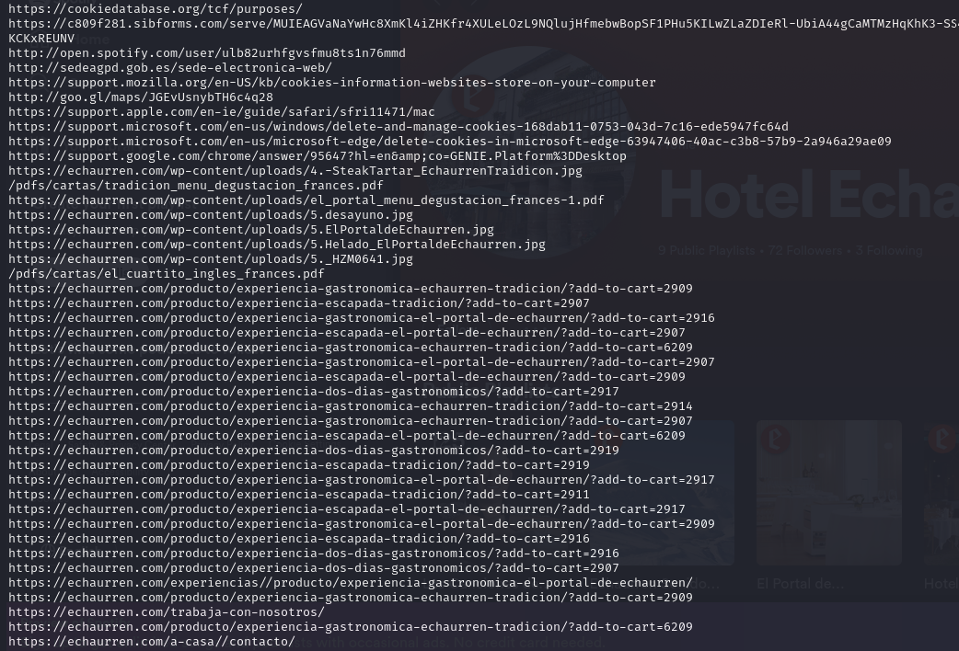

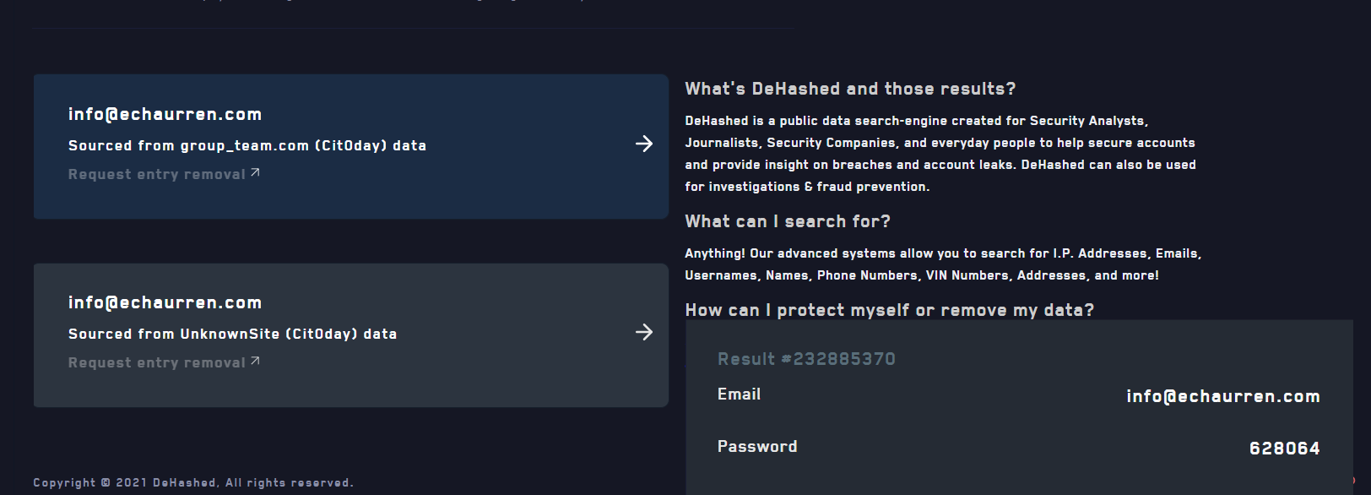

Geolocalización

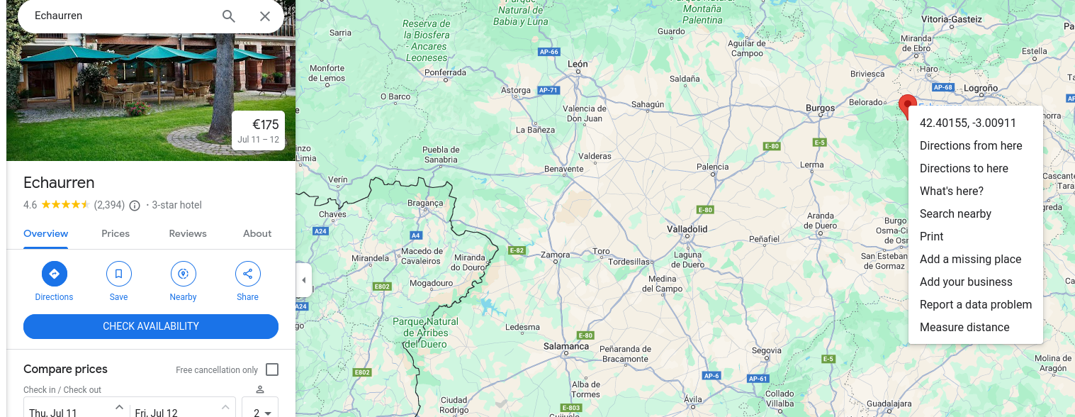

Cuenta de spotify

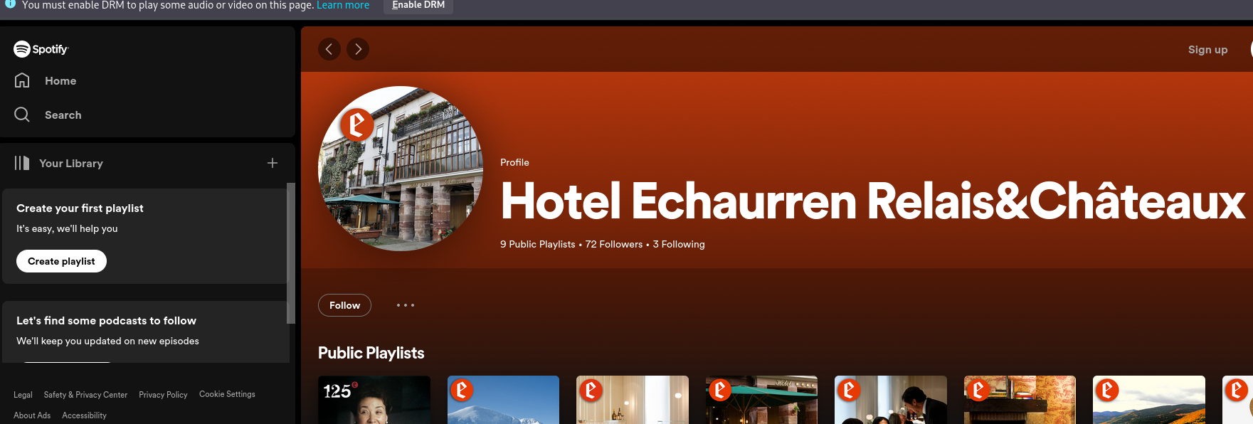

Nombre e imagen

Fraancis Paniego

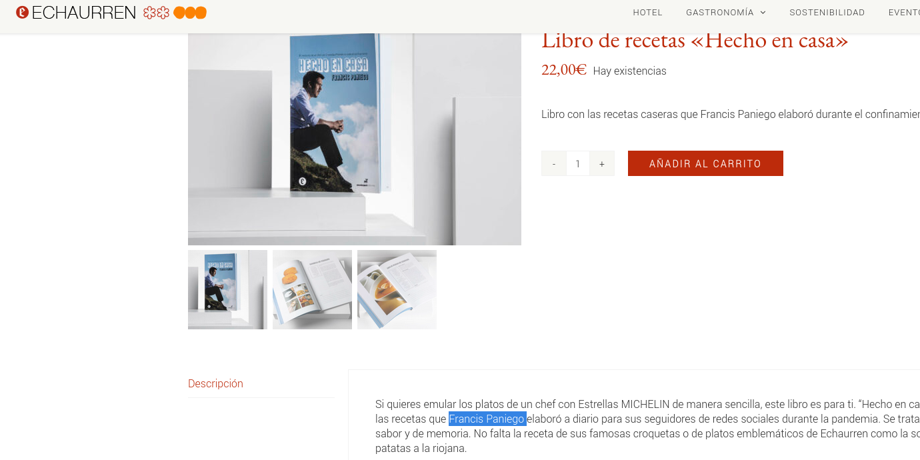

# Usando Amass

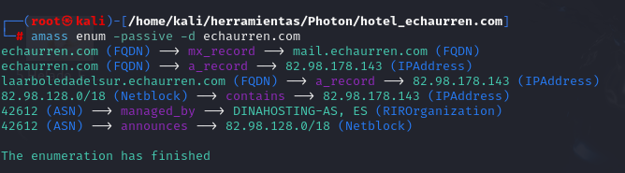

Subdominio nuevo

Laarboledadelsur

**Con la herramienta Photon en modo pasivo, extraemos las url, internas, externasy algún archivo jpg y pdf que ahora pasaremos analizar con exiftool**.

**Exiftool**



