RM 294 – Optimization I

Project 1 – Linear Programming

Advertising | Group 12

Jake Johnson, Ping Zhang, Prakhar Bansal, Vishal Gupta

**Objective**

The problem statement is to recommend the marketing department an optimal budget allocation strategy for different media platforms. Monthly budget available tis $10M which can be spent on 10 different media platforms that can have different Return on Investment (ROI). The final allocation to be recommended should maximize the overall return on investment every month. To arrive at the allocation ROI estimates from two different firms are available for each platform as below -

|  |  |  |  |  |  |  |  |  |  |  |
| --- | --- | --- | --- | --- | --- | --- | --- | --- | --- | --- |
| **Platform** | **Print** | **TV** | **SEO** | **AdWords** | **Facebook** | **LinkedIn** | **Instagram** | **Snapchat** | **Twitter** | **Email** |
| **First Firm's ROI estimates** | 0.031 | 0.049 | 0.024 | 0.039 | 0.016 | 0.024 | 0.046 | 0.026 | 0.033 | 0.044 |
| **Second Firm's ROI estimate** | 0.049 | 0.023 | 0.024 | 0.039 | 0.044 | 0.046 | 0.026 | 0.019 | 0.037 | 0.026 |

The manager, along with the ROI estimates, have added few constraints on the budget allocation based on experience that needs to honored while recommending budget allocations. The three constraints imposed by the manager are below –

1. The amount invested in print and TV should be no more than the amount spent on Facebook and Email. Surprisingly, email seems to be a great channel for reaching real people.
2. The total amount used in social media (Facebook, LinkedIn, Instagram, Snapchat, and Twitter) should be at least twice of SEO and AdWords.
3. For each platform, the amount invested should be no more than $3M.

**Mathematical Formulation**

The business problems will be mathematically formulated as a linear optimization problem with constraints (set by the manager) before programming happens.

The *fraction of total budget allocated to each platform* will be represented as xi, with different i’s representing different platforms from Print to Email. On top of the three constraints provided by the manager, an additional constraint will be required to take into account the fact that overall budget for allocation is $10M. Since the variables considered in the formulation are fractions of the budget and not actual budget, the constraint applicable will be that the sum of all fraction for all the platform should be 1. The constraint equations and overall ROI function are below –

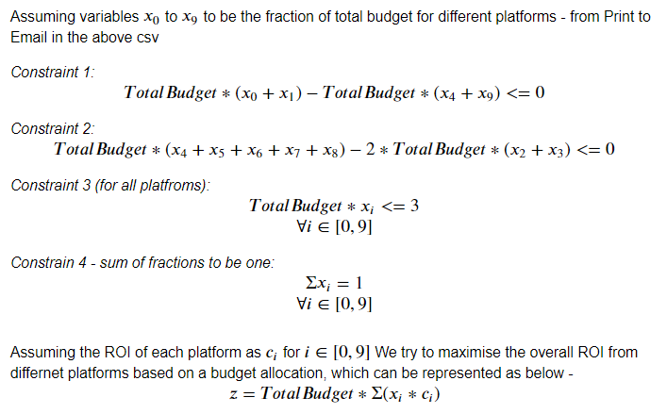Based on the above-mentioned set of equations - constraint matrix A, bounding vector b, and ROI vector c is defined and solved via Gurobi for the two different set of estimates provided.

**Optimal Allocation**

To understand the maximum TODO

*Budget allocation and optimal ROI for First firm's vs Second firm's estimates*

The following questions were posed to understand the allocation and overall ROI differences when using the two different platform’s ROI estimates –

1. Are the allocations the same?

***No allocations are not the same.*** Non zero budget is allocated to only 4 platforms in both the cases.

Only AdWords allocation is same in both cases - $1M monthly budget. It can be noted that both firms estimate AdWords’ ROI is 3.9%, identical allocation is not happening due to this. As the ROI of one platform can be the same for both firm, it may be possible that in one firm’s estimates that particular platform is ranked different in the order of ROI. But in the shared estimate for both firms, AdWords ROI is not just same, it’s also ranked the same i.e., 4th in decreasing order.

While for the rest of the three platforms with non-zero budget, there is no similarity in the two allocations as can be seen in the below graph. While first firm values TV, Instagram and Email more, the second firm expects to get more ROI from Print, Facebook & LinkedIn.

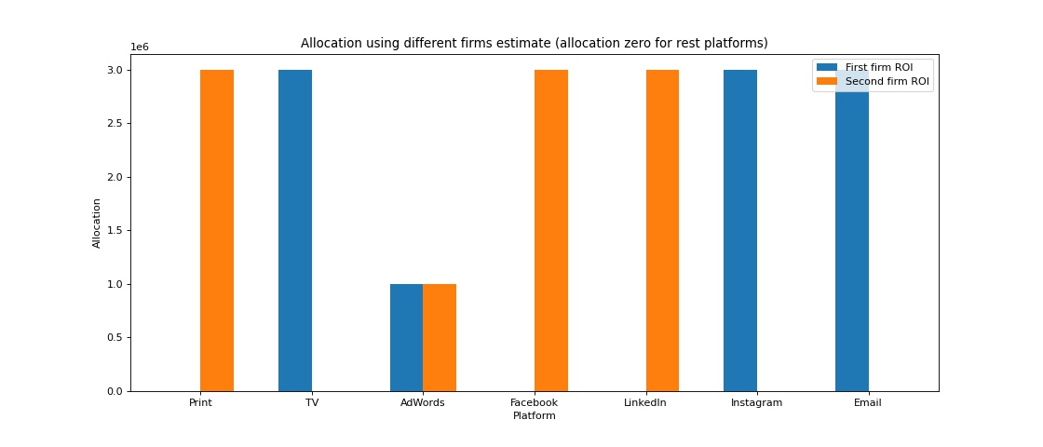

1. Assuming the first ROI data is correct, if you were to use the second allocation (the allocation that assumed the second ROI data was correct) how much lower would the objective be relative to the optimal objective (the one that uses the first ROI data and the first allocation)?

**Objective is lower by 204,000**

1. Assuming the second ROI data is correct, if you used the first allocation how much lower would the objective be relative to the optimal objective?

**Objective is lower by 192,000**