INTRODUCTION
1.1 Overview of the project

Attendance is a major part when withholding the standards of an establishment. This project is tailored to the liking of the college to implement an easy and quick leave management system to track and note every absence of a faculty and student.

1.2 Aim of the project

This project aims to help management of leave applications for staff, teachers students and even the principal of a college in such a way that is intuitive and easy to understand. This can ensure that all faculty and students can use the application very easily and use its functions with high efficiency.

1.3 Scope of the project

It can be easily noted that even in the year of 2024, there are a lot of institutional establishments that rely on written or email sent letters for leave applications and this can be highly inefficient and time consuming as a lot it can be confusing and frustrating when a lot of applications come through, not to mention the hard work that needs to be done to sort through the applications.

With this system, the advantages are:
- Very easy and intuitive.
- Applications can be sent with a single button click.
- Application responses can be sent quickly.
- Management of individuals are implemented to make adding and updating easier.
- User-friendly .
- Admins and Principals can send notifications to everyone.

TOOLS AND PLATFORMS
2.1 Languages

Python is a high-level, general-purpose programming language. Its design philosophy emphasizes code readability with the use of significant indentation via the off-side rule. Python is dynamically typed and garbage collected. It supports multiple programming paradigms, including structured (particularly procedural), object oriented and functional programming. It is often described as a "batteries included" language due to its comprehensive standard library.

Guido van Rossum began working on Python in the late 1980s as a successor to the ABC programming language and first released it in 1991 as Python 0.9.0. Python 2.0 was released in 2000. Python 3.0, released in 2008, was a major revision not completely backward-compatible with earlier versions. Python 2.7.18, released in 2020, was the last release of Python 2.

Python consistently ranks as one of the most popular programming languages.

2.2 Database

A Database Management System or DBMS is a software package including specific computer programs that control the creation, maintenance and use of a database. It provides an environment that is both convenient and efficient to use. A DBMS allows different user application programs to concurrently access the same database. It allows organization to conveniently develop database for various applications through database administrators (DBAs) and other specialists SQL is the widely used database language providing means of data manipulation (store, retrieve, update, delete) and database creation.

The SELECT statement in SQL is used to select queried data from a database in SQL. The result is stored in a result table called the result-set. The database transaction must be Atomic, Consistent, Isolated and Durable, i.e., ACID. A DBMS provides facilities for controlling data access, enforcing data integrity, managing concurrency control and recovering the database after failures and restoring it from backup files, as well as maintaining database security.

In software architecture there may be many layers between the hardware and end users. Each can be spoken of as having a front end and a back end. The front end is an abstraction, simplifying the underlying components by providing a user-friendly interface. Technically the front end and back end are generalized terms that refer to the initial and the final stage of a process. The front end is responsible for collecting input in various forms from the user and the processing it to confirm to a specification the back end can use. Hence the front end is an interface between the user and the back end.

2.3 Platform

Windows 11 Windows 11, developed by Microsoft, is an advanced operating system designed for personal computers, laptops, and other computing devices. Building upon the foundation laid by its predecessor, Windows 10, Windows 11 introduces a refined and visually captivating user interface, providing a fresh and modern experience for users. Released as the successor to Windows 10, Windows 11 was unveiled by Microsoft in June 2021.

Windows 11 brings a host of new features and improvements, including a redesigned Start Menu, centered taskbar icons, and enhanced window management capabilities. The operating system showcases a sleek and intuitive design, with rounded corners and a more streamlined appearance. Users can enjoy a more seamless and efficient workflow, thanks to the improved Snap feature, allowing for easier multitasking and organizing of open windows.

For IT professionals and organizations, Windows 11 supports various management options, including mobile device management (MDM) software for securing and controlling devices. Additionally, traditional desktop management solutions like Microsoft System Center Configuration Manager can be utilized to manage and maintain Windows 11 devices.

Windows 11 features

Windows 11 introduces a host of compelling features to enhance the user experience. The redesigned Start Menu takes center stage with a streamlined layout, offering quick access to frequently used applications and a more organized desktop experience. Windows 11 prioritizes productivity with the introduction of Snap Layouts and Snap Groups, allowing seamless organization of open windows for efficient multitasking. The revamped Microsoft Store simplifies app installations, while the Widgets feature provides personalized at-a-glance information on the desktop. Security is a key focus, with Windows Hello offering secure bio metric authentication methods. Virtual Desktops receive enhancements, enabling users to create customized layouts for different tasks. Gaming experiences are elevated with Direct Storage technology for faster loading times. Microsoft Edge, the default browser, includes features like Web Notes and Reading View for an enriched browsing experience.

Cortana, the digital assistant, supports both text and voice input, enhancing user interaction. The operating system's search capabilities span local and web searches simultaneously. In summary, Windows 11 combines a visually appealing interface with powerful features, aiming to provide users with an intuitive and elevated computing experience.

Windows 11 system requirements

The minimum Windows 10 hardware requirements for a PC or 2-in-1 device are:
• Processor: 1 gigahertz (GHz) or faster processor with 2 or more cores
• RAM: 4 gigabyte (GB)
• Hard disk space: 64GB or larger
• Graphics card: DirectX 12 or later with Windows Display Driver Model 2.0
• Display: 720p (1280×720p)

ORGANIZATIONS PROFILE

RISS TECHNOLOGIES

RISS TECHNOLOGIES is a rapidly growing company that provides professional IT services. We are one of the largest and Best software development companies in Kerala with focus on .Net, PHP, Java, Software testing, SEO and Web Design. As a leader in providing Offshore Software Development and related services, RISS TECHNOLOGIES functions from an offshore set-up, based in Kerala, India. Our reputation enables us to serve in terms of Outsourced Software Development, Web Development, designing of website and their corresponding development. Particularly high end developments using Microsoft .NET, Java J2EE platforms, ASP, ASP.NET, PHP development as well as VB.6.0 Development adjoins us to a particularly niche sector of the global servicing. We have worked for and have provided services to the 6 of the top 10 Fortune 500 companies of the world. We aim to provide our clients with comprehensive, end-to-end technology solutions that give them an advantage over the competition. From building applications that increase your productivity, to internet-enabling your business for maximum profits.

PROBLEM DEFINITION
4.1 Problem definition

The first step in this system study is to identify particular problem to be solved or the tasks to be accomplished and setting the system goals to achieved after defining the problem, the goals of the project are reviewed which has to be fulfilled in order to complete it successfully. Commencement of my project was done with an objective of developing an application which reduces the work load and increases the system performance.

4.2 Existing system

The existing system is one that is highly inefficient and include a lot of manual work. This can result in lots of time wasted by sorting through applications and by manually sending out acceptance letters and notifications. This can also lead to many errors to form. The system also poses much complex methods making them much less user friendly

Limitations of manual system: -
• It is time consuming: Since the current system requires a lot of paper works and it lacks of computerization its valuable time in just recording and retrieving data as well as creating.

• It leads to error prone results: The existing system requires and lot of man power and time. Since most of its functioning is manually. It is vulnerable to errors as well as brand.

• It consumes a lot of man power to better results: As already noted the existing system consumes a lot of man power for better results. Reducing man power means poor results.

• It lacks data security: The existing system does not provide any means for the protection and security of the data and information stored in the system.

• Limitation in report generation: In the existing system report generation is one of the biggest problems. As one record may reference to other over all data. This results a lag in the report generation

4.3 Proposed system

The proposed system is designed to eliminate all the disadvantages of the existing one. It is designed keeping in mind all the drawbacks of the present system in order to provide a solution to the existing system.

Proposed system is a computerized system in which all leave related functions will be stored in a centralized like database. This system helps the admin to easily manage the system and maintain its integrity.

The advantages of the systems are:
• Reduce the paper work.
• Accessing of information is much easier, faster, relevant and more efficient.
• Large volume of data can be stored effective security by password and user name, protection and less time conception.

The benefits of the proposed system:
The proposed system supports a wide range of features, some of them are:
• Shortage of time.
• Very fast compared to the manual system.
• Simple.
• User-friendly.
• Easier handling and flexibility.
• System is highly secure.

4.4 Feasibility study

During the system analysis a feasibility study of proposed system carried out to see whether it was beneficial to the organization. Three key considerations are involved and results are:

4.4.1 Technical Feasibility

Round existing environment and to what extend it can support the proposed system. While considering the technical factors of the organization that it presently has sufficient to implementation of the new system. The new system can use the existing premises inside the firm and no premises needed extra.

4.4.2 Economical Feasibility

Most frequently used as evaluating the effectiveness of candidate system more commonly known as cost benefit analysis. The procedure is to determine the benefits and savings that are expected from a candidate system and compare them with the existing system. If the benefits of the candidate system are out of weight the existing, the decision is made to design and implement.

4.4.3 Operational feasibility

People are inherently resisted to change and computers have been known to facilitate change. An estimate should be made about the reaction of the user staff towards the development of new system it has to do with the turn over transfers and changes and changes in issues easily.

SYSTEM REQUIREMENT SPECIFICATION
5.1 Software specification

The software for the development of proposed system is as follows.
The software for the development has been selected based on several functions such as: -
• Support
• Cost effectiveness
• Development tools
• Stability
• Reliability
• Accuracy

OS – Windows 11
Front-end – Python, HTML, CSS
Back-end – Python, SQL

5.2 Hardware specification

The selection of hardware configuration is very important task related to the software development, particularly inefficient RAM may affect adversely on the speed and corresponding on the efficiency of the entries system. The processor should be powerful to handle all the operations. The hard disk should have the sufficient capacity to solve the database and the application.
Micro processor Intel I7
Speed 1.99 GHz
RAM 16 GB
Hard drive 52 X
Monitor Inbuilt laptop screen
Keyboard Magegee 67keys
Mouse Logitech MX Master 2S

DESIGN TOOL
6.1 Data Flow Diagram

A Graphical representation is used to describe and analyze the movement of data through a system manual or automated including the processes, storing of data and delays in the system. Data flow diagrams are the central tool and the basis from which other components are developed. The transformation of data, from input to output through process may be described logically and independently of the physical components associated with the system. They are termed logical data flow diagrams, showing the actual implementation and the movement of data between people, departments and workstations. DFD is one of the most important modeling tools used in system design. DFD shows the flow of data through different process in the system.

PURPOSE

The purpose of the design is to create architecture for the evolving implementation and to establish the common tactical policies that must be used by desperate elements of the system. We begin the design process as soon as we have some reasonably completed model of the behavior of the system. It is important to avoid premature designs, wherein develop designs before analysis reaches closer. It is important to avoid delayed designing where in the organization crashes while trying to complete an unachievable analysis model.

Throughout my project, the context flow diagrams, data flow diagrams and flow charts have been extensively used to achieve the successful design of the system.

In my opinion," efficient design of the data flow and context flow diagram helps to design the system successfully without much major flaws with in the scheduled time". This is the most complicated part in a project. In the designing process, my project took more than the activities in the software life cycle. If we design a system efficiently with all the future enhancements the project will never become junk and it will be operational. The data flow diagrams were first developed by Larry Constantine as a way of expressing system requirements in graphical form. A data flow diagram also known as "bubble chare” has the purpose of clarifying system requirements and identifying major transformations that will become programs in system design. It functionally decomposes the requirement specification down to the lowest level.

Data Flow Diagram depicts the information flow, the transformation flow and the transformations that are applied as data move from input to output. Thus DFD describes what data flows rather than how they are processed. Data Flow Diagram is quite effective, especially when the required design is unclear and the user and analyst need a notational language for communication. It is one of the most important tools used during system analysis. It is used to model the system components such as the system process, the data used by the process, any external entities that interact with the system and information flows in the system. Data Flow Diagrams are made up of a number of symbols, which represents system components. Data flow modeling method uses four kinds of symbols, which are used to represent four kinds of system components. These are :
• Process
• Data stores
• Data flows
• External entity

Process

Process shows the work of the system. Each process has one or more data inputs and produce one or more data outputs. Processes are represented by rounded rectangles in Data Flow Diagram. Each process has a unique name and number. This name and number appear inside the rectangle that represents the process in a Data Flow Diagram.

Data Stores

A data store is a repository of data. Processes can enter data, into a store or retrieve the data from the data store. Each data has a unique name.

Data Flows

Data flows show the passage of data in the system and are represented by lines joining system components. An arrow indicates the direction of flow and the line is labelled by name of the data flow.

External Entity

External entities are outside the system but they either supply input data into the system or use other systems output. They are entities on which the designer has control. They may be an organizations customer or other bodies with which the system interacts. External entities that supply data into the system are sometimes called source. External entities that use the system data are sometimes called sinks. These are represented by rectangles in the Data flow Diagram.

Four basic symbols are used to construct data flow diagrams. They are symbols that represent data source, data flows, and data transformations and data storage. The points at which data are transformed are represented by enclosed figures, usually circles, which are called nodes.

Basic data flow diagram symbols are:

A Rectangle defines a source (originator) or destination of a system data.


An Arrow or arc identifies data flow. It is a pipeline through which information flows.

OR


An Oval represents a process that transforms incoming data flow(s) into outgoing data flow(s).


An Open Rectangle with a vertical line is used to indicate data store.


Four steps are commonly used to construct a DFD
i. Process should be named and numbered for easy reference. Each name should be representative of the process.
ii. The direction of flow is from top to bottom and from left to right.
iii. When a process is exploded into lower-level details they are numbered.
iv. The names of data stores, sources and destinations are written in capital letters.
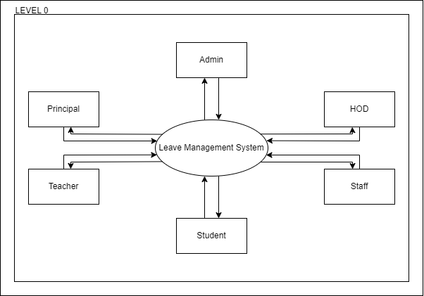

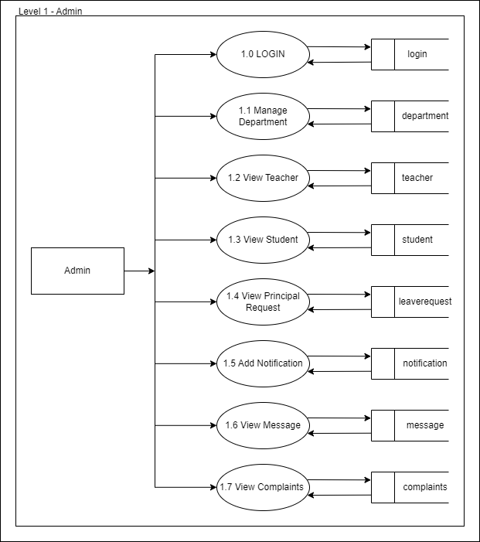
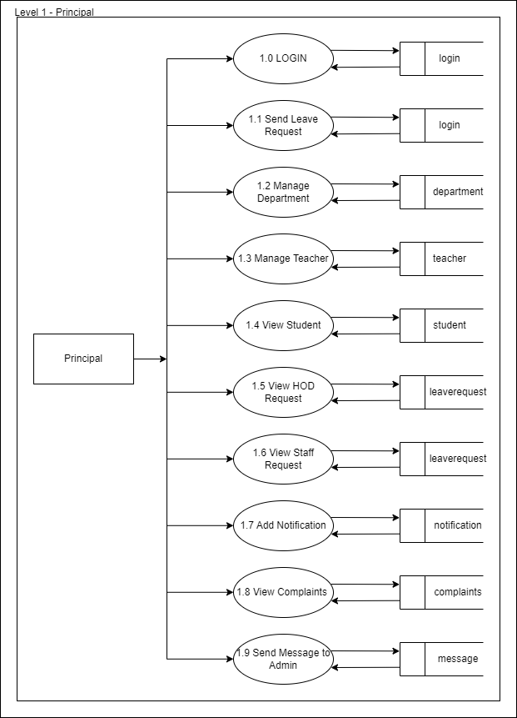
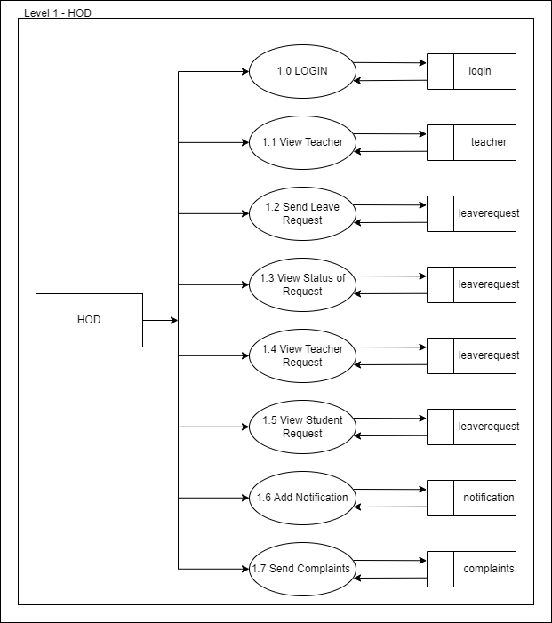
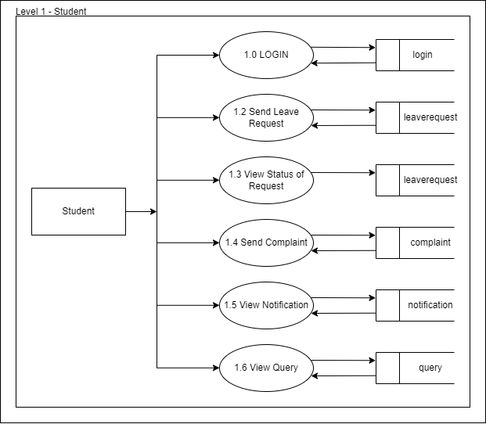
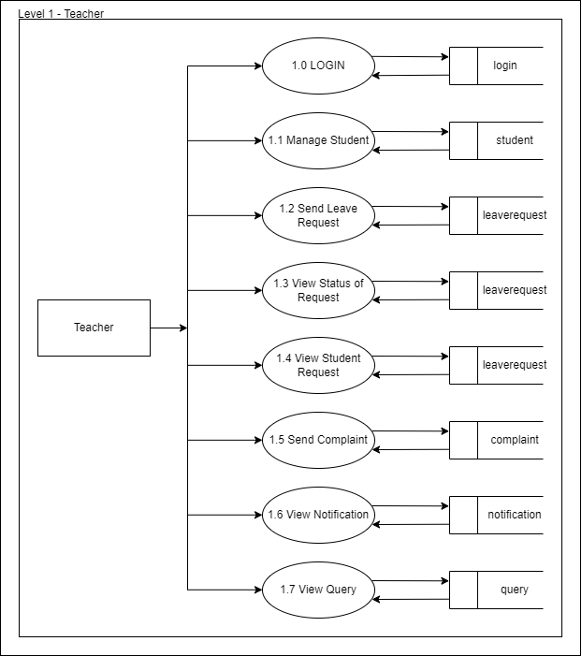
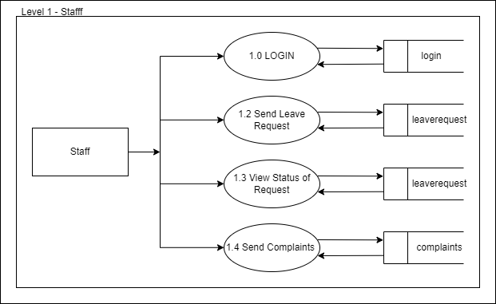
6.2 Entity-Relationship Diagram
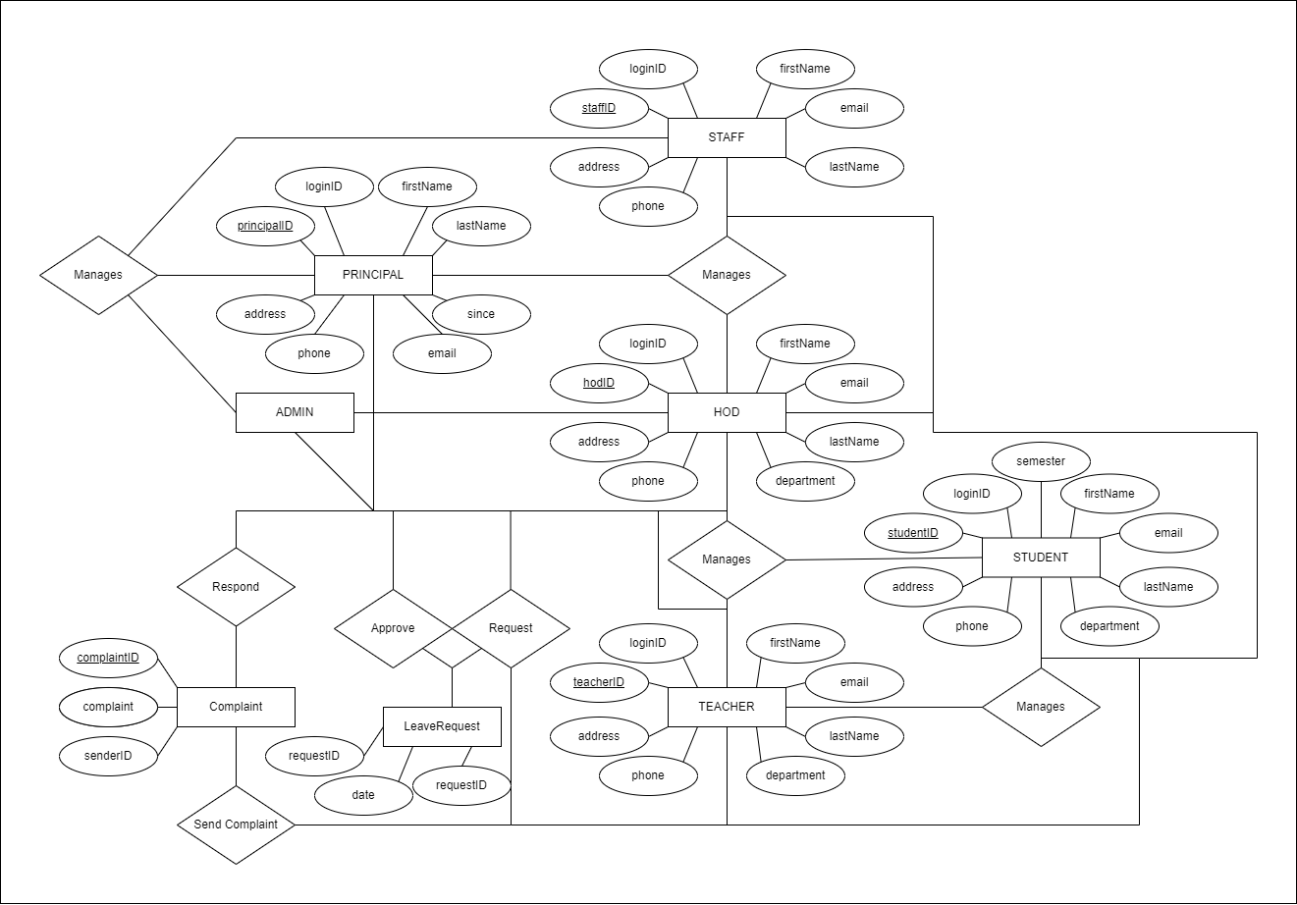

SYSTEM DESIGN
7.1 Introduction

The most creative and challenges phase of the system development is system design, is a solution to how to approach to the creation of the proposed system. It refers to the technical specification that will be applied. It provides the understanding and procedural details necessary for implementing the system recommended in the feasibility study. Design goes through the logical and physical stages of development. At an early stage in designing a new system, the system analyst must have a clear understanding of the objectives, which the design is aiming to fulfill. The first step is to determine how the output is to be produced and in what format. Second input data and master files (database) have to be designed to meet the requirements of the proposed output. The operational (processing) phases are handled through program construction and testing.

The system design includes
• Modularization
• Input design
• Output design
• Database design

7.2 Modular design

Structured design partitions a program into small, independent modules. They are arranged in a hierarchy that approximates a model of the business area and is organized in a top-down manner. Structured design is an attempt to minimize complexity and make a problem manageable by subdividing it into smaller segments, which is called modularization or decomposition. The primary advantage of this design is as follows:
• Critical interfaces are tested first.
• Early versions of the design, though incomplete, are useful enough to resemble the real system.
• Structuring the design provides control and improves morale.
• The procedural characteristics define the order that determines processing

Modules that perform only one task are said to be less error-prone than modules that perform multiple tasks.

Modules are:
1. Admin
2. Principal
3. HOD
4. Teacher
5. Student
6. Staff

- Admin
- Manage Department
- View Teachers
- View Students
- View Principal Request for Leave
- View Notifications
- View Messages
- View Complaints
- Principal
- Send Request for Leave
- View Status of Request
- Manage HOD
- Manage Teachers
- View Students
- View HOD Request for Leave
- View Staff Request for Leave
- Add Notifications
- View Complaints
- Send Messages to Admin
- HOD
- Send Request for Leave
- View Status of Request
- View Teachers
- View Teachers Request for Leave
- View Students Request for Leave
- View Notification
- Send Complaint
- Teacher
- Send Request for Leave
- View Status of Request
- Manage Students
- View Student Request for Leave
- Send Complaint
- View Notification
- View Queries
- Student
- Send Request for Leave
- View Request Status
- Send Complaint
- View Notification
- Send Queries
- Staff
- Send Request for Leave
- View Status of Request
- Send Complaint

7.3 Input design

Input design is the process of converting user-oriented inputs to computer-based format. It also includes determining the record media, method of input, speed of capture, and entry into system. Inaccurate input data are the most common cause of errors in data processing. Errors entered by the user can be controlled by input design and control checking. Input design is the process of converting user originated inputs to a computer-based format. In the system design phase, the data flow diagram (DFD) identifies logical data flows, data stores, source and destinations. A system flow chart specifies master files (Data base) transaction files and computer programs. Input data are collected and organized into groups of similar data.

7.4 Output design

The outputs can be in the form of operational documents and lengthy reports. The input records have to be validated, edited, organized and accepted by the system before being processed to produce outputs. The most important and direct source of information to user efficient, intelligible output design should improve the systems relationship with the user and help in decision making. A major form of output is hard copy from the printer. Printouts should have designed around the output requirements of the user. The output devices to consider depends on the factors such as compatibility of the device with the system response time requirements, expected print quantity and quality requirements, expected print quantity and quality.

7.5 Database design

Design is the logical form of design of data storage in the form of records in a particular structure in the form of tables with fields which is not transparent to the normal user but it actually acts as the backbone of the systems. As we know database is a collection of which helps the system to manage and store data is called database management system. Database management system builds some forms of constrains like integrity constrains, that is the primary key or unique key and referential integrity which help to keep storage and access of data from labels efficiently and accurately and take necessary steps to concurrent access of data and avoid redundancy of data in tables by normalization criterion.

Normalization is the method of breaking down complex tables structure into simple table structure by using certain rules thus reduce redundancy and inconsistency and disk space usage and thus increase the design and also solve the problems of anomalies.

There are different forms of normalization, some are:
• First normal form
• Second normal form
• Third normal form
• Boyce code normal form
• Fourth normal form
• Fifth normal form

The database design of the new system is second normal form and everyone key attribute is functionally depend only on the primary key. The master and transaction tables and their structure are shown below.
TABLE 1- COMPLAINT

Sl.No. | Field Name | Datatype | Constraints
1 | complaintID | int(11) | PK, Not NULL, AI
2 | loginID | int(11)
3 | by | varchar(100)
4 | complaint | varchar(1000)
5 | reply | varchar(1000)
6 | date | varchar(10)

TABLE 2- DEPARTMENT

Sl.No. | Field Name | Datatype | Constraints
1 | departmentID | int(11) | PK, Not NULL, AI
2 | department | varchar(100)

TABLE 3- HOD

Sl.No. | Field Name | Datatype | Constraints
1 | hodID | int(11) | PK, Not NULL, AI
2 | loginID | int(11)
3 | departmentID | int(11)
4 | firstName | varchar(300)
5 | lastName | varchar(300)
6 | address | varchar(300)
7 | phoneNumber | varchar(300)
8 | email | varchar(300)

TABLE 4- LEAVEREQUEST

Sl.No. | Field Name | Datatype | Constraints
1 | leaveRequestID | int(11) | PK, Not NULL, AI
2 | loginID | int(11)
3 | requestedBy | varchar(100)
4 | date | varchar(100)
5 | type | varchar(100)
6 | status | varchar(100)
7 | receipt | varchar(100)

TABLE 5- LOGIN

Sl.No. | Field Name | Datatype | Constraints
1 | loginID | int(11) | PK, Not NULL, AI
2 | username | varchar(300)
3 | password | varchar(100)
4 | userType | varchar(100)

TABLE 6- MESSAGE

Sl.No. | Field Name | Datatype | Constraints
1 | messageID | int(11) | PK, Not NULL, AI
2 | senderID | int(11)
3 | message | varchar(1000)
4 | reply | varchar(1000)
5 | date | varchar(100)

TABLE 7- NOTIFICATION

Sl.No. | Field Name | Datatype | Constraints
1 | notificationID | int(11) | PK, Not NULL, AI
2 | departmentID | int(11)
3 | notification | varchar(1000)
4 | date | varchar(100)
5 | time | varchar(100)
6 | sender | varchar(100)

TABLE 8- PRINCIPAL

Sl.No. | Field Name | Datatype | Constraints
1 | principalID | int(11) | PK, Not NULL, AI
2 | loginID | int(11)
3 | firstName | varchar(300)
4 | lastName | varchar(300)
5 | address | varchar(300)
6 | phoneNumber | varchar(300)
7 | email | varchar(300)
8 | since | varchar(300)

TABLE 9- QUERIES

Sl.No. | Field Name | Datatype | Constraints
1 | queryID | int(11) | PK, Not NULL, AI
2 | senderID | int(11)
3 | recieverID | int(11)
4 | query | varchar(1000)
5 | reply | varchar(1000)
6 | date | varchar(100)
TABLE 10- STAFF

Sl.No. | Field Name | Datatype | Constraints
1 | staffID | int(11) | PK, Not NULL, AI
2 | loginID | int(11)
3 | firstName | varchar(300)
4 | lastName | varchar(300)
5 | address | varchar(300)
6 | phoneNumber | varchar(300)
7 | email | varchar(300)

TABLE 11- STUDENTS
Sl.No. | Field Name | Datatype | Constraints
1 | studentID | int(11) | PK, Not NULL, AI
2 | loginID | int(11)
3 | departmentID | int(11)
4 | semester | int(11)
5 | firstName | varchar(300)
6 | lastName | varchar(300)
7 | address | varchar(300)
8 | phoneNumber | varchar(300)
9 | email | varchar(300)

TABLE 12- TEACHERS
Sl.No. | Field Name | Datatype | Constraints
1 | teachersID | int(11) | PK, Not NULL, AI
2 | loginID | int(11)
3 | departmentID | int(11)
4 | firstName | varchar(300)
5 | lastName | varchar(300)
6 | address | varchar(300)
7 | phoneNumber | varchar(300)
8 | email | varchar(300)

SYSTEM TESTING
8.1 Software testing

Testing process

Testing is the process of executing the program with the intention of finding errors. System testing is actually a series of different tests whose primary purpose e is to fully exercise the computer-based systems. Each test has a different purpose, but all work to verify that system elements have been properly integrated and perform allocated functions. There are many strategies that can be used to test software. A few of the common tests are the following: -
• Unit Testing
• Integration Testing
• Validation Testing
• Output Testing
• User-Acceptance Testing

Unit testing

Unit testing focuses verification effort on the smallest unit of software design - the software components or modules. Important control path tested to uncover errors within the boundary of the module, by using the components—level design description as a guide. The unit test focuses on the internal processing logic and data processing within the boundaries of a component.

Integration testing

Integration testing is a systematic technique for constructing the software architecture while at the same time conducting tests to uncover errors associated with interfacing. The objective is to take unit tested components and build a program structure that has been dedicated by design. Incremental integration is a type of integration testing where in the program is constructed and tested in small increments, where the errors are easier to isolate and correct.

Validation testing

At this the software completely assembled as a package. It is final series software test. Validation test is based on validation criteria of the software requirement specification. Software validation achieved through a series of black box testing. It succeeds when user get satisfied by the software. In validation testing if the user wants to enter the numeric value, he can only enter the numeric value not the text value.

SYSTEM IMPLEMENTATION
9.1 System implementation

Implementation is the stage in the project where the theoretical designed is turned into a working system and is giving confidence on the new system for the user that it will work efficiently and effectively. It involves careful planning, investigation of the current system and its constraints on implementation, design of methods to achieve the changeover, an evaluation of change over methods. Apart from planning major task of preparing the implementation are education and training of users. The more complex system being implementation, the more involved will be the system analyst and design effort required just for implementation.

An implementation co-ordination comity based on policies of individual organization has been appointed. The implementation process begins with preparing a plan for the implementation of the system. According to this plan activities are to resources and the additional equipment has to be acquired to implement the new system.

Implementation is the final and important phase. This is the most critical stage in achieving a successful new system and giving the users confidence that the new system will work is effective. The system can be implemented only after through testing. This method also offers the greatest security. Since the old system can take over if the errors are found or inability to handle certain the type of transaction while using the new system.

The implementation phase includes the following tasks:
• Careful planning
• Investigation
• Design of methods
• Training of the staff in the changeover phase
• Evaluation of changeover

We implement this new system in parallel run plan without making any disruptions to the ongoing system, but only computerizing the whole system to make the work, evaluation and retrieval of data easier, faster and reliable.

9.2 Implementation plan

System implementation is the process of making the newly designed system fully operational and consistent in performance. The preparation of implementation of documentation process. In a well-defined software development environment, however the presentation of implementation documents is essentially an interactive process that synthesis and recognize document items that were produced during the analysis and design phase for the presentation to user.

MAINTENANCE AND REVIEW

Maintenance involves the software industry captive, typing up system resources. It means restoring something to its original conditions. Maintenance follows conversion to the extended that changes are necessary to maintain satisfactory operation relative to user environment. Maintenance often includes minor enhancement or corrections to problems that suffers in the system operations. Maintenance is also done based on fixing the problem reported, changing the interface with other software or hardware enhancing the software.

Any system developed should be secured and protected against possible hazards. Security measures are provided to prevent unauthorized access of the database at various levels. An uninterrupted power supply should be that the power failure or voltage fluctuations will not erase the data in the files.

Password protection and simple procedures to prevent the unauthorized access are provided to the users. The system allows the users to enter the system only through proper user name and password.

CONCLUSION

This system, being the first we have created in PHP, has proven more difficult than originally imagined. While it may sound simple to fill out a few forms and process the information, much more is involved in the selection of applicants than this. Every time progress was made and features were added, ideas for additional features or methods to improve the usability of the system made they apparent. Furthermore, adding one feature meant that another required feature was now possible and balancing completing these required features with the ideas for improvement as well as remembering everything that had to be done was a project in itself.

Debugging can sometimes be a relatively straight forward process, or rather finding out what you must debug can be. Since so many parts of the admissions system are integrated into one another, if an error occurs on one page, it may be a display error, for example; it may be the information is not correctly read from the database; or even that the information is not correctly stored in the database initially, and all three must be checked on each occasion. This slows down the process and can be frustrating if the apparent cause of a problem is not obvious at first. Language used must be simple and easy to understand and compatibility is paramount. If this system were not designed as an entirely web based application, it would not have been possible to recreate its current state of portability.

Overall, the system performs well, and while it does not include all of the features that may have been desired, it lives up to initial expectations. The majority of features that are included work flawlessly and the errors that do exist are minor or graphical.

APPENDIX
12.1 Sample Code

main.py

from flask import Flask
from public import public
from admin import admin
from hod import hod
from teacher import teacher
from student import student
from staff import staff
from principal import principal

app=Flask(__name__)

app.secret_key='car'

app.register_blueprint(public)
app.register_blueprint(admin)
app.register_blueprint(hod)
app.register_blueprint(teacher)
app.register_blueprint(student)
app.register_blueprint(staff)
app.register_blueprint(principal)

app.run(debug=True,port=5004)

admin.py

from flask import *
from database import *

admin = Blueprint('admin',__name__)

@admin.route('/')
def home():
return render_template('home.html')

@admin.route('/adminheader')
def adminheader():
data = {}
sel = "SELECT COUNT(*) FROM message where reply='pending'"
data['messagecount'] = select(sel)
return render_template('adminheader.html',data=data)

@admin.route('/adminHome')
def adminHome():
current_page='adminHome'
data = {}
sel = "SELECT COUNT(*) FROM message where reply='pending'"
data['messagecount'] = select(sel)
return render_template('adminHome.html',data=data,current_page=current_page)

@admin.route('/contact_admin')
def contact():
user='admin'
return render_template('contact.html',user=user)

@admin.route('/manageDepartment_admin',methods=['get','post'])
def manageDepartment():
data={}
sel = "SELECT * FROM department"
data['dept'] = select(sel)

if 'addDepartment' in request.form:
deptName = request.form['deptName']

ins = "INSERT INTO department VALUES(null,'%s')"%(deptName)
insert(ins)
return redirect(url_for('admin.manageDepartment'))

if 'action' in request.args:
action = request.args['action']
deptId = request.args['deptId']
else:
action = None

if action == 'delete':
d = "DELETE FROM department WHERE departmentID='%s'"%(deptId)
delete(d)
return redirect(url_for('admin.manageDepartment'))

if action == 'update':
s = "SELECT * FROM department WHERE departmentID='%s'"%(deptId)
data['upd'] = select(s)

if 'updDepartment' in request.form:
department = request.form['deptName']

upd = "UPDATE department SET department='%s' WHERE departmentID='%s'"%(department,deptId)
update(upd)
return redirect(url_for('admin.manageDepartment'))

return render_template('manageDepartment.html',data=data)

@admin.route('/manageHOD_admin',methods=['get','post'])
def manageHOD():
data={}
sel = "SELECT * FROM hod"
data['HOD'] = select(sel)

dept = "SELECT * from department"
data['deptID'] = select(dept)

if 'addHOD' in request.form:
departmentID = request.form['departmentID']
firstName = request.form['firstName']
lastName = request.form['lastName']
address = request.form['address']
phoneNumber = request.form['phoneNumber']
email = request.form['email']

uname = request.form['uname']
pword = request.form['pword']

ins1 = "INSERT INTO login VALUES(null,'%s','%s','HOD')"%(uname,pword)
insert(ins1)

qry = "SELECT loginID from login WHERE username='%s'"%(uname)
logID = select(qry)

ins2 = "INSERT INTO hod VALUES(null,'%s','%s','%s','%s','%s','%s','%s')"%(logID[0]['loginID'],departmentID,firstName,lastName,address,phoneNumber,email)
insert(ins2)
return redirect(url_for('admin.manageHOD'))

if 'action' in request.args:
action = request.args['action']
hodId = request.args['hodId']
else:
action = None

if action == 'delete':
d = "DELETE FROM hod WHERE hodID='%s'"%(hodId)
delete(d)
return redirect(url_for('admin.manageHOD'))

if action == 'update':
s = "SELECT * FROM hod WHERE hodID='%s'"%(hodId)
data['upd'] = select(s)

if 'updHOD' in request.form:
departmentID = request.form['departmentID']
firstName = request.form['firstName']
lastName = request.form['lastName']
address = request.form['address']
phoneNumber = request.form['phoneNumber']
email = request.form['email']

upd = "UPDATE hod SET departmentID='%s',firstName='%s',lastName='%s',address='%s',phoneNumber='%s',email='%s' WHERE hodID='%s'"%(departmentID,firstName,lastName,address,phoneNumber,email,hodId)
update(upd)
return redirect(url_for('admin.manageHOD'))

return render_template('manageHOD.html',data=data)

@admin.route('/manageStaff_admin',methods=['get','post'])
def manageStaff():
data={}
sel = "SELECT * FROM staff"
data['staff'] = select(sel)

if 'addStaff' in request.form:
firstName = request.form['firstName']
lastName = request.form['lastName']
address = request.form['address']
phoneNumber = request.form['phoneNumber']
email = request.form['email']

uname = request.form['uname']
pword = request.form['pword']

ins1 = "INSERT INTO login VALUES(null,'%s','%s','Staff')"%(uname,pword)
insert(ins1)

qry = "SELECT loginID from login WHERE username='%s'"%(uname)
logID = select(qry)

ins2 = "INSERT INTO staff VALUES(null,'%s','%s','%s','%s','%s','%s')"%(logID[0]['loginID'],firstName,lastName,address,phoneNumber,email)
insert(ins2)
return redirect(url_for('admin.manageStaff'))

if 'action' in request.args:
action = request.args['action']
staffId = request.args['staffId']
else:
action = None

if action == 'delete':
d = "DELETE FROM staff where staffID='%s'"%(staffId)
delete(d)
return redirect(url_for('admin.manageStaff'))

if action == 'update':
s = "SELECT * FROM staff WHERE staffID='%s'"%(staffId)
data['upd'] = select(s)

if 'updStaff' in request.form:
firstName = request.form['firstName']
lastName = request.form['lastName']
address = request.form['address']
phoneNumber = request.form['phoneNumber']
email = request.form['email']

upd = "UPDATE staff SET firstName='%s',lastName='%s',address='%s',phoneNumber='%s',email='%s' WHERE staffID='%s'"%(firstName,lastName,address,phoneNumber,email,staffId)
update(upd)
return redirect(url_for('admin.manageStaff'))

return render_template('manageStaff.html',data=data)

@admin.route('/viewTeachers_admin')
def viewTeachers():
data={}
sel = "SELECT * FROM teachers"
data['teachers'] = select(sel)

return render_template('viewTeachers.html',data=data)

@admin.route('/viewStudents_admin')
def viewStudents():
data={}
sel = "SELECT * FROM students"
data['student'] = select(sel)

return render_template('viewStudents.html',data=data)

@admin.route('/viewPrincipalLR_admin')
def viewPrincipalLR():
data={}
sel = "SELECT * FROM leaverequest r ,principal p WHERE r.loginID = p.loginID AND requestedBy='Principal' AND status='Pending'"
data['principalLR'] = select(sel)

if 'action' in request.args:
action = request.args['action']
leaveReqId = request.args['leaveReqId']
else:
action = None

if action == 'accept':
upd = "UPDATE leaverequest SET status='Accepted' WHERE leaveRequestID='%s'"%(leaveReqId)
update(upd)

return redirect(url_for('admin.viewPrincipalLR'))

if action == 'reject':
upd = "UPDATE leaverequest SET status='Rejected' WHERE leaveRequestID='%s'"%(leaveReqId)
update(upd)

return redirect(url_for('admin.viewPrincipalLR'))

return render_template('viewPrincipalLR.html',data=data)

@admin.route('/viewHODLR_admin')
def viewHODLR():
data={}
sel = "SELECT * FROM leaverequest r ,hod h WHERE r.loginID = h.loginID AND requestedBy='HOD' AND (status ='Pending' OR status='Accepted') ORDER BY leaveRequestID DESC"
data['HODLR'] = select(sel)

if 'action' in request.args:
action = request.args['action']
leaveReqId = request.args['leaveReqId']
else:
action = None

if action == 'accept':
upd = "UPDATE leaverequest SET status='Accepted' WHERE leaveRequestID='%s'"%(leaveReqId)
update(upd)

return redirect(url_for('admin.viewHODLR'))

if action == 'reject':
upd = "UPDATE leaverequest SET status='Rejected' WHERE leaveRequestID='%s'"%(leaveReqId)
update(upd)

return redirect(url_for('admin.viewHODLR'))

return render_template('viewHODLR.html',data=data)

@admin.route('/viewStaffLR_admin')
def viewStaffLR():
data = {}
sel = "SELECT * FROM leaverequest r ,staff s WHERE r.loginID = s.loginID AND requestedBy='Staff'"
data['staffLR'] = select(sel)

if 'action' in request.args:
action = request.args['action']
leaveReqId = request.args['leaveReqId']
else:
action = None

if action == 'accept':
upd = "UPDATE leaverequest SET status='Accepted' WHERE leaveRequestID='%s'"%(leaveReqId)
update(upd)

return redirect(url_for('admin.viewStaffLR'))

if action == 'reject':
upd = "UPDATE leaverequest SET status='Rejected' WHERE leaveRequestID='%s'"%(leaveReqId)
update(upd)

return redirect(url_for('admin.viewStaffLR'))

return render_template('viewStaffLR.html',data=data)

@admin.route('/addNotification_admin',methods=['get','post'])
def addNotification():
data={}
sel = "SELECT * FROM department"
data['dept'] = select(sel)

if 'addNotification' in request.form:
deptID = request.form['dept']
notification = request.form['notification']

ins = "INSERT INTO notification VALUES (null,'%s','%s',curdate(),curtime(),'admin')"%(deptID,notification)
insert(ins)
return redirect(url_for('admin.adminHome'))

return render_template('addNotification.html',data=data)

@admin.route('/viewMessage_admin')
def viewMessage():
data = {}
sel = "SELECT * FROM message m , principal p WHERE m.senderID = p.loginID"
data['message'] = select(sel)

return render_template('viewMessage.html',data=data)

@admin.route('/messageResponse',methods=['get','post'])
def messageResponse():
if 'submitResponse' in request.form:
response = request.form['response']
messageId = request.args['messageId']

res = "UPDATE message SET reply='%s' WHERE messageID='%s'"%(response,messageId)
update(res)

return redirect(url_for('admin.viewMessage'))

return render_template('messageResponse.html')

@admin.route('/viewComplaint_admin')
def viewComplaint():
data = {}
sel = "SELECT * FROM COMPLAINT c, Login l WHERE c.loginID = l.loginID"
data['complaint'] = select(sel)

return render_template('viewComplaint.html',data=data)

@admin.route('/complaintResponse',methods=['get','post'])
def complaintResponse():
if 'submitResponse' in request.form:
response = request.form['response']
complaintId = request.args['complaintId']

res = "UPDATE complaint SET reply='%s' WHERE complaintID='%s'"%(response,complaintId)
update(res)

return redirect(url_for('admin.viewComplaint'))

return render_template('complaintResponse.html')

home.html

{% include 'publicheader.html' %}

<!-- ======= Hero Section ======= -->
<section id="hero" class="d-flex flex-column justify-content-end align-items-center">
<div id="heroCarousel" data-bs-interval="5000" class="container carousel carousel-fade" data-bs-ride="carousel">

<!-- Slide 1 -->
<div class="carousel-item active">
<div class="carousel-container">
<h2 class="animate__animated animate__fadeInUp">Welcome to the <span>Leave Management System</span></h2>

<marquee class="animate__animated animate__fadeInUp">
<b>Latest Notifications : </b>
{%for i in data['notifications']%}
{{i['notification']}} &nbsp;&nbsp;&nbsp;&nbsp;&nbsp;&nbsp;&nbsp;&nbsp;&nbsp;
{%endfor%}
</marquee>
</div>
</div>

</div>

<svg class="hero-waves" xmlns="http://www.w3.org/2000/svg" xmlns:xlink="http://www.w3.org/1999/xlink" viewBox="0 24 150 28 " preserveAspectRatio="none">
<defs>
<path id="wave-path" d="M-160 44c30 0 58-18 88-18s 58 18 88 18 58-18 88-18 58 18 88 18 v44h-352z">
</defs>
<g class="wave1">
<use xlink:href="#wave-path" x="50" y="3" fill="rgba(255,255,255, .1)">
</g>
<g class="wave2">
<use xlink:href="#wave-path" x="50" y="0" fill="rgba(255,255,255, .2)">
</g>
<g class="wave3">
<use xlink:href="#wave-path" x="50" y="9" fill="#fff">
</g>
</svg>

</section><!-- End Hero -->

<center>
<br>
<a href="login"><h3>Login to continue</h3></a>
<br>
</center>
{% include 'footer.html' %}

public.py

from flask import *
from database import *
from admin import *

public = Blueprint('public',__name__)

@public.route('/')
def home():
data = {}
notif = "SELECT * FROM notification WHERE departmentID=0 ORDER BY notificationID DESC LIMIT 5"
data['notifications'] = select(notif)

return render_template('home.html',data=data)

@public.route('/contact_public')
def contact():
user='public'
return render_template('contact.html',user=user)

@public.route('/login',methods=['get','post'])
def login():
if 'login' in request.form:
uname = request.form['uname']
pword = request.form['pword']

loginQry = "SELECT * FROM login WHERE username='%s' AND password='%s'"%(uname,pword)
sel = select(loginQry)

if sel:
session['loginID']=sel[0]['loginID']
if sel[0]['userType']=='admin':
session['desig'] = 'Admin'
return redirect(url_for('admin.adminHome'))
elif sel[0]['userType']=='HOD':
q="SELECT * FROM hod WHERE loginID = '%s'"%(session['loginID'])
val=select(q)
if val:
session['hodId']=val[0]['hodID']
session['desig']='HOD'
res = "SELECT firstName FROM hod WHERE loginID='%s'"%(session['loginID'])
name = select(res)
session['name'] = name[0]['firstName']
return redirect(url_for('hod.hodHome'))
elif sel[0]['userType']=='Teacher':
q="SELECT * FROM teachers WHERE loginID = '%s'"%(session['loginID'])
val=select(q)
if val:
session['teachersID'] = val[0]['teachersID']
session['desig'] = 'Teacher'
res = "SELECT firstName FROM teachers WHERE loginID='%s'"%(session['loginID'])
name = select(res)
session['name'] = name[0]['firstName']
return redirect(url_for('teacher.teacherHome'))
elif sel[0]['userType']=='Student':
q="SELECT * FROM students WHERE loginID = '%s'"%(session['loginID'])
val=select(q)
if val:
session['studentID'] = val[0]['studentID']
session['desig'] = 'Student'
res = "SELECT firstName FROM students WHERE loginID='%s'"%(session['loginID'])
name = select(res)
session['name'] = name[0]['firstName']
return redirect(url_for('student.studentHome'))
elif sel[0]['userType']=='Staff':
q="SELECT * FROM staff WHERE loginID = '%s'"%(session['loginID'])
val=select(q)
if val:
session['staffID'] = val[0]['staffID']
session['desig'] = 'Staff'
res = "SELECT firstName FROM staff WHERE loginID='%s'"%(session['loginID'])
name = select(res)
session['name'] = name[0]['firstName']
return redirect(url_for('staff.staffHome'))
elif sel[0]['userType']=='Principal':
session['desig'] = 'Principal'
res = "SELECT firstName FROM principal WHERE loginID='%s'"%(session['loginID'])
name = select(res)
session['name'] = name[0]['firstName']
return redirect(url_for('principal.principalHome'))

return render_template('login.html')

manageDepartment.html

{% include 'adminheader.html' %}

<center>
<h1> Department Detials </h1>
<form><table border="2" cellpadding="2">
<tr align="center">
<th> Department ID </th>
<th> Department </th>
</tr>
{%for i in data['dept']%}
<tr align="center">
<td> {{i['departmentID']}} </td>
<td> {{i['department']}} </td>
<td> <a href="?action=delete&deptId={{i['departmentID']}}">Delete</a> </td>
<td> <a href="?action=update&deptId={{i['departmentID']}}">Update</a> </td>
</tr>
{%endfor%}
</table></form>

{%if data['upd']%}
<h3> Update Department </h3>
<form method="POST"><table>
<tr>
<th>Department : </th>
<td> <input type="text" name="deptName" value="{{data['upd'][0]['department']}}" required=""></td>
<td> <input type="submit" name="updDepartment" value="Update Department"></td>
</tr>
</table></form>
{%else%}
<br>
<h3> Add Department </h3>
<form method="POST"><table>
<tr>
<th>Department : </th>
<td> <input type="text" name="deptName" required="" class="inpfld"></td>
<td> <input type="submit" name="addDepartment" value="Add Department" class="subbutn"></td>
</tr>
</table></form>
{%endif%}
</center>

{% include 'footer.html' %}

student.py

from flask import *
from database import *

student = Blueprint('student',__name__)

@student.route('/')
def home():
return render_template('home.html')

@student.route('/studentHome')
def studentHome():
current_page = 'studentHome'
sel = "SELECT firstName FROM students WHERE loginID='%s'"%(session['loginID'])
name = select(sel)

sel1 = "SELECT receipt FROM leaverequest WHERE loginID='%s' AND status='Accepted' ORDER BY leaveRequestID DESC LIMIT 1"%(session['loginID'])
data= select(sel1)
if data:
receipt = data[0]['receipt']
else:
receipt = None
return render_template('studentHome.html',name=name,receipt=receipt,current_page=current_page)

@student.route('/contact_student')
def contact():
user='student'
return render_template('contact.html',user=user)

@student.route('/sendLR_student',methods=['get','post'])
def sendLR():
if 'sendReq' in request.form:
dateOfLeave = request.form['dateOfLeave']
leaveType = request.form['leaveType']

ins = "INSERT INTO leaverequest VALUES(null,'%s','Student','%s','%s','Pending','unread')"%(session['loginID'],dateOfLeave,leaveType)
insert(ins)

return redirect(url_for('student.studentHome'))
return render_template('sendLR.html')

@student.route('/viewReqStatus_student',methods=['get','post'])
def viewReqStatus():

data = {}
sel = "SELECT * FROM leaverequest r ,login l WHERE r.loginID = l.loginID AND r.loginID='%s' AND receipt NOT LIKE 'read'"%(session['loginID'])
data['reqStatus'] = select(sel)

if 'action' in request.args:
action = request.args['action']
leaveReqId = request.args['leaveReqId']
else:
action = None

if action == 'markAsRead':
upd = "UPDATE leaverequest SET receipt='read' WHERE leaveRequestID='%s'"%(leaveReqId)
update(upd)

return redirect(url_for('student.viewReqStatus'))

return render_template('viewReqStatus.html',data=data)

@student.route('/sendComplaint_student',methods=['get','post'])
def sendComplaint():
if 'sendComplaint' in request.form:
complaint = request.form['complaint']

ins = "INSERT INTO complaint VALUES(null,'%s','Student','%s','Pending',curdate())"%(session['loginID'],complaint)
insert(ins)
return redirect(url_for('student.studentHome'))
return render_template('sendComplaint.html')

@student.route('/viewNotifications_student',methods=['get','post'])
def viewNotifications():
data = {}

deptid = "SELECT departmentID from students WHERE loginID = '%s'"%(session['loginID'])
dId = select(deptid)

sel = "SELECT * FROM notification WHERE departmentID = '%s'"%(dId[0]['departmentID'])
data['notification'] = select(sel)
return render_template('viewNotifications.html',data=data)

@student.route('/sendQueries_student',methods=['get','post'])
def sendQueries():
data = {}
deptid = "SELECT departmentID from students WHERE loginID = '%s'"%(session['loginID'])
dId = select(deptid)
sel = "SELECT * FROM teachers WHERE departmentID = '%s'"%(dId[0]['departmentID'])

data['teachers'] = select(sel)

sel1 = "SELECT * FROM queries WHERE senderID = '%s'"%(session['loginID'])
data['query'] = select(sel1)

if 'sendQuery' in request.form:
query = request.form['query']
reciever = request.form['reciever']

ins = "INSERT INTO queries VALUES (null,'%s','%s','%s','Pending',curdate())"%(session['loginID'],reciever,query)
insert(ins)
return redirect(url_for('student.studentHome'))
return render_template('sendQueries.html',data=data)

footer.html

<!-- ======= Footer ======= -->
<br><footer id="footer">
<div class="container">
<h3>Leave Management System</h3>
<p>Created by Vishal V Santhosh Kumar</p>
<div class="copyright">
&copy; Copyright <strong><span>TimeTroveLMS</span></strong> 2024. All Rights Reserved
</div>
<div class="credits">
<!-- All the links in the footer should remain intact. -->
<!-- You can delete the links only if you purchased the pro version. -->
<!-- Licensing information: https://bootstrapmade.com/license/ -->
<!-- Purchase the pro version with working PHP/AJAX contact form: https://bootstrapmade.com/selecao-bootstrap-template/ -->
Designed using <a href="https://bootstrapmade.com/">BootstrapMade</a>
</div>
</div>
</footer><!-- End Footer -->

<a href="#" class="back-to-top d-flex align-items-center justify-content-center"><i class="bi bi-arrow-up-short"></i></a>

<!-- Vendor JS Files -->
<script src="static/assets/vendor/aos/aos.js"></script>
<script src="static/assets/vendor/bootstrap/js/bootstrap.bundle.min.js"></script>
<script src="static/assets/vendor/glightbox/js/glightbox.min.js"></script>
<script src="static/assets/vendor/isotope-layout/isotope.pkgd.min.js"></script>
<script src="static/assets/vendor/swiper/swiper-bundle.min.js"></script>
<script src="static/assets/vendor/php-email-form/validate.js"></script>

<!-- Template Main JS File -->
<script src="static/assets/js/main.js"></script>

</body>

</html>

adminHeader.html

<!DOCTYPE html>
<html lang="en">

<head>
<meta charset="utf-8">
<meta content="width=device-width, initial-scale=1.0" name="viewport">

<title>Admin Home</title>
<meta content="" name="description">
<meta content="" name="keywords">

<!-- Favicons -->
<link href="static\images\logo.png" rel="icon">
<link href="static/assets/img/apple-touch-icon.png" rel="apple-touch-icon">

<!-- Google Fonts -->
<link href="https://fonts.googleapis.com/css?family=Open+Sans:300,300i,400,400i,600,600i,700,700i|Raleway:300,300i,400,400i,500,500i,600,600i,700,700i|Poppins:300,300i,400,400i,500,500i,600,600i,700,700i" rel="stylesheet">

<!-- Vendor CSS Files -->
<link href="static/assets/vendor/animate.css/animate.min.css" rel="stylesheet">
<link href="static/assets/vendor/aos/aos.css" rel="stylesheet">
<link href="static/assets/vendor/bootstrap/css/bootstrap.min.css" rel="stylesheet">
<link href="static/assets/vendor/bootstrap-icons/bootstrap-icons.css" rel="stylesheet">
<link href="static/assets/vendor/boxicons/css/boxicons.min.css" rel="stylesheet">
<link href="static/assets/vendor/glightbox/css/glightbox.min.css" rel="stylesheet">
<link href="static/assets/vendor/remixicon/remixicon.css" rel="stylesheet">
<link href="static/assets/vendor/swiper/swiper-bundle.min.css" rel="stylesheet">

<!-- Template Main CSS File -->
<link href="static/assets/css/style.css" rel="stylesheet">
</head>

<body>

<!-- ======= Header ======= -->
<header id="header" class="fixed-top d-flex align-items-center header-transparent ">
<div class="container d-flex align-items-center justify-content-between">

<div class="logo">
<h1><a href="index.html">TimeTroveLMS</a></h1>
<!-- Uncomment below if you prefer to use an image logo -->
<!-- <a href="index.html"><img src="static/assets/img/logo.png" alt="" class="img-fluid"></a>-->
</div>

<nav id="navbar" class="navbar">
<ul>
<li><a class="nav-link scrollto" href="adminHome">Home</a></li>
<li><a class="nav-link scrollto" href="/">Logout</a></li>
<li><a class="nav-link scrollto" href="contact_admin">Contact</a></li>
</ul>
<i class="bi bi-list mobile-nav-toggle"></i>
</nav><!-- .navbar -->

</div>
</header><!-- End Header -->

<!-- ======= Hero Section ======= -->
<section id="hero" class="d-flex flex-column justify-content-end align-items-center">
<div id="heroCarousel" data-bs-interval="5000" class="container carousel carousel-fade" data-bs-ride="carousel">

<!-- Slide 1 -->
<div class="carousel-item active">
<div class="carousel-container">
<h2 class="animate__animated animate__fadeInDown">Welcome <span>Admin</span></h2>
{%if current_page == 'adminHome'%}
<p class="animate__animated animate__fadeInUp"><font color="red" ><b> New Messages : {%for i in data['messagecount']%} {{i['COUNT(*)']}} {%endfor%} </b></font></p>
{%endif%}
</div>
</div>
</div>

<svg class="hero-waves" xmlns="http://www.w3.org/2000/svg" xmlns:xlink="http://www.w3.org/1999/xlink" viewBox="0 24 150 28 " preserveAspectRatio="none">
<defs>
<path id="wave-path" d="M-160 44c30 0 58-18 88-18s 58 18 88 18 58-18 88-18 58 18 88 18 v44h-352z">
</defs>
<g class="wave1">
<use xlink:href="#wave-path" x="50" y="3" fill="rgba(255,255,255, .1)">
</g>
<g class="wave2">
<use xlink:href="#wave-path" x="50" y="0" fill="rgba(255,255,255, .2)">
</g>
<g class="wave3">
<use xlink:href="#wave-path" x="50" y="9" fill="#fff">
</g>
</svg>

</section><!-- End Hero -→<br>

contact.html

<!DOCTYPE html>
<html lang="en">

<head>
<meta charset="utf-8">
<meta content="width=device-width, initial-scale=1.0" name="viewport">

<title>Contact</title>
<meta content="" name="description">
<meta content="" name="keywords">

<!-- Favicons -->
<link href="static\images\logo.png" rel="icon">
<link href="static/assets/img/apple-touch-icon.png" rel="apple-touch-icon">

<!-- Google Fonts -->
<link href="https://fonts.googleapis.com/css?family=Open+Sans:300,300i,400,400i,600,600i,700,700i|Raleway:300,300i,400,400i,500,500i,600,600i,700,700i|Poppins:300,300i,400,400i,500,500i,600,600i,700,700i" rel="stylesheet">

<!-- Vendor CSS Files -->
<link href="static/assets/vendor/animate.css/animate.min.css" rel="stylesheet">
<link href="static/assets/vendor/aos/aos.css" rel="stylesheet">
<link href="static/assets/vendor/bootstrap/css/bootstrap.min.css" rel="stylesheet">
<link href="static/assets/vendor/bootstrap-icons/bootstrap-icons.css" rel="stylesheet">
<link href="static/assets/vendor/boxicons/css/boxicons.min.css" rel="stylesheet">
<link href="static/assets/vendor/glightbox/css/glightbox.min.css" rel="stylesheet">
<link href="static/assets/vendor/remixicon/remixicon.css" rel="stylesheet">
<link href="static/assets/vendor/swiper/swiper-bundle.min.css" rel="stylesheet">

<!-- Template Main CSS File -->
<link href="static/assets/css/style.css" rel="stylesheet">
</head>

<body>

<!-- ======= Header ======= -->
<header id="header" class="fixed-top d-flex align-items-center header-transparent ">
<div class="container d-flex align-items-center justify-content-between">

<div class="logo">
<h1><a href="index.html">LMS</a></h1>
</div>

<nav id="navbar" class="navbar">
<ul>
{% if user=='admin' %}
<li><a class="nav-link scrollto" href="adminHome">Home</a></li>
{% elif user=='principal' %}
<li><a class="nav-link scrollto" href="principalHome">Home</a></li>
{% elif user=='hod' %}
<li><a class="nav-link scrollto" href="hodHome">Home</a></li>
{% elif user=='teacher' %}
<li><a class="nav-link scrollto" href="teacherHome">Home</a></li>
{% elif user=='student' %}
<li><a class="nav-link scrollto" href="studentHome">Home</a></li>
{% elif user=='staff' %}
<li><a class="nav-link scrollto" href="staffHome">Home</a></li>
{% elif user=='public' %}
<li><a class="nav-link scrollto" href="/">Home</a></li>
{% endif %}

<li><a class="nav-link scrollto" href="/">Logout</a></li>
<li><a class="nav-link scrollto" href="contact">Contact</a></li>
</ul>
<i class="bi bi-list mobile-nav-toggle"></i>
</nav><!-- .navbar -->

</div>
</header><!-- End Header -->

<!-- ======= Hero Section ======= -->
<section id="hero" class="d-flex flex-column justify-content-end align-items-center">
<div id="heroCarousel" data-bs-interval="5000" class="container carousel carousel-fade" data-bs-ride="carousel">

<!-- Slide 1 -->
<div class="carousel-item active">
<div class="carousel-container">
<h2 class="animate__animated animate__fadeInDown">Contact</span></h2>

</div>
</div>
</div>

<svg class="hero-waves" xmlns="http://www.w3.org/2000/svg" xmlns:xlink="http://www.w3.org/1999/xlink" viewBox="0 24 150 28 " preserveAspectRatio="none">
<defs>
<path id="wave-path" d="M-160 44c30 0 58-18 88-18s 58 18 88 18 58-18 88-18 58 18 88 18 v44h-352z">
</defs>
<g class="wave1">
<use xlink:href="#wave-path" x="50" y="3" fill="rgba(255,255,255, .1)">
</g>
<g class="wave2">
<use xlink:href="#wave-path" x="50" y="0" fill="rgba(255,255,255, .2)">
</g>
<g class="wave3">
<use xlink:href="#wave-path" x="50" y="9" fill="#fff">
</g>
</svg>

</section><!-- End Hero --><br>

{% include 'footer.html' %}

12.2 Screenshots
Home page
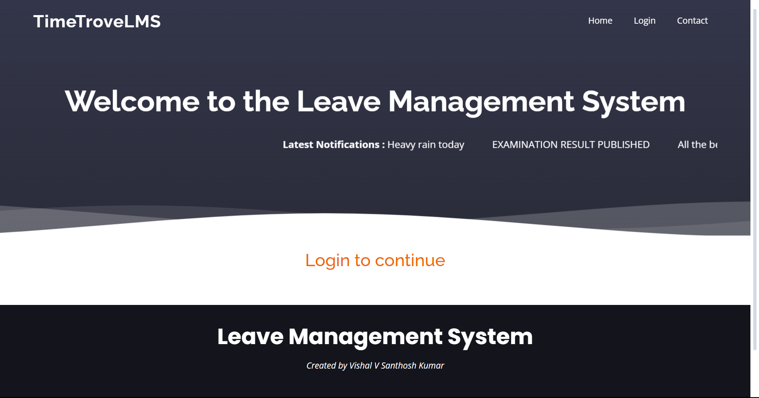
Login Page
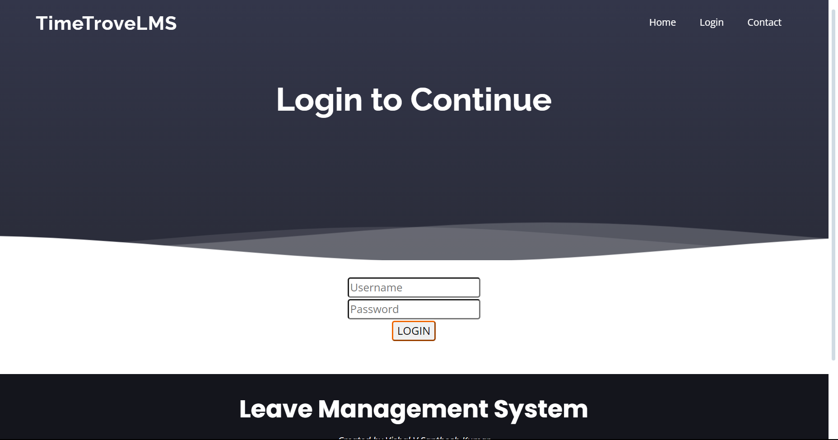

Admin page
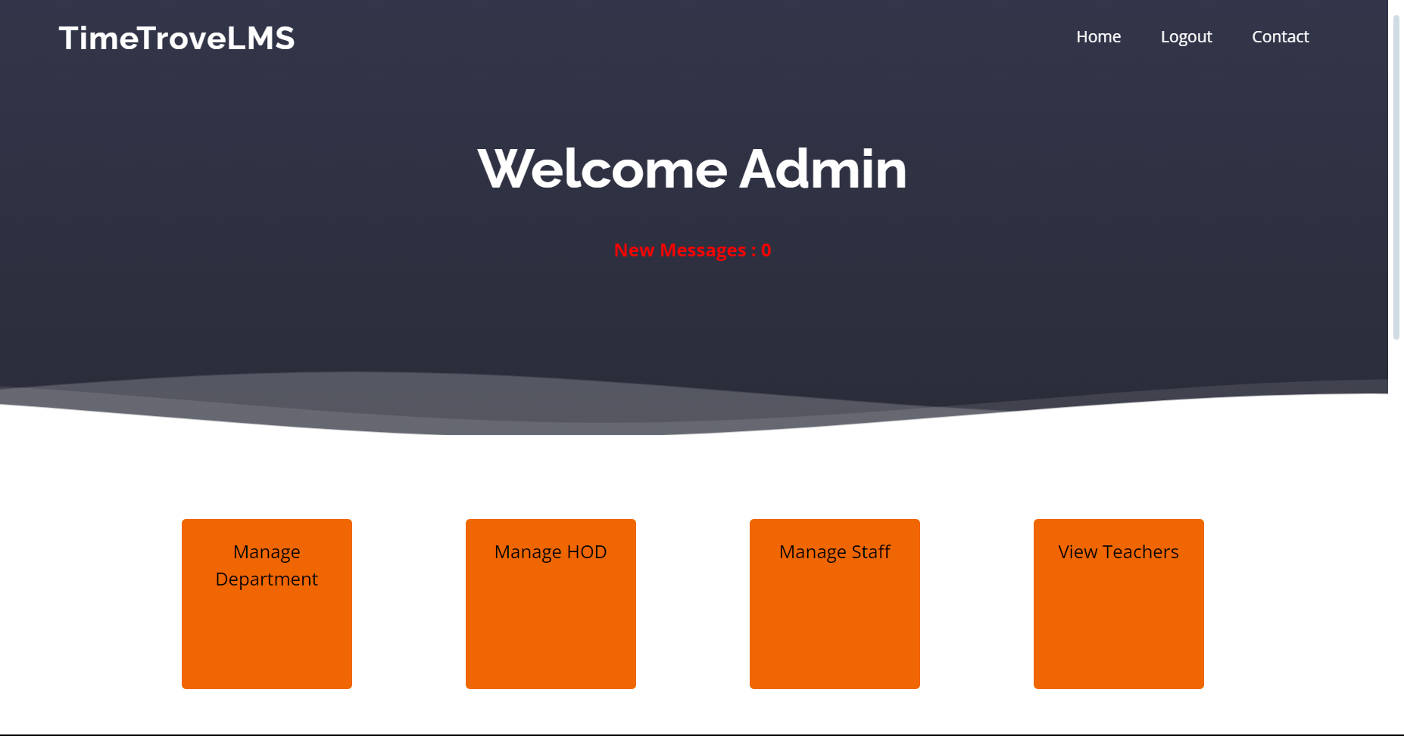
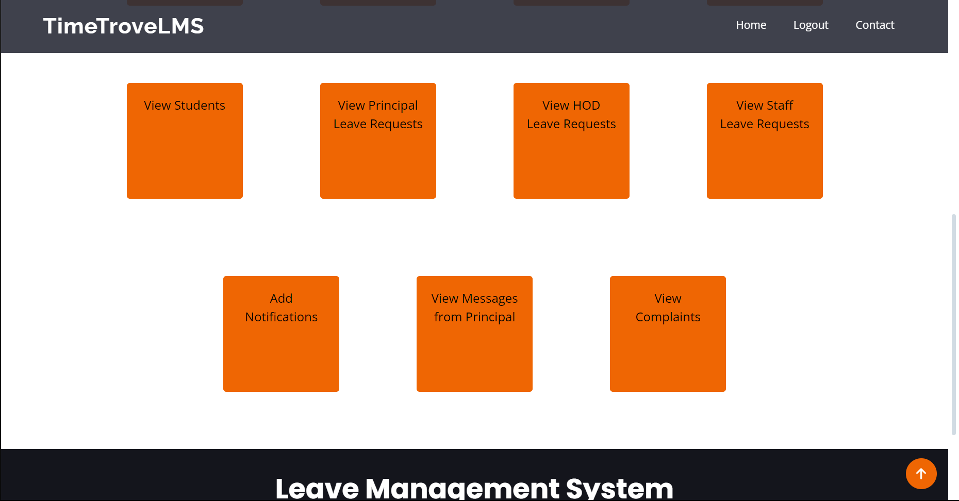

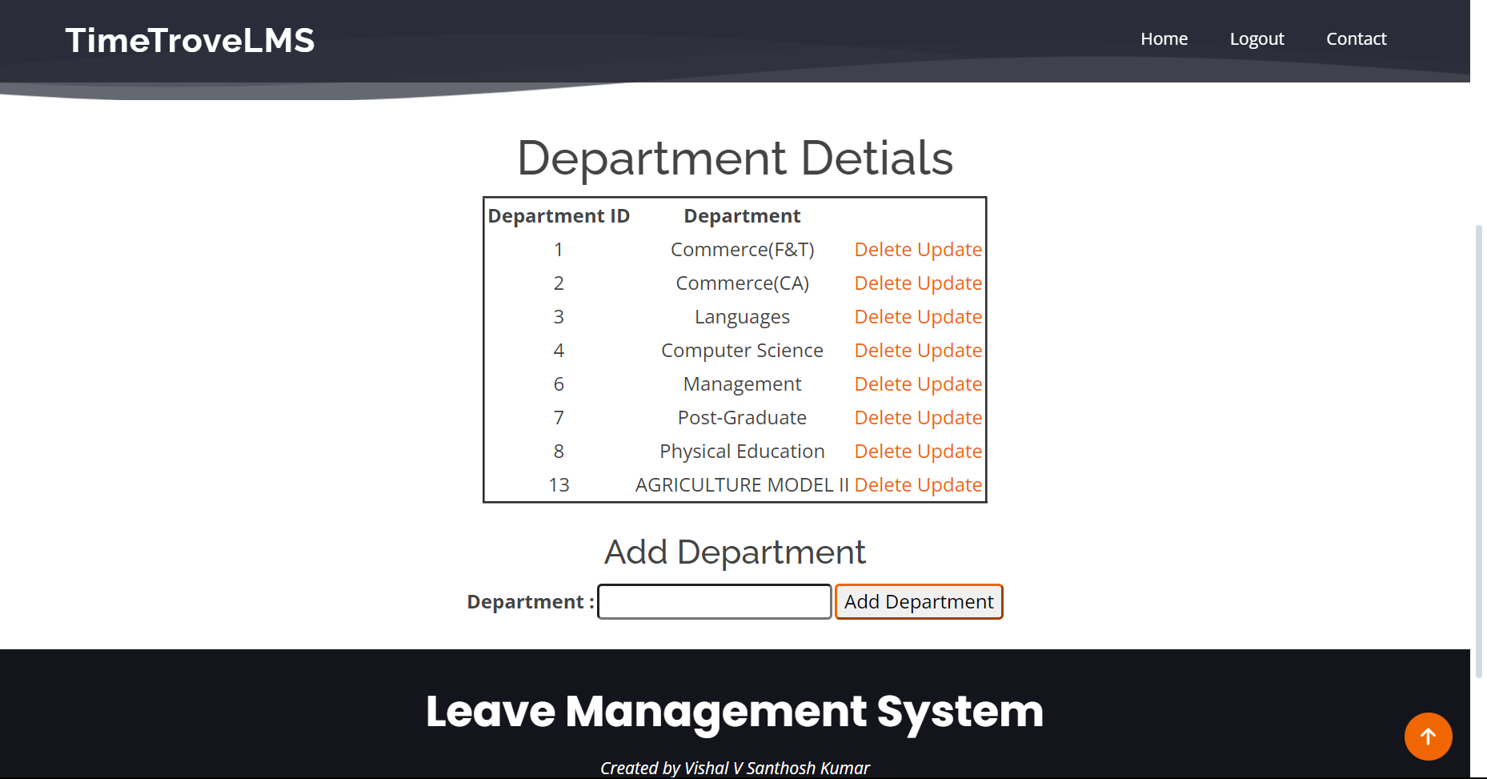
Manage Department Page

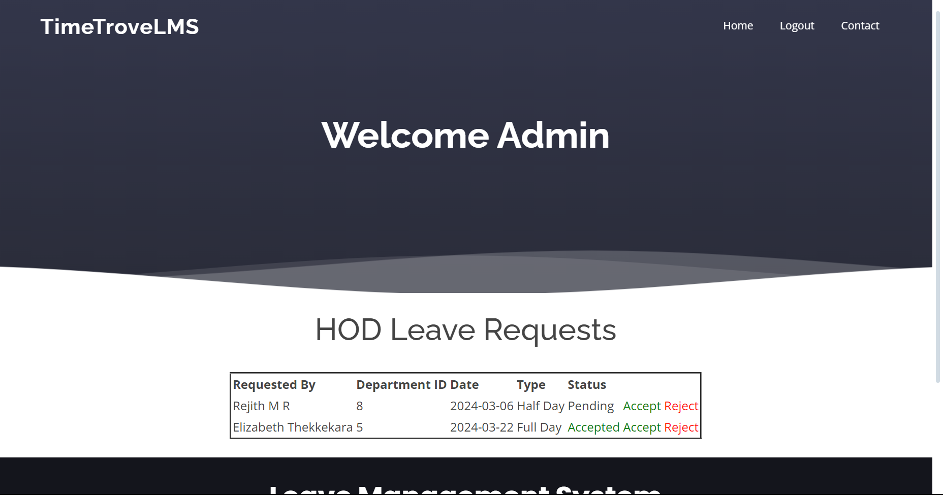
HOD Leave Request Page

View Messages Page
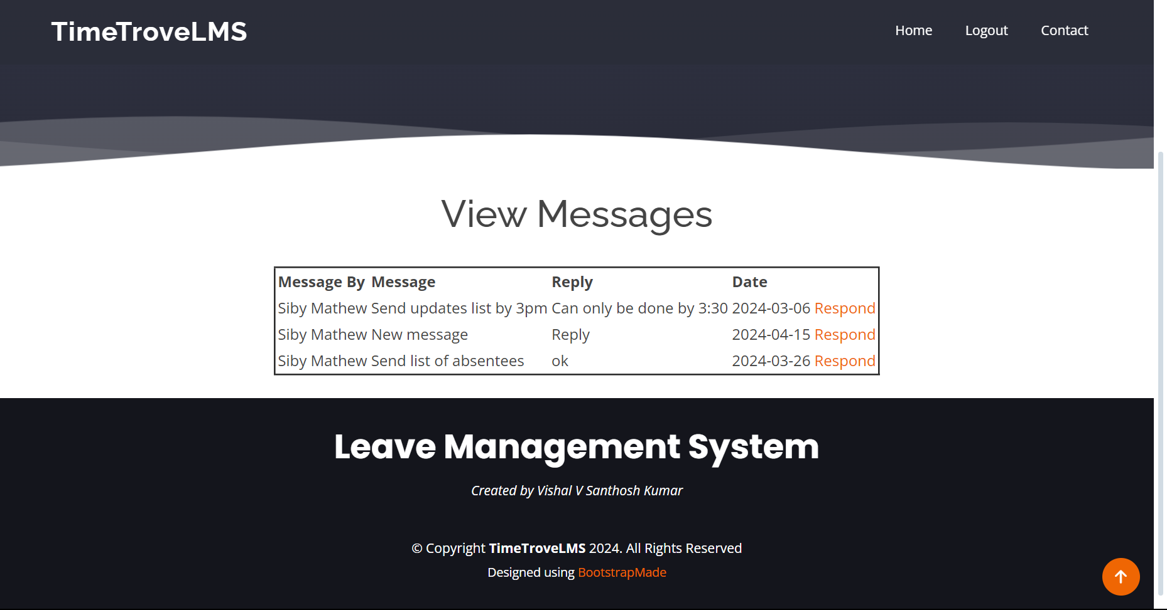
Principal Page
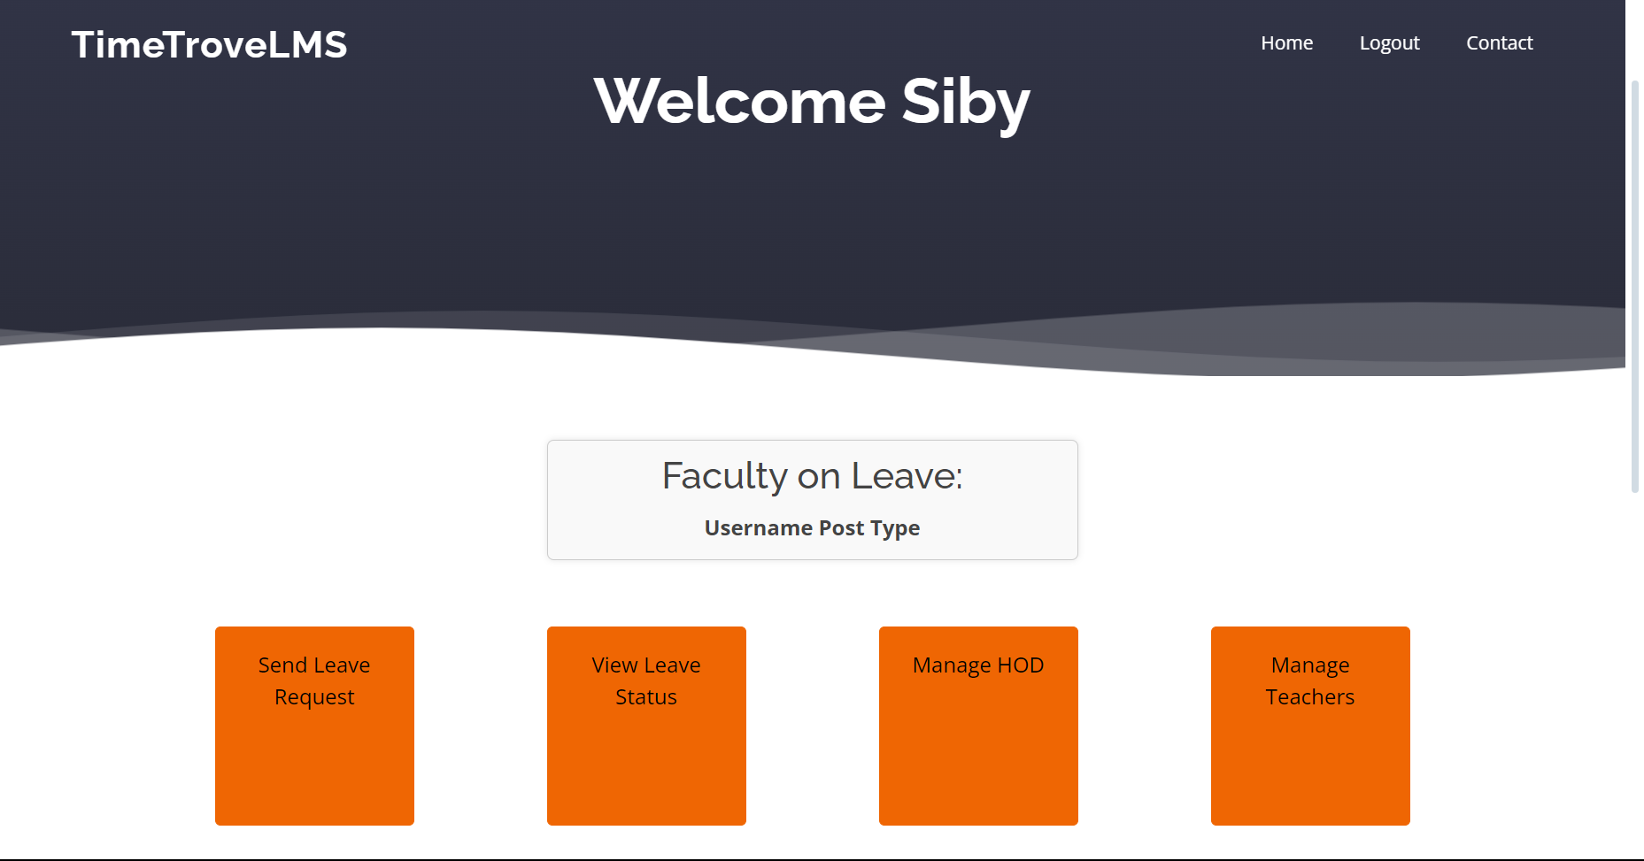

BIBLIOGRAPHY

Websites References

Following websites are referred to create this project reports:
• www.stackoverflow.com
• www.mysqltutorial.com
• www.geeksforgeeks.org
• www.w3schools.com

