**Out of office**

**Description**

1. **Structure description**
2. **Functional description**
   1. **HR manager**
   2. **Project manager**
   3. **Employee**
   4. **Administrator**
3. **Database**
   1. **Description**
   2. **Entity diagram**
4. **Structure description**

The project was developed using React for the client-side and ASP.NET for the REST API. Therefore, the application is divided into two parts:

* API (ASP.NET)
* Client-side (React)

The finished application can be accessed via the following link, where I have deployed it on Azure: [link to the client-side application.](https://red-rock-0b3f6ce0f.5.azurestaticapps.net)

GitHub links:

* API: [API GitHub repository](https://github.com/vichukin/Out_of_Office_API)
* Client-side: [Client-side GitHub repository](https://github.com/vichukin/Out_Of_Company_Client_Side)

1. **Functional Description**

In project we have 4 positions:

* Employee
* HR manager
* Project manager
* Administrator

**2.1 HR manager**

The HR manager opens the system and has to see the ability to navigate to the list of employees, projects, leave requests, approval requests.



With a list of employees, the HR manager can:

* sort table rows using sorting in the column headers

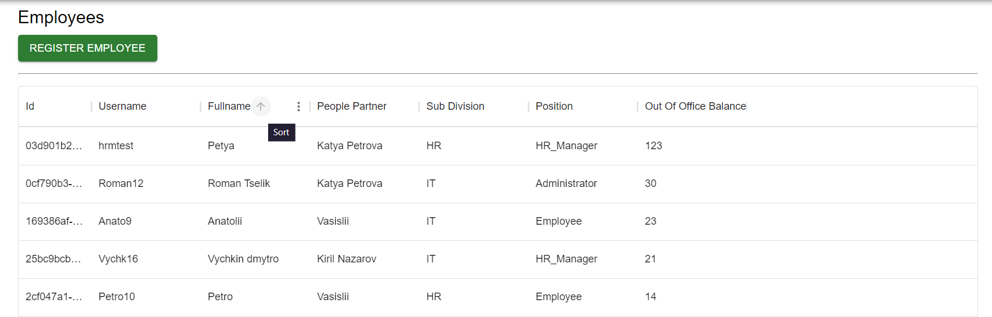

* use filters for table rows; – (*) •

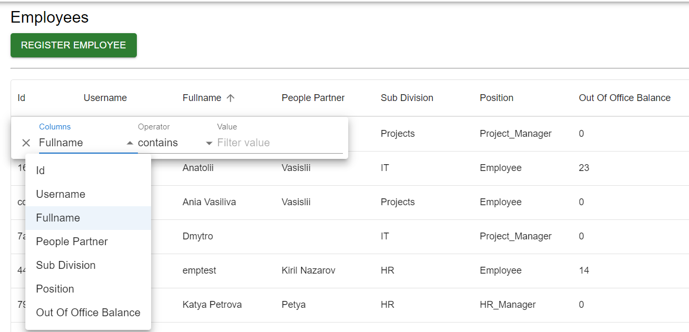

* add/update/deactivate employees in the list

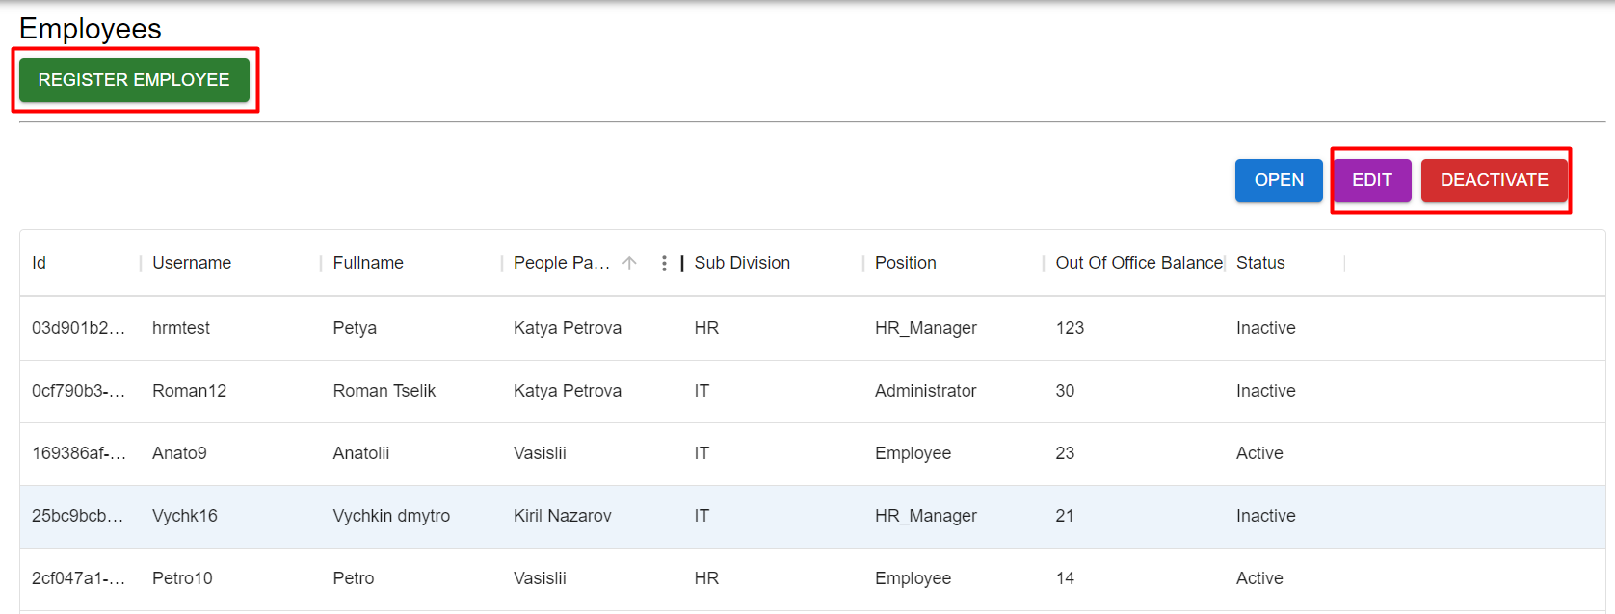

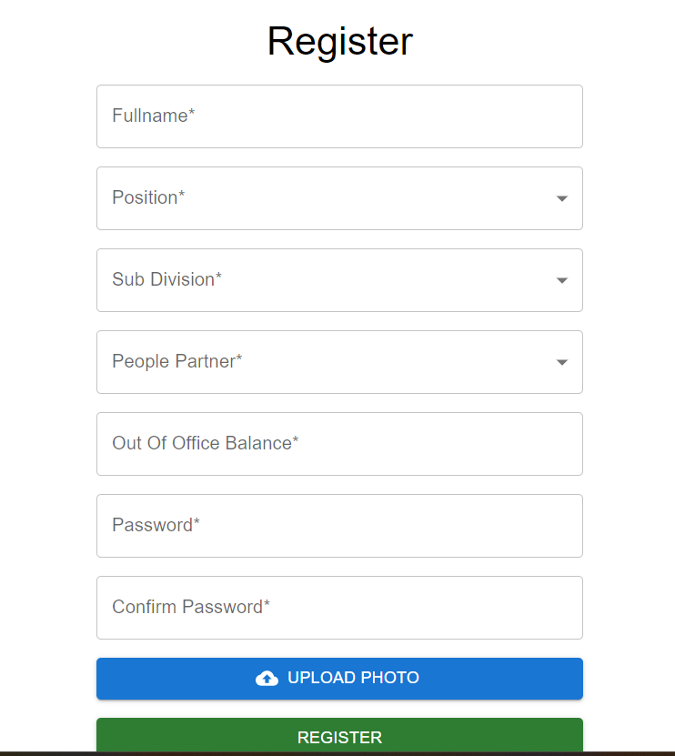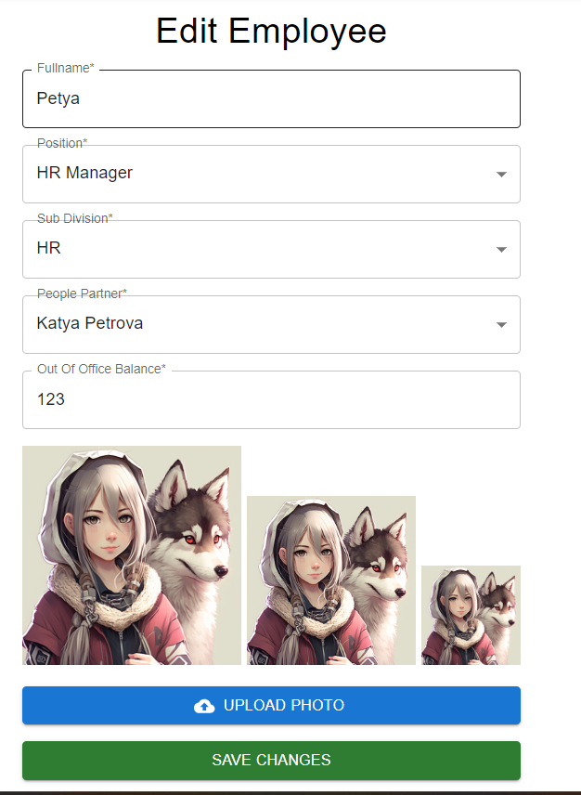

With a list of approval requests, the HR manager can:

* sort table rows using sorting in the column headers

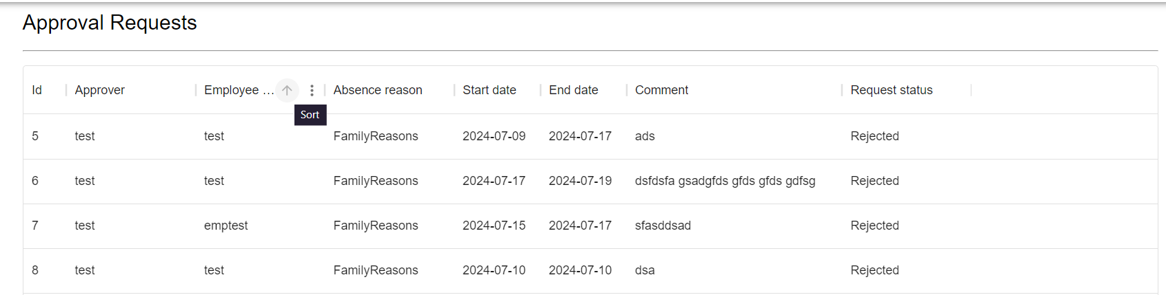

* use filters for table rows; – (*)

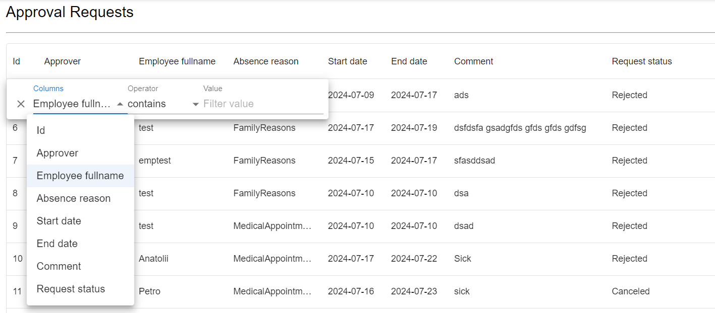

* open a request – a new form opens with details.

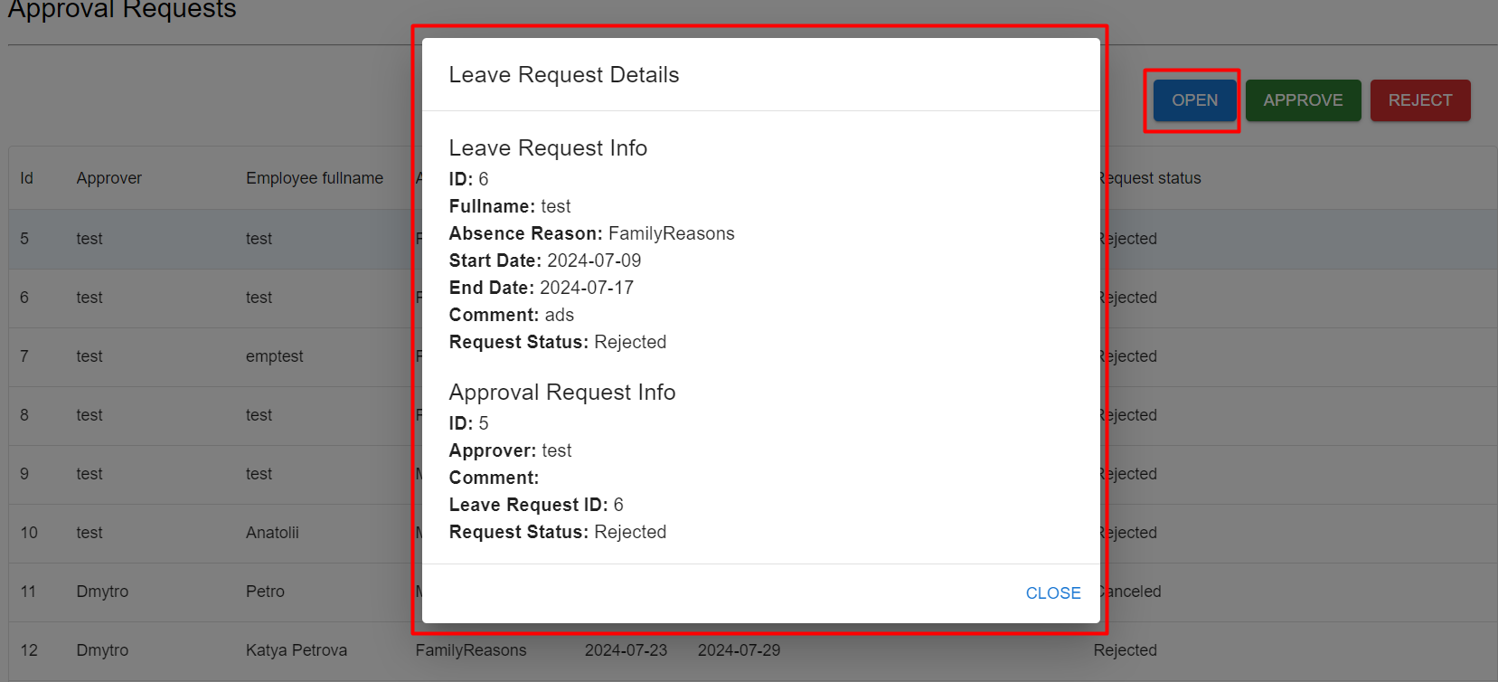

* approve the request – related leave request is updated with the corresponding status, and employee absence balance is recalculated;

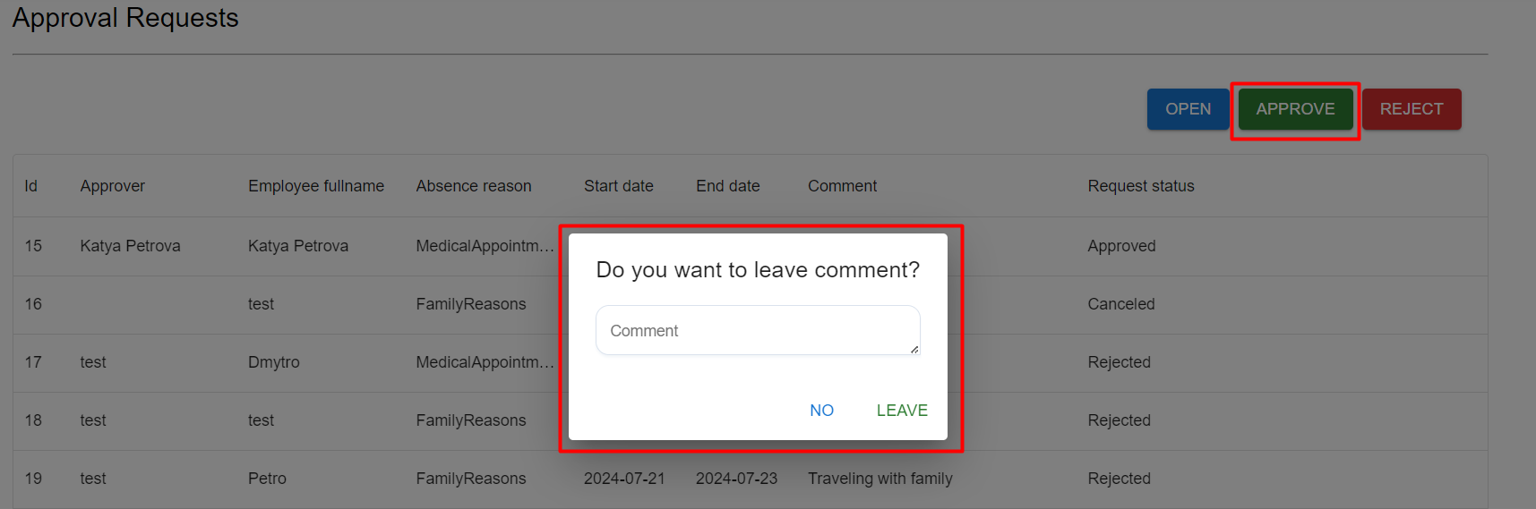

* reject the request – related leave request is updated with the corresponding status. Write a comment explaining that rejection should be possible.

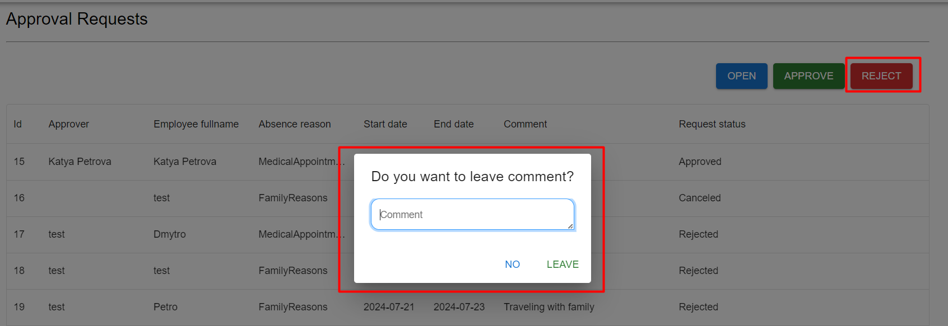

With a list of leave requests, the HR manager can:

* sort table rows using sorting in the column headers,

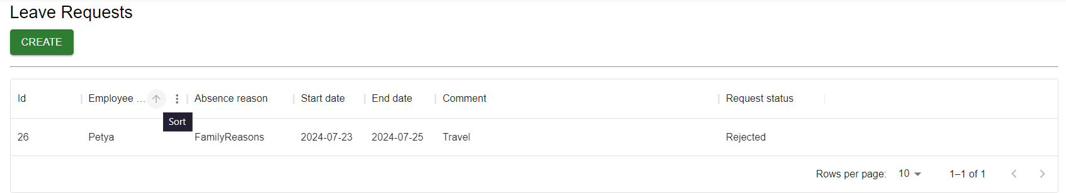

* use filters for table rows; – (*)

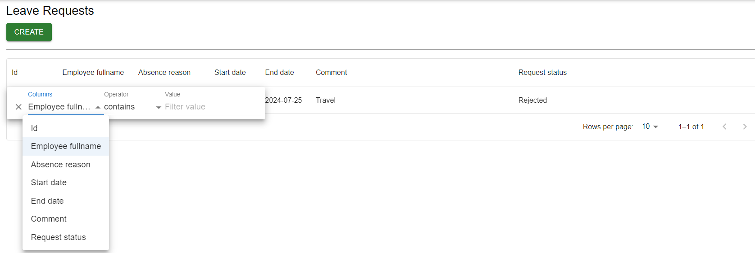

* open a request – a new form opens with details.

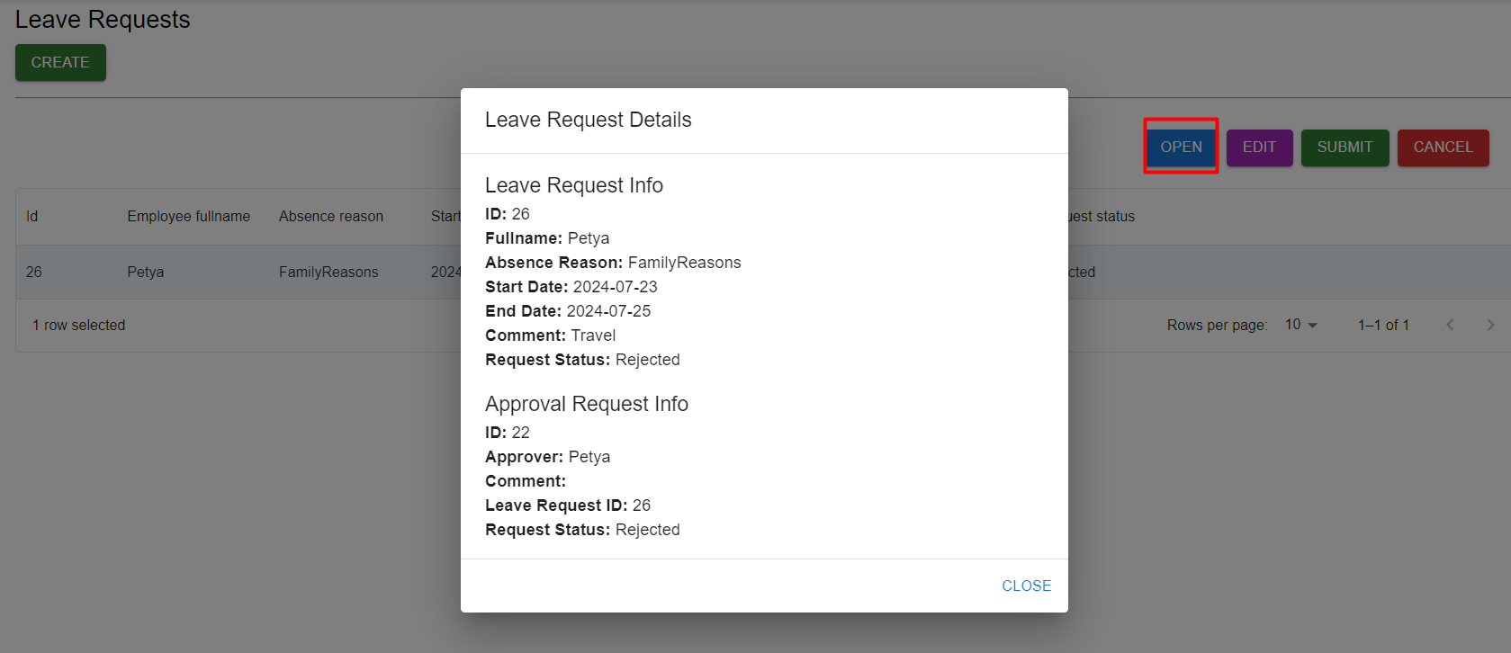

With a list of projects, the HR manager can:

* sort table rows using sorting in the column headers

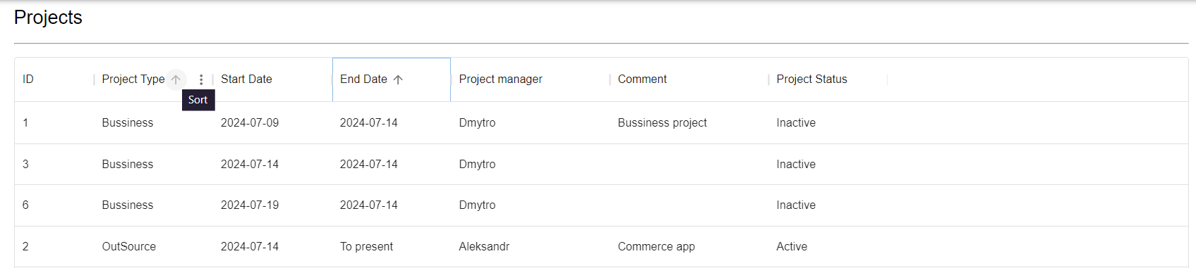

* use filters for table rows; – (*)

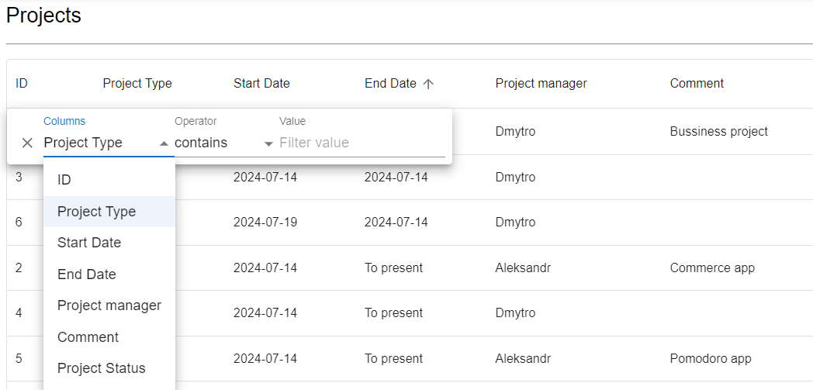

* open a project– a new form opens with details. 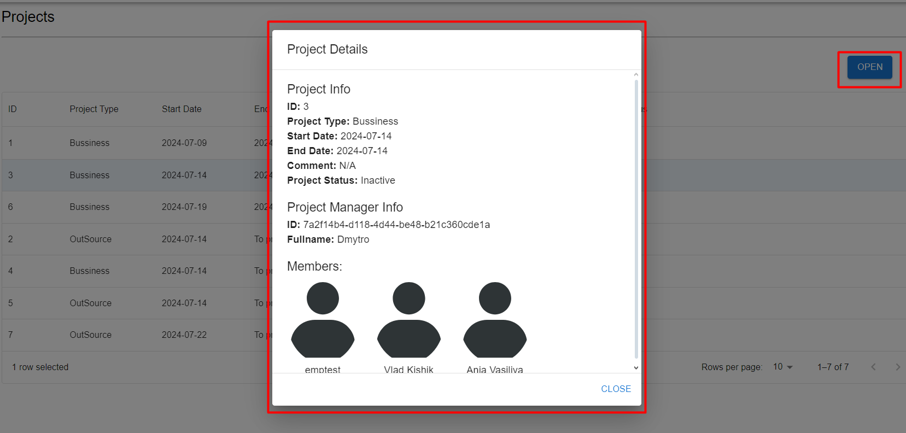

**2.2 Project manager**

The Project manager opens the system and has to see the ability to navigate to the list of employees, projects, leave requests, approval requests.



With a list of employees, the Project manager can:

* sort table rows using sorting in the column headers

It was shown earlier in HR manager Employee list

* use filters for table rows; – (*)

It was shown earlier in HR manager Employee list

* open an employee – a new form opens with details.

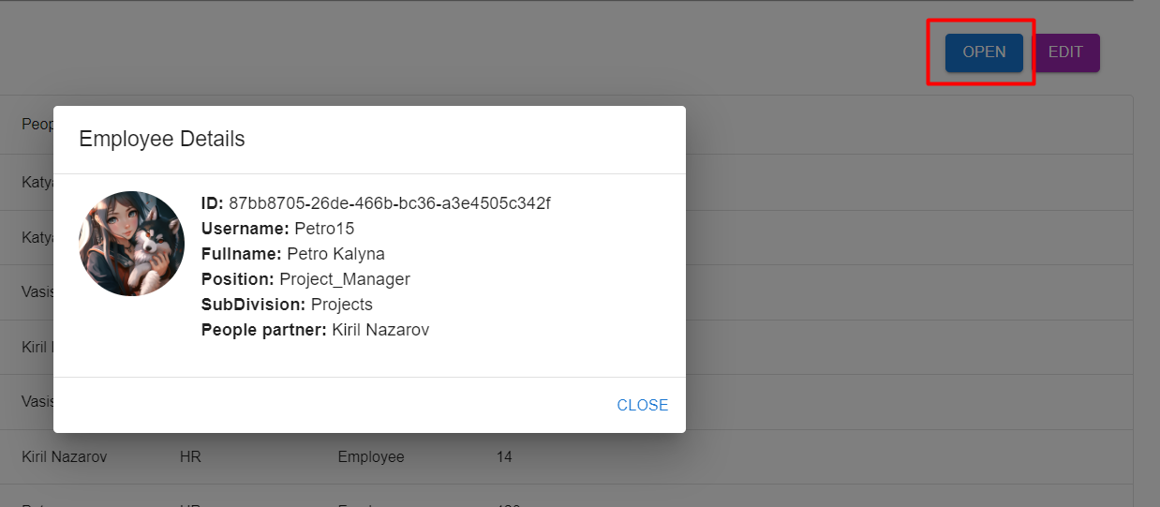

* assign an employee to projects.

Did it in edit project

With a list of approval requests, the Project manager can:

* sort table rows using sorting in the column headers

It was shown earlier in HR manager approval request list

* use filters for table rows; – (*)

It was shown earlier in HR manager approval request list

* open a request – a new form opens with details.

It was shown earlier in HR manager approval request list

* approve the request – related leave request is updated with the corresponding status, and employee absence balance is recalculated;

It was shown earlier in HR manager approval request list

* reject the request – related leave request is updated with the corresponding status. Write a comment explaining that rejection should be possible.

It was shown earlier in HR manager approval request list

With a list of leave requests, the Project manager can:

* sort table rows using sorting in the column headers,

It was shown earlier in HR manager leave request list

* use filters for table rows; – (*)

It was shown earlier in HR manager leave request list

* open a request – a new form opens with details.

It was shown earlier in HR manager leave request list

With a list of projects, the Project manager can:

* sort table rows using sorting in the column headers,

It was shown earlier in HR manager project list

* use filters for table rows; – (*)

It was shown earlier in HR manager project list

* open a project– a new form opens with details

It was shown earlier in HR manager project list

* add/update/deactivate projects in the list.

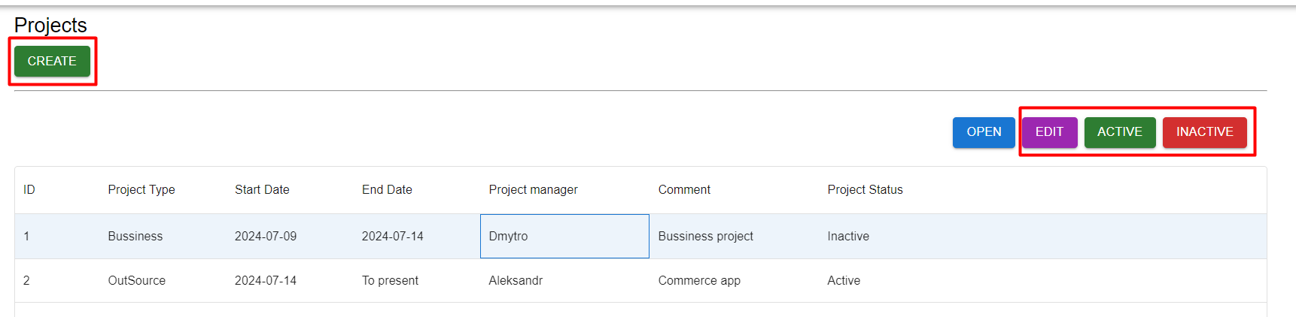

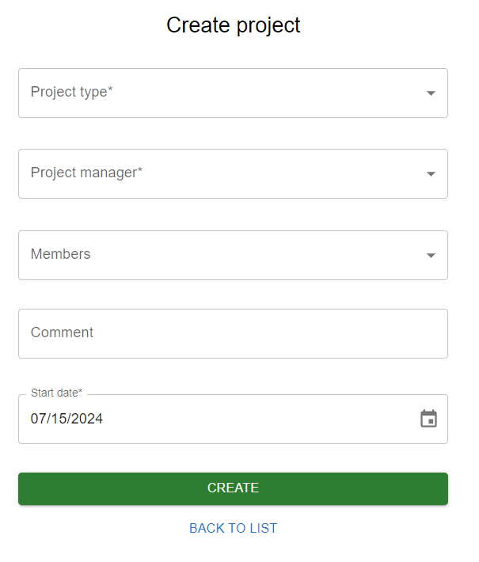 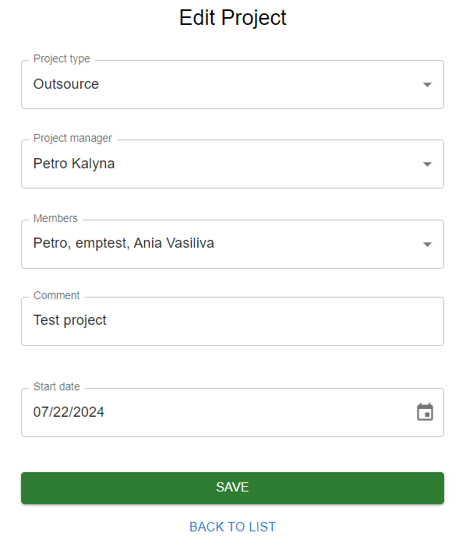

**2.3 Employee**

The company employees opens the system and has to see the ability to navigate to the list of their projects and leave requests.



With a list of leave requests, the employee can:

* sort table rows using sorting in the column headers,

It was shown earlier in HR manager leave request list

* use filters for table rows; – (*)

It was shown earlier in HR manager leave request list

* open a new and existing request – a form opens, and employee can create and update the request.

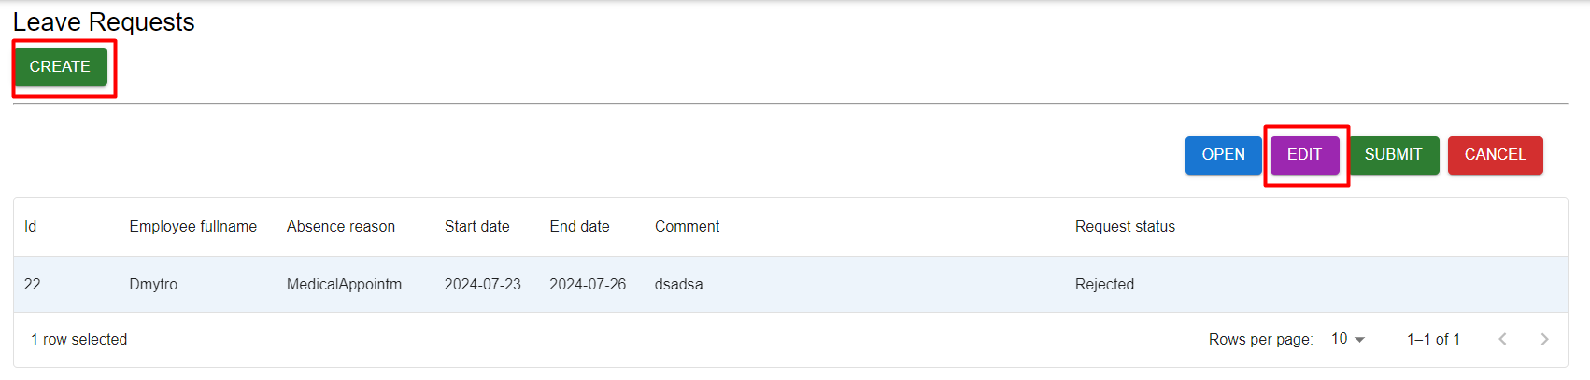

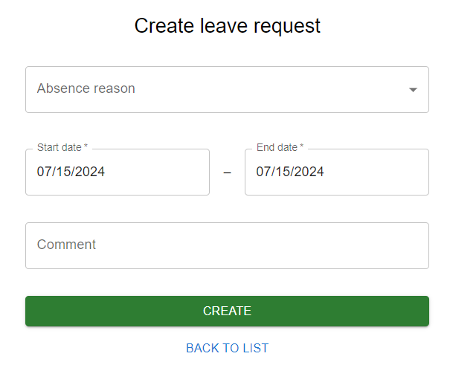 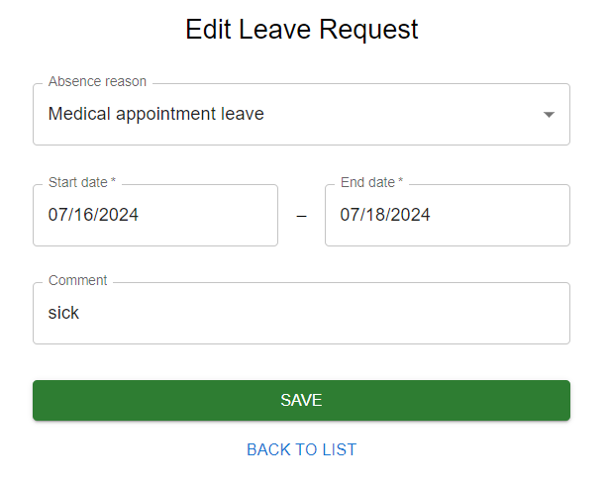

* submit the request – the status is updated to “Submitted,” and a new approval request is created for the responsible HR Manager and Project Managers responsible for employee’s projects;

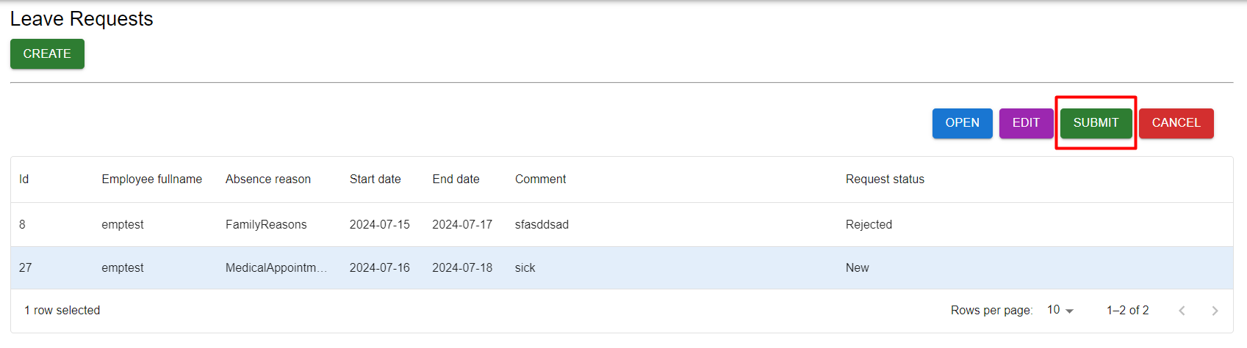

* cancel the request – the status is updated to “Canceled,” and approval requests are canceled if they already exist.

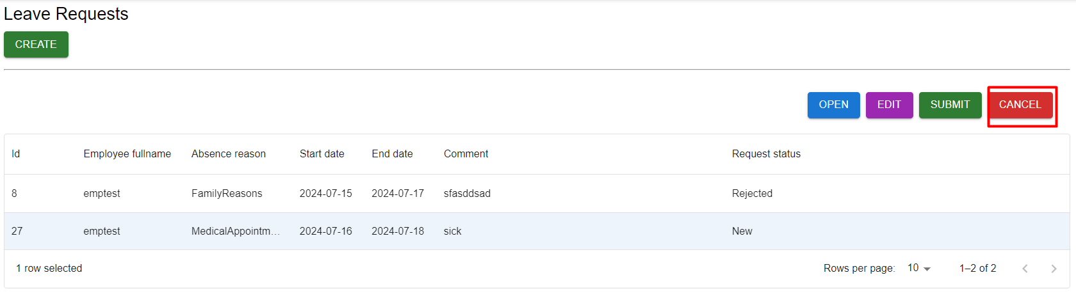

**2.4 Administrator**

Can perform all the above-mentioned tasks

1. **Database**

**3.1 Description**

The database was created using the Code-First method with Entity Framework and migrations. Therefore, I can’t provide SQL queries, but I can provide an entity diagram that explains the database structure.

**3.2 Entity diagram**

