Name: Victor Ipinmoroti

CIS: 430

Question 1

First we insert the new information into the table like so

use COMPANY

go

INSERT INTO [DEPENDENT] VALUES('453453453','Joe','M','1962-07-31','Spouse');

INSERT INTO [DEPENDENT] VALUES('987654321','Erica','F','4-04-19','Daughter');

INSERT INTO WORKS_ON VALUES('987654321',10,0);

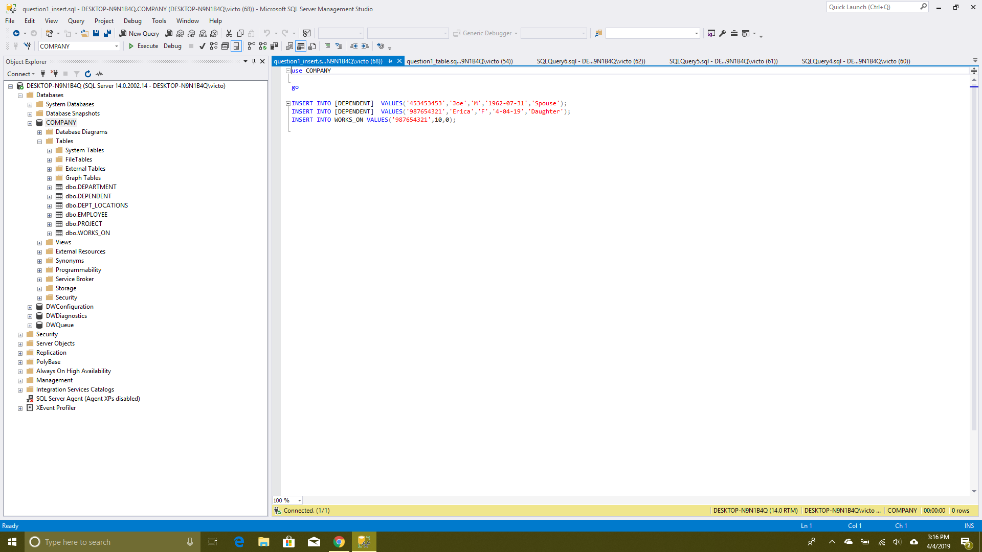

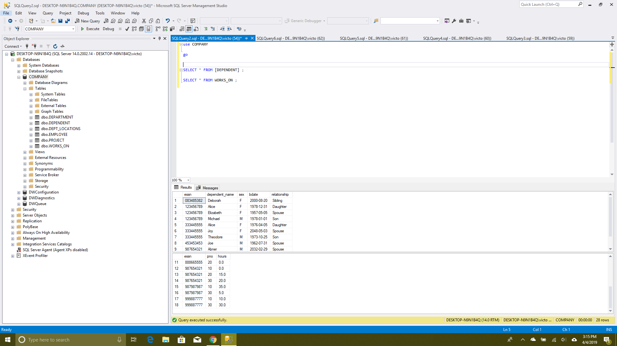

Question 2

First we do part A

use COMPANY;

go

Select E.Fname, E.Lname, E.Dno, E.Super_ssn, D.Dnumber

From Department D LEFT OUTER JOIN Employee E

On D.Dnumber = E.dno;

**Out put**

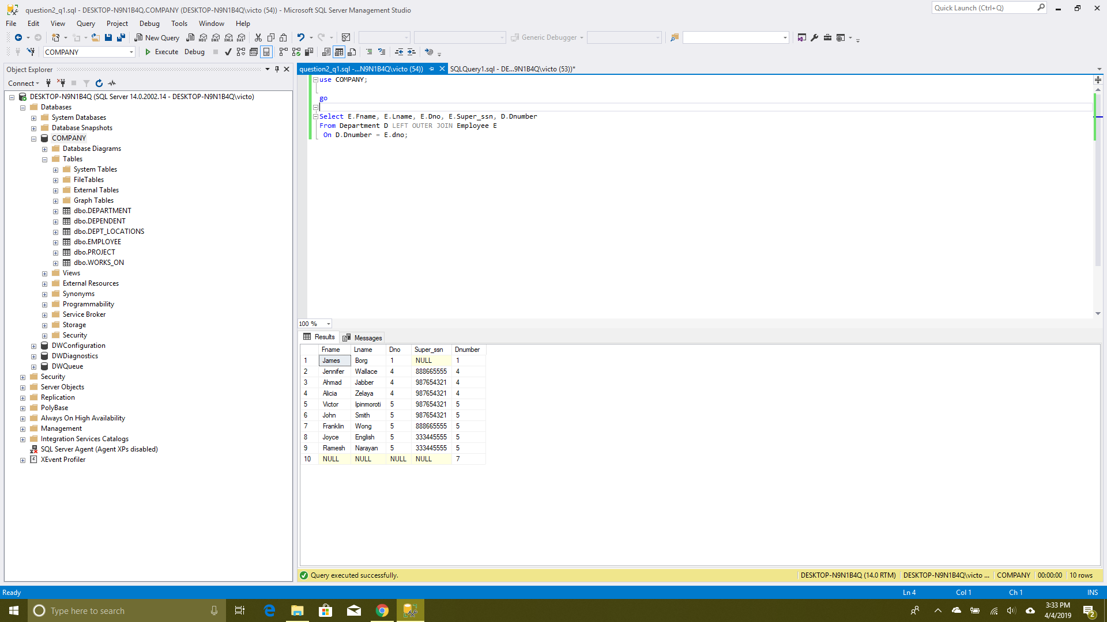

For the second part we do the same command but this time we use the right join

use COMPANY;

go

Select E.Fname, E.Lname, E.Dno, E.Super_ssn, D.Dnumber

From Department D right OUTER JOIN Employee E

On D.Dnumber = E.dno

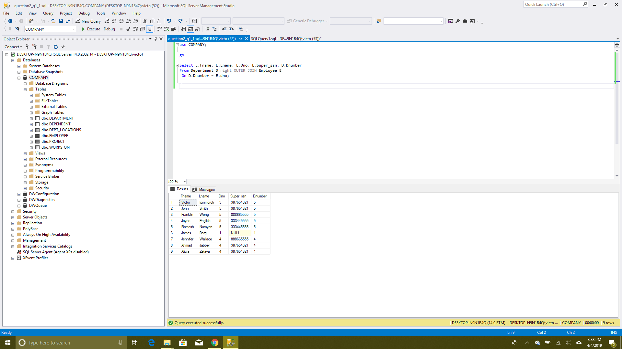

For question 2 of part 2

First, we find where employee SSN is equal to dependent ssn then we make sure it is a female employee and the relationship is a spouse. Then we loop through the works on table to get the amount of times the employee as worked on the project.

use COMPANY;

go

Select e.SSN, e.LNAME

From Employee e, Dependent d

Where e.SSN=d.essn AND e.SEX='F' AND d.relationship='spouse' AND

e.SSN IN (Select w.Essn

From WORKS_ON w

Group By w.Essn

Having COUNT(w.Essn)>=3);

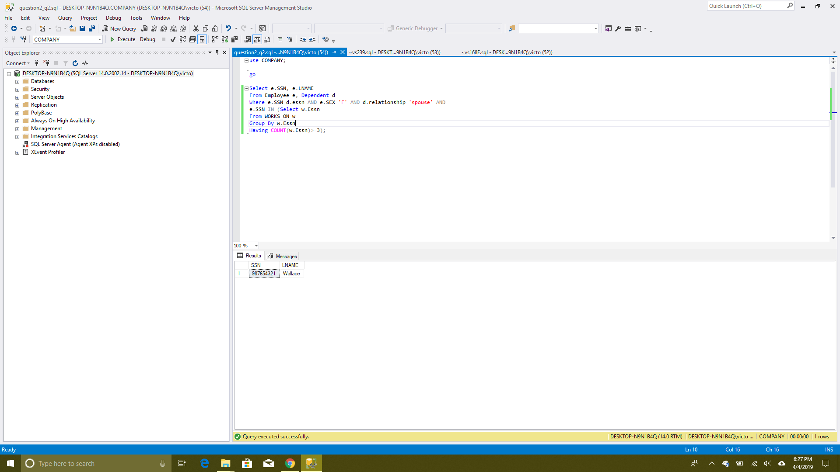

For the third question we first make sure the relationship is a spouse or married then we search in the research department for some one who have no son or daughter.

Use Company;

go

Select e.FNAME, e.LNAME

From Employee e

Where Exists (Select A.essn

From Dependent A

Where e.SSN=A.essn AND A.relationship='spouse') /* first we get sposes*/

AND Exists (Select B.DNAME

From Department B

Where e.DNO=B.DNUMBER AND B.DNAME='Research')

AND NOT Exists (Select C.essn/* then we get those who have children in research compare and take the missing row */

From Dependent C

Where e.SSN=C.essn AND (C.relationship='daughter' OR C.relationship='son'))

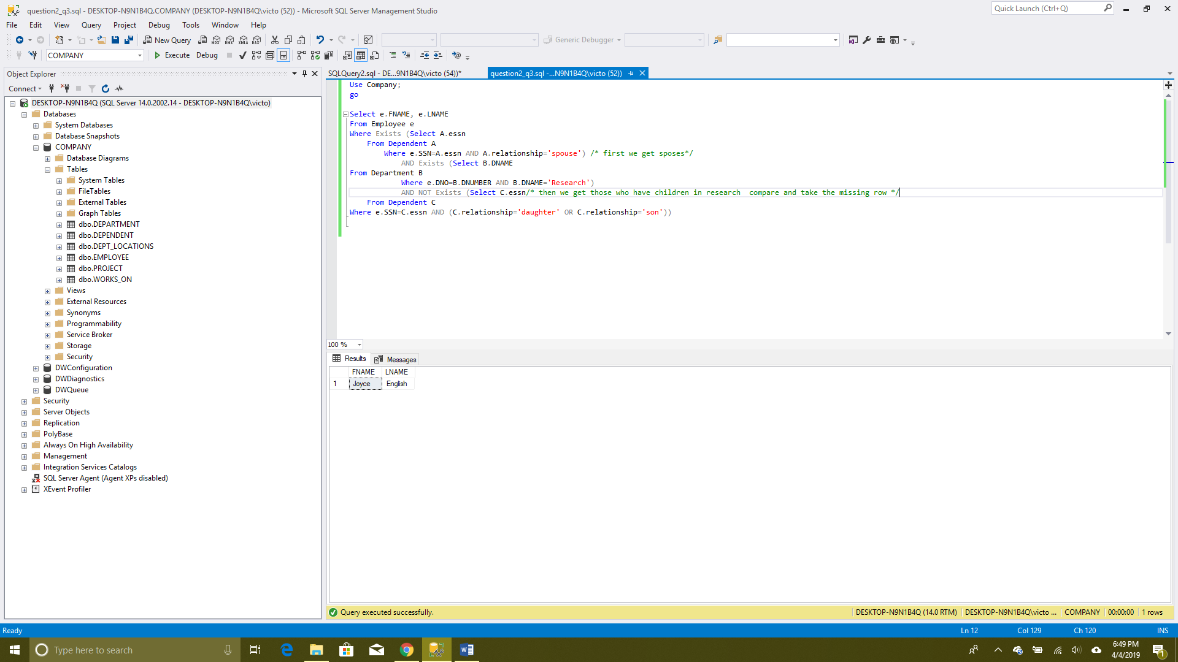

We do some thing similar for question four but this time we are looking for daughter instead. Thus

Use Company;

go

Select e.LNAME

From Employee e

Where Exists (Select f.essn

From Dependent f

Where e.SSN=f.essn AND f.relationship='spouse')

AND Exists (Select g.essn

From Dependent g

Where e.SSN=g.essn AND g.relationship='daughter')

AND NOT Exists (Select h.essn

From Dependent h

Where e.SSN=h.essn AND h.relationship='son')

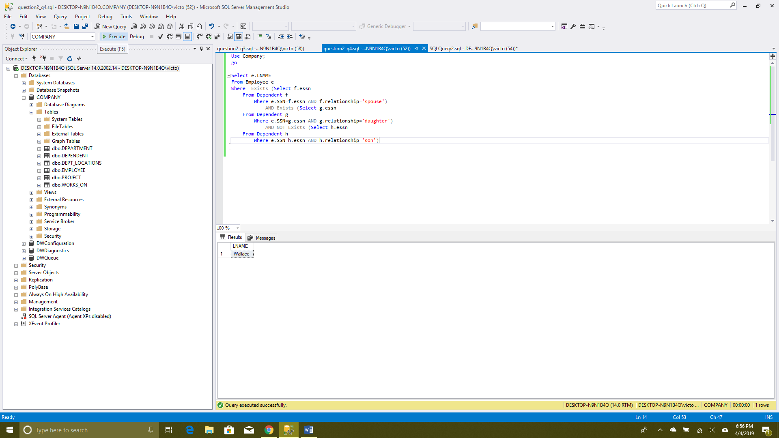

Then in 5 we try to get project with more female than male by last name

Use Company;

go

Select e.LNAME , e.SSN

From Employee e , WORKS_ON w ,

(Select a.Pno , COUNT ( a.Essn)

From WORKS_ON a , Employee e

Where a.Essn = e.SSN AND e.SEX = 'F'

Group By a.Pno ) as female (Pno, Fcount),

(Select b.Pno, COUNT (b.Essn)

From WORKS_ON b, Employee f

Where b.Essn = f.SSN AND f.SEX = 'M'

Group by b.Pno ) as male (Pno, Mcount)

Where e.SSN = w.Essn AND w.Pno = female.Pno AND female.Pno = male.Pno AND female.Fcount > male.Mcount ;

