Victor Ipinmoroti

CIS 430

Lab 2.2

Part1

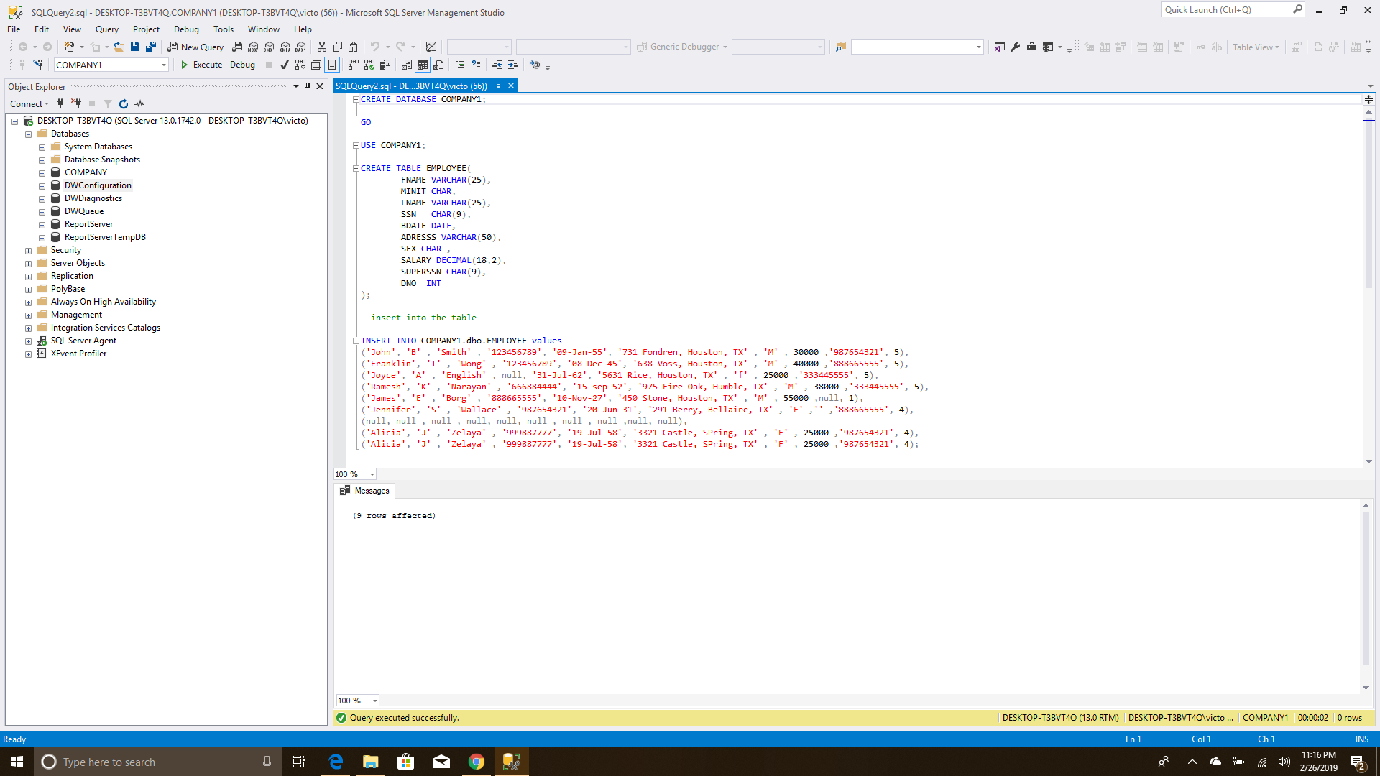

First we try to insert bad values with out any constaints, as shown below this did not have an effect on the table compilation.

CREATE DATABASE COMPANY1;

GO

USE COMPANY1;

CREATE TABLE EMPLOYEE /*create employee table*/

(fname varchar(15)

minit char,

lname Varchar(15)

ssn char(9)

bdate date,

adress varchar(30),

sex char,

salary decimal(10,2),

super_ssn char(9),

dno int

);

Inserted the bad data

And selected from the table.

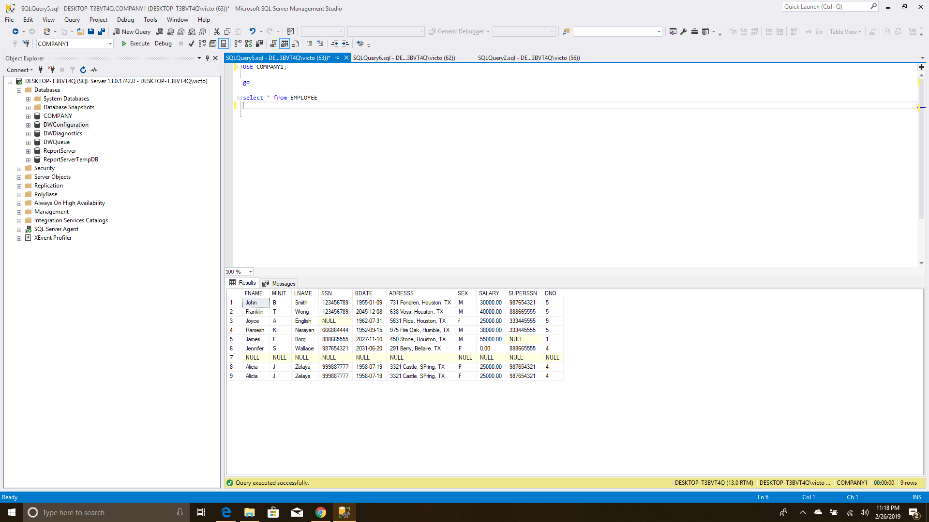

Then we try to do the right relationship and schema

CREATE DATABASE COMPANY;

GO

USE COMPANY;

CREATE TABLE EMPLOYEE /*create employee table*/

(fname varchar(15) not null,

minit char,

lname Varchar(15) not null,

ssn char(9) not null,

bdate date,

adress varchar(30),

sex char,

salary decimal(10,2),

super_ssn char(9),

dno int not null,

primary key (ssn), /*assign primary key*/

);

CREATE TABLE DEPARTMENT /*create department table*/

(dname varchar(15) not null,

dnumber int not null,

mgr_ssn char(9) not null,

mgr_sstart_date date,

primary key (dnumber), /*assign primary key*/

unique (dname), /*make sure every dname is unique and there are no dublicate name*/

foreign key (mgr_ssn) references EMPLOYEE(ssn), /*foreign key of mgr_ssn that is refreced in employee as ssn*/

);

/*we alter the employee table later for the sake of department table that is refrenced but not yet created*/

ALTER TABLE EMPLOYEE ADD CONSTRAINT FKCONSTR1 /* we add and name a foreign constraint*/

FOREIGN KEY (super_ssn) REFERENCES EMPLOYEE(ssn); /*foreign key of mgr_ssn that is refreced in employee as ssn*/

alter table EMPLOYEE add constraint fkemployee_dep

foreign key (dno) references DEPARTMENT(dnumber);

/*we create the other table but include and primary and forign key in them given that the componet are in prevoius table or current table*/

CREATE TABLE DEPT_LOCATIONS

(dnumber int not null,

dlocation varchar(15) not null,

primary key (dnumber,dlocation),

foreign key (dnumber) references DEPARTMENT(dnumber),

);

CREATE TABLE PROJECT

(pname varchar(15) not null,

pnumber int not null,

plocation varchar(15),

dnum int not null,

primary key (pnumber),

unique (pname),

foreign key (dnum) references DEPARTMENT(dnumber),

);

CREATE TABLE WORKS_ON

(essn char(9) not null,

pno int not null,

[hours] DECIMAL(3,1) not null,

primary key (essn,pno),

foreign key (essn) references EMPLOYEE(ssn),

foreign key (pno) references PROJECT(pnumber),

);

CREATE TABLE [DEPENDENT]

(essn char(9) not null,

dependent_name varchar(15) not null,

sex char,

bdate date,

relationship varchar(8),

primary key (essn,dependent_name),

foreign key (essn) references EMPLOYEE(ssn),

);

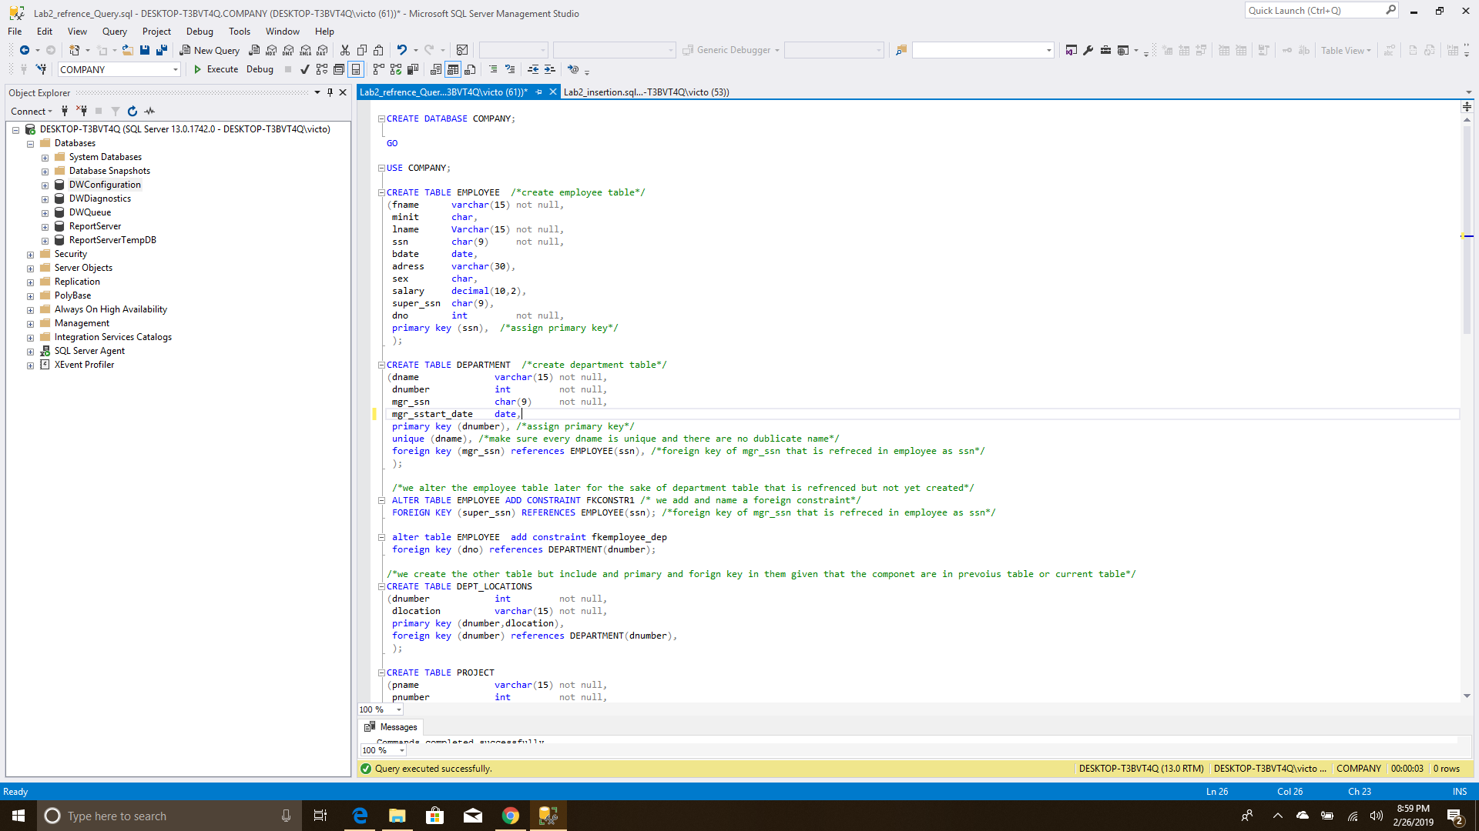

Used altered table for situation where one present table relies on table that has not been created after that all other tables had the components they need either presently or on previous table.

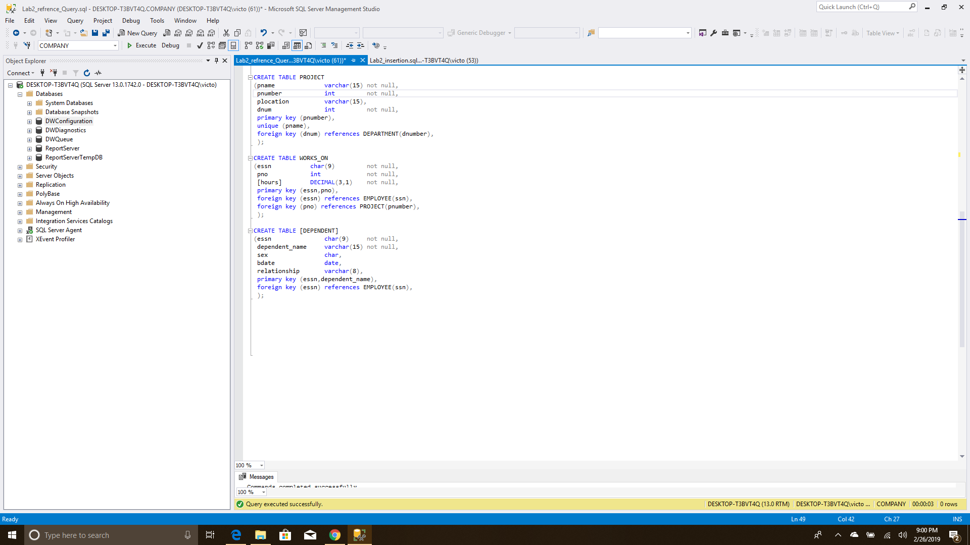

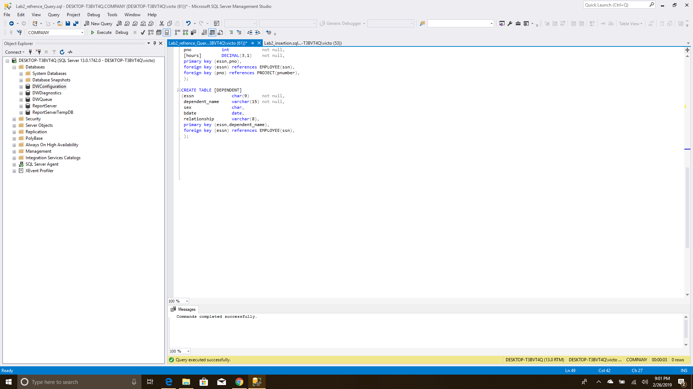

Table compiles successfully.

Next, we populate the table.

USE COMPANY;

go

ALTER TABLE dbo.EMPLOYEE NOCHECK CONSTRAINT fkemployee_dep /*dont check for this constraint*/

INSERT INTO COMPANY.dbo.EMPLOYEE values

('John', 'B' , 'Smith' , '123456789', '09-Jan-55', '731 Fondren, Houston, TX' , 'M' , 30000 ,'987654321', 5),

('Franklin', 'T' , 'Wong' , '333445555', '08-Dec-45', '638 Voss, Houston, TX' , 'M' , 40000 ,'888665555', 5),

('Joyce', 'A' , 'English' , '453453453', '31-Jul-62', '5631 Rice, Houston, TX' , 'f' , 25000 ,'333445555', 5),

('Ramesh', 'K' , 'Narayan' , '666884444', '15-sep-52', '975 Fire Oak, Humble, TX' , 'M' , 38000 ,'333445555', 5),

('James', 'E' , 'Borg' , '888665555', '10-Nov-27', '450 Stone, Houston, TX' , 'M' , 55000 ,null, 1),

('Jennifer', 'S' , 'Wallace' , '987654321', '20-Jun-31', '291 Berry, Bellaire, TX' , 'F' , 43000 ,'888665555', 4),

('Ahmad', 'V' , 'Jabber' , '987987987', '29-Mar-59', '980 Dallas, Houston, TX' , 'M' , 25000 ,'987654321', 4),

('Alicia', 'J' , 'Zelaya' , '999887777', '19-Jul-58', '3321 Castle, SPring, TX' , 'F' , 25000 ,'987654321', 4);

INSERT INTO COMPANY.dbo.DEPARTMENT values

('Headquarters', 1, '888665555', '1971-06-19'),

('Administration', 4, '987654321', '1985-01-01'),

('Research', 5, '333445555', '1978-05-22'),

('Automation', 7, '123456789', '2006-10-05');

INSERT INTO COMPANY.dbo.DEPT_LOCATIONS values

( 1, 'Houston'),

( 4, 'Stafford'),

( 5, 'Bellaire'),

( 5, 'Sugarland'),

( 5,'Houston');

INSERT INTO COMPANY.dbo.PROJECT values

('ProductX', 1, 'Bellaire', 5),

('ProductY', 2, 'Sugarland', 5),

('ProductZ', 3, 'Houston', 5),

('Computerization', 10, 'Stafford', 4),

('Reorganization', 20, 'Houston', 1),

('Newbenefits', 30, 'Stafford', 4);

INSERT INTO COMPANY.dbo.WORKS_ON values

('123456789',1 ,32.5),

('123456789', 2,7.5),

('333445555', 2, 10),

('333445555', 3, 10),

('333445555', 10, 10),

('333445555', 20, 10),

('453453453', 1, 20),

('453453453', 2, 20),

('666884444', 3, 40),

('888665555', 20, 0),

('987654321', 20, 15),

('987654321', 30, 20),

('987987987', 10, 35),

('987987987', 30, 5),

('999887777', 10, 10),

('999887777', 30, 30);

INSERT INTO COMPANY.dbo.[DEPENDENT] values

('123456789','Alice','F','31-Dec-78','Daughter'),

('123456789','Elizabeth','F', '05-May-57','Spouse'),

('123456789','Michael','M', '01-Jan-78','Son'),

('333445555','Alice','F', '05-Apr-76','Daughter'),

('333445555','Joy','F', '03-May-48','Spouse'),

('333445555','Theodore','M', '25-Oct-73','Son'),

('987654321','Abner','M', '29-Feb-32','Spouse');



Before populating the Employee, we make sure that we do not check constraint that relies on future table (department).

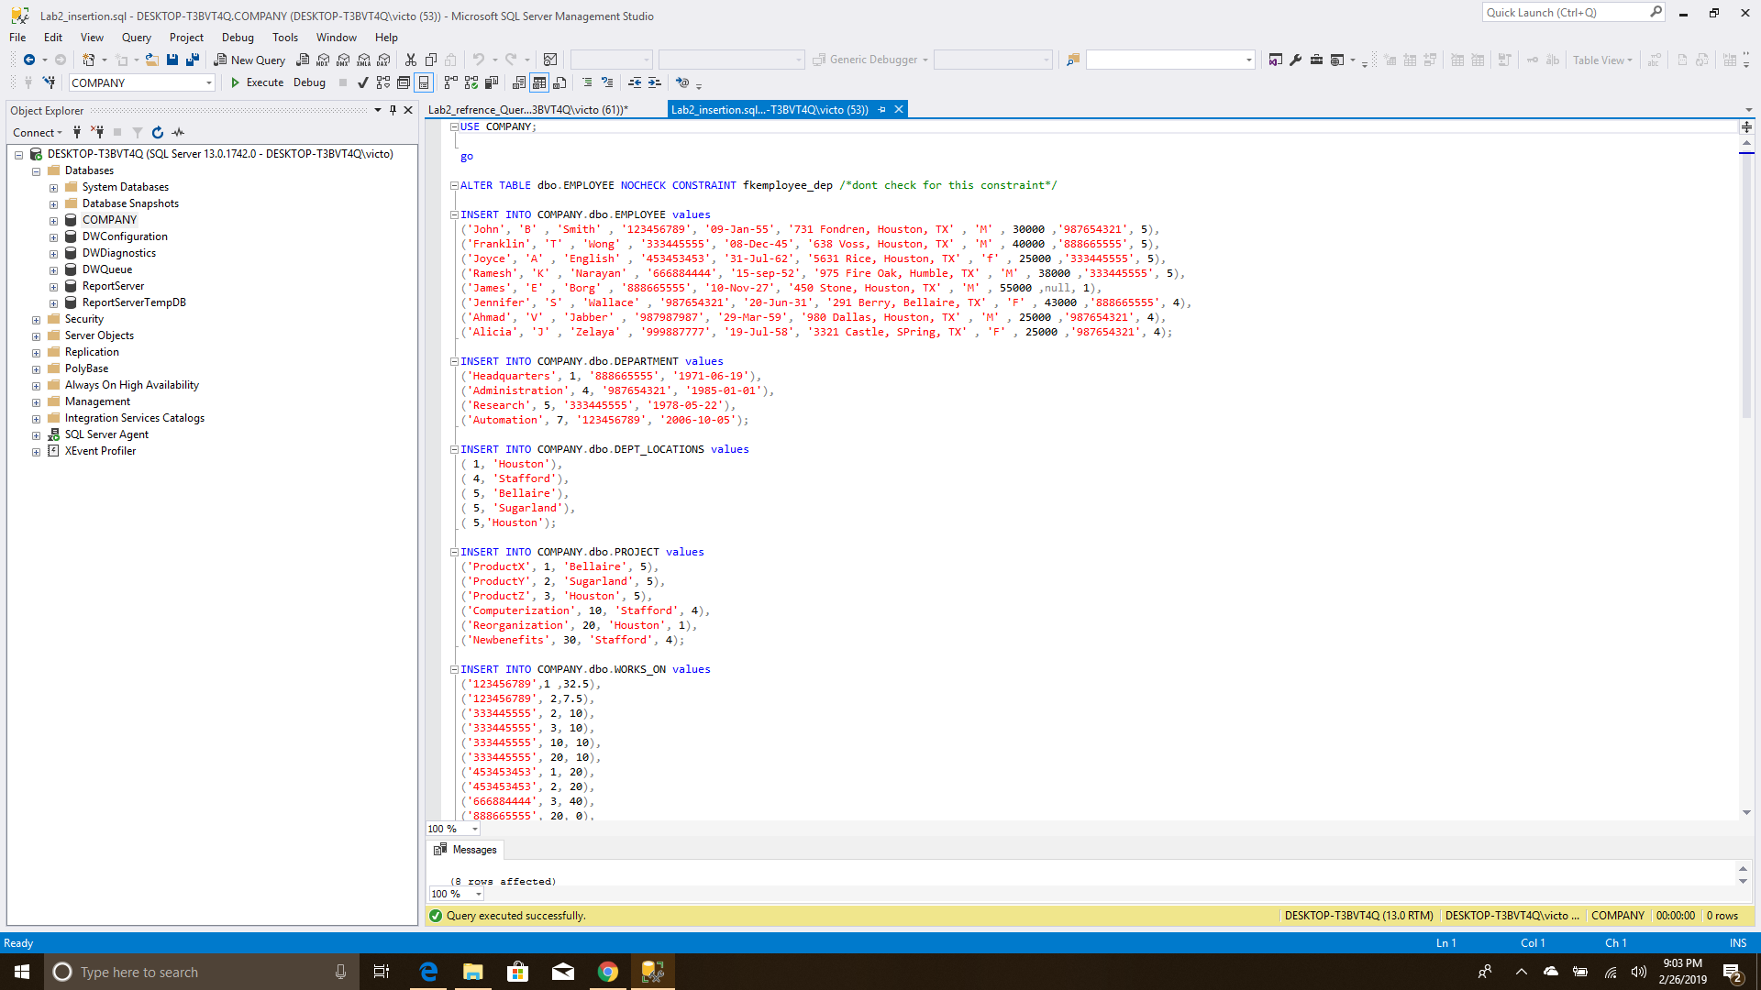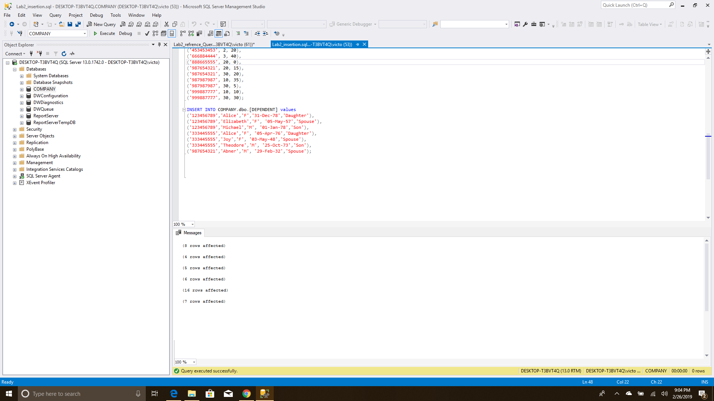

After we use the select statement to view all the tables we made and populate.

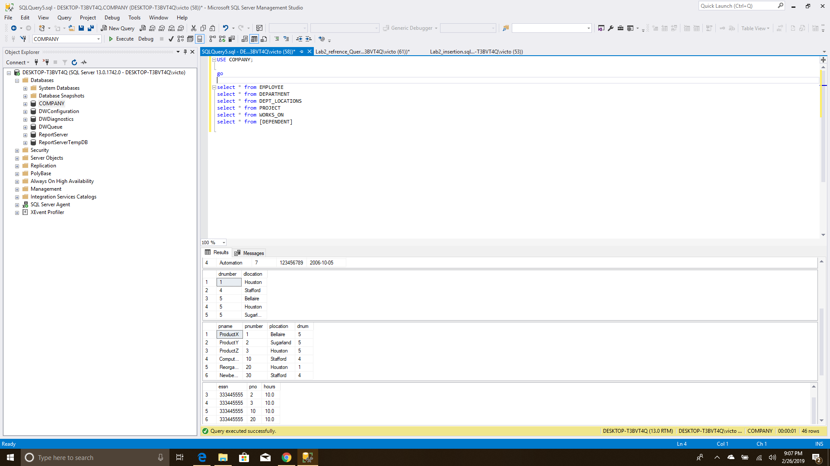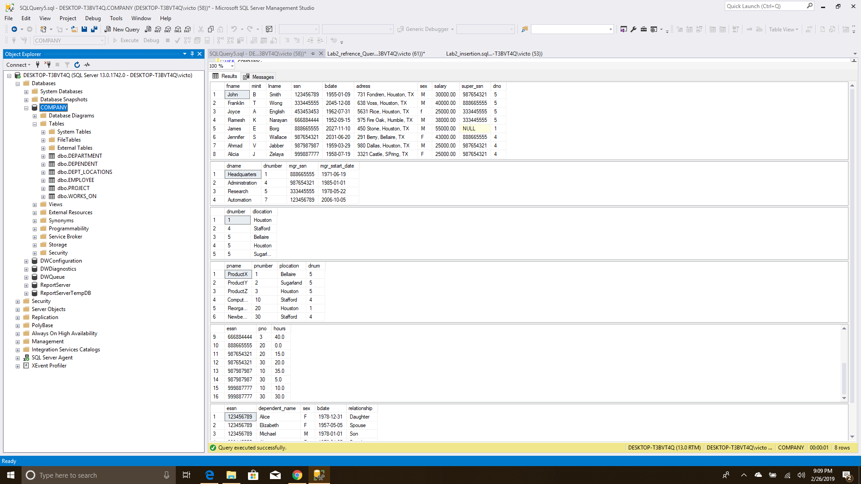

Next, we try to get a visual diagram of the database we created.

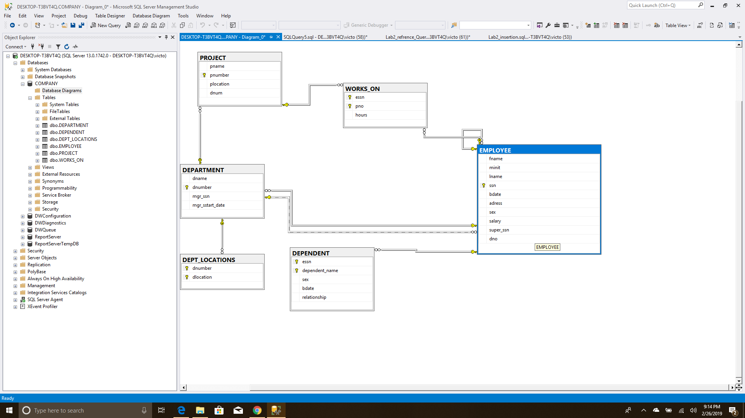

Next, we try to do the same test we did with bad data but this time with constraints.

CREATE DATABASE COMPANY4;

GO

USE COMPANY4;

CREATE TABLE EMPLOYEE /*create employee table*/

(fname varchar(15) not null,

minit char,

lname Varchar(15) not null,

ssn char(9) not null,

bdate date,

adress varchar(30),

sex char,

salary decimal(10,2),

super_ssn char(9),

dno int not null,

primary key (ssn), /*assign primary key*/

);

CREATE TABLE DEPARTMENT /*create department table*/

(dname varchar(15) not null,

dnumber int not null,

mgr_ssn char(9) not null,

mgr_sstart_date date,

primary key (dnumber), /*assign primary key*/

unique (dname), /*make sure every dname is unique and there are no dublicate name*/

foreign key (mgr_ssn) references EMPLOYEE(ssn), /*foreign key of mgr_ssn that is refreced in employee as ssn*/

);

/*we alter the employee table later for the sake of department table that is refrenced but not yet created*/

ALTER TABLE EMPLOYEE ADD CONSTRAINT FKCONSTR1 /* we add and name a foreign constraint*/

FOREIGN KEY (super_ssn) REFERENCES EMPLOYEE(ssn); /*foreign key of mgr_ssn that is refreced in employee as ssn*/

alter table EMPLOYEE add constraint fkemployee_dep

foreign key (dno) references DEPARTMENT(dnumber);

--insert into the table

ALTER TABLE dbo.EMPLOYEE NOCHECK CONSTRAINT fkemployee_dep /*dont check for this constraint*/

INSERT INTO COMPANY4.dbo.EMPLOYEE values

('John', 'B' , 'Smith' , '123456789', '09-Jan-55', '731 Fondren, Houston, TX' , 'M' , 30000 ,'987654321', 5),

('Franklin', 'T' , 'Wong' , '333445555', '08-Dec-45', '638 Voss, Houston, TX' , 'M' , 40000 ,'888665555', 5),

('Joyce', 'A' , 'English' , '453453453', '31-Jul-62', '5631 Rice, Houston, TX' , 'f' , 25000 ,'333445555', 5),

('Ramesh', 'K' , 'Narayan' , '666884444', '15-sep-52', '975 Fire Oak, Humble, TX' , 'M' , 38000 ,'333445555', 5),

('James', 'E' , 'Borg' , '888665555', '10-Nov-27', '450 Stone, Houston, TX' , 'M' , 55000 ,null, 1),

('Jennifer', 'S' , 'Wallace' , '987654321', '20-Jun-31', '291 Berry, Bellaire, TX' , 'F' , 43000 ,'888665555', 4),

('Ahmad', 'V' , 'Jabber' , '987987987', '29-Mar-59', '980 Dallas, Houston, TX' , 'M' , 25000 ,'987654321', 4),

('Alicia', 'J' , 'Zelaya' , '999887777', '19-Jul-58', '3321 Castle, SPring, TX' , 'F' , 25000 ,'987654321', 4),

('Alicia', 'J' , 'Zelaya' , '999887777', '19-Jul-58', '3321 Castle, SPring, TX' , 'F' , 25000 ,'987654321', 4);/*dupilicate touble*/

Due to the constraint we made as expected it did not compile both when we had null and duplicate tuple with duplicate primary key

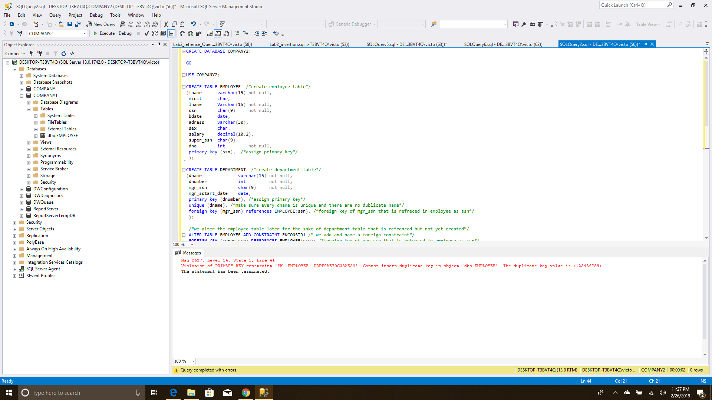

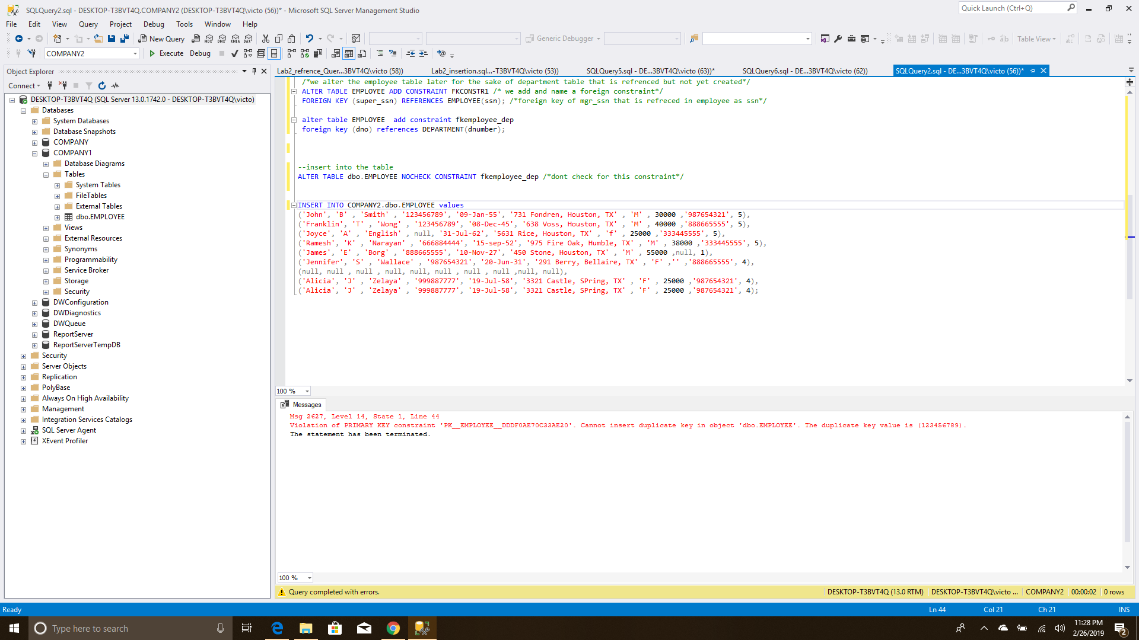

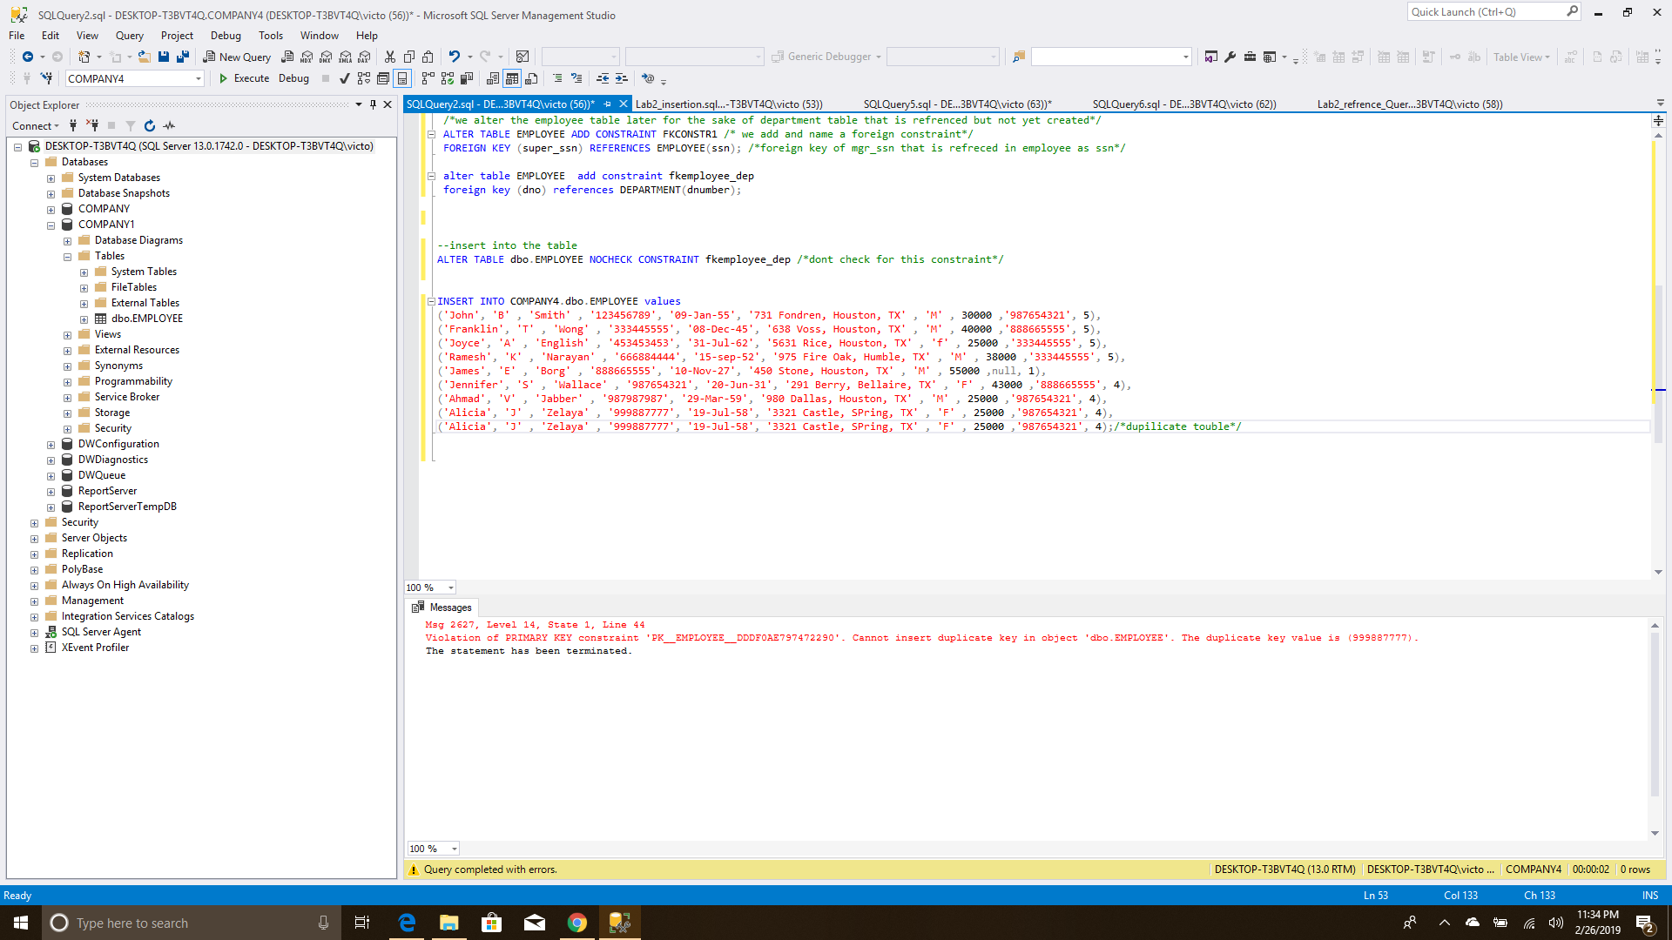

Conclusion

Overall the lab was an interesting lab it would have helped if I started earlier regardless I learnt a lot. The lab also made me understand more about the primary key and foreign key concept. You may notice that when I create database and I compiled it does not show up on the left column this I found out later was because I did not refresh the sever. Behind is the screenshots of the lab as I did in sequence.