CIS 430

Victor Ipinmoroti

First we create the view and add all the necessary columns with the quarry

use company

go

/*creating the Vdept_Budget view*/

create view VDept_Budget(Dept_Name,Dept_Number,No_Emp)/*view has 3 clomuns*/

as select dname,dnumber,count(*) /*dname dnumber and count the amount of times dnumber matches employee dnumber*/

from DEPARTMENT,EMPLOYEE /*using table department and employee*/

where dnumber=dno /*condition dnumber department is equal to dnumber employee*/

group by dname,dnumber; /*we then group by dname*/

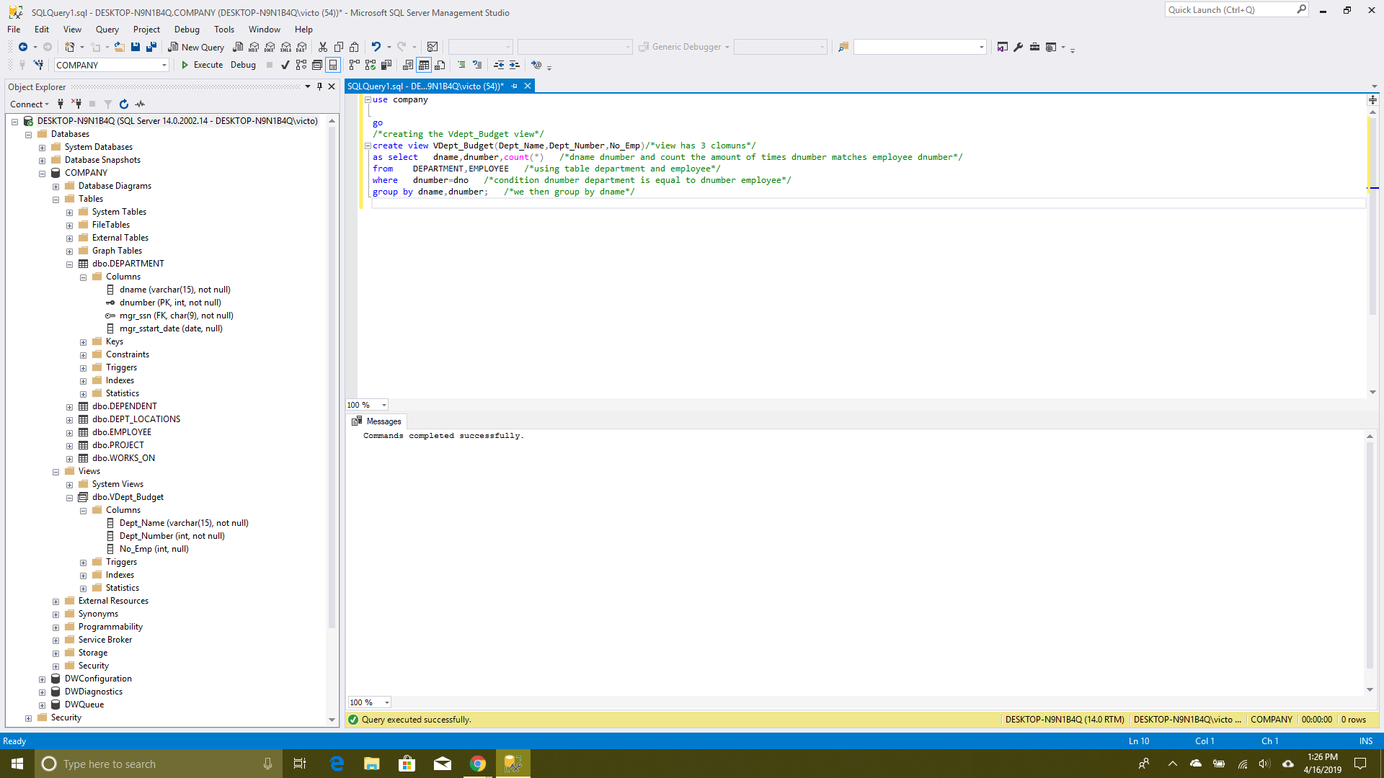

Then we use the select stamen to view result

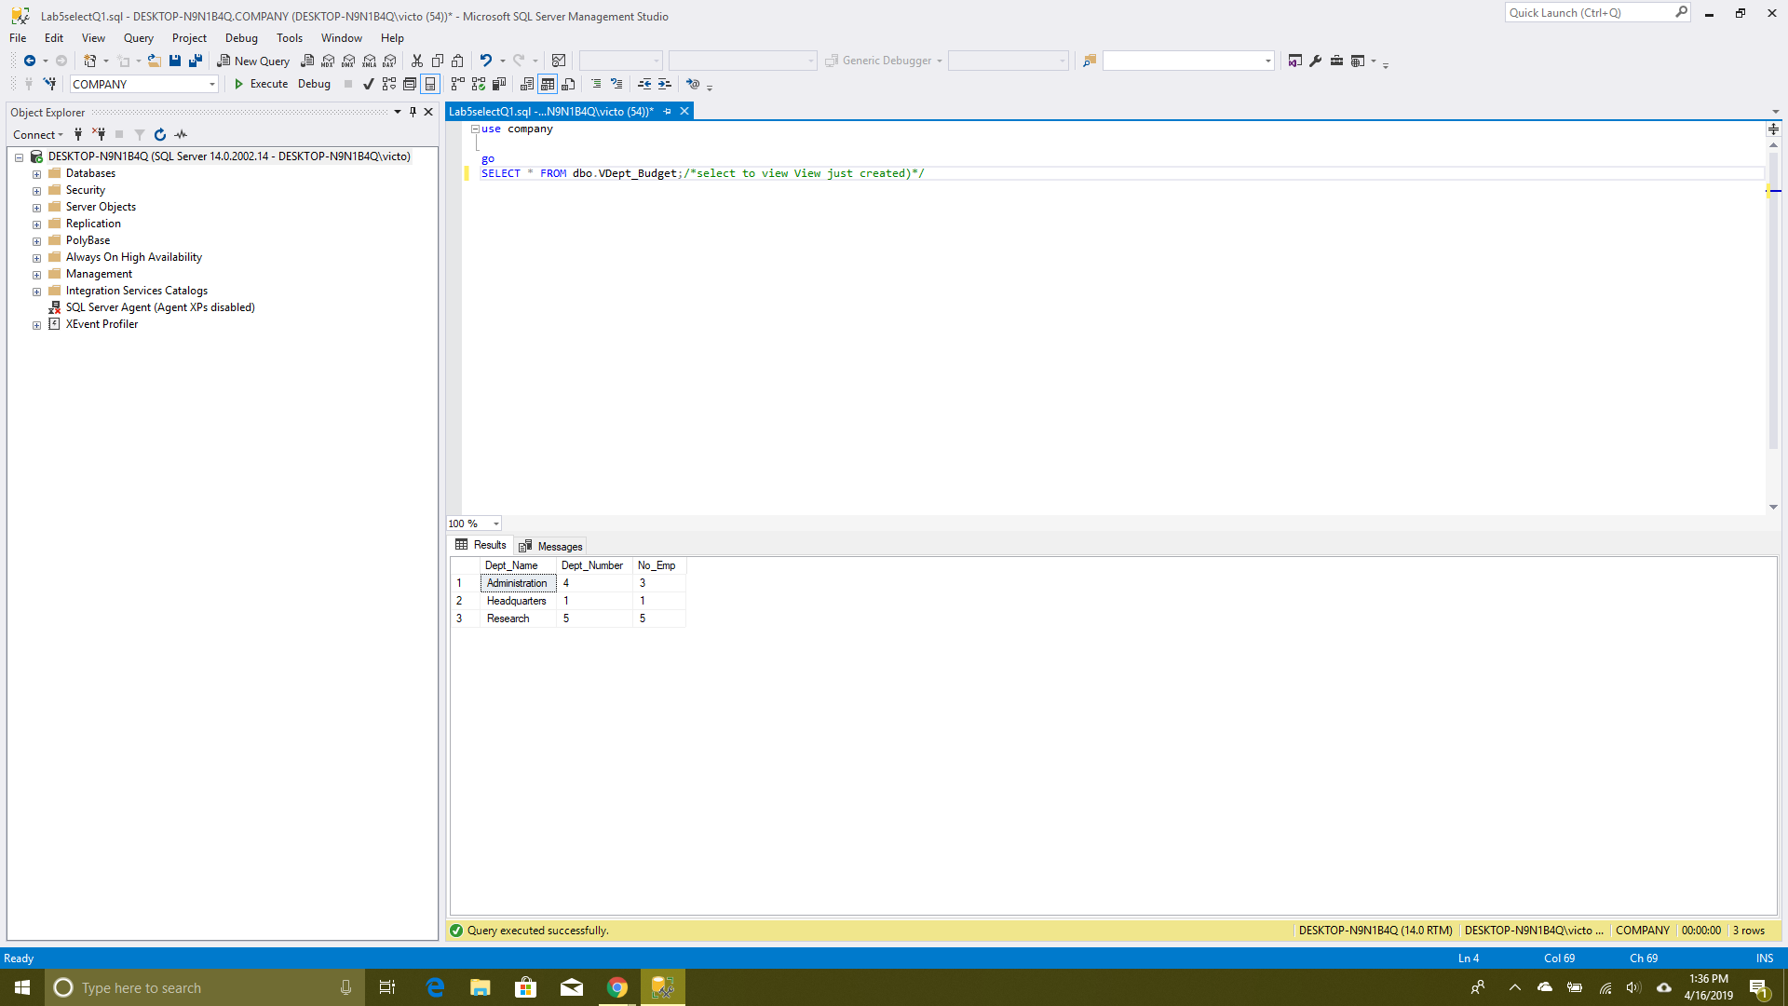

After that we add a new paerson to the employee table

INSERT INTO COMPANY.dbo.EMPLOYEE values

('Crazy', 'F' , 'Man' , '162800084', '03-Dec-55', '731 Fondren, Houston, TX' , 'M' , 40000 ,'987654321', 7);

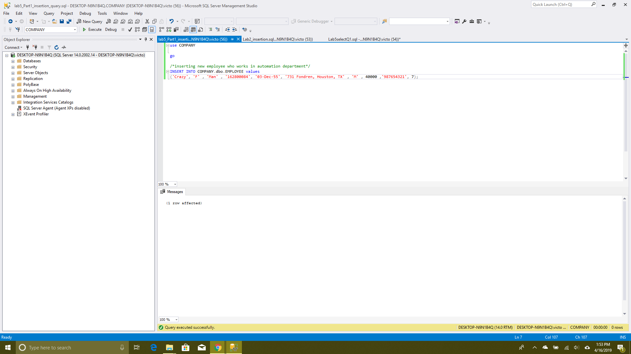

Then we use select to view the impact

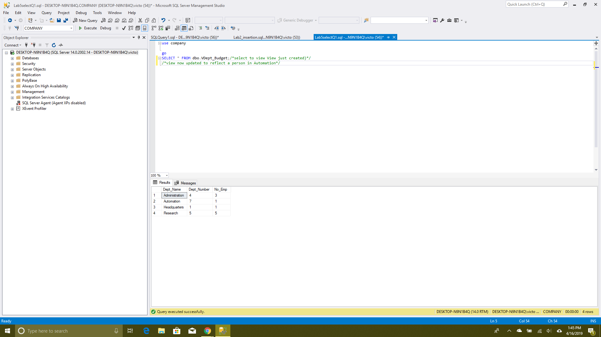

Next we alter the view to show salary and average salary

use company

go

alter view VDept_Budget(Dept_Name,Dept_Number,No_Emp,Sum_Salary,Ave_Salary)/*view has 3 clomuns*/

as select dname,dnumber,count(*),sum(salary),AVG(salary) /*dname dnumber and count the amount of times dnumber matches employee dnumber*/

from DEPARTMENT,EMPLOYEE /*using table department and employee*/

where dnumber=dno /*condition dnumber department is equal to dnumber employee*/

group by dname,dnumber; /*we then group by dname*/

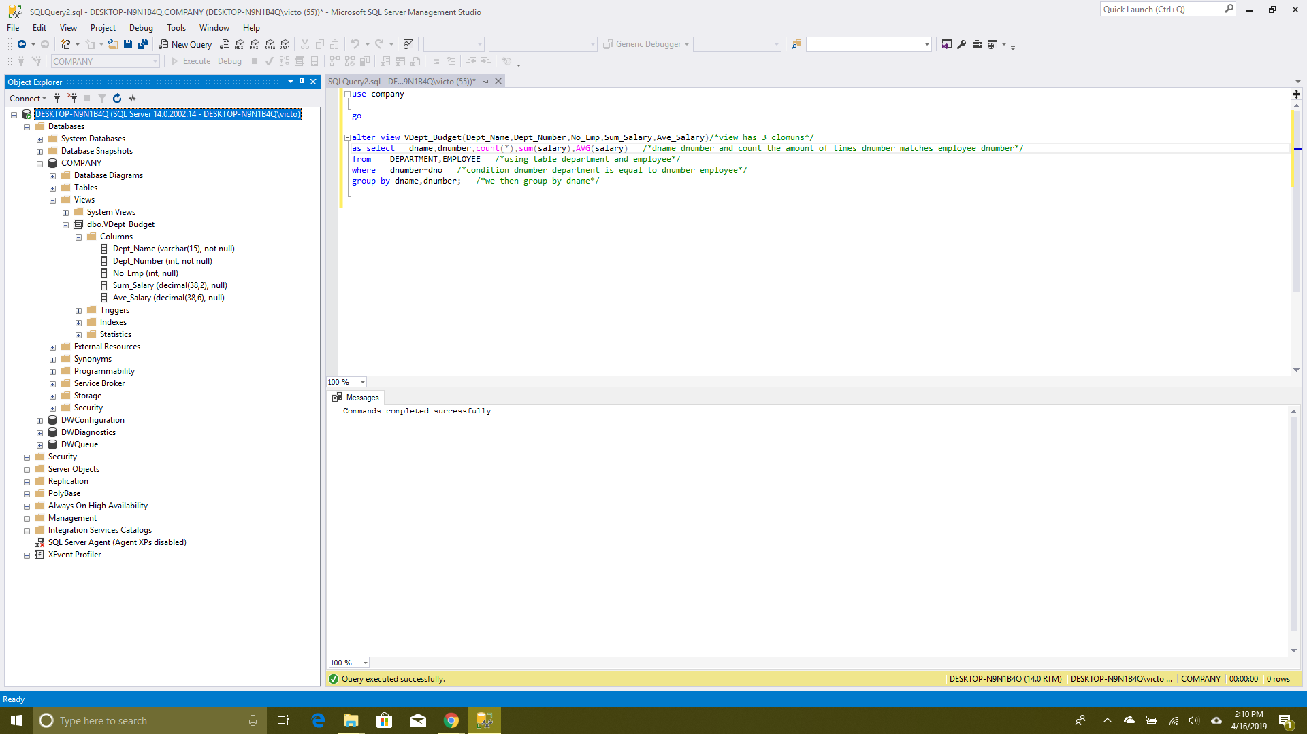

Then we select to view our impact

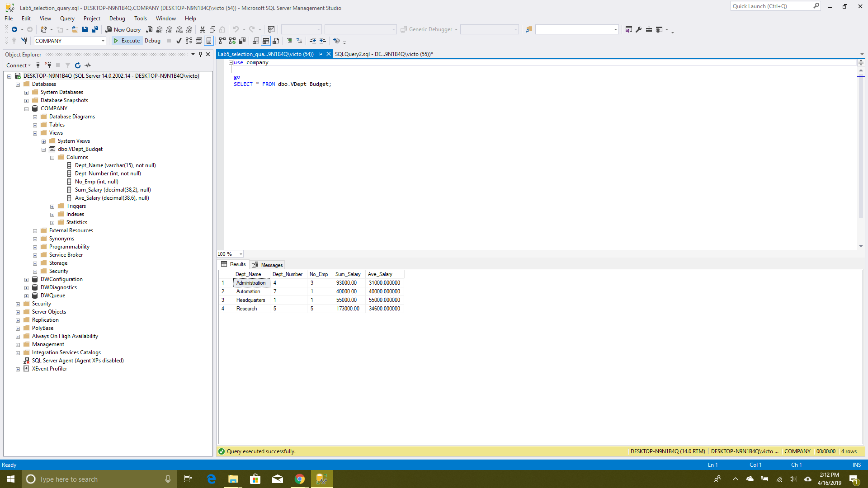

Next we make the procedure

use COMPANY

go

create or alter procedure sp_report_new_budget

as

declare @Count int

declare @newDept_Name char(30) /* declare varaibles*/

declare @newDept_No int

declare @count_Emp int

declare @Sum_Salary int

declare @Ave_Salary int

declare @new_Sum_Salary int

declare @new_Ave_Salary int

/*check if table exist or not*/ /* for personal use not realy needed*/

if not exists(SELECT * FROM INFORMATION_SCHEMA.TABLES

WHERE TABLE_NAME = N'NEW_Dept_Budget')

Begin

CREATE TABLE NEW_Dept_Budget /*create NEW_Dept_Budget table*/

(

newDept_Name char(30),

newDept_No int,

count_Emp int,

new_Sum_Salary int,

new_Ave_Salary int,

primary key (newDept_Name), /*assign primary key*/

);

End

select @Count=COUNT(*)/* check if the view is empty*/

from dbo.VDept_Budget

if @Count=0 /* if view is empty purpulate it*/

Begin

print 'view is empty porpulate it'

return

end

declare budget_cursor cursor for /* declare cursor to check each cell for each row in the view*/

select Dept_Name, Dept_Number,No_Emp,Sum_Salary,Ave_Salary

from dbo.VDept_Budget

open budget_cursor

fetch next from budget_cursor into @newDept_Name, @newDept_No, @count_Emp, @Sum_Salary, @Ave_Salary /*for each value checked put that vale into this variables*/

while @@FETCH_STATUS=0

begin

if @newDept_No=1 /*for each case change sum as needed given that we change the sum avrage is not affected be cause we scale up and amount does not change*/

begin

set @new_Sum_Salary=((@Sum_Salary*0.1)+@Sum_Salary)

set @new_Ave_Salary=(@new_Sum_Salary/@count_Emp)

insert into dbo.NEW_Dept_Budget

(newDept_Name, newDept_No,count_Emp, new_Sum_Salary, new_Ave_Salary)

values(@newDept_Name, @newDept_No, @count_Emp, @new_Sum_Salary,@new_Ave_Salary)

fetch next from budget_cursor into @newDept_Name,@newDept_No,@count_Emp,@Sum_Salary,@Ave_Salary

end

if @newDept_No=4 /*for each case change sum as needed given that we change the sum avrage is not affected be cause we scale up and amount does not change*/

begin

set @new_Sum_Salary=((@Sum_Salary*0.2)+@Sum_Salary)

set @new_Ave_Salary=(@new_Sum_Salary/@count_Emp)

insert into dbo.NEW_Dept_Budget

(newDept_Name, newDept_No,count_Emp, new_Sum_Salary, new_Ave_Salary)

values(@newDept_Name, @newDept_No, @count_Emp, @new_Sum_Salary,@new_Ave_Salary)

fetch next from budget_cursor into @newDept_Name,@newDept_No,@count_Emp,@Sum_Salary,@Ave_Salary

end

if @newDept_No=5 /*for each case change sum as needed given that we change the sum avrage is not affected be cause we scale up and amount does not change*/

begin

set @new_Sum_Salary=((@Sum_Salary*0.3)+@Sum_Salary)

set @new_Ave_Salary=(@new_Sum_Salary/@count_Emp)

insert into dbo.NEW_Dept_Budget

(newDept_Name, newDept_No,count_Emp, new_Sum_Salary, new_Ave_Salary)

values(@newDept_Name, @newDept_No, @count_Emp, @new_Sum_Salary,@new_Ave_Salary)

fetch next from budget_cursor into @newDept_Name,@newDept_No,@count_Emp,@Sum_Salary,@Ave_Salary

end

if @newDept_No=7 /*for each case change sum as needed given that we change the sum avrage is not affected be cause we scale up and amount does not change*/

begin

set @new_Sum_Salary=((@Sum_Salary*0.4)+@Sum_Salary)

set @new_Ave_Salary=(@new_Sum_Salary/@count_Emp)

insert into dbo.NEW_Dept_Budget

(newDept_Name, newDept_No,count_Emp, new_Sum_Salary, new_Ave_Salary)

values(@newDept_Name, @newDept_No, @count_Emp, @new_Sum_Salary,@new_Ave_Salary)

fetch next from budget_cursor into @newDept_Name,@newDept_No,@count_Emp,@Sum_Salary,@Ave_Salary

end

end

close budget_cursor

deallocate budget_cursor

note the if statement used to check if the table exist is not needed I used it because I made a mistake initial version but while making the new version I was not sure if I deleted the table or not so I just checked for it first.

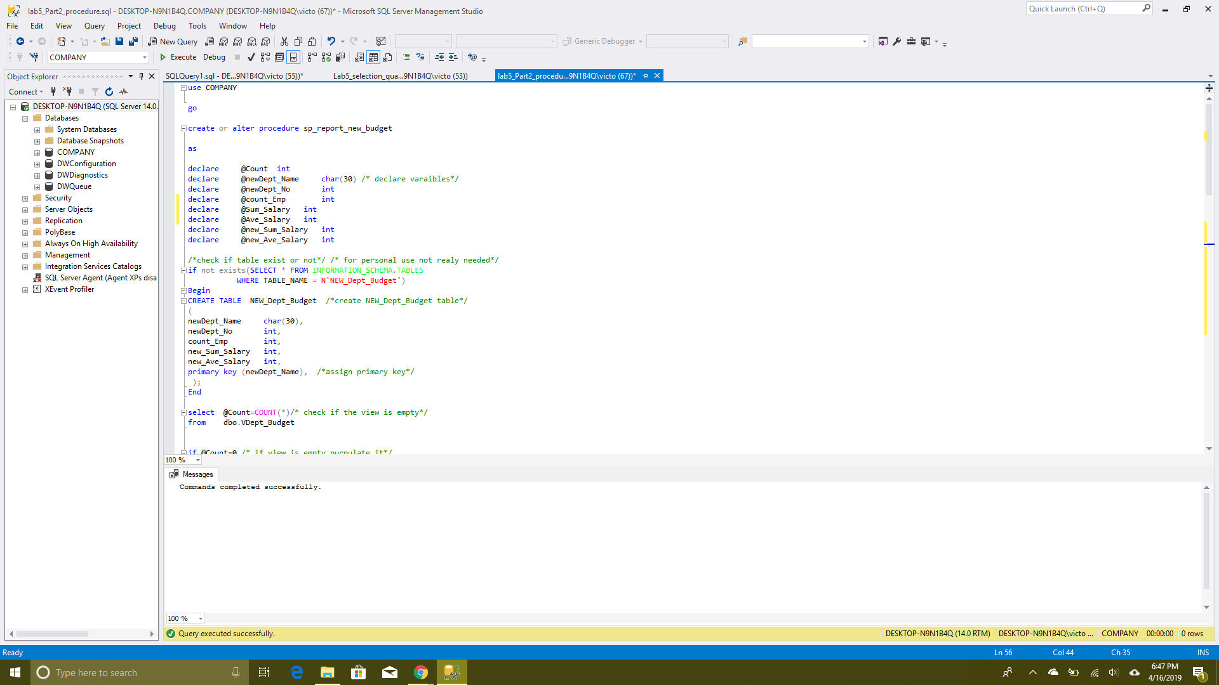

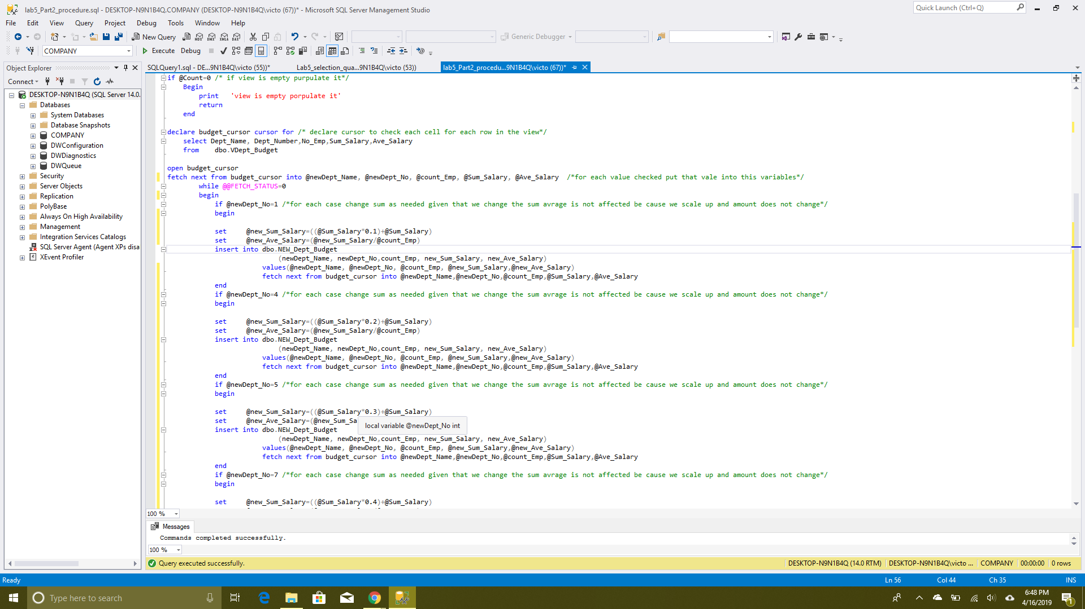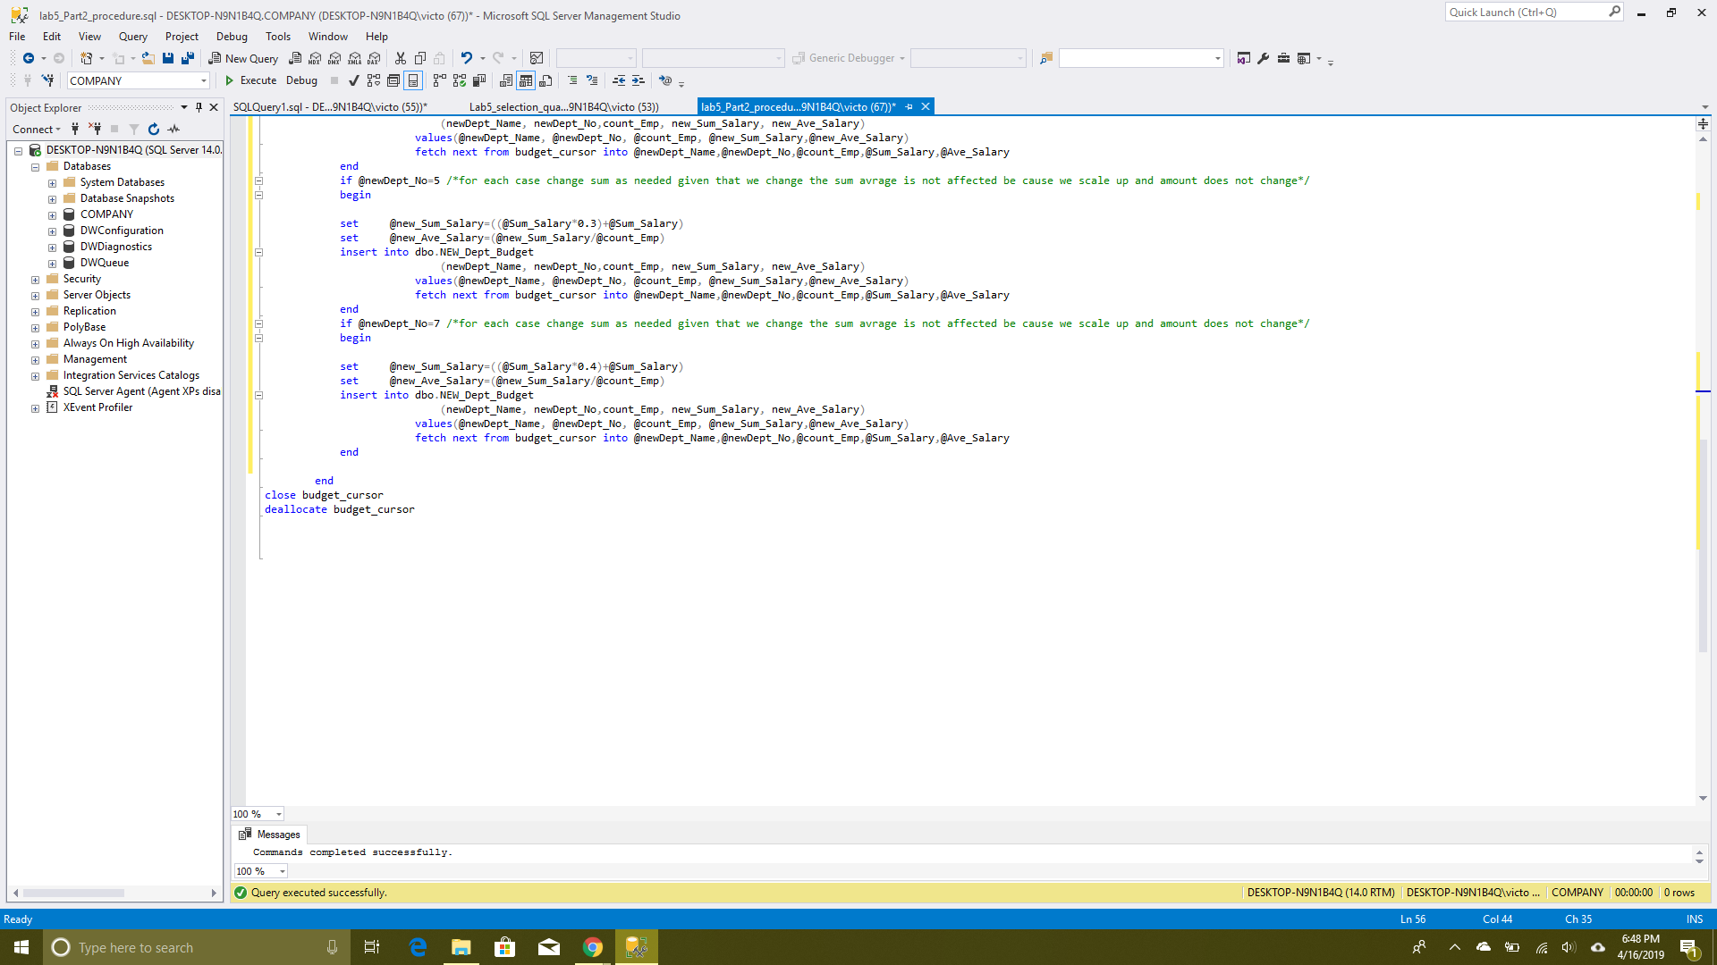

After this we execute the procedure and use the select statement to view the table created by the procedure

use company

go

exec sp_report_new_budget;

