

READY PLAYER VIDEO GAME SALES

Project 1

Bala Ganapathy, Galen Etie, Beau Nguyen, Taylor Vickers | SMUDAL20190528DATA | 7/20/19

# Introduction

The global video game industry has a current market value of nearly $135 billion. However, console and PC games have lost significant market shares over the years to the growing popularity of tablets and smartphones. To help our clients stay relevant, our analysis aims to provide industry giants like Nintendo, Electronic Arts, and Ubisoft with the knowledge they need to regain a competitive advantage and stay profitable in the years to come.

Utilizing the dataset “Video_Game_Sales_as_at_22_Dec_2016.csv” created by Rush Kirubi that combined video game sales and a web scraping of Metacritic’s scores from 1985 – 2016, we were able to analyze video game sales from North America, Europe, and Japan.

With that said, in order to prepare the dataset and make it relevant for our analysis, we used Jupyter Notebook to clean our data and filter out certain years that were missing data. From there, we dropped any video games that were missing critic and user scores because we only wanted to analyze games that had both. Our final dataset provided a sample size of 7,359 video games and spanned from 2005 – 2016.

# Does the genre of a game dictate higher sales in the region (NA, EU, JP) of the world?

Using the data provided, we created our first visualization to show the total sales (by millions of units) for each genre separated by region. This visualization creates an idea of how the market differs around the world, showing the bias towards certain genres as well as the size of the market. We concluded that NA has the largest market for the video game industry, with “action” being the most popular genre for NA and EU while “Role-Playing” was more popular in Japan. Using this, we can see a slight bias in genre by region.

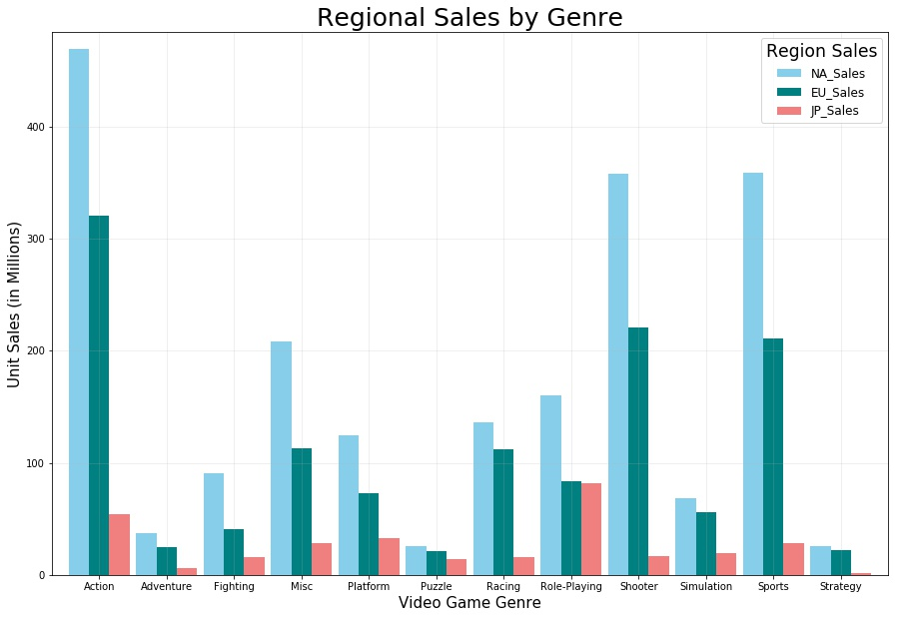

Breaking the data down even further, we decided to take the top genre by region to depict the total sales by release date. Hypothetically, this will show a trend of how successful (or unsuccessful) the video game market has done over the past 10 years. The data produced visualized a negative trend in total sales since 2008. This analysis further supports our findings that the console and PC game sales has decreased in the past 10 years.

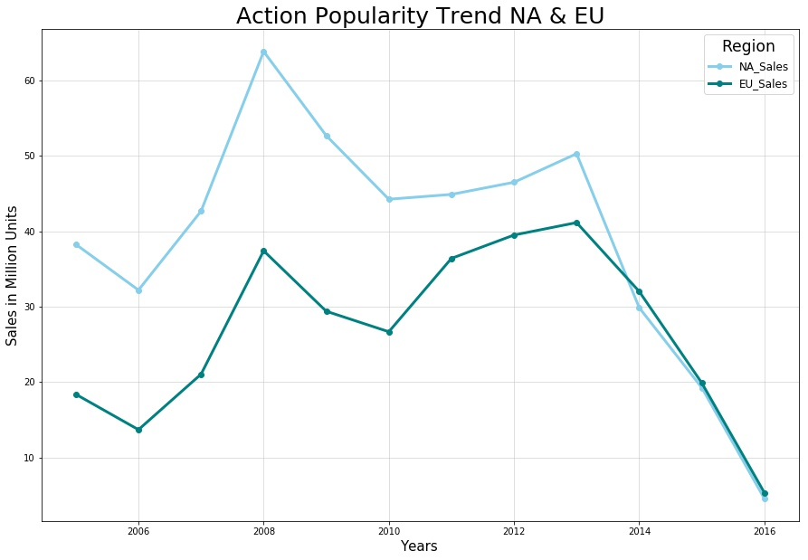

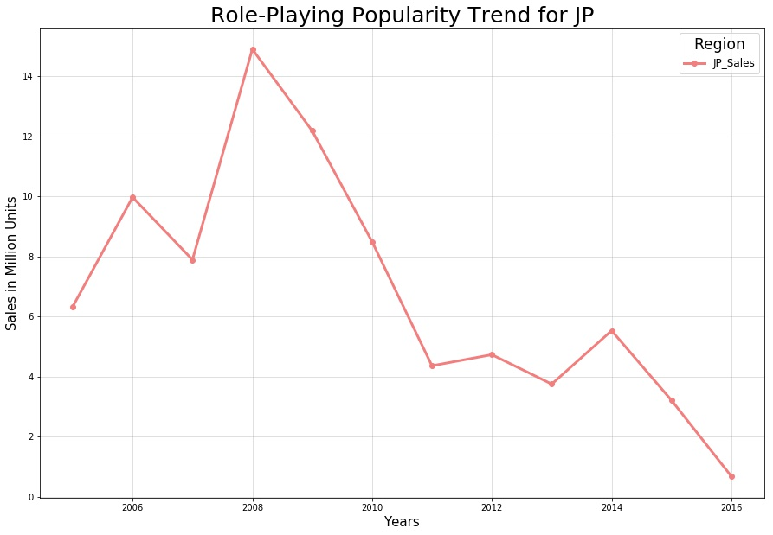

# Do critic score or user scores correlate with higher sales?

* Regional total sales in **NA, EU and JP**
* Using the data provided, we create the visualization below showing the mean of critic score and user score of each genre
* The visualization also shows the total sales of each genre showing ‘Action’, ‘Shooter’ and ‘Sports’ have the most sales
* User score does not show an impact on total sales
* Critics scores does show an impact on total sales

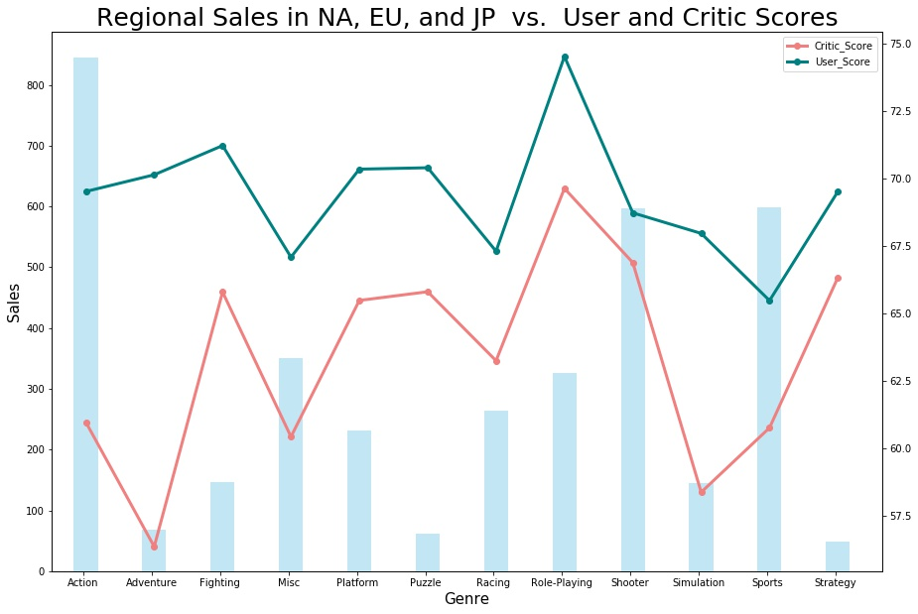

**Create a hypothesis to see if user/critic score has an impact on Global Sales**

* We used the top genre: Action, Sports and Shooters
* With a p-value less than 0.05, we reject the null hypothesis that there is no impact on total sales
* With a p-value greater than 0.05, we accept the hypothesis that there is may be an impact on total sale
* The data shows Critic Score may have an impact on Total Sales

Total Sales:

|  |  |  |
| --- | --- | --- |
| **Genre** | **User Score** | **Critic Score** |
| **Action** | May impact total sales (  | May Impact total sales ( |
| **Sports** | May not impact on total sales ( | May Impact total sales ( |
| **Shooter** | May not impact on total sales ( | May Impact total sales ( |

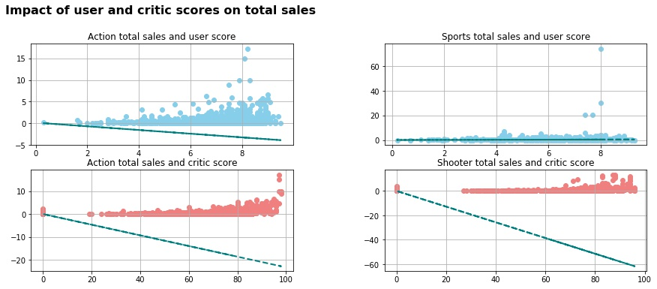

**Break down the Data even further by analyzing critic score for Action Genre in North America**

* The data shows Critic Score may have an impact on Total Sales for Action Genre in NA

|  |  |
| --- | --- |
| **Genre** |  |
| **Action** | May Impact ( |
| **Sports** | May Impact ( |
| **Shooter** | May Impact ( |

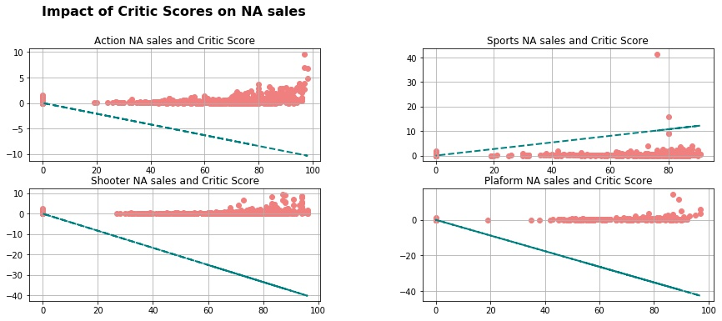

**Conclusion:**

**Based on the data provided, we concluded that critic score may have an impact on total sales and user score may need more additional data to determine the impact of sales.**