Task 1.

Use a package management tool to install a program on a machine (at home or work) where you can do this. Document the process; include some snapshots that show a couple of the more important steps you had to take.

Observations:

- On Linux, it is very likely that you already have a package management tool that you can use

- On Windows, Chocolatey might be a good candidate. You’ll first have to install it though.

- Do not try to install a program on Euler; do this exercise on a machine at home (or work, if you are allowed to)

Step 1 (after installing Chocolatey)

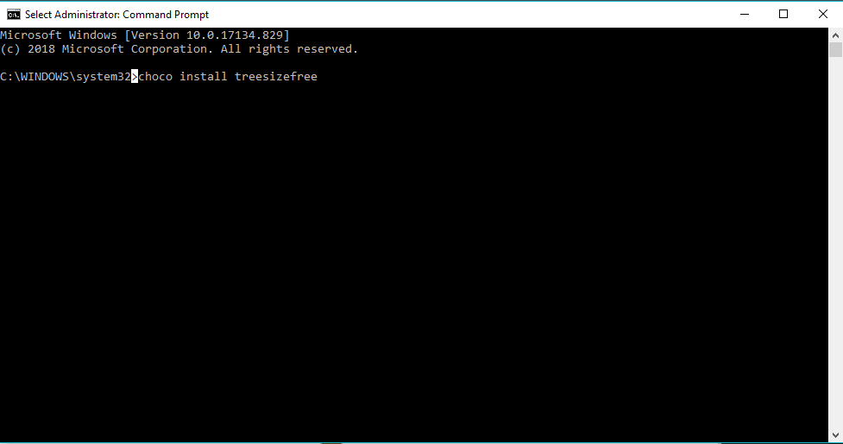

Step 2:

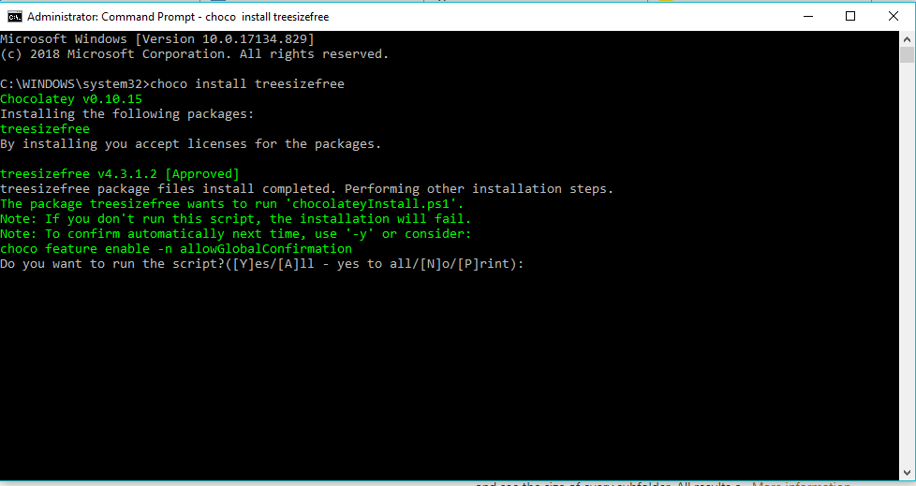

Step 3:

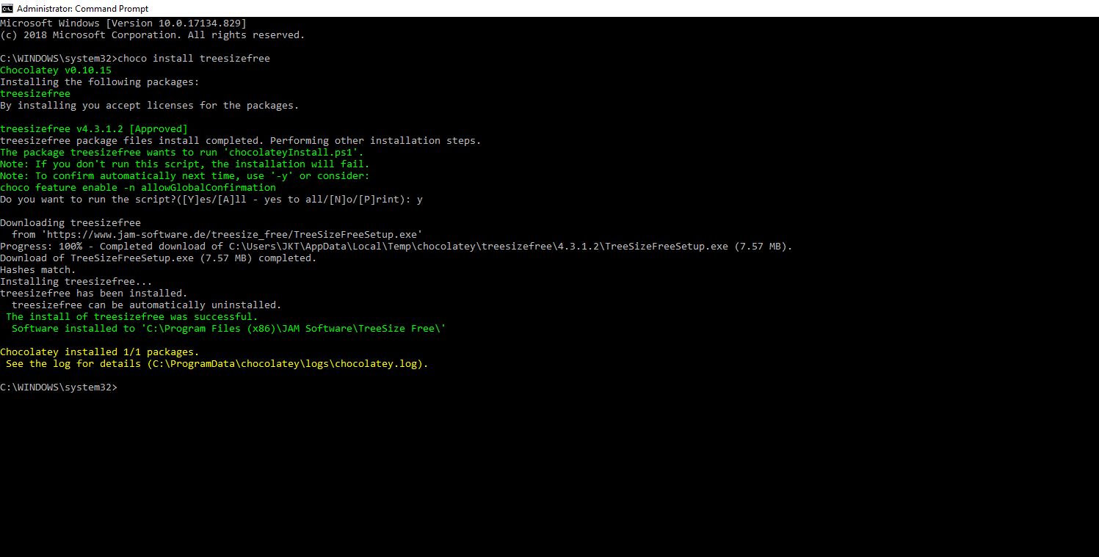

Step 4:   
Done!