**Assignment 2: Due – Sunday, July 21 at 9 PM**

**Turning in:** All **written responses & code** should be placed in your git repository on GitHub in a subfolder called HW02 by the due date. If you are part of a team, only one set of files will be needed for all students who are members of the team.

All scripts and programs will be graded **on Euler** under the **default environment** (unless otherwise specified). Make sure that your responses are tested and run on Euler.

**Task 1**.

In a folder of your choice, run the following command:

git clone https://github.com/nicolsen/ME459Upstream.git

By doing this you’ll be cloning a GitHub repo that was used last time ME459 was taught at UW-Madison. In the ME459Upstream you’ll find several sub-folders that contain helpful files. For this assignment, the sub-folder of interest is HW04 – please take a look therein.

**Task 2.**

Run: module load gcc/latest

1. Write a C program, task2a.c, that prints (only) the following to standard out without quotation marks: “Hello, world!\n”. It will be compiled as follows: gcc task2a.c output.c -o task2a and it will be run as follows: ./task2a
2. Write a C program, task2b.c, that takes one command line argument, a positive integer n, and calls the outputT2 function from output.h on each integer from 0 up to and including n. It will be compiled as follows: gcc task2b.c output.c -o task2b and it will be run as follows, where n is a positive integer:

./task2b n

A note on the output function: Its goal is to make sure that no one loses points because of a small formatting error. With more complicated output in the future, it will be more necessary than it is here, but we wanted to get you used to the process of using a provided output function now.

**Task 3.** The below C program outputs 3 lines, what are these output lines? Give a brief explanation of what happens at each function call.

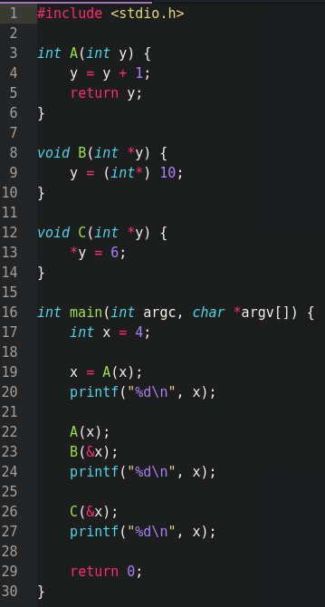

**Task 4.** In C, what is the difference between <…> and “...” for including files? Answer in a few sentences.

#include <stdio.h>

vs.

#include “output.h”

**Task 5**. Write a piece of code in a file task5.c that does the following:  
Run: module load gcc/latest

1. Reads in an integer value $n$, where $0<n<100$
2. Allocates dynamically an array of ints to store the all integer values between $n$ (including $n$) and 0 (including 0)
3. Use qsort to sort the array in ascending order – from 0 to $n$
4. Call the function outputT5 from output.h on the array, with count being the size of the array, after sorting it.
5. Make sure you free the memory that you allocate in your program

We will test your code with a bunch of integer values $n$– some positive, some negative, and zero. Make sure you have the right guards in place to only run for legitimate values of $n$. We will compile your code as follows: gcc task5.c output.c -o task5. We will run the code like this: ./task5 $n$.