2018AIML600

The analysis is given as below

Explained variance: **[1.3305e+03 5.7010e+02 2.8230e+02 1.9840e+02 1.6520e+02 1.2090e+02**

**6.7600e+01 4.7700e+01 4.1800e+01 3.5100e+01 2.9400e+01 2.6200e+01**

**2.4200e+01 1.5700e+01 9.4000e+00 8.0000e+00 6.0000e+00 5.3000e+00**

**5.0000e+00 3.1000e+00 3.0000e+00 2.7000e+00 2.4000e+00 1.8000e+00**

**1.6000e+00 8.0000e-01 7.0000e-01 2.0000e-01 1.0000e-01 0.0000e+00]**

explained variance ratio :: **[44.3 19. 9.4 6.6 5.5 4. 2.3 1.6 1.4 1.2 1. 0.9 0.8 0.5**

**0.3 0.3 0.2 0.2 0.2 0.1 0.1 0.1 0.1 0.1 0.1 0. 0. 0.**

**0. 0. ]**

Cumulative sum of variance :: **[ 44.3 63.3 72.7 79.3 84.8 88.8 91.1 92.7 94.1 95.3 96.3 97.2**

**98. 98.5 98.8 99.1 99.3 99.5 99.7 99.8 99.9 100. 100.1 100.2**

**100.3 100.3 100.3 100.3 100.3 100.3]**

By above analysis, we can see that first 5 features can save variance upto 95.3%. Here By graph, maximum variance can be 25 features with 100.3.

Figure 1.

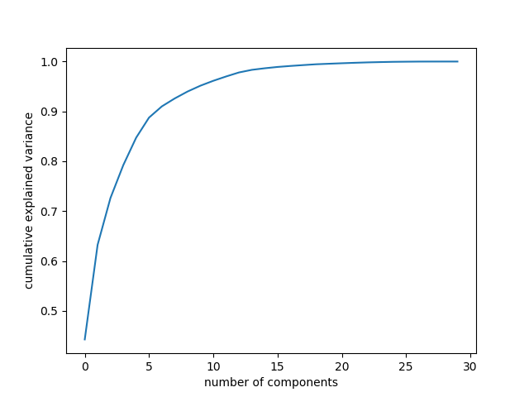

Figure 2

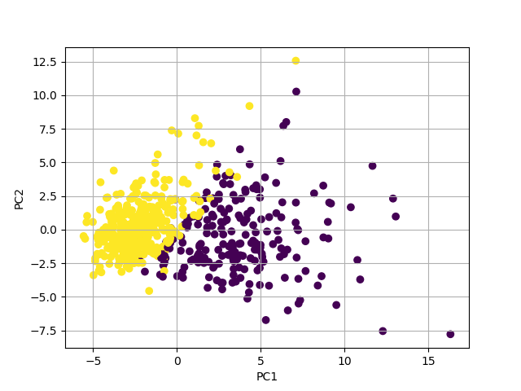

Figure 3

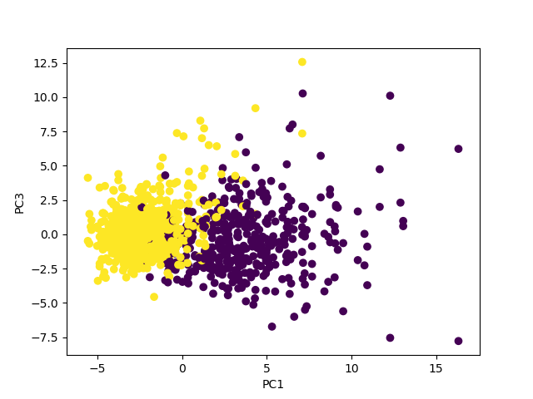

Figure 4

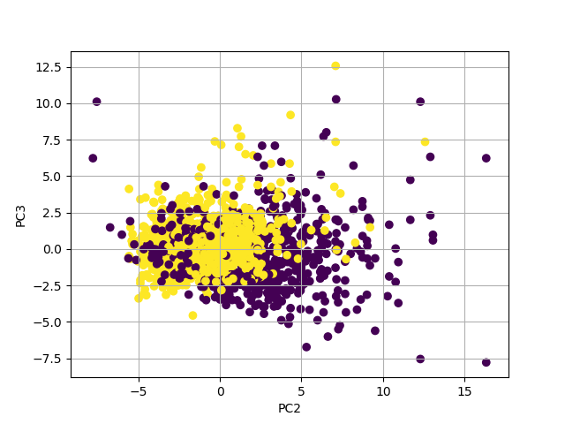

Figure 5

