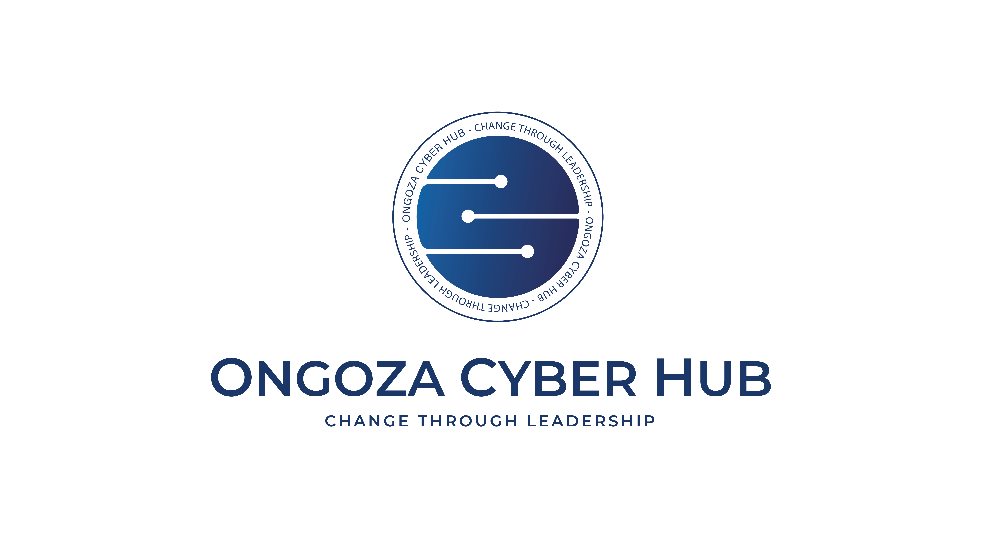 | ONGOZA CYBER HUB  Change Through Leadership | Certificate Number  {{certificate_id}}  Status: {{certificate_status}}

CERTIFICATE OF COHORT COMPLETION
COHORT PROGRAMME
This is to acknowledge that
{{student_name}}

This certifies that {{student_name}} (ID: {{student_id}}) has successfully completed the {{cohort_name}} cohort programme on the Ongoza Cyber Hub platform. This cohort drew resources from multiple tracks, demonstrating cross-disciplinary cybersecurity competence. {{cohort_description}}
Total Hours: {{total_hours}} | Missions Completed: {{missions_completed}}
Renewal Count: {{renewal_count}} | Certificate Status: {{certificate_status}}
Issue Date  {{completion_date}}  Expiry Date  {{expiry_date}} | {{accreditation_badge}}  Accreditation | {{signature_image}}  {{issuer_name}}  {{issuer_title}} | {{verification_qr}}  Scan to Verify

Verify this certificate at: https://ongozacyberhub.com/verify/{{certificate_id}}

