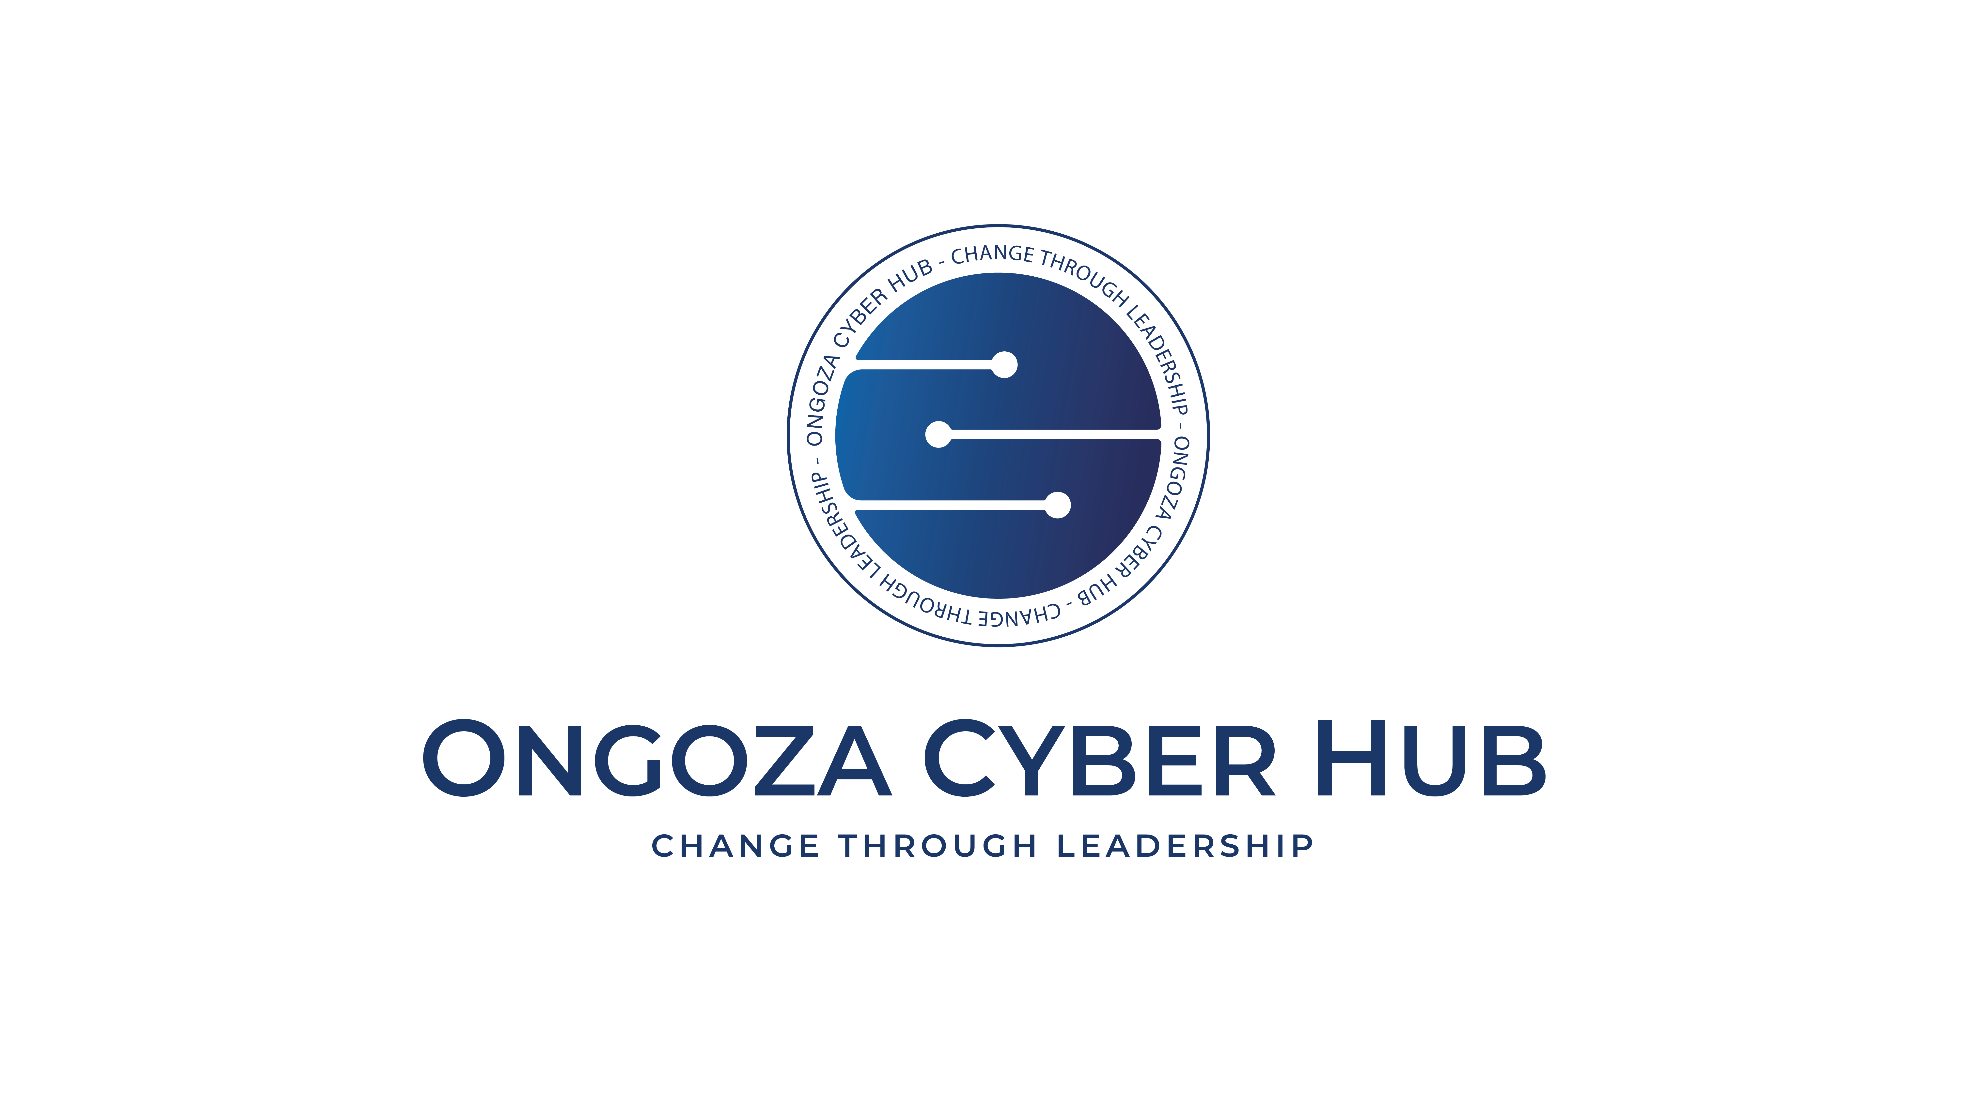 | ONGOZA CYBER HUB  Change Through Leadership | Certificate Number  {{certificate_id}}  Status: {{certificate_status}}

CERTIFICATE OF COMPLETION
OFFENSIVE SECURITY • LEVEL III: ADVANCED
This is to acknowledge that
{{student_name}}

This certifies that {{student_name}} (ID: {{student_id}}) has successfully demonstrated advanced expertise in the Offensive Security track at the Advanced (Level III) milestone on the Ongoza Cyber Hub platform.
Total Hours: {{total_hours}} | Missions Completed: {{missions_completed}}
Renewal Count: {{renewal_count}} | Certificate Status: {{certificate_status}}
Issue Date  {{completion_date}}  Expiry Date  {{expiry_date}} | {{accreditation_badge}}  Accreditation | {{signature_image}}  {{issuer_name}}  {{issuer_title}} | {{verification_qr}}  Scan to Verify

Verify this certificate at: https://ongozacyberhub.com/verify/{{certificate_id}}

