Definition of MOM (Minutes of the meeting)

Minutes of the meeting are the notes that one takes throughout the course of the meeting recording what ensues in the meeting. It would include the key points discussed, the participants involved, the resolution arrived at etc

Schedule a meeting

There are several ways to schedule a meeting in Teams:

* Select Schedule a meeting in a chat (below the box where you type a new message) to book a meeting with the people in the chat.
* Go to Calendar on the left side of the app and select New meeting in the top right corner.
* Select a range of time in the calendar. A scheduling form will pop open.

The scheduling form is where you'll give your meeting a title, invite people, and add meeting details. Use the Scheduling Assistant to find a time that works for everyone.

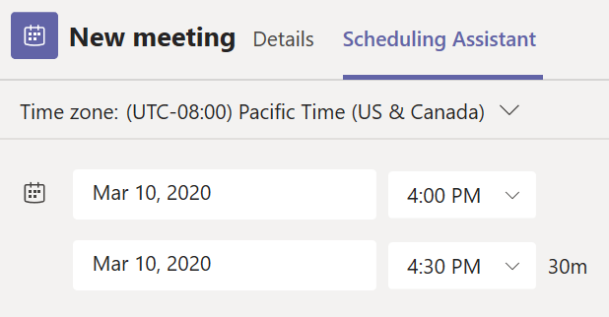

Once you're done filling out the details, select Save. This will close the scheduling form and send an invite to everyone's Outlook inbox.

## **OUT OF OFFICE MESSAGE IN TEAMS**

## Option 1: Schedule an out of office from your profile picture

1. Go to your profile picture at the top of Teams and select Set status message. 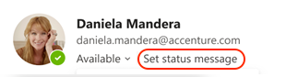
2. Select Schedule out of office at the bottom of the options.  
     
     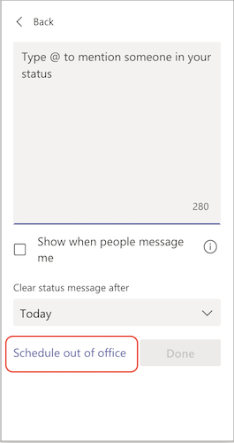
3. From the screen that appears, turn on the toggle next to Turn on automatic replies.
4. Type an out of office message in the text box. This message will appear when people contact you in Teams or open your profile. It'll also be sent as an automatic reply in Outlook.
5. If you'd like to send an automatic message to people outside of your organization, select the check box next to Send replies outside my organization and choose between your contacts or all external senders. You can tailor your out of office message to this audience, or use the same message you typed above by copying/pasting it into the text box.
6. Based on when you'll be out of the office, pick the dates and times that your out of office message and status will start and stop displaying by selecting the check box next to Send replies only during a time period.   
     
   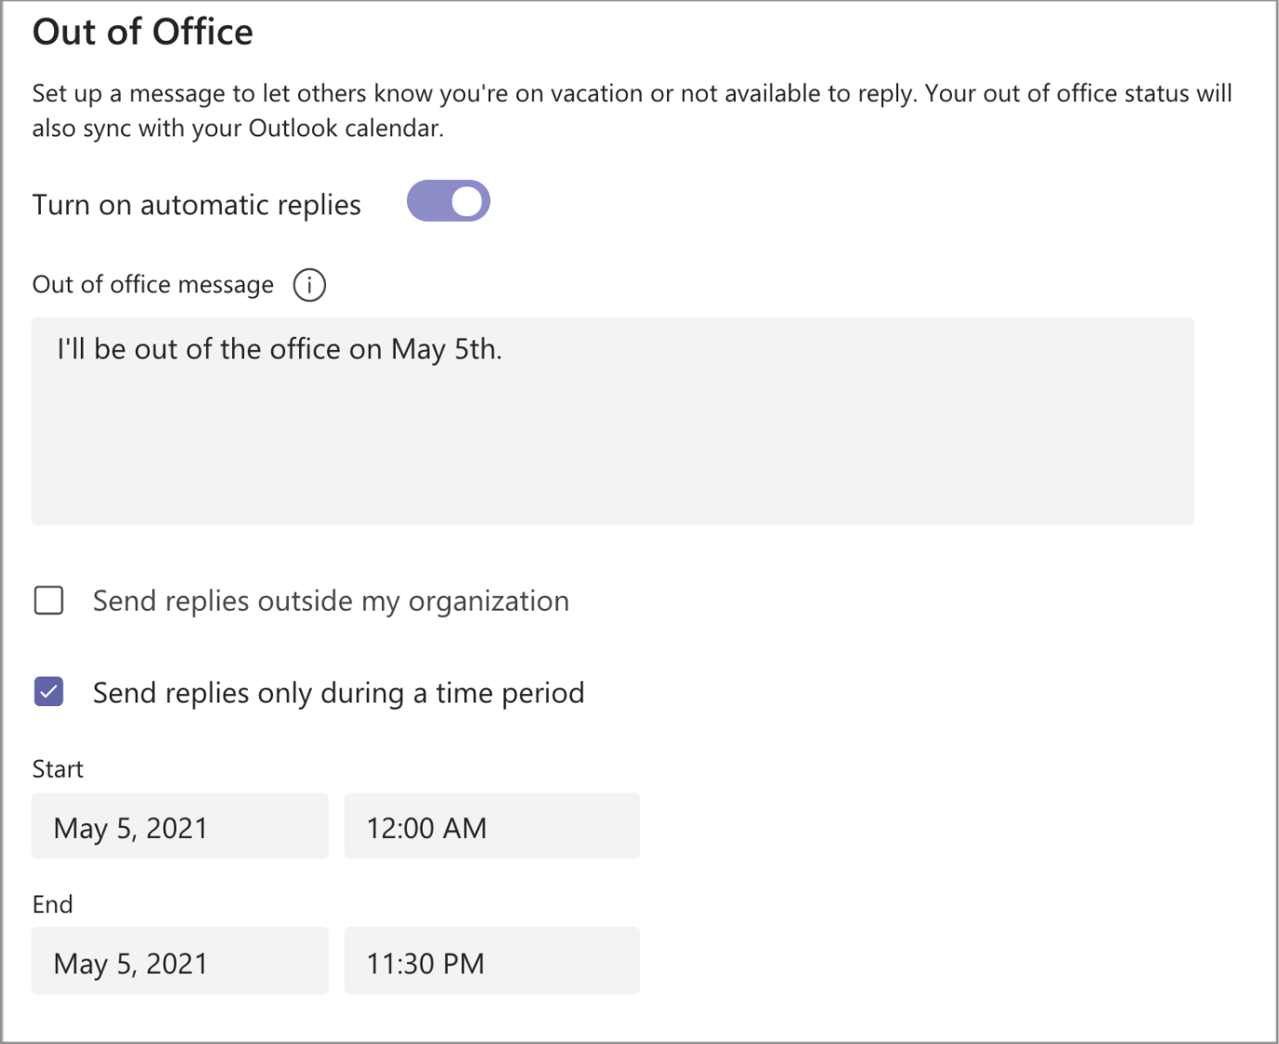
7. Select the Save button.

## Option 2: Schedule an out of office in settings

1. Go to your profile picture in the top right of Teams. Next, select  Settings button  Settings >  General and locate the Out of Office section.
2. Select the Schedule button to open the out of office screen. Then follow steps 3 through 7 above to set your preferences.   
     
   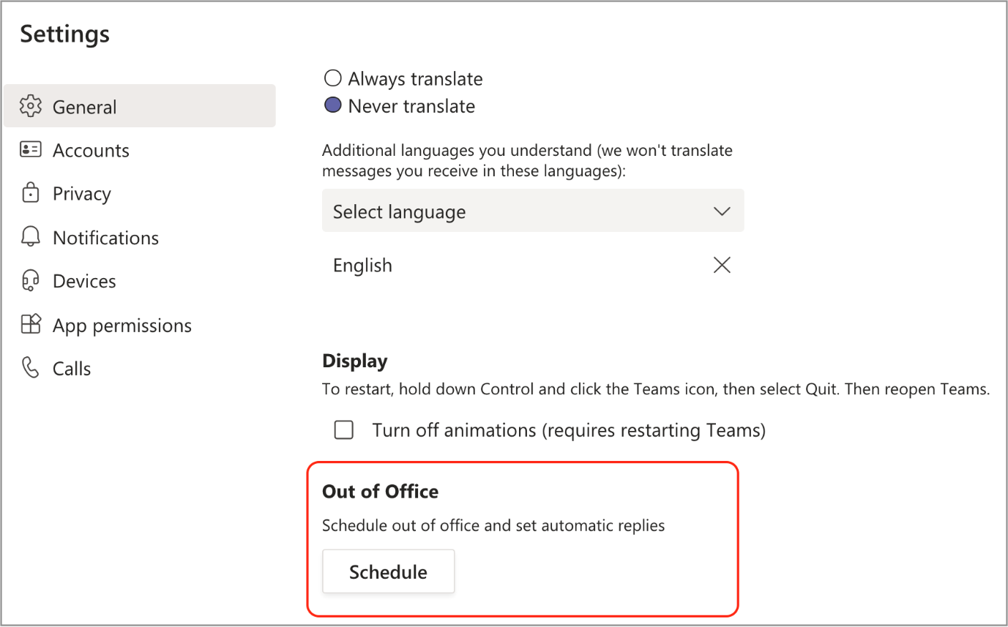

To clear your out of office status and turn off your automatic reply in Teams, select your profile picture and go back to the Out of Office screen either from  Settings button  Settings > General > Out of Office or by selecting Set status message > Schedule out of office from your profile picture. Turn off the toggle next to Turn on automatic replies and select the Save button.

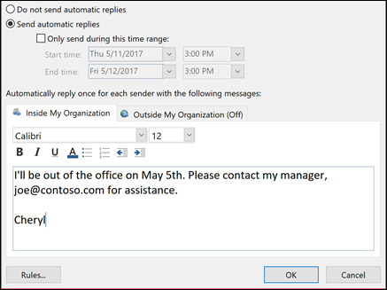

## **How to Create Recurring Meetings in Teams**

* 1. Sign into [**Microsoft Teams**](https://harvard.service-now.com/ithelp?id=kb_article&sys_id=bfe86094db2a3b005b2be3f3ca961977)
  2. Click on the Calendar icon on the Microsoft Teams left Sidebar
  3. In upper right corner, click the “+ New meeting” button
  4. When the new Meeting window opens, fill in the following fields:  
     + Title
     + Invite People
     + Check the Repeat box
     + Enter meeting data/time/recurrence information  
       Note: Harvard Room Locations are not available in the Teams meeting interface.  A room location can be added, if needed, in Outlook after the meeting has been scheduled.
  5. Click on Schedule.
  6. Calendar invitations to the recurring meeting will be sent to all invitees.