*Submitted by:* **Kushal**  
*Submitted to:* **Ketan Sabale**  
*Roll No:* **20BCP217**  
College Name: PDEU

# NodeJS Code for File Read, Write, Append, Delete

'use strict';  
const http = require('http');  
const fs = require('fs');  
const querystring = require('querystring');  
  
  
  
//create a server object:  
http.createServer((req, res) => {  
 if (req.method == 'GET')  
 {  
 res.setHeader("Content-Type", "text/html");  
 switch (req.url)   
 {  
 case "/":  
 case "/index.html":  
 res.writeHead(200);  
 try   
 {  
 res.write(fs.readFileSync('index.html', 'utf8')); //write a response to the client  
 } catch (err) {  
 console.error(err);  
 process.exit();  
 }  
 res.end(); // end the response  
 break;  
   
 default:  
 res.write("404");  
 res.end();  
 }  
 }  
 else if (req.method == "POST")  
 {  
 if (req.url == "/submission")   
 {  
 req.once("data", function(data) {  
 let post;  
 res.setHeader('Content-Type', 'text/html');  
 res.writeHead(200);  
 post = querystring.parse(data.toString());  
 if (post.filename1)  
 {  
 if (post.task1 == "read")  
 {  
 try {  
 res.write(`-----------------------------------${post.filename1}--------------------<br>`);  
 res.write(`<html><body><pre>${fs.readFileSync(post.filename1, 'utf8')}</pre></body></html>`); //write a response to the clieNt  
 } catch (err) {  
 console.error(err);  
 process.exit();  
 }   
 }  
   
 if (post.task1 == "write")  
 {  
 try {  
 res.write(`written text: "${post.data2write}" ${post.filename1}`);  
 fs.writeFile(post.filename1, post.data2write, (err) => {  
 if (err) throw err;  
 res.write('The file has been saved');  
 });  
 } catch (err) {  
 console.error(err);  
 process.exit();  
 }  
 }  
 if (post.task1 == "append")  
 {  
 try {  
 res.write(`appended text: "${post.data2write}" ${post.filename2}`);  
 fs.appendFile(post.filename1, post.data2write, (err) => {  
 if (err) throw err;  
 res.write('The data to append was append to file!');  
 });  
 }  
 catch (err) {  
 console.error(err);  
 }  
 }  
 if (post.task1 == "delete")  
 {  
 fs.unlink(post.filename1, (err) => {  
 if (err) throw err;  
 res.write(`${post.filename1} was deleted`);  
 })  
 }  
 }  
 if (post.filename2)  
 {  
 if (post.task1 == "read")  
 {  
 try {  
 res.write(`-----------------------------------${post.filename2}--------------------<br>`);  
 res.write(`<html><body><pre>${fs.readFileSync(post.filename2, 'utf8')}</pre></body></html>`); //write a response to the clieNt  
 } catch (err) {  
 console.error(err);  
 process.exit();  
 }   
 }  
 else if (post.task1 == "write")  
 {  
 try {  
 res.write(`written text: "${post.data2write}" ${post.filename2}`);  
 fs.writeFile(post.filename2, post.data2write, (err) => {  
 if (err) throw err;  
 res.write('The file has been saved');  
 });   
 } catch (err) {  
 console.error(err);  
 process.exit();  
 }  
 }  
 if (post.task1 == "append")  
 {  
 try {  
 res.write(`appended text: "${post.data2write}" ${post.filename2}`);  
 fs.appendFile(post.filename2, post.data2write, (err) => {  
 if (err) throw err;  
 res.write('The data to append was append to file!');  
 });  
 }  
 catch (err) {  
 console.error(err);  
 }  
 }  
 if (post.task1 == "delete")  
 {  
 fs.unlink(post.filename2, (err) => {  
 if (err) throw err;  
 res.write(`${post.filename2} was deleted`);  
 });  
 }  
 }  
 res.end();  
 });  
 }  
 }  
}).listen(8080); // the server object listens on port 8080

**Output**  
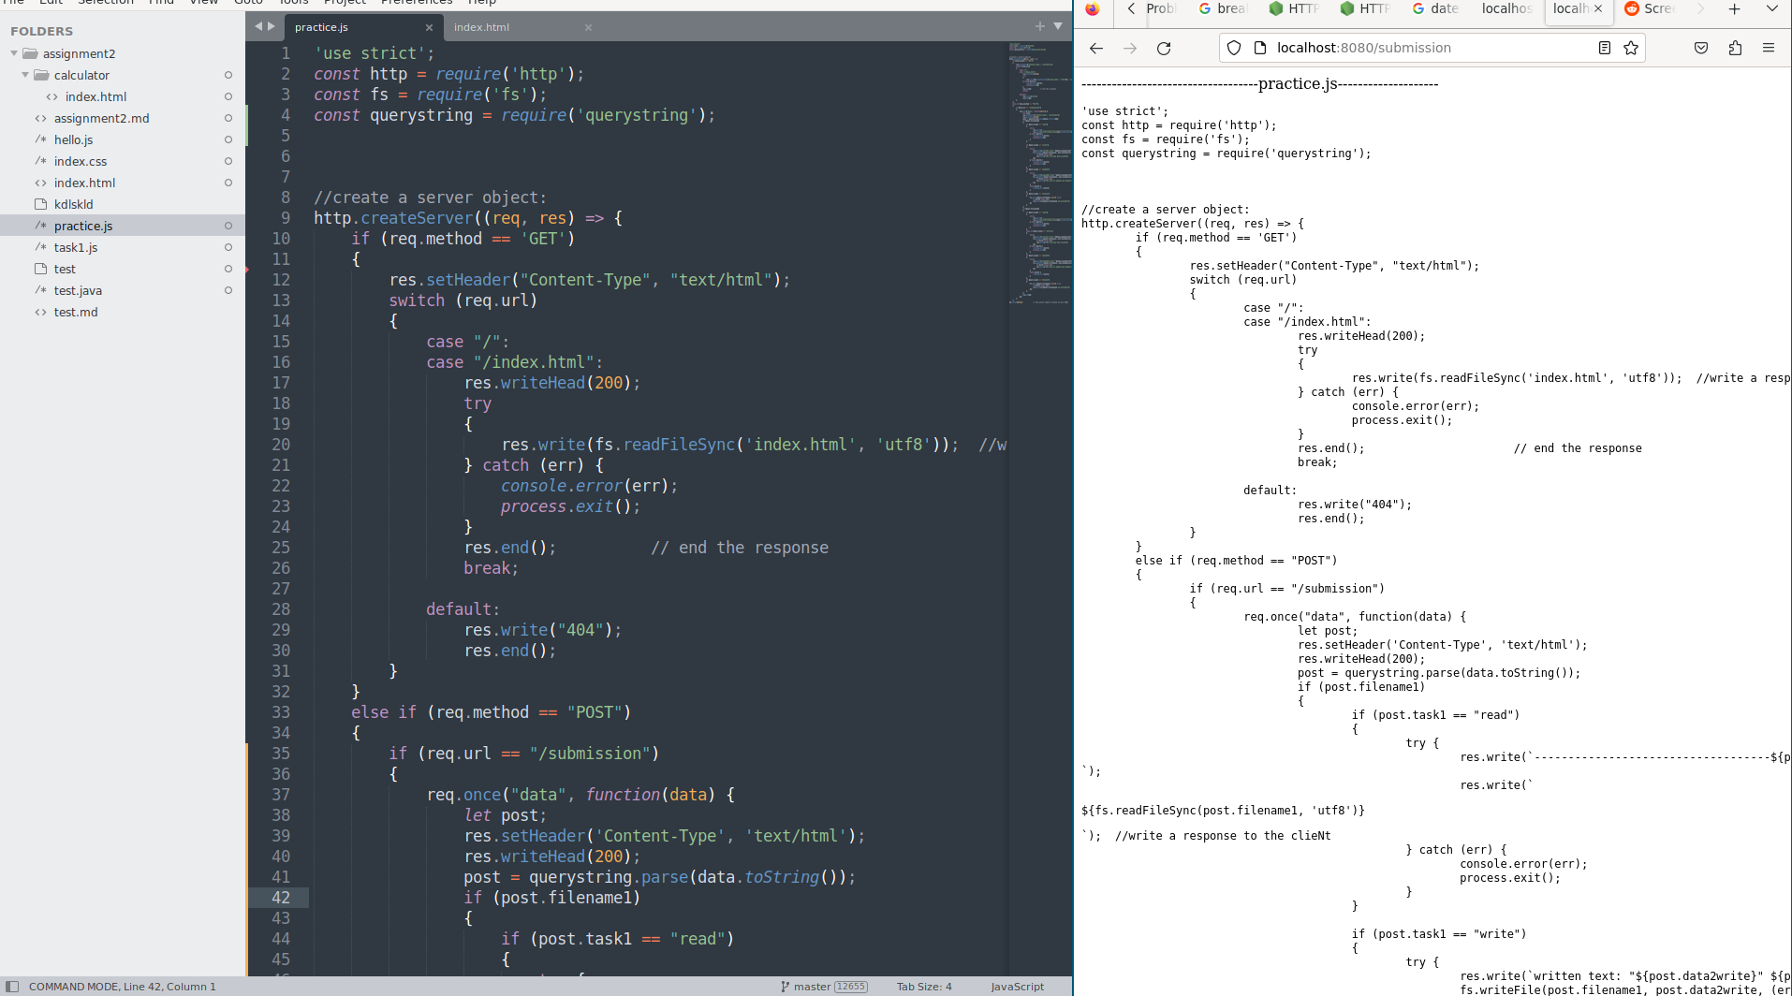

# NodeJS Code For Renaming File

function fun(myFun, str) {  
 myFun(str);  
 }  
 fun( function(str){ console.log(str) }, "OK!" );  
var fs = require("fs");  
console.log("This is a sample to rename a file!");  
fs.rename("aaa.txt", "bbb.txt", function(err) {  
if (err) {  
return console.error(err);  
}  
console.log("aaa.txt has renamed as bbb.txt successfully!");  
});  
  
console.log('You can see the next message in 6 seconds:')

# NodeJS Code for Multiple Event Execution

var EventEmitter = require('events')   
var eventObj = new EventEmitter();   
eventObj.on('delayEvent', function() {   
console.log('The event delays 6000 milliseconds');  
});  
setTimeout(function() {   
eventObj.emit('delayEvent');   
}, 6000);  
var events = require('events');  
  
var eventObj = new events.EventEmitter();  
  
eventObj.on('Event001', function(){  
console.log('Event001 Done!');  
});  
  
eventObj.on('Event002', function(){  
console.log('Event002 Done!');  
});  
  
eventObj.emit('Event001');  
  
eventObj.emit('Event002');  
console.log ("All events are done successfully!");

var fs = require("fs");   
var data = 'Read the File Stream: ';   
var obj = fs.createReadStream('mytext.txt');  
obj.setEncoding('utf8');   
obj.on('data', function(datas) {   
data += datas;   
});  
obj.on('end',function(){   
console.log(data);  
});  
obj.on('error', function(e){   
console.log(e.stack);   
});  
console.log("An example of reading a file stream");

function fun(str) {   
 console.log(str);  
 }  
 fun("MySQL in 8 Hours!");

function fun1(str) {  
 console.log(str);  
}  
function fun2(myFun, str) {  
 myFun(str);  
}  
fun2(fun1, "Good!");

# NodeJS code for read os information

var os = require("os");  
console.log('The information of the current os is as follows:');  
  
console.log('The host name is: ' + os.hostname());  
  
console.log('The type of the operating system is: ' + os.type());  
  
console.log('The platform is: ' + os.platform());  
  
console.log('The total memory is: ' + os.totalmem() + " bytes.");  
  
console.log('The free memory is: ' + os.freemem() + " bytes.");  
  
console.log('The os version is: ' + os.release() + " version.");  
  
console.log('The os runtime is: ' + os.uptime() + " seconds.");

**Output**

The information of the current os is as follows:  
The host name is: narzo-50A  
The type of the operating system is: Windows  
The platform is: Windows 10  
The total memory is: 7719272448 bytes.  
The free memory is: 4487004160 bytes.  
The os version is: 5.15.0-57-generic version.  
The os runtime is: 7036.89 seconds.

# NodeJS code for doing database operation

var mysql = require('mysql');  
var con = mysql.createConnection({  
 host: "localhost",  
 user: "root",  
 password: ""  
});  
  
con.connect(function (err) {  
   
 console.log("Connected!");  
 con.query("CREATE DATABASE demo", function (err, result) {  
   
 console.log("Database created");  
 });  
});