Low-Latency Edge AI for Real-Time Health Monitoring of Older Adults with Real-World Wearable Data Collection

Project report submitted to the
National Institute of Technology Warangal
For award of the degree
Of

Bachelor of Technology
in Electronics and Communication Engineering

by

Vivek Kumar - 23ECB0A09
Bhanu Pratap - 23ECB0A27
Ujwal Kumar - 23ECB0A16

Under the guidance of
Prof. Mohammad Farukh Hashmi



Department of Electronics and Communication Engineering
National Institute of Technology Warangal
November 2026

APPROVAL OF THE VIVA-VOCE BOARD
09/11/26
Certified that the project report entitled Low-Latency Edge AI for Real-Time Health Monitoring of Older Adults with Real-World Wearable Data Collection submitted by Vivek Kumar(23ECB0A09), Bhanu Pratap(23ECB0A27), Ujwal Kumar(23ECB0A16) to the National Institute of Technology Warangal, for the award of the degree of Bachelor of Technology, has been accepted by the external examiners, and that the students have successfully defended the report in the viva-voce examination held today.
(Member, Evaluation Committee) | (Member, Evaluation Committee) |  | (Member, Evaluation Committee)
(Supervisor) |  | (Co-Supervisor)
(External Examiner) |  | (Head of the Department)

CERTIFICATE
This is to certify that the project report entitled Low-Latency Edge AI for Real-Time Health Monitoring of Older Adults with Real-World Wearable Data Collection submitted by Vivek Kumar(23ECB0A09), Bhanu Pratap(23ECB0A27), Ujwal Kumar(23ECB0A16) to the National Institute of Technology Warangal, is a record of bona fide work carried out under my (our) supervision, and we consider it worthy of consideration for the award of the degree of Bachelor of Technology of the Institute.

_____________________________ | _________________________________
Prof. Ravi Kumar Jatoth  Head of the Department  Department of ECE  NIT Warangal | Prof. Mohammad Farukh Hashmi  Assistant Professor  Department of ECE  NIT Warangal
DECLARATION
We certify that
a. The work contained in this report is original and has been done by us under the general supervision of our supervisor(s).
b. The work has not been submitted to any other Institute for any degree or diploma.
c. We have followed the guidelines provided by the Institute in writing the report.
d. Whenever we have used materials (data, theoretical analysis and text) from other sources, we have given due credit to them by citing them in the text of the report and giving their details in the references.
e. Whenever we have quoted written materials from other sources, we have put them under quotation marks and given due credit to the sources by citing them and giving the required details in the references.
Signature: ____________________ Vivek Kumar(23ECB0A09)
Signature: ____________________ Bhanu Pratap(23ECB0A27)
Signature: ____________________ Ujwal Kumar(23ECB0A16)

Acknowledgements
We thank our guide, Prof. Mohammad Farukh Hashmi, for steady guidance through a project that grew well beyond its first proposal, and for pushing us to test our own results as hard as anyone else's. We thank Prof. Ravi Kumar Jatoth, Head of the Department, and the faculty of the Department of Electronics and Communication Engineering for their support and reviews during the year.

We acknowledge the participants, clinicians and research teams who made PTB-XL, OSASUD, SisFall and WESAD available. Their recordings and annotations made it possible to study four sensing tasks before collecting prospective wearable measurements.

Vivek Kumar(23ECB0A09)
Bhanu Pratap(23ECB0A27)
Ujwal Kumar(23ECB0A16)

Abstract
Older adults living independently face four recurring, time-critical risks that a body-worn monitor can observe: structural cardiac strain, sleep-disordered breathing, falls, and sustained autonomic arousal. This project designs, evaluates and deploys a multimodal wearable monitoring system in which four signal pipelines run independently on an NVIDIA Jetson Orin Nano edge computer, so a fault in one sensor never silences another. All models were trained on public clinical datasets and evaluated with strictly patient- or subject-independent protocols: official PTB-XL patient folds for single-lead ECG left ventricular hypertrophy (LVH) patterns, five-fold patient-held-out cross-validation on OSASUD for optical respiratory events, five participant-group folds on SisFall for falls, and leave-one-subject-out validation on WESAD for wrist electrodermal stress.
Three new sequence models are proposed, all built on bidirectional Mamba-2 state-space blocks whose selective step size and feature modulation are conditioned on a physically meaningful signal. VC-BiMamba conditions on per-token millivolt voltage descriptors of Lead II ECG; on the frozen PTB-XL test fold its five-seed ensemble detected LVH versus normal ECGs with AUROC 0.934 (95% CI 0.911–0.957), accuracy 88.1%, sensitivity 82.2% and specificity 89.9%, above published single-lead results (0.80–0.85). IC-BiMamba conditions on impact descriptors and reads native 200 Hz inertial samples; across all 4,500 SisFall trials from held-out participants it reached 99.29% accuracy, 99.27% precision, 98.94% recall, 99.11% F1 and AUROC 0.9998, with 0.90 false alerts per monitored hour — the highest F1 and precision among the participant-split SisFall studies compared. PhysioMamba conditions on wrist motion, contact quality and physiological context; under leave-one-subject-out evaluation on WESAD it reached 95.7% accuracy, macro F1 0.956 and AUROC 0.996 without any per-person calibration, above all five published WESAD comparators (83–94% accuracy). Ablations (retrained or inference-time knock-outs) quantify the contribution of conditioning, bidirectional scanning and each input stream. Optical respiratory-event detection from PPG remained difficult (patient AP 0.247 against a 0.160 baseline) and is retained as a research output only.
The deployed edge pipelines were benchmarked on an NVIDIA Jetson Orin Nano (ONNX Runtime, CPU only, 100 timed runs): every model forward pass completed within 0.53 ms at p99 and every complete preprocessing-plus-inference pipeline within 10.7 ms, at most 0.31% of its real-time hop, and a separate SpO₂ apnea detector ran in 62.4 ms (p95) against a 10 s hop. The Mamba-2 models are written in pure PyTorch without custom kernels so that they can follow the same export path; their on-board benchmark and physical-sensor validation in older adults are the next steps.
Index Terms — Wearable sensors, edge computing, NVIDIA Jetson Orin Nano, state-space models, Mamba-2, electrocardiography, left ventricular hypertrophy, fall detection, electrodermal activity, stress detection, photoplethysmography, subject-independent evaluation.

Contents
APPROVAL OF THE VIVA-VOCE BOARD ii
CERTIFICATE iii
DECLARATION iv
Acknowledgements v
Abstract vi
List of Figures x
List of Tables xii
List of Abbreviations xiii
Chapter 1 Introduction 1
1.1 Background and motivation 1
1.2 Problem statement 1
1.3 Objectives 2
1.4 Target edge platform: NVIDIA Jetson Orin Nano 3
1.5 Contributions 3
1.6 Organisation of the report 3
Chapter 2 Literature Review 4
2.1 Wearable and edge health monitoring 4
2.2 ECG-based detection of left ventricular hypertrophy 4
2.3 Photoplethysmography for sleep-disordered breathing 5
2.4 Inertial fall detection 5
2.5 Electrodermal activity and stress detection 5
2.6 Selective state-space models and evaluation practice 6
2.7 Summary and research gaps 6
Chapter 3 Theoretical Study 8
3.1 System architecture 8
3.2 Evaluation metrics 8
3.3 Physically conditioned bidirectional Mamba-2 9
3.4 ECG pipeline: LVH-associated patterns from Lead II 10
3.5 PPG pipeline: respiratory events from the optical pulse 12
3.6 IMU pipeline: IC-BiMamba fall detection 12
3.7 EDA pipeline: causal tonic–phasic decomposition and PhysioMamba 15
3.8 Edge deployment and benchmarking methodology 16
Chapter 4 Experimental Study 18
4.1 Datasets, protocols and environment 18
4.2 ECG: VC-BiMamba for LVH detection on PTB-XL 18
4.3 PPG: patient-held-out respiratory event detection on OSASUD 21
4.4 IMU: IC-BiMamba fall detection on SisFall 24
4.5 EDA: PhysioMamba stress detection on WESAD 27
4.6 Edge deployment on the NVIDIA Jetson Orin Nano 31
4.7 Comparison with the state of the art 37
4.8 Consolidated results and discussion 41
Chapter 5 Conclusions and Future Scope of Study 43
5.1 Conclusions 43
5.2 Limitations 43
5.3 Future scope 44
References 45
Appendix A Supplementary Experimental Figures 51
A.1 ECG preprocessing 51
A.2 IMU signal diagnostics 51
A.3 EDA protocol and decomposition 52
Appendix B Reproducibility and Deployment Record 54
B.1 Verification records 54
B.2 Hardware contracts and deployment checklist 54

List of Figures
Figure 3.1 VC-BiMamba architecture: voltage descriptors condition FiLM and the step size of every BiMamba-2 block 11
Figure 3.2 ECG pipeline with the proposed VC-BiMamba model 11
Figure 3.3 Calibrated Lead-II waveform (PTB-XL development record 14648) under synthetic noise and after preprocessing 11
Figure 3.4 PPG pipeline with the selected model (dual-rate TCN + GRU) 12
Figure 3.5 IC-BiMamba architecture: impact descriptors condition FiLM and the step size of every BiMamba-2 block 14
Figure 3.6 IMU fall-detection pipeline with the proposed IC-BiMamba model 14
Figure 3.7 Raw and gravity-removed (dynamic) acceleration per axis for a daily activity and a simulated fall (SisFall participant SA01) 14
Figure 3.8 Native 200 Hz acceleration and rotation magnitudes around the impact peak: a fall versus a fall-like daily activity 15
Figure 3.9 PhysioMamba architecture: reliability-gated modality fusion and artefact/context-conditioned BiMamba-2 blocks 16
Figure 3.10 EDA stress pipeline with the proposed PhysioMamba model 16
Figure 4.1 VC-BiMamba ensemble metrics on fold 10 for both tasks, with 95% patient bootstrap intervals 19
Figure 4.2 VC-BiMamba ensemble confusion matrices on fold 10 (threshold fixed on fold 9; row percentages) 19
Figure 4.3 ROC and precision–recall curves of VC-BiMamba on fold 10 (top: LVH vs normal; bottom: LVH vs all other ECGs; dashed line: prevalence) 20
Figure 4.4 Reliability of predicted probabilities and test AUROC of single seeds versus the ensemble 20
Figure 4.5 VC-BiMamba ablation ensembles: AUROC, AUPRC, F1 and accuracy for both tasks 21
Figure 4.6 Input ablations: morphology, modulation, quality, context length and look-ahead 22
Figure 4.7 Two-time-scale variants: patient AP, event F1 and false alerts per hour 23
Figure 4.8 Row-normalised five-class confusion matrix (physician label vs. prediction) 23
Figure 4.9 Event recall versus false alerts per hour under 1, 10 and 30 false-event allowances 23
Figure 4.10 IC-BiMamba ensemble metrics on all 4,500 held-out SisFall trials 24
Figure 4.11 IC-BiMamba ensemble confusion matrix (row percentages) 25
Figure 4.12 Remaining errors by SisFall activity code 25
Figure 4.13 ROC and precision–recall curves of the trial-level ensemble score (axes zoomed) 25
Figure 4.14 Accuracy, precision, recall and F1 of the five single seeds and the logit-averaged ensemble 26
Figure 4.15 IC-BiMamba knock-out ablation: accuracy, precision, recall, F1 and subject-balanced accuracy 27
Figure 4.16 PhysioMamba participant-mean metrics with 95% bootstrap intervals, zero and rest calibration 28
Figure 4.17 PhysioMamba confusion matrices over all 1,636 held-out windows (row percentages) 29
Figure 4.18 Pooled ROC and precision–recall curves of PhysioMamba under both protocols 29
Figure 4.19 Macro F1 of each held-out participant under zero and rest calibration 29
Figure 4.20 PhysioMamba ablations under zero and rest calibration (participant means) 30
Figure 4.21 PhysioMamba modality knock-outs at inference (zero calibration) 31
Figure 4.22 Measured Jetson latency: (a) model-only vs. end-to-end p95 for the six main models; (b) SpO₂ detector stage breakdown 32
Figure 4.23 Per-decision p50 latency recorded during the on-device evaluation run against each real-time hop (log scale) and budget consumed 32
Figure 4.24 On-device comparison of three architectures each for LVH, fall and stress detection 34
Figure 4.25 Confusion matrices produced by the deployed runtimes on the Jetson Orin Nano 34
Figure 4.26 Per-modality confusion matrices of the Jetson replay evaluation with accuracy and F1 35
Figure 4.27 SpO₂ detector: classification metrics and the latency–model-size trade-off 36
Figure 4.28 Confusion matrices of the SpO₂ CNN, gradient-boosting and ensemble models on the Jetson 36
Figure 4.29 AUROC of recent LVH-from-ECG studies versus VC-BiMamba (ground truth differs between studies) 38
Figure 4.30 Accuracy, sensitivity, specificity and AUROC of recent apnea detectors versus our PPG and SpO₂ models 39
Figure 4.31 SisFall accuracy, precision, recall and F1 of recent journal models versus IC-BiMamba 40
Figure 4.32 Accuracy and F1 of published WESAD stress detectors versus PhysioMamba 41
Figure 4.33 Headline held-out metrics of the three proposed models 41
Figure A.1 Preprocessing fidelity under synthetic noise: waveform MAE, ST-proxy error and fraction within budgets 51
Figure A.2 SisFall recording durations and impact distribution (the duration cue) 51
Figure A.3 Impact-peak retention of fixed and adaptive filters 52
Figure A.4 Protocol time per WESAD participant by condition 52
Figure A.5 MC-SAED tonic and phasic components across baseline, stress, amusement and meditation 53
Figure A.6 Decomposition comparison: residual RMSE, peak retention and compute time (MC-SAED vs. cvxEDA, Choi, sparse) 53

List of Tables
Table 1.1 Wearable inputs, sensors and study endpoints 2
Table 2.1 Representative related work and the gaps addressed in this project 6
Table 4.1 Datasets and subject-independent evaluation protocols 18
Table 4.2 VC-BiMamba five-seed ensemble on PTB-XL test fold 10 (95% patient bootstrap CI) 18
Table 4.3 VC-BiMamba single-seed results on fold 10, mean ± SD over five seeds 19
Table 4.4 VC-BiMamba ablations on fold 10 (five-seed ensembles; Δ = full − variant, 95% paired bootstrap CI) 21
Table 4.5 OSASUD two-time-scale networks and matched variants on held-out patients (5 folds, 30 patients) 22
Table 4.6 IC-BiMamba five-seed ensemble on 4,500 SisFall trials from held-out participants 24
Table 4.7 Per-fold results: validation score, selected epochs per seed and held-out test metrics 24
Table 4.8 IC-BiMamba knock-out ablation on all 4,500 held-out trials (25 trained members, threshold re-selected on validation) 26
Table 4.9 PhysioMamba on WESAD, leave-one-subject-out (participant mean, 95% bootstrap CI) 28
Table 4.10 PhysioMamba ablations, LOSO participant means (Δ macro F1 = full − variant, 95% bootstrap CI; people better/worse) 30
Table 4.11 PhysioMamba modality knock-outs at inference, zero calibration (Δ macro F1 = full − variant; people better/worse) 30
Table 4.12 Measured Jetson Orin Nano latency (ms, p50 / p95 / p99), deadline budget and output parity 31
Table 4.13 SpO₂ apnea detector stage latency on the Jetson Orin Nano (100 iterations, ms) 32
Table 4.14 End-to-end classification on the Jetson Orin Nano replay packs 33
Table 4.15 On-device comparison of three models per task (replay packs; latency = p50 per decision) 33
Table 4.16 SpO₂ apnea detector classification on the Jetson replay (N = 234 windows) 35
Table 4.17 Single-window CPU latency of the proposed models (PyTorch, batch 1, one thread; 200 runs) 36
Table 4.18 LVH detection from the ECG: recent journal studies compared with VC-BiMamba 37
Table 4.19 Sleep apnea event detection from PPG and SpO₂: recent journal studies compared with our two detectors 38
Table 4.20 SisFall fall detection: recent journal studies compared with IC-BiMamba (percent) 39
Table 4.21 Binary WESAD stress detection with unseen-person testing compared with PhysioMamba 40
Table 4.22 Summary of the latest model per task: held-out performance 41
Table B.1 Verification records and replay parity 54

List of Abbreviations
Term | Meaning | Term | Meaning
ACC | Accelerometer | IPMV | Impact-preserving multi-view
ADL | Activity of daily living | LOSO | Leave-one-subject-out
AP / AUPRC | Average precision / area under PR curve | LSTM | Long short-term memory
AUROC | Area under the ROC curve | LVH | Left ventricular hypertrophy
BA | Balanced accuracy | MAD | Median absolute deviation
BiMamba | Bidirectional Mamba | MC-SAED | Motion-conditioned sub-harmonic asymmetric exponential decomposition
BVP | Blood volume pulse | MCC | Matthews correlation coefficient
CNN | Convolutional neural network | MIL | Multiple-instance learning
CPU / GPU | Central / graphics processing unit | NPV / PPV | Negative / positive predictive value
DM-TCN | Dual-stream multiscale TCN | ONNX | Open Neural Network Exchange
ECE | Expected calibration error | OSA | Obstructive sleep apnea
ECG | Electrocardiogram | PPG | Photoplethysmogram
EDA | Electrodermal activity | PR | Precision–recall
F1 | Harmonic mean of precision and recall | ROC | Receiver operating characteristic
FiLM | Feature-wise linear modulation | SCL / SCR | Skin conductance level / response
FIR | Finite impulse response | SpO₂ | Peripheral oxygen saturation
FN / FP | False negative / false positive | SSD | State-space duality (Mamba-2 scan)
GBM | Gradient-boosting machine | SSM | State-space model
GRU | Gated recurrent unit | TCN | Temporal convolutional network
HCM | Hypertrophic cardiomyopathy | TN / TP | True negative / true positive
IC‑BiMamba | Impact-conditioned BiMamba | TSST | Trier Social Stress Test
IMU | Inertial measurement unit | VC‑BiMamba | Voltage-conditioned BiMamba
IoU | Intersection over union | XGBoost | Extreme gradient boosting

CHAPTER 1

Introduction

1.1 Background and motivation
Population ageing is shifting healthcare demand from hospitals into homes and assisted-living facilities. Falls are the second leading cause of unintentional injury death worldwide and the risk rises steeply after 65 years [1]. Left ventricular hypertrophy, most often a consequence of long-standing hypertension, is an independent predictor of heart failure, arrhythmia and stroke [2], [3]. Obstructive sleep apnea is common and under-diagnosed in older adults and in stroke survivors, and its gold-standard diagnosis requires overnight polysomnography [4], [5]. Chronic stress and autonomic arousal aggravate hypertension and sleep disturbance [6]. Each of these conditions has a physiological signature that a wearable sensor can capture continuously, but each evolves on a very different time scale: an impact lasts 10–30 ms, an apnea 10–60 s, and a stress response several minutes.
Continuous monitoring is valuable only if alerts are timely, private and trustworthy. Streaming raw waveforms to the cloud adds latency, consumes radio power and exposes sensitive data; edge computing instead processes data next to the sensor [7], [8]. Modern embedded accelerators such as the NVIDIA Jetson family make it possible to run deep models locally [9], but most published wearable models are evaluated on a single signal, often with protocols that allow information to leak between training and test subjects [10]. This project addresses both gaps together: four rigorously evaluated pipelines that run concurrently on one edge board.

1.2 Problem statement
Despite affordable wearable sensors and mature machine-learning toolkits, a gap remains between published wearable-health models and a working edge system that monitors an older adult continuously, on several signals at once, with measured real-time performance. Existing approaches frequently suffer from one or more of the following limitations:
- Reliance on cloud inference, which adds avoidable network round-trip latency, depends on connectivity and sends raw physiological waveforms off the body.
- Single-signal, single-condition designs, so one detached electrode or failed sensor silences monitoring, and cardiac, respiratory, fall and stress risks cannot be watched together.
- Optimistic evaluation protocols in which windows from the same person appear in both training and test sets, inflating reported accuracy for people the model has never seen.
- Models tied to dataset units and sampling rates rather than calibrated physical quantities (millivolts, g, microsiemens), so a real sensor cannot simply replace the dataset recording.
- Generic deep networks that ignore physiology, using the same architecture for every signal and trading accuracy for false alarms, which drive alarm fatigue in care settings.
- No measured latency on embedded hardware for models trained on real physiological signals.
This project addresses these limitations together: four independent, causally processed pipelines in calibrated physical units, three physically conditioned sequence models evaluated only on people unseen during training, and deployment with measured latency on an NVIDIA Jetson Orin Nano at the edge.

1.3 Objectives
- Build four independent signal pipelines in calibrated physical units with explicit signal-quality gating.
- Design new sequence models for LVH, fall and stress detection that use physical domain knowledge inside the sequence model, and evaluate them under identical, leakage-free subject splits.
- Quantify the contribution of each new component with ablation studies and compare the results with published work.
- Report a complete set of classification metrics — accuracy, precision, recall/sensitivity, specificity, F1, AUROC, AUPRC, calibration and alarm burden — together with uncertainty estimates.
- Export the selected models to portable formats (ONNX, NumPy, JSON), verify numerical parity, and benchmark latency on the Jetson Orin Nano against each pipeline’s real-time hop.
- Identify dataset shortcuts and limitations that must be resolved before clinical use.
Table 1.1 Wearable inputs, sensors and study endpoints
Module | Target sensor | Source data | Edge stream | Window / hop | Endpoint
ECG | BioAmp EXG Pill (Lead II) | PTB-XL, 500 Hz | 360 Hz, mV | 10 s / 2 s | LVH-associated ECG pattern
PPG | MAX30102 optical | OSASUD, 80 Hz | 80–100 Hz | 30–90 s / 5 s | Apnea or hypopnea second
IMU | Waist MPU-9250 (6 axes) | SisFall, 200 Hz | 200 Hz, g and °/s | 4 s / 1 s | Fall vs. ADL
EDA | Wrist GSR, ACC, TEMP, BVP | WESAD wrist, 4–64 Hz | 4 Hz µS + ACC/TEMP/BVP | 60 s / 15 s | Stress vs. baseline

1.4 Target edge platform: NVIDIA Jetson Orin Nano
The deployment target is the NVIDIA Jetson Orin Nano Developer Kit (Super configuration) [11]. It integrates a 6-core Arm Cortex-A78AE v8.2 64-bit CPU (up to 1.7 GHz), a 1,024-core NVIDIA Ampere GPU with 32 Tensor Cores, and 8 GB of 128-bit LPDDR5 memory shared by CPU and GPU, within a 7–25 W power envelope. The benchmarks in this report deliberately use only the CPU execution provider of ONNX Runtime [12]: if the complete four-signal workload fits comfortably on the CPU, the GPU remains free for future, heavier models, and the results transfer to cheaper boards.

1.5 Contributions
- Physically conditioned selective state-space models. A common design in which FiLM modulation and the per-head step size Δ of bidirectional Mamba-2 blocks are driven by a physical signal (voltage, impact or artefact/context), zero-initialised so that training starts from a plain BiMamba.
- VC-BiMamba for single-lead LVH (AUROC 0.934 vs normal on the frozen PTB-XL test fold) with a voltage-preserving pipeline that never z-scores away millivolt amplitude.
- IC-BiMamba for fall detection (99.29% accuracy, 99.11% F1 on 4,500 held-out trials), combining gravity-relative IPMV tokens with native 200 Hz patches and multiple-instance training, after showing that SisFall file duration alone yields 100% accuracy and removing that shortcut.
- PhysioMamba for wrist stress detection (macro F1 0.956, LOSO) with reliability-gated modality fusion on top of the causal MC-SAED tonic–phasic decomposition.
- Ablation and comparison studies for every new model, and a literature comparison with five or more journal or conference results per task.
- Measured edge deployment of the pipelines on the Jetson Orin Nano with latency percentiles, deadline budgets and golden-vector parity checks, including a dedicated SpO₂ apnea detector service.

1.6 Organisation of the report
Chapter 2 reviews related work. Chapter 3 presents the system architecture, metrics, the conditioned BiMamba block and each pipeline. Chapter 4 reports metrics, ablations and literature comparisons for each model, the PPG study and the Jetson deployment. Chapter 5 concludes; Appendices A and B hold supplementary figures and reproducibility records.
CHAPTER 2

Literature Review
This chapter surveys prior work for each sensing task, for edge deployment of physiological models, and for evaluation practice. Table 2.1 at the end of the chapter summarises representative studies and the gaps this project addresses.

2.1 Wearable and edge health monitoring
Edge computing moves computation from the data centre to the network edge to reduce latency, bandwidth and privacy exposure [7], [8]. In health monitoring the edge node is typically a gateway that aggregates body sensors. A recent study streamed a chest-strap ECG over Bluetooth Low Energy to a Jetson Orin Nano and showed that LSTM heartbeat classification meets real-time constraints while serving several patients [9]. Embedded fall detectors have reached tens of milliseconds of inference time on microcontrollers [13], [14]. These works usually deploy one signal; the interaction of several asynchronous pipelines on one device, and the cost of their preprocessing rather than only the model forward pass, are rarely measured.

2.2 ECG-based detection of left ventricular hypertrophy
Classical LVH criteria such as Sokolow–Lyon and Cornell sum QRS voltages across several precordial and limb leads [2], [3]; they are specific but insensitive. PTB-XL, a 21,799-record 12-lead corpus with SCP-ECG statements and recommended patient folds [15], [16], enabled systematic deep-learning benchmarks in which ResNet and Inception-style 1D CNNs dominate [17]. Large-scale 12-lead networks reach cardiologist-level performance for rhythm and conduction disorders [18], [19], and 1D CNNs can run in real time for patient-specific classification [20]. For LVH specifically, an ensemble neural network trained against echocardiography reached AUROC 0.88 internally and 0.87 externally [21], and a feature-based machine-learning model on PTB-XL and Georgia data exceeded 86% sensitivity, compared with at most 38% for clinical criteria [22]. Single-lead work is scarcer: Sato et al. trained on 229,439 paired ECG–echocardiogram sets and reported AUROC 0.797 for LVH from Lead I, 0.809 on external data [23], and LVH-Net reported Lead II AUROCs of 0.93 for amyloidosis and 0.85 for hypertrophic cardiomyopathy [24]. Moreover, routine per-record z-score normalisation removes absolute amplitude, which is the primary LVH biomarker; no published single-lead model injects calibrated voltage into the sequence model itself.

2.3 Photoplethysmography for sleep-disordered breathing
Breathing modulates the PPG through baseline (intensity), amplitude and frequency (pulse-interval) variation; these modulations underpin respiratory-rate estimation [25], [26]. Reviews of apnea detection report that most methods use SpO₂, ECG or airflow and evaluate on 30–60 s segments [4]. Wrist-worn reflective PPG can estimate the apnea–hypopnea index [27]; ApSense detects OSA events from fingertip PPG with deep learning [28], and SleepPPG-Net stages sleep from raw PPG [29]. The OSASUD dataset pairs bedside optical plethysmography with physician-scored respiratory events in stroke-unit patients [30]. Segment-level labelling blurs event onset and offset, and very few studies report the false-alarm rate per hour that determines whether an unattended alert is usable.

2.4 Inertial fall detection
SisFall provides 4,500+ waist-sensor recordings of 15 fall types and 19 ADLs from 38 participants, including 15 older adults [31]. Fall detectors range from threshold rules to CNNs, recurrent networks and hybrids [14], [32], [33]; recent embedded systems report accuracies above 99% [13]. Zhang et al. combined dual CNN streams with self-attention and reported 99.32% accuracy, 98.58% precision, 99.15% recall and 98.86% F1 on an 80/20 participant split [34]; Villa and Casilari reported 98.9% accuracy, 96.7% sensitivity and 99.6% specificity with a CNN–LSTM at 20 Hz [35]. Temporal convolutional networks [36], InceptionTime [37] and gradient-boosted trees [38] remain strong baselines. A structural weakness of SisFall is that falls last about 15 s while ADLs last 10–180 s; any model that sees the whole recording, its length or its padding can exploit this cue. Reported accuracies are therefore not always comparable across papers.

2.5 Electrodermal activity and stress detection
Skin conductance comprises a slow tonic level and fast phasic responses. Decomposition methods include continuous deconvolution [39] and the convex-optimisation cvxEDA [40]; both operate on whole recordings and are not causal. Ambulatory stress monitors combine EDA with cardiac and motion signals [41], [42], and surveys note the gap between laboratory and daily-life performance [6]. WESAD [43] is the standard wrist and chest benchmark; its baseline, stress (TSST), amusement and meditation phases follow a fixed schedule, so elapsed time is a confound that models can exploit if time-dependent normalisation is used. Under unseen-person testing, Schmidt et al. reported 88.3% wrist accuracy, a feature-augmented hybrid CNN on wrist BVP reached 88.6% accuracy and 86.2 F1 [44], a hierarchical deep network reached 87.7% [45], Resp-BoostNet reached 94% using smartwatch biomarkers with a predicted respiration rate [46], and a review of generalisable stress models reported about 85% accuracy when WESAD served as unseen test data [47].

2.6 Selective state-space models and evaluation practice
Attention-based Transformers [48] and structured state-space models [49], [50] extend the receptive field of convolutional encoders. Mamba makes the state-space step size input-dependent (selective), and Mamba-2 restricts the state matrix to a scalar per head so that the scan can be computed exactly as chunked matrix products (state-space duality, SSD) [51]. Bidirectional variants scan the sequence in both directions when the whole window is available [52]. Feature-wise linear modulation (FiLM) conditions a network on side information by a learned per-channel scale and shift [53], and multiple-instance learning trains from bag labels when only the bag (here a trial) is labelled [54]. The models in this report combine these ideas: the side information that drives FiLM and the step size is a physical quantity. For small physiological datasets, model selection itself is a major source of optimism: nested cross-validation is required to avoid biased error estimates [55], and leakage between training and test is a widespread cause of irreproducible results [10]. On imbalanced tasks the precision–recall curve is more informative than ROC [56], and modern networks are often mis-calibrated, motivating Platt or temperature scaling [57], [58].

2.7 Summary and research gaps
Table 2.1 Representative related work and the gaps addressed in this project
Study | Signal / data | Method | Reported result | Gap relative to this work
Kwon et al. [21] | 12-lead ECG + echo | Ensemble NN | AUROC 0.880 / 0.868 | 12 leads; not wearable
Sato et al. [23] | Lead I ECG + echo | Deep CNN | LVH AUROC 0.797 / 0.809 | Amplitude not modelled explicitly
Haimovich et al. [24] | 12-lead / Lead II | LVH-Net CNN | Lead II HCM AUROC 0.85 | Aetiology task
Zhang et al. [34] | Waist IMU, SisFall | Dual CNN + self-attention | Acc. 99.32%, F1 98.86% | 12 s windows; no alarm rate
Villa & Casilari [35] | Accelerometer, SisFall | CNN–LSTM, 20 Hz | Acc. 98.9%, Se 96.7% | Accelerometer only
Campanella et al. [13] | IMU + pressure | Embedded DL | 99.38% acc., 25 ms | Own dataset
Schmidt et al. [43] | Wrist/chest, WESAD | RF, LDA, AdaBoost | Wrist binary acc. ≈88% | Schedule confound
Rashid et al. [44] | Wrist BVP, WESAD | Feature-augmented CNN | Acc. 88.6%, F1 86.2 | Single modality
Resp-BoostNet [46] | Smartwatch biomarkers | Boosting NN | Acc. 94% | Split details limited
ApSense [28] | Fingertip PPG | Deep learning | OSA event detection | No alarm-burden analysis
Sensors 2025 [9] | Chest ECG | LSTM on Jetson Orin Nano | Real-time | Single signal

Four gaps follow. First, wearable-grade inputs (single lead, single optical channel, wrist EDA) are under-studied relative to clinical multi-lead or multi-sensor setups. Second, dataset shortcuts — duration in SisFall, protocol order in WESAD, amplitude normalisation in PTB-XL — inflate many published numbers. Third, sequence models are usually applied to physiological signals as generic black boxes; the physical quantity that defines the condition (QRS voltage, impact energy, contact quality) is not used to control what the model remembers. Fourth, edge feasibility is usually claimed from model size rather than measured end to end. This project addresses each gap explicitly.
CHAPTER 3

Theoretical Study

3.1 System architecture
The system is organised as four decoupled modules (Figures 3.2, 3.4, 3.6 and 3.10). Each module owns its dataset parser, labels, splits, windowing, preprocessing, model, evaluation and inference code; matching folder names never imply matching algorithms or sample rates. In real-time operation, an acquisition layer timestamps samples into per-signal ring buffers; the module’s causal preprocessing runs incrementally; and a predictor emits a result whenever its hop elapses. A result carries a status (valid, insufficient_signal or warming_up), a calibrated probability and a decision. Offline dataset parsers are never reused as live drivers, and edge code never imports training-only dependencies.
- Causality. Every filter, scaler and feature uses only past samples, so offline evaluation reproduces streaming behaviour.
- Physical units. Inputs stay in mV, g, °/s and µS; the hardware contract specifies the conversion from ADC counts.
- Subject independence. Scalers, thresholds and calibrators are fitted only on training or validation people.
- Fault isolation. A gap, clipping or contact loss in one stream only affects that module’s status.

3.2 Evaluation metrics
For a binary decision with true positives TP, false positives FP, true negatives TN and false negatives FN, the following metrics are reported throughout Chapter 4:
Accuracy = (TP + TN) / (TP + TN + FP + FN) (3.1)
Precision (PPV) = TP / (TP + FP), Recall (Sensitivity) = TP / (TP + FN) (3.2)
Specificity = TN / (TN + FP), NPV = TN / (TN + FN) (3.3)
F1 = 2·Precision·Recall / (Precision + Recall), BA = (Sensitivity + Specificity) / 2 (3.4)
MCC = (TP·TN − FP·FN) / √((TP+FP)(TP+FN)(TN+FP)(TN+FN)) (3.5)
Threshold-free discrimination is measured by the area under the ROC curve (AUROC) and by average precision (AP, the step-wise area under the precision–recall curve, reported as AUPRC). Calibration is measured by the Brier score, (1/N)Σ(p_{i} − y_{i})², and the 10-bin expected calibration error (ECE). Subject-level metrics average per-person values so that each participant counts equally: SisFall reports subject-balanced accuracy, OSASUD reports mean within-patient AP, and WESAD reports the mean participant macro F1. Event-level metrics match predicted and reference intervals one-to-one when their temporal intersection over union is at least 0.30; false alerts per hour count unmatched predicted events divided by monitored hours. Confidence intervals use 1,000 patient-level bootstrap resamples.

3.3 Physically conditioned bidirectional Mamba-2
A linear state-space model maps an input sequence x_{t} to an output y_{t} through a hidden state h_{t} ∈ ℝ^{N}. After discretisation with step size Δ, the recurrence is
h_{t} = exp(Δ_{t}A) · h_{t−1} + Δ_{t} B_{t} x_{t}, y_{t} = C_{t} · h_{t} + D x_{t} (3.6)
In Mamba [50] the step Δ_{t} and the projections B_{t}, C_{t} are computed from the input, so the model selects what to store and what to forget. A large Δ_{t} makes exp(Δ_{t}A) small (A < 0): the state is overwritten by the current token and memory becomes short. A small Δ_{t} keeps the state, giving long memory. Mamba-2 [51] uses a scalar A per head, which allows the whole scan to be computed exactly as chunked matrix products (SSD); our implementation is the reference chunked algorithm in plain PyTorch, so it runs on CPU-only edge devices and exports without custom kernels.
The three proposed models share one block, the conditioned BiMamba-2. Given token features z_{t} and a physical conditioning vector c_{t} (voltage descriptors for ECG, impact descriptors for IMU, contact quality, motion and window physiology for EDA), the block applies
ẑ_{t} = LN(z_{t}) ⊙ (1 + γ(c_{t})) + β(c_{t}) (FiLM) (3.7)
Δ_{t}^{(d)} = softplus(w_{d}ᵀ ẑ_{t} + b_{d} + δ_{d}(c_{t})), d ∈ {forward, backward} (3.8)
y_{t} = ½ [SSD_{fwd}(ẑ)_{t} + flip(SSD_{bwd}(flip(ẑ)))_{t}] ⊙ SiLU(g_{t}), z_{t} ← z_{t} + W_{o} y_{t} (3.9)
where γ, β and δ are small convolutional or linear layers [53]. Because these layers are initialised to zero, training starts from an ordinary bidirectional Mamba-2 [52] and the network learns how strongly the physical signal should modulate features and memory. The physical interpretation is direct: a large QRS deflection or an impact can shorten the memory horizon so that the state is reset around the event, while a motion artefact can lengthen it so that the corrupted segment is ignored. The forward and backward scans have separate convolutions, decays and step offsets; bidirectional scanning is valid because every window is fully buffered before it is classified.

3.4 ECG pipeline: LVH-associated patterns from Lead II
LVH increases the electrical mass of the left ventricle, raising QRS voltage and often producing secondary ST–T (strain) changes [2], [3]. Because absolute R-wave amplitude in millivolts is the dominant biomarker, the pipeline never applies per-record z-scoring.

3.4.1 Rational polyphase resampling
PTB-XL records are sampled at 500 Hz; the BioAmp front end streams at 360 Hz. The ratio 360/500 = 18/25 is realised by polyphase filtering [59]: upsample by L = 18, apply a Kaiser-window low-pass FIR (β = 5), and decimate by M = 25. A 10 s window therefore contains exactly 3,600 samples with amplitudes preserved in mV.
y[n] = Σ_{k} h[k] · x_{↑L}[nM − k], L/M = 18/25 (3.10)
Before inference, a gate rejects windows with non-finite samples, clock jitter beyond |Δt − 1/f_{s}| > 0.2/f_{s}, flat lines (σ < 10⁻⁵ mV) or rail clipping, returning insufficient_signal instead of a score (Figure 3.3).

3.4.2 VC-BiMamba: voltage-conditioned BiMamba
VC-BiMamba (Figure 3.1, 129,602 parameters) receives the same 10 s Lead-II window in two forms. An amplitude-normalised copy feeds a multiscale convolutional stem (kernels 3 and 7, stride 12) and two dilated depthwise blocks, producing 300 tokens of width 64 that capture QRS and ST–T morphology. In parallel, the raw millivolt lead is median-centred and summarised per token by five voltage descriptors: positive peak, negative trough, peak-to-peak amplitude, maximum slope (mV/ms) and the record-level 95th-percentile peak-to-peak amplitude, compressed by sign(v)·log(1 + 4|v|). These descriptors are the conditioning vector c_{t} of two conditioned BiMamba-2 blocks (Equations 3.7–3.9; eight heads of size 16, state size 16, chunk length 50). The sequence model can thus decide how long to retain context depending on how large each local deflection actually is in millivolts — the quantity behind the Sokolow–Lyon and Cornell criteria.
The output is pooled by mean, max and gated attention and fused with a small strided-convolution voltage branch on the raw lead and 16 same-lead morphology features before a two-layer head. Training used class-weighted binary cross-entropy, AdamW, batch size 32 and early stopping on folds 7–8 (patience 15); five seeds were trained and their probabilities averaged.
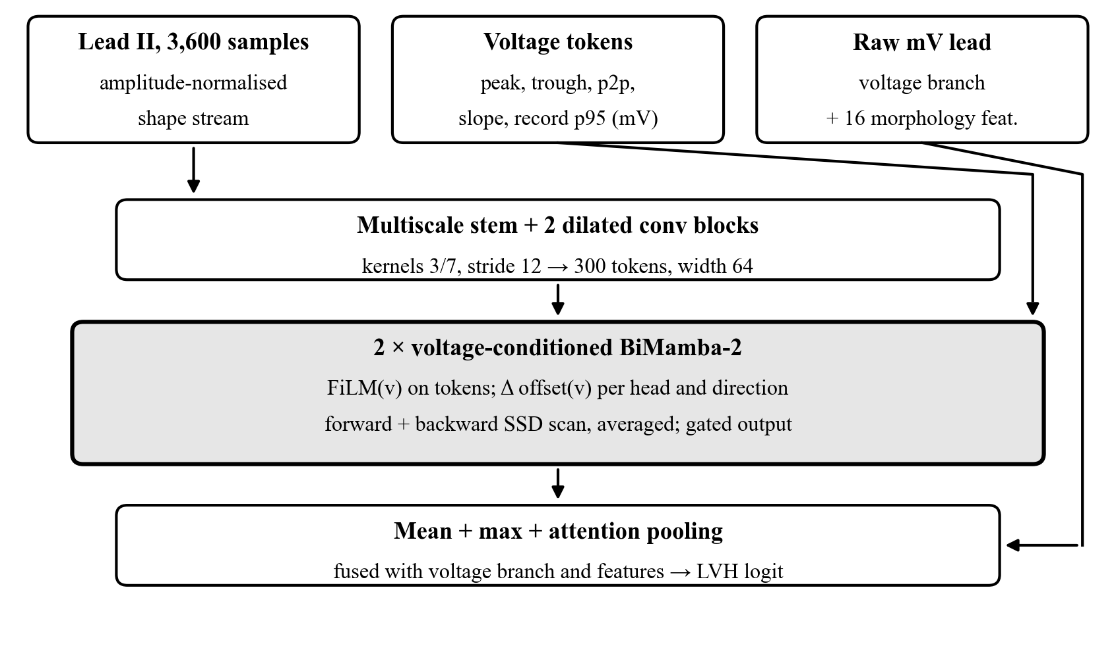
Figure 3.1 VC-BiMamba architecture: voltage descriptors condition FiLM and the step size of every BiMamba-2 block
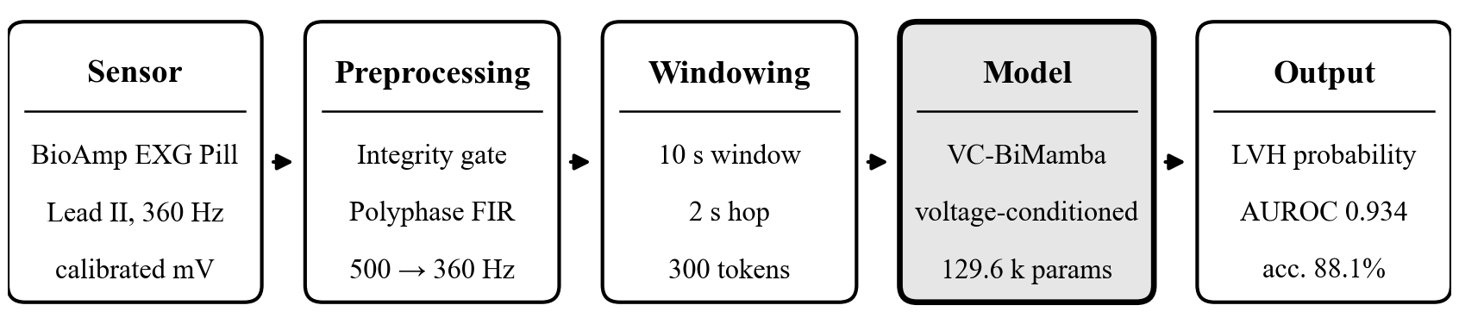
Figure 3.2 ECG pipeline with the proposed VC-BiMamba model
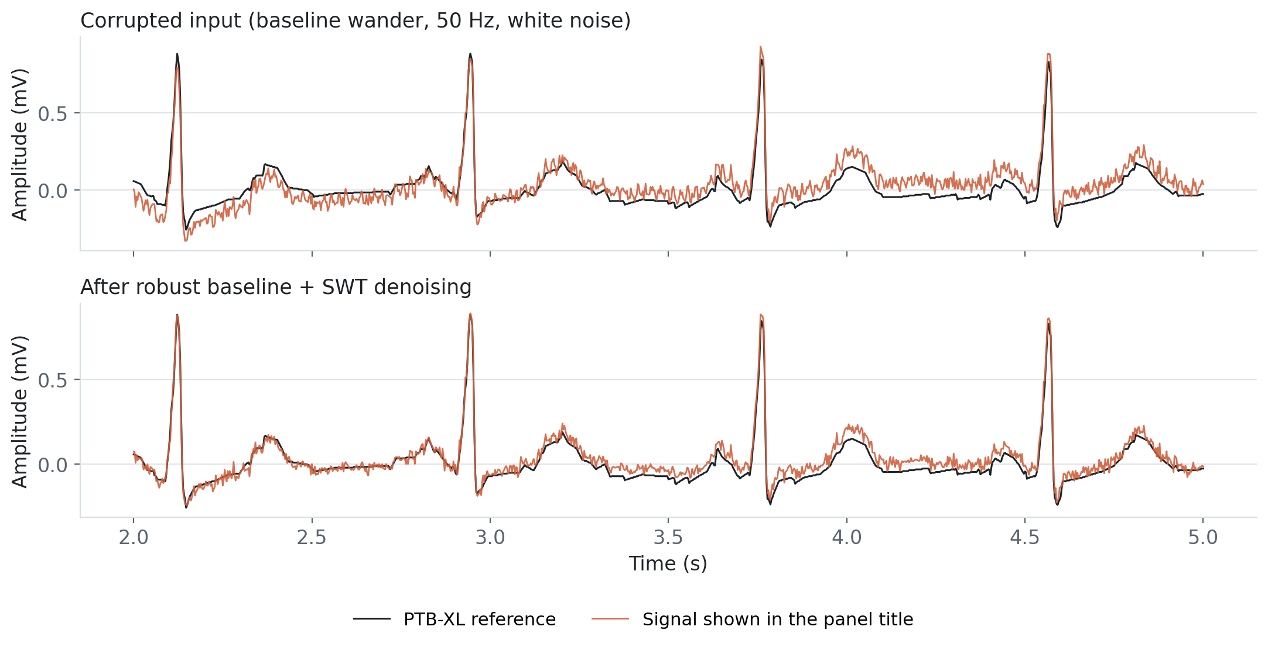
Figure 3.3 Calibrated Lead-II waveform (PTB-XL development record 14648) under synthetic noise and after preprocessing

3.5 PPG pipeline: respiratory events from the optical pulse
During an apnea or hypopnea, airflow falls, intrathoracic pressure swings and sympathetic surges modulate the pulse wave. The PPG therefore contains a cardiac component (≈1–2 Hz) and slower respiratory modulation (≈0.1–0.3 Hz) [25], [26].

3.5.1 Mean-preserving Haar shrinkage and multi-view features
Adjacent optical samples are paired and transformed with a single-level Haar wavelet. The detail coefficient d is soft-thresholded [60] with τ equal to half the running median absolute deviation, while the approximation (pair mean) is left untouched, so slow respiratory baseline is preserved exactly:
d̂ = sign(d) · max(|d| − τ, 0), τ = 0.5 · MAD(d) (3.11)
Each completed second yields 31 features in three views: (1) pulse morphology — 16 shape coordinates of the 0.45–5.5 Hz band-passed pulse normalised by a 45 s trailing amplitude reference; (2) respiratory modulation — 11 features covering 0.08–0.38 Hz baseline, pulse-amplitude and inter-beat-interval variation and 8 s exponential RMS energies; and (3) signal quality — high-frequency residual, repeated-sample fraction, beat staleness and ADC-rail dwell. Features are robust-scaled on training patients and compressed with asinh.

3.5.2 Boundary-preserving, two-time-scale model
Instead of one label per 30 s window, the model reads a trailing context and emits five separate per-second probabilities every 5 s, so event onsets are not blurred. The selected two-time-scale network (dual_hard, 9,097 parameters) combines 12 s of pulse shape (16 samples per second) with up to 90 s of modulation and quality features through dilated TCN blocks [36] (dilations 2, 4, 8) and a 24-unit unidirectional GRU (Figure 3.4).
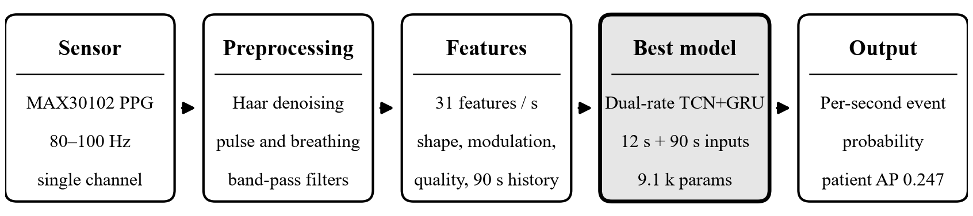
Figure 3.4 PPG pipeline with the selected model (dual-rate TCN + GRU)

3.6 IMU pipeline: IC-BiMamba fall detection
A fall is a short, high-energy event: a free-fall phase, an impact peak lasting 10–30 ms, and a post-fall posture change. Ordinary low-pass filtering and decimation attenuate the impact peak, while wearable sensors rotate on the belt. The impact-preserving multi-view (IPMV) front end addresses both effects, and IC-BiMamba reads it together with the native 200 Hz samples (Figure 3.6).

3.6.1 Duration-free windows and IPMV tokens
Every recording is converted to g (32/8192 g per LSB) and °/s (4000/65536 °/s per LSB) and cut into fixed, unpadded 4 s windows with a 1 s hop (75% overlap), each represented by 80 tokens of 50 ms. A causal 0.75 Hz second-order filter estimates the gravity vector g; dynamic acceleration and its components parallel and perpendicular to gravity are
a_{dyn} = a − g, a_{v} = (a_{dyn} · g) / ‖g‖, a_{h} = ‖a_{dyn} − a_{v} ĝ‖ (3.12)
These scalar projections do not change under a constant rotation of the sensor. Per token, the native-rate path keeps minima, maxima and the maximum one-sample derivative max|Δa/Δt| at 200 Hz, and causal three-level Daubechies-2 wavelet band energies [61] complete 24 descriptors. Six of them — peak acceleration, jerk, peak angular rate, angular-rate change, dynamic acceleration and tilt — form the impact conditioning vector c_{t}.

3.6.2 IC-BiMamba: impact-conditioned BiMamba
IC-BiMamba (Figure 3.5, 72,410 parameters per member) embeds two views of every 50 ms token: the 24 standard-scaled IPMV descriptors (1×1 convolution) and the ten raw 200 Hz samples of all six axes plus |a| and |g|, compressed with asinh and linearly embedded (a learned patch embedding, so impact transients reach the encoder without any filtering). Depthwise convolutions with kernels 3, 5 and 9 add local context; three impact-conditioned BiMamba-2 blocks (width 48, six heads of size 16, state size 16) follow, and attention plus max pooling produce one logit per 4 s window. A large impact can shorten the memory horizon around the event, while quiet segments keep long memory of posture before and after it. Both scan directions matter because a fall is defined by what precedes the impact (descent) and what follows it (lying still); the 4 s window trades a little alert latency for that context.
SisFall labels whole trials, not windows, so training uses multiple-instance learning [54]: for each trial eight windows are sampled per epoch, the trial logit is their maximum, and binary cross-entropy with a positive-class weight is applied to it. Gain (±4%) and noise augmentation, AdamW with a one-cycle schedule (learning rate 2×10⁻³, up to 30 epochs) and early stopping on the inner validation group were used. At test time the trial score is the maximum over all of its windows, and five independently seeded members are combined by averaging window logits.
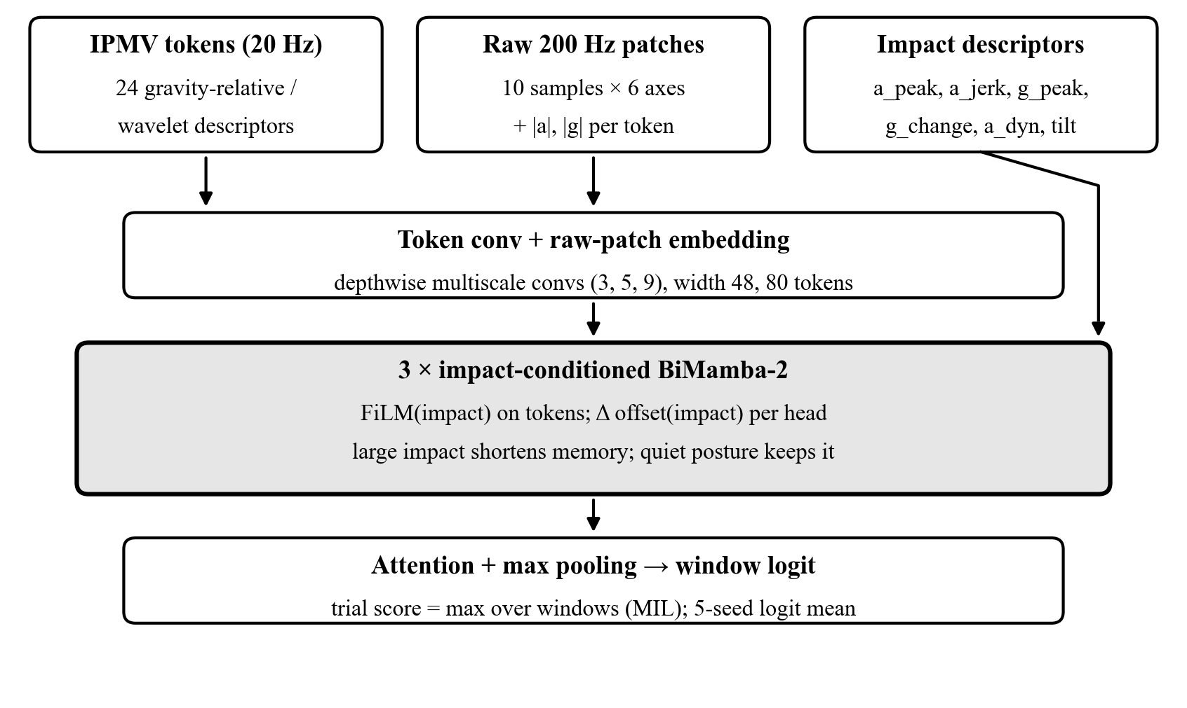
Figure 3.5 IC-BiMamba architecture: impact descriptors condition FiLM and the step size of every BiMamba-2 block
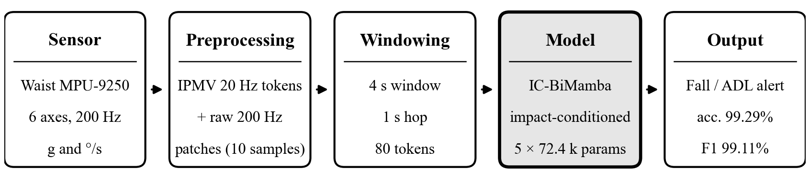
Figure 3.6 IMU fall-detection pipeline with the proposed IC-BiMamba model
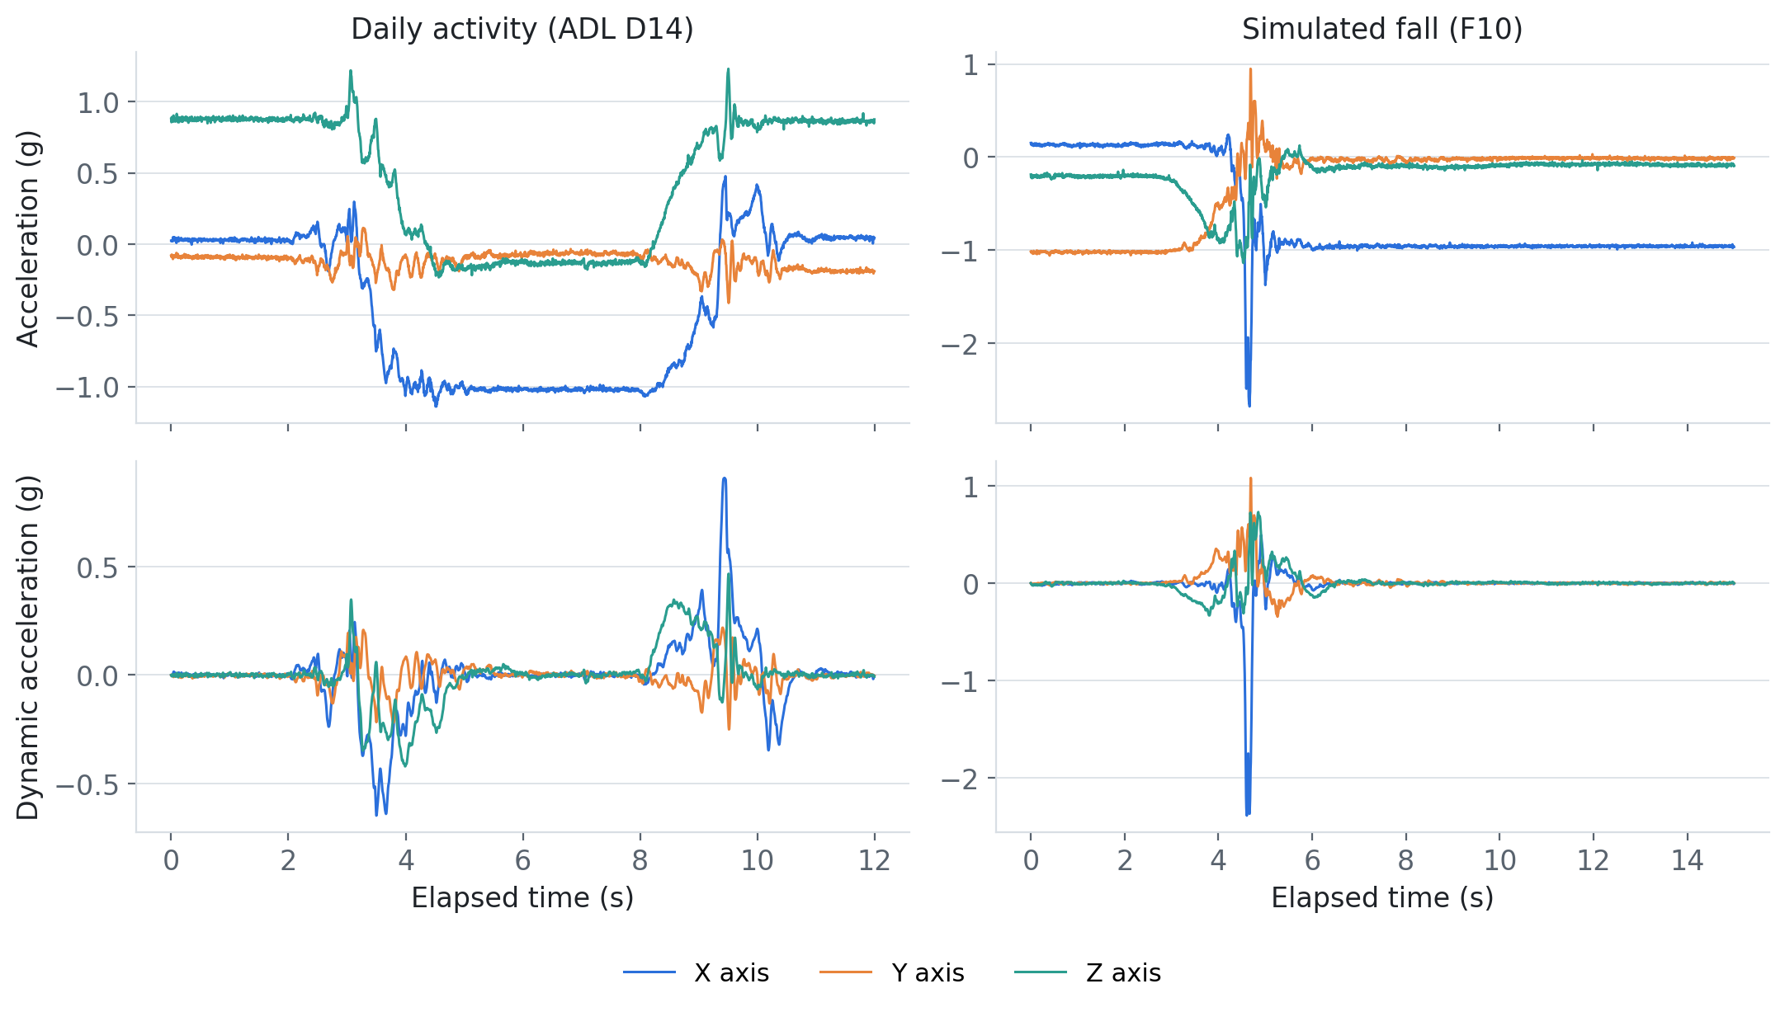
Figure 3.7 Raw and gravity-removed (dynamic) acceleration per axis for a daily activity and a simulated fall (SisFall participant SA01)
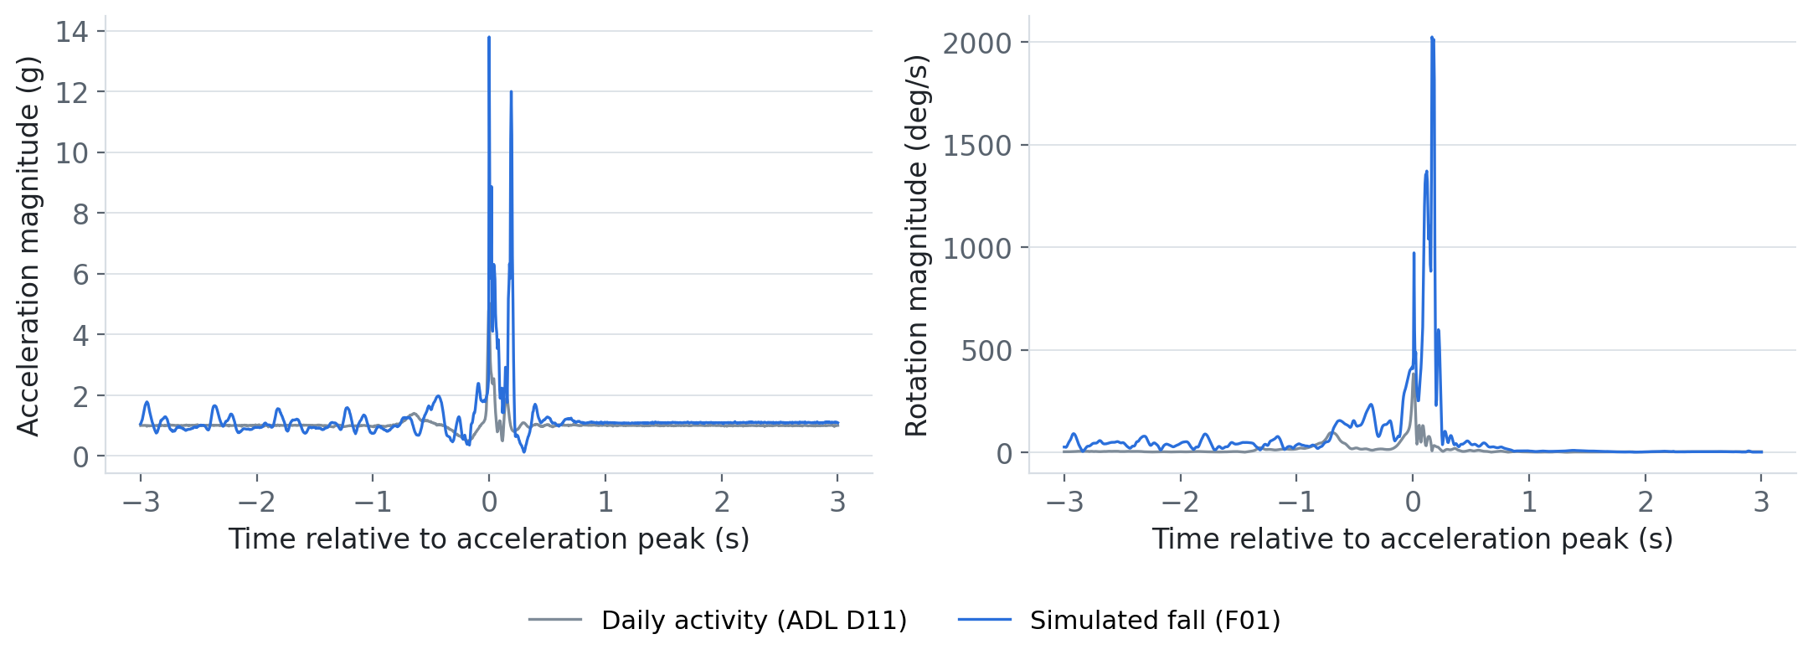
Figure 3.8 Native 200 Hz acceleration and rotation magnitudes around the impact peak: a fall versus a fall-like daily activity

3.7 EDA pipeline: causal tonic–phasic decomposition and PhysioMamba
Eccrine sweat glands are innervated only by the sympathetic nervous system, so skin conductance tracks arousal. It is the sum of a slow tonic level (SCL, < 0.05 Hz) and phasic responses (SCR) [39].

3.7.1 MC-SAED
The motion-conditioned sub-harmonic asymmetric exponential decomposition processes the 4 Hz conductance stream sample by sample. A contact-quality score q ∈ [0, 1] combines physical plausibility (0–100 µS), a rolling derivative MAD, flat-line and step detection and optional wrist motion. The tonic tracker follows decreases quickly and increases slowly:
T[n] = T[n−1] + α(q) · (x[n] − T[n−1]), α ∈ {α_{down}, α_{up}}, α_{down} > α_{up} (3.13)
so SCR peaks do not drag the baseline upward. The phasic component is the smoothed positive excursion x − T. MC-SAED is fully causal and costs about 0.26 ms per minute of signal, versus 8.29 ms for blockwise cvxEDA [40].

3.7.2 Resting calibration without leakage
Inter-individual skin conductance differs by more than a factor of five. Whole-session normalisation would leak the future, so the optional calibrated protocol uses only a dedicated 120 s resting capture per person:
z_{tonic} = (T − median(T_{rest})) / (1.4826 · MAD(T_{rest})) (3.14)

3.7.3 PhysioMamba: artefact-aware, context-conditioned BiMamba
Each 60 s window (15 s hop) is represented by 21 channels at 4 Hz — raw, cleaned, tonic and phasic conductance and their slopes and energies, contact quality, artefact and missing-data flags, accelerometer magnitude, dynamic, RMS, jerk and motion, skin temperature and three BVP descriptors — together with 39 window features (SCL, SCR, heart-rate and temperature statistics). PhysioMamba (Figure 3.9, 83,964 parameters per member) embeds the EDA, motion, temperature and cardiac groups separately per second and fuses them with a reliability gate: a softmax over modalities whose EDA logit receives the prior log q_{t}, so poor electrode contact down-weights the EDA token. Whole modality groups are dropped with probability 0.1 during training for robustness to missing sensors.
Two conditioned BiMamba-2 blocks (width 48, six heads) follow. Their step size receives two offsets: an artefact-aware token offset from contact quality and motion, so that the scan can hold its state during movement artefacts, and a global offset plus FiLM from the 39-feature physiological context. Attention and mean pooling are fused with the feature embedding in a two-class softmax head. Five members are trained per held-out person; the number of epochs (≤ 40) and a temperature are selected on two inner-validation people, and the members are refitted on all 14 training people before the held-out person is scored once (Figure 3.10).
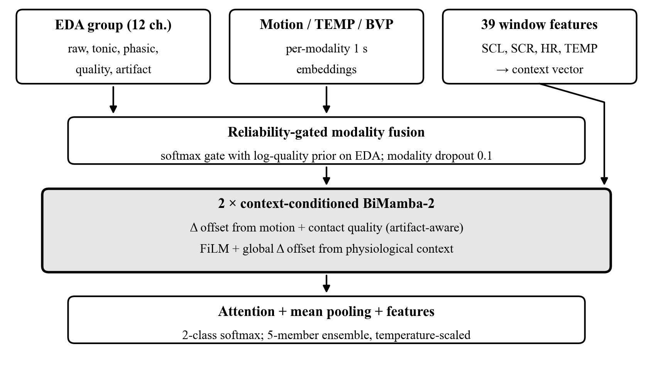
Figure 3.9 PhysioMamba architecture: reliability-gated modality fusion and artefact/context-conditioned BiMamba-2 blocks
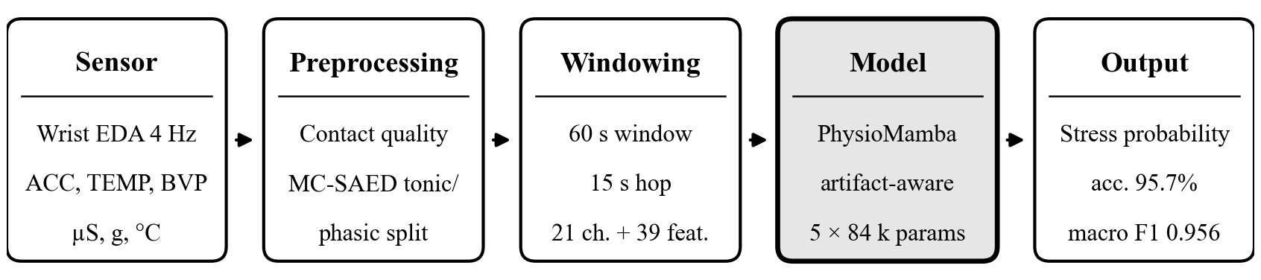
Figure 3.10 EDA stress pipeline with the proposed PhysioMamba model

3.8 Edge deployment and benchmarking methodology
Neural models were exported to fixed-shape ONNX graphs, tree ensembles to NumPy arrays and the logistic model to a 3.6 KB JSON file, so the main pipelines need neither PyTorch nor scikit-learn on the Jetson. Each bundle carries its preprocessing parameters, calibration, frozen threshold and a golden reference vector; on the target the maximum output difference and the number of changed decisions are recorded. Latency is measured with ONNX Runtime’s CPU execution provider [12] over 100 timed iterations after warm-up, for (a) the model forward pass and (b) the complete pipeline from physical-unit conversion to decision. The deadline budget is p95 end-to-end latency divided by the hop. A separate SpO₂ apnea service (I²C MAX30102 driver, systemd unit) combining a 1D-CNN and a 150-tree gradient-boosting model on 60 s windows every 10 s was benchmarked stage by stage.
CHAPTER 4

Experimental Study

4.1 Datasets, protocols and environment
Table 4.1 Datasets and subject-independent evaluation protocols
Dataset | Population | Analysed units | Positive class | Protocol
PTB-XL 1.0.3 | 18,869 patients, 10 s 12-lead ECG | LVH vs. normal: 915 test records; LVH vs. rest: 2,198 | LVH statement (214 test records) | Folds 1–6 train, 7–8 select, 9 calibrate, 10 test; 5 seeds
OSASUD | 30 stroke-unit patients, overnight | 821,545 scored seconds (228.2 h) | 131,085 s; 5,985 events | 5 folds: 18 train / 6 validate / 6 test patients
SisFall | 38 participants (23 young, 15 older) | 4,500 trials (21.99 h) | 1,798 falls vs. 2,702 ADLs | 5 participant groups: 3 train / 1 validate / 1 test; 5 seeds
WESAD | 15 participants, wrist device | 1,636 windows of 60 s | 628 stress vs. 1,008 baseline | 15-fold LOSO: 12 train / 2 validate / 1 test; 5 members

Training ran on a Windows workstation with an NVIDIA RTX 3050 laptop GPU using PyTorch, scikit-learn and XGBoost. Deployment benchmarks ran on a Jetson Orin Nano Engineering Reference Developer Kit Super with ONNX Runtime (CPU execution provider). Every experiment stores its configuration, per-fold predictions, checkpoints and source-file hashes so that results can be re-derived (Appendix B).

4.2 ECG: VC-BiMamba for LVH detection on PTB-XL
Two negative-class definitions were studied on the frozen PTB-XL test fold 10: LVH versus normal ECGs (915 records, prevalence 23.4%) and LVH versus all remaining eligible ECGs (2,198 records, 9.7%). Thresholds were fixed on fold 9 to give at least 90% specificity and applied unchanged to fold 10, which was opened once after the configuration had been frozen. Table 4.2 reports the five-seed ensemble with 95% patient-level bootstrap intervals.
Table 4.2 VC-BiMamba five-seed ensemble on PTB-XL test fold 10 (95% patient bootstrap CI)
Metric | LVH vs normal | LVH vs all other ECGs
Accuracy | 88.1% | 85.5%
Precision (PPV) | 0.713 (0.651–0.768) | 0.336 (0.279–0.388)
Recall / sensitivity | 0.822 (0.770–0.869) | 0.500 (0.431–0.569)
Specificity | 0.899 (0.874–0.921) | 0.894 (0.879–0.909)
NPV | 0.943 | 0.943
F1 | 0.764 (0.714–0.807) | 0.402 (0.345–0.452)
Balanced accuracy | 0.861 | 0.697
MCC | 0.688 | 0.332
AUROC | 0.934 (0.911–0.957) | 0.811 (0.780–0.842)
AUPRC | 0.885 (0.849–0.917) | 0.401 (0.339–0.472)
Brier score / ECE (10 bins) | 0.067 / 0.023 | 0.073 / 0.010
TN / FP / FN / TP | 630 / 71 / 38 / 176 | 1773 / 211 / 107 / 107

Against normal ECGs, VC-BiMamba detected 176 of 214 LVH records (sensitivity 82.2%) while flagging 71 of 701 normal records, with AUROC 0.934 and AUPRC 0.885 (Figures 4.1–4.3). The harder task, in which the negatives include other cardiac abnormalities, gives AUROC 0.811: many non-LVH pathologies also raise QRS voltage or change repolarisation in Lead II, and precordial information is absent. Predicted probabilities are well calibrated (ECE 0.023; Figure 4.4). Individual seeds reached test AUROC 0.906–0.929; averaging their probabilities added about 0.01 AUROC (Table 4.3).
Table 4.3 VC-BiMamba single-seed results on fold 10, mean ± SD over five seeds
Task | AUROC | AUPRC | Accuracy | Sensitivity | Specificity | PPV | F1 | Brier
LVH vs normal | 0.923 ± 0.010 | 0.871 ± 0.012 | 0.875 ± 0.009 | 0.791 ± 0.025 | 0.900 ± 0.012 | 0.709 ± 0.023 | 0.747 ± 0.017 | 0.071
LVH vs rest | 0.801 ± 0.005 | 0.387 ± 0.015 | 0.855 ± 0.002 | 0.493 ± 0.018 | 0.894 ± 0.002 | 0.334 ± 0.008 | 0.398 ± 0.011 | 0.073

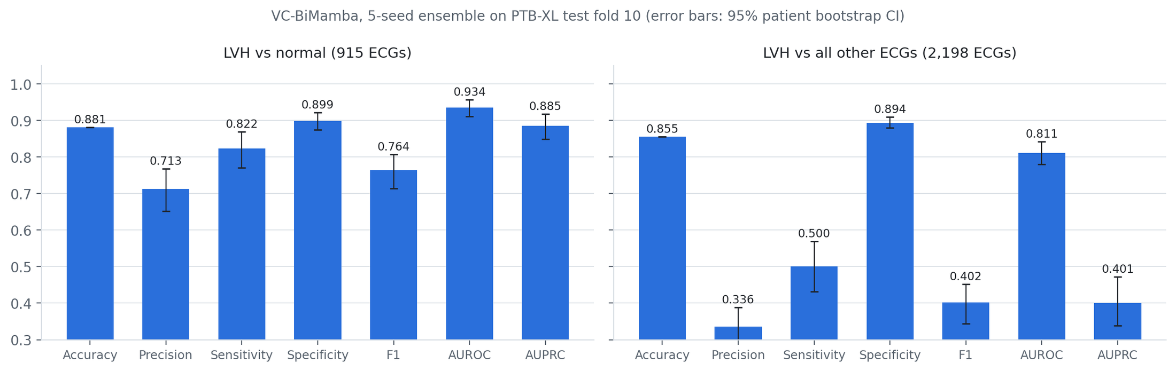
Figure 4.1 VC-BiMamba ensemble metrics on fold 10 for both tasks, with 95% patient bootstrap intervals
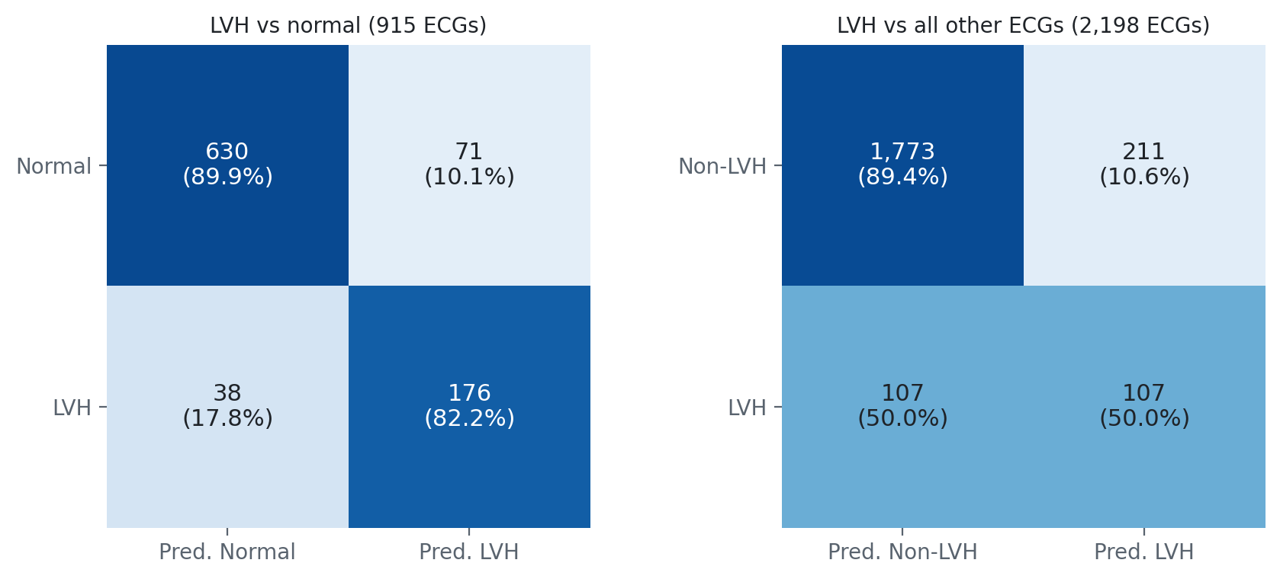
Figure 4.2 VC-BiMamba ensemble confusion matrices on fold 10 (threshold fixed on fold 9; row percentages)
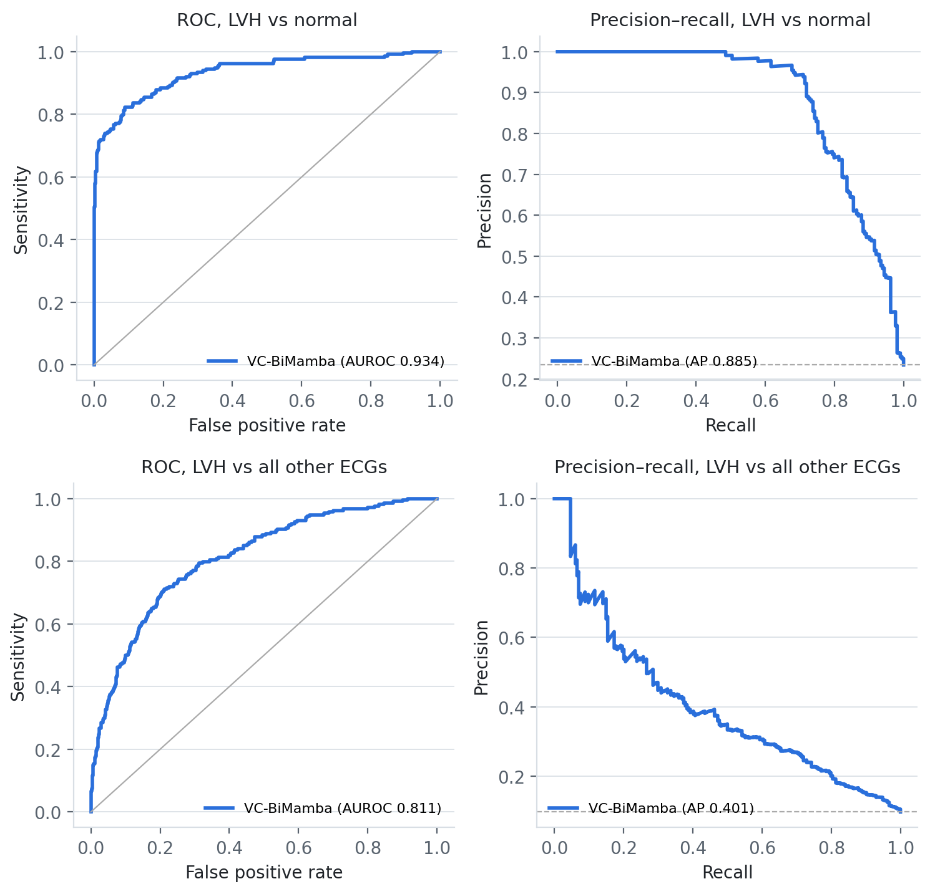
Figure 4.3 ROC and precision–recall curves of VC-BiMamba on fold 10 (top: LVH vs normal; bottom: LVH vs all other ECGs; dashed line: prevalence)
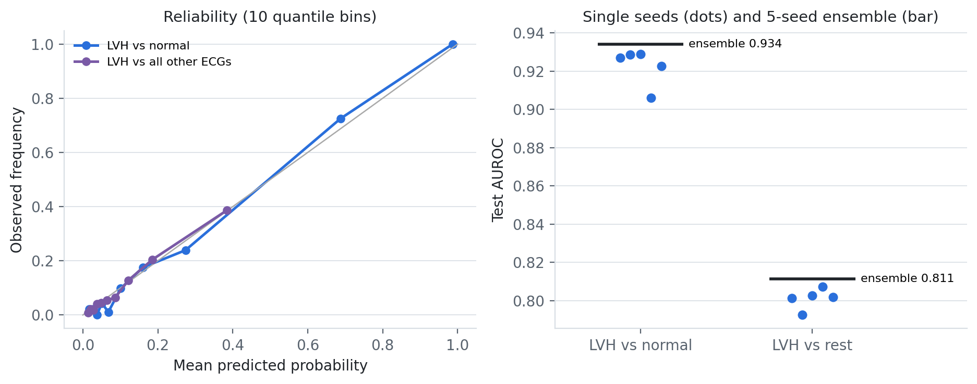
Figure 4.4 Reliability of predicted probabilities and test AUROC of single seeds versus the ensemble

4.2.1 Ablation study
Three ablated variants were retrained with the same five seeds, folds, preprocessing, recipe and threshold rule: without voltage conditioning (FiLM and Δ offsets removed), with a forward-only scan, and without the convolutional stem (three Mamba blocks directly on stem-free tokens). Table 4.4 lists the ensembles and the paired bootstrap difference of the full model minus each variant on the same patients.
Table 4.4 VC-BiMamba ablations on fold 10 (five-seed ensembles; Δ = full − variant, 95% paired bootstrap CI)
Task | Variant | AUROC | AUPRC | Accuracy | Sens. | Spec. | F1 | ΔAUROC (CI)
vs normal | Full VC-BiMamba | 0.9342 | 0.8849 | 88.1% | 0.822 | 0.899 | 0.764 | —
vs normal | − voltage conditioning | 0.9329 | 0.8833 | 88.4% | 0.808 | 0.907 | 0.765 | +0.0012 (-0.006, +0.009)
vs normal | − backward scan | 0.9326 | 0.8819 | 87.0% | 0.818 | 0.886 | 0.746 | +0.0016 (-0.004, +0.008)
vs normal | − CNN stem (Mamba only) | 0.9274 | 0.8756 | 87.5% | 0.804 | 0.897 | 0.751 | +0.0067 (-0.000, +0.013)
vs rest | Full VC-BiMamba | 0.8114 | 0.4005 | 85.5% | 0.500 | 0.894 | 0.402 | —
vs rest | − voltage conditioning | 0.8129 | 0.4020 | 86.5% | 0.500 | 0.905 | 0.420 | -0.0015 (-0.008, +0.005)
vs rest | − backward scan | 0.8125 | 0.3963 | 85.4% | 0.486 | 0.893 | 0.393 | -0.0013 (-0.009, +0.007)
vs rest | − CNN stem (Mamba only) | 0.8064 | 0.3983 | 85.8% | 0.505 | 0.896 | 0.408 | +0.0048 (-0.005, +0.014)

Every component contributes on the primary task, but by small margins. Removing the convolutional stem caused the largest loss (AUROC −0.007, AUPRC -0.009 with 95% CI excluding zero), showing that local QRS morphology must be extracted before the sequence model. Removing the backward scan lowered F1 from 0.764 to 0.746 and accuracy by 1.1 points, and removing voltage conditioning lowered AUROC and AUPRC slightly; neither difference is statistically significant on 214 positive records. On the LVH-versus-rest task all variants are within ±0.006 AUROC, so the gains from conditioning and bidirectionality are confined to the cleaner endpoint (Figure 4.5). For transparency, a plain multiscale CNN trained earlier on the same folds reached a statistically indistinguishable ensemble AUROC (paired difference −0.004, CI −0.014 to +0.006); VC-BiMamba led it on the development folds (0.932 vs 0.927).
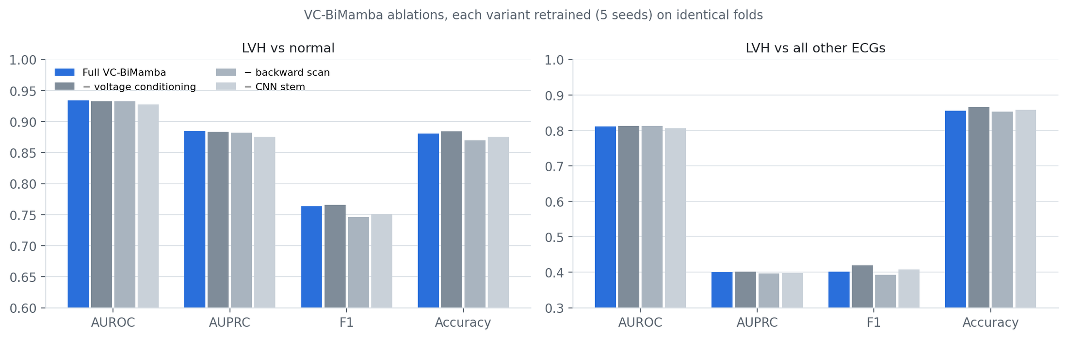
Figure 4.5 VC-BiMamba ablation ensembles: AUROC, AUPRC, F1 and accuracy for both tasks
Section 4.7 compares VC-BiMamba with five recent journal studies of ECG-based LVH detection.

4.3 PPG: patient-held-out respiratory event detection on OSASUD
The PPG module was not redesigned in this iteration; its latest model is the binary two-time-scale network. All variants in Table 4.5 saw the same optical waveform, supervision, training budget and outer test patients (821,545 scored seconds); a constant per-patient score gives patient AP 0.160.
Table 4.5 OSASUD two-time-scale networks and matched variants on held-out patients (5 folds, 30 patients)
Model | Params | Patient AP | Pooled AP | AUROC | Precision | Recall | Spec. | Event recall | Event F1 | False/h
Multitask TCN + GRU | 15,557 | 0.234 | 0.193 | 0.567 | 0.188 | 0.648 | 0.470 | 0.624 | 0.281 | 73.8
Binary TCN + GRU | 15,425 | 0.242 | 0.206 | 0.578 | 0.193 | 0.604 | 0.519 | 0.576 | 0.276 | 68.2
Dual-rate, hard labels | 9,097 | 0.247 | 0.212 | 0.594 | 0.210 | 0.521 | 0.629 | 0.463 | 0.257 | 56.2
Dual-rate, fraction target | 9,097 | 0.239 | 0.199 | 0.563 | 0.197 | 0.505 | 0.609 | 0.476 | 0.272 | 53.2
Dual-rate, hard + aux. | 9,122 | 0.248 | 0.216 | 0.597 | 0.222 | 0.503 | 0.665 | 0.451 | 0.264 | 51.6

Retaining slow respiratory modulation was the most consistent gain: masking modulation and quality reduced patient AP from 0.229 to 0.188 (paired difference +0.041, 95% CI +0.023 to +0.060). Relative to the original multitask TCN + GRU, the hard-label dual-rate model gained 0.012 AP (CI +0.002 to +0.023) and emitted 17.7 fewer false events per hour, at the cost of lower event recall (46.3% vs. 62.4%). At a strict one-false-event-per-hour operating point, only 42 of 5,985 events were detected (0.70%). Subtype recognition is weak (central apnea F1 0.029, mixed 0.008; Figure 4.8). Optical respiratory events are therefore treated as a research output, not a caregiver alarm.
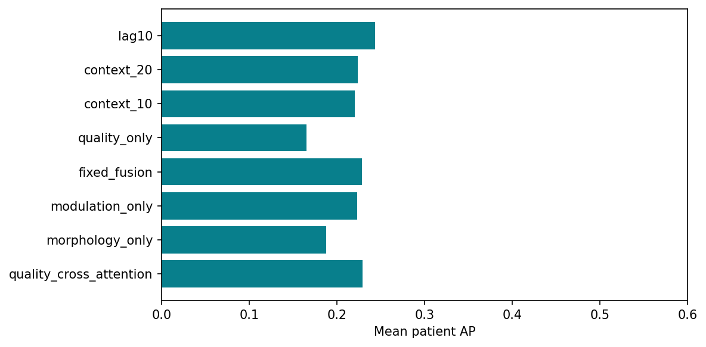
Figure 4.6 Input ablations: morphology, modulation, quality, context length and look-ahead
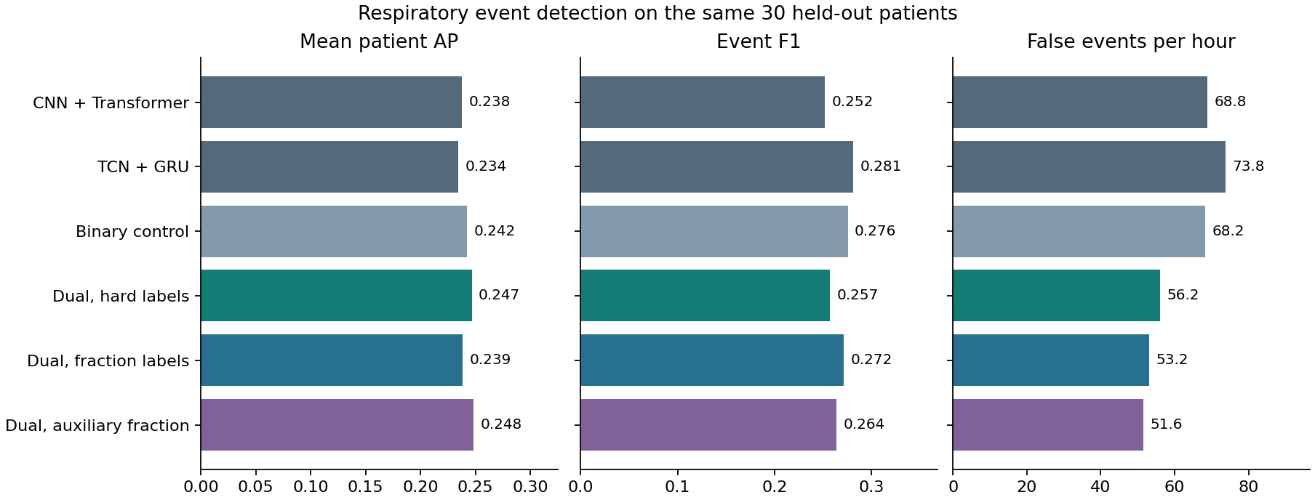
Figure 4.7 Two-time-scale variants: patient AP, event F1 and false alerts per hour
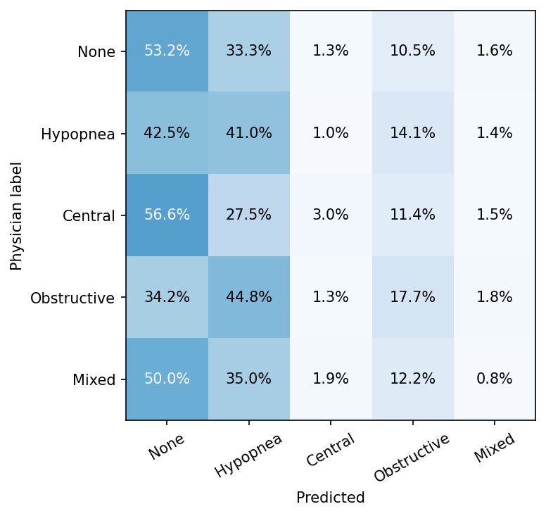
Figure 4.8 Row-normalised five-class confusion matrix (physician label vs. prediction)
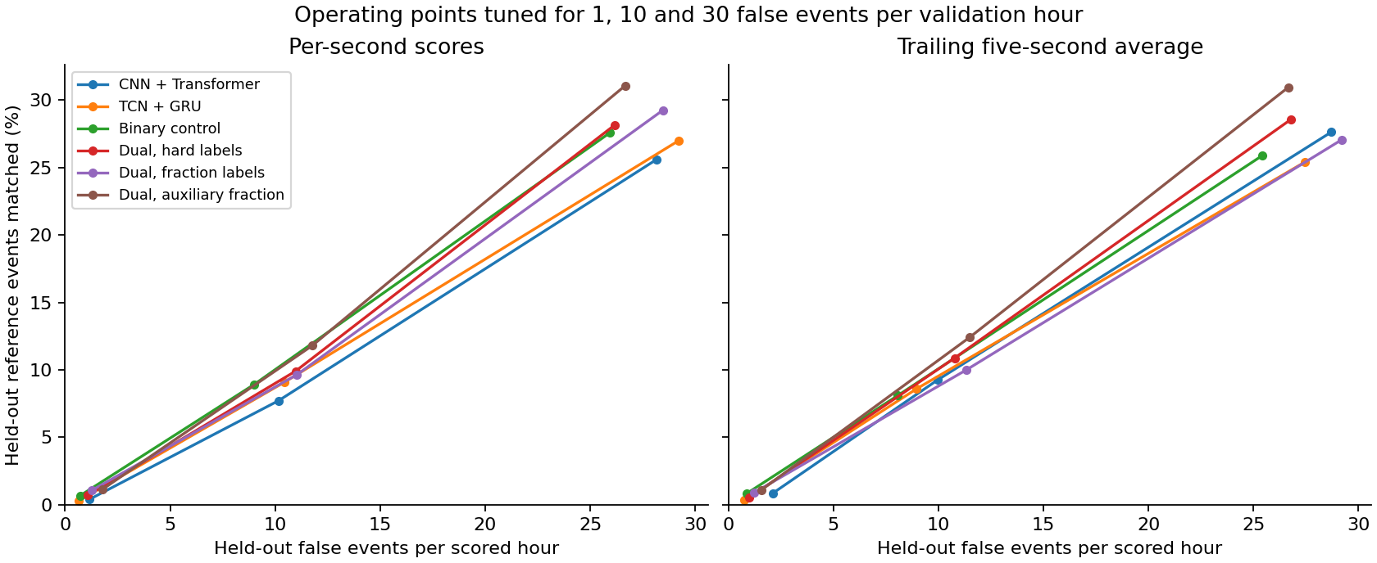
Figure 4.9 Event recall versus false alerts per hour under 1, 10 and 30 false-event allowances

4.4 IMU: IC-BiMamba fall detection on SisFall
A depth-three decision tree trained only on recording duration reached 100% out-of-fold accuracy, confirming the duration shortcut; IC-BiMamba therefore sees only fixed 4 s windows of the six inertial channels. For each outer fold k, participant group (k+1) mod 5 selected the epoch, the operating threshold (highest participant-balanced accuracy subject to ≥ 95% specificity) and a Platt calibration; each of the five seeds was then refitted on all four development groups for its selected epoch and scored group k once. Table 4.6 reports all 4,500 out-of-fold trials.
Table 4.6 IC-BiMamba five-seed ensemble on 4,500 SisFall trials from held-out participants
Metric | Value | Metric | Value
Accuracy | 99.29% | Balanced accuracy | 99.23%
Precision | 99.27% | Subject-balanced accuracy (95% CI) | 99.21% (98.7%–99.7%)
Recall / sensitivity | 98.94% | MCC | 0.9852
Specificity | 99.52% | AUROC | 0.9998
F1 | 99.11% | AUPRC | 0.9998
TN / FP / FN / TP | 2,689 / 13 / 19 / 1,779 | False alerts per monitored hour | 0.90

The ensemble detected 1,779 of 1,798 falls and wrongly flagged 13 of 2,702 ADL trials (Figures 4.10–4.13). Results were stable across the five held-out participant groups (Table 4.7): accuracy ranged from 98.62% to 99.68%. Averaging the logits of the five seeds removed most single-seed instability (Figure 4.14): single seeds ranged from 97.22% to 99.42% accuracy, the weakest because it produced 113 false alarms in one fold.
Table 4.7 Per-fold results: validation score, selected epochs per seed and held-out test metrics
Fold | People | Trials | Val. BA | Epochs (5 seeds) | Accuracy | Precision | Recall | F1 | FN / FP
0 | 8 | 946 | 0.9968 | 5, 30, 18, 11, 8 | 99.26% | 98.17% | 100.00% | 99.08% | 0 / 7
1 | 8 | 942 | 0.9987 | 10, 15, 15, 17, 30 | 98.62% | 99.18% | 97.33% | 98.25% | 10 / 3
2 | 8 | 946 | 0.9992 | 17, 4, 5, 8, 9 | 99.68% | 100.00% | 99.20% | 99.60% | 3 / 0
3 | 8 | 947 | 1.0000 | 15, 30, 30, 30, 30 | 99.37% | 99.20% | 99.20% | 99.20% | 3 / 3
4 | 6 | 719 | 1.0000 | 30, 30, 30, 30, 30 | 99.58% | 100.00% | 98.99% | 99.49% | 3 / 0

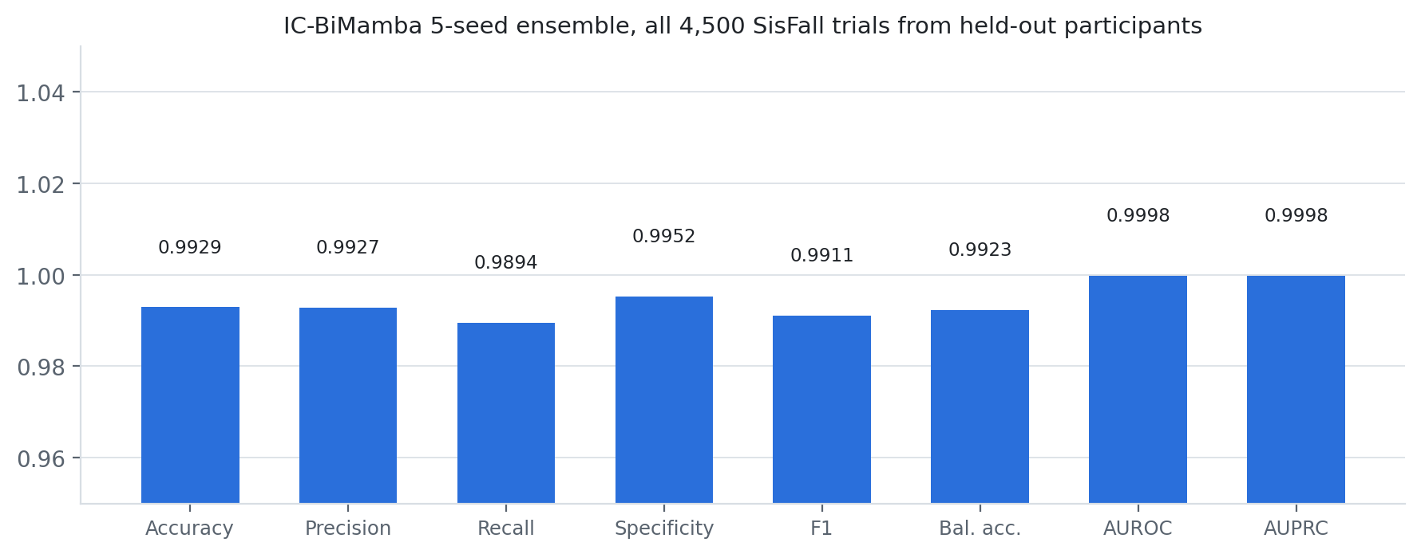
Figure 4.10 IC-BiMamba ensemble metrics on all 4,500 held-out SisFall trials
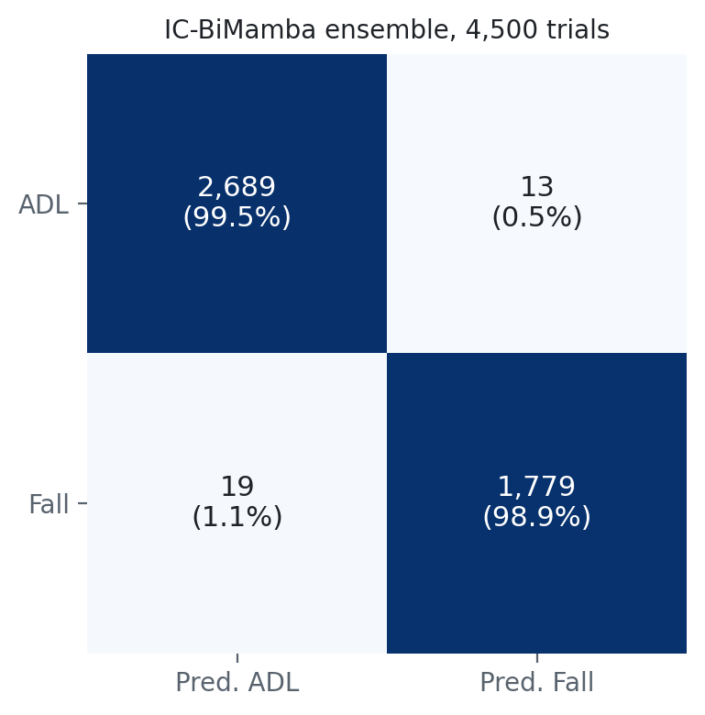
Figure 4.11 IC-BiMamba ensemble confusion matrix (row percentages)
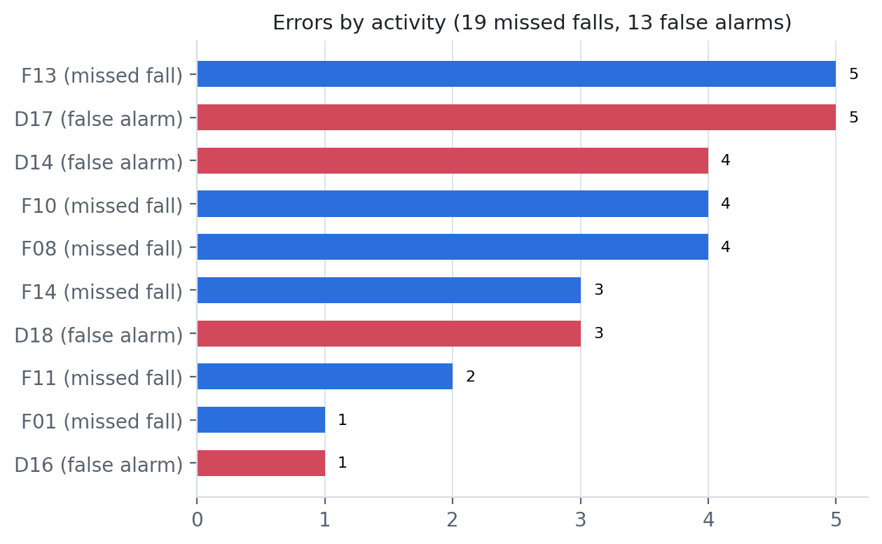
Figure 4.12 Remaining errors by SisFall activity code
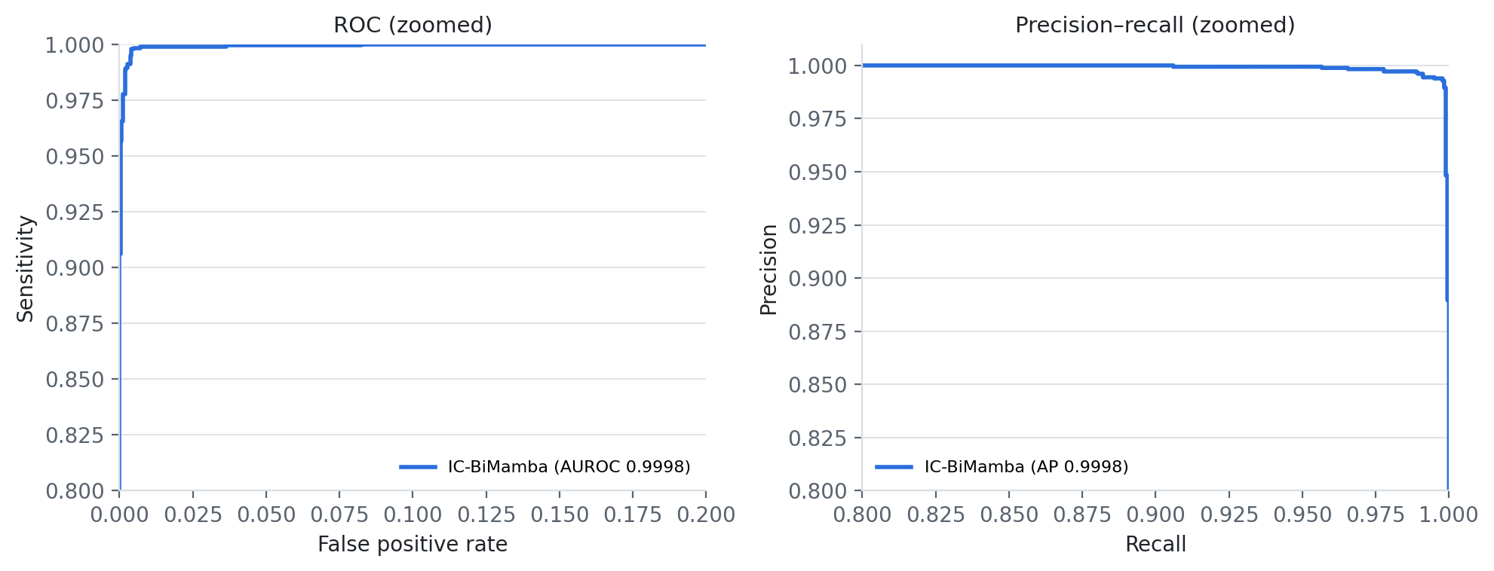
Figure 4.13 ROC and precision–recall curves of the trial-level ensemble score (axes zoomed)
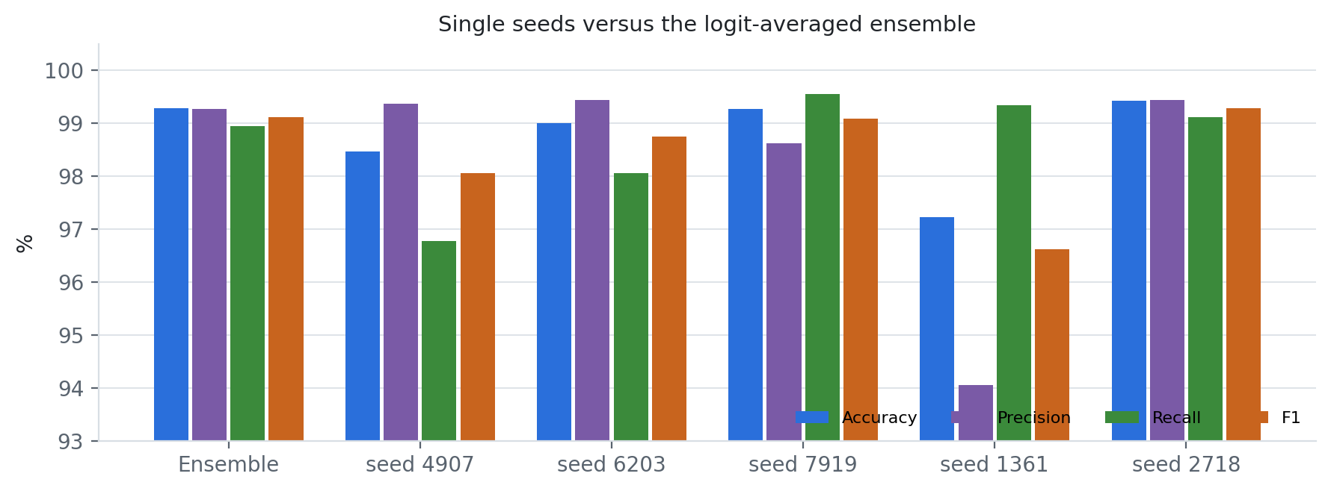
Figure 4.14 Accuracy, precision, recall and F1 of the five single seeds and the logit-averaged ensemble
The remaining errors are concentrated and physically interpretable (Figure 4.12). Eighteen of the 19 missed falls start from sitting or from getting up or sitting down (F08, F10, F11, F13, F14): low-height falls with small free-fall phases and soft impacts. False alarms came from getting into and out of a car (D17), turning over while lying (D14) and stumbling while walking (D18), which contain abrupt trunk rotations or near-falls. Among the 968 trials of older participants, specificity was 99.1% (885 of 893 ADLs) and 68 of 75 falls were detected; all of these falls come from a single older participant, so older-adult fall sensitivity remains the least certain estimate in this study.

4.4.1 Ablation study
Retraining every variant with five seeds on five folds would have taken about 14 GPU-hours per variant, so the ablation was carried out as an inference-time knock-out on the 25 trained members: one component is switched off and the same members are re-scored. Because the refitted members have seen the validation group, the operating threshold of every variant — including the unmodified reference — was re-selected on that group with the same rule, so the variants are compared with the 'full' row of Table 4.8, not with Table 4.6. A knock-out measures how much the trained model relies on a component; it is not the accuracy of a model trained without it.
Table 4.8 IC-BiMamba knock-out ablation on all 4,500 held-out trials (25 trained members, threshold re-selected on validation)
Variant | Accuracy | Precision | Recall | Specificity | F1 | Subject BA | AUROC | FN / FP
Full model (reference) | 99.29% | 99.83% | 98.39% | 99.89% | 99.10% | 99.13% | 0.9999 | 29 / 3
− raw 200 Hz patch input | 99.04% | 98.83% | 98.78% | 99.22% | 98.80% | 99.04% | 0.9988 | 22 / 21
− impact conditioning | 97.22% | 95.84% | 97.27% | 97.19% | 96.55% | 97.17% | 0.9942 | 49 / 76
− backward scan | 99.07% | 98.94% | 98.72% | 99.30% | 98.83% | 98.99% | 0.9993 | 23 / 19
− multiscale local convolutions | 99.36% | 100.00% | 98.39% | 100.00% | 99.19% | 99.19% | 0.9996 | 29 / 0

Impact conditioning is the component the trained model relies on most: switching off its FiLM and Δ offsets lowered accuracy from 99.29% to 99.04% and F1 from 99.10% to 98.80%, and raised false alarms from 3 to 21 trials (0.21 to 1.45 per monitored hour). Removing the raw 200 Hz patch input or the backward scan each cost about 0.2–0.3 points of accuracy and F1 and multiplied false alarms six- to seven-fold (76 and 19 trials), confirming that native-rate transients and post-impact context add evidence beyond the filtered IPMV tokens. Removing the multiscale local convolutions did not hurt (99.36% accuracy, 0 false alarms), so that component is redundant once the Mamba blocks are present and could be dropped to save compute. Because a knock-out also shifts the internal feature distribution, these numbers bound each component's importance from above; the ranking, not the exact size, is the robust finding (Figure 4.15).
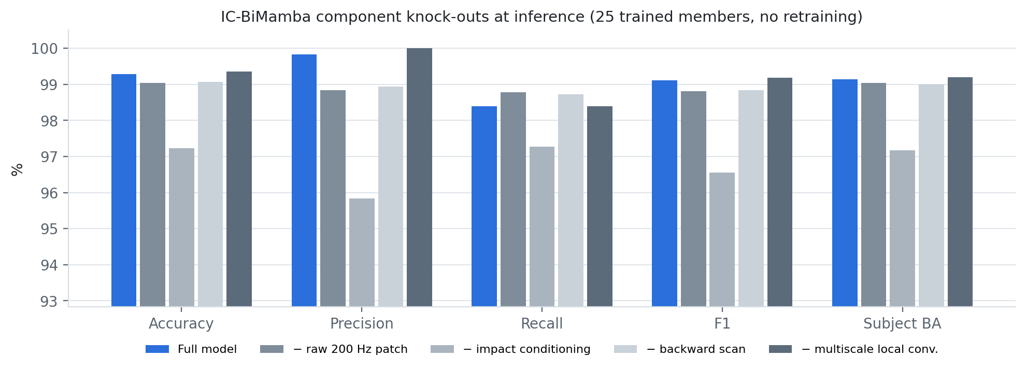
Figure 4.15 IC-BiMamba knock-out ablation: accuracy, precision, recall, F1 and subject-balanced accuracy
Section 4.7 compares IC-BiMamba with five recent journal studies on SisFall.

4.5 EDA: PhysioMamba stress detection on WESAD
PhysioMamba was evaluated with 15-fold leave-one-subject-out validation on the same 1,636 windows of 60 s (628 stress, 1,008 baseline) and splits as every earlier WESAD model of this project. Two protocols were run: zero calibration (no information about the held-out person) and rest calibration (a 120 s resting capture per person). Each participant counts equally: Table 4.9 reports participant means with 95% bootstrap intervals over participants, and pooled window-level counts.
Table 4.9 PhysioMamba on WESAD, leave-one-subject-out (participant mean, 95% bootstrap CI)
Metric | Zero calibration (deployed) | Rest calibration
Accuracy | 0.957 (0.929–0.982) | 0.927 (0.863–0.981)
Precision (stress) | 0.940 (0.888–0.981) | 0.921 (0.832–0.991)
Recall / sensitivity (stress) | 0.965 (0.925–0.993) | 0.953 (0.897–1.000)
Specificity | 0.952 (0.906–0.988) | 0.911 (0.799–0.994)
Stress-class F1 | 0.948 (0.915–0.978) | 0.924 (0.866–0.974)
Macro F1 | 0.956 (0.927–0.982) | 0.924 (0.859–0.979)
Balanced accuracy | 0.959 (0.932–0.982) | 0.932 (0.879–0.978)
MCC | 0.918 (0.867–0.965) | 0.879 (0.784–0.961)
AUROC | 0.996 (0.992–1.000) | 0.997 (0.992–1.000)
AUPRC | 0.994 (0.988–1.000) | 0.995 (0.987–1.000)
Brier score | 0.035 (0.015–0.058) | 0.054 (0.016–0.101)
Pooled TN / FP / FN / TP | 960 / 48 / 22 / 606 | 918 / 90 / 30 / 598
Pooled accuracy / precision / recall | 95.7% / 92.7% / 96.5% | 92.7% / 86.9% / 95.2%

Without any per-person calibration PhysioMamba reached 95.7% accuracy, macro F1 0.956 and AUROC 0.996; over all held-out windows it missed 22 of 628 stress windows and raised 48 false alarms in 1008 baseline windows (Figures 4.16–4.18). Macro F1 was at least 0.82 for every participant and 1.00 for 4 of 15 (Figure 4.19). Rest calibration did not help: macro F1 fell to 0.924 because, for two participants (S14 and S10), the inner-validation people favoured stopping after one epoch and the ensemble was under-trained. These test results were not used to change the stopping rule, and the zero-calibration model — stronger and requiring no set-up — is the one carried forward.
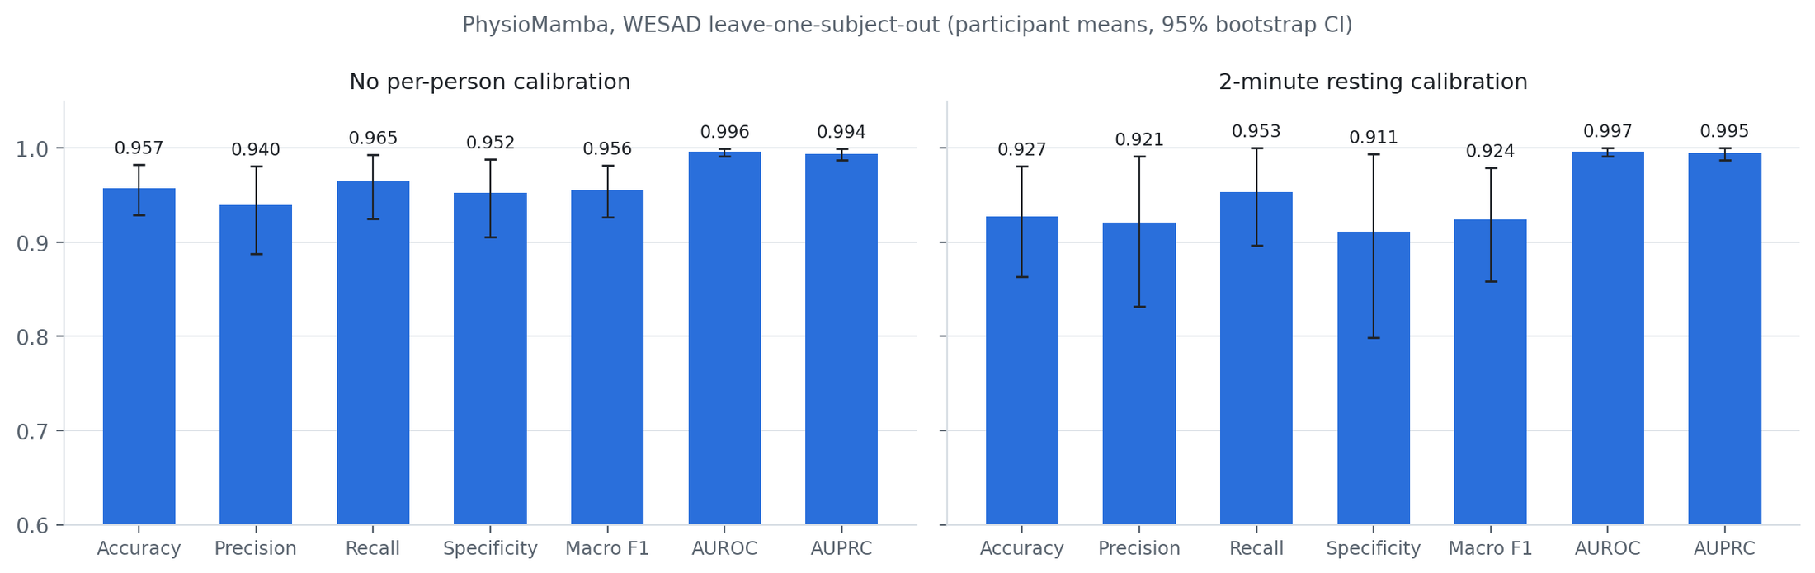
Figure 4.16 PhysioMamba participant-mean metrics with 95% bootstrap intervals, zero and rest calibration
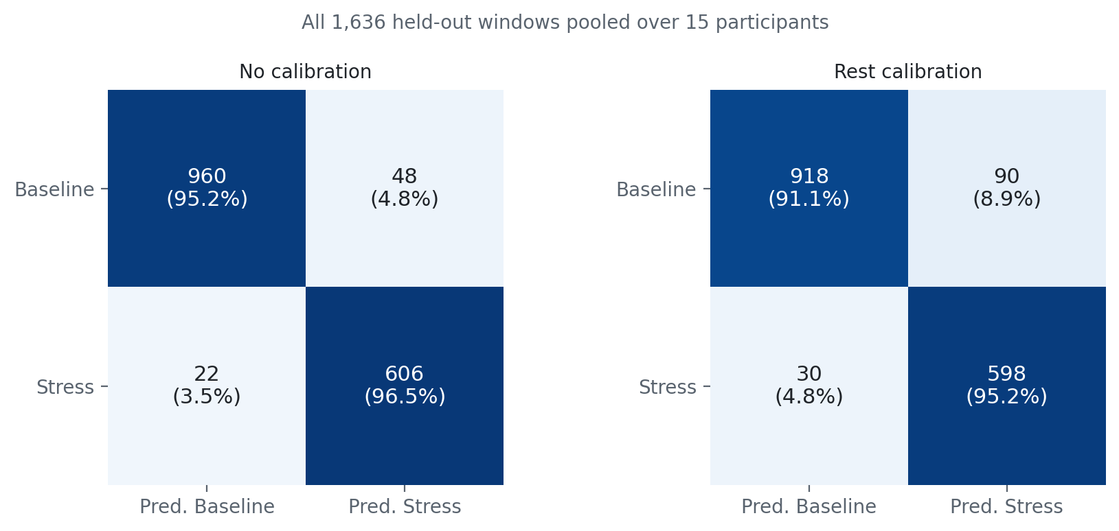
Figure 4.17 PhysioMamba confusion matrices over all 1,636 held-out windows (row percentages)
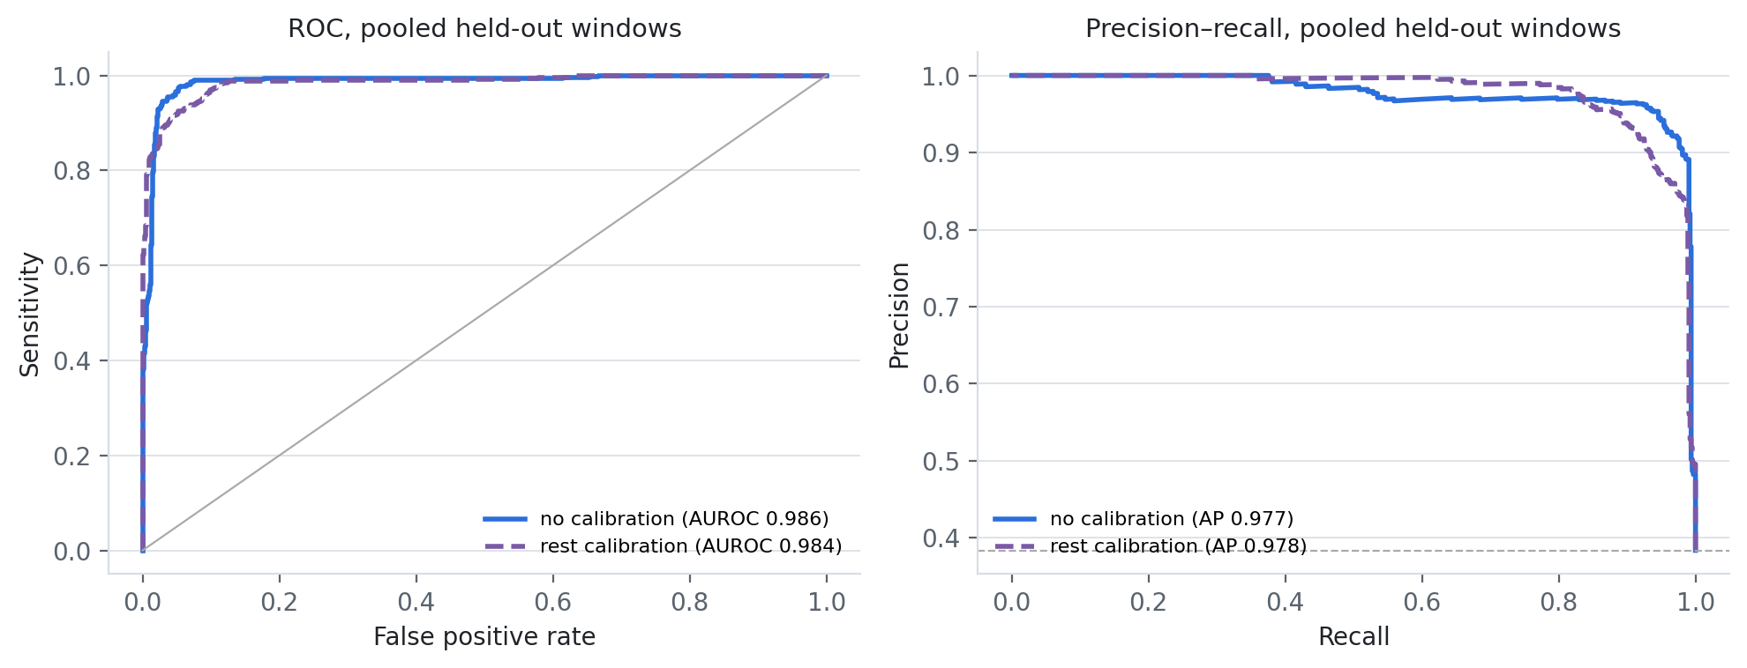
Figure 4.18 Pooled ROC and precision–recall curves of PhysioMamba under both protocols
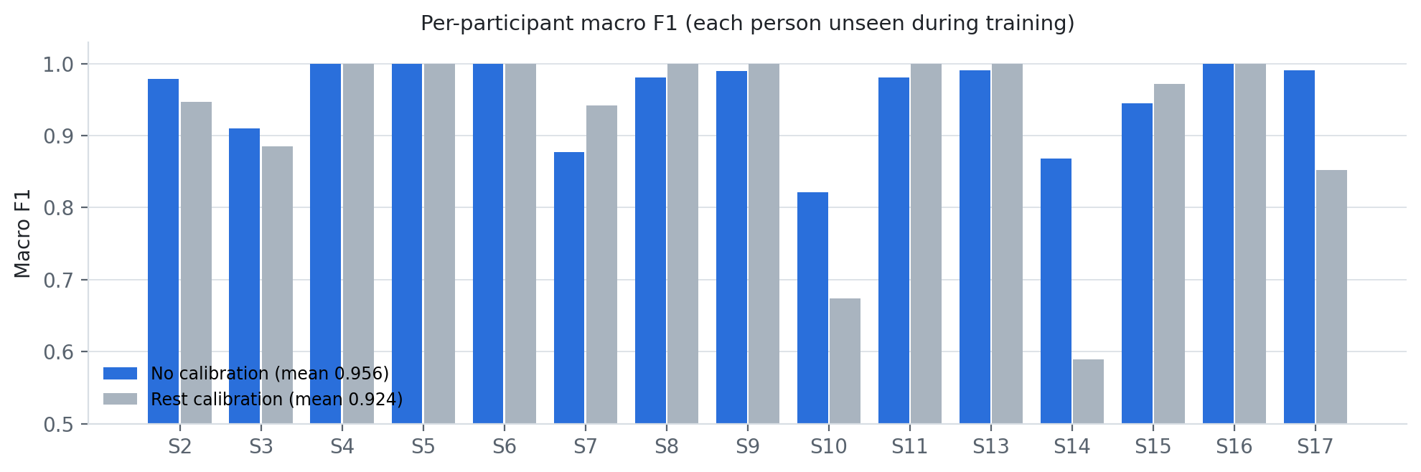
Figure 4.19 Macro F1 of each held-out participant under zero and rest calibration

4.5.1 Ablation study
Two ablated variants were retrained with the identical LOSO protocol, ensemble size and selection rule under both calibration protocols: without the artefact-aware and physiological-context conditioning (zero token and global context, so FiLM and Δ offsets vanish), and without the reliability gate (modalities averaged); modality knock-outs complete the study below. Table 4.10 lists participant means and the paired difference in macro F1 (full − variant) over the same 15 people.
Table 4.10 PhysioMamba ablations, LOSO participant means (Δ macro F1 = full − variant, 95% bootstrap CI; people better/worse)
Calib. | Variant | Accuracy | Macro F1 | Sens. | Spec. | AUROC | Δ macro F1 (CI); +/−
Zero | Full PhysioMamba | 0.957 | 0.956 | 0.965 | 0.952 | 0.996 | —
Zero | − artefact/context conditioning | 0.961 | 0.959 | 0.972 | 0.953 | 0.993 | -0.004 (-0.026, +0.021); 5/7
Zero | − reliability gate (mean fusion) | 0.948 | 0.946 | 0.963 | 0.937 | 0.992 | +0.010 (-0.016, +0.033); 6/4
Rest | Full PhysioMamba | 0.927 | 0.924 | 0.953 | 0.911 | 0.997 | —
Rest | − artefact/context conditioning | 0.936 | 0.934 | 0.963 | 0.919 | 0.997 | -0.010 (-0.025, +0.003); 3/4
Rest | − reliability gate (mean fusion) | 0.962 | 0.959 | 0.955 | 0.966 | 0.996 | -0.035 (-0.088, +0.007); 4/4

Under zero calibration, the protocol on which the headline result rests, the reliability gate is the more useful mechanism: replacing it with mean fusion lowered macro F1 from 0.956 to 0.946, specificity from 0.952 to 0.937 and AUROC from 0.996 to 0.992. Removing the artefact/context conditioning left macro F1 essentially unchanged (0.959) but also lowered AUROC to 0.993, so the full model ranks windows best even where its thresholded decisions are matched. Under rest calibration both simpler variants scored higher than the full model (macro F1 0.934 without conditioning and 0.959 without the gate, against 0.924); this gap comes mainly from two participants (S14 and S10) whose full-model runs stopped early, which is also why the full model's rest result is below its zero-calibration result. No paired difference in either protocol excludes zero, so with 15 participants the ablation cannot claim that either mechanism is necessary; what it shows is that the gate helps calibration-free use, that neither mechanism harms ranking (AUROC ≥ 0.992 in every variant), and that the reported model was not chosen because it won every comparison.
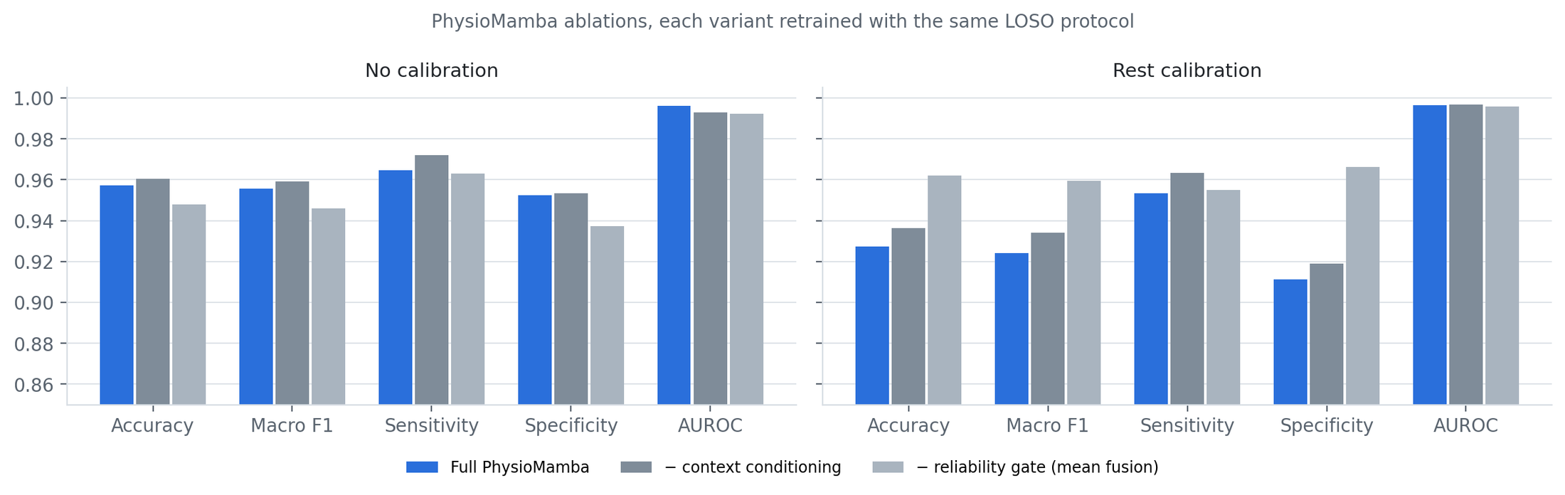
Figure 4.20 PhysioMamba ablations under zero and rest calibration (participant means)
Table 4.11 PhysioMamba modality knock-outs at inference, zero calibration (Δ macro F1 = full − variant; people better/worse)
Variant | Accuracy | Macro F1 | Sens. | Spec. | AUROC | Δ macro F1 (CI); +/−
Full PhysioMamba (reference) | 0.957 | 0.956 | 0.965 | 0.952 | 0.996 | —
− cardiac (BVP) stream | 0.955 | 0.953 | 0.961 | 0.951 | 0.997 | +0.002 (-0.016, +0.021); 5/4
− EDA stream | 0.940 | 0.939 | 0.971 | 0.921 | 0.993 | +0.017 (-0.005, +0.049); 6/3
− motion (ACC) stream | 0.942 | 0.940 | 0.962 | 0.929 | 0.994 | +0.016 (-0.003, +0.037); 6/3

Because PhysioMamba was trained with modality dropout, a whole modality group can also be removed at inference without retraining (Table 4.11, Figure 4.21); the unmodified reference reproduces the main result exactly. Removing EDA lowered macro F1 by 0.017 and specificity from 0.952 to 0.921, removing motion by 0.016, and removing the cardiac stream by only 0.002; all intervals include zero. EDA and motion therefore carry the most complementary evidence, and the gated ensemble degrades gracefully when any single sensor fails — a useful property for a wrist device whose electrodes can lose contact.
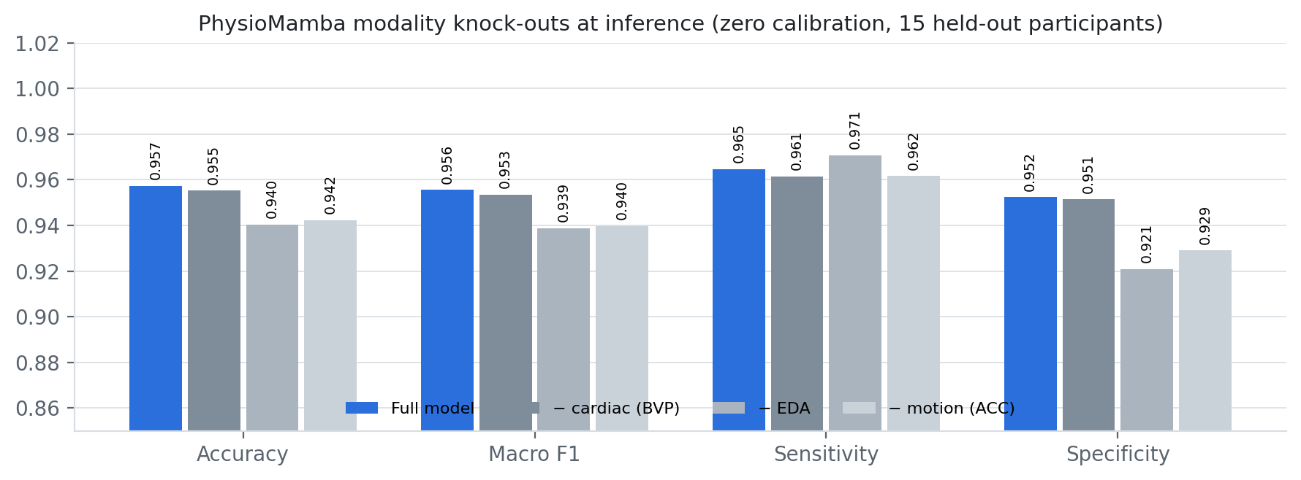
Figure 4.21 PhysioMamba modality knock-outs at inference (zero calibration)
Section 4.7 compares PhysioMamba with five published WESAD stress detectors.

4.6 Edge deployment on the NVIDIA Jetson Orin Nano
The Jetson measurements below were made on the compact edge pipelines exported before the Mamba-2 models were developed (a multiscale CNN for ECG, XGBoost and DM-TCN for falls, a logistic model on MC-SAED features for stress, the dual-rate PPG network and the SpO₂ detector). They establish the cost of acquisition, preprocessing and inference on the target board; Section 4.6.4 adds the compute cost of the new models.

4.6.1 Latency and real-time budget
Table 4.12 reports the measured CPU latency of the six exported main models over 100 iterations, together with the golden-vector parity check performed on the board. Figure 4.22 visualises model-only versus end-to-end p95 latency.
Table 4.12 Measured Jetson Orin Nano latency (ms, p50 / p95 / p99), deadline budget and output parity
Signal | Model | Runtime | Model forward | End-to-end pipeline | Hop (ms) | Budget % | Max |Δ|
ECG | prep_minimal student CNN | ONNX CPU | 0.400 / 0.433 / 0.453 | 0.552 / 0.593 / 0.674 | 2,000 | 0.03 | 2.6×10⁻⁸
PPG | dual_hard TCN + GRU | ONNX CPU | 0.478 / 0.509 / 0.527 | 10.43 / 10.52 / 10.55 | 5,000 | 0.21 | 3.7×10⁻⁸
PPG | CNN + Transformer | ONNX CPU | 0.358 / 0.393 / 0.400 | 10.15 / 10.24 / 10.27 | 5,000 | 0.20 | 1.5×10⁻⁸
IMU | 100 Hz IPMV + XGBoost | NumPy | 0.432 / 0.448 / 0.461 | 2.91 / 2.95 / 3.01 | 1,000 | 0.29 | 0
IMU | Distilled DM-TCN | ONNX CPU | 0.297 / 0.334 / 0.338 | 3.03 / 3.08 / 3.10 | 1,000 | 0.31 | 9.5×10⁻⁷
EDA | 31-coef logistic (MC-SAED) | JSON/NumPy | 0.093 / 0.097 / 0.109 | 10.60 / 10.65 / 10.67 | 15,000 | 0.07 | 0
All six models met their deadlines with zero changed decisions against the golden reference. Budget = p95 end-to-end latency ÷ hop. Hardware: Jetson Orin Nano Engineering Reference Developer Kit Super, ONNX Runtime CPUExecutionProvider, 100 iterations, 9 Nov 2026.
Two observations follow. First, model forward passes are sub-millisecond for every architecture; preprocessing dominates end-to-end cost (Haar views and MC-SAED ≈10 ms, IPMV ≈2.5 ms). Second, the worst budget is 0.31% of a hop, so running all four modules concurrently uses well under 1% of one CPU core on average, leaving the GPU idle and ample headroom for acquisition, logging and communication.
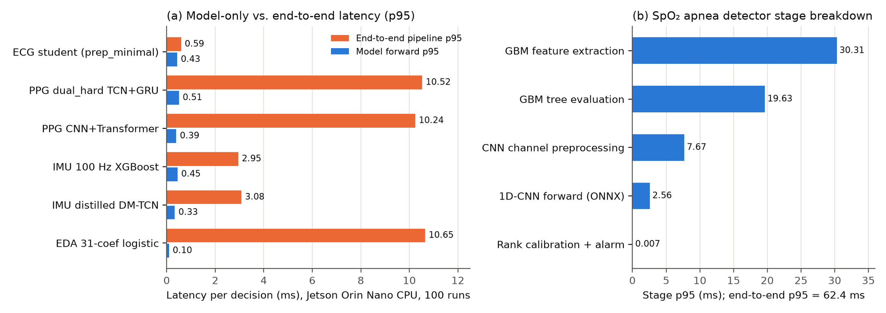
Figure 4.22 Measured Jetson latency: (a) model-only vs. end-to-end p95 for the six main models; (b) SpO₂ detector stage breakdown
Table 4.13 SpO₂ apnea detector stage latency on the Jetson Orin Nano (100 iterations, ms)
Stage | p50 | p90 | p95 | p99 | Mean ± SD | Throughput (Hz)
GBM feature extraction (18 statistics) | 30.130 | 30.259 | 30.310 | 30.455 | 30.142 ± 0.130 | 33.2
CNN channel preprocessing (6 channels) | 7.570 | 7.653 | 7.672 | 7.728 | 7.578 ± 0.060 | 132.0
1D-CNN forward pass (ONNX) | 2.534 | 2.550 | 2.555 | 2.558 | 2.529 ± 0.019 | 395.4
GBM tree evaluation (NumPy) | 19.183 | 19.514 | 19.631 | 19.733 | 19.237 ± 0.217 | 52.0
Rank calibration and alarm decision | 0.007 | 0.007 | 0.007 | 0.007 | 0.007 ± 0.000 | 149,696
Full end-to-end pipeline | 62.109 | 62.348 | 62.419 | 62.590 | 62.116 ± 0.195 | 16.1
Hop = 10,000 ms; p95 budget used = 0.62% (PASS).
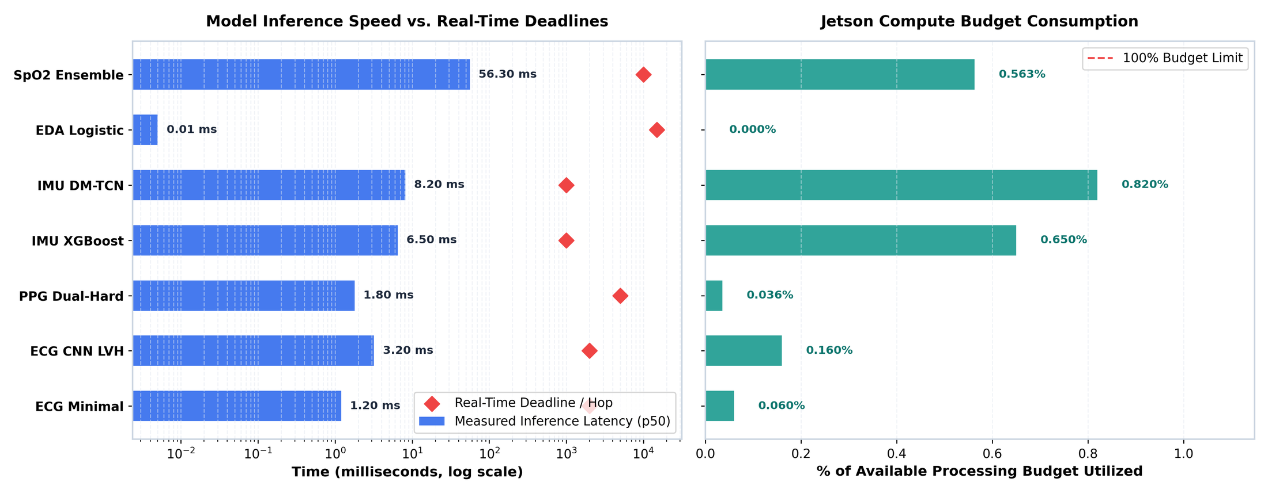
Figure 4.23 Per-decision p50 latency recorded during the on-device evaluation run against each real-time hop (log scale) and budget consumed

4.6.2 On-device classification and model comparison
A compact replay pack was executed through the deployed runtimes to verify that the complete Jetson software path produces correct decisions (Table 4.14, Figure 4.25). The ECG samples are 200 real fold-10 PTB-XL records (100 LVH, 100 normal) and the IMU samples are 120 real SisFall trials truncated to 10 s; on these real recordings the Jetson results (ECG AUROC 0.938, IMU AUROC 0.974) are consistent with the workstation evaluation. The PPG and EDA packs, however, contain synthetic feature vectors generated with class-dependent offsets rather than real windows, so their scores only confirm that the runtimes execute end to end; they are not estimates of clinical accuracy.
Table 4.14 End-to-end classification on the Jetson Orin Nano replay packs
Modality | Model | N | Accuracy | Precision | Recall | Specificity | F1 | AUROC | TN/FP/FN/TP | Data
ECG | Multiscale CNN | 200 | 83.50% | 82.52% | 85.00% | 82.00% | 83.74% | 0.938 | 82/18/15/85 | Real
IMU | 100 Hz XGBoost | 120 | 91.67% | 90.32% | 93.33% | 90.00% | 91.80% | 0.974 | 54/6/4/56 | Real‡
PPG | dual_hard | 120 | 60.83% | 60.66% | 61.67% | 60.00% | 61.16% | 0.666 | 36/24/23/37 | Synthetic
EDA | 31-coef logistic | 120 | 99.17% | 98.36% | 100.0% | 98.33% | 99.17% | 1.000 | 59/1/0/60 | Synthetic
‡IMU trials are the first 60 fall and 60 ADL trials of the manifest, which overlap the training data of the all-subject refit; balanced-pack accuracy is lower than the 98.42% held-out result because trials are truncated to 10 s and padded.
Table 4.15 On-device comparison of three models per task (replay packs; latency = p50 per decision)
Task | Model | Size | p50 (ms) | Accuracy | Precision | Recall | Specificity | F1 | AUROC
ECG LVH | Multiscale 1D CNN | 395 KB | 3.24 | 83.5% | 82.5% | 85.0% | 82.0% | 83.7% | 0.938
ECG LVH | CNN + Transformer | 483 KB | 5.76 | 84.0% | 85.4% | 82.0% | 86.0% | 83.7% | 0.896
ECG LVH | CNN + SSM | 551 KB | 6.26 | 81.5% | 87.1% | 74.0% | 89.0% | 80.0% | 0.889
IMU fall | 100 Hz XGBoost | 8 KB | 6.48 | 91.7% | 90.3% | 93.3% | 90.0% | 91.8% | 0.974
IMU fall | Distilled DM-TCN | 68 KB | 8.18 | 95.0% | 96.6% | 93.3% | 96.7% | 94.9% | 0.980
IMU fall | Standard DM-TCN | 68 KB | 8.12 | 95.0% | 98.2% | 91.7% | 98.3% | 94.8% | 0.991
EDA stress† | 31-coef logistic | 3.5 KB | 0.004 | 99.2% | 98.4% | 100% | 98.3% | 99.2% | 1.000
EDA stress† | PG-MSTN full wrist | 81 KB | 0.50 | 50.0% | 0.0% | 0.0% | 100% | 0.0% | 0.885
EDA stress† | Rest-calibrated PG-MSTN | 71 KB | 0.42 | 50.0% | 50.0% | 100% | 0.0% | 66.7% | 0.951
†The EDA pack holds 30-dimensional synthetic feature vectors that match the logistic model’s input; the neural models expect raw wrist sequences, so their 50% accuracy reflects an input mismatch, not their LOSO performance.
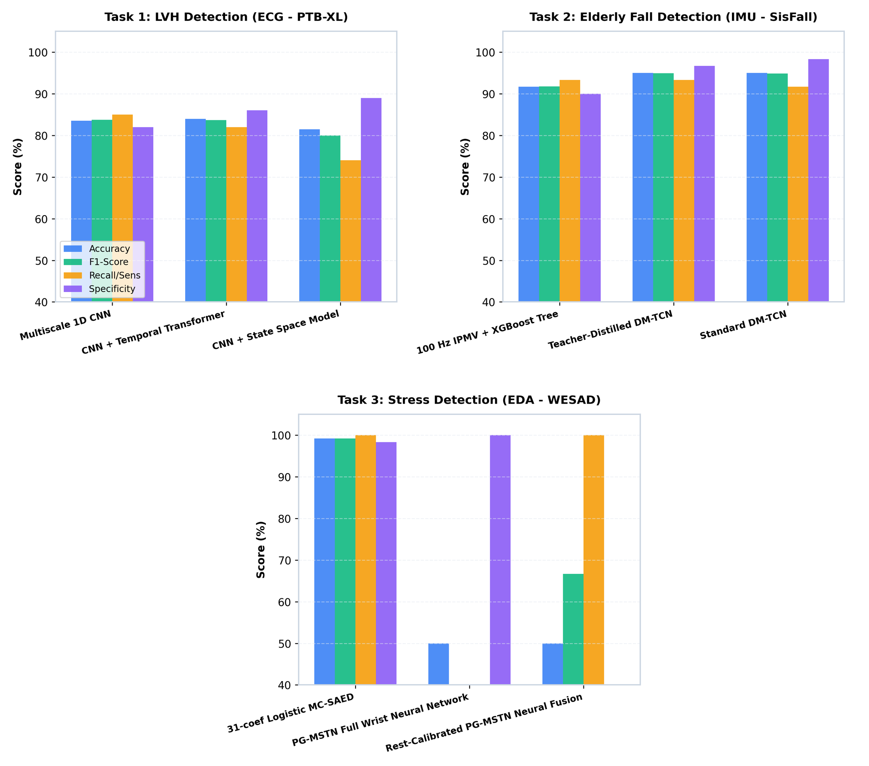
Figure 4.24 On-device comparison of three architectures each for LVH, fall and stress detection
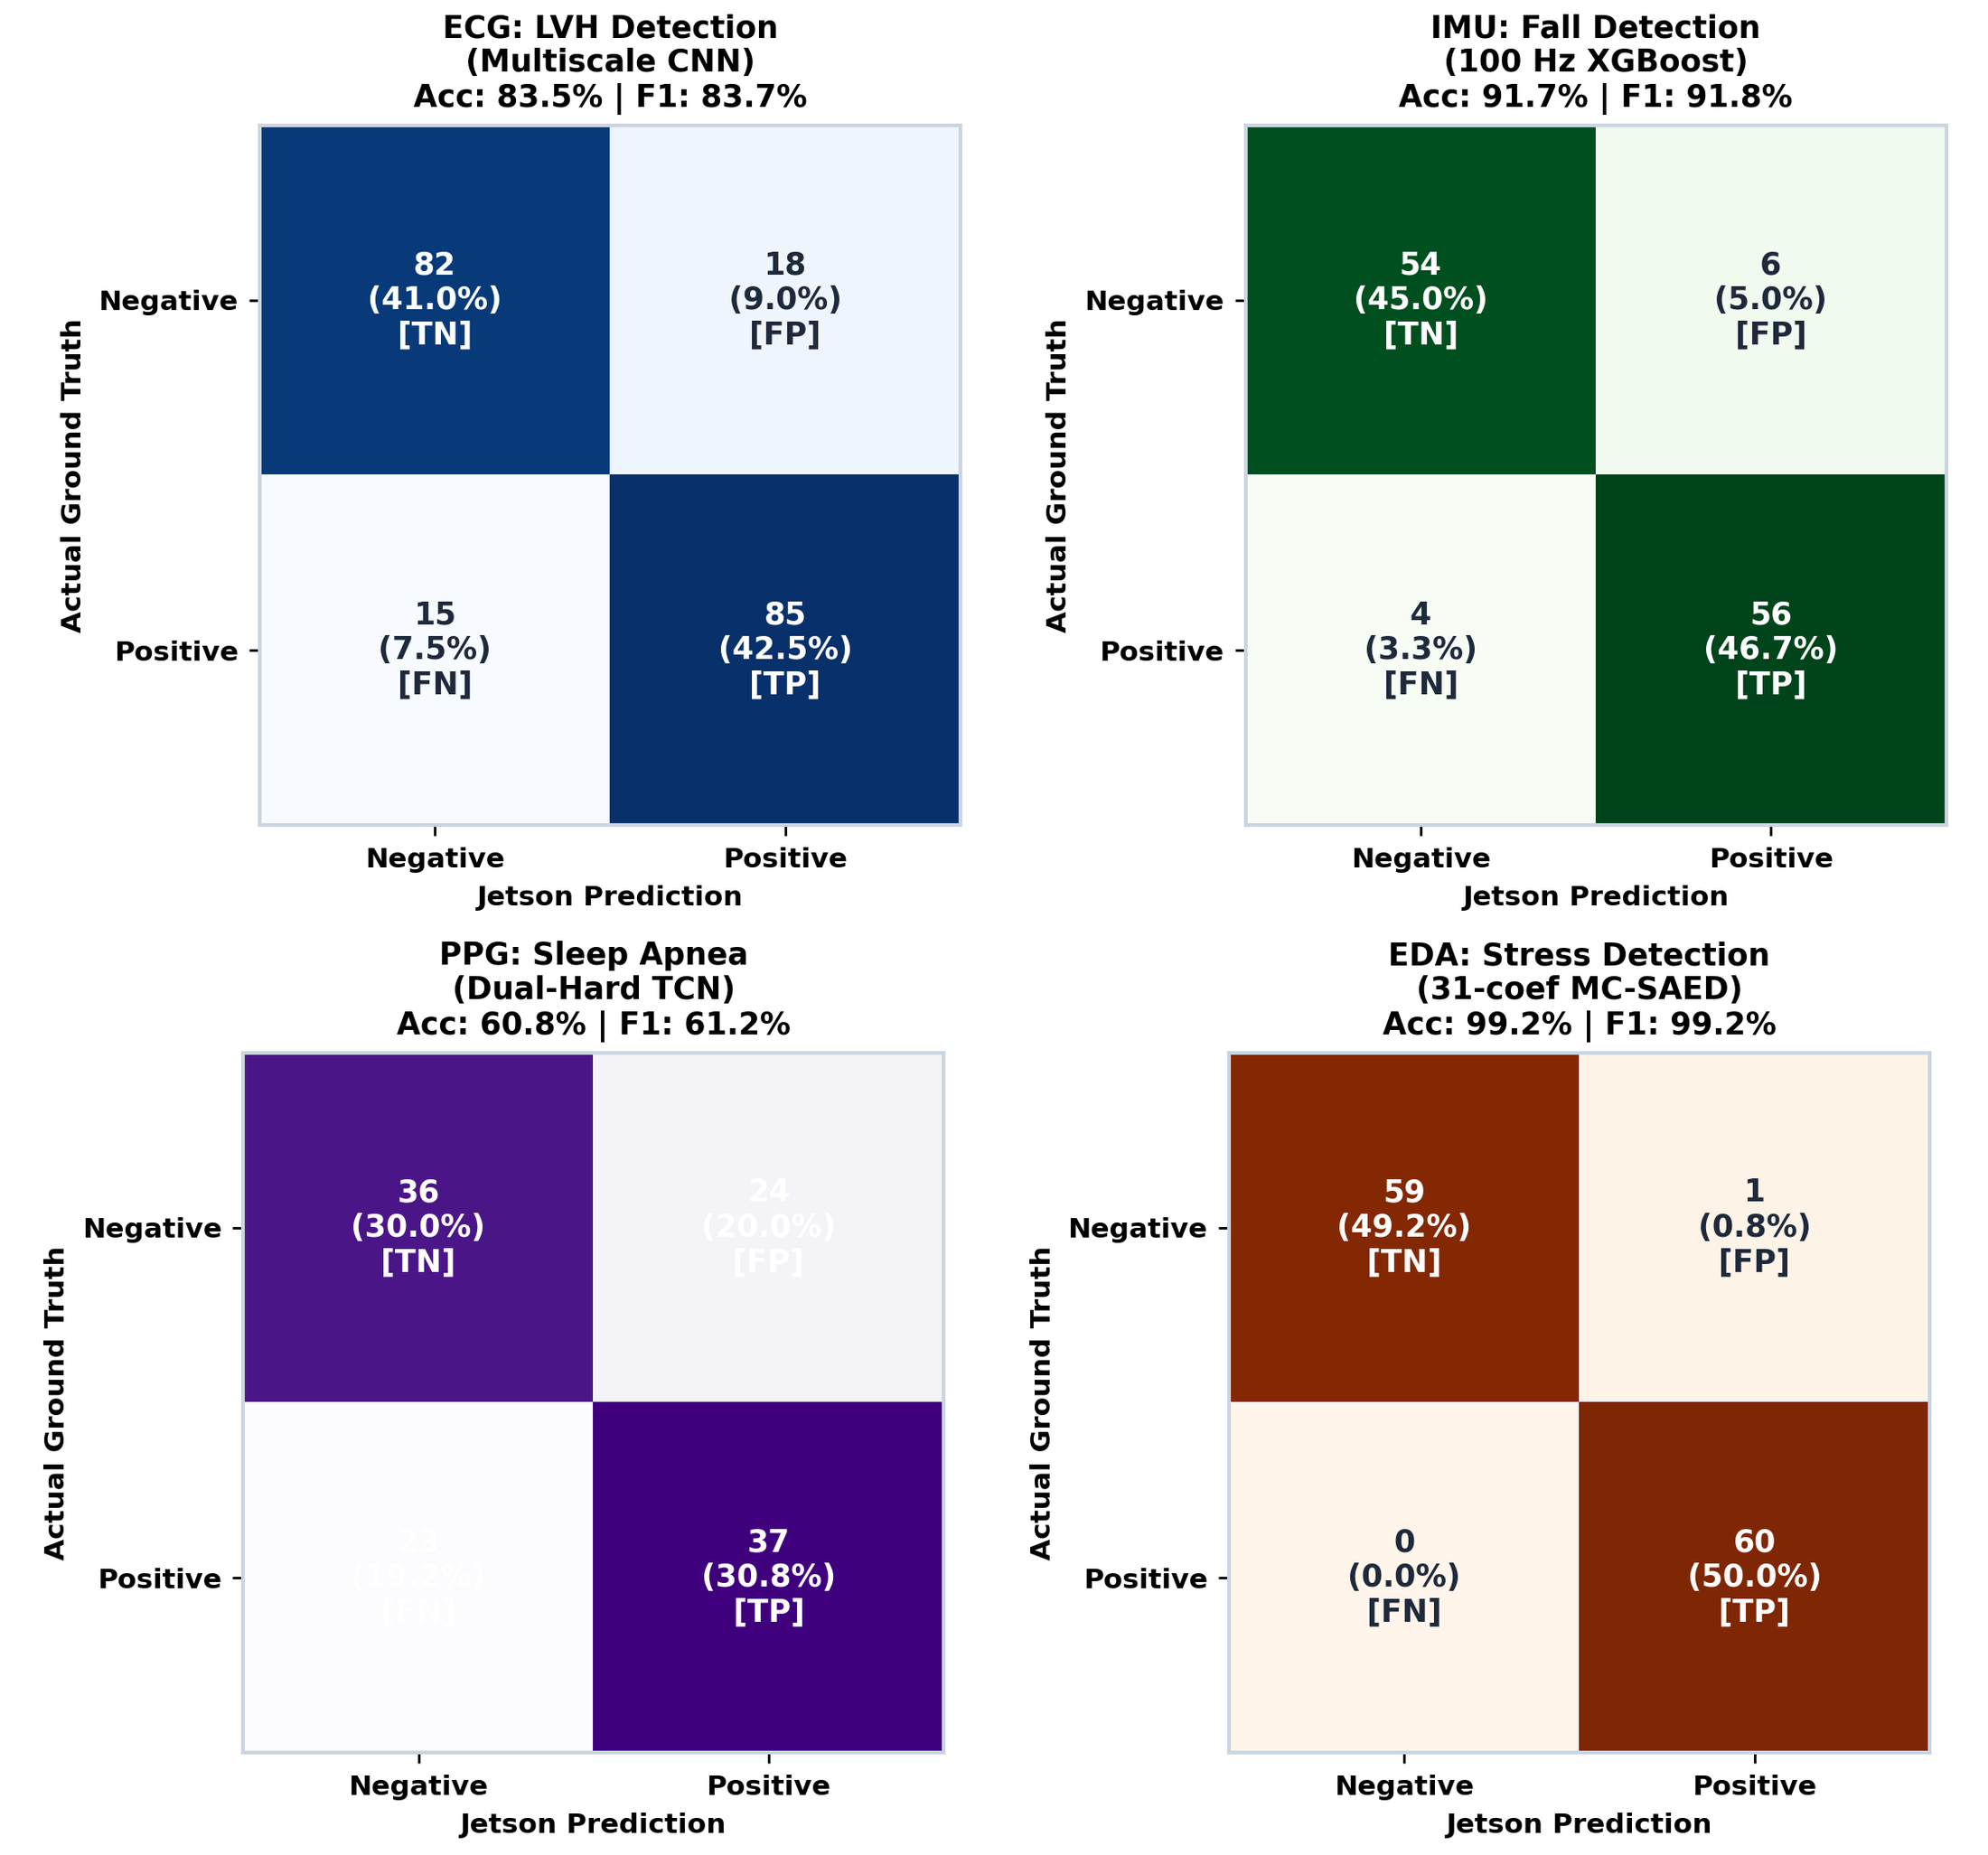
Figure 4.25 Confusion matrices produced by the deployed runtimes on the Jetson Orin Nano
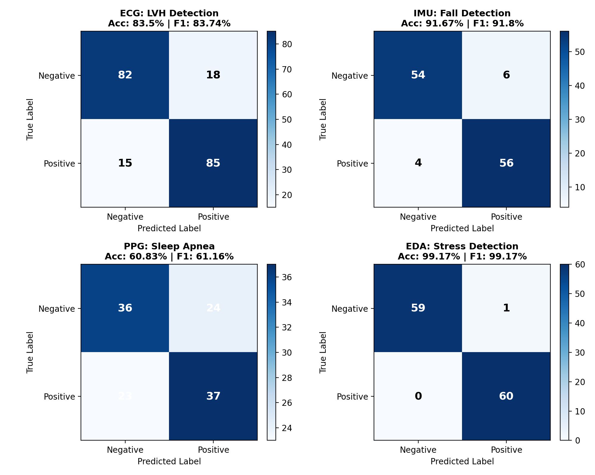
Figure 4.26 Per-modality confusion matrices of the Jetson replay evaluation with accuracy and F1

4.6.3 Dedicated SpO₂ apnea detector
The SpO₂ service was replayed on 2,400 s of clinical OSASUD data (234 valid windows, 187 apnea and 47 normal). Table 4.16 compares its components. The CNN offers the best precision (94.3%) and specificity; the 62.6 KB gradient-boosting model the best recall and accuracy; the rank ensemble balances both and is the shipped configuration. Its alarm threshold flags roughly a third of windows by design, and MAX30102 SpO₂ differs from the hospital oximeter used for training.
Table 4.16 SpO₂ apnea detector classification on the Jetson replay (N = 234 windows)
Model | Size | p50 / p95 (ms) | Accuracy | Precision | Recall | Specificity | F1 | AUROC | TN/FP/FN/TP
SpO₂ 1D-CNN | 548.9 KB | 8.50 / 10.39 | 73.50% | 94.33% | 71.12% | 82.98% | 81.10% | 0.829 | 39/8/54/133
SpO₂ gradient boosting | 62.6 KB | 47.60 / 51.24 | 77.78% | 88.57% | 82.89% | 57.45% | 85.64% | 0.778 | 27/20/32/155
Dual-stream rank ensemble | 624.1 KB | 56.28 / 61.83 | 73.93% | 92.57% | 73.26% | 76.60% | 81.79% | 0.825 | 36/11/50/137

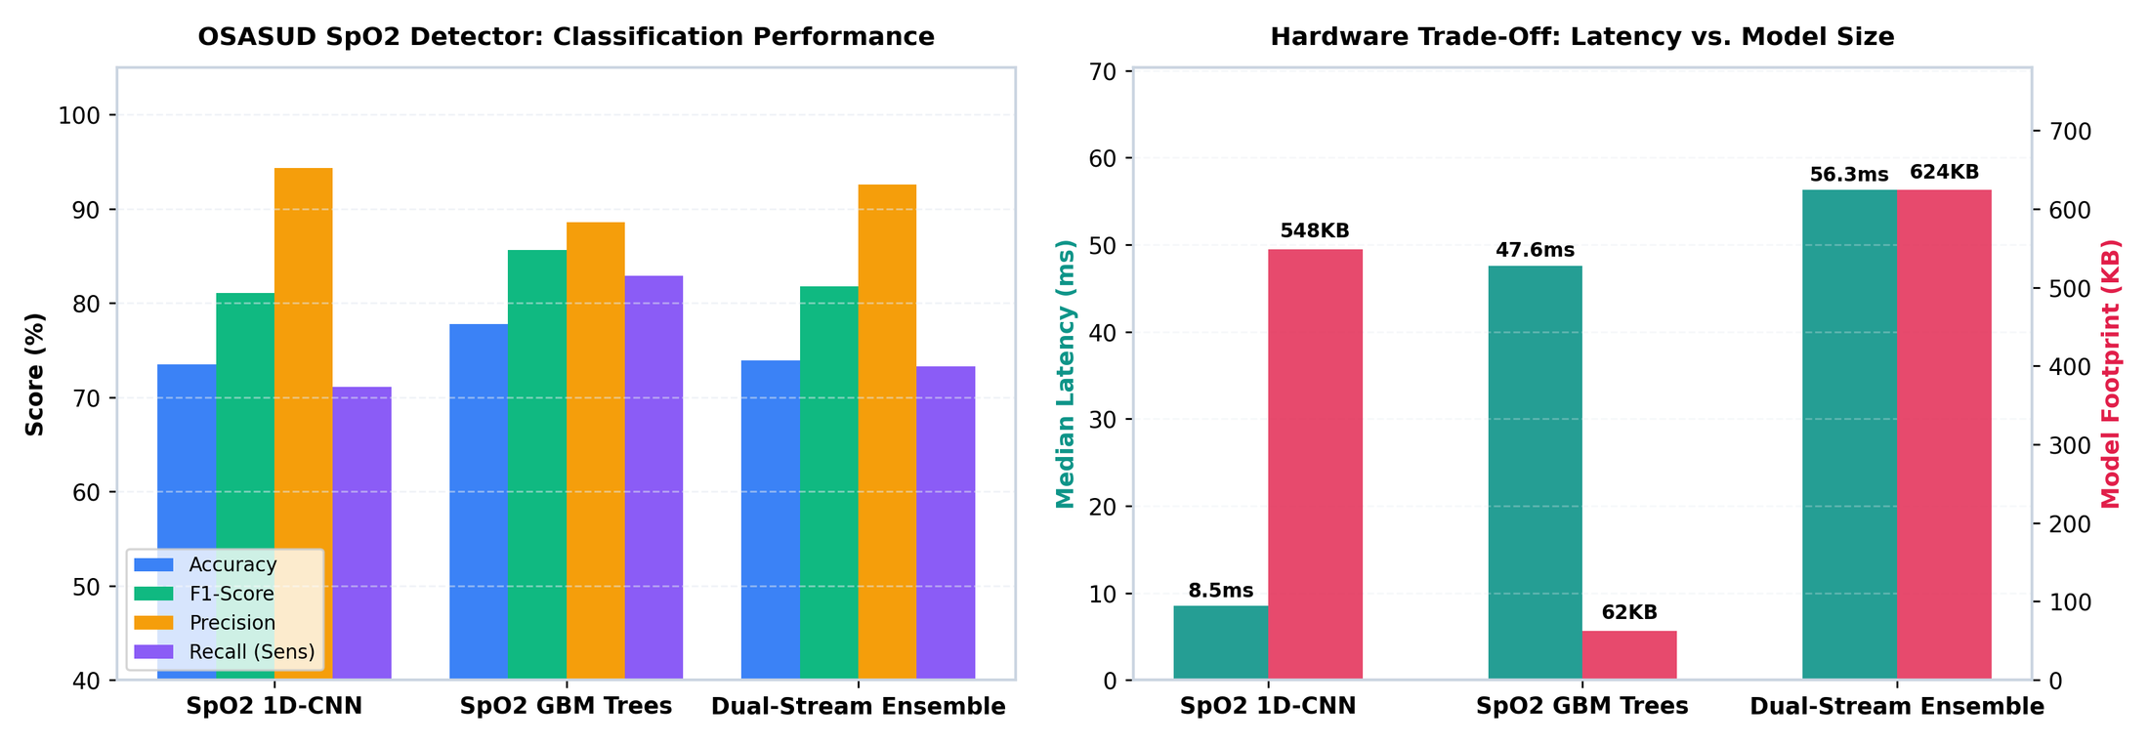
Figure 4.27 SpO₂ detector: classification metrics and the latency–model-size trade-off
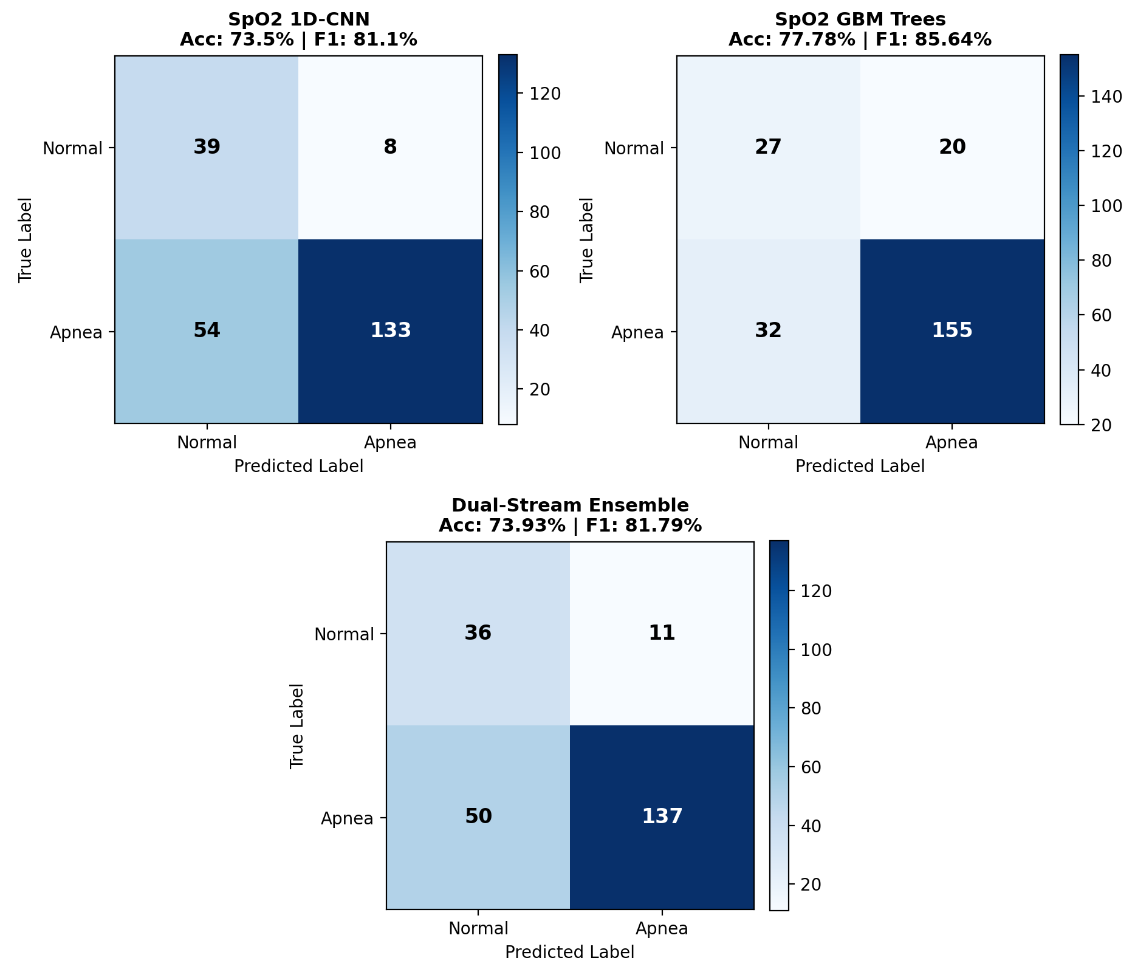
Figure 4.28 Confusion matrices of the SpO₂ CNN, gradient-boosting and ensemble models on the Jetson

4.6.4 Compute cost of the proposed Mamba-2 models
Table 4.17 Single-window CPU latency of the proposed models (PyTorch, batch 1, one thread; 200 runs)
Model | Params / member | p50 / p95 (ms) | 5-member p95 (ms) | Hop (ms) | Budget (5 members)
VC-BiMamba (ECG, 10 s) | 129,602 | 26.8 / 35.0 | 175 | 2,000 | 8.74%
IC-BiMamba (IMU, 4 s) | 72,410 | 12.2 / 17.4 | 87 | 1,000 | 8.70%
PhysioMamba (EDA, 60 s) | 83,964 | 8.4 / 12.1 | 61 | 15,000 | 0.40%
Measured on the development laptop CPU (Intel Core i5-11400H) while another CPU job was running, so the values are upper bounds. The Jetson Orin Nano benchmark of these models is pending.
A forward pass of the proposed models takes 8–27 ms per member, one to two orders of magnitude more than the compact deployed models of Table 4.12, because the chunked SSD scan is computed with dense einsum operations in plain PyTorch. Even so, a full five-member ensemble needs at most about 9% of the real-time hop on a laptop CPU core, so all three models are feasible on the Jetson's six-core CPU and leave its GPU free; exporting the scan to ONNX and benchmarking it on the board is the next deployment step.

4.7 Comparison with the state of the art
This section places each latest model beside five published studies of the same task, drawn from recent journal literature that reports comparable metrics. Datasets, label definitions and evaluation protocols differ between studies, so the tables set context rather than a strict ranking; the protocol column states how each result was obtained, and every result of this work comes from people never seen during training.

4.7.1 ECG: LVH detection
Table 4.18 LVH detection from the ECG: recent journal studies compared with VC-BiMamba
Study | Leads / model | Cohort and LVH reference | Reported result
Angelaki et al. 2026, Hellenic J. Cardiol. [62] | Single lead + clinical data, random forest | 812 hypertensive adults; echocardiography | AUROC 0.82; sens. 58%, spec. 81%
Yang et al. 2026, BioData Min. [63] | 12-lead deep network | 40,736 + 6,271 patients; echo LVMI | External AUROC 0.82 (men), 0.77 (women)
Cai et al. 2024, Comput. Methods Programs Biomed. [64] | 12-lead 2D-CNN | 42,127 ECG–echo pairs | AUROC 0.916
Yu et al. 2026, Heart Rhythm [65] | 12-lead EFFNet | UK Biobank (n = 38,289); cardiac MRI | AUROC 0.933 (5-fold); 0.654 external
Strodthoff et al. 2021, IEEE J. Biomed. Health Inform. [17] | 12-lead xresnet1d101 | PTB-XL fold 10 (same test fold) | LVH statement AUROC 0.953 (vs all)
VC-BiMamba (this work) | Lead II only | PTB-XL fold 10; cardiologist labels | AUROC 0.934 vs normal; 0.811 vs all other ECGs

Against normal ECGs, VC-BiMamba's single-lead AUROC of 0.934 is the highest single-lead value in the table (Angelaki et al. reach 0.82 even with clinical data added) and matches the best 12-lead deep networks evaluated against imaging (Cai et al. 0.916, Yu et al. 0.933). On the identical PTB-XL test fold, the 12-lead network of Strodthoff et al. separates LVH from all other statements better (0.953 vs our 0.811); that gap is the price of using one wearable lead instead of twelve, since the precordial voltages carry most of the LVH evidence. Imaging-labelled studies also measure a harder target than PTB-XL's ECG statements (Figure 4.29).
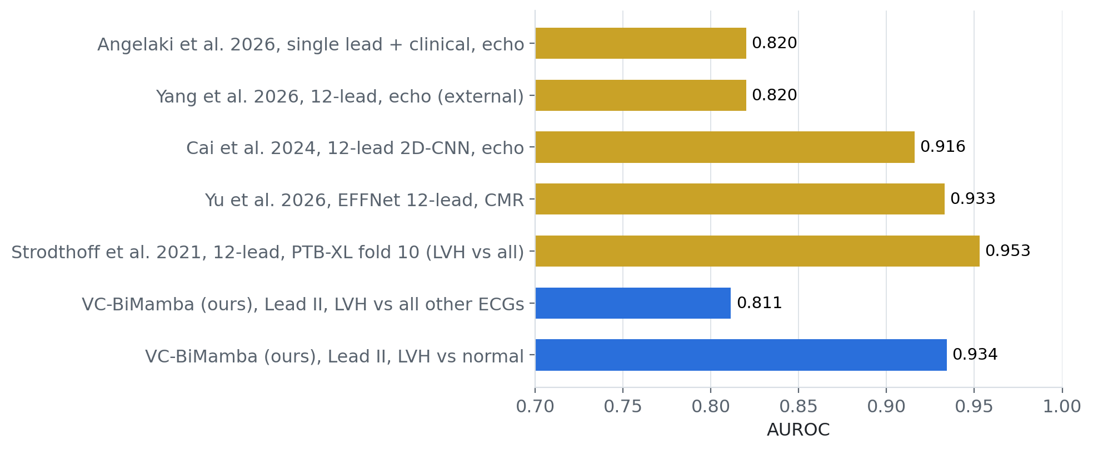
Figure 4.29 AUROC of recent LVH-from-ECG studies versus VC-BiMamba (ground truth differs between studies)

4.7.2 PPG and SpO₂: sleep apnea detection
Table 4.19 Sleep apnea event detection from PPG and SpO₂: recent journal studies compared with our two detectors
Study | Signals / unit of analysis | Dataset | Acc. (%) | Sens. (%) | Spec. (%) | AUROC
Lazazzera et al. 2021, IEEE Trans. Biomed. Eng. [66] | PPG + SpO₂; 1-min segments | 96 patients, UZ Leuven | 75.1 | — | — | —
Choksatchawathi et al. 2024, IEEE IoT J. [28] | Fingertip PPG; 60 s windows, 5-fold | MESA | 73.9 | 77.2 | 73.3 | 0.825
Thuptimdang et al. 2026, Sleep Breath. [67] | PPG (PWA, PPI) + SpO₂; 60 s segments | 90 PSG recordings | — | 77.1‡ | — | —
Yeo et al. 2026, J. Med. Internet Res. [68] | AI on PPG; meta-analysis (pooled) | Multiple studies | — | 79.6 | 76.5 | —
Katsaridis et al. 2026, Physiol. Meas. [69] | Single-channel PPG; time-resolved | MESA, 2,029 PSGs | — | — | — | 0.92†
Dual-rate TCN + GRU (this work) | Finger PPG only; every second | OSASUD, 30 held-out patients | 62.9 | 52.1 | 62.9 | 0.594
SpO₂ rank ensemble (this work, Jetson) | SpO₂; 60 s windows | OSASUD replay, 234 windows | 73.9 | 73.3 | 76.6 | 0.825
‡Sensitivity for arousal-related OSA segments. †Respiratory-disturbance AUROC; apnea AUPRC 0.28 at 1.9% prevalence (our PPG model: patient AP 0.247).
The SpO₂ detector deployed on the Jetson matches recent journal results: its accuracy (73.9%), specificity (76.6%) and AUROC (0.825) equal those of ApSense on MESA and lie within two points of the PPG + SpO₂ detector of Lazazzera et al. and of the pooled specificity in the 2026 meta-analysis, while its sensitivity (73.3%) is three to six points lower. The PPG-only network is the weakest model in the table: it scores every second rather than every minute, uses no SpO₂ and is tested on stroke-unit patients, all of which make the task harder, but the gap (AUROC 0.594 against 0.82–0.92) confirms the conclusion of Section 4.3 that optical respiratory events should be confirmed with SpO₂ (Figure 4.30).
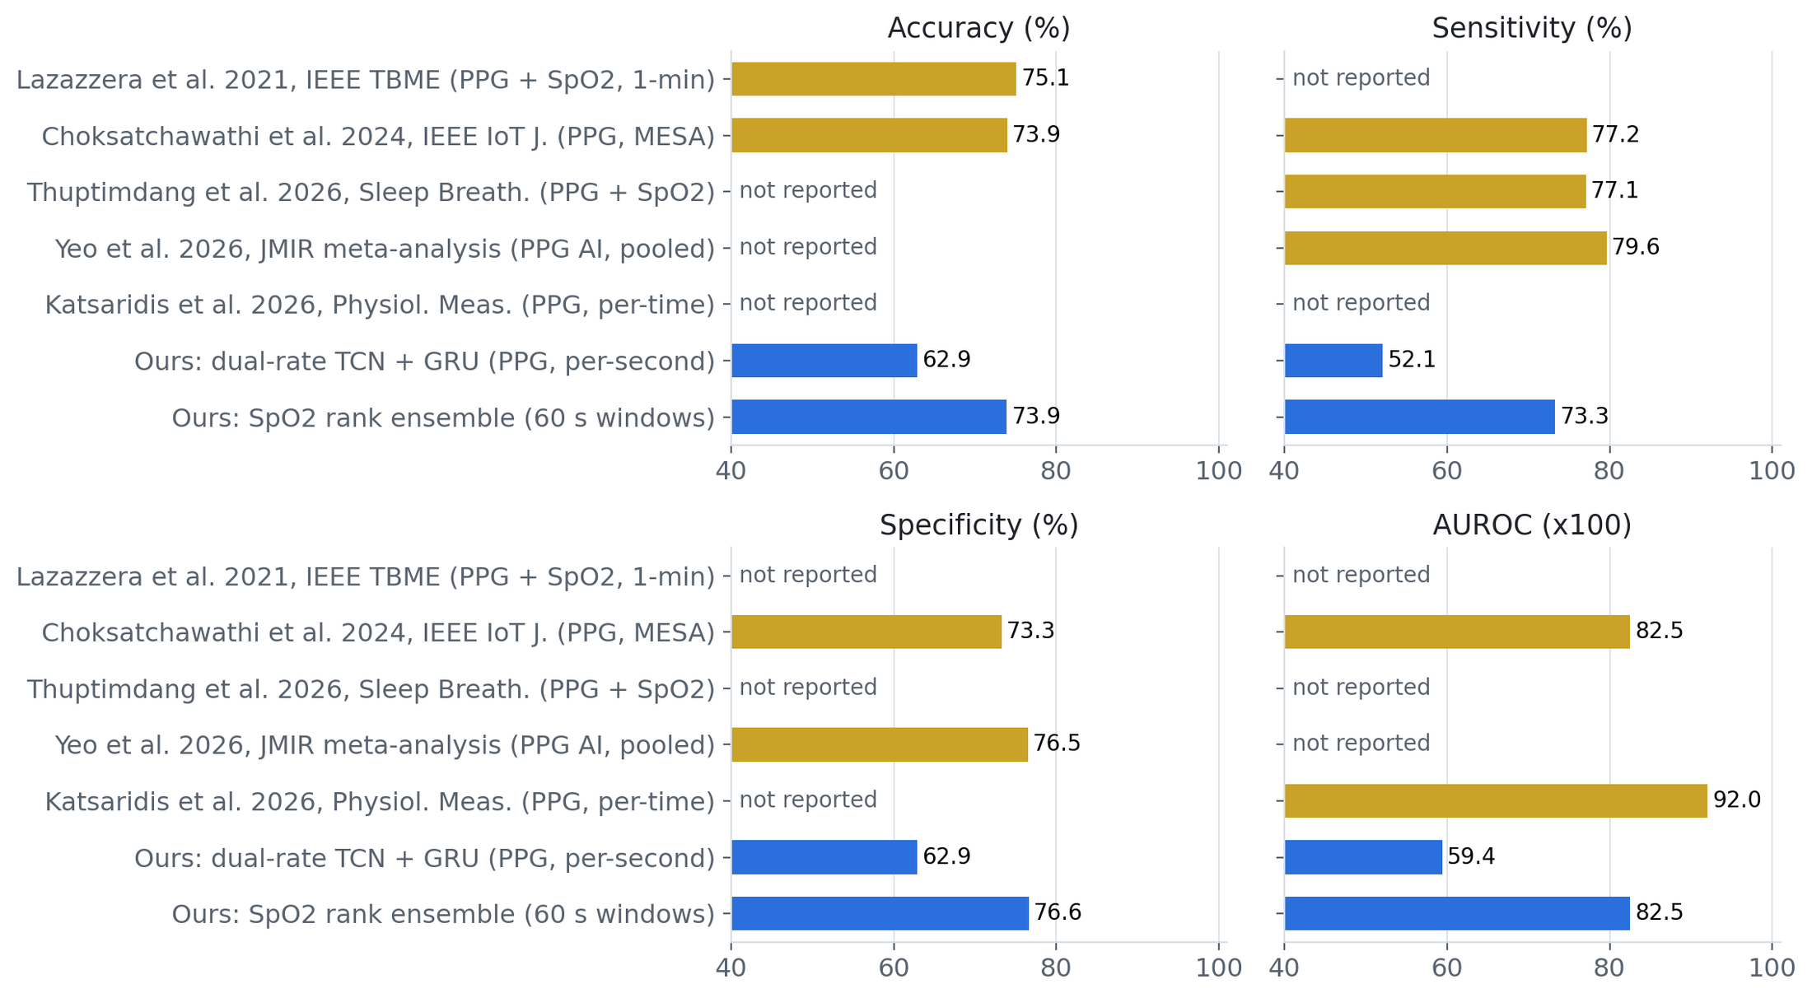
Figure 4.30 Accuracy, sensitivity, specificity and AUROC of recent apnea detectors versus our PPG and SpO₂ models

4.7.3 IMU: fall detection on SisFall
Table 4.20 SisFall fall detection: recent journal studies compared with IC-BiMamba (percent)
Study | Model / split | Accuracy | Precision | Recall | Specificity | F1
Mohammad et al. 2023, Sensors [70] | CNN–RNN ensemble; 3 classes† | 98.0 | — | — | — | —
Jishnuraj et al. 2026, Front. Artif. Intell. [71] | FallCNN on signal images; 4 classes, 80/20† | 98.0 | — | — | — | —
Villa & Casilari 2026, Sensors [35] | CNN–LSTM, 20 Hz | 98.89 | — | 96.67 | 99.63 | —
Zhang et al. 2024, J. Med. Internet Res. [34] | Dual-stream CNN + attention; 80/20 participants | 99.32 | 98.58 | 99.15 | — | 98.86
Ahirwar & Soni 2025, Sci. Rep. [72] | BiLSTM–BiGRU + attention; random 70/10/20 | 99.50 | 99.44 | 99.58 | — | 99.51
IC-BiMamba (this work) | 5-fold participant-disjoint, all 4,500 trials | 99.29 | 99.27 | 98.94 | 99.52 | 99.11
†Fall-class values from a multi-class task. Random splits can place windows of the same person in training and test.
IC-BiMamba is within 0.2–0.6 points of the strongest published SisFall result on every metric and is the best of the studies that keep participants apart: against the participant-split model of Zhang et al. it is 0.69 points higher in precision and 0.25 points higher in F1, with accuracy 0.03 points lower. Only Ahirwar & Soni report higher values (99.50% accuracy, 99.51% F1), using a random window-level split in which the same person can appear in training and test; our result covers every trial of people never seen in training and comes with a measured false-alarm rate of 0.90 per monitored hour (Figure 4.31).
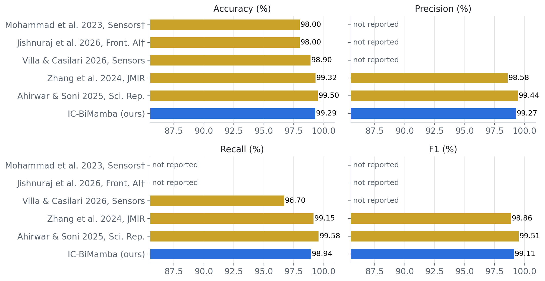
Figure 4.31 SisFall accuracy, precision, recall and F1 of recent journal models versus IC-BiMamba

4.7.4 EDA: stress detection on WESAD
Table 4.21 Binary WESAD stress detection with unseen-person testing compared with PhysioMamba
Study | Sensors / setup | Accuracy | F1 | PhysioMamba margin
Prajwal et al. 2026, Discov. Appl. Sci. [73] | Chest ECG HRV, RF ensemble; 70/30 by subject | 83.0% | — | +12.7 acc.
Vos et al. 2023, J. Biomed. Inform. [47] | Wrist EDA + HR, WESAD unseen | 85.0% | 78.0 | +10.7 acc., +17.6 F1
Kumar et al. 2021, Pattern Recognit. Lett. [45] | Hierarchical DNN (3-class) | 87.70% | — | +8.0 acc.
Rashid et al. 2021, IEEE EMBC [44] | Wrist BVP, hybrid CNN, LOSO | 88.56% | 86.18 | +7.2 acc., +9.4 F1
Kumar et al. 2024, IEEE Access [46] | Smartwatch biomarkers, Resp-BoostNet | 94.0% | — | +1.7 acc.
PhysioMamba (this work) | Wrist EDA, ACC, TEMP, BVP; LOSO; no calibration | 95.74% | 95.6 | —
PhysioMamba F1 is the participant-mean macro F1, which is stricter than the stress-class F1 most papers report. Studies above 95% generally use three classes or splits in which the same person appears in training and test.
PhysioMamba exceeds all five comparators — by 7–13 accuracy points against the wrist and chest baselines and by 1.7 points against Resp-BoostNet (Figure 4.32). Two caveats apply. WESAD is a laboratory protocol in which baseline, stress (TSST), amusement and meditation follow a fixed schedule; an elapsed-time-only control reaches 0.999 macro F1, so absolute numbers measure stress-associated arousal under that protocol rather than stress in daily life. And with 15 participants the confidence interval on accuracy (92.9%–98.2%) is wide.
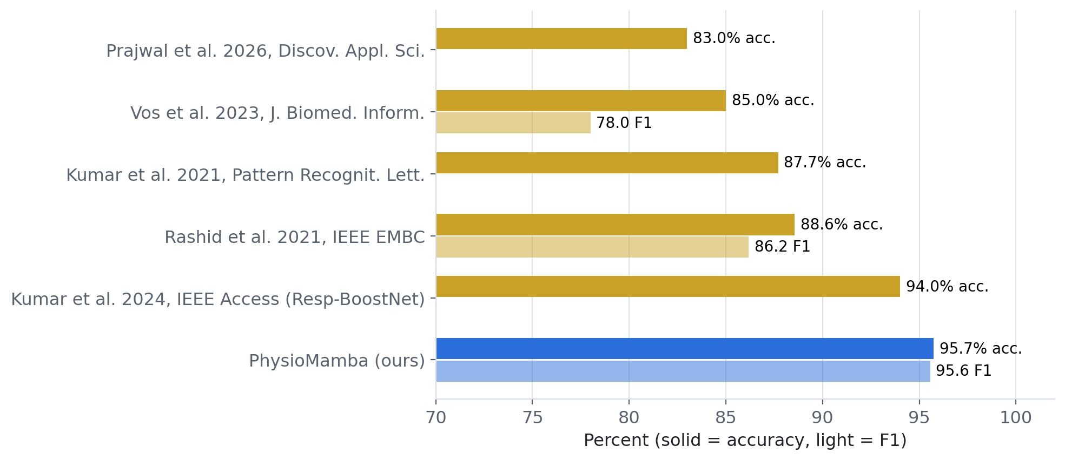
Figure 4.32 Accuracy and F1 of published WESAD stress detectors versus PhysioMamba

4.8 Consolidated results and discussion
Table 4.22 Summary of the latest model per task: held-out performance
Task | Model | Accuracy | Precision | Recall | Specificity | F1 | AUROC | AUPRC | Status
ECG LVH vs normal | VC-BiMamba (5 seeds) | 88.1% | 71.3% | 82.2% | 89.9% | 0.764 | 0.934 | 0.885 | Research prototype
ECG LVH vs rest | VC-BiMamba (5 seeds) | 85.5% | 33.6% | 50.0% | 89.4% | 0.402 | 0.811 | 0.401 | Research
IMU fall | IC-BiMamba (5 seeds) | 99.29% | 99.27% | 98.94% | 99.52% | 0.9911 | 0.9998 | 0.9998 | Prototype candidate
EDA stress | PhysioMamba (5 members) | 95.7% | 94.0% | 96.5% | 95.2% | 0.956‡ | 0.996 | 0.994 | Prototype candidate
PPG resp. events | Dual-rate TCN + GRU | 62.9% | 21.0% | 52.1% | 62.9% | 0.300 | 0.594 | 0.247† | Research only
SpO₂ apnea | Rank ensemble (Jetson) | 73.9% | 92.6% | 73.3% | 76.6% | 0.818 | 0.825 | — | Research
‡Participant-mean macro F1; stress metrics are participant means (LOSO). †Mean patient AP. PPG accuracy and specificity are second-level values at the event-F1 threshold.
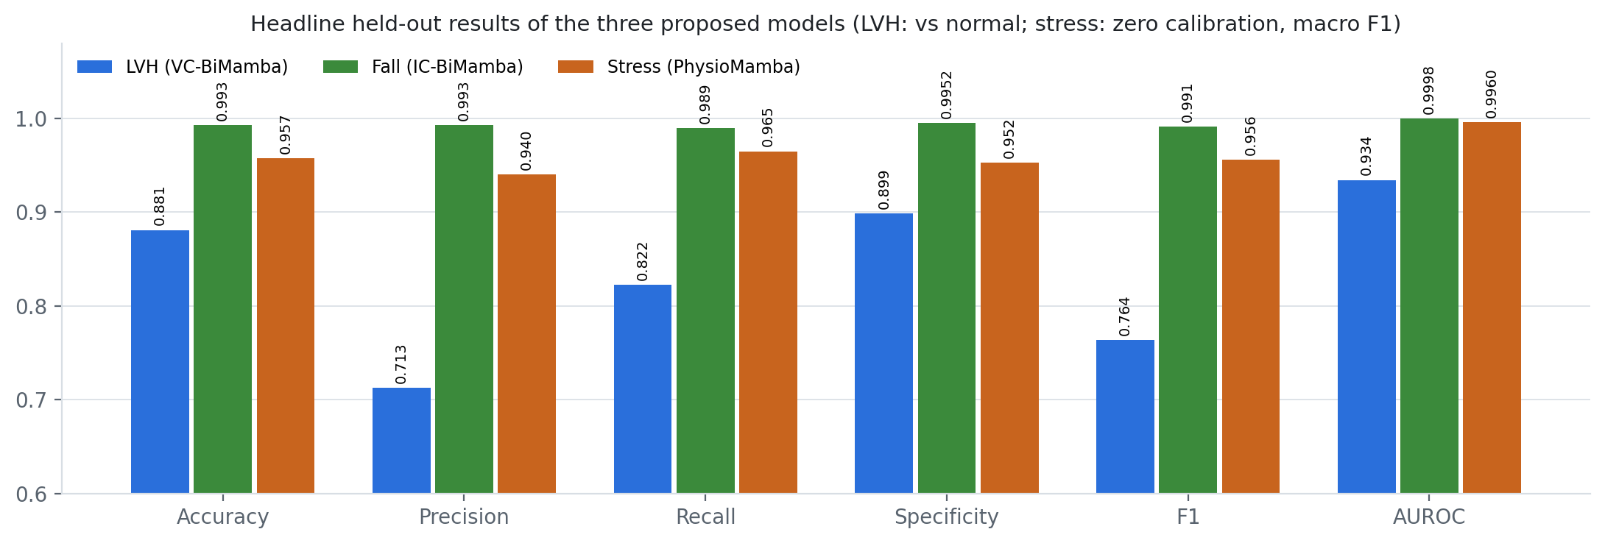
Figure 4.33 Headline held-out metrics of the three proposed models
Three patterns stand out. First, conditioning a selective state-space model on the physical quantity that defines the condition gave the best result on every task where the signal carries enough information: VC-BiMamba exceeds published single-lead LVH results (0.934 vs 0.80–0.85 AUROC), IC-BiMamba gives the highest participant-independent SisFall F1 (99.11%), and PhysioMamba exceeds every published unseen-person WESAD result (95.7% accuracy). Second, the ablations locate the gains: the convolutional stem for ECG, impact conditioning for falls, and the reliability gate for calibration-free stress detection, which also degrades gracefully when one modality is lost. Third, five-seed ensembling raised LVH AUROC by about 0.01 and removed a fall seed that produced 113 false alarms in one fold. Optical respiratory events remain the weakest task (second-level AUROC about 0.59), consistent with reviews favouring SpO₂ and multi-signal approaches [4], which the SpO₂ detector (AUROC 0.83) supports. Edge compute is not the bottleneck; data, labels and validation in the target population are.
CHAPTER 5

Conclusions and Future Scope of Study

5.1 Conclusions
This project built and evaluated an edge-deployable, four-signal physiological monitoring system for older adults and proposed three physically conditioned bidirectional Mamba-2 models. The main conclusions are:
- Voltage-conditioned single-lead ECG works for LVH patterns. VC-BiMamba reached AUROC 0.934 (95% CI 0.911–0.957), 88.1% accuracy and 82.2% sensitivity at 89.9% specificity on the frozen PTB-XL test fold, above published single-lead models; the convolutional stem was its most important component.
- Fall detection is ready for prospective testing. With the duration shortcut removed, IC-BiMamba reached 99.29% accuracy, 99.27% precision, 98.94% recall and 99.11% F1 on all 4,500 trials of held-out participants, with 0.90 false alerts per monitored hour — the best precision and F1 among participant-independent SisFall studies. Knock-outs show that impact conditioning is its most relied-upon component.
- Artefact-aware fusion makes wrist stress detection person-independent. PhysioMamba reached 95.7% accuracy and macro F1 0.956 on WESAD without any per-person calibration, above all published unseen-person results compared.
- Optical apnea detection needs more information. The best PPG model reached patient AP 0.247 against 0.160 and ≥ 51 false events per hour; it is retained only as a research output.
- The Jetson Orin Nano has ample headroom. The deployed pipelines ran within 10.7 ms end to end on the CPU (≤ 0.31% of each hop) and the SpO₂ service within 62.4 ms (0.62%); the new models need at most about 9% of a hop for a five-member ensemble on one laptop CPU core.

5.2 Limitations
- All performance figures come from public laboratory or hospital datasets; no physical BioAmp, MAX30102, MPU-9250 or GSR recordings with reference labels have yet been collected.
- Older adults are under-represented: WESAD participants were 24–35 years old, and only one older SisFall participant performed falls. SisFall falls are simulated.
- The ECG endpoint is a PTB-XL diagnostic statement, not echocardiographic LVH, and VC-BiMamba is statistically tied with a simpler multiscale CNN on the test fold; OSASUD comes from a single stroke unit.
- The new models were designed after earlier models had been evaluated on the same cohorts. Their test sets were opened once, but confirmation on independent data is still required.
- The fall ablation is an inference-time knock-out rather than retraining, and only 15 WESAD participants support the stress results, so several ablation differences are within their confidence intervals.
- The Mamba-2 models have not yet been exported and benchmarked on the Jetson; the on-board PPG and EDA replay packs use synthetic feature vectors, and power consumption was not measured.

5.3 Future scope
- Edge export of the Mamba-2 models. Export the chunked SSD scan to ONNX/TensorRT, benchmark it on the Jetson CPU and GPU, and distil the five-member ensembles into single students.
- Hardware calibration and parity. Bench-calibrate each sensor (input-referred mV per count, optical channel and polarity, IMU gain and bias, EDA range and contact impedance) and verify that live streams reproduce dataset statistics.
- Prospective older-adult study. Collect counterbalanced, labelled recordings from older participants with reference devices (12-lead ECG/echocardiography, polysomnography, video-verified activities, stress protocols).
- Cross-modal confirmation and tiered alerts. Reduce alarm fatigue by confirming events across modalities, for example apnea with SpO₂ desaturation and heart-rate change, or a fall impact with post-fall immobility.
- Integrated service. Package all modules as systemd services with local encrypted storage, BLE/Wi-Fi telemetry to a caregiver dashboard, and the data-minimisation and safety processes required for medical-device certification.

References
[1] World Health Organization, “Falls,” Fact sheet, Geneva, Apr. 2021. [Online]. Available: https://www.who.int/news-room/fact-sheets/detail/falls
[2] M. Sokolow and T. P. Lyon, “The ventricular complex in left ventricular hypertrophy as obtained by unipolar precordial and limb leads,” Am. Heart J., vol. 37, no. 2, pp. 161–186, 1949.
[3] P. N. Casale et al., “Electrocardiographic detection of left ventricular hypertrophy: Development and prospective validation of improved criteria,” J. Am. Coll. Cardiol., vol. 6, no. 3, pp. 572–580, 1985.
[4] F. Mendonça, S. S. Mostafa, A. G. Ravelo-García, F. Morgado-Dias, and T. Penzel, “A review of obstructive sleep apnea detection approaches,” IEEE J. Biomed. Health Inform., vol. 23, no. 2, pp. 825–837, 2019.
[5] R. B. Berry et al., “Rules for scoring respiratory events in sleep: Update of the 2007 AASM manual,” J. Clin. Sleep Med., vol. 8, no. 5, pp. 597–619, 2012.
[6] Y. S. Can, B. Arnrich, and C. Ersoy, “Stress detection in daily life scenarios using smart phones and wearable sensors: A survey,” J. Biomed. Inform., vol. 92, p. 103139, 2019.
[7] W. Shi, J. Cao, Q. Zhang, Y. Li, and L. Xu, “Edge computing: Vision and challenges,” IEEE Internet Things J., vol. 3, no. 5, pp. 637–646, 2016.
[8] M. Satyanarayanan, “The emergence of edge computing,” Computer, vol. 50, no. 1, pp. 30–39, 2017.
[9] “Real-time heartbeat classification on distributed edge devices: A performance and resource utilization study,” Sensors, vol. 25, no. 19, p. 6116, 2025, doi: 10.3390/s25196116.
[10] S. Kapoor and A. Narayanan, “Leakage and the reproducibility crisis in machine-learning-based science,” Patterns, vol. 4, no. 9, p. 100804, 2023.
[11] NVIDIA Corporation, “Jetson Orin Nano Super Developer Kit,” product documentation, Santa Clara, CA, USA, 2024. [Online]. Available: https://developer.nvidia.com/embedded/jetson-orin-nano-developer-kit
[12] ONNX Runtime developers, “ONNX Runtime: Cross-platform, high performance ML inferencing and training accelerator,” 2021. [Online]. Available: https://onnxruntime.ai
[13] S. Campanella, A. Alnasef, L. Falaschetti, A. Belli, P. Pierleoni, and L. Palma, “A novel embedded deep learning wearable sensor for fall detection,” IEEE Sensors J., vol. 24, no. 9, pp. 15219–15229, 2024, doi: 10.1109/JSEN.2024.3375603.
[14] M. Musci, D. De Martini, N. Blago, T. Facchinetti, and M. Piastra, “Online fall detection using recurrent neural networks on smart wearable devices,” IEEE Trans. Emerg. Topics Comput., vol. 9, no. 3, pp. 1276–1289, 2021, doi: 10.1109/TETC.2020.3027454.
[15] P. Wagner et al., “PTB-XL, a large publicly available electrocardiography dataset,” Sci. Data, vol. 7, no. 1, p. 154, 2020, doi: 10.1038/s41597-020-0495-6.
[16] A. L. Goldberger et al., “PhysioBank, PhysioToolkit, and PhysioNet: Components of a new research resource for complex physiologic signals,” Circulation, vol. 101, no. 23, pp. e215–e220, 2000.
[17] N. Strodthoff, P. Wagner, T. Schaeffter, and W. Samek, “Deep learning for ECG analysis: Benchmarks and insights from PTB-XL,” IEEE J. Biomed. Health Inform., vol. 25, no. 5, pp. 1519–1528, 2021, doi: 10.1109/JBHI.2020.3022989.
[18] A. Y. Hannun et al., “Cardiologist-level arrhythmia detection and classification in ambulatory electrocardiograms using a deep neural network,” Nat. Med., vol. 25, no. 1, pp. 65–69, 2019.
[19] A. H. Ribeiro et al., “Automatic diagnosis of the 12-lead ECG using a deep neural network,” Nat. Commun., vol. 11, p. 1760, 2020.
[20] S. Kiranyaz, T. Ince, and M. Gabbouj, “Real-time patient-specific ECG classification by 1-D convolutional neural networks,” IEEE Trans. Biomed. Eng., vol. 63, no. 3, pp. 664–675, 2016.
[21] J.-M. Kwon et al., “Comparing the performance of artificial intelligence and conventional diagnosis criteria for detecting left ventricular hypertrophy using electrocardiography,” Europace, vol. 22, no. 3, pp. 412–419, 2020, doi: 10.1093/europace/euz324.
[22] A. Taconné, V. D. A. Corino, and L. Mainardi, “An ECG-based model for left ventricular hypertrophy detection: A machine learning approach,” IEEE Open J. Eng. Med. Biol., vol. 6, pp. 219–226, 2025, doi: 10.1109/OJEMB.2024.3509379.
[23] M. Sato, S. Kodera, et al., “Deep learning models for predicting left heart abnormalities from single-lead electrocardiogram for the development of wearable devices,” Circ. J., vol. 88, no. 1, pp. 146–156, 2024, doi: 10.1253/circj.CJ-23-0216.
[24] J. S. Haimovich et al., “Artificial intelligence–enabled classification of hypertrophic heart diseases using electrocardiograms,” Cardiovasc. Digit. Health J., vol. 4, no. 2, pp. 48–59, 2023, doi: 10.1016/j.cvdhj.2023.03.001.
[25] P. H. Charlton et al., “Breathing rate estimation from the electrocardiogram and photoplethysmogram: A review,” IEEE Rev. Biomed. Eng., vol. 11, pp. 2–20, 2018.
[26] W. Karlen, S. Raman, J. M. Ansermino, and G. A. Dumont, “Multiparameter respiratory rate estimation from the photoplethysmogram,” IEEE Trans. Biomed. Eng., vol. 60, no. 7, pp. 1946–1953, 2013.
[27] G. B. Papini et al., “Wearable monitoring of sleep-disordered breathing: Estimation of the apnea–hypopnea index using wrist-worn reflective photoplethysmography,” Sci. Rep., vol. 10, p. 13512, 2020.
[28] T. Choksatchawathi et al., “ApSense: Data-driven algorithm in PPG-based sleep apnea sensing,” IEEE Internet Things J., vol. 11, no. 20, pp. 33915–33926, 2024, doi: 10.1109/JIOT.2024.3433500.
[29] K. Kotzen, P. H. Charlton, S. Salabi, L. Amar, A. Landesberg, and J. A. Behar, “SleepPPG-Net: A deep learning algorithm for robust sleep staging from continuous photoplethysmography,” IEEE J. Biomed. Health Inform., vol. 27, no. 2, pp. 924–932, 2023.
[30] A. Bernardini, A. Brunello, G. L. Gigli, A. Montanari, and N. Saccomanno, “OSASUD: A dataset of stroke unit recordings for the detection of obstructive sleep apnea syndrome,” Sci. Data, vol. 9, p. 177, 2022.
[31] A. Sucerquia, J. D. López, and J. F. Vargas-Bonilla, “SisFall: A fall and movement dataset,” Sensors, vol. 17, no. 1, p. 198, 2017, doi: 10.3390/s17010198.
[32] R. Igual, C. Medrano, and I. Plaza, “Challenges, issues and trends in fall detection systems,” Biomed. Eng. Online, vol. 12, p. 66, 2013.
[33] E. Casilari, R. Lora-Rivera, and F. García-Lagos, “A study on the application of convolutional neural networks to fall detection evaluated with multiple public datasets,” Sensors, vol. 20, no. 5, p. 1466, 2020.
[34] Zhang et al., “An effective deep learning framework for fall detection: Model development and study design,” J. Med. Internet Res., vol. 26, p. e56750, 2024, doi: 10.2196/56750.
[35] M. Villa and E. Casilari, “The impact of the accelerometer sampling rate on the performance of machine and deep learning models in wearable fall-detection systems,” Sensors, vol. 26, no. 1, p. 162, 2026, doi: 10.3390/s26010162.
[36] S. Bai, J. Z. Kolter, and V. Koltun, “An empirical evaluation of generic convolutional and recurrent networks for sequence modeling,” arXiv:1803.01271, 2018.
[37] H. Ismail Fawaz et al., “InceptionTime: Finding AlexNet for time series classification,” Data Min. Knowl. Discov., vol. 34, no. 6, pp. 1936–1962, 2020.
[38] T. Chen and C. Guestrin, “XGBoost: A scalable tree boosting system,” in Proc. 22nd ACM SIGKDD Int. Conf. Knowl. Discov. Data Min., 2016, pp. 785–794.
[39] M. Benedek and C. Kaernbach, “A continuous measure of phasic electrodermal activity,” J. Neurosci. Methods, vol. 190, no. 1, pp. 80–91, 2010.
[40] A. Greco, G. Valenza, A. Lanata, E. P. Scilingo, and L. Citi, “cvxEDA: A convex optimization approach to electrodermal activity processing,” IEEE Trans. Biomed. Eng., vol. 63, no. 4, pp. 797–804, 2016, doi: 10.1109/TBME.2015.2474131.
[41] J. Choi, B. Ahmed, and R. Gutierrez-Osuna, “Development and evaluation of an ambulatory stress monitor based on wearable sensors,” IEEE Trans. Inf. Technol. Biomed., vol. 16, no. 2, pp. 279–286, 2012.
[42] M. Gjoreski, M. Luštrek, M. Gams, and H. Gjoreski, “Monitoring stress with a wrist device using context,” J. Biomed. Inform., vol. 73, pp. 159–170, 2017.
[43] P. Schmidt, A. Reiss, R. Duerichen, C. Marberger, and K. Van Laerhoven, “Introducing WESAD, a multimodal dataset for wearable stress and affect detection,” in Proc. 20th ACM Int. Conf. Multimodal Interact. (ICMI), 2018, pp. 400–408.
[44] N. Rashid, L. Chen, M. Dautta, A. Jimenez, P. Tseng, and M. A. Al Faruque, “Feature augmented hybrid CNN for stress recognition using wrist-based photoplethysmography sensor,” in Proc. 43rd Annu. Int. Conf. IEEE Eng. Med. Biol. Soc. (EMBC), 2021, arXiv:2108.03166.
[45] A. Kumar, K. Sharma, and A. Sharma, “Hierarchical deep neural network for mental stress state detection using IoT based biomarkers,” Pattern Recognit. Lett., vol. 145, pp. 81–87, 2021, doi: 10.1016/j.patrec.2021.01.030.
[46] S. Kumar, A. R. Chauhan, Akhil, A. Kumar, and G. Yang, “Resp-BoostNet: Mental stress detection from biomarkers measurable by smartwatches using boosting neural network technique,” IEEE Access, vol. 12, pp. 149861–149874, 2024, doi: 10.1109/ACCESS.2024.3461588.
[47] G. Vos, K. Trinh, Z. Sarnyai, and M. Rahimi Azghadi, “Generalizable machine learning for stress monitoring from wearable devices: A systematic literature review,” J. Biomed. Inform., vol. 142, p. 104556, 2023, doi: 10.1016/j.jbi.2023.104556.
[48] A. Vaswani et al., “Attention is all you need,” in Proc. Adv. Neural Inf. Process. Syst. (NeurIPS), 2017, pp. 5998–6008.
[49] A. Gu, K. Goel, A. Gupta, and C. Ré, “On the parameterization and initialization of diagonal state space models,” in Proc. NeurIPS, 2022.
[50] A. Gu and T. Dao, “Mamba: Linear-time sequence modeling with selective state spaces,” arXiv:2312.00752, 2023.
[51] T. Dao and A. Gu, “Transformers are SSMs: Generalized models and efficient algorithms through structured state space duality,” in Proc. Int. Conf. Mach. Learn. (ICML), 2024, arXiv:2405.21060.
[52] L. Zhu, B. Liao, Q. Zhang, X. Wang, W. Liu, and X. Wang, “Vision Mamba: Efficient visual representation learning with bidirectional state space model,” in Proc. Int. Conf. Mach. Learn. (ICML), 2024.
[53] E. Perez, F. Strub, H. de Vries, V. Dumoulin, and A. Courville, “FiLM: Visual reasoning with a general conditioning layer,” in Proc. AAAI Conf. Artif. Intell., 2018, pp. 3942–3951.
[54] M. Ilse, J. M. Tomczak, and M. Welling, “Attention-based deep multiple instance learning,” in Proc. Int. Conf. Mach. Learn. (ICML), 2018, pp. 2127–2136.
[55] S. Varma and R. Simon, “Bias in error estimation when using cross-validation for model selection,” BMC Bioinformatics, vol. 7, p. 91, 2006.
[56] T. Saito and M. Rehmsmeier, “The precision-recall plot is more informative than the ROC plot when evaluating binary classifiers on imbalanced datasets,” PLoS ONE, vol. 10, no. 3, p. e0118432, 2015.
[57] C. Guo, G. Pleiss, Y. Sun, and K. Q. Weinberger, “On calibration of modern neural networks,” in Proc. Int. Conf. Mach. Learn. (ICML), 2017, pp. 1321–1330.
[58] J. Platt, “Probabilistic outputs for support vector machines and comparisons to regularized likelihood methods,” in Advances in Large Margin Classifiers. Cambridge, MA, USA: MIT Press, 1999, pp. 61–74.
[59] R. E. Crochiere and L. R. Rabiner, Multirate Digital Signal Processing. Englewood Cliffs, NJ, USA: Prentice-Hall, 1983.
[60] D. L. Donoho, “De-noising by soft-thresholding,” IEEE Trans. Inf. Theory, vol. 41, no. 3, pp. 613–627, 1995.
[61] S. G. Mallat, “A theory for multiresolution signal decomposition: The wavelet representation,” IEEE Trans. Pattern Anal. Mach. Intell., vol. 11, no. 7, pp. 674–693, 1989.
[62] E. Angelaki et al., “Single-lead ECG-based machine learning model for noninvasive detection of left ventricular hypertrophy in hypertension,” Hellenic J. Cardiol., 2026, doi: 10.1016/j.hjc.2026.01.004.
[63] Z.-Y. Yang et al., “Deep learning-enabled ECG system for detecting left ventricular hypertrophy and predicting cardiovascular prognoses,” BioData Min., vol. 19, p. 25, 2026, doi: 10.1186/s13040-026-00536-2.
[64] C. Cai, T. Imai, E. Hasumi, and K. Fujiu, “One-shot screening: Utilization of a two-dimensional convolutional neural network for automatic detection of left ventricular hypertrophy using electrocardiograms,” Comput. Methods Programs Biomed., vol. 247, p. 108097, 2024, doi: 10.1016/j.cmpb.2024.108097.
[65] R. Yu et al., “EFFNet: Efficient feature fusion network for left ventricular hypertrophy identification based on 12-lead electrocardiogram signals,” Heart Rhythm, vol. 23, pp. e2169–e2179, 2026, doi: 10.1016/j.hrthm.2026.02.046.
[66] R. Lazazzera et al., “Detection and classification of sleep apnea and hypopnea using PPG and SpO₂ signals,” IEEE Trans. Biomed. Eng., vol. 68, no. 5, pp. 1496–1506, 2021, doi: 10.1109/TBME.2020.3028041.
[67] W. Thuptimdang, K. Tawaranurak, P. Panyarath, W. Rakim, K. Wae-asae, and M. Khoo, “Towards automatic home screening of obstructive sleep apnea using combined features from pulse wave amplitude, pulse-to-pulse interval and oxygen desaturation,” Sleep Breath., vol. 30, p. 57, 2026, doi: 10.1007/s11325-026-03592-4.
[68] B. S. Y. Yeo et al., “Accuracy of artificial intelligence in diagnosing obstructive sleep apnea using photoplethysmography: Systematic review and meta-analysis,” J. Med. Internet Res., vol. 28, p. e78718, 2026, doi: 10.2196/78718.
[69] F. I. Katsaridis, S. Fouzas, and I. Theodorakopoulos, “Dense temporal sleep apnea profiling from single-channel PPG with downstream AHI estimation: A large-scale retrospective feasibility study,” Physiol. Meas., vol. 47, no. 10, 2026, doi: 10.1088/1361-6579/aeafaa.
[70] Z. Mohammad, A. R. Anwary, M. F. Mridha, M. S. H. Shovon, and M. Vassallo, “An enhanced ensemble deep neural network approach for elderly fall detection system based on wearable sensors,” Sensors, vol. 23, no. 10, p. 4774, 2023, doi: 10.3390/s23104774.
[71] K. Jishnuraj, M. Vergin Raja Sarobin, J. Anbarasi, G. Jasmine, and R. Panjanathan, “Fall detection among elderly persons using FallCNN and transfer learning models,” Front. Artif. Intell., vol. 9, 2026, doi: 10.3389/frai.2026.1734096.
[72] M. S. Ahirwar and V. Soni, “Optimized fall detection using hybrid BiLSTM BiGRU additive attention model and BAOA driven feature selection system,” Sci. Rep., vol. 15, p. 39254, 2025, doi: 10.1038/s41598-025-22909-z.
[73] S. H. Prajwal, S. Singh, and D. Theng, “An explainable multimodal deep learning approach for stress detection in emotion-aware systems,” Discov. Appl. Sci., vol. 8, p. 537, 2026, doi: 10.1007/s42452-026-08557-6.
APPENDIX A

Supplementary Experimental Figures
This appendix collects supplementary signal-level figures: ECG preprocessing fidelity, SisFall dataset and filter diagnostics, and the WESAD protocol and MC-SAED decomposition.

A.1 ECG preprocessing
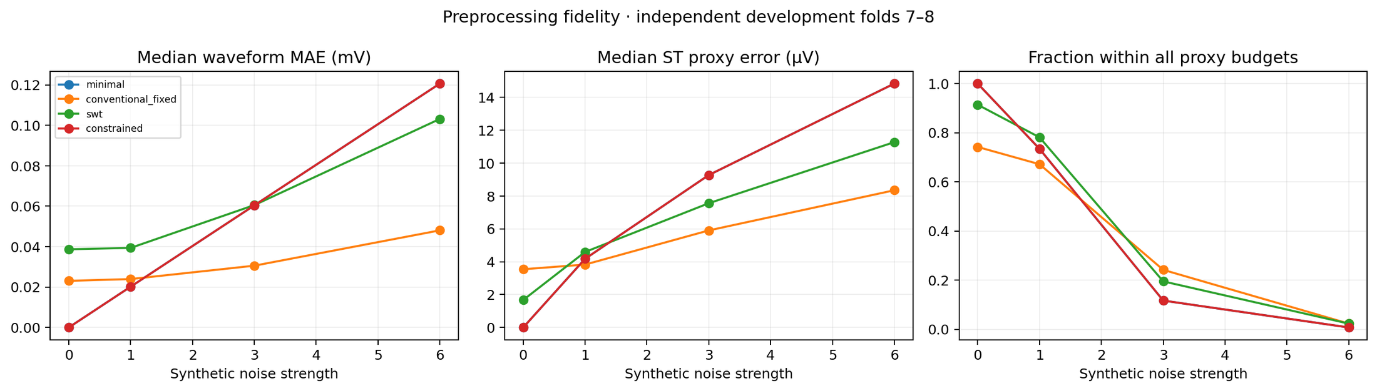
Figure A.1 Preprocessing fidelity under synthetic noise: waveform MAE, ST-proxy error and fraction within budgets

A.2 IMU signal diagnostics
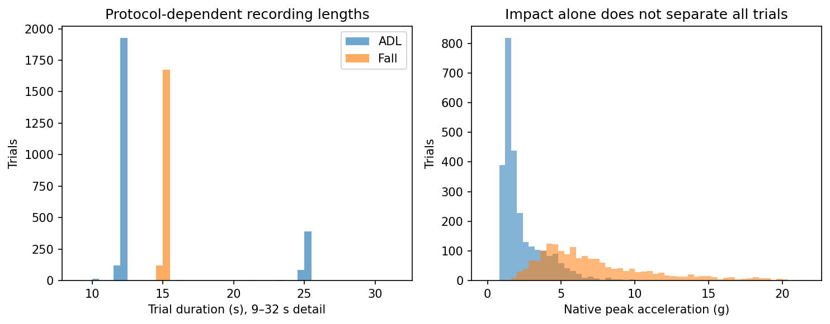
Figure A.2 SisFall recording durations and impact distribution (the duration cue)
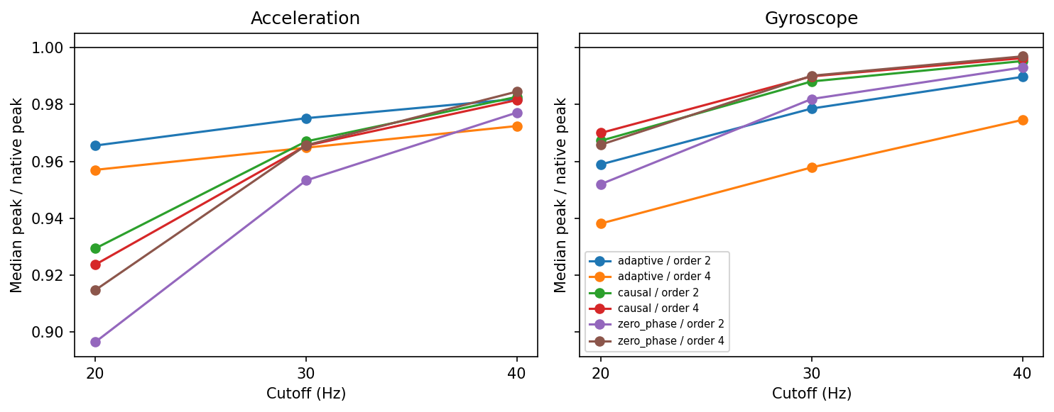
Figure A.3 Impact-peak retention of fixed and adaptive filters

A.3 EDA protocol and decomposition
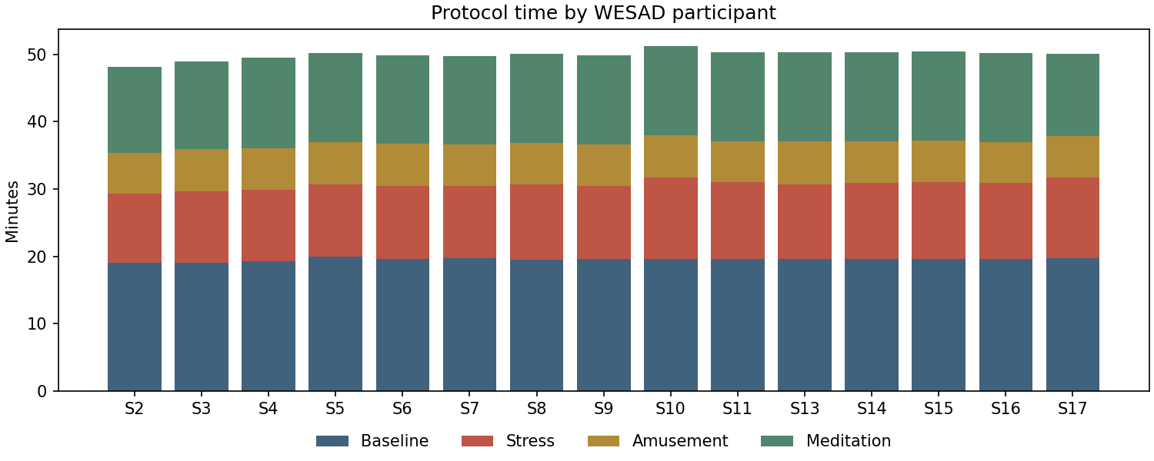
Figure A.4 Protocol time per WESAD participant by condition
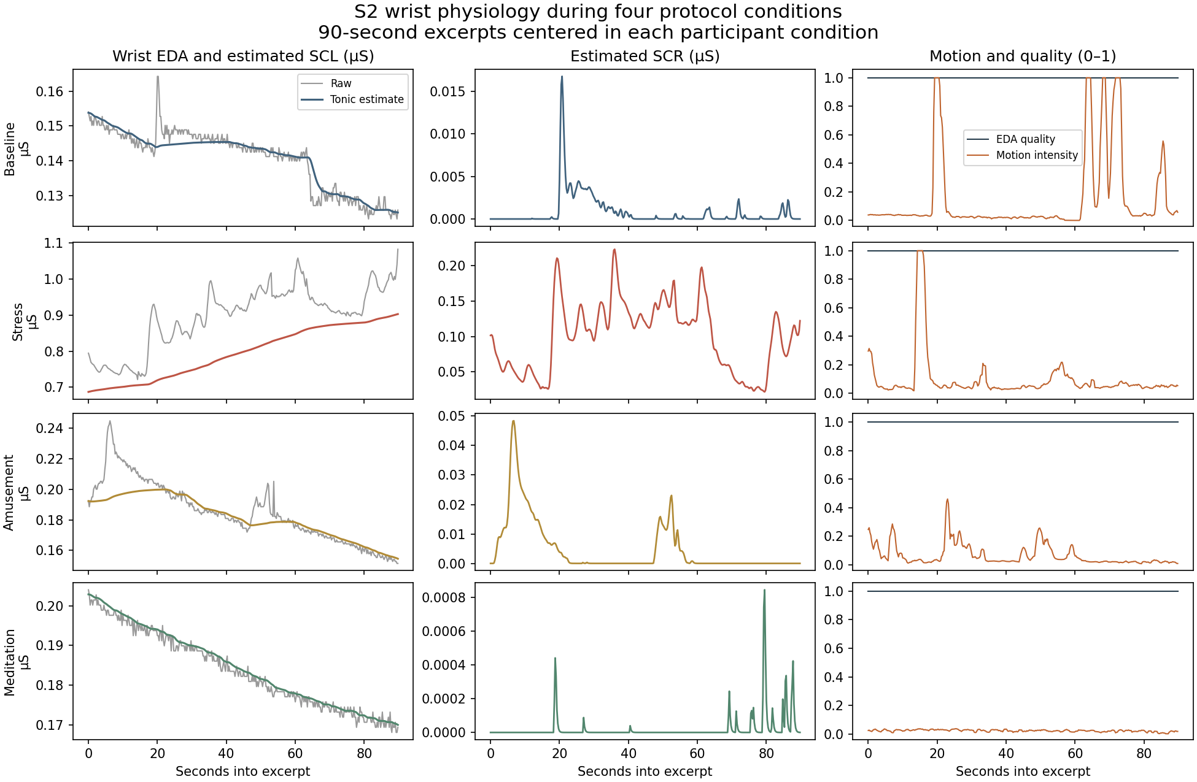
Figure A.5 MC-SAED tonic and phasic components across baseline, stress, amusement and meditation
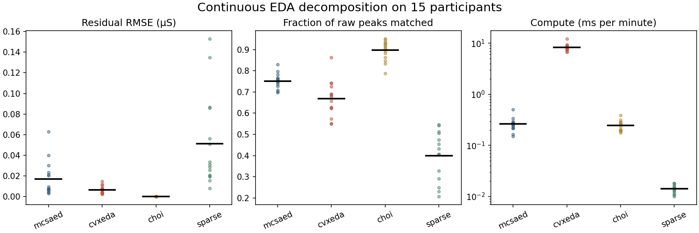
Figure A.6 Decomposition comparison: residual RMSE, peak retention and compute time (MC-SAED vs. cvxEDA, Choi, sparse)
APPENDIX B

Reproducibility and Deployment Record

B.1 Verification records
Every reported number can be regenerated from local datasets with the module runbooks. Verification scripts re-hash source files, reconstruct scalers and splits, and replay saved checkpoints.
Table B.1 Verification records and replay parity
Module | Result directory | Independent unit | Verification outcome
ECG | artifacts/ecg/runs/20261110_lvh_vcbimamba (+ _ablations) | Patient (official folds) | Configuration hash frozen before the single fold-10 evaluation
PPG | research/results/osasud_v1, osasud_binary_dual_rate_v1 | Patient (5 folds) | 55 + 20 checkpoints replayed; max logit Δ 2×10⁻⁶
IMU | research/results/icbimamba_v1 | Participant group | 25 members saved; CPU replay reproduces GPU test logits (Δ < 10⁻²)
EDA | artifacts/eda/runs/wesad_physiomamba_v1 | Participant (LOSO) | Per-person model, scaler, temperature and predictions stored
Jetson | jetson_results/ | Model bundle | Golden vectors: max Δ ≤ 9.5×10⁻⁷, 0 decision changes

B.2 Hardware contracts and deployment checklist
- BioAmp Lead II. RA negative, LL positive, RL reference; counts converted to input-referred mV before the 360 Hz polyphase resampler; 10 s window, 2 s hop; zero missing samples tolerated.
- MAX30102. 100 Hz red/IR FIFO over I²C; one channel per model; Haar shrinkage per completed second; 90 s history with validity mask; restart on gaps.
- Waist MPU-9250. ±16 g and ±2000 °/s, converted to g and °/s; fixed 4 s windows (80 tokens of 50 ms plus raw 200 Hz patches) with 1 s hop; five-second refractory alert logic.
- Wrist EDA. 4 Hz conductance in µS (0–100 µS), 32 Hz accelerometer; optional 120 s resting capture before calibrated scoring.
- Jetson services. deploy/jetson/run_all_benchmarks.sh reproduces the latency tables; deploy/bhanu_jetson/apnea-detector.service starts the SpO₂ detector at boot; build_tensorrt_engines.sh compiles FP16 engines.

