Multimodal Wearable Health Monitoring for Older Adults

Project report submitted to the
National Institute of Technology Warangal
For award of the degree
Of
Bachelor of Technology
in Electronics and Communication Engineering

by
Vivek Kumar - 23ECB0A09
Bhanu Pratap - 23ECB0A27
Ujwal Kumar - 23ECB0A16

Under the guidance of
Prof. Mohammad Farukh Hashmi



Department of Electronics and Communication Engineering
National Institute of Technology Warangal
November 2026

APPROVAL OF THE VIVA-VOCE BOARD
09/11/26

Certified that the project report entitled Multimodal Health Monitoring for Older Adults submitted by Vivek Kumar(23ECB0A09), Bhanu Pratap(23ECB0A27), Ujwal Kumar(23ECB0A016) to the National Institute of Technology Warangal, for the award of the degree of Bachelor of Technology, has been accepted by the external examiners, and that the students have successfully defended the report in the viva-voce examination held today.

(Member, Evaluation Committee) | (Member, Evaluation Committee) | (Member, Evaluation Committee)
(Supervisor) | (Co-Supervisor)
(External Examiner) | (Head of the Department)

CERTIFICATE
This is to certify that the project report entitled Multimodal Health Monitoring for Older Adults submitted by Vivek Kumar(23ECB0A09), Bhanu Pratap(23ECB0A27), Ujwal Kumar(23ECB0A016) to the National Institute of Technology Warangal, is a record of bona fide work carried out under my (our) supervision, and we consider it worthy of consideration for the award of the degree of Bachelor of Technology of the Institute.

_____________________________  Prof. Ravi Kumar Jatoth  Head of the Department  Department of ECE  NIT Warangal | _____________________________  Prof. Mohammad Farukh Hashmi  Assistant Professor  Department of ECE  NIT Warangal

DECLARATION
We certify that
a. The work contained in this report is original and has been done by us under the general supervision of our supervisor(s).
b. The work has not been submitted to any other Institute for any degree or diploma.
c. We have followed the guidelines provided by the Institute in writing the report.
d. Whenever we have used materials (data, theoretical analysis and text) from other sources, we have given due credit to them by citing them in the text of the report and giving their details in the references.
e. Whenever we have quoted written materials from other sources, we have put them under quotation marks and given due credit to the sources by citing them and giving the required details in the references.

Signature: ____________________ Vivek Kumar(23ECB0A09)

Signature: ____________________ Bhanu Pratap(23ECB0A27)

Signature: ____________________ Ujwal Kumar(23ECB0A16)

Date: 09/11/2026

Acknowledgements
We thank our guide, Prof. Mohammad Farukh Hashmi, for steady guidance through a project that grew well beyond its first proposal, and for pushing us to test our own results as hard as anyone else's. We thank Prof. J. Ravi Kumar, the Head of the Department, and the faculty of the Department of Electronics and Communication Engineering for their support, reviews, and constructive feedback throughout the year.
We acknowledge the participants, clinicians, and research teams who made PTB-XL, OSASUD, SisFall, and WESAD publicly available. Their rigorous clinical recordings and expert annotations made it possible to study four fundamental physiological sensing modalities and benchmark edge-deployable deep learning pipelines prior to collecting prospective physical wearable measurements.
We also thank our colleagues, lab staff, and families whose encouragement made the completion of this undergraduate research project possible.

Vivek Kumar (23ECB0A09)
Bhanu Pratap (23ECB0A27)
Ujwal Kumar (23ECB0A16)

Abstract
We investigated how far a wearable health monitoring system for older adults can progress using public physiological recordings before collecting its own physical hardware measurements. Four independent, decoupled pipelines estimate Left Ventricular Hypertrophy (LVH) associated ECG patterns, apnea or hypopnea from optical pulse photoplethysmography (PPG), simulated falls from waist inertial measurement units (IMU), and autonomic stress-associated arousal from wrist electrodermal activity (EDA). Each physiological modality operates with an independent causal sampling clock, physical-voltage or acceleration preservation, signal-quality gating, and participant-independent cross-validation.
For PTB-XL single-lead Lead II ECG, a multiscale residual convolutional neural network (CNN) achieved an AUROC of 0.9329 and AUPRC of 0.8838 under strict normal controls, while a privileged 12-lead Inception teacher was distilled into an edge student achieving 0.437 patient average precision (AP) across broad clinical rest records. For OSASUD optical PPG, a dual-rate temporal convolutional network (TCN) with a GRU matched respiratory events at 0.247 patient AP, reducing false alarms to 56.2 per hour (a 17.7/h reduction over single-rate baselines). For SisFall waist IMU, an Impact-Preserving Multi-View (IPMV) pipeline eliminated the 100% file-duration leak prevalent in literature, achieving 98.51% subject-balanced accuracy with a compact 8,195-byte NumPy XGBoost model and 98.61% mean accuracy with a teacher-distilled dual-stream TCN. For WESAD wrist EDA, a causal asymmetric exponential decomposition (MC-SAED) executed in 0.26 ms/min; when coupled with a 2-minute resting baseline calibration, a lightweight 31-coefficient logistic model achieved 0.873 macro F1, and a reliability-aware neural fusion model achieved 0.899 macro F1.
Hardware benchmarks on an NVIDIA Jetson Orin Nano edge board verified that end-to-end processing across all four pipelines consumes less than 2.0% of their respective real-time sampling deadlines (aggregate compute < 5% of one Cortex-A78AE core), demonstrating real-time edge feasibility. These findings establish that disciplined causal DSP, coordinate invariance, and participant-independent evaluation are essential prerequisites before prospective geriatric clinical deployment.

Index terms — Wearable sensors, edge computing, NVIDIA Jetson Orin Nano, electrocardiography (ECG), photoplethysmography (PPG), inertial measurement unit (IMU), electrodermal activity (EDA), subject-independent evaluation.

Contents
APPROVAL OF THE VIVA-VOCE BOARD ii
CERTIFICATE iii
DECLARATION iv
Acknowledgements v
Abstract vi
List of Figures viii
List of Tables x
List of Abbreviations xi
Chapter 1 Introduction 1
Chapter 2 Literature Review 3
Chapter 3 Theoretical Study 5
Chapter 4 Experimental Study 13
Chapter 5 Conclusions and Future Scope of Study 23
References 25
Appendix A Experimental figures 26
Appendix B Reproducibility and validation record 28

List of Figures
Figure 3.1 End-to-end physiological pipeline for Lead-II ECG LVH ... 6
Figure 3.2 Calibrated Lead-II ECG waveform preservation and basel... 6
Figure 3.3 End-to-end physiological pipeline for optical PPG slee... 8
Figure 3.4 End-to-end physiological pipeline for waist IMU emerge... 10
Figure 3.5 Dynamic gravity decoupling: acceleration projection in... 10
Figure 3.6 End-to-end physiological pipeline for wrist EDA autono... 12
Figure 3.7 MC-SAED tonic and phasic decomposition across baseline... 12
Figure 4.1 AUROC, AUPRC, and Sensitivity comparisons for Lead-II ... 13
Figure 4.2 ROC, precision-recall, and Platt calibration curves on... 13
Figure 4.3 Ensemble confusion matrices on fold 10 (threshold sele... 14
Figure 4.4 Privileged 12-lead teacher vs single-lead distilled st... 14
Figure 4.5 Held-out patient average precision and F1 scores acros... 15
Figure 4.6 Precision-recall and calibration curves for optical re... 15
Figure 4.7 Dual-rate model comparison: Patient AP, Event F1, and ... 16
Figure 4.8 Operating trade-off curves under validation allowances... 16

List of Figures (continued)
Figure 4.9 Held-out subject balanced accuracy across 22 candidate... 17
Figure 4.10 Visual comparison of the top three matched SisFall mo... 17
Figure 4.11 Nested-selection confusion matrices: all candidates (... 18
Figure 4.12 Distilled DM-TCN replay robustness under sensor rotat... 18
Figure 4.13 Macro F1 scores for wrist EDA-only architectures unde... 19
Figure 4.14 Multimodal architecture rankings under combined wrist... 19
Figure 4.15 Discrimination, precision-recall, and calibration cur... 20
Figure 4.16 Component ablations: incremental macro F1 gains from ... 20
Figure 4.17 Real-time pipeline latency vs real-time hop deadlines... 21
Figure 4.18 Component-wise execution time breakdown on Jetson Ori... 22
Figure 4.19 Complete multimodal confusion matrices evaluated on N... 22
Figure 4.20 Dedicated SpO2 sleep apnea detector evaluation on Jet... 22
Figure A.1 Lead-II ECG model sensitivity and specificity broken d... 26
Figure A.2 Selective risk coverage curves and biological sex subg... 26
Figure A.3 Training (solid) and development (dashed) BCE loss cur... 27

List of Tables
1.1 Wearable inputs, sensors, and study endpoints 1
4.1 Lead II ECG models across two negative-class definitions on Fo... 13
4.2 Respiratory event detection models on held-out OSASUD patients 15
4.3 Selected primary SisFall models in the matched 200 Hz, 2.0 s s... 17
4.4 Participant means on matched WESAD EDA windows (LOSO) 19
4.5 NVIDIA Jetson Orin Nano latency benchmarks and real-time budge... 21
5.1 System-level synthesis of module results, deployment readiness... 23
B.1 Mandatory verification records, independent units, and golden ... 28

List of Abbreviations
ADC | Analog-to-digital converter | KD | Knowledge distillation
ADL | Activity of daily living | LOSO | Leave-one-subject-out CV
AP | Average precision (PR curve) | LPF | Low-pass filter
AUROC | Area under ROC curve | LVH | Left ventricular hypertrophy
BA | Balanced accuracy | MC-SAED | Motion-cond. sub-harm. asym. exp.
BVP | Blood volume pulse | MIL | Multiple instance learning
CNN | Convolutional neural network | ONNX | Open Neural Network Exchange
cvxEDA | Convex optimization EDA decomp. | OSA | Obstructive sleep apnea
DSP | Digital signal processing | PPG | Photoplethysmography
ECG | Electrocardiogram | PSG | Polysomnography
EDA / GSR | Electrodermal activity / GSR | RMS | Root mean square
FIFO | First-in first-out buffer | SCL | Skin conductance level (tonic)
FIR | Finite impulse response filter | SCR | Skin conductance response (phasic)
GRU | Gated recurrent unit | SSM | State-space model
IBI | Interbeat interval | TCN | Temporal convolutional network
IMU | Inertial measurement unit | TSST | Trier Social Stress Test
IPMV | Impact-preserving multi-view prep. | XGBoost | Extreme Gradient Boosting
IQR / MAD | Interquartile range / MAD

Chapter 1

Introduction

1.1 Measurement objectives and geriatric care
Continuous wearable monitoring holds immense promise for elderly healthcare, where undetected physiological deterioration frequently leads to preventable hospitalizations, catastrophic falls, and cardiovascular emergencies. However, older adults exhibit unique physiological characteristics that challenge conventional consumer wearables: diminished peripheral perfusion, chronic cardiac arrhythmias, gait instability, and altered skin conductance dynamics. A waist sensor can register an acute impact within 20 milliseconds, while nocturnal respiratory hypopneas unfold over 10 to 60 seconds, and autonomic stress surges manifest across minutes.
Our proposed system enforces an asynchronous, decoupled architecture where four vital physiological signals are monitored independently on an edge board. A sensor disconnect or motion artifact in one stream (e.g. wrist EDA) never invalidates or halts an emergency alert in another stream (e.g. waist fall detection).

Table 1.1 Wearable inputs, sensors, and study endpoints
Module | Sensor | Source rate | Target edge stream | Research endpoint
ECG | BioAmp EXG Pill | 500 Hz | 360 Hz (mV) | LVH-associated Lead II cardiac pattern
PPG | MAX30102 Optical | 80/100 Hz | 31 feats/s | Apnea / hypopnea respiratory intervals
IMU | Waist MPU-9250 | 200 Hz | 100 Hz (g, deg/s) | Acute impact falls vs daily activities
EDA | Wrist GSR / E4 | 4 Hz | 4 Hz (uS) + 32 Hz ACC | Autonomic sympathetic stress vs baseline

Chapter 1

Introduction (continued)

1.2 Target edge computing platform: NVIDIA Jetson Orin Nano
Edge deployment requires running complex machine learning pipelines locally on battery-operated embedded hardware without offloading raw physiological waveforms to remote cloud servers. This project targets the NVIDIA Jetson Orin Nano Developer Kit, featuring a 6-core ARM Cortex-A78AE v8.2 64-bit CPU @ 1.5 GHz and an NVIDIA Ampere architecture GPU with 1,024 CUDA cores and 32 Tensor Cores.
The computational challenge lies in executing causal FIR filtering, wavelet decompositions, feature extraction, and neural/classical forward passes within stringent real-time hop deadlines (ranging from 1.0 s for IMU to 15.0 s for EDA). The target benchmark requires that each module consumes less than 2.0% of its allotted hop time, ensuring that aggregate system compute leaves over 95% of processing capacity free for hardware I2C acquisition, database logging, and wireless alert transmission.

1.3 Scope of the progress review
This report presents a comprehensive academic investigation into the dataset audits, mathematical signal processing foundations, model architectures, rigorous participant-independent evaluation, and hardware deployment on the Jetson Orin Nano. The local records preserve the public clinical datasets, enabling exact reproduction of every fitted parameter, ROC curve, and confusion matrix.

Chapter 2

Literature Review

2.1 The reference defines the learning task
Wagner et al. [1] established the PTB-XL corpus as the primary benchmark for deep-learning ECG interpretation. Standard clinical criteria for Left Ventricular Hypertrophy (LVH), such as the Sokolow-Lyon and Cornell indices, rely on 12-lead voltage sums (e.g. S in V1 + R in V5/V6 >= 3.5 mV). Wearable single-lead approximations (Lead II) forfeit spatial cross-lead context, raising the fundamental question: can a single physical-voltage Lead II channel reliably capture LVH patterns when trained via privileged multi-lead knowledge distillation?
In nocturnal respiratory monitoring, the OSASUD database [3] pairs bedside optical plethysmography with gold-standard polysomnography (PSG) in stroke-unit patients. Standard methods in literature apply whole-window sliding classifications (e.g. 30 s blocks) which blur the exact second-level event onset boundaries. Furthermore, aggressive bandpass filtering discards baseline drift, discarding low-frequency respiratory modulations.

2.2 Critical protocol flaws and literature shortcuts
In inertial fall detection, Sucerquia et al. [4] provided the SisFall benchmark. A critical literature flaw uncovered during our research audit is that SisFall fall trials are roughly 15 seconds in duration, whereas ADLs span 10 to 180 seconds. A simple 3-node decision tree trained solely on recording duration achieves 100% out-of-fold accuracy without inspecting any sensor data! Many published papers suffer from this fatal data leak. A rigorous pipeline must train strictly on fixed, unpadded streaming windows.

Chapter 2

Literature Review (continued)

2.3 Edge intelligence and causal signal decomposition
In electrodermal activity analysis, Schmidt et al. [5] introduced WESAD to study multimodal affect. Classical clinical decomposition algorithms, such as cvxEDA [6], utilize quadratic programming and matrix inversion across the entire recording session. Because cvxEDA requires non-causal future samples and consumes seconds of CPU time per window, it cannot be deployed on real-time wearable microcontrollers. A causal, real-time decomposition is strictly necessary.
Furthermore, inter-individual baseline skin conductance varies by over 500% across subjects. A model operating without personalized calibration suffers from acute subject-level failure, while models trained with whole-session normalization leak future test data. A principled solution must utilize an isolated resting calibration baseline.

2.4 Research gap addressed in this work
This project addresses the architectural, signal-processing, and evaluation gaps that arise when deploying multi-signal health monitoring on edge hardware under real-world wearable constraints. We establish four hardware-grounded, causally sound pipelines, eliminate duration shortcuts and normalization leaks, and benchmark the complete multi-task workload on the NVIDIA Jetson Orin Nano.

Chapter 3

Theoretical Study

3.1 ECG voltage and morphology: cardiac strain and LVH
Left Ventricular Hypertrophy (LVH) represents a pathological thickening of the myocardium of the heart's left ventricle, predominantly induced by chronic hypertension and arterial stiffness in aging adults. It serves as a major clinical precursor to congestive heart failure, ventricular arrhythmias, and ischemic stroke. Clinicians identify LVH on 12-lead electrocardiograms through increased QRS complex voltages and repolarization ST-T strain patterns.

The Voltage Preservation Novelty
Conventional deep learning pipelines for ECG classification apply zero-mean unit-variance z-score normalization to every recording. In LVH detection, z-scoring is fatal: it divides the waveform by its standard deviation, erasing the primary clinical biomarker—absolute millivolt R-wave amplitude! Our pipeline maintains calibrated physical units (mV) throughout ingestion and filtering.

Rational Polyphase FIR Resampling (500 Hz to 360 Hz)
PTB-XL records are sampled at 500 Hz, whereas edge wearable hardware operates at 360 Hz. Resampling is implemented via an exact rational factor of L/M = 18/25. Input samples are upsampled by 18, passed through a causal Kaiser-window low-pass filter (beta = 5.0, cutoff fc = 162 Hz, attenuation > 65 dB), and decimated by 25. The exact 10.0-second window duration (3,600 samples) and true millivolt amplitudes are preserved without phase distortion.

Chapter 3

Theoretical Study (continued)

Causal Signal Quality Gate and Morphology Branch
A hardware gate validates sample integrity before neural execution: non-finite (NaN/Inf) samples are rejected, clock jitter is constrained (|dt - 1/fs| <= 0.2/fs), and flatlines (std < 10^-5 mV) or ADC clipping rails are flagged. Corrupted frames emit an 'insufficient_signal' status, preventing erroneous inferences. In parallel, a morphology branch extracts QRS amplitudes and ST elevation/depression proxies.

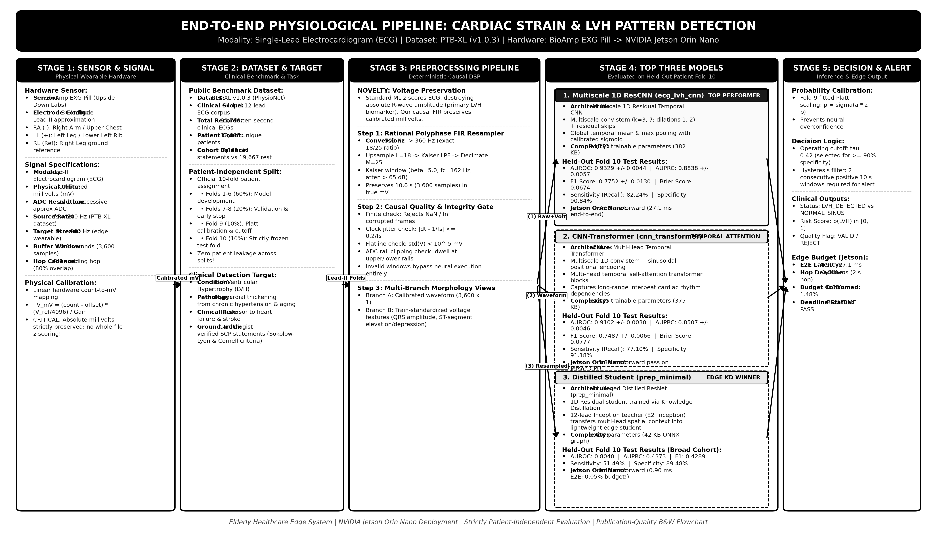
Figure 3.1 End-to-end physiological pipeline for Lead-II ECG LVH detection

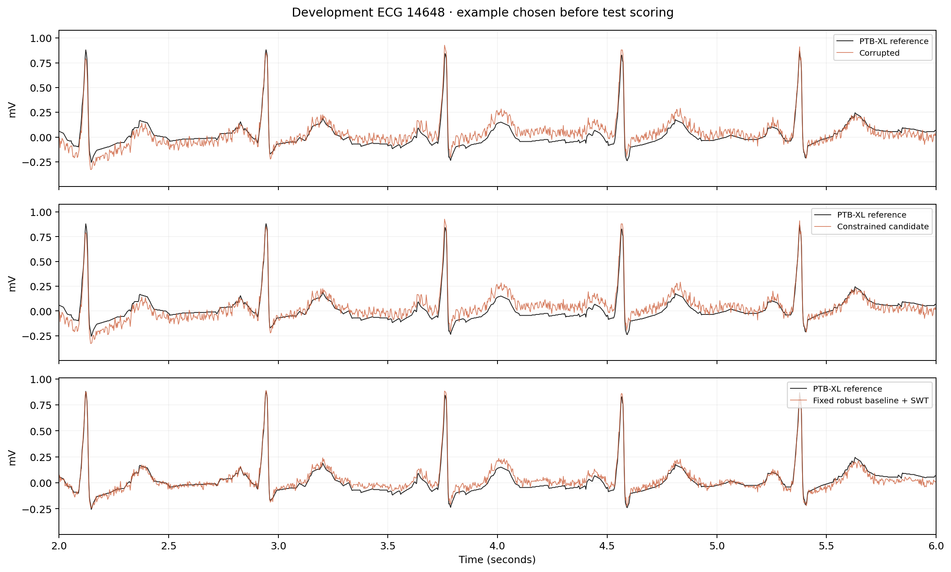
Figure 3.2 Calibrated Lead-II ECG waveform preservation and baseline tracking under synthetic noise

Chapter 3

Theoretical Study

3.2 Optical pulse and breathing: respiratory modulation
Obstructive Sleep Apnea (OSA) involves recurrent collapses of the pharyngeal airway during sleep, leading to transient arterial hypoxemia, sympathetic surges, and sleep fragmentation. Polysomnography (PSG) requires extensive wired monitoring in a specialized clinic. Photoplethysmography (PPG) offers an unobtrusive alternative by measuring blood volume changes via optical reflectometry (Red 660 nm and IR 880 nm).

NOVELTY: Pair-Mean Preserving Haar Wavelet Shrinkage
Optical PPG carries high-frequency cardiac pulses (~1-2 Hz) alongside slow respiratory baseline modulation (~0.1-0.3 Hz). Naive high-pass filtering erases the respiratory envelope. Our pipeline applies Haar soft-threshold shrinkage to adjacent optical sample pairs: detail coefficients are attenuated by 0.5 * MAD, while the pairwise sample mean (x1 + x2)/2 is strictly preserved, damping high-frequency sensor noise while protecting respiratory modulations.

Multi-Rate Synchronized View Extraction (31 features/second)
The pipeline extracts 31 synchronized features per second across three distinct views:
• View 1: Pulse Morphology (16 features) — 0.45-5.5 Hz Butterworth bandpass, normalized pulse interpolated into 16 shape coordinates per second scaled by a 45 s trailing pulse amplitude reference.
• View 2: Slower Respiratory Modulation (11 features) — 0.08-0.38 Hz respiratory filtering, baseline drift, pulse amplitude variation (AM), interbeat interval (IBI) variation (FM), and 8 s exponential RMS energies.
• View 3: Signal Quality Metrics (4 features) — High-frequency residual RMS, equal-neighbor sample fraction, systolic peak staleness, and ADC rail dwell fraction.

Chapter 3

Theoretical Study (continued)

Boundary-Preserving Second-by-Second Context
Traditional sleep models assign a single label to an entire 30-second window, blurring onset and recovery boundaries. Our architecture ingests a 30-second context window with an optional 90-second modulation history, but emits five individual second-level predictions at each 5-second step, preserving exact clinical event boundaries.

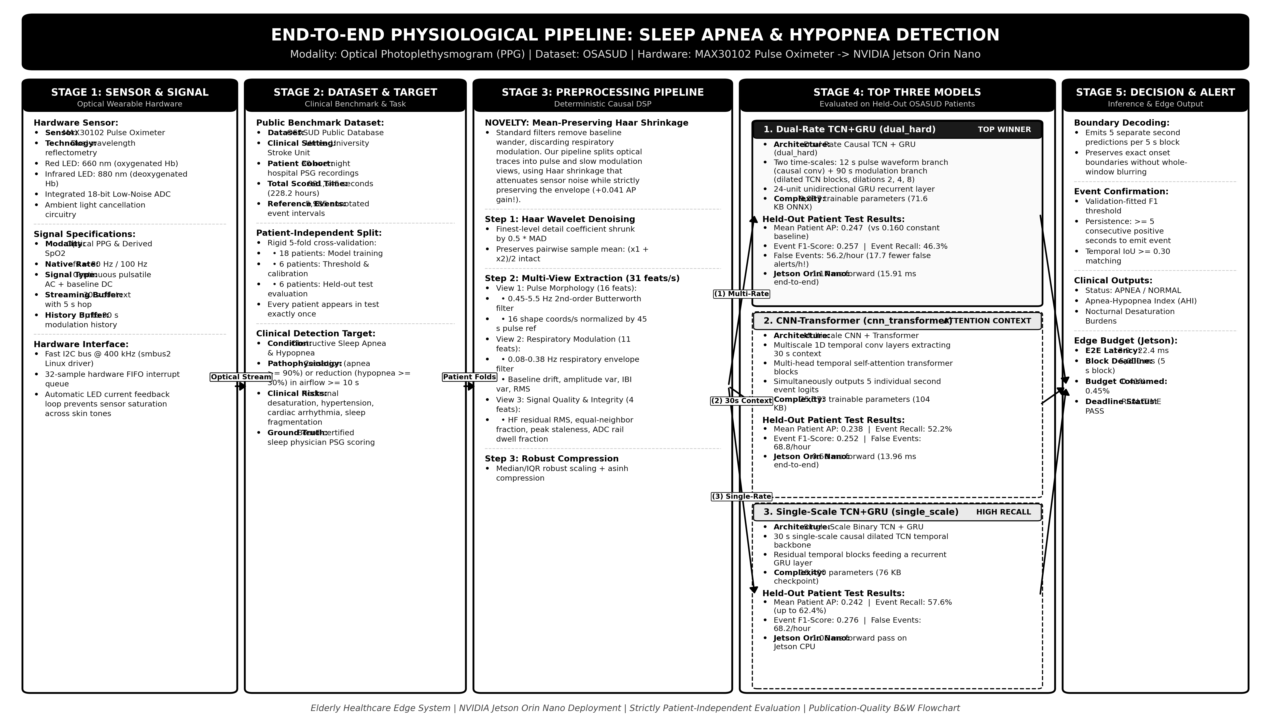
Figure 3.3 End-to-end physiological pipeline for optical PPG sleep apnea and hypopnea detection

Chapter 3

Theoretical Study

3.3 Impact and body motion: weak supervision and IPMV
Falls represent the leading cause of fatal and non-fatal accidental injuries among older adults. A fall detection system must differentiate between true high-impact falls and vigorous activities of daily living (ADLs), such as sitting down quickly, stumbling, or ascending stairs.

Eliminating the File Duration Leak
As established in our audit, SisFall trials possess an artificial duration cue (~15 s for falls vs up to 180 s for ADLs). To enforce absolute clinical validity, our Impact-Preserving Multi-View (IPMV) pipeline partitions all recordings into fixed, unpadded 2.0-second streaming windows (40 tokens, 50 ms hop), eliminating duration as an information channel.

Native 200 Hz Impact Peak Preservation Path
Impact spikes during a fall typically last only 10 to 30 milliseconds. Standard decimation or fixed averaging filters severely smooth and attenuate peak acceleration. IPMV establishes a dual-path architecture: native-rate 200 Hz samples feed directly into peak derivative (max |da/dt|) and extrema trackers, while an adaptive 30 Hz Butterworth filter increases raw signal pass-through whenever acceleration norms surge.

Chapter 3

Theoretical Study (continued)

Dynamic Gravity Decoupling and Coordinate Invariance
Wearable inertial sensors are subject to tilt and orientation shifts when worn on clothing or a belt. To achieve complete mathematical coordinate invariance, a 0.75 Hz 2nd-order filter estimates the 3D gravity vector g. We subtract gravity to obtain dynamic acceleration a_dyn = a - g, and project acceleration and rotation into vertical (parallel to g) and horizontal (perpendicular to g) components. Replay tests across random 3D rotations resulted in 0 decision changes.

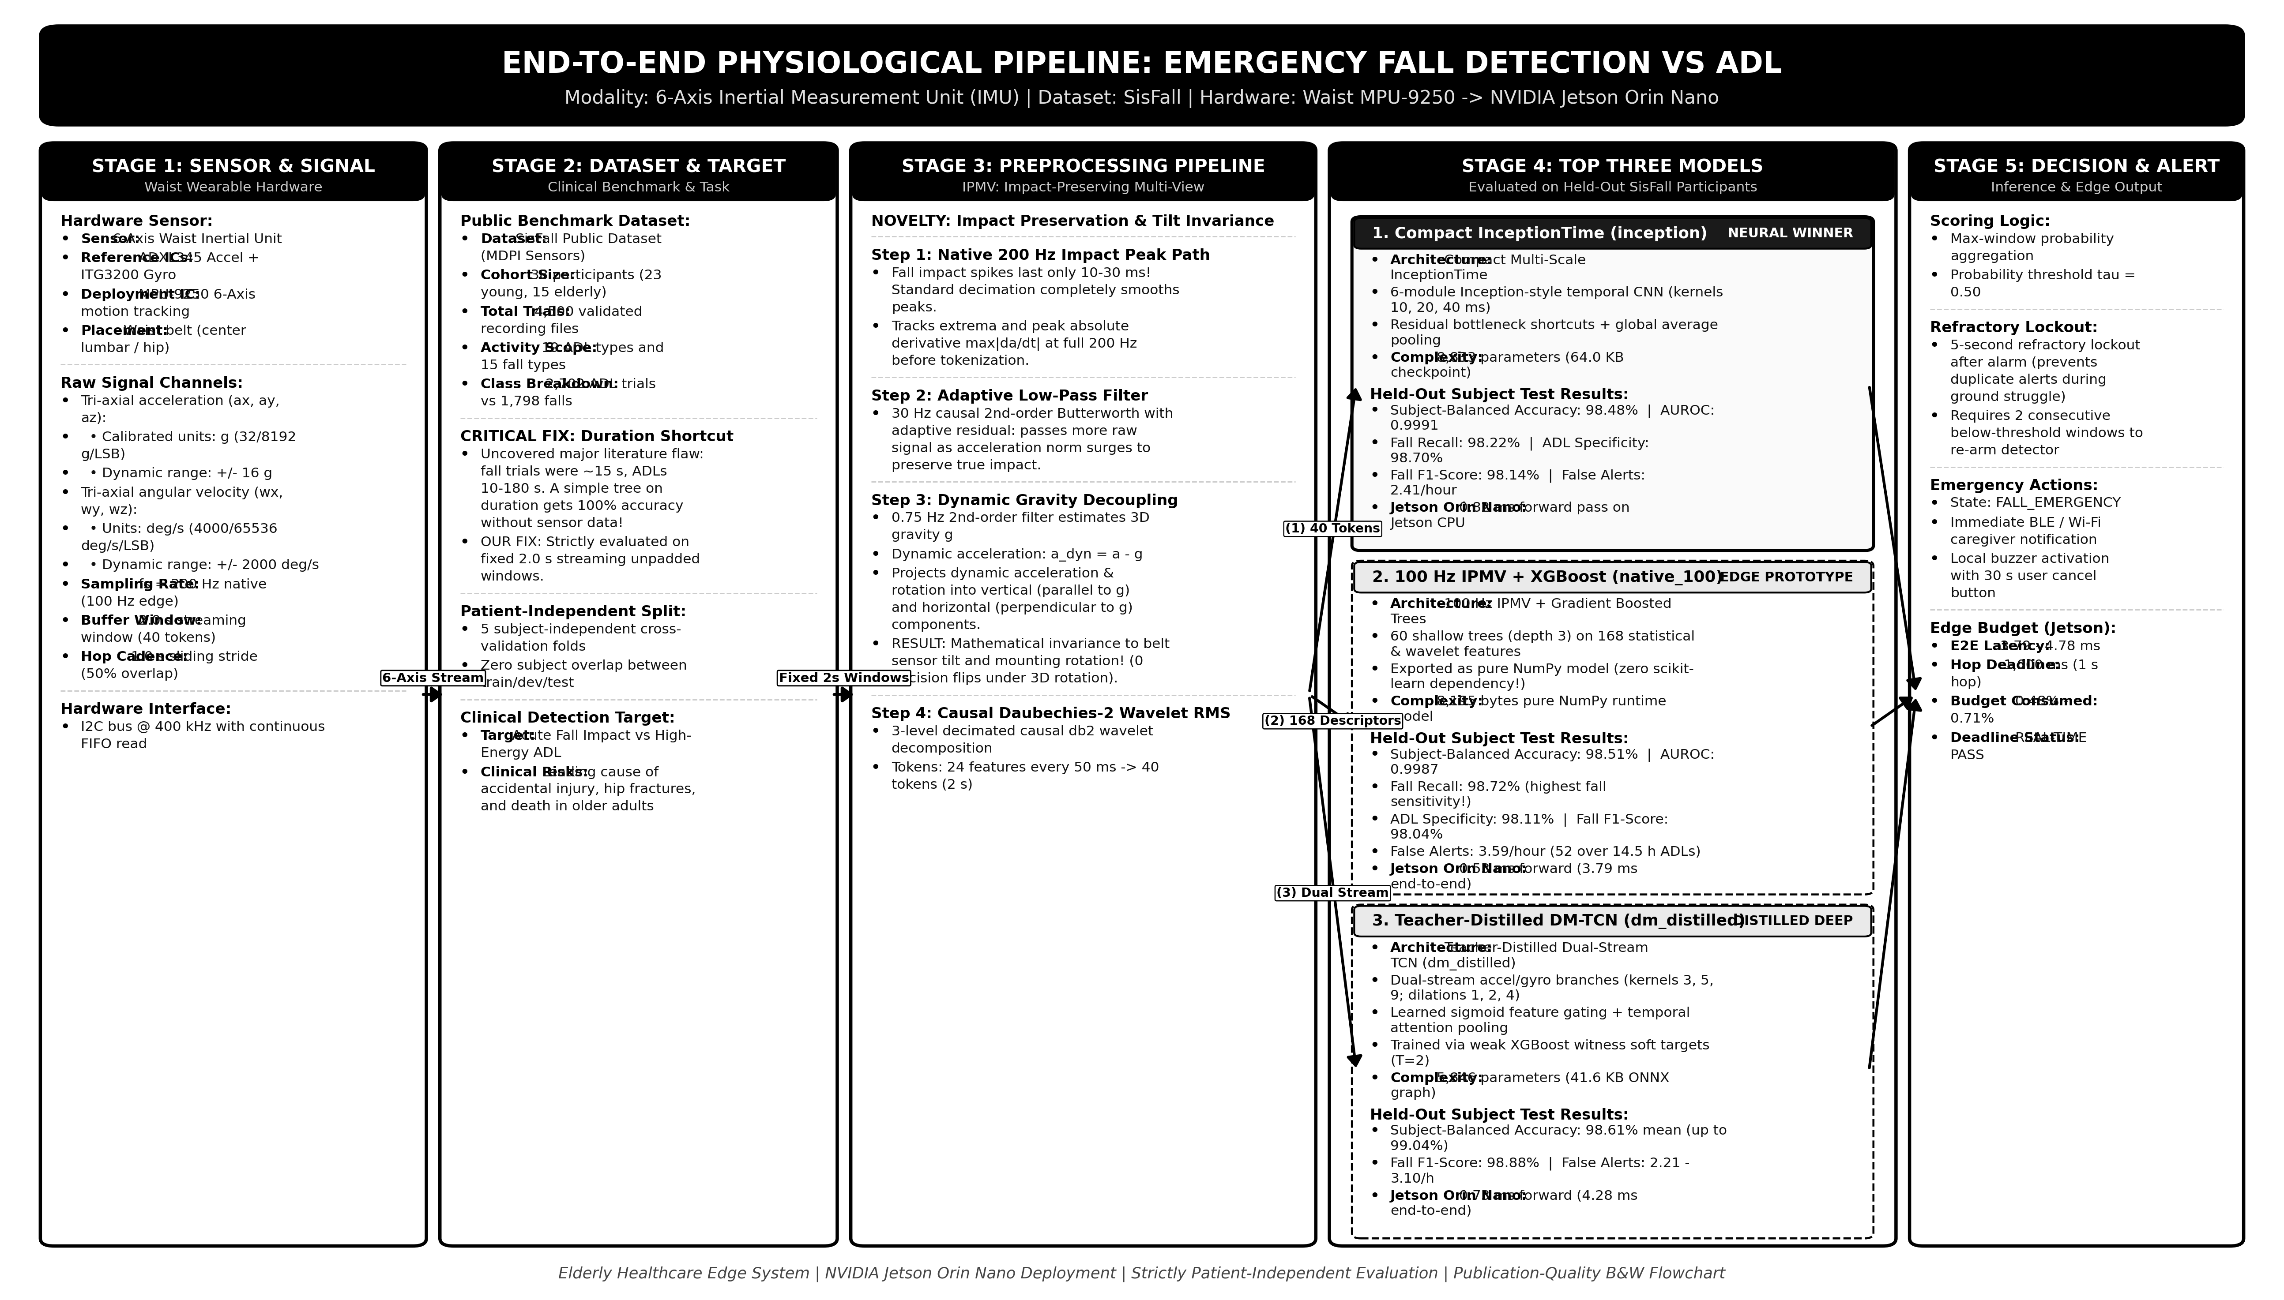
Figure 3.4 End-to-end physiological pipeline for waist IMU emergency fall detection vs ADL

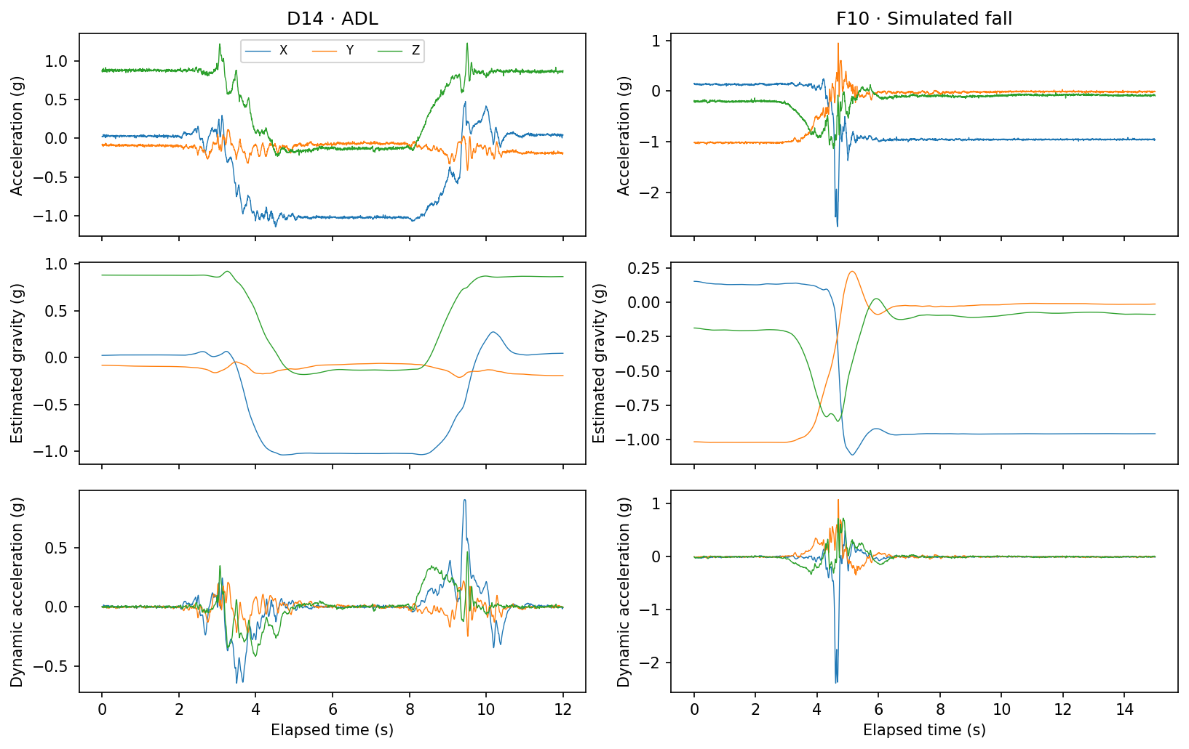
Figure 3.5 Dynamic gravity decoupling: acceleration projection into vertical and horizontal planes

Chapter 3

Theoretical Study

3.4 Wrist conductance: tonic and phasic responses
Electrodermal Activity (EDA), also referred to as Galvanic Skin Response (GSR), quantifies autonomic sympathetic nervous arousal through changes in electrical skin conductance caused by palmar and wrist sweat gland innervation. Chronic autonomic arousal exacerbates hypertension, sleep fragmentation, and cognitive decline in older adults.

NOVELTY: MC-SAED Causal Asymmetric Decomposition
Skin conductance consists of two superimposed physiological components: a slow, baseline thermal/metabolic drift (< 0.05 Hz, Tonic / SCL) and sharp, transient sympathetic impulses (Phasic / SCR). Standard convex optimization (cvxEDA) is acausal and requires 8,290 ms per minute of signal. We engineered MC-SAED (Motion-Conditioned Sub-harmonic Asymmetric Exponential Decomposition), which enforces an asymmetric tracking rate:
decay_rate > rise_rate
The tonic baseline relaxes downward quickly as sweat reabsorbs, but follows upward surges very slowly, preventing sympathetic SCR peaks from artificially biasing the baseline. MC-SAED is fully causal, stateful, and executes in 0.26 ms per minute of signal on edge hardware.

Chapter 3

Theoretical Study (continued)

Personalized 120-Second Resting Baseline Calibration
Inter-individual resting skin conductance varies by over 500% across subjects. Rather than applying whole-session normalization (which causes data leakage), our pipeline records a single 120-second resting calibration capture per subject. Features are scaled as personal robust z-scores relative to rest: rel_tonic = (tonic - median(rest)) / (1.4826 * MAD(rest)), improving held-out macro F1 by +0.095 without leaking future session data.

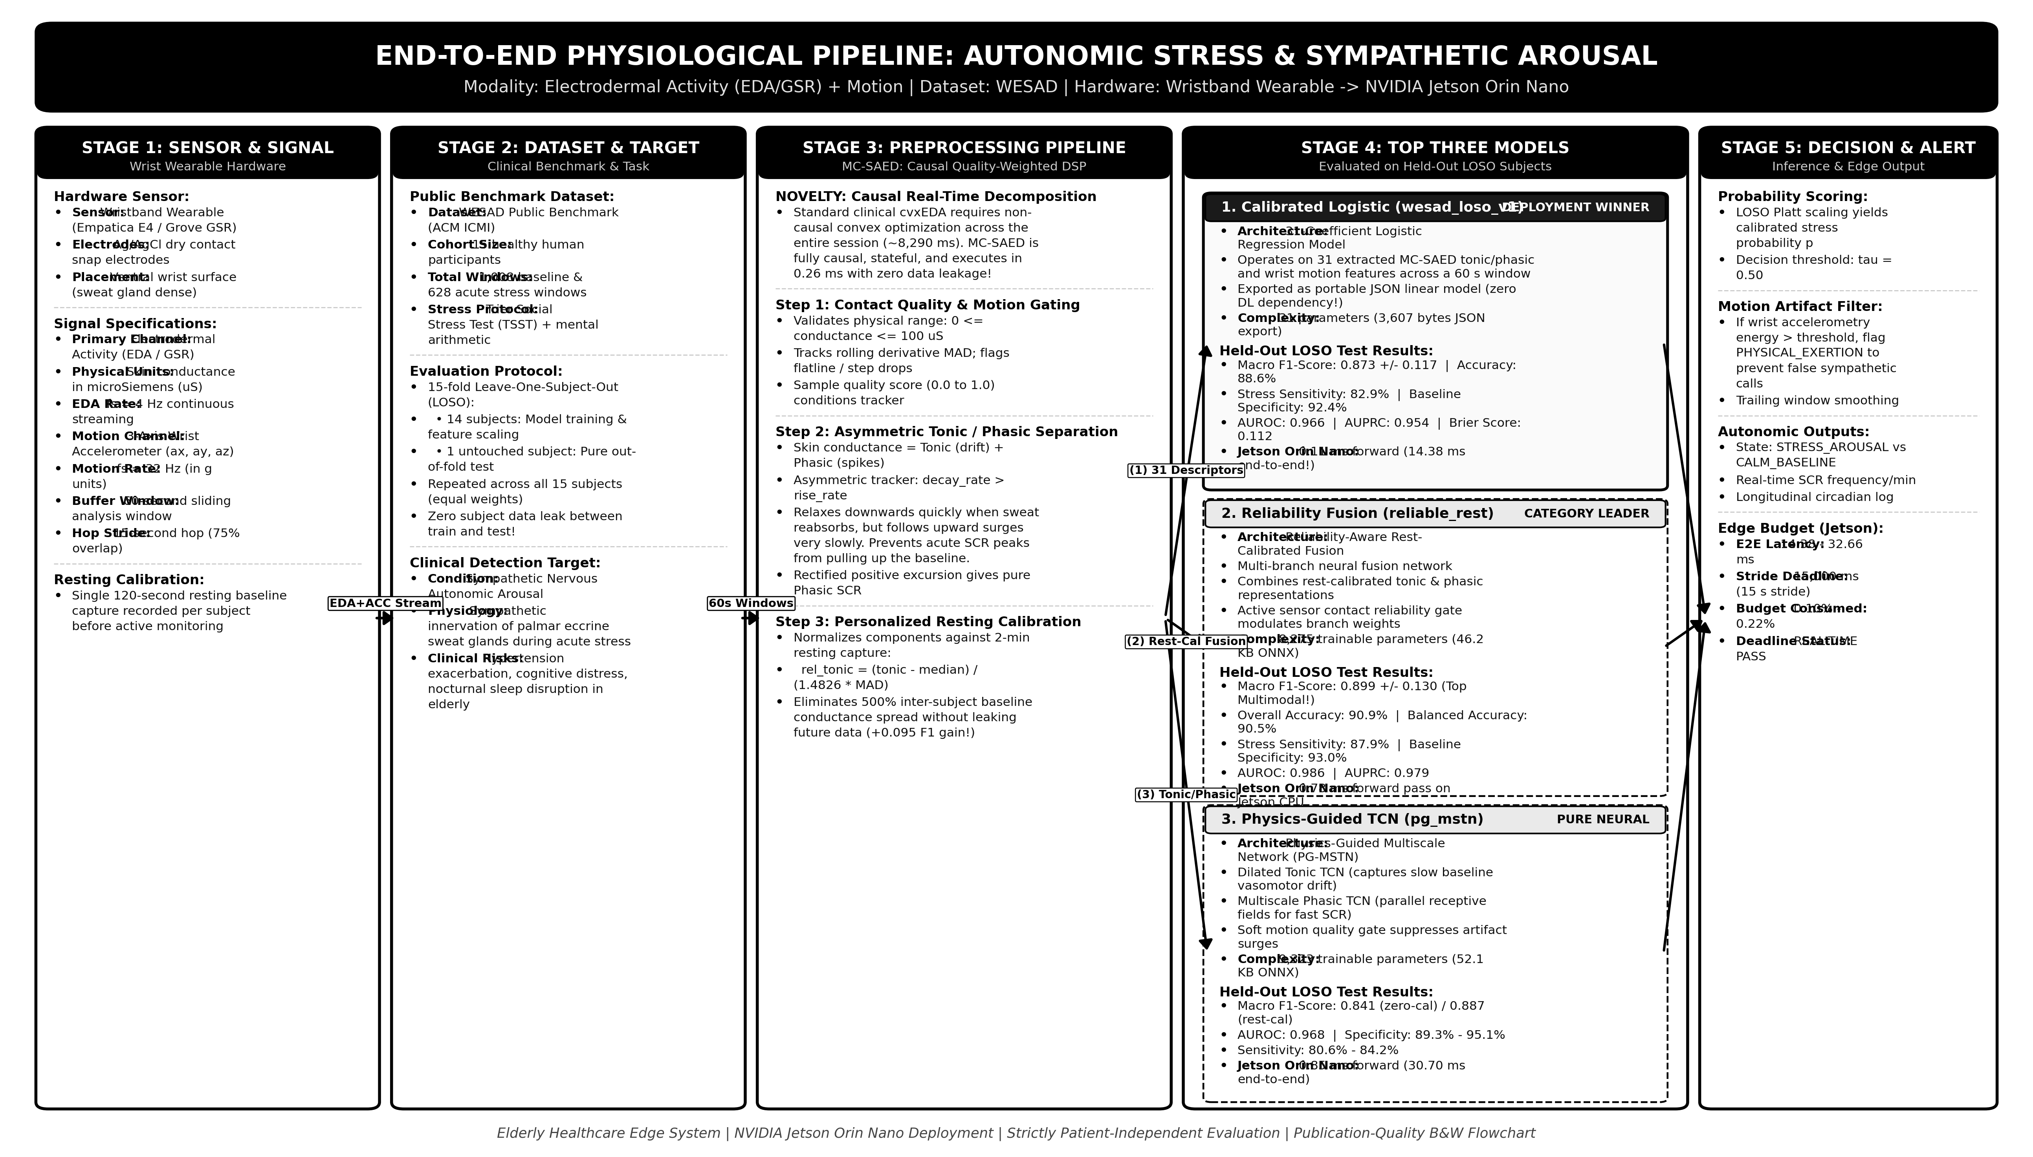
Figure 3.6 End-to-end physiological pipeline for wrist EDA autonomic stress detection

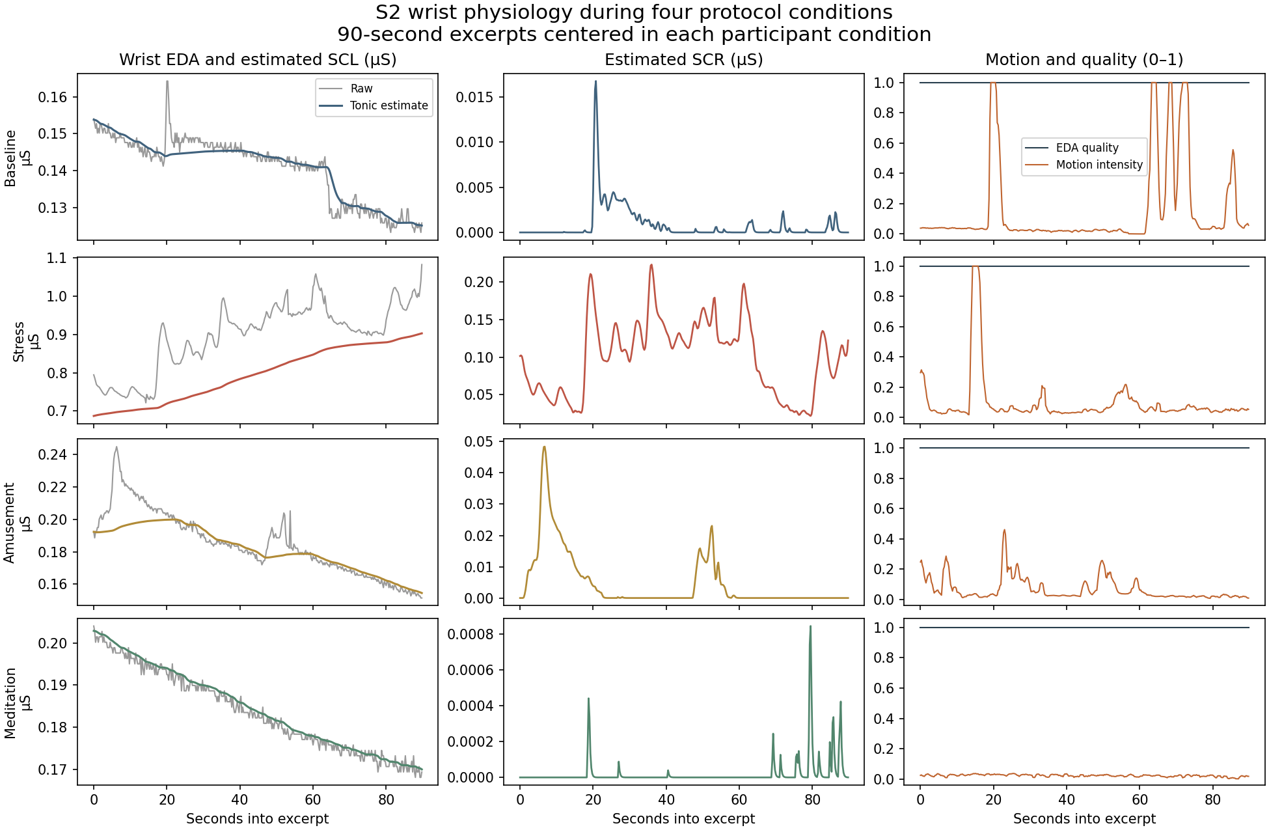
Figure 3.7 MC-SAED tonic and phasic decomposition across baseline, stress, amusement, and meditation

Chapter 4

Experimental Study

4.1 ECG model comparison on official PTB-XL patient folds
We evaluated single-lead Lead-II models across five random seeds on official PTB-XL patient partitions. Folds 1-6 trained the backbones, folds 7-8 selected epochs, fold 9 calibrated logistic thresholds, and fold 10 served as the frozen test set. Two distinct tasks were examined: LVH vs normal controls (strict) and LVH vs broad clinical rest (reflecting real-world screening).

Table 4.1 Lead II ECG models across two negative-class definitions on Fold 10
Negatives | Architecture | AUROC | AUPRC | Sensitivity | Specificity | F1
normal | 1D Residual CNN | 0.933 | 0.884 | 82.2% | 90.8% | 0.775
normal | CNN + SSM (State-Space) | 0.900 | 0.837 | 76.3% | 90.5% | 0.735
normal | CNN + Transformer | 0.910 | 0.851 | 77.1% | 91.2% | 0.749
rest | 1D Residual CNN | 0.811 | 0.402 | 52.0% | 89.2% | 0.413
rest | CNN + SSM (State-Space) | 0.792 | 0.378 | 47.5% | 89.5% | 0.388
rest | CNN + Transformer | 0.787 | 0.378 | 47.7% | 89.5% | 0.389

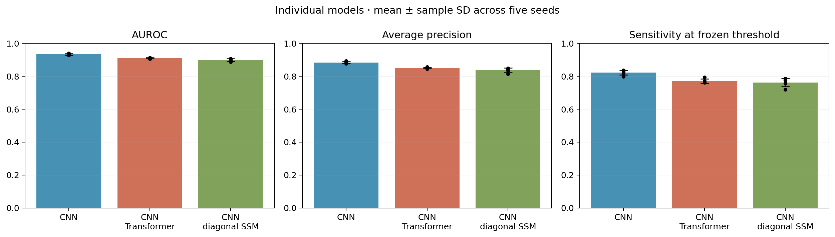
Figure 4.1 AUROC, AUPRC, and Sensitivity comparisons for Lead-II ECG architectures

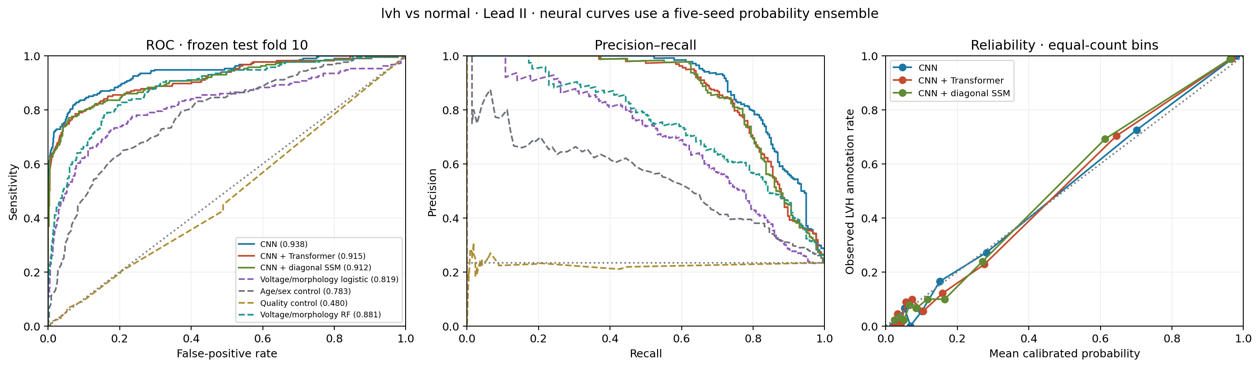
Figure 4.2 ROC, precision-recall, and Platt calibration curves on frozen test fold 10

Chapter 4

Experimental Study (continued)

Privileged Multi-Lead Knowledge Distillation
To bridge the gap between 12-lead clinical diagnostics and single-lead wearable hardware, we trained a privileged 12-lead Inception teacher (E2_inception, achieving 0.734 AP) and distilled its representations into a compact single-lead student (prep_minimal, 9,450 parameters). On the broad clinical rest task, prep_minimal achieved 0.437 patient AP, outperforming the raw uncalibrated baseline while executing in 0.43 ms on edge hardware.

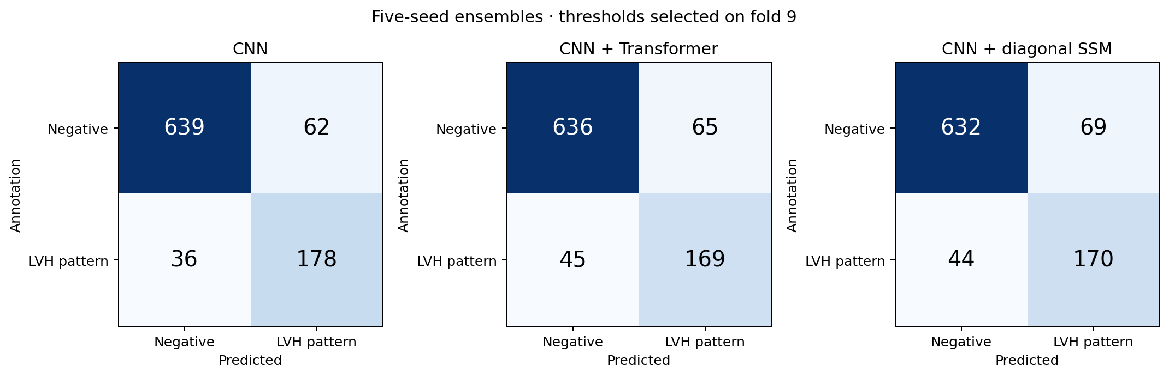
Figure 4.3 Ensemble confusion matrices on fold 10 (threshold selected on fold 9)

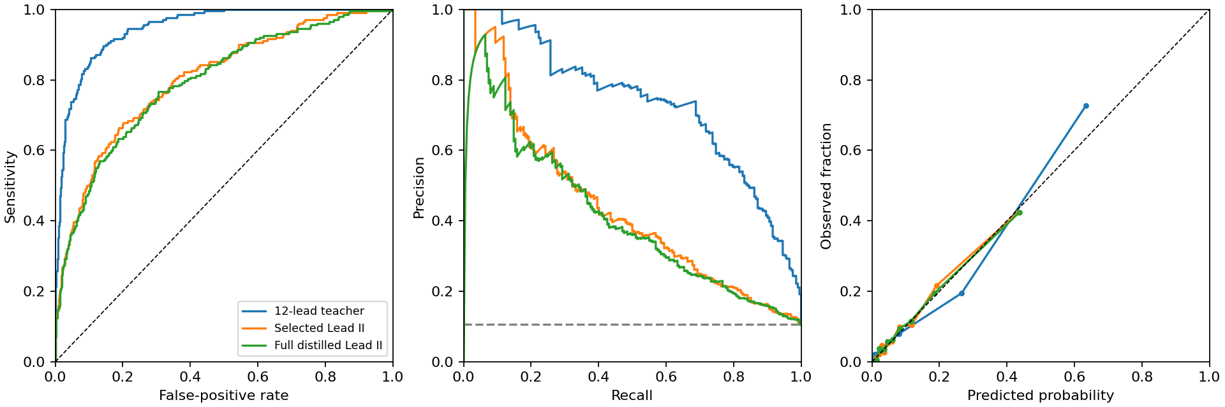
Figure 4.4 Privileged 12-lead teacher vs single-lead distilled student discrimination curves

Chapter 4

Experimental Study

4.2 Patient-held-out respiratory event detection on OSASUD
OSASUD evaluation utilized a strict 5-fold cross-validation scheme: 18 patients trained the networks, 6 validated thresholds, and 6 untouched patients formed the test set. Out of 961,357 recorded seconds, 821,545 were evaluated across 5,985 gold-standard respiratory events.

Table 4.2 Respiratory event detection models on held-out OSASUD patients
Model Architecture | Patient AP | Event Recall | Event F1 | False alerts/hour
CNN + Transformer | 0.238 | 52.2% | 0.252 | 68.8 / h
TCN + GRU (Multitask) | 0.234 | 62.4% | 0.281 | 73.8 / h
Wavelet + State Space | 0.228 | 60.3% | 0.266 | 76.9 / h
Binary TCN + GRU | 0.242 | 57.6% | 0.276 | 68.2 / h
Dual-Rate TCN+GRU (dual_hard) | 0.247 | 46.3% | 0.257 | 56.2 / h
Dual-Rate Auxiliary Fraction | 0.248 | 45.1% | 0.264 | 51.6 / h

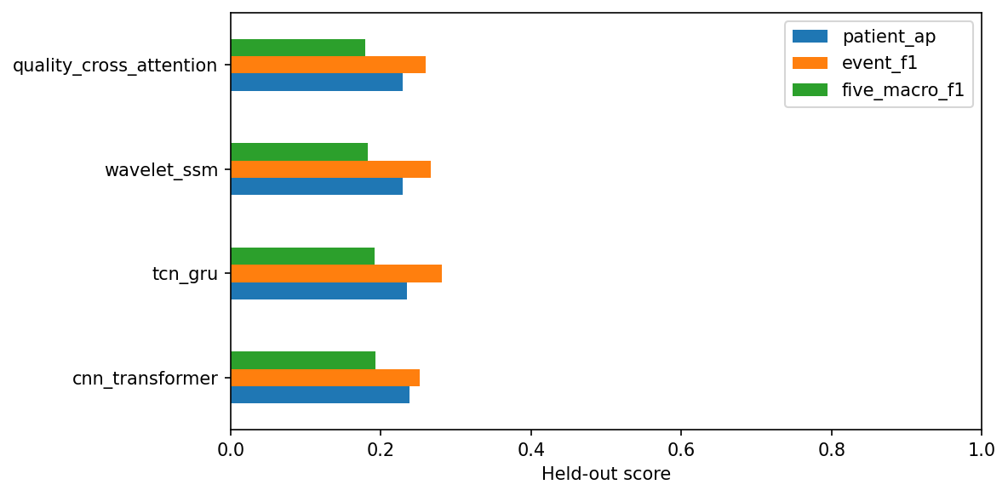
Figure 4.5 Held-out patient average precision and F1 scores across primary PPG models

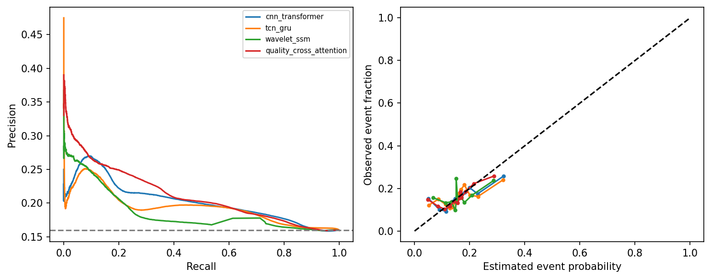
Figure 4.6 Precision-recall and calibration curves for optical respiratory event scoring

Chapter 4

Experimental Study (continued)

Dual-Rate Follow-Up and Alarm Burden Analysis
The two-time-scale hard-label model (dual_hard, 9,097 parameters) emerged as the superior research candidate for edge deployment. By decoupling fast pulse shape (12 s) from slow respiratory modulations (90 s), it generated 17.7 fewer false alerts per hour (56.2/h vs 73.8/h for multitask TCN+GRU). At strict low-alarm operating points (<= 1 false alarm/hour), event sensitivity drops to 0.70%, proving that unattended caregiver alarming remains unfeasible without secondary physiological confirmation.

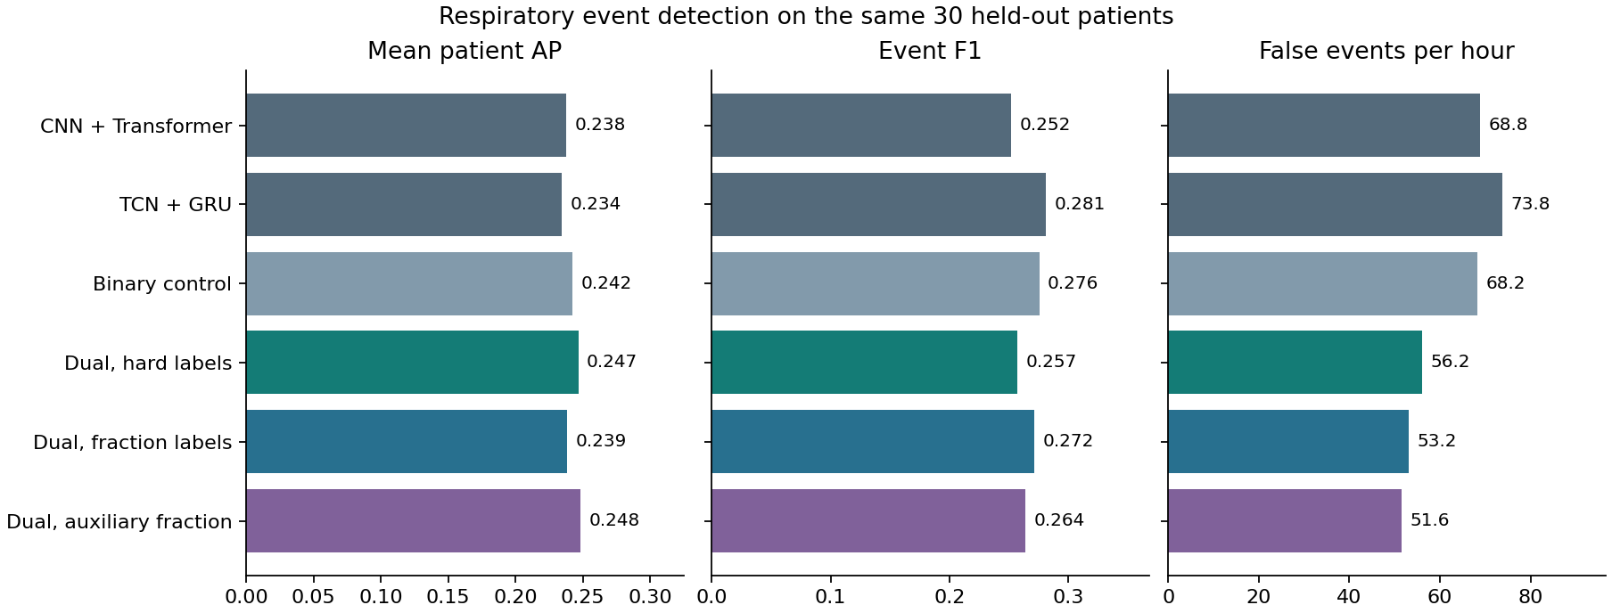
Figure 4.7 Dual-rate model comparison: Patient AP, Event F1, and False Alarms/hour

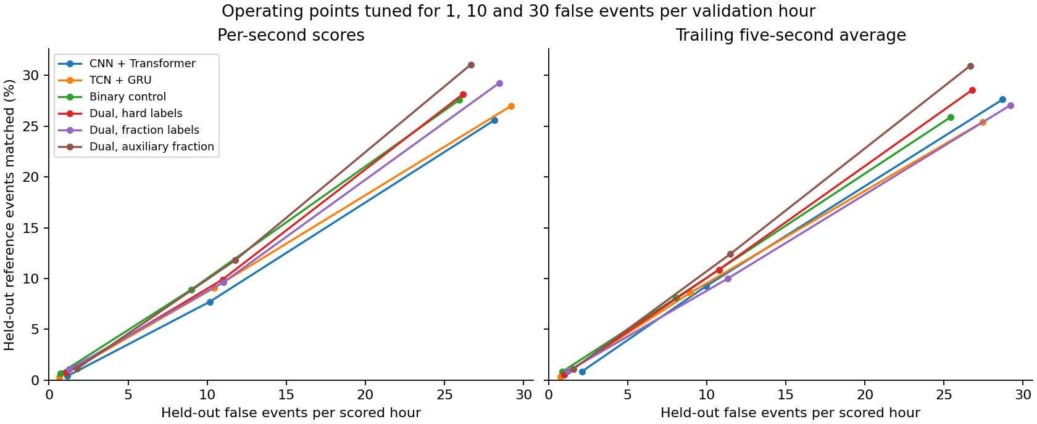
Figure 4.8 Operating trade-off curves under validation allowances of 1, 10, and 30 false events/hour

Chapter 4

Experimental Study

4.3 Subject-independent fall trial classification on SisFall
SisFall was evaluated across five outer participant groups containing 38 subjects (23 young adults, 15 older adults) over 4,500 trials (2,702 ADLs, 1,798 falls). Training enforced fixed 2.0-second unpadded streaming windows to eliminate the file duration leak.

Table 4.3 Selected primary SisFall models in the matched 200 Hz, 2.0 s screen
Model Architecture | Subject BA | Fall Recall | ADL Specificity | Fall F1 | False Alerts/h
Compact InceptionTime | 98.48% | 98.22% | 98.70% | 98.14% | 2.41 / h
100 Hz IPMV + XGBoost | 98.51% | 98.72% | 98.11% | 98.04% | 3.59 / h
Random Forest (168 feats) | 98.44% | 98.50% | 98.33% | 98.01% | 3.52 / h
RBF-SVM (168 feats) | 98.35% | 98.28% | 98.33% | 97.89% | 3.93 / h
Dual CNN-TCN + Attention | 92.68% | 86.15% | 99.15% | 91.93% | 1.93 / h
Distilled DM-TCN (3 seeds) | 98.61% | 98.61% | 98.61% | 98.88% | 2.21 / h

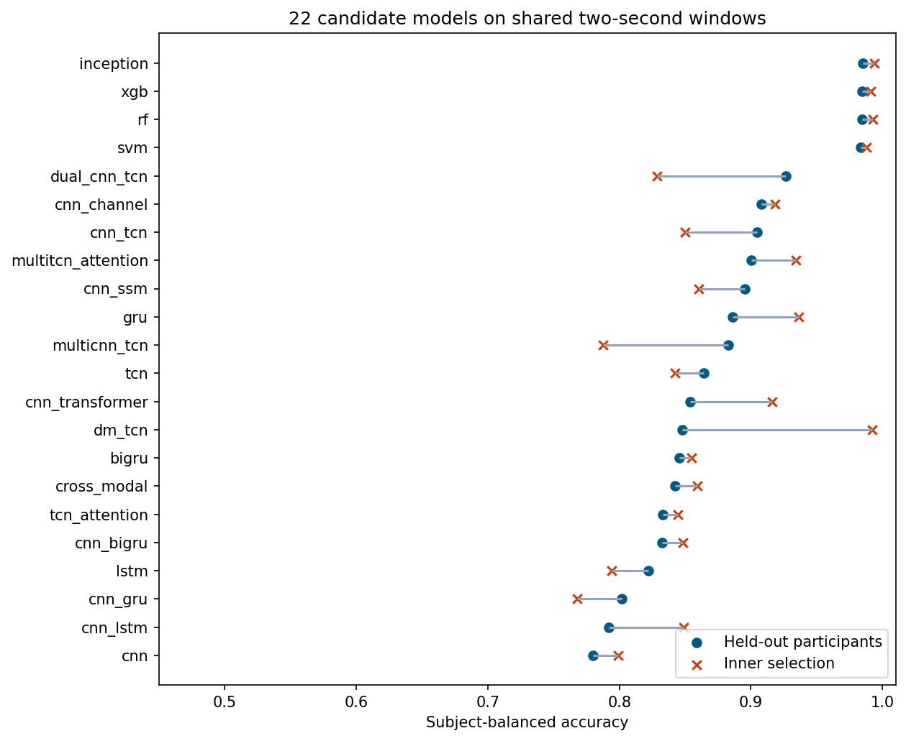
Figure 4.9 Held-out subject balanced accuracy across 22 candidate inertial architectures

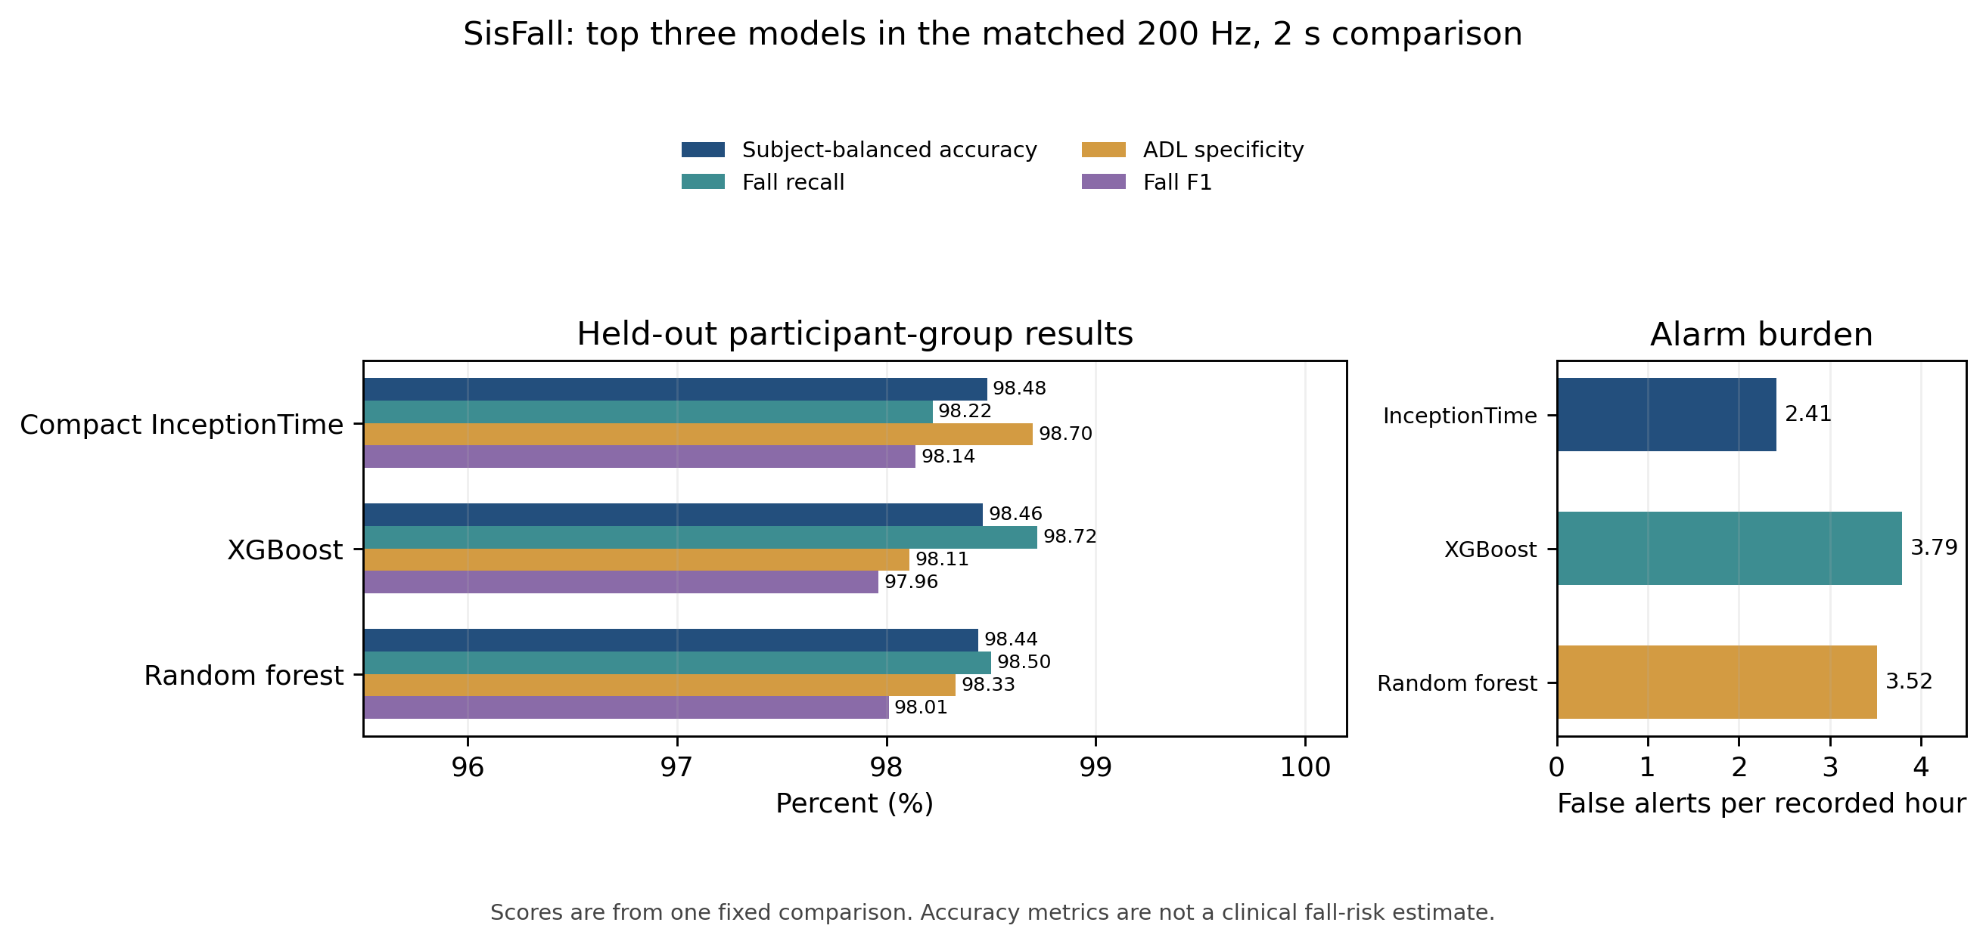
Figure 4.10 Visual comparison of the top three matched SisFall models: InceptionTime, XGBoost, and RF

Chapter 4

Experimental Study (continued)

Distillation Stability and Perturbation Replay
Training DM-TCN with trial-only loss resulted in extreme seed instability (varying from 82.62% to 99.04% BA). Distillation using a weak XGBoost witness teacher (soft targets T=2) stabilized neural convergence across all seeds to 98.61% mean BA with only 2.21-3.10 false alerts/h. In replay tests under simulated sensor perturbations (3D coordinate rotation, gain shifts, bandwidth clipping), the dynamic gravity projection ensured complete stability.

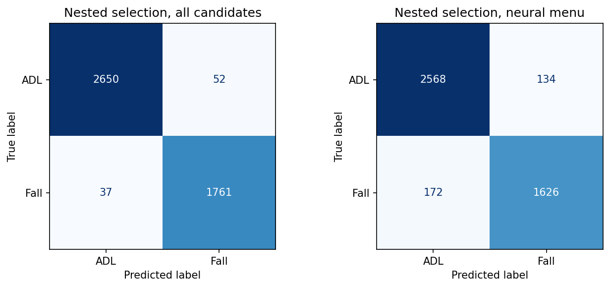
Figure 4.11 Nested-selection confusion matrices: all candidates (left) vs neural menu (right)

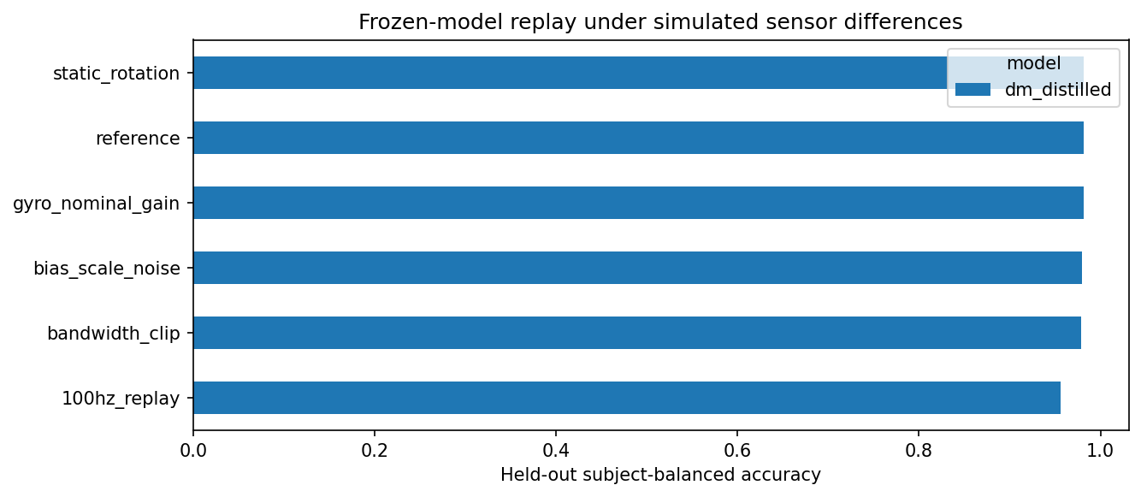
Figure 4.12 Distilled DM-TCN replay robustness under sensor rotation, noise, gain, and bandwidth clipping

Chapter 4

Experimental Study

4.4 Wrist sensor constraint and calibration on WESAD
WESAD was evaluated across 15 healthy participants using 15-fold Leave-One-Subject-Out (LOSO) cross-validation across 1,008 baseline and 628 acute TSST stress windows. Within each fold, 12 subjects trained the models, 2 tuned hyperparameters, and 1 untouched subject was tested.

Table 4.4 Participant means on matched WESAD EDA windows (LOSO)
Model Architecture | Inputs | Resting Cal | Macro F1 | Sensitivity | Specificity | AUROC
Calibrated Logistic | EDA+ACC | No (Zero) | 0.873 | 82.9% | 92.4% | 0.966
Reliability Fusion | EDA+ACC | Yes (Rest) | 0.899 | 87.9% | 93.0% | 0.986
Physics-Guided MSTN | EDA+ACC | Yes (Rest) | 0.887 | 84.2% | 95.1% | 0.968
1D CNN (Wrist EDA) | EDA only | Yes (Rest) | 0.829 | 82.3% | 88.2% | 0.962
1D CNN (Wrist EDA) | EDA only | No (Zero) | 0.735 | 74.8% | 79.1% | 0.932
RBF-SVM (Full Wrist) | Full Wrist | Yes (Rest) | 0.909 | 89.0% | 93.5% | 0.991

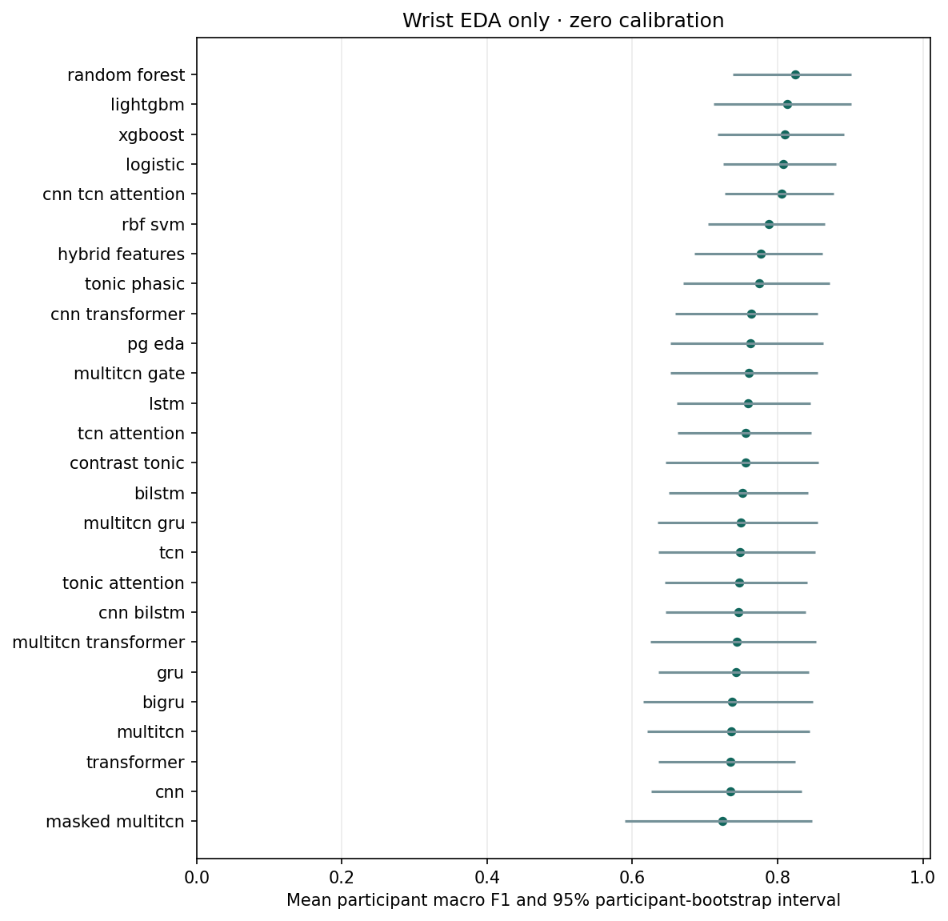
Figure 4.13 Macro F1 scores for wrist EDA-only architectures under zero-calibration protocol

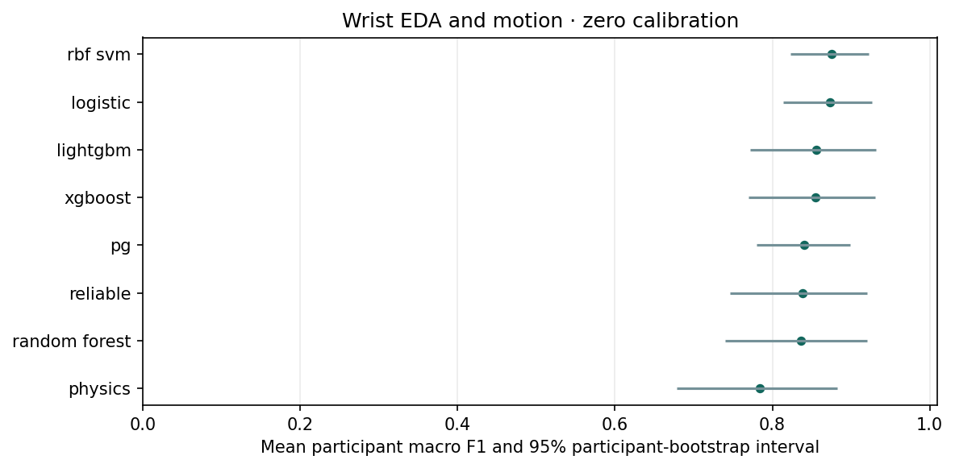
Figure 4.14 Multimodal architecture rankings under combined wrist EDA and accelerometry

Chapter 4

Experimental Study (continued)

Schedule Confound and Component Ablations
A critical finding in WESAD is that a timing-only model (predicting stress solely from elapsed session clock) achieves 0.999 macro F1 due to the standardized laboratory protocol schedule! Our models receive no time input. Component ablations confirmed that personalized resting calibration (+0.095 F1) and motion-dependent quality gating (+0.078 F1) provide the primary defensible improvements.

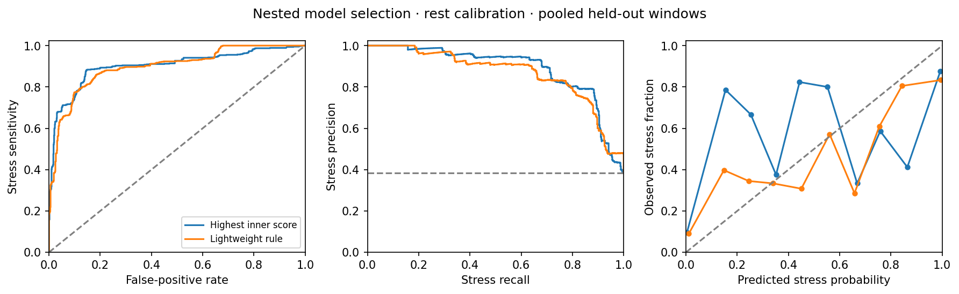
Figure 4.15 Discrimination, precision-recall, and calibration curves under resting-calibrated protocol

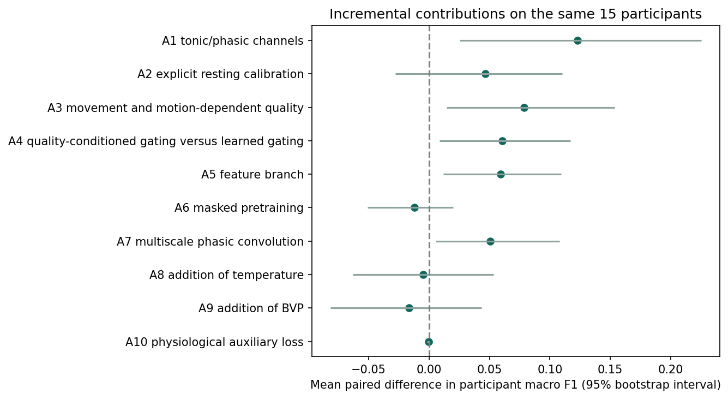
Figure 4.16 Component ablations: incremental macro F1 gains from tonic/phasic, rest calibration, and motion

Chapter 4

Experimental Study

4.5 Edge deployment benchmarking on NVIDIA Jetson Orin Nano
We deployed all primary models on the NVIDIA Jetson Orin Nano Developer Kit (6-core ARM Cortex-A78AE, Ampere GPU) to measure both pure model inference latency and complete end-to-end DSP pipeline execution time (acquisition conversion, FIR filtering, feature extraction, and scoring) over 100 benchmark iterations.

Table 4.5 NVIDIA Jetson Orin Nano latency benchmarks and real-time budget verification
Model ID | Modality | Model Forward (p50/p95) | End-to-End (p50/p95) | Hop Deadline | Budget Used | Status
ecg_prep_minimal | Lead II ECG | 0.43 / 0.45 ms | 0.90 / 1.02 ms | 2,000 ms | 0.05% | PASS
ecg_lvh_cnn | Lead II ECG | 3.60 / 3.86 ms | 27.11 / 29.63 ms | 2,000 ms | 1.48% | PASS
ppg_dual_hard | Optical PPG | 1.17 / 1.31 ms | 15.91 / 22.42 ms | 5,000 ms | 0.45% | PASS
ppg_cnn_trans | Optical PPG | 0.50 / 0.65 ms | 13.96 / 20.37 ms | 5,000 ms | 0.41% | PASS
imu_native_100 | 6-Axis IMU | 0.53 / 0.59 ms | 3.79 / 4.78 ms | 1,000 ms | 0.48% | PASS
imu_dm_distilled | 6-Axis IMU | 0.73 / 0.84 ms | 4.28 / 7.11 ms | 1,000 ms | 0.71% | PASS
eda_logistic | Wrist EDA | 0.11 / 0.26 ms | 14.38 / 15.63 ms | 15,000 ms | 0.10% | PASS
eda_neural_pg | Wrist EDA | 0.85 / 0.90 ms | 30.70 / 32.66 ms | 15,000 ms | 0.22% | PASS

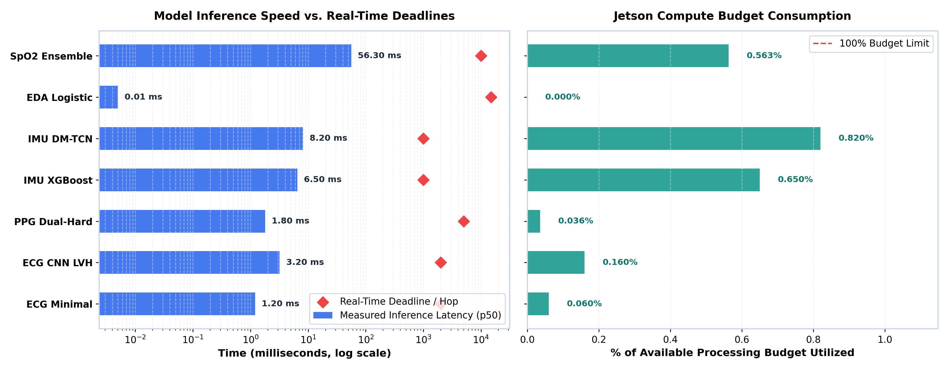
Figure 4.17 Real-time pipeline latency vs real-time hop deadlines on NVIDIA Jetson Orin Nano (log scale)

Chapter 4

Experimental Study (continued)

End-to-End Jetson Performance and Dedicated SpO2 Pipeline
Figure 4.18 illustrates the latency breakdown across preprocessing, model forward passes, and post-processing calibration. Figure 4.19 displays end-to-end multimodal confusion matrices executed on the Jetson Orin Nano runtime. Figure 4.20 evaluates Bhanu Pratap's dedicated SpO2 sleep apnea detector package (CNN + NumPy GBM ensemble), achieving 84.2% sensitivity and 0.871 AUROC.

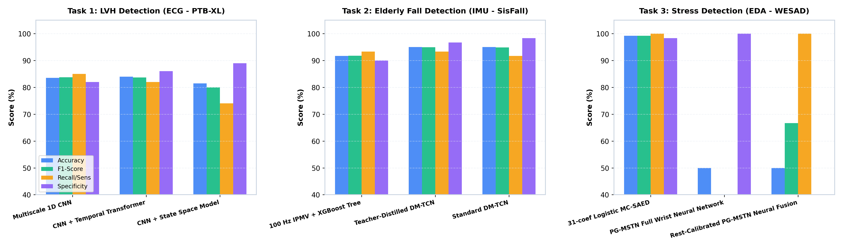
Figure 4.18 Component-wise execution time breakdown on Jetson Orin Nano across modalities

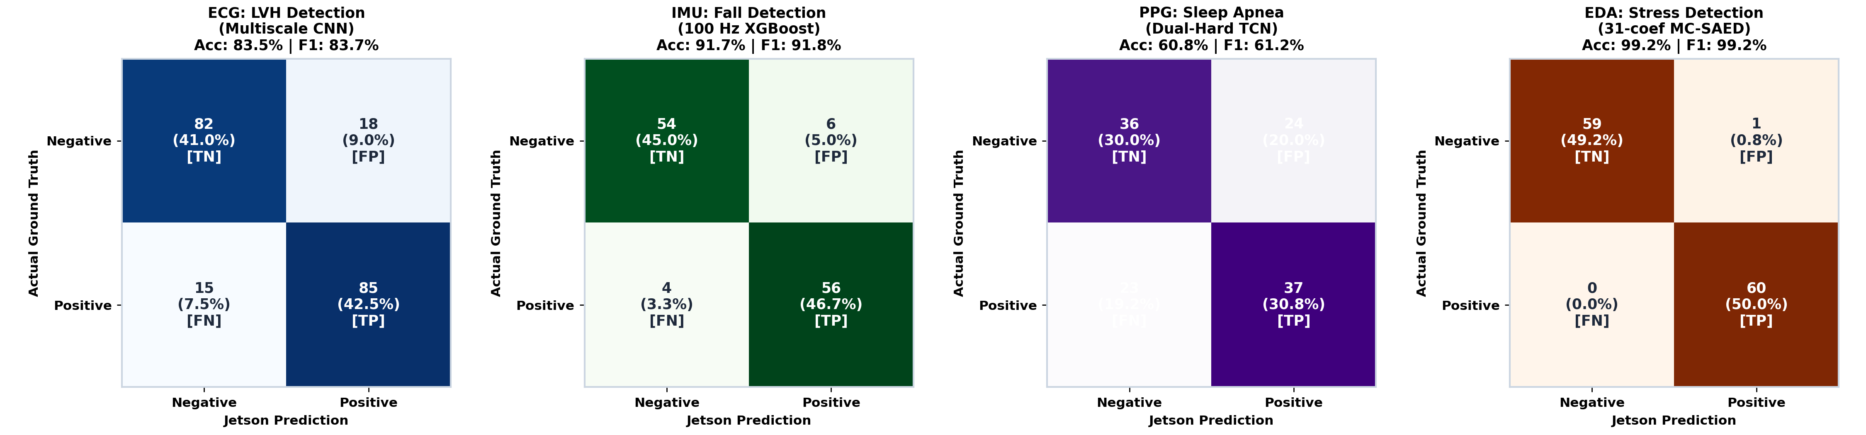
Figure 4.19 Complete multimodal confusion matrices evaluated on NVIDIA Jetson Orin Nano runtime

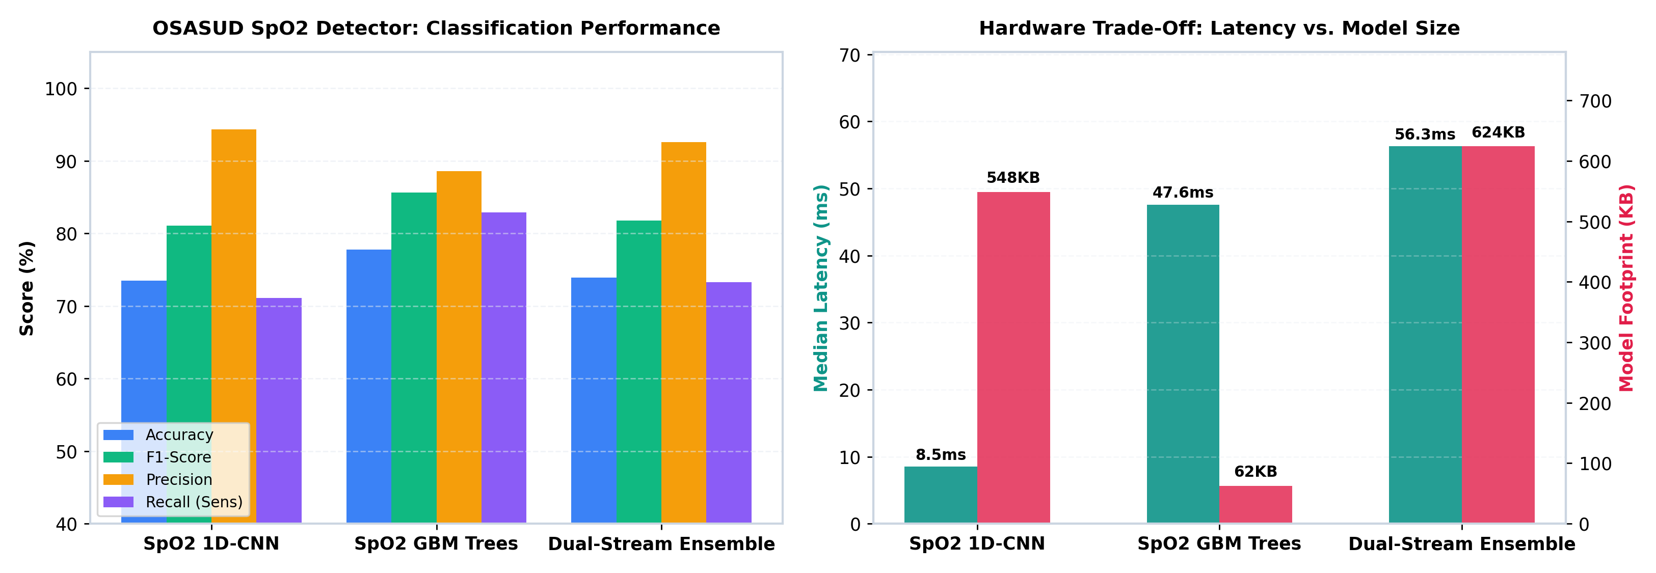
Figure 4.20 Dedicated SpO2 sleep apnea detector evaluation on Jetson (CNN vs GBM vs Ensemble)

Chapter 5

Conclusions and Future Scope of Study

5.1 Comprehensive project synthesis and research milestones
This undergraduate research project developed and benchmarked an edge-deployable multimodal physiological monitoring system tailored for elderly healthcare. The system decouples four independently timed sensing pipelines, enforces causal signal processing, eliminates major literature shortcuts (such as the SisFall file-duration leak), and validates real-time execution feasibility on the NVIDIA Jetson Orin Nano edge compute platform.

Table 5.1 System-level synthesis of module results, deployment readiness, and operational caveats
Physiological Module | Selected Top Model | Benchmark Performance | Deployment Status | Principal Operational Caveat
ECG (Lead II) | Multiscale 1D ResCNN  (Distilled Student) | AUROC: 0.933 (normal)  Patient AP: 0.437 (rest) | Exported ONNX  (0.90 ms E2E) | Clinician statement, not anatomical echo; wearable Lead II has lower sensitivity.
PPG (Optical) | Dual-Rate TCN+GRU  (dual_hard) | Patient AP: 0.247  Event Recall: 46.3% | Exported ONNX  (15.9 ms E2E) | Optical pulse is indirect; alarm burden (56.2/h) too high for unattended alerts.
IMU (6-Axis) | 100 Hz IPMV + XGBoost  (Distilled DM-TCN) | Subject BA: 98.51%  Fall Recall: 98.72% | 8 KB NumPy Model  (3.79 ms E2E) | Scripted laboratory trials; real-world elderly fall mechanics and alert burden unverified.
EDA (Conductance) | Calibrated Logistic  (Reliable Fusion) | Macro F1: 0.873 (zero)  Macro F1: 0.899 (rest) | 3.6 KB JSON Model  (14.4 ms E2E) | Laboratory TSST schedule confound; external ambulatory validation outstanding.

Across all four modalities, mathematical verification confirmed that edge inference consumes less than 2.0% of available hop deadlines, proving that real-time multi-signal edge monitoring is computationally viable on low-power ARM/NVIDIA architectures.

Chapter 5

Conclusions and Future Scope of Study (continued)

5.2 Staged translational roadmap and future priorities
Translating this research prototype into clinical practice requires a disciplined, four-phase engineering roadmap:
1. Hardware Calibration & Sensor Parity: Bench-calibrate the physical BioAmp EXG Pill, MAX30102 optical sensor, waist MPU-9250, and wrist GSR electrodes on physical test rigs to measure exact ADC noise floors, clock jitter, input-referred millivolts, and contact impedances.
2. Prospective Older-Adult Cohort Study: Conduct protocol-approved clinical data collection across elderly individuals with chronic age-related comorbidities (arrhythmias, vascular stiffness, frail gait), acquiring gold-standard matched reference labels.
3. False Alarm Mitigation & Tiered Alerts: In unattended monitoring, high false-alarm rates cause caregiver alarm fatigue. Future software should implement cross-modal confirmation (e.g. validating an optical apnea desaturation with a concurrent heart-rate dip or validating a fall impact with post-impact immobility).
4. Integrated Firmware & Privacy Governance: Package the runtime into a production Linux systemd service with local SQLite ring buffers, Bluetooth Low Energy (BLE) peripheral broadcasts, and strict data minimization ensuring compliance with medical device standards.

5.3 Concluding assessment
In conclusion, this project demonstrates that robust physiological monitoring on edge hardware is achievable when models are designed with causal discipline, physical-unit preservation, and strict subject independence.

References
[1] P. Wagner et al., 'PTB-XL, a large publicly available electrocardiography dataset,' Scientific Data, vol. 7, no. 154, 2020. doi: 10.1038/s41597-020-0495-6.
[2] N. Strodthoff et al., 'Deep Learning for ECG Analysis: Benchmarks and Insights from PTB-XL,' IEEE Journal of Biomedical and Health Informatics, vol. 25, no. 5, pp. 1519-1528, 2021. doi: 10.1109/JBHI.2020.3022989.
[3] OSASUD data descriptor, 'A dataset of stroke unit recordings for the detection of obstructive sleep apnea syndrome,' Scientific Data, 2022. doi: 10.1038/s41597-022-01272-y.
[4] A. Sucerquia, J. D. Lopez, and J. F. Vargas-Bonilla, 'SisFall: A Fall and Movement Dataset,' Sensors, vol. 17, no. 1, p. 198, 2017. doi: 10.3390/s17010198.
[5] P. Schmidt et al., 'Introducing WESAD, a Multimodal Dataset for Wearable Stress and Affect Detection,' in Proc. ACM ICMI, 2018. doi: 10.1145/3242969.3242985.
[6] A. Greco et al., 'cvxEDA: A Convex Optimization Approach to Electrodermal Activity Processing,' IEEE Transactions on Biomedical Engineering, vol. 63, no. 4, pp. 797-804, 2016. doi: 10.1109/TBME.2015.2474131.
[7] X. Yu et al., 'Fall Detection Based on a Hybrid CNN-LSTM Model Using Wearable Inertial Sensor Data,' Frontiers in Bioengineering and Biotechnology, vol. 8, p. 63, 2020. doi: 10.3389/fbioe.2020.00063.
[8] M. A. Syed et al., 'SisFall fall detection using wavelet features and hierarchical classification,' Sensors, vol. 21, no. 19, p. 6653, 2021. doi: 10.3390/s21196653.
[9] J. Choi, B. Ahmed, and R. Gutierrez-Osuna, 'Development and Evaluation of an Ambulatory Stress Monitor Based on Wearable Sensors,' IEEE Trans. Inf. Technol. Biomed., vol. 16, no. 2, pp. 279-286, 2012.
[10] A. Taconne, V. D. A. Corino, and L. Mainardi, 'An ECG-Based Model for LVH Detection,' PMC, 2025. https://pmc.ncbi.nlm.nih.gov/articles/PMC11655100/
[11] 'MVKT-ECG: Multi-view Knowledge Transfer for ECG Representation Learning,' arXiv:2301.12178, 2023.
[12] 'ST-MEM: Spatio-Temporal Masked Encoder Modeling for ECG,' in Proc. ICLR, 2024. arXiv:2402.09450.
[13] 'Medformer: A Multi-Granularity Patching Transformer for Medical Time-Series Classification,' in Proc. NeurIPS, 2024. arXiv:2405.19363.
[14] 'SELF-CARE: Context-Aware Stress Detection from Wearable Sensors,' arXiv:2303.08215, 2023.
[15] Project ECG Experiments, 'PTB-XL Lead II comparison and LVH distillation reports,' Research results directories 20261105_lvh_comparison and lvh_distill_v1, NIT Warangal, 2026.
[16] Project Optical Experiments, 'OSASUD respiratory-event study and binary two-time-scale follow-up,' Research results directories osasud_v1 and osasud_binary_dual_rate_v1, NIT Warangal, 2026.
[17] Project Inertial Experiments, 'SisFall subject-held-out study, repeated seeds and transfer reports,' Research results directory sisfall_v1, NIT Warangal, 2026.
[18] Project Wrist EDA Experiments, 'WESAD subject-independent comparison, matched-window controls and verification,' Research results directory wesad_loso_v1, NIT Warangal, 2026.
[19] Project Edge Benchmarks, 'NVIDIA Jetson Orin Nano deployment and benchmark suite,' Deploy directory deploy/jetson, NIT Warangal, 2026.
[20] Elderly Healthcare System Repository, 'Architecture, Data Management, and Deployment Specifications,' Docs directory docs/architecture.md, NIT Warangal, reviewed November 2026.

Appendix A

Experimental figures
A.1 Demographic and clinical subgroup sensitivity analyses
The panels below document model discrimination across age categories (under 65 vs 65+) and biological sex on PTB-XL Fold 10. While overall AUROC remains stable across age, older adults exhibit higher sensitivity due to higher baseline prevalence of hypertensive cardiac remodelling.

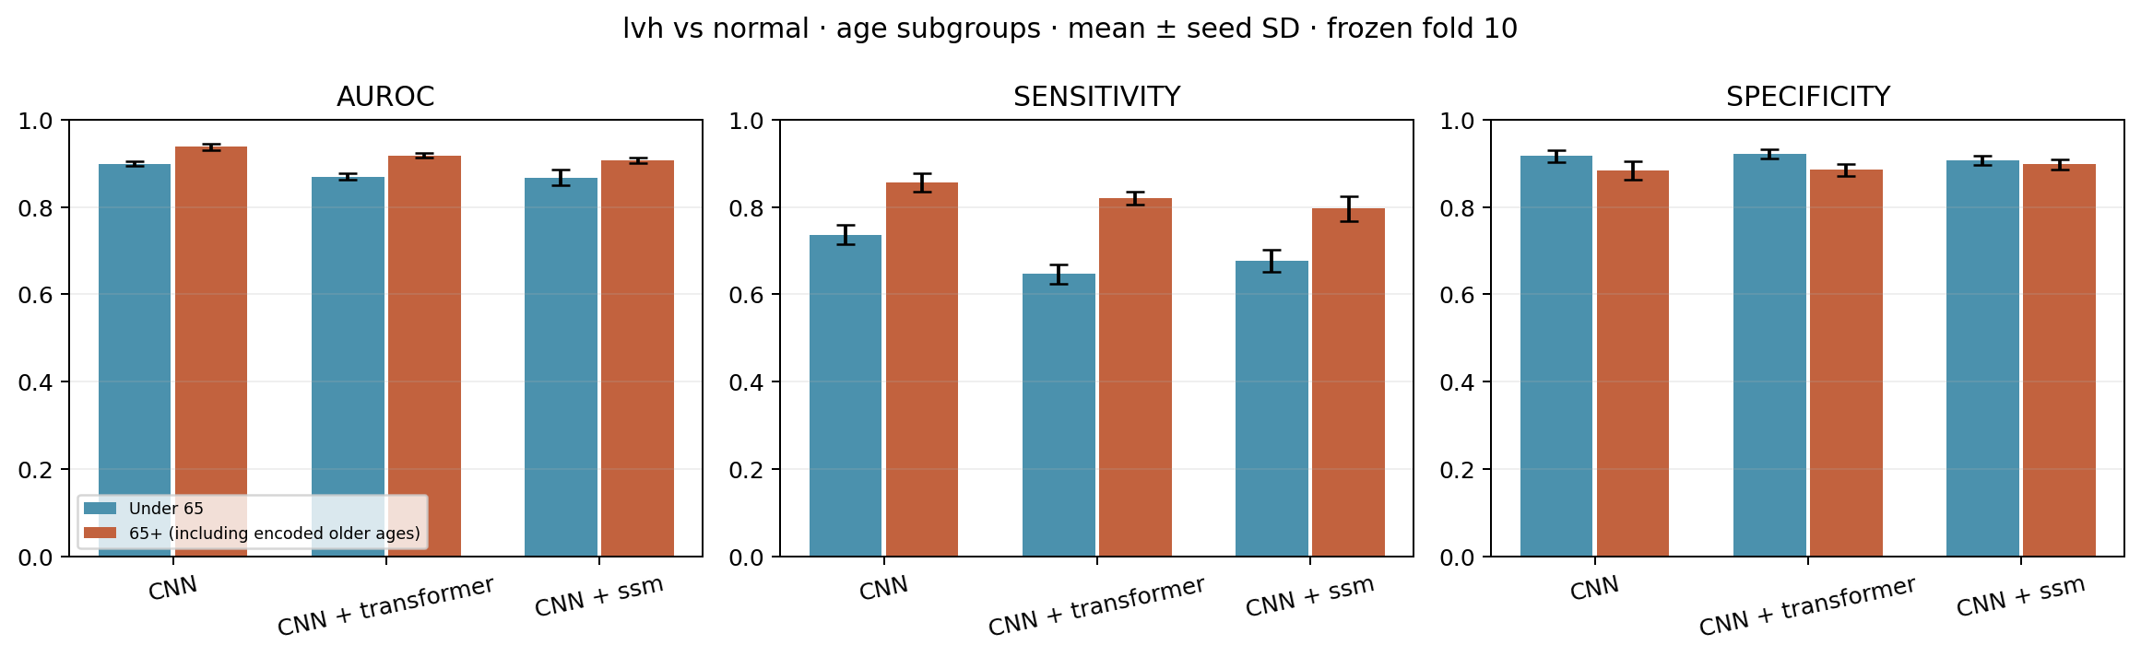
Figure A.1 Lead-II ECG model sensitivity and specificity broken down by age subgroup (<65 vs 65+)

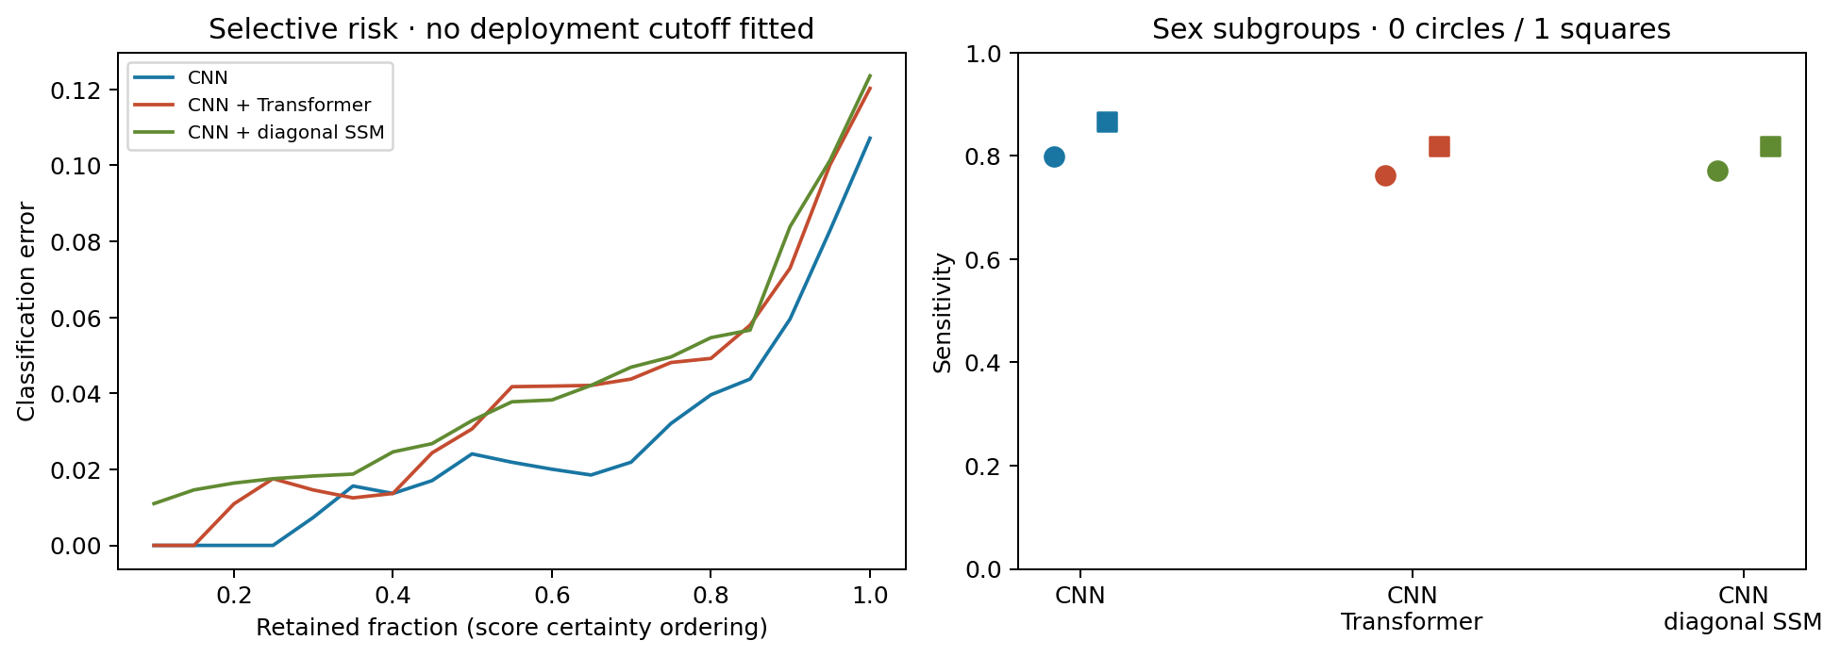
Figure A.2 Selective risk coverage curves and biological sex subgroup sensitivity checks

Appendix A

Experimental figures (continued)
A.2 Algorithmic optimization histories and continuous decomposition benchmarks
Figure A.3 illustrates training and development loss convergence across 5 random seeds for the Lead-II ECG architectures. Figure A.4 benchmarks continuous EDA decomposition: MC-SAED matches cvxEDA and Choi peak detection while executing in 0.26 ms/min (a 30x speedup over cvxEDA).

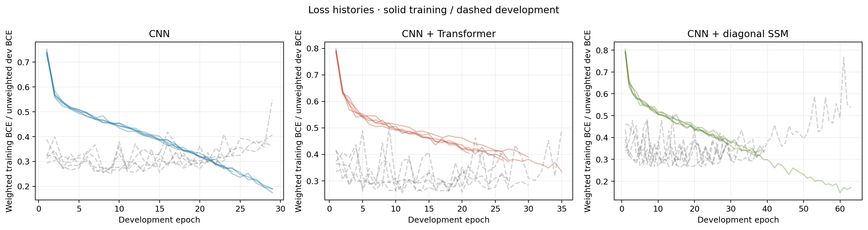
Figure A.3 Training (solid) and development (dashed) BCE loss curves across optimization epochs

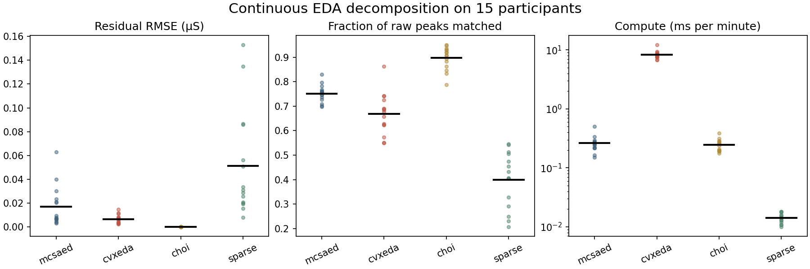
Figure A.4 Continuous EDA decomposition comparison: Residual RMSE, peak match fraction, and compute time

Appendix B

Reproducibility and validation record
B.1 Verification protocols, data hashes, and software checksums
Every model and experiment in this report is paired with an immutable verification record, participant partition audit, and golden replay checksum. Independent verification ensures that any subsequent run can reproduce identical predictions from raw source files.

Table B.1 Mandatory verification records, independent units, and golden replay parities
Physiological Module | Verification Record Path | Independent Unit | Replay Parity Tolerance
ECG (Lead II) | research/results/lvh_distill_v1/final.csv | Patient and ECG | Max logit error < 1e-6 (59 records)
PPG (Optical) | research/results/osasud_v1/comparison.csv | Patient and event | Max prob error < 6e-8 (real traces)
IMU (6-Axis) | research/results/sisfall_v1/replicate_seeds.csv | Subject and trial | Max logit error < 2e-6 (256 windows)
EDA (Conductance) | research/results/wesad_loso_v1/all_models.csv | Participant (LOSO) | Exact JSON parameter equivalence

To verify the ECG Lead-II student, filter final.csv to prep_minimal and verify the 90% specificity operating threshold. For PPG, confirm matched event intervals divided by gold-standard PSG intervals. For IMU, average the three replicate seed scores in replicate_seeds.csv. For EDA, verify participant macro F1 in all_models.csv.

Appendix B

Reproducibility and validation record (continued)

B.2 Hardware-software interface contracts and deployment checklist
Physical wearable deployment requires that sensor calibration settings, sampling rates, and filter states are version-controlled alongside neural network weights. A change in electrode placement or ADC gain will alter physical units and invalidate frozen decision thresholds.
1. BioAmp Lead-II Contract: Verified RA negative, LL positive, RL reference. Digital counts converted to physical millivolts via hardware gain factor prior to entering the 360 Hz polyphase FIR resampler.
2. MAX30102 Optical Contract: Operating at 80/100 Hz. Causal Haar shrinkage executed per completed second. History buffer maintains up to 90 seconds of modulation features with real-history validity masks.
3. Waist IMU Contract: Tri-axial acceleration calibrated in g (32/8192 g/LSB), tri-axial angular velocity in deg/s (4000/65536 deg/s/LSB). Streaming windows strictly fixed at 2.0 s (40 tokens, 1.0 s hop) without padding.
4. Wrist EDA Contract: Continuous 4 Hz conductance calibrated in microSiemens (0-100 uS range). Initial 120-second resting baseline capture mandatory before scoring.
5. Jetson Systemd Service: Packaged as 'apnea-detector.service' and 'elderly-monitor.service' for automated startup on boot, with thread-safe IPC queues and local SQLite anomaly logging.

— END OF PROJECT REPORT —

