Edge-to-Cloud Healthcare Telemetry Architecture: A QUIC- Based URLLC and Edge AI Approach

Project report submitted to the
National Institute of Technology Warangal
For award of the degree
Of

Bachelor of Technology
in Electronics and Communication Engineering

by

Vivek Kumar - 23ECB0A09
Bhanu Pratap - 23ECB0A27
Ujwal Kumar - 23ECB0A16

Under the guidance of
Prof. Mohammad Farukh Hashmi



Department of Electronics and Communication Engineering
National Institute of Technology Warangal
November 2026

APPROVAL OF THE VIVA-VOCE BOARD
09/11/26
Certified that the project report entitled Multimodal Health Monitoring for Older Adults submitted by Vivek Kumar(23ECB0A09), Bhanu Pratap(23ECB0A27), Ujwal Kumar(23ECB0A016) to the National Institute of Technology Warangal, for the award of the degree of Bachelor of Technology, has been accepted by the external examiners, and that the students have successfully defended the report in the viva-voce examination held today.
(Member, Evaluation Committee) | (Member, Evaluation Committee) |  | (Member, Evaluation Committee)
(Supervisor) |  | (Co-Supervisor)
(External Examiner) |  | (Head of the Department)

CERTIFICATE
This is to certify that the project report entitled Multimodal Health Monitoring for Older Adults submitted by Vivek Kumar(23ECB0A09), Bhanu Pratap(23ECB0A27), Ujwal Kumar(23ECB0A016) to the National Institute of Technology Warangal, is a record of bona fide work carried out under my (our) supervision, and we consider it worthy of consideration for the award of the degree of Bachelor of Technology of the Institute.
_____________________________ | _________________________________
Prof. Ravi Kumar Jatoth  Head of the Department  Department of ECE  NIT Warangal | Prof. Mohammad Farukh Hashmi  Assistant Professor  Department of ECE  NIT Warangal

DECLARATION
We certify that
a. The work contained in this report is original and has been done by us under the general supervision of our supervisor(s).
b. The work has not been submitted to any other Institute for any degree or diploma.
c. We have followed the guidelines provided by the Institute in writing the report.
d. Whenever we have used materials (data, theoretical analysis and text) from other sources, we have given due credit to them by citing them in the text of the report and giving their details in the references.
e. Whenever we have quoted written materials from other sources, we have put them under quotation marks and given due credit to the sources by citing them and giving the required details in the references.
Signature: ____________________ Vivek Kumar(23ECB0A09)
Signature: ____________________ Bhanu Pratap(23ECB0A27)
Signature: ____________________ Ujwal Kumar(23ECB0A16)

Acknowledgements
We thank our guide, Prof. Mohammad Farukh Hashmi, for steady guidance through a project that grew well beyond its first proposal, and for pushing us to test our own results as hard as anyone else's. We thank Prof.J.Ravi Kumar the Head of the Department and the faculty of the Department of Electronics and Communication Engineering Department for their support and reviews during the year.

We acknowledge the participants, clinicians and research teams who made PTB-XL, OSASUD, SisFall and WESAD available. Their recordings and annotations made it possible to study four sensing tasks before collecting prospective wearable measurements.

Vivek Kumar(23ECB0A09)
Bhanu Pratap(23ECB0A27)
Ujwal Kumar(23ECB0A16)

Abstract
Older adults living independently face four recurring, time-critical risks that a body-worn monitor can observe: structural cardiac strain, sleep-disordered breathing, falls, and sustained autonomic arousal. This project designs, evaluates and deploys a multimodal wearable monitoring system in which four signal pipelines run independently on an NVIDIA Jetson Orin Nano edge computer, so a fault in one sensor never silences another. All models were trained on public clinical datasets and evaluated with strictly patient- or subject-independent protocols: official PTB-XL patient folds for single-lead ECG left ventricular hypertrophy (LVH) patterns, five-fold patient-held-out cross-validation on OSASUD for optical respiratory events, five participant-group folds on SisFall for falls, and leave-one-subject-out validation on WESAD for wrist electrodermal stress.
On the frozen PTB-XL test fold, a 94,753-parameter multiscale CNN that preserves millivolt amplitude reached AUROC 0.933 ± 0.004, AUPRC 0.884, sensitivity 82.2% and specificity 90.8% (five seeds); its seed ensemble gave 89.3% accuracy and 74.2% precision. An impact-preserving multi-view (IPMV) feature pipeline with an 8.2 KB XGBoost model detected 1,776 of 1,798 SisFall falls (subject-balanced accuracy 98.51%, F1 98.04%, AUROC 0.999) with 3.59 false alerts per recorded hour, and a teacher-distilled 5,846-parameter temporal convolutional network averaged 98.61% across three seeds. A causal tonic–phasic decomposition (MC-SAED) feeding a 31-coefficient logistic model reached 0.873 macro F1 and AUROC 0.966 on WESAD; a rest-calibrated fusion network reached 0.899. Optical respiratory-event detection remained difficult: the best two-time-scale network achieved a mean patient average precision of 0.247 against a 0.160 prevalence baseline, and is therefore retained as a research model only.
On the Jetson Orin Nano (ONNX Runtime, CPU only, 100 timed runs), every model forward pass completed within 0.53 ms at p99 and every complete preprocessing-plus-inference pipeline within 10.7 ms, which is at most 0.31% of its real-time hop. A separate SpO₂ apnea detector ran end to end in 62.4 ms (p95) against a 10 s hop. Exported models reproduced their reference outputs to within 10⁻⁶ with zero changed decisions; physical-sensor validation in older adults is the next step.
Index Terms — Wearable sensors, edge computing, NVIDIA Jetson Orin Nano, electrocardiography, left ventricular hypertrophy, photoplethysmography, sleep apnea, fall detection, electrodermal activity, stress detection, subject-independent evaluation, knowledge distillation.

Contents
APPROVAL OF THE VIVA-VOCE BOARD ii
CERTIFICATE iii
DECLARATION v
Acknowledgements vi
Abstract vii
List of Figures x
List of Tables xiii
List of Abbreviations xiv
Chapter 1 Introduction 1
1.1 Background and motivation 1
1.2 Problem statement 1
1.3 Objectives 1
1.4 Target edge platform: NVIDIA Jetson Orin Nano 2
1.5 Contributions 2
1.6 Organisation of the report 3
Chapter 2 Literature Review 4
2.1 Wearable and edge health monitoring 4
2.2 ECG-based detection of left ventricular hypertrophy 4
2.3 Photoplethysmography for sleep-disordered breathing 4
2.4 Inertial fall detection 5
2.5 Electrodermal activity and stress detection 5
2.6 Sequence models, distillation and evaluation practice 5
2.7 Summary and research gaps 6
Chapter 3 Theoretical Study 7
3.1 System architecture 7
3.2 Evaluation metrics 7
3.3 ECG pipeline: LVH-associated patterns from Lead II 8
3.4 PPG pipeline: respiratory events from the optical pulse 9
3.5 IMU pipeline: impact-preserving multi-view (IPMV) fall detection 10
3.6 EDA pipeline: causal tonic–phasic decomposition 11
3.7 Edge deployment and benchmarking methodology 12
Chapter 4 Experimental Study 13
4.1 Datasets, protocols and environment 13
4.2 ECG: LVH-associated pattern detection on PTB-XL 13
4.3 PPG: patient-held-out respiratory event detection on OSASUD 17
4.4 IMU: subject-independent fall detection on SisFall 19
4.5 EDA: participant-independent stress detection on WESAD 22
4.6 Edge deployment on the NVIDIA Jetson Orin Nano 25
4.7 Consolidated results and discussion 29
Chapter 5 Conclusions and Future Scope of Study 31
5.1 Conclusions 31
5.2 Limitations 31
5.3 Future scope 32
References 33
Appendix A Supplementary Experimental Figures 37
A.1 ECG: LVH versus all remaining ECGs and subgroup analyses 37
A.2 IMU signal diagnostics 38
A.3 EDA protocol, decomposition and verification 39
Appendix B Reproducibility and Deployment Record 40
B.1 Verification records 40
B.2 Hardware contracts and deployment checklist 40

List of Figures
Figure 3.1 ECG pipeline with the best model (multiscale 1D CNN) 8
Figure 3.2 Calibrated Lead-II waveform after preprocessing, with baseline tracking under synthetic noise 9
Figure 3.3 PPG pipeline with the best model (dual-rate TCN + GRU) 10
Figure 3.4 IMU fall-detection pipeline with the best model (IPMV + XGBoost) 11
Figure 3.5 Per-axis gravity estimate and dynamic acceleration during a fall 11
Figure 3.6 Native 200 Hz accelerometer and gyroscope traces for a fall and an ADL 11
Figure 3.7 EDA stress pipeline with the best model (MC-SAED + 31-coefficient logistic model) 12
Figure 4.1 AUROC, AUPRC and sensitivity of the three Lead-II architectures (LVH vs. normal; five seeds) 14
Figure 4.2 ROC, precision–recall and reliability curves on fold 10 (LVH vs. normal) 14
Figure 4.3 Five-seed ensemble confusion matrices on fold 10 (threshold fixed on fold 9) 15
Figure 4.4 Development AUROC (solid) and AP (dashed) per epoch on folds 7–8 15
Figure 4.5 Training (solid) and development (dashed) loss histories for each seed 15
Figure 4.6 Training wall time and desktop model-only p95 inference per architecture 15
Figure 4.7 Development patient AP of all distillation, imbalance and preprocessing configurations 16
Figure 4.8 Selective risk versus coverage and sensitivity by sex (LVH vs. normal) 16
Figure 4.9 Held-out ROC, precision–recall and calibration curves: 12-lead teacher vs. single-lead students 16
Figure 4.10 Held-out patient AP and event F1 of the four primary architectures 17
Figure 4.11 Input ablations: morphology, modulation, quality, context length and look-ahead 17
Figure 4.12 Per-patient average precision versus event prevalence for the selected model 18
Figure 4.13 Second-level precision–recall and calibration curves for respiratory-event scores 18
Figure 4.14 Training and validation curves across outer folds 18
Figure 4.15 Row-normalised five-class confusion matrix (physician label vs. prediction) 18
Figure 4.16 Binary follow-up: patient AP, event F1 and false alerts per hour 18
Figure 4.17 Event recall versus false alerts per hour under 1, 10 and 30 false-event validation allowances 19
Figure 4.18 Held-out subject-balanced accuracy of all primary architectures 20
Figure 4.19 Initialisation and training-order sensitivity across three seeds 20
Figure 4.20 Top three matched SisFall models: balanced accuracy, recall, specificity, F1 and alarm burden 21
Figure 4.21 Grouped confusion matrices of the nested selection policies 21
Figure 4.22 ROC, precision–recall and reliability curves of the primary fall detectors 21
Figure 4.23 Controlled configurations: window length, filtering, gravity, wavelets, fusion and pooling 21
Figure 4.24 Neural training and validation curves on SisFall 22
Figure 4.25 Sensor-transfer stress tests of the primary model 22
Figure 4.26 Stress tests of the teacher-distilled DM-TCN 22
Figure 4.27 Macro F1 of EDA-only architectures, zero calibration 23
Figure 4.28 Architecture ranking with wrist EDA plus accelerometry 23
Figure 4.29 ROC, precision–recall and calibration curves, zero-calibration protocol 24
Figure 4.30 Pooled confusion matrix and per-participant scores, zero-calibration protocol 24
Figure 4.31 ROC, precision–recall and calibration curves, rest-calibrated protocol 24
Figure 4.32 Pooled confusion matrix and per-participant scores, rest-calibrated protocol 24
Figure 4.33 Fixed deployment candidates: pooled ROC, PR and confusion matrices (logistic and PG-MSTN) 25
Figure 4.34 Component ablations of PG-MSTN (paired macro-F1 differences) 25
Figure 4.35 Stress-call rates on amusement and meditation windows 25
Figure 4.36 Decomposition comparison: residual RMSE, peak retention and compute time (MC-SAED vs. cvxEDA, Choi, sparse) 25
Figure 4.37 Measured Jetson latency: (a) model-only vs. end-to-end p95 for the six main models; (b) SpO₂ detector stage breakdown 26
Figure 4.38 Per-decision p50 latency recorded during the on-device evaluation run against each real-time hop (log scale) and budget consumed 27
Figure 4.39 On-device comparison of three architectures each for LVH, fall and stress detection 28
Figure 4.40 Confusion matrices produced by the deployed runtimes on the Jetson Orin Nano 28
Figure 4.41 Per-modality confusion matrices of the Jetson replay evaluation with accuracy and F1 28
Figure 4.42 SpO₂ detector: classification metrics and the latency–model-size trade-off 29
Figure 4.43 Confusion matrices of the SpO₂ CNN, gradient-boosting and ensemble models on the Jetson 29
Figure A.1 AUROC, AUPRC and sensitivity of the three architectures (LVH vs. rest) 37
Figure A.2 ROC, precision–recall and reliability curves (LVH vs. rest) 37
Figure A.3 Five-seed ensemble confusion matrices (LVH vs. rest) 37
Figure A.4 Development AUROC and AP per epoch (LVH vs. rest) 37
Figure A.5 Training and development loss histories (LVH vs. rest) 37
Figure A.6 Sensitivity and specificity by age group, < 65 vs. ≥ 65 years (LVH vs. normal) 38
Figure A.7 Sensitivity and specificity by age group (LVH vs. rest) 38
Figure A.8 Selective risk and sex subgroups (LVH vs. rest) 38
Figure A.9 Training time and desktop inference (LVH vs. rest) 38
Figure A.10 Preprocessing fidelity under synthetic noise: waveform MAE, ST-proxy error and fraction within budgets 38
Figure A.11 SisFall recording durations and impact distribution (the duration cue) 38
Figure A.12 Impact-peak retention of fixed and adaptive filters 38
Figure A.13 Sensor-transfer stress tests of the neural comparators 39
Figure A.14 Protocol time per WESAD participant by condition 39
Figure A.15 MC-SAED tonic and phasic components across baseline, stress, amusement and meditation 39
Figure A.16 Learned tonic/phasic decomposition of a held-out subject 39
Figure A.17 Training objective and validation macro F1 per epoch 39

List of Tables
Table 1.1 Wearable inputs, sensors and study endpoints 2
Table 2.1 Representative related work and the gaps addressed in this project 6
Table 4.1 Datasets and subject-independent evaluation protocols 13
Table 4.2 Single-lead (Lead II) models on frozen PTB-XL fold 10, mean ± SD over five seeds 13
Table 4.3 Five-seed ensemble classification metrics on PTB-XL fold 10 14
Table 4.4 Non-deep controls on the same cohort and folds (single deterministic runs) 14
Table 4.5 Patient-level results on fold 10 for the distillation study (threshold for 90% specificity on fold 9) 16
Table 4.6 Primary OSASUD architectures on held-out patients (5 folds, 30 patients) 17
Table 4.7 Binary follow-up: two-time-scale networks versus matched controls 17
Table 4.8 All 22 primary SisFall models (matched 200 Hz input, 2 s windows, held-out participant groups) 19
Table 4.9 Deployment candidates for fall detection (held-out participants) 20
Table 4.10 Seed sensitivity of neural fall detectors (subject-balanced accuracy, %) 20
Table 4.11 Selected WESAD models (mean over 15 held-out participants) 22
Table 4.12 EDA-only neural architectures without calibration (macro F1 and AUROC) 23
Table 4.13 Measured Jetson Orin Nano latency (ms, p50 / p95 / p99), deadline budget and output parity 26
Table 4.14 SpO₂ apnea detector stage latency on the Jetson Orin Nano (100 iterations, ms) 26
Table 4.15 End-to-end classification on the Jetson Orin Nano replay packs 27
Table 4.16 On-device comparison of three models per task (replay packs; latency = p50 per decision) 27
Table 4.17 SpO₂ apnea detector classification on the Jetson replay (N = 234 windows) 28
Table 4.18 Summary of the selected model per task: held-out performance and measured edge cost 29
Table B.1 Verification records and replay parity 40

List of Abbreviations
Term | Meaning | Term | Meaning
ACC | Accelerometer | KD | Knowledge distillation
ADL | Activity of daily living | LOSO | Leave-one-subject-out
AP / AUPRC | Average precision / area under PR curve | LSTM | Long short-term memory
AUROC | Area under the ROC curve | LVH | Left ventricular hypertrophy
BA | Balanced accuracy | MAD | Median absolute deviation
BVP | Blood volume pulse | MC-SAED | Motion-conditioned sub-harmonic asymmetric exponential decomposition
CNN | Convolutional neural network | MCC | Matthews correlation coefficient
CPU / GPU | Central / graphics processing unit | NPV / PPV | Negative / positive predictive value
DM-TCN | Dual-stream multiscale TCN | ONNX | Open Neural Network Exchange
DSP | Digital signal processing | OSA | Obstructive sleep apnea
ECE | Expected calibration error | PG-MSTN | Physics-guided multiscale tonic–phasic network
ECG | Electrocardiogram | PPG | Photoplethysmogram
EDA | Electrodermal activity | PR | Precision–recall
F1 | Harmonic mean of precision and recall | PSG | Polysomnography
FIR | Finite impulse response | ROC | Receiver operating characteristic
FN / FP | False negative / false positive | RF | Random forest
FP16 / FP32 | 16 / 32-bit floating point | SCL / SCR | Skin conductance level / response
GBM | Gradient-boosting machine | SpO₂ | Peripheral oxygen saturation
GRU | Gated recurrent unit | SSM | State-space model
GSR | Galvanic skin response | SVM | Support vector machine
IMU | Inertial measurement unit | TCN | Temporal convolutional network
IoU | Intersection over union | TN / TP | True negative / true positive
IPMV | Impact-preserving multi-view | TSST | Trier Social Stress Test

CHAPTER 1

Introduction

1.1 Background and motivation
Population ageing is shifting healthcare demand from hospitals into homes and assisted-living facilities. Falls are the second leading cause of unintentional injury death worldwide and the risk rises steeply after 65 years [1]. Left ventricular hypertrophy, most often a consequence of long-standing hypertension, is an independent predictor of heart failure, arrhythmia and stroke [2], [3]. Obstructive sleep apnea is common and under-diagnosed in older adults and in stroke survivors, and its gold-standard diagnosis requires overnight polysomnography [4], [5]. Chronic stress and autonomic arousal aggravate hypertension and sleep disturbance [6]. Each of these conditions has a physiological signature that a wearable sensor can capture continuously, but each evolves on a very different time scale: an impact lasts 10–30 ms, an apnea 10–60 s, and a stress response several minutes.
Continuous monitoring is valuable only if alerts are timely, private and trustworthy. Streaming raw waveforms to the cloud adds latency, consumes radio power and exposes sensitive data; edge computing instead processes data next to the sensor [7], [8]. Modern embedded accelerators such as the NVIDIA Jetson family make it possible to run deep models locally [9], but most published wearable models are evaluated on a single signal, often with protocols that allow information to leak between training and test subjects [10]. This project addresses both gaps together: four rigorously evaluated pipelines that run concurrently on one edge board.

1.2 Problem statement
Given four body-worn sensors that sample at different rates — a single-lead ECG front end, an optical PPG sensor, a waist IMU and a wrist EDA electrode pair — design causal processing and classification pipelines that (i) detect LVH-associated ECG patterns, respiratory events, falls and stress-associated arousal, (ii) generalise to people never seen during training, (iii) operate on calibrated physical units so that a real sensor can replace the dataset recording, and (iv) meet their real-time deadlines with large margin on an NVIDIA Jetson Orin Nano.

1.3 Objectives
- Build four independent, causally implemented signal pipelines with explicit signal-quality gating.
- Compare classical machine learning and deep architectures for each task under identical, leakage-free subject splits.
- Report a complete set of classification metrics — accuracy, precision, recall/sensitivity, specificity, F1, AUROC, AUPRC, calibration and alarm burden — together with uncertainty estimates.
- Export the selected models to portable formats (ONNX, NumPy, JSON), verify numerical parity, and benchmark latency on the Jetson Orin Nano against each pipeline’s real-time hop.
- Identify dataset shortcuts and limitations that must be resolved before clinical use.
Table 1.1 Wearable inputs, sensors and study endpoints
Module | Target sensor | Source data | Edge stream | Window / hop | Endpoint
ECG | BioAmp EXG Pill (Lead II) | PTB-XL, 500 Hz | 360 Hz, mV | 10 s / 2 s | LVH-associated ECG pattern
PPG | MAX30102 optical | OSASUD, 80 Hz | 80–100 Hz | 30–90 s / 5 s | Apnea or hypopnea second
IMU | Waist MPU-9250 (6 axes) | SisFall, 200 Hz | 100–200 Hz, g and °/s | 2 s / 1 s | Fall vs. ADL
EDA | Wrist GSR + accelerometer | WESAD wrist, 4/32 Hz | 4 Hz µS + 32 Hz ACC | 60 s / 15 s | Stress vs. baseline

1.4 Target edge platform: NVIDIA Jetson Orin Nano
The deployment target is the NVIDIA Jetson Orin Nano Developer Kit (Super configuration) [11]. It integrates a 6-core Arm Cortex-A78AE v8.2 64-bit CPU (up to 1.7 GHz), a 1,024-core NVIDIA Ampere GPU with 32 Tensor Cores, and 8 GB of 128-bit LPDDR5 memory shared by CPU and GPU, within a 7–25 W power envelope. The benchmarks in this report deliberately use only the CPU execution provider of ONNX Runtime [12]: if the complete four-signal workload fits comfortably on the CPU, the GPU remains free for future, heavier models, and the results transfer to cheaper boards.

1.5 Contributions
- Voltage-preserving single-lead ECG pipeline with rational polyphase resampling (500→360 Hz), an integrity gate and a privileged 12-lead teacher distilled into a compact Lead-II student.
- Boundary-preserving optical respiratory-event detector that predicts each second individually from a two-time-scale (12 s pulse shape, 90 s modulation) causal network, with a quantified alarm-burden analysis.
- Duration-leak-free fall detection. We show that SisFall file duration alone yields 100% accuracy, remove this shortcut with fixed unpadded windows, and introduce gravity-relative IPMV features that are invariant to sensor rotation.
- Causal EDA decomposition (MC-SAED) that matches the acausal cvxEDA in downstream accuracy at roughly 30× lower cost, plus a leakage-free resting-calibration protocol.
- Measured edge deployment of all pipelines on the Jetson Orin Nano with latency percentiles, deadline budgets and golden-vector parity checks, including a dedicated SpO₂ apnea detector service.

1.6 Organisation of the report
Chapter 2 reviews related work. Chapter 3 presents the theoretical basis: system architecture, evaluation metrics, and the signal processing and models of each pipeline. Chapter 4 reports the experiments, including complete classification metrics and the Jetson Orin Nano deployment. Chapter 5 concludes and outlines future work. Appendix A collects supplementary figures and Appendix B records reproducibility and deployment details.
CHAPTER 2

Literature Review
This chapter surveys prior work for each sensing task, for edge deployment of physiological models, and for evaluation practice. Table 2.1 at the end of the chapter summarises representative studies and the gaps this project addresses.

2.1 Wearable and edge health monitoring
Edge computing moves computation from the data centre to the network edge to reduce latency, bandwidth and privacy exposure [7], [8]. In health monitoring the edge node is typically a gateway that aggregates body sensors. A recent study streamed a chest-strap ECG over Bluetooth Low Energy to a Jetson Orin Nano and showed that LSTM heartbeat classification meets real-time constraints while serving several patients [9]. Embedded fall detectors have reached tens of milliseconds of inference time on microcontrollers [13], [14]. These works usually deploy one signal; the interaction of several asynchronous pipelines on one device, and the cost of their preprocessing rather than only the model forward pass, are rarely measured.

2.2 ECG-based detection of left ventricular hypertrophy
Classical LVH criteria such as Sokolow–Lyon and Cornell sum QRS voltages across several precordial and limb leads [2], [3]; they are specific but insensitive. PTB-XL, a 21,799-record 12-lead corpus with SCP-ECG statements and recommended patient folds [15], [16], enabled systematic deep-learning benchmarks in which ResNet and Inception-style 1D CNNs dominate [17]. Large-scale 12-lead networks reach cardiologist-level performance for rhythm and conduction disorders [18], [19], and 1D CNNs can run in real time for patient-specific classification [20]. For LVH specifically, an ensemble neural network trained against echocardiography reached AUROC 0.88 internally and 0.87 externally [21], and a feature-based machine-learning model on PTB-XL and Georgia data exceeded 86% sensitivity, compared with at most 38% for clinical criteria [22]. Almost all of this work uses 12 leads; a wearable provides one. Moreover, routine per-record z-score normalisation removes absolute amplitude, which is the primary LVH biomarker. Knowledge distillation [23] and learning with privileged information [24] offer a principled way to transfer multi-lead knowledge to a single-lead student.

2.3 Photoplethysmography for sleep-disordered breathing
Breathing modulates the PPG through baseline (intensity), amplitude and frequency (pulse-interval) variation; these modulations underpin respiratory-rate estimation [25], [26]. Reviews of apnea detection report that most methods use SpO₂, ECG or airflow and evaluate on 30–60 s segments [4]. Wrist-worn reflective PPG can estimate the apnea–hypopnea index [27]; ApSense detects OSA events from fingertip PPG with deep learning [28], and SleepPPG-Net stages sleep from raw PPG [29]. The OSASUD dataset pairs bedside optical plethysmography with physician-scored respiratory events in stroke-unit patients [30]. Segment-level labelling blurs event onset and offset, and very few studies report the false-alarm rate per hour that determines whether an unattended alert is usable.

2.4 Inertial fall detection
SisFall provides 4,500+ waist-sensor recordings of 15 fall types and 19 ADLs from 38 participants, including 15 older adults [31]. Fall detectors range from threshold rules to CNNs, recurrent networks and hybrids [14], [32], [33]; recent embedded systems report accuracies above 99% [13]. Temporal convolutional networks [34] and InceptionTime [35] are strong general-purpose time-series classifiers, and gradient-boosted trees [36] remain competitive on engineered features. A structural weakness of SisFall is that falls last about 15 s while ADLs last 10–180 s; any model that sees the whole recording, its length or its padding can exploit this cue. Reported accuracies are therefore not always comparable across papers.

2.5 Electrodermal activity and stress detection
Skin conductance comprises a slow tonic level and fast phasic responses. Decomposition methods include continuous deconvolution [37] and the convex-optimisation cvxEDA [38]; both operate on whole recordings and are not causal. Ambulatory stress monitors combine EDA with cardiac and motion signals [39], [40], and surveys note the gap between laboratory and daily-life performance [6]. WESAD [41] is the standard wrist and chest benchmark; its baseline, stress (TSST), amusement and meditation phases follow a fixed schedule, so elapsed time is a confound that models can exploit if time-dependent normalisation is used.

2.6 Sequence models, distillation and evaluation practice
Attention-based Transformers [42] and structured state-space models [43], [44] extend the receptive field of convolutional encoders. For small physiological datasets, however, model selection itself is a major source of optimism: nested cross-validation is required to avoid biased error estimates [45], and leakage between training and test is a widespread cause of irreproducible results [10]. On imbalanced tasks the precision–recall curve is more informative than ROC [46], and modern networks are often mis-calibrated, motivating Platt or temperature scaling [47], [48].

2.7 Summary and research gaps
Table 2.1 Representative related work and the gaps addressed in this project
Study | Signal / data | Method | Reported result | Gap relative to this work
Strodthoff et al. [17] | 12-lead ECG, PTB-XL | 1D ResNet / Inception | Macro AUROC ≈0.93 (all statements) | 12 leads; z-scored input
Kwon et al. [21] | 12-lead ECG + echo | Ensemble NN | AUROC 0.880 / 0.868 | 12 leads; not wearable
Taconné et al. [22] | 12-lead ECG, PTB-XL | Features + RF/SVM | Sensitivity > 86% | Multi-lead features
Papini et al. [27] | Wrist PPG | Feature model | AHI estimation | Proprietary data
ApSense [28] | Fingertip PPG | Deep learning | OSA event detection | No alarm-burden analysis
Musci et al. [14] | Waist IMU, SisFall | LSTM RNN | Online detection | Duration cue not controlled
Campanella et al. [13] | IMU + pressure | Embedded DL | 99.38% acc., 25 ms | Own dataset
Greco et al. [38] | EDA | cvxEDA | Tonic/phasic split | Acausal, whole-session
Schmidt et al. [41] | Wrist/chest, WESAD | RF, LDA, AdaBoost | Wrist binary acc. ≈88% | Schedule confound
Sensors 2025 [9] | Chest ECG | LSTM on Jetson Orin Nano | Real-time | Single signal

Three gaps follow. First, wearable-grade inputs (single lead, single optical channel, wrist EDA) are under-studied relative to clinical multi-lead or multi-sensor setups. Second, dataset shortcuts — duration in SisFall, protocol order in WESAD, amplitude normalisation in PTB-XL — inflate many published numbers. Third, edge feasibility is usually claimed from model size rather than measured end to end. This project addresses each gap explicitly.
CHAPTER 3

Theoretical Study

3.1 System architecture
The system is organised as four decoupled modules (Figures 3.1, 3.3, 3.4 and 3.7). Each module owns its dataset parser, labels, splits, windowing, preprocessing, model, evaluation and inference code; matching folder names never imply matching algorithms or sample rates. In real-time operation, an acquisition layer timestamps samples into per-signal ring buffers; the module’s causal preprocessing runs incrementally; and a predictor emits a result whenever its hop elapses. A result carries a status (valid, insufficient_signal or warming_up), a calibrated probability and a decision. Offline dataset parsers are never reused as live drivers, and edge code never imports training-only dependencies.
- Causality. Every filter, scaler and feature uses only past samples, so offline evaluation reproduces streaming behaviour.
- Physical units. Inputs stay in mV, g, °/s and µS; the hardware contract specifies the conversion from ADC counts.
- Subject independence. Scalers, thresholds and calibrators are fitted only on training or validation people.
- Fault isolation. A gap, clipping or contact loss in one stream only affects that module’s status.

3.2 Evaluation metrics
For a binary decision with true positives TP, false positives FP, true negatives TN and false negatives FN, the following metrics are reported throughout Chapter 4:
Accuracy = (TP + TN) / (TP + TN + FP + FN) (3.1)
Precision (PPV) = TP / (TP + FP), Recall (Sensitivity) = TP / (TP + FN) (3.2)
Specificity = TN / (TN + FP), NPV = TN / (TN + FN) (3.3)
F1 = 2·Precision·Recall / (Precision + Recall), BA = (Sensitivity + Specificity) / 2 (3.4)
MCC = (TP·TN − FP·FN) / √((TP+FP)(TP+FN)(TN+FP)(TN+FN)) (3.5)
Threshold-free discrimination is measured by the area under the ROC curve (AUROC) and by average precision (AP, the step-wise area under the precision–recall curve, reported as AUPRC). Calibration is measured by the Brier score, (1/N)Σ(p_{i} − y_{i})², and the 10-bin expected calibration error (ECE). Subject-level metrics average per-person values so that each participant counts equally: SisFall reports subject-balanced accuracy, OSASUD reports mean within-patient AP, and WESAD reports the mean participant macro F1. Event-level metrics match predicted and reference intervals one-to-one when their temporal intersection over union is at least 0.30; false alerts per hour count unmatched predicted events divided by monitored hours. Confidence intervals use 1,000 patient-level bootstrap resamples.

3.3 ECG pipeline: LVH-associated patterns from Lead II
LVH increases the electrical mass of the left ventricle, raising QRS voltage and often producing secondary ST–T (strain) changes [2], [3]. Because absolute R-wave amplitude in millivolts is the dominant biomarker, the pipeline never applies per-record z-scoring.

3.3.1 Rational polyphase resampling
PTB-XL records are sampled at 500 Hz; the BioAmp front end streams at 360 Hz. The ratio 360/500 = 18/25 is realised by polyphase filtering [49]: upsample by L = 18, apply a Kaiser-window low-pass FIR (β = 5), and decimate by M = 25. A 10 s window therefore contains exactly 3,600 samples with amplitudes preserved in mV.
y[n] = Σ_{k} h[k] · x_{↑L}[nM − k], L/M = 18/25 (3.6)

3.3.2 Integrity gate and models
Before inference, a gate rejects windows with non-finite samples, clock jitter beyond |Δt − 1/f_{s}| > 0.2/f_{s}, flat lines (σ < 10⁻⁵ mV) or rail clipping, returning insufficient_signal instead of a score. Three supervised backbones share a multiscale convolutional stem (kernels 3 and 7, dilations 1 and 2), a separate physical-voltage branch and same-lead morphology features: a pure CNN (94,753 parameters), a CNN–Transformer (92,835) [42] and a CNN with a diagonal real-exponential state-space layer (82,529) [43]. A privileged 12-lead Inception teacher (E2_inception) was distilled into compact single-lead students using temperature-scaled soft targets [23], [24]. Training used class-weighted binary cross-entropy, AdamW, batch size 32 and early stopping (patience 15). Figure 3.1 summarises the flow and Figure 3.2 illustrates waveform preservation.
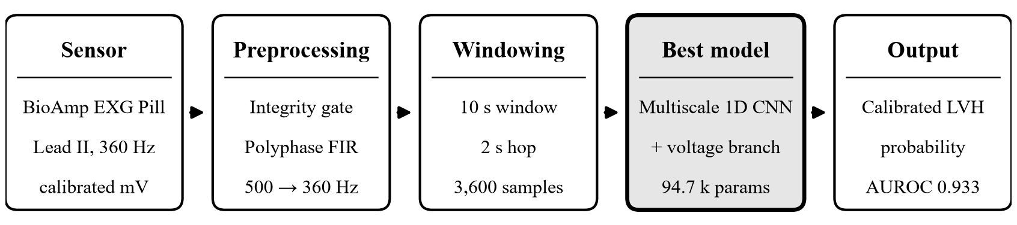
Figure 3.1 ECG pipeline with the best model (multiscale 1D CNN)
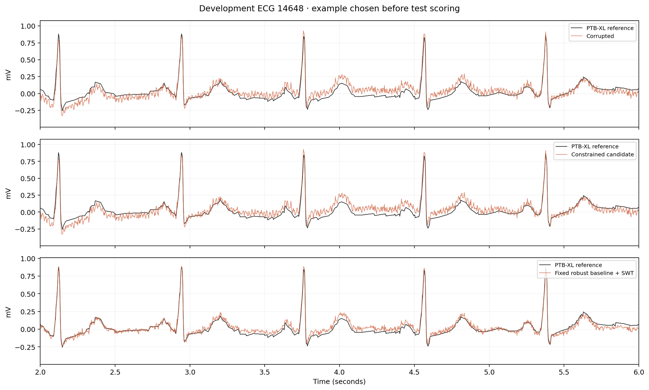
Figure 3.2 Calibrated Lead-II waveform after preprocessing, with baseline tracking under synthetic noise

3.4 PPG pipeline: respiratory events from the optical pulse
During an apnea or hypopnea, airflow falls, intrathoracic pressure swings and sympathetic surges modulate the pulse wave. The PPG therefore contains a cardiac component (≈1–2 Hz) and slower respiratory modulation (≈0.1–0.3 Hz) [25], [26].

3.4.1 Mean-preserving Haar shrinkage and multi-view features
Adjacent optical samples are paired and transformed with a single-level Haar wavelet. The detail coefficient d is soft-thresholded [50] with τ equal to half the running median absolute deviation, while the approximation (pair mean) is left untouched, so slow respiratory baseline is preserved exactly:
d̂ = sign(d) · max(|d| − τ, 0), τ = 0.5 · MAD(d) (3.7)
Each completed second yields 31 features in three views: (1) pulse morphology — 16 shape coordinates of the 0.45–5.5 Hz band-passed pulse normalised by a 45 s trailing amplitude reference; (2) respiratory modulation — 11 features covering 0.08–0.38 Hz baseline, pulse-amplitude and inter-beat-interval variation and 8 s exponential RMS energies; and (3) signal quality — high-frequency residual, repeated-sample fraction, beat staleness and ADC-rail dwell. Features are robust-scaled on training patients and compressed with asinh.

3.4.2 Boundary-preserving, two-time-scale models
Instead of one label per 30 s window, each model reads a trailing context and emits five separate per-second probabilities every 5 s, so event onsets are not blurred. Four architectures were compared: a multiscale CNN + Transformer (25,573 parameters), a dilated TCN + GRU (15,557) [34], a multiresolution filter bank + selective SSM [44], and a quality-conditioned dual TCN with cross-attention. The follow-up two-time-scale network (dual_hard, 9,097 parameters) combines 12 s of pulse shape (16 samples per second) with up to 90 s of modulation and quality features through dilated TCN blocks (dilations 2, 4, 8) and a 24-unit unidirectional GRU (Figure 3.3).
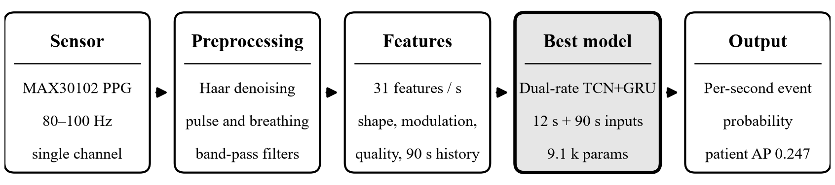
Figure 3.3 PPG pipeline with the best model (dual-rate TCN + GRU)

3.5 IMU pipeline: impact-preserving multi-view (IPMV) fall detection
A fall is a short, high-energy event: a free-fall phase, an impact peak lasting 10–30 ms, and a post-fall posture change. Ordinary low-pass filtering and decimation attenuate the impact peak, while wearable sensors rotate on the belt. IPMV addresses both effects (Figure 3.4).

3.5.1 Duration-free windows and native-rate impact path
Every recording is converted to g (32/8192 g per LSB) and °/s (4000/65536 °/s per LSB) and cut into fixed, unpadded 2 s windows with a 1 s hop, each represented by 40 tokens of 50 ms. A direct path computes minima, maxima, means and the maximum absolute one-sample derivative max|Δa/Δt| at the native 200 Hz before tokenisation; a parallel causal second-order Butterworth path (30 Hz) passes more raw residual as the acceleration norm grows.

3.5.2 Gravity decoupling and rotation invariance
A causal 0.75 Hz second-order filter estimates the gravity vector g. Dynamic acceleration and its components parallel and perpendicular to gravity are then
a_{dyn} = a − g, a_{v} = (a_{dyn} · g) / ‖g‖, a_{h} = ‖a_{dyn} − a_{v} ĝ‖ (3.8)
These scalar projections are unchanged by any constant rotation of the sensor. Causal three-level Daubechies-2 wavelet band energies [51] complete the 24 values per token. Classical models (XGBoost [36], random forest, RBF-SVM) use 168 aggregate descriptors; the dual-stream multiscale TCN (DM-TCN, 5,846 parameters) splits accelerometer and gyroscope streams, applies parallel causal kernels 3/5/9 with dilations 1/2/4, fuses them with a learned sigmoid gate and pools with temporal attention. Because SisFall provides only trial-level labels, the deep model is trained on the maximum window logit per trial; in the distilled variant, a weak XGBoost witness supplies soft window targets at temperature 2.
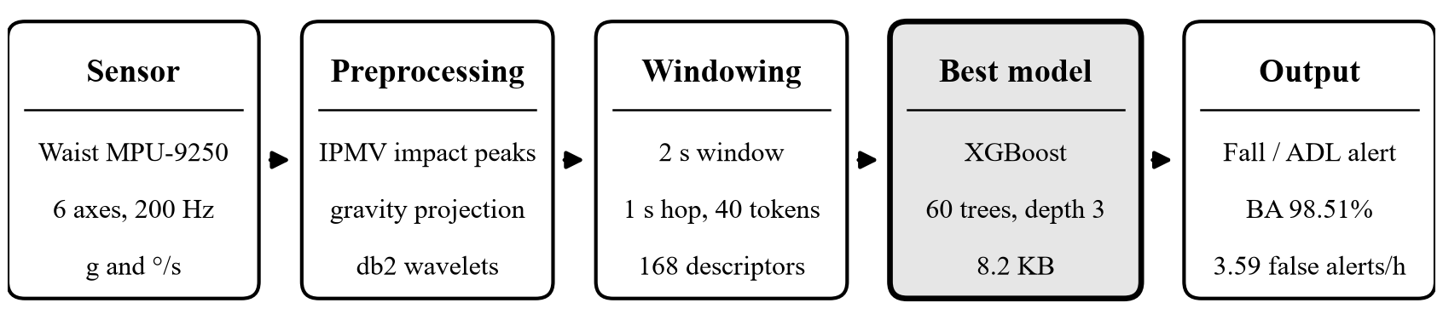
Figure 3.4 IMU fall-detection pipeline with the best model (IPMV + XGBoost)
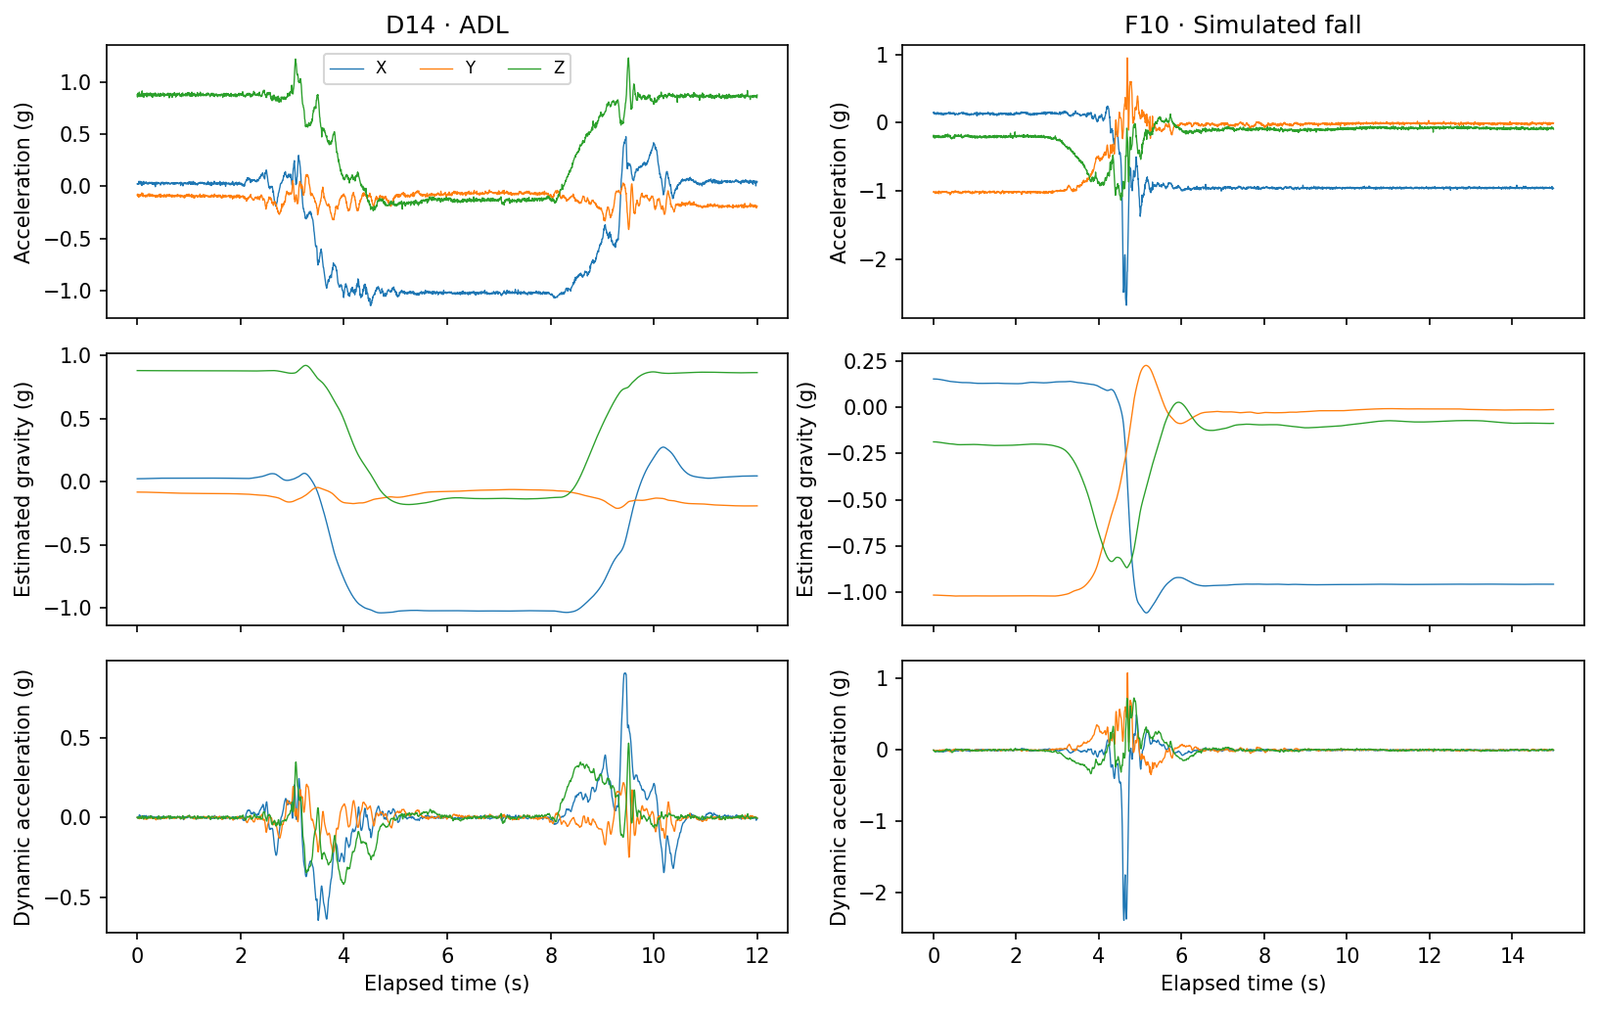  Figure 3.5 Per-axis gravity estimate and dynamic acceleration during a fall | 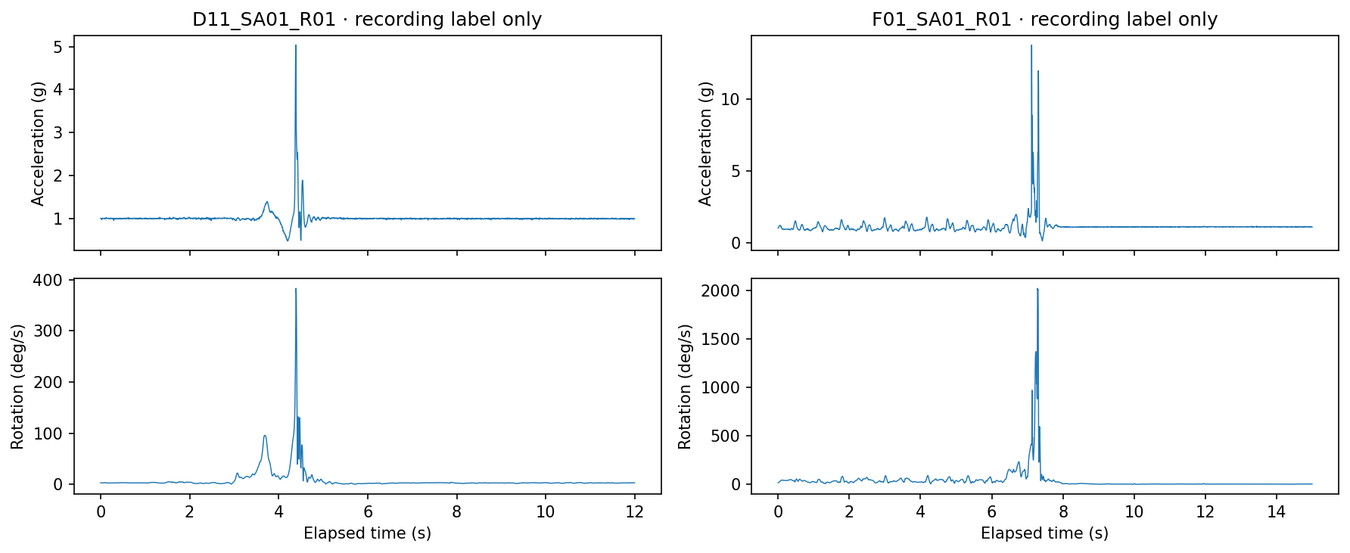  Figure 3.6 Native 200 Hz accelerometer and gyroscope traces for a fall and an ADL

3.6 EDA pipeline: causal tonic–phasic decomposition
Eccrine sweat glands are innervated only by the sympathetic nervous system, so skin conductance tracks arousal. It is the sum of a slow tonic level (SCL, < 0.05 Hz) and phasic responses (SCR) [37].

3.6.1 MC-SAED
The motion-conditioned sub-harmonic asymmetric exponential decomposition processes the 4 Hz conductance stream sample by sample. A contact-quality score q ∈ [0, 1] combines physical plausibility (0–100 µS), a rolling derivative MAD, flat-line and step detection and optional wrist motion. The tonic tracker follows decreases quickly and increases slowly:
T[n] = T[n−1] + α(q) · (x[n] − T[n−1]), α ∈ {α_{down}, α_{up}}, α_{down} > α_{up} (3.9)
so SCR peaks do not drag the baseline upward. The phasic component is the smoothed positive excursion x − T. MC-SAED is fully causal and costs about 0.26 ms per minute of signal, versus 8.29 ms for blockwise cvxEDA [38].

3.6.2 Resting calibration without leakage
Inter-individual skin conductance differs by more than a factor of five. Whole-session normalisation would leak the future, so the calibrated protocol uses only a dedicated 120 s resting capture per person:
z_{tonic} = (T − median(T_{rest})) / (1.4826 · MAD(T_{rest})) (3.10)
Thirty-one features over 60 s windows (15 s hop) feed a logistic model; the neural PG-MSTN combines a dilated tonic TCN, a multiscale phasic TCN, a motion/quality encoder and a handcrafted-feature branch through a reliability-conditioned gate (Figure 3.7).
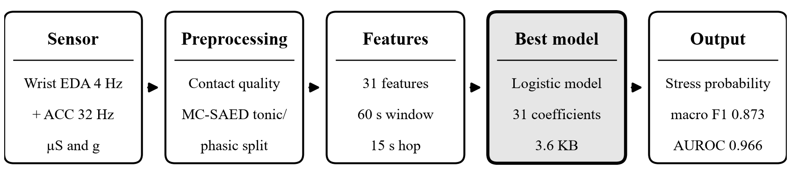
Figure 3.7 EDA stress pipeline with the best model (MC-SAED + 31-coefficient logistic model)

3.7 Edge deployment and benchmarking methodology
Neural models were exported to fixed-shape ONNX graphs, tree ensembles to NumPy arrays and the logistic model to a 3.6 KB JSON file, so the main pipelines need neither PyTorch nor scikit-learn on the Jetson. Each bundle carries its preprocessing parameters, calibration, frozen threshold and a golden reference vector; on the target the maximum output difference and the number of changed decisions are recorded. Latency is measured with ONNX Runtime’s CPU execution provider [12] over 100 timed iterations after warm-up, for (a) the model forward pass and (b) the complete pipeline from physical-unit conversion to decision. The deadline budget is p95 end-to-end latency divided by the hop. A separate SpO₂ apnea service (I²C MAX30102 driver, systemd unit) combining a 1D-CNN and a 150-tree gradient-boosting model on 60 s windows every 10 s was benchmarked stage by stage.
CHAPTER 4

Experimental Study

4.1 Datasets, protocols and environment
Table 4.1 Datasets and subject-independent evaluation protocols
Dataset | Population | Analysed units | Positive class | Protocol
PTB-XL 1.0.3 | 18,869 patients, 10 s 12-lead ECG | LVH vs. normal: 915 test records; LVH vs. rest: 2,198 | LVH statement (214 test records) | Folds 1–6 train, 7–8 select, 9 calibrate, 10 test; 5 seeds
OSASUD | 30 stroke-unit patients, overnight | 821,545 scored seconds (228.2 h) | 131,085 s; 5,985 events | 5 folds: 18 train / 6 validate / 6 test patients
SisFall | 38 participants (23 young, 15 older) | 4,500 trials (21.99 h) | 1,798 falls vs. 2,702 ADLs | 5 participant groups, nested inner selection
WESAD | 15 participants, wrist device | 1,636 windows of 60 s | 628 stress vs. 1,008 baseline | 15-fold LOSO: 12 train / 2 validate / 1 test

Training ran on a Windows workstation with an NVIDIA RTX 3050 laptop GPU using PyTorch, scikit-learn and XGBoost. Deployment benchmarks ran on a Jetson Orin Nano Engineering Reference Developer Kit Super with ONNX Runtime (CPU execution provider). Every experiment stores its configuration, per-fold predictions, checkpoints and source-file hashes so that results can be re-derived (Appendix B).

4.2 ECG: LVH-associated pattern detection on PTB-XL
Two negative-class definitions were studied: LVH versus normal ECGs (prevalence 23.4% on fold 10) and LVH versus all remaining eligible ECGs (9.7%). Thresholds were fixed on fold 9 to give at least 90% specificity and applied unchanged to fold 10. Table 4.2 lists mean ± standard deviation over five independently trained seeds.
Table 4.2 Single-lead (Lead II) models on frozen PTB-XL fold 10, mean ± SD over five seeds
Task | Model | AUROC | AUPRC | Sensitivity | Specificity | F1 | Brier | Params
LVH vs normal | CNN | 0.933 ± 0.004 | 0.884 ± 0.006 | 0.822 ± 0.015 | 0.908 ± 0.015 | 0.775 ± 0.013 | 0.067 | 94,753
LVH vs normal | CNN + Transformer | 0.910 ± 0.003 | 0.851 ± 0.005 | 0.771 ± 0.014 | 0.912 ± 0.007 | 0.749 ± 0.007 | 0.078 | 92,835
LVH vs normal | CNN + diagonal SSM | 0.900 ± 0.008 | 0.837 ± 0.014 | 0.763 ± 0.026 | 0.905 ± 0.009 | 0.735 ± 0.017 | 0.082 | 82,529
LVH vs rest | CNN | 0.811 ± 0.006 | 0.402 ± 0.013 | 0.520 ± 0.008 | 0.892 ± 0.009 | 0.413 ± 0.011 | 0.073 | 94,753
LVH vs rest | CNN + Transformer | 0.787 ± 0.009 | 0.378 ± 0.009 | 0.477 ± 0.028 | 0.895 ± 0.007 | 0.389 ± 0.011 | 0.074 | 92,835
LVH vs rest | CNN + diagonal SSM | 0.793 ± 0.007 | 0.378 ± 0.007 | 0.475 ± 0.010 | 0.895 ± 0.006 | 0.388 ± 0.013 | 0.074 | 82,529

Averaging the five seeds’ probabilities gives the ensemble confusion counts and threshold-dependent metrics in Table 4.3. The plain multiscale CNN is best on every discrimination metric in both tasks; the attention and state-space layers add latency without benefit on 10 s windows (Figures 4.1–4.6).
Table 4.3 Five-seed ensemble classification metrics on PTB-XL fold 10
Task | Model | Accuracy | Precision | Recall | Specificity | F1 | AUROC | AUPRC | TN/FP/FN/TP
vs normal | CNN | 89.3% | 74.2% | 83.2% | 91.2% | 0.784 | 0.938 | 0.892 | 639/62/36/178
vs normal | CNN+Transf. | 88.0% | 72.2% | 79.0% | 90.7% | 0.754 | 0.915 | 0.860 | 636/65/45/169
vs normal | CNN+SSM | 87.7% | 71.1% | 79.4% | 90.2% | 0.751 | 0.912 | 0.858 | 632/69/44/170
vs rest | CNN | 85.4% | 34.6% | 55.6% | 88.7% | 0.427 | 0.820 | 0.416 | 1759/225/95/119
vs rest | CNN+Transf. | 85.4% | 33.1% | 48.6% | 89.4% | 0.394 | 0.802 | 0.396 | 1774/210/110/104
vs rest | CNN+SSM | 85.2% | 32.7% | 49.5% | 89.0% | 0.394 | 0.806 | 0.396 | 1766/218/108/106

Table 4.4 Non-deep controls on the same cohort and folds (single deterministic runs)
Task | Control | AUROC | AUPRC | Sensitivity | Specificity
LVH vs normal | Voltage/morphology logistic | 0.819 | 0.694 | 0.612 | 0.907
LVH vs normal | Voltage/morphology random forest | 0.881 | 0.751 | 0.664 | 0.899
LVH vs normal | Age and sex only (logistic) | 0.783 | 0.546 | 0.463 | 0.907
LVH vs normal | Signal quality only (logistic) | 0.480 | 0.229 | 0.089 | 0.909
LVH vs rest | Voltage/morphology random forest | 0.747 | 0.281 | 0.402 | 0.895
LVH vs rest | Age and sex only (logistic) | 0.636 | 0.131 | 0.168 | 0.881

The CNN outperforms a random forest on hand-crafted voltage features by 0.05 AUROC and 0.13 AUPRC, and the age/sex control shows that demographics alone carry part of the signal (models never receive demographics). The quality-only control is at chance, confirming that recording artefacts do not reveal the label.
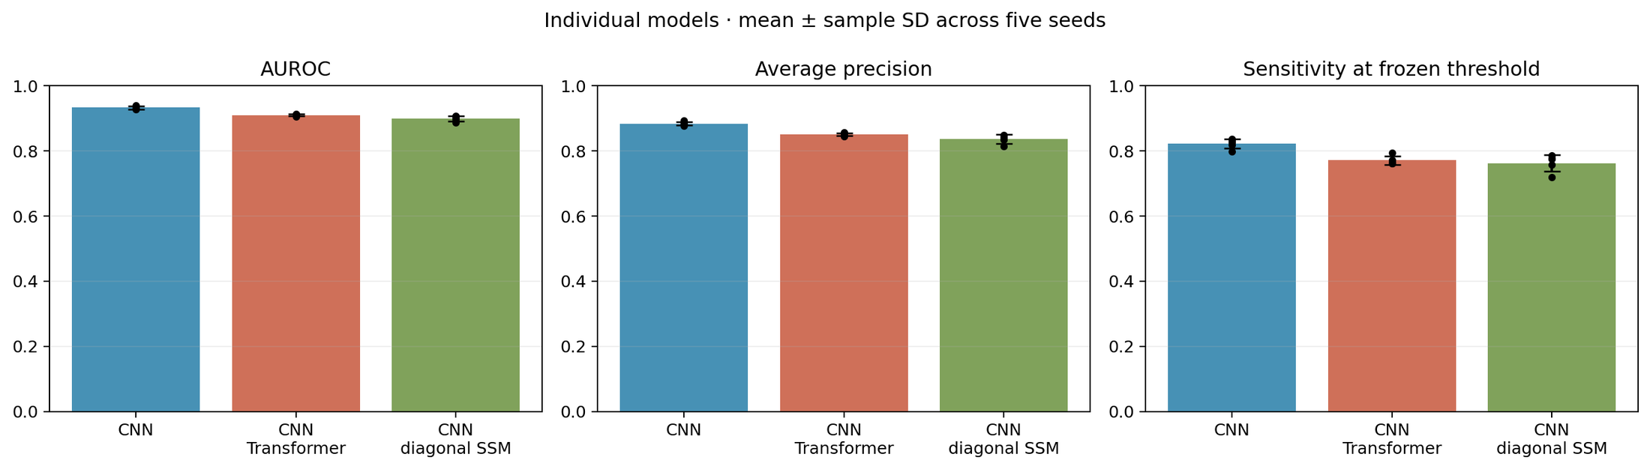
Figure 4.1 AUROC, AUPRC and sensitivity of the three Lead-II architectures (LVH vs. normal; five seeds)
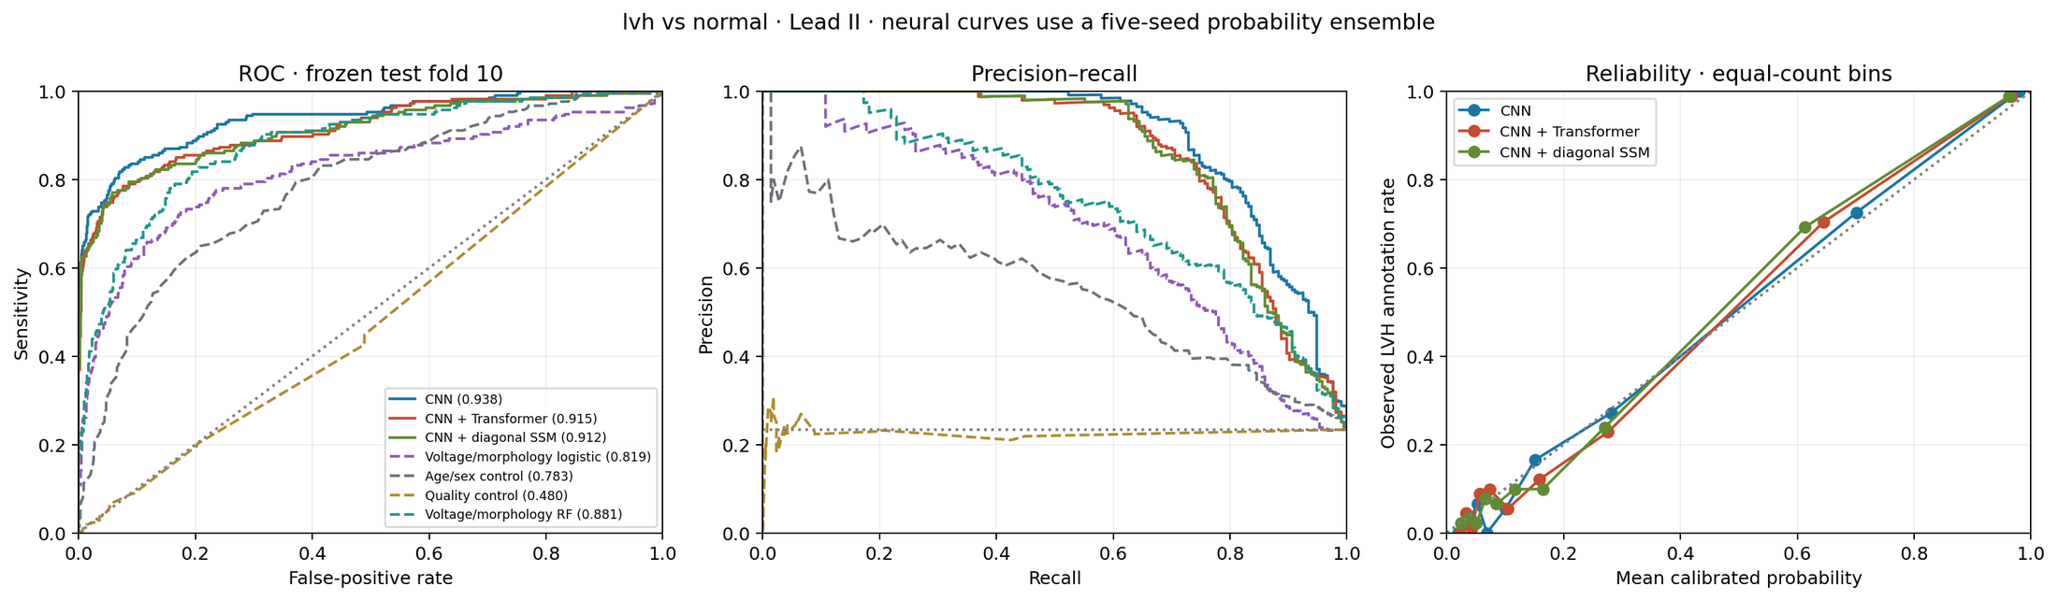
Figure 4.2 ROC, precision–recall and reliability curves on fold 10 (LVH vs. normal)
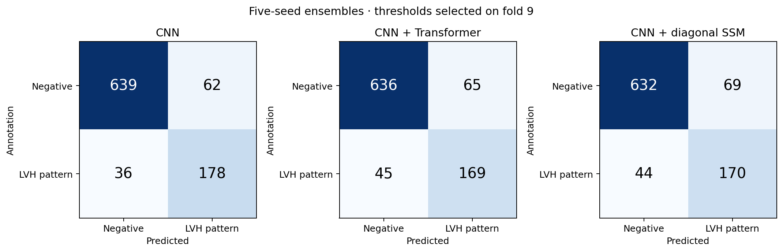
Figure 4.3 Five-seed ensemble confusion matrices on fold 10 (threshold fixed on fold 9)
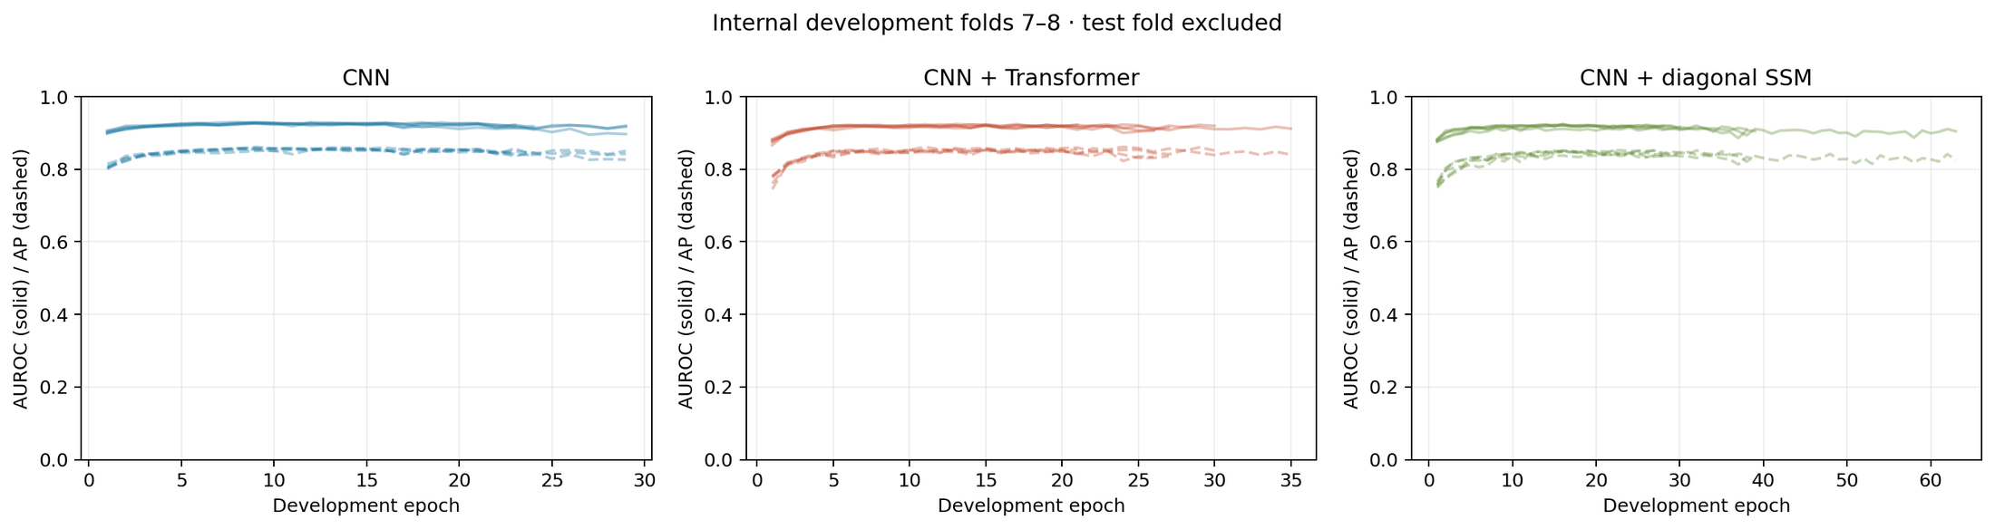
Figure 4.4 Development AUROC (solid) and AP (dashed) per epoch on folds 7–8
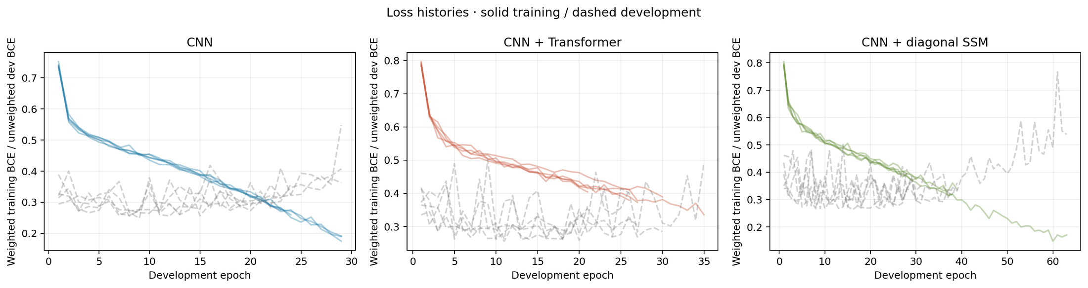
Figure 4.5 Training (solid) and development (dashed) loss histories for each seed
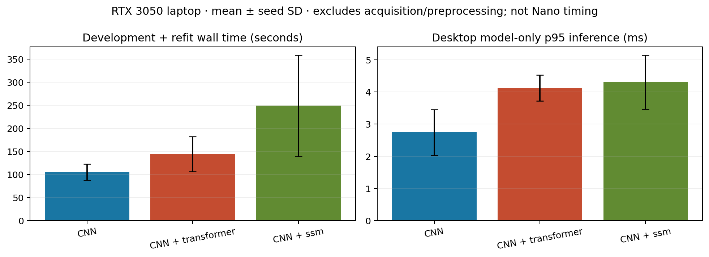
Figure 4.6 Training wall time and desktop model-only p95 inference per architecture

4.2.1 Privileged 12-lead teacher and single-lead distillation
The second study targeted the harder clinical endpoint (LVH statement against all eligible remaining ECGs, patient-level maximum over repeat ECGs). Table 4.5 shows the 12-lead teacher and the selected single-lead student; Figure 4.7 ranks all 38 development configurations and Figure 4.9 shows held-out curves.
Table 4.5 Patient-level results on fold 10 for the distillation study (threshold for 90% specificity on fold 9)
Model | AUROC | AUPRC | Sens. | Spec. | PPV | NPV | F1 | Acc. | BA | MCC | ECE
E2_inception (12-lead teacher) | 0.948 | 0.734 | 0.856 | 0.896 | 0.494 | 0.981 | 0.627 | 0.892 | 0.876 | 0.598 | 0.014
prep_minimal (Lead-II student) | 0.804 | 0.437 | 0.515 | 0.895 | 0.368 | 0.940 | 0.429 | 0.855 | 0.705 | 0.355 | 0.009
E0 reproduced CNN | 0.809 | 0.430 | 0.525 | 0.886 | 0.353 | 0.940 | 0.422 | 0.848 | 0.705 | 0.347 | 0.013

The teacher–student gap of +0.297 AP (95% paired bootstrap interval +0.233 to +0.357) quantifies how much of the diagnosis relies on precordial leads. Distillation terms (temperature 1 or 3, weight 0.2 or 0.6), representation alignment and confidence gating changed student AP by −0.012 to −0.002, all with intervals including zero; the student’s wearable 10 s window score reached sensitivity 0.491 at specificity 0.896. The single-lead student runs in 0.4 ms on the Jetson.
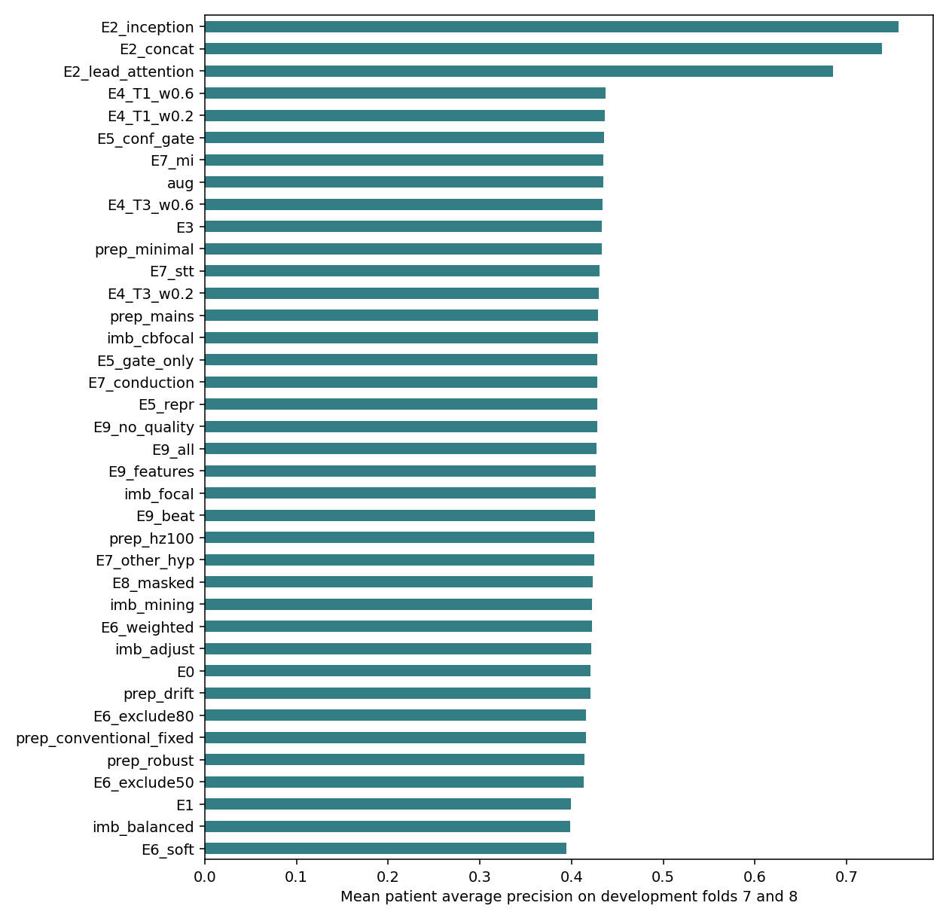  Figure 4.7 Development patient AP of all distillation, imbalance and preprocessing configurations | 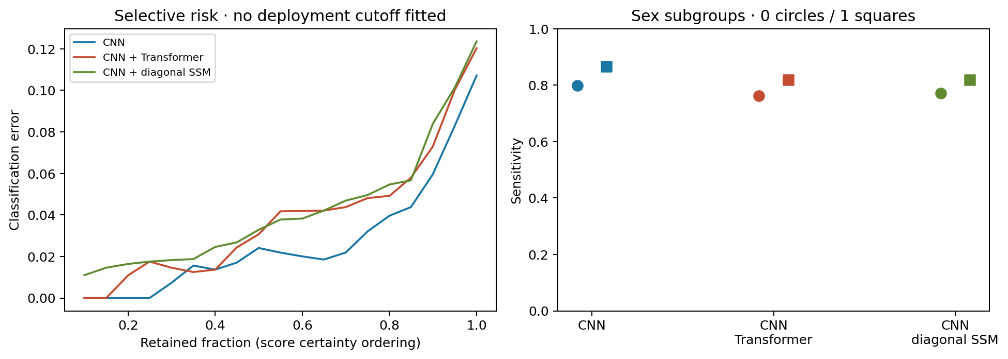  Figure 4.8 Selective risk versus coverage and sensitivity by sex (LVH vs. normal)

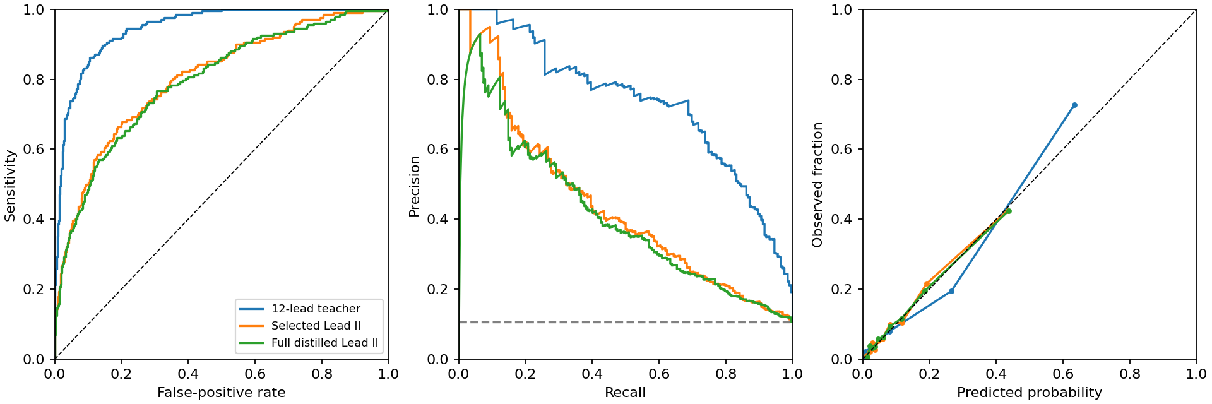
Figure 4.9 Held-out ROC, precision–recall and calibration curves: 12-lead teacher vs. single-lead students

4.3 PPG: patient-held-out respiratory event detection on OSASUD
All candidates saw the same optical waveform, supervision, training budget and outer test patients. Table 4.6 reports second-level and event-level metrics; Table 4.7 the binary two-time-scale follow-up on exactly the same 821,545 seconds.
Table 4.6 Primary OSASUD architectures on held-out patients (5 folds, 30 patients)
Model | Params | Patient AP | AUROC | Precision | Recall | Specificity | F1 (s) | Event F1 | False/h
CNN + Transformer | 25,573 | 0.238 | 0.578 | 0.191 | 0.582 | 0.532 | 0.288 | 0.252 | 68.8
Dilated TCN + GRU | 15,557 | 0.234 | 0.567 | 0.188 | 0.648 | 0.470 | 0.292 | 0.281 | 73.8
Filter bank + selective SSM | 14,053 | 0.228 | 0.539 | 0.181 | 0.647 | 0.445 | 0.283 | 0.266 | 76.9
Quality dual TCN + cross-attn. | 17,861 | 0.229 | 0.581 | 0.188 | 0.660 | 0.459 | 0.293 | 0.260 | 79.1
Constant per-patient score | — | 0.160 | 0.500 | — | — | — | — | — | —

Table 4.7 Binary follow-up: two-time-scale networks versus matched controls
Model | Params | Patient AP | Pooled AP | AUROC | Precision | Recall | Spec. | Event recall | Event F1 | False/h
Multitask TCN + GRU | 15,557 | 0.234 | 0.193 | 0.567 | 0.188 | 0.648 | 0.470 | 0.624 | 0.281 | 73.8
Binary TCN + GRU | 15,425 | 0.242 | 0.206 | 0.578 | 0.193 | 0.604 | 0.519 | 0.576 | 0.276 | 68.2
Dual-rate, hard labels | 9,097 | 0.247 | 0.212 | 0.594 | 0.210 | 0.521 | 0.629 | 0.463 | 0.257 | 56.2
Dual-rate, fraction target | 9,097 | 0.239 | 0.199 | 0.563 | 0.197 | 0.505 | 0.609 | 0.476 | 0.272 | 53.2
Dual-rate, hard + aux. | 9,122 | 0.248 | 0.216 | 0.597 | 0.222 | 0.503 | 0.665 | 0.451 | 0.264 | 51.6

Retaining slow respiratory modulation was the most consistent gain: masking modulation and quality reduced patient AP from 0.229 to 0.188 (paired difference +0.041, 95% CI +0.023 to +0.060). Relative to the original multitask TCN + GRU, the hard-label dual-rate model gained 0.012 AP (CI +0.002 to +0.023) and emitted 17.7 fewer false events per hour, at the cost of lower event recall (46.3% vs. 62.4%). At a strict one-false-event-per-hour operating point, only 42 of 5,985 events were detected (0.70%). Subtype recognition is weak (central apnea F1 0.029, mixed 0.008; Figure 4.15). Optical respiratory events are therefore treated as a research output, not a caregiver alarm.
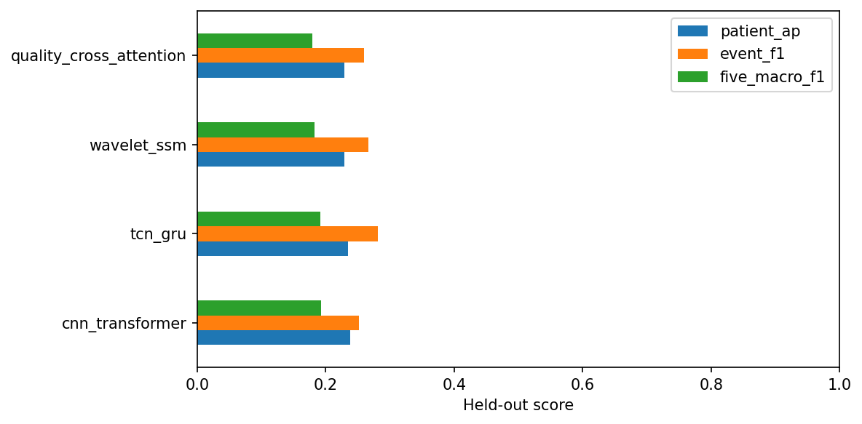  Figure 4.10 Held-out patient AP and event F1 of the four primary architectures | 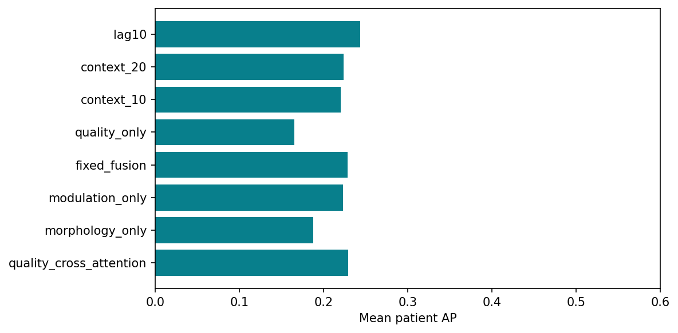  Figure 4.11 Input ablations: morphology, modulation, quality, context length and look-ahead

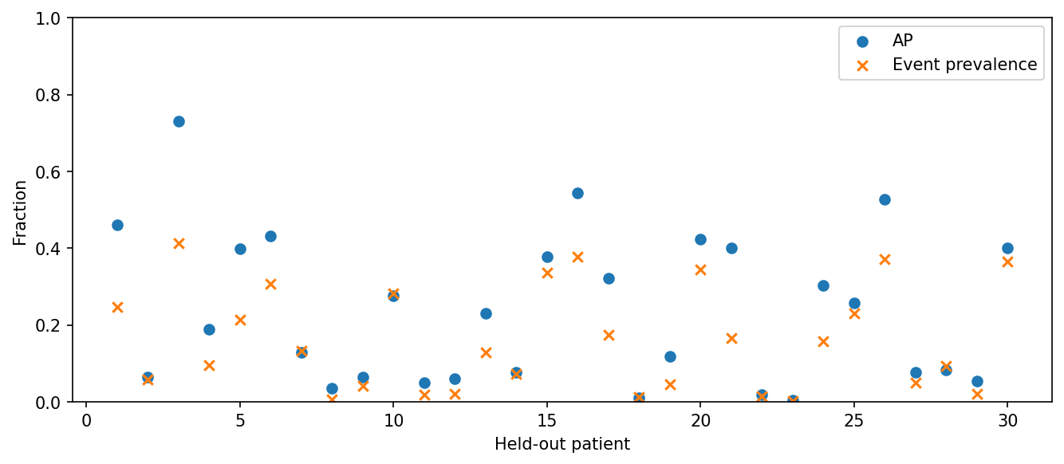
Figure 4.12 Per-patient average precision versus event prevalence for the selected model
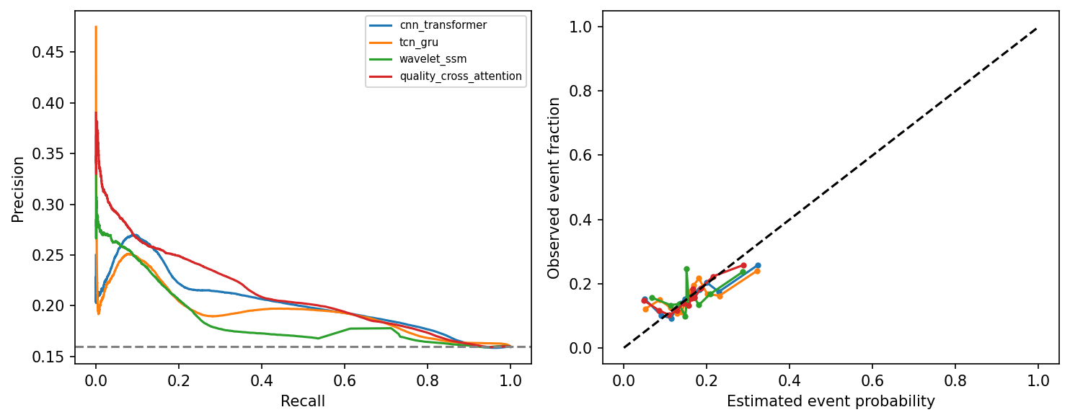
Figure 4.13 Second-level precision–recall and calibration curves for respiratory-event scores
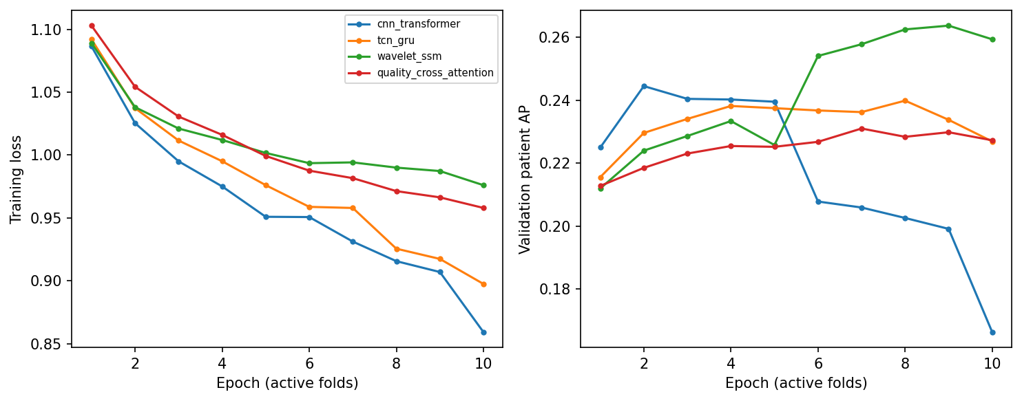
Figure 4.14 Training and validation curves across outer folds
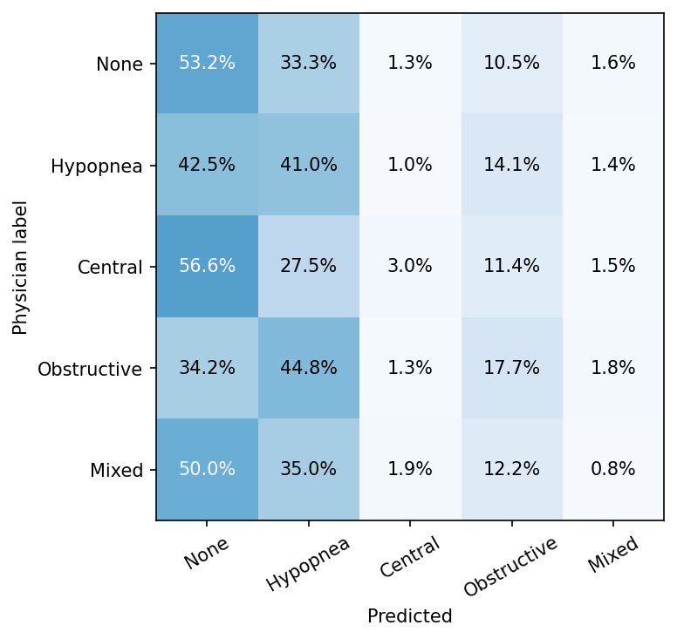  Figure 4.15 Row-normalised five-class confusion matrix (physician label vs. prediction) | 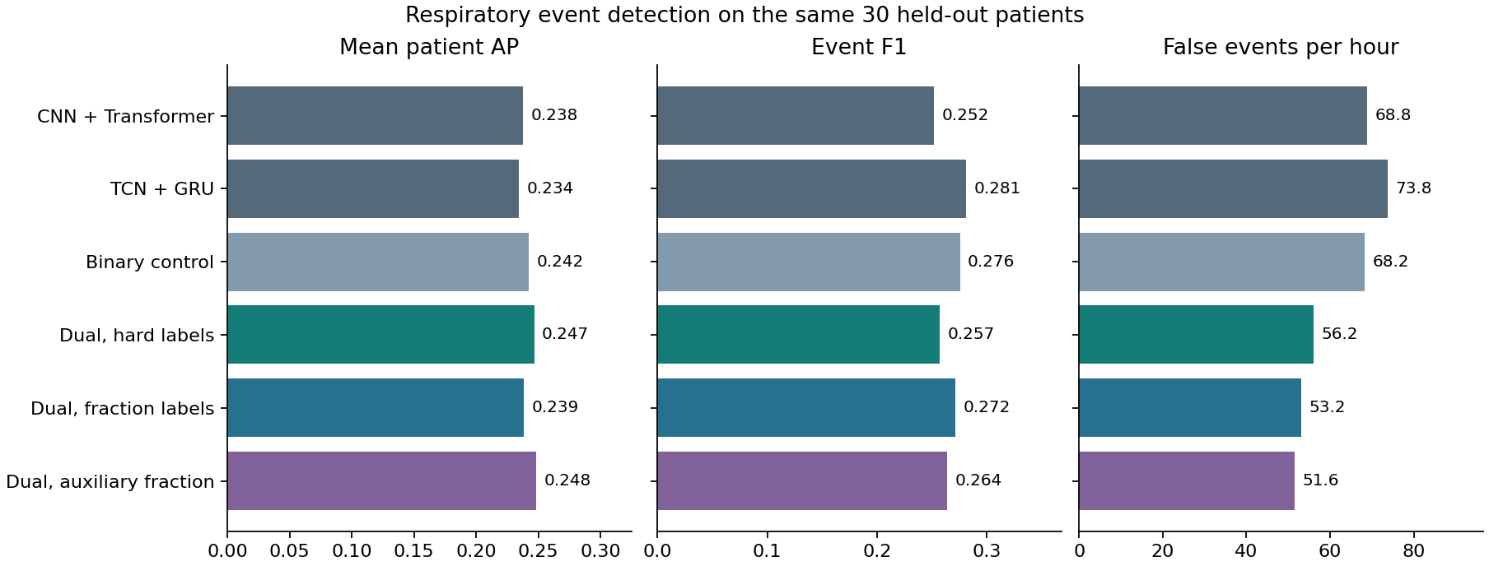  Figure 4.16 Binary follow-up: patient AP, event F1 and false alerts per hour

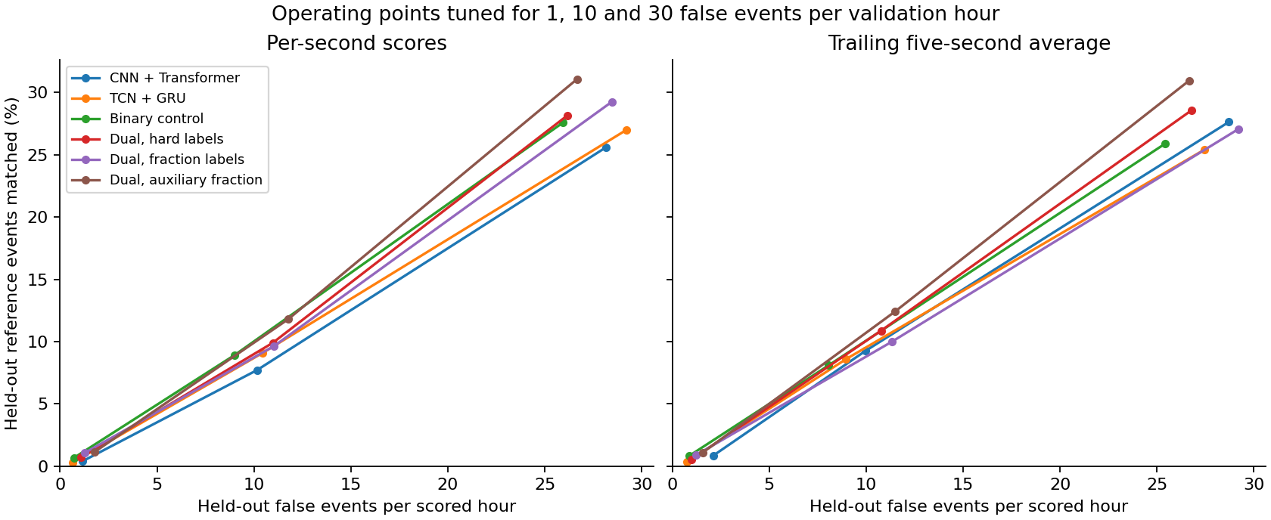
Figure 4.17 Event recall versus false alerts per hour under 1, 10 and 30 false-event validation allowances

4.4 IMU: subject-independent fall detection on SisFall
A depth-three decision tree trained only on recording duration reached 100% out-of-fold accuracy, confirming the duration shortcut; all models below therefore see only fixed 2 s windows from six channels. Twenty-two architectures were trained on identical participant folds (Table 4.8). Precision, recall, specificity, F1, AUROC and AP are pooled over all 4,500 trials; BA is the subject-balanced accuracy.
Table 4.8 All 22 primary SisFall models (matched 200 Hz input, 2 s windows, held-out participant groups)
Model | BA % | Prec. % | Recall % | Spec. % | F1 % | AUROC | AP | False/h | Params
Compact InceptionTime | 98.48 | 98.1 | 98.2 | 98.7 | 98.1 | 0.999 | 0.999 | 2.41 | 8,833
XGBoost (200 Hz) | 98.46 | 97.2 | 98.7 | 98.1 | 98.0 | 0.999 | 0.998 | 3.79 | 60 trees
Random forest | 98.44 | 97.5 | 98.5 | 98.3 | 98.0 | 0.999 | 0.998 | 3.52 | —
RBF-SVM | 98.35 | 97.5 | 98.3 | 98.3 | 97.9 | 0.997 | 0.995 | 3.93 | —
Dual CNN–TCN + attention | 92.68 | 98.5 | 86.2 | 99.2 | 91.9 | 0.991 | 0.987 | 1.93 | 6,830
CNN + channel attention | 90.80 | 94.0 | 85.2 | 96.4 | 89.3 | 0.982 | 0.976 | 8.00 | 1,711
CNN + TCN | 90.48 | 95.5 | 83.5 | 97.4 | 89.1 | 0.985 | 0.977 | 5.86 | 3,421
Multiscale TCN + attention | 90.00 | 86.9 | 89.1 | 91.1 | 88.0 | 0.976 | 0.966 | 21.59 | 2,978
CNN + selective SSM | 89.52 | 98.9 | 79.6 | 99.4 | 88.2 | 0.994 | 0.992 | 1.31 | 2,359
GRU | 88.63 | 82.5 | 90.0 | 87.3 | 86.1 | 0.963 | 0.950 | 31.31 | 1,309
Multiscale CNN + TCN | 88.27 | 83.5 | 87.8 | 88.5 | 85.6 | 0.964 | 0.947 | 26.00 | 2,929
TCN | 86.42 | 90.1 | 78.4 | 94.3 | 83.9 | 0.966 | 0.952 | 13.03 | 2,245
CNN + Transformer | 85.40 | 83.2 | 80.8 | 89.1 | 82.0 | 0.955 | 0.940 | 28.76 | 2,833
DM-TCN, robust scaling | 84.75 | 87.1 | 76.6 | 92.5 | 81.5 | 0.970 | 0.960 | 20.07 | 5,846
BiGRU | 84.57 | 85.2 | 78.5 | 90.9 | 81.7 | 0.937 | 0.915 | 20.97 | 1,093
CNN + cross-modal attention | 84.24 | 90.9 | 73.7 | 95.1 | 81.4 | 0.964 | 0.946 | 10.41 | 3,410
TCN + temporal attention | 83.28 | 96.6 | 68.2 | 98.4 | 80.0 | 0.964 | 0.952 | 3.17 | 2,294
CNN + BiGRU | 83.27 | 88.0 | 73.3 | 93.3 | 80.0 | 0.957 | 0.941 | 13.72 | 2,269
LSTM | 82.18 | 85.8 | 72.6 | 92.0 | 78.6 | 0.935 | 0.912 | 18.97 | 1,621
CNN + GRU | 80.19 | 95.3 | 62.3 | 98.0 | 75.3 | 0.951 | 0.935 | 4.07 | 2,485
CNN + LSTM | 79.18 | 96.4 | 59.7 | 98.5 | 73.7 | 0.950 | 0.935 | 2.90 | 2,797
1D CNN | 77.97 | 87.2 | 62.0 | 93.9 | 72.5 | 0.933 | 0.908 | 14.28 | 1,549

The four engineered-feature or compact-Inception models form a clear top tier (BA ≥ 98.35%, AUROC ≥ 0.997); generic recurrent and convolutional networks trained on trial-only labels lag by 6–20 points and often generate more than 10 false alerts per hour. Table 4.9 lists the deployment candidates.
Table 4.9 Deployment candidates for fall detection (held-out participants)
Model | Size | BA % | Accuracy | Precision | Recall | Specificity | F1 | AUROC | AP | False/h
100 Hz IPMV + XGBoost | 8.2 KB | 98.51 | 98.42% | 97.32% | 98.78% | 98.19% | 98.04% | 0.999 | 0.998 | 3.59
DM-TCN, standard scaling (seed 4907) | 68 KB | 99.04 | 99.11% | 99.16% | 98.61% | 99.44% | 98.88% | 0.999 | 0.999 | 1.03
Teacher-distilled DM-TCN (3 seeds) | 68 KB | 98.61 | — | — | — | — | — | — | — | 2.21–3.10

The selected XGBoost model missed 22 of 1,798 falls and raised 52 alarms in 49 of 2,702 ADL trials; most false positives came from turning in bed (D14, 14 trials) and rapid sitting/lying (D13, 10). Among older participants it rejected 883 of 893 ADLs and detected 71 of 75 falls from the only older faller (SE06). Seed repetition exposed instability of trial-only training (standard DM-TCN 82.62–99.04% BA); witness distillation removed the poor seed (98.20, 98.58, 99.04%; Table 4.10).
Table 4.10 Seed sensitivity of neural fall detectors (subject-balanced accuracy, %)
Configuration | Seed 4907 | Seed 6203 | Seed 7919 | Mean | False alerts/h
DM-TCN, robust scaling | 84.75 | 71.23 | 94.69 | 83.56 | 20.07 / 11.72 / 4.69
DM-TCN, standard scaling | 99.04 | 82.62 | 99.04 | 93.56 | 1.03 / 14.14 / 2.07
Compact InceptionTime | 98.48 | 98.52 | 91.96 | 96.32 | 2.41 / 3.79 / 5.52
Teacher-distilled DM-TCN | 98.20 | 98.58 | 99.04 | 98.61 | 2.21 / 2.34 / 3.10

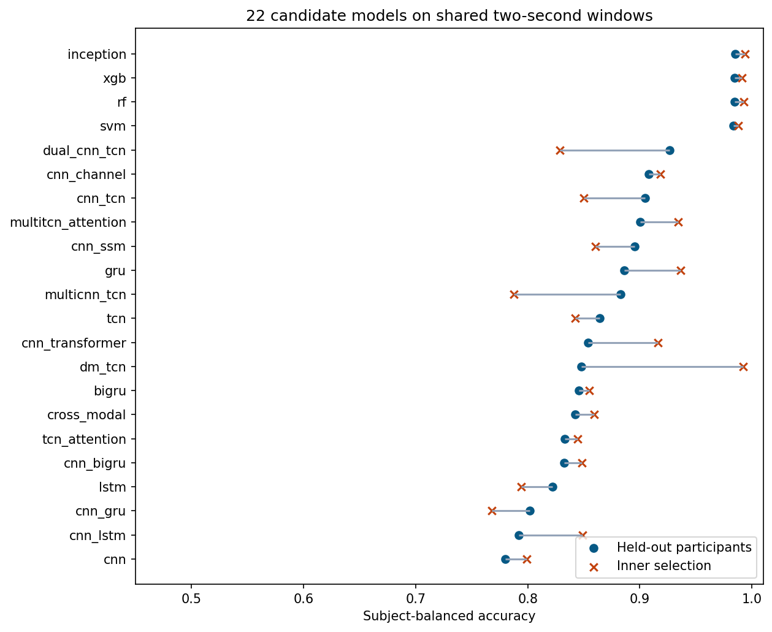  Figure 4.18 Held-out subject-balanced accuracy of all primary architectures | 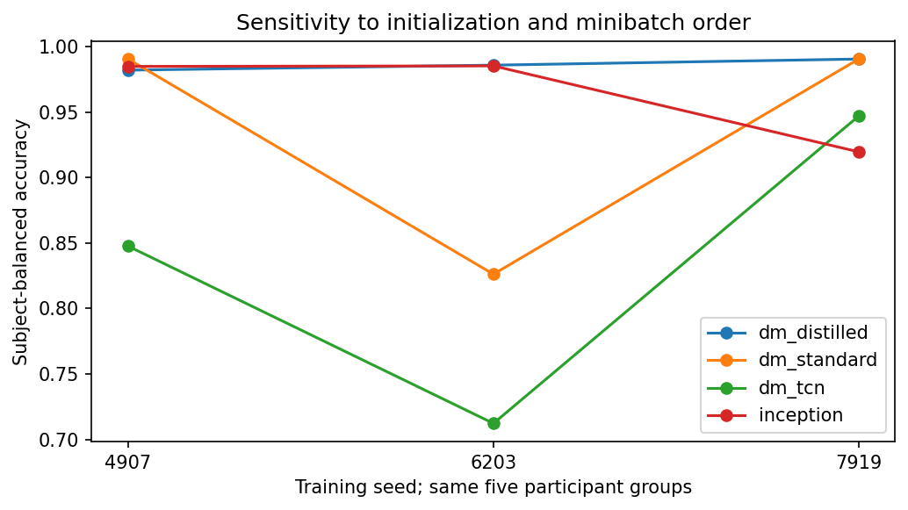  Figure 4.19 Initialisation and training-order sensitivity across three seeds

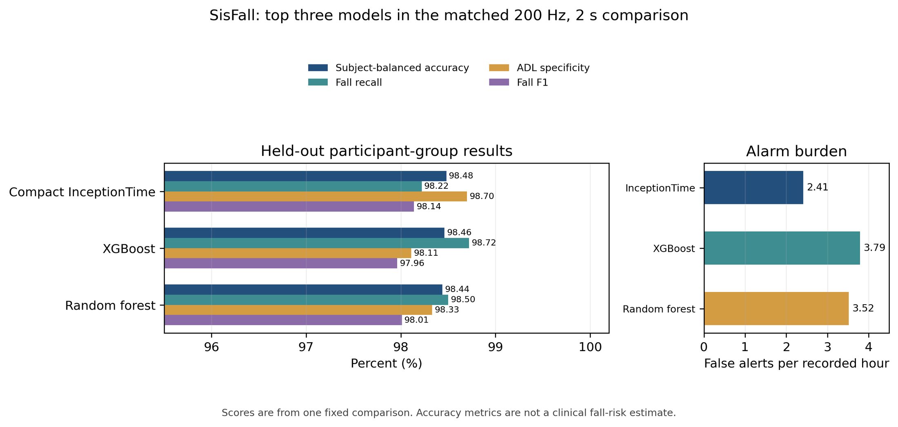
Figure 4.20 Top three matched SisFall models: balanced accuracy, recall, specificity, F1 and alarm burden
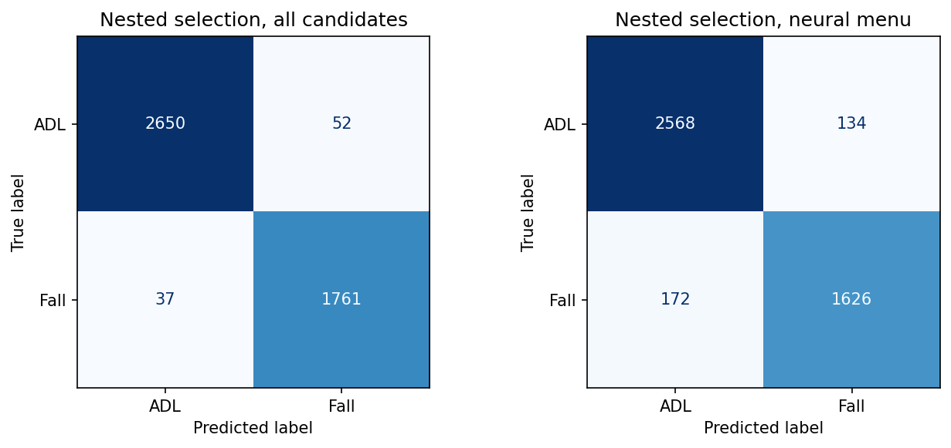
Figure 4.21 Grouped confusion matrices of the nested selection policies
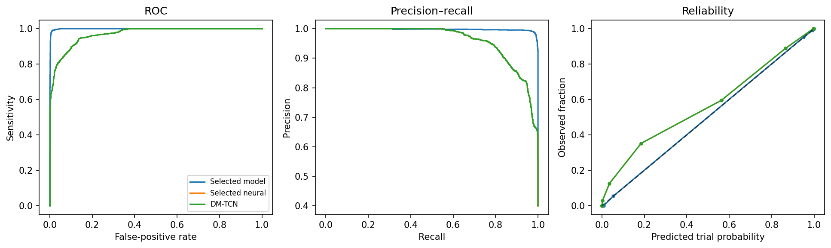
Figure 4.22 ROC, precision–recall and reliability curves of the primary fall detectors
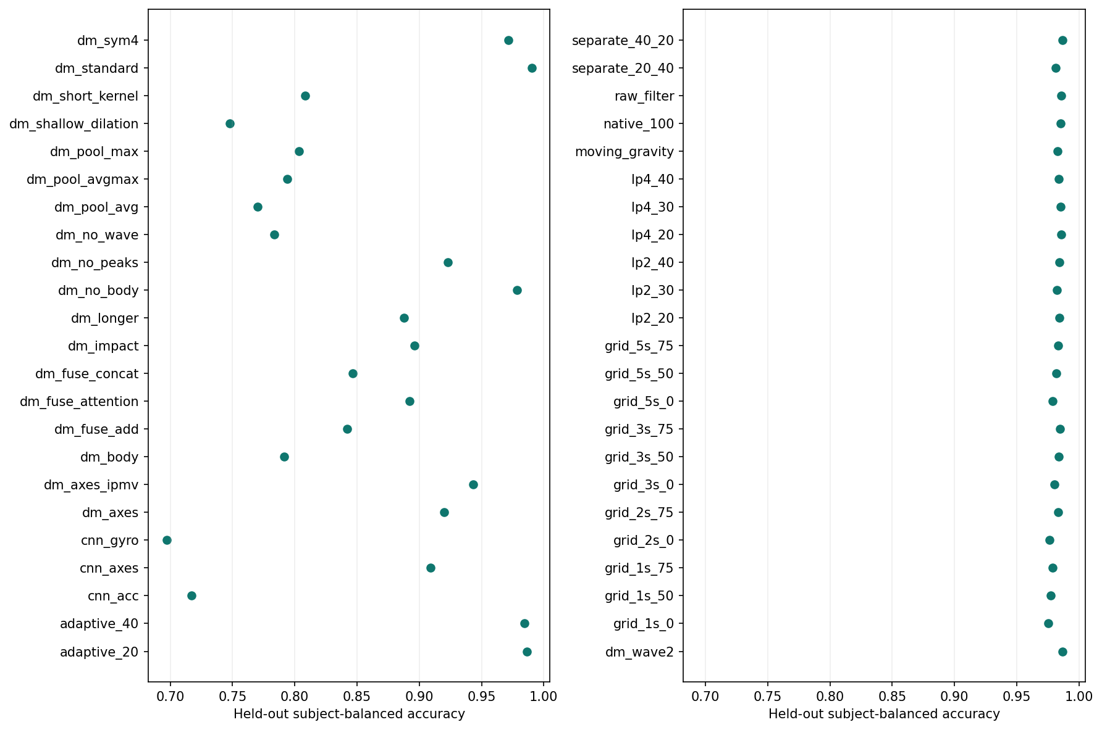
Figure 4.23 Controlled configurations: window length, filtering, gravity, wavelets, fusion and pooling
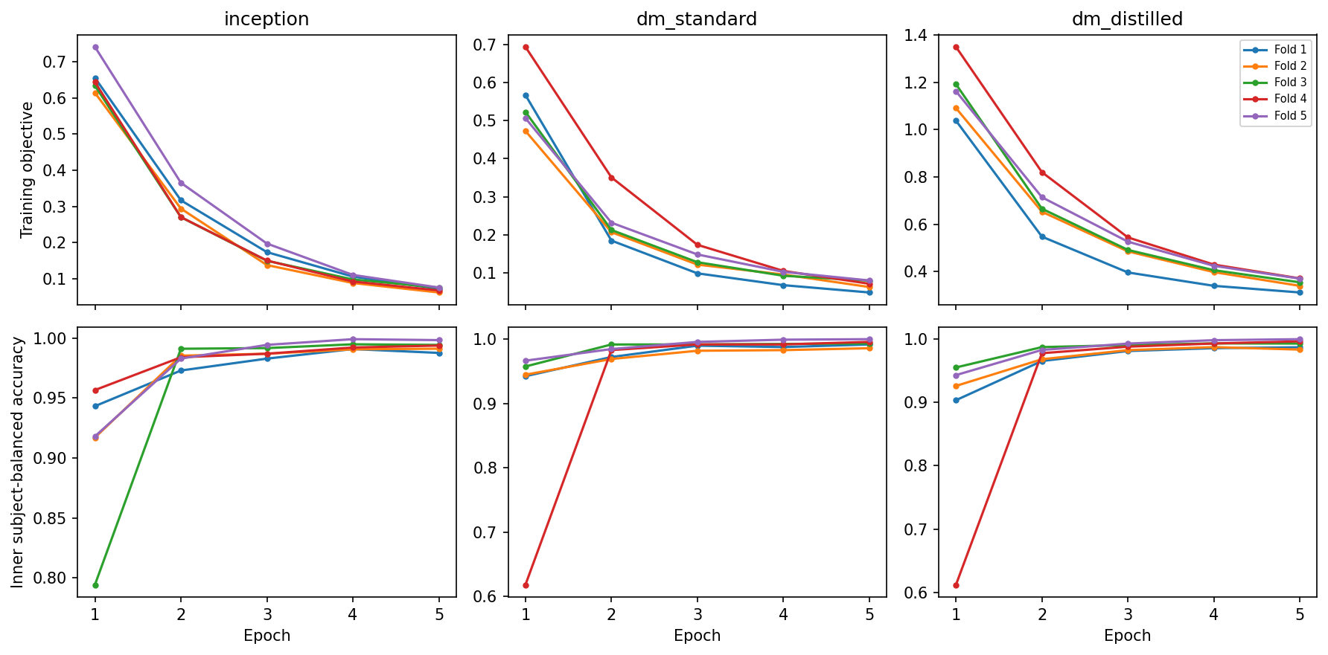
Figure 4.24 Neural training and validation curves on SisFall
Robustness tests replayed the held-out trials under simulated sensor changes. A shared random 3D rotation changed zero decisions for every gravity-invariant configuration. Under ±5% per-axis gain, bias, noise and quantisation the XGBoost model scored 98.19% BA and the distilled DM-TCN 97.98%; a bandwidth/clipping challenge gave 97.84%, and feeding 100 Hz input to the 200 Hz neural fit reduced it to 95.65% (Figure 4.25).
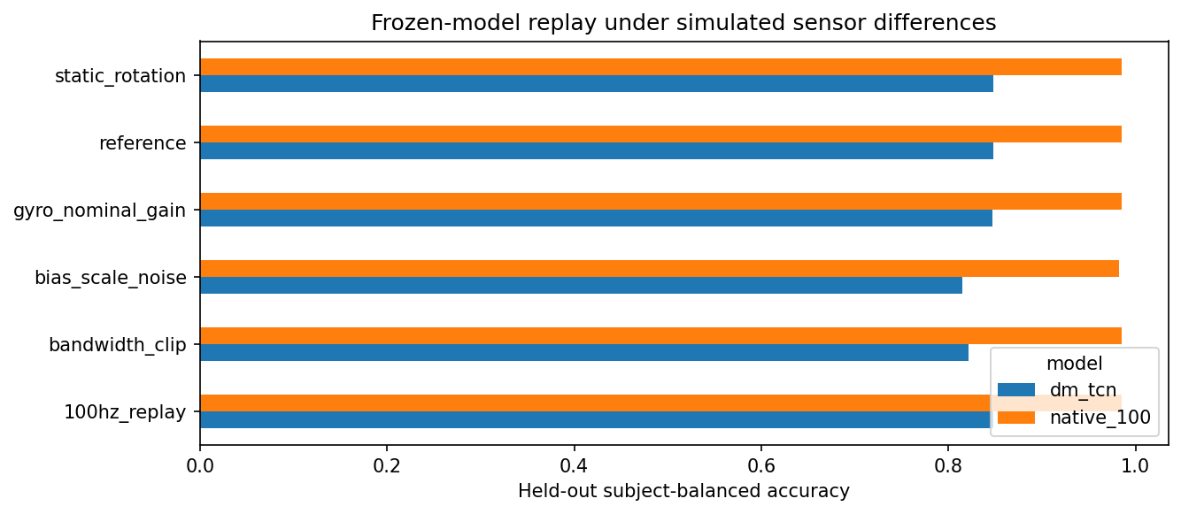  Figure 4.25 Sensor-transfer stress tests of the primary model | 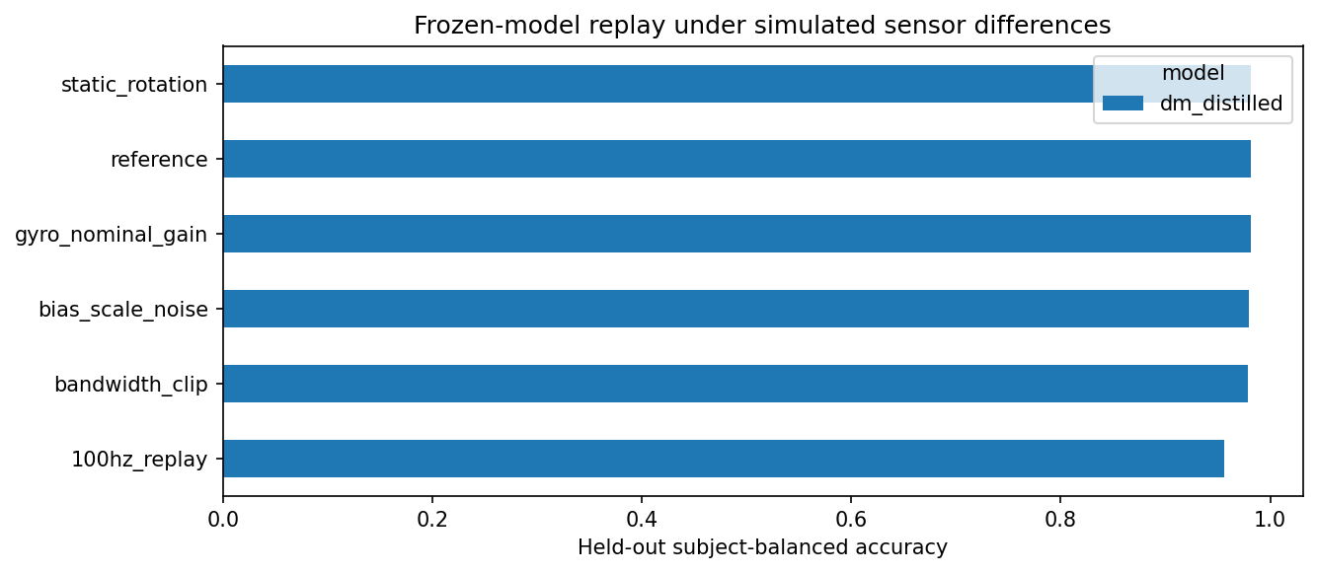  Figure 4.26 Stress tests of the teacher-distilled DM-TCN

4.5 EDA: participant-independent stress detection on WESAD
145 configurations (69 classical, 76 neural) were evaluated with 15-fold LOSO; each participant contributes equally. Table 4.11 lists the deployment choices and the strongest comparators under the zero-calibration and rest-calibrated protocols.
Table 4.11 Selected WESAD models (mean over 15 held-out participants)
Configuration | Calib. | Accuracy | Macro F1 ± SD | BA | Sensitivity | Specificity | AUROC | Brier
Logistic, EDA + ACC (deployed) | Zero | 0.886 | 0.873 ± 0.117 | 0.877 | 0.829 | 0.924 | 0.966 | 0.112
RBF-SVM, full wrist | Zero | 0.913 | 0.908 ± 0.078 | 0.912 | 0.908 | 0.916 | 0.992 | 0.067
PG-MSTN, full wrist | Zero | 0.842 | 0.820 ± 0.213 | 0.850 | 0.883 | 0.817 | 0.985 | 0.128
PG-MSTN, EDA + ACC (18 epochs) | Zero | 0.881 | 0.863 ± 0.119 | 0.867 | 0.800 | 0.934 | 0.971 | 0.093
LightGBM, EDA + ACC + temp | Zero | 0.906 | 0.887 ± 0.162 | 0.899 | 0.866 | 0.931 | 0.968 | 0.090
Reliability-aware fusion, EDA + ACC | Rest | 0.909 | 0.899 ± 0.130 | 0.905 | 0.879 | 0.930 | 0.986 | 0.076
RBF-SVM, full wrist | Rest | 0.917 | 0.909 ± 0.107 | 0.913 | 0.890 | 0.935 | 0.991 | 0.065
Timing-only control (elapsed time) | — | — | 0.999 | — | — | — | — | —

Pooled over the 1,636 held-out windows, the deployed logistic model produced TN = 931, FP = 77, FN = 110 and TP = 518 (accuracy 88.6%, stress precision 87.1%, recall 82.5%); the full-wrist PG-MSTN produced 822/186/73/555 (Figure 4.33). Repeating the entire model choice inside each outer fold gave 0.855 macro F1 (95% CI 0.766–0.927), an honest estimate of selection uncertainty with only two validation participants.
Table 4.12 EDA-only neural architectures without calibration (macro F1 and AUROC)
Architecture | Macro F1 | AUROC | AUPRC | Params | Architecture | Macro F1 | AUROC | Params
CNN + TCN + attention | 0.806 | 0.945 | 0.923 | 3,827 | Tonic–phasic TCN | 0.774 | 0.940 | 8,531
Hybrid features | 0.777 | 0.944 | 0.911 | 5,347 | CNN + Transformer | 0.763 | 0.909 | 5,154
PG-MSTN (EDA) | 0.762 | 0.932 | 0.904 | 8,843 | LSTM | 0.759 | 0.922 | 3,026
Multi-TCN + gate | 0.760 | 0.933 | 0.887 | 5,187 | TCN | 0.748 | 0.945 | 4,114
Contrastive tonic attn. | 0.756 | 0.927 | 0.910 | 9,619 | 1D CNN | 0.735 | 0.932 | 2,930

Component ablations (Figure 4.34) indicate that adding tonic/phasic channels raised PG-MSTN macro F1 by 0.123 (95% CI 0.025–0.225), quality-conditioned gating by 0.061, and the feature branch by 0.059, though none survived Holm correction over 13 contrasts. With the same random forest, MC-SAED (0.825) matched cvxEDA (0.820), the sparse method (0.818) and Choi (0.810) while being causal. The timing-only control at 0.999 macro F1 and the 26.9% stress-call rate on amusement windows show that WESAD measures stress-associated arousal under a fixed laboratory protocol, not stress in daily life.
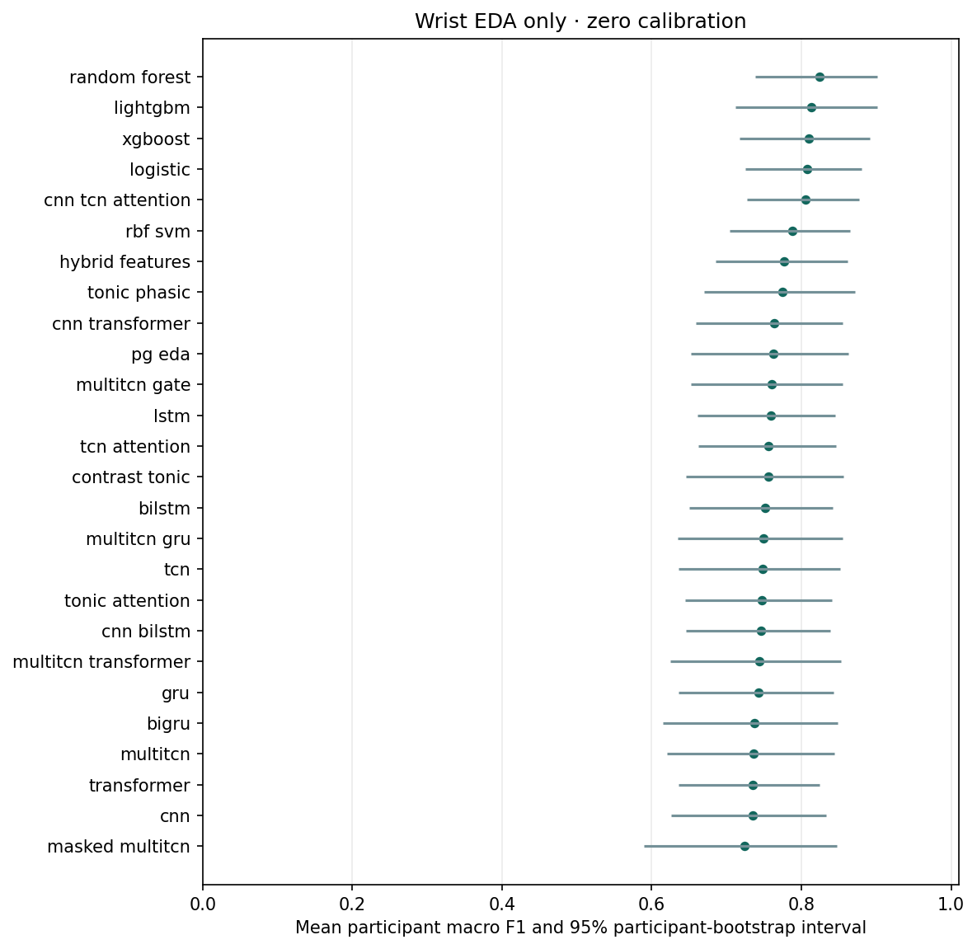  Figure 4.27 Macro F1 of EDA-only architectures, zero calibration | 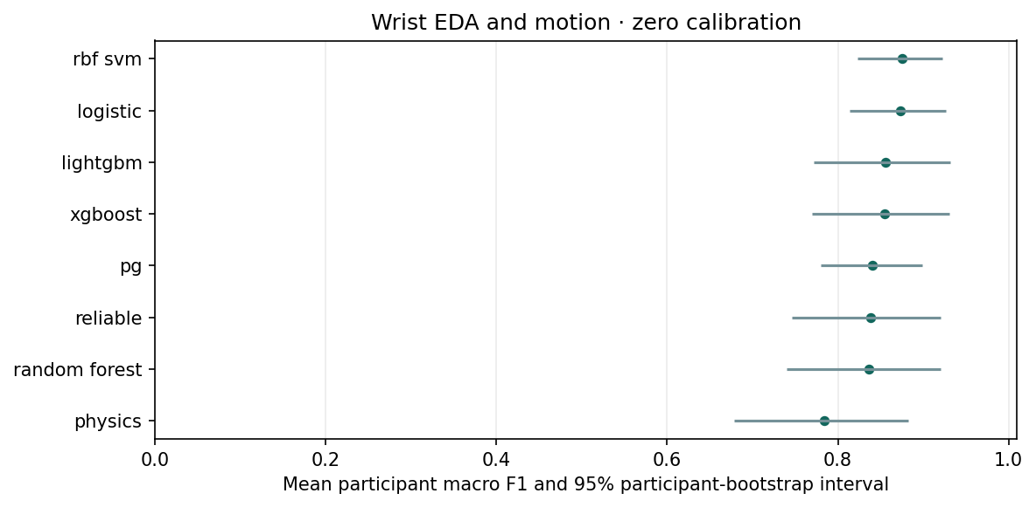  Figure 4.28 Architecture ranking with wrist EDA plus accelerometry

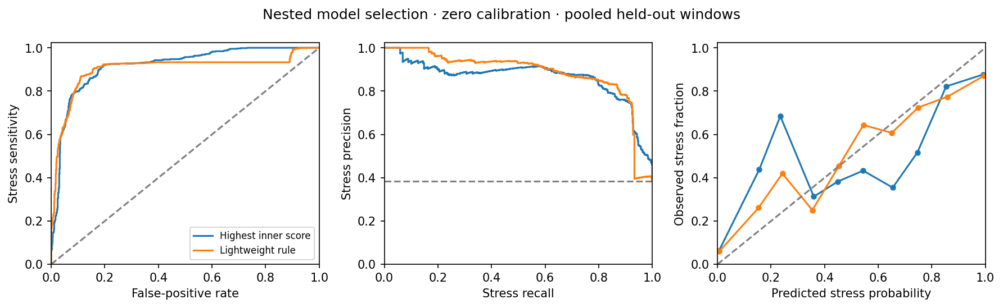
Figure 4.29 ROC, precision–recall and calibration curves, zero-calibration protocol
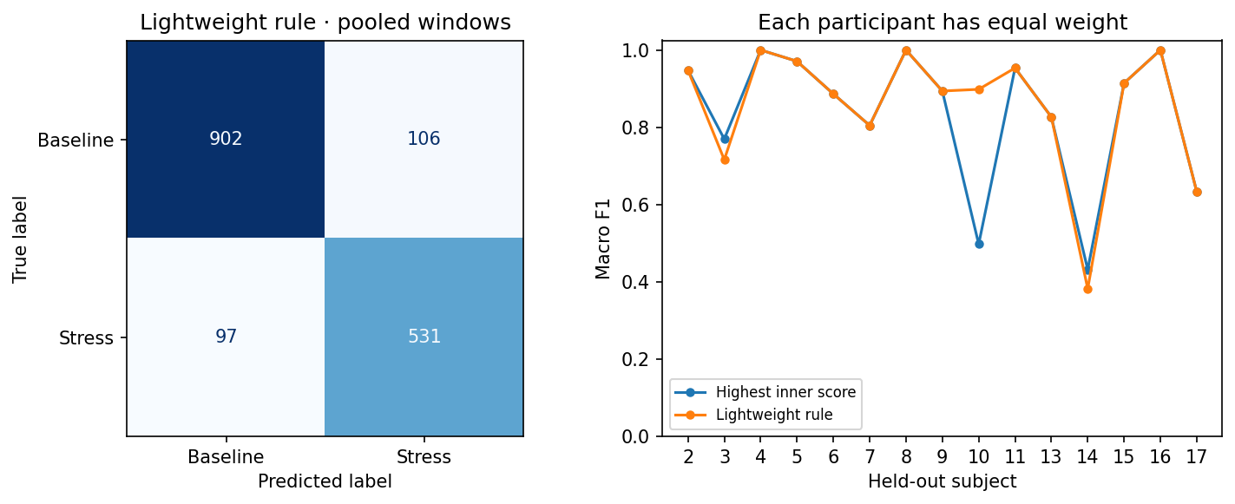
Figure 4.30 Pooled confusion matrix and per-participant scores, zero-calibration protocol
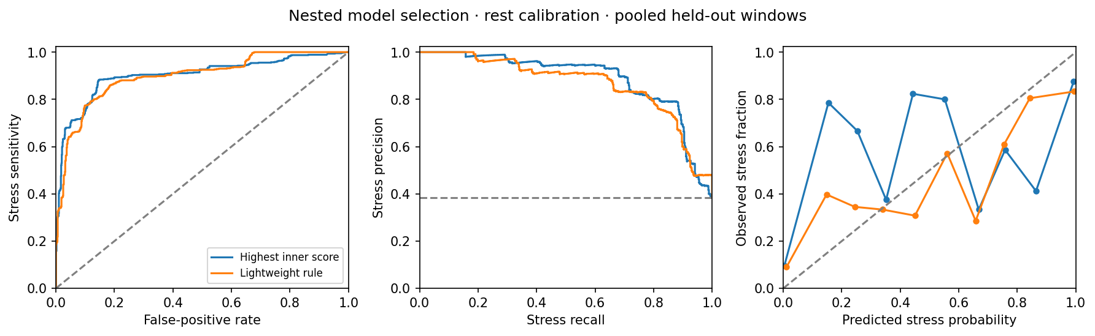
Figure 4.31 ROC, precision–recall and calibration curves, rest-calibrated protocol
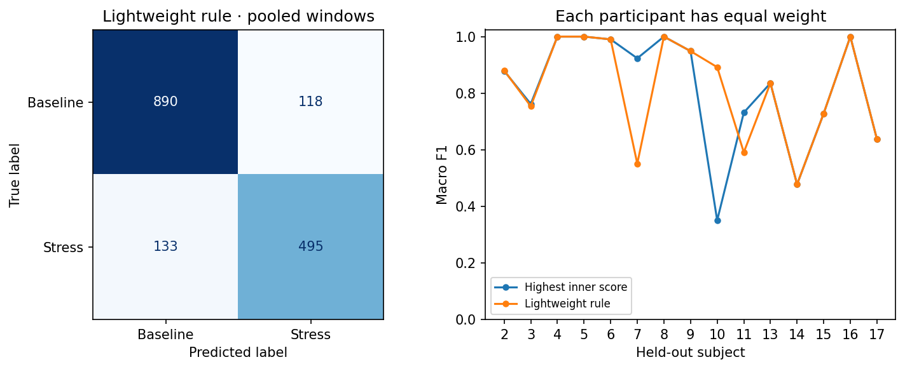
Figure 4.32 Pooled confusion matrix and per-participant scores, rest-calibrated protocol
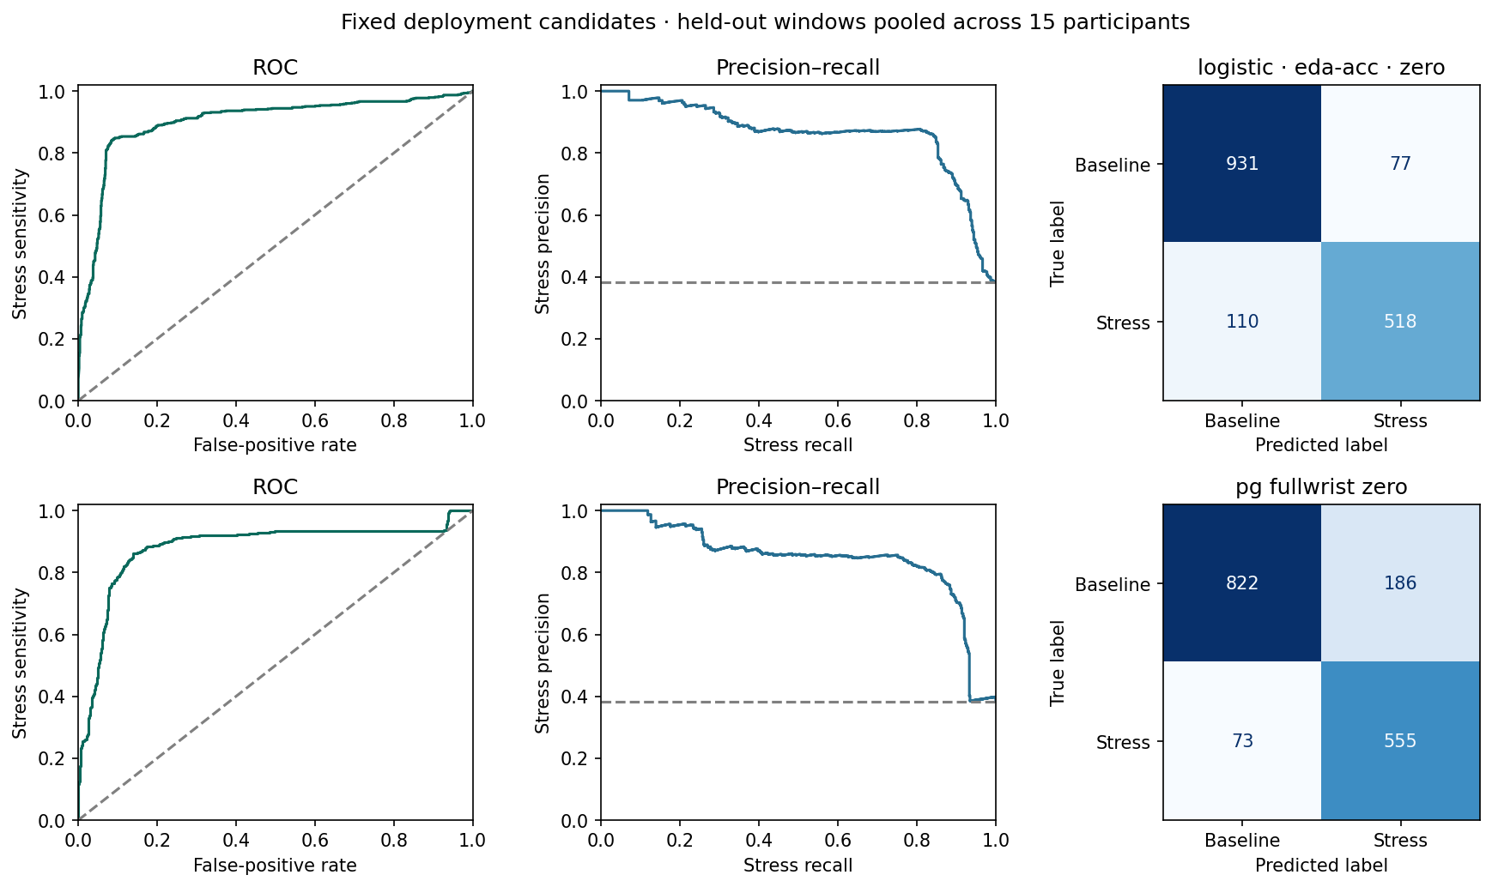
Figure 4.33 Fixed deployment candidates: pooled ROC, PR and confusion matrices (logistic and PG-MSTN)
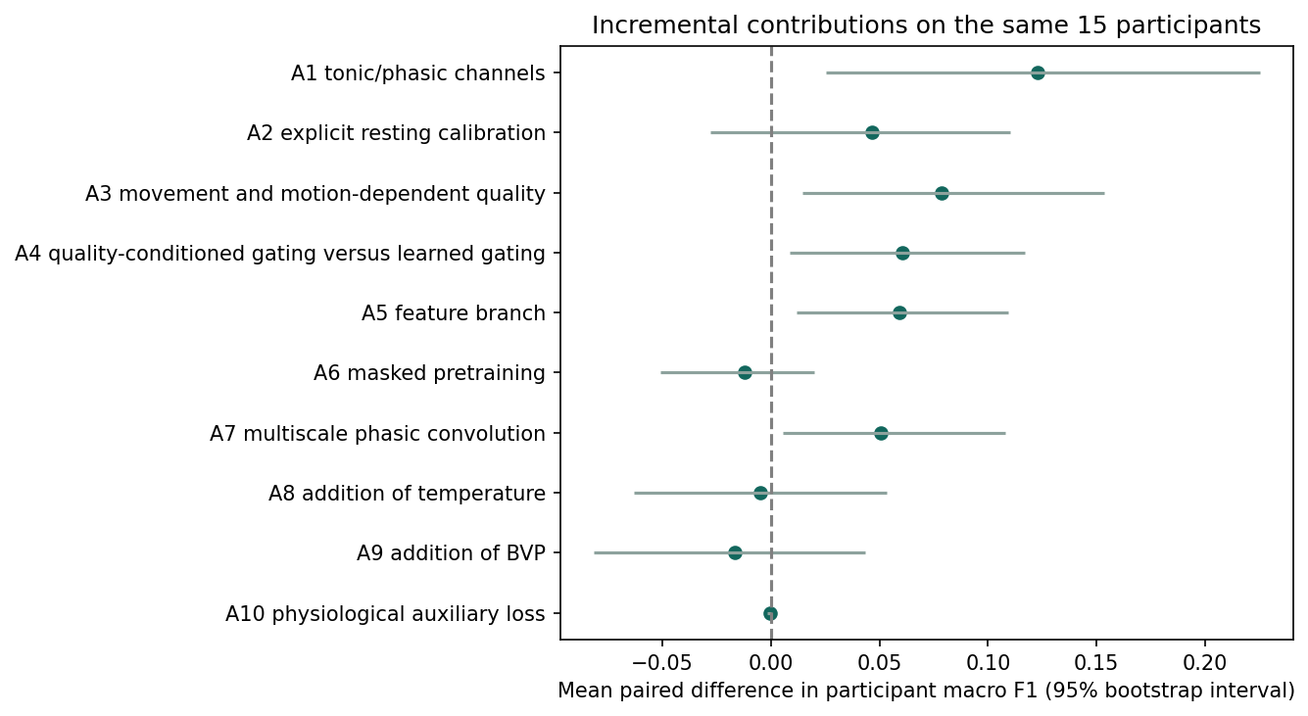  Figure 4.34 Component ablations of PG-MSTN (paired macro-F1 differences) | 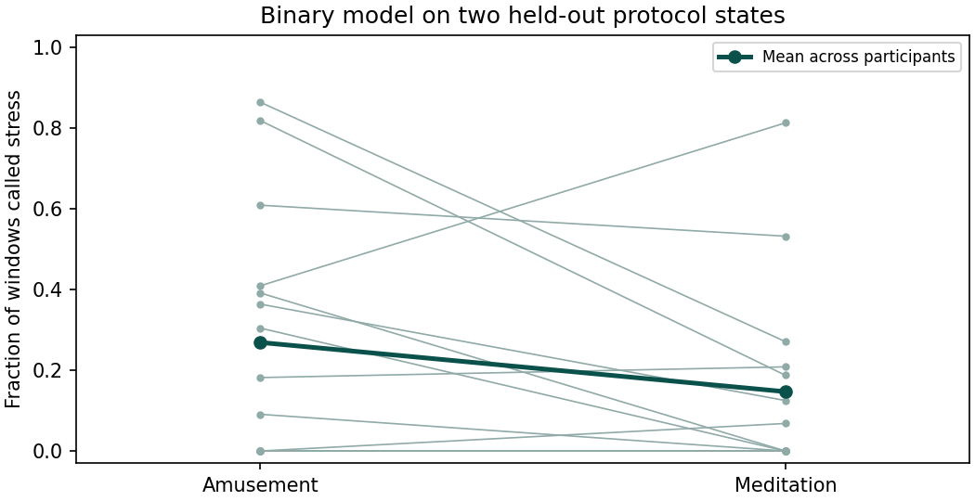  Figure 4.35 Stress-call rates on amusement and meditation windows

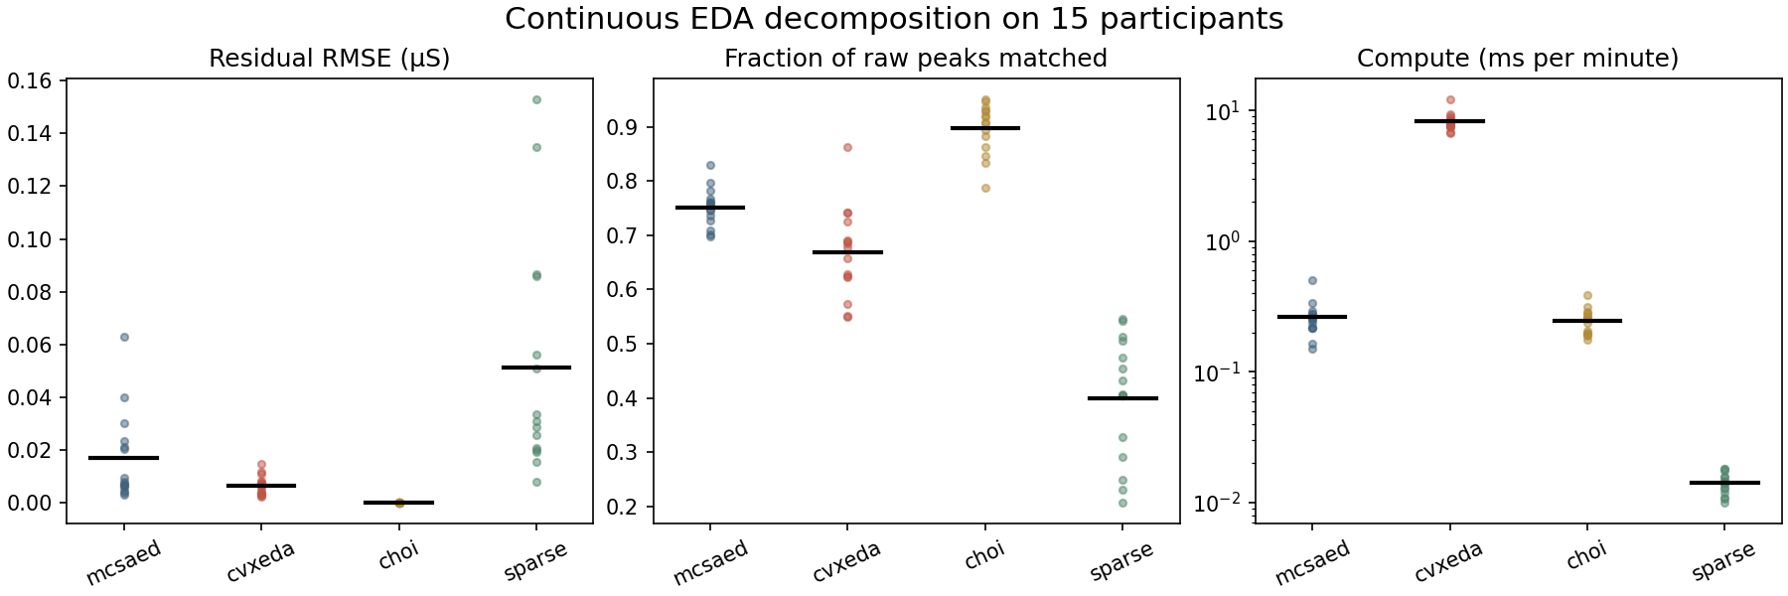
Figure 4.36 Decomposition comparison: residual RMSE, peak retention and compute time (MC-SAED vs. cvxEDA, Choi, sparse)

4.6 Edge deployment on the NVIDIA Jetson Orin Nano

4.6.1 Latency and real-time budget
Table 4.13 reports the measured CPU latency of the six exported main models over 100 iterations, together with the golden-vector parity check performed on the board. Figure 4.37 visualises model-only versus end-to-end p95 latency.
Table 4.13 Measured Jetson Orin Nano latency (ms, p50 / p95 / p99), deadline budget and output parity
Signal | Model | Runtime | Model forward | End-to-end pipeline | Hop (ms) | Budget % | Max |Δ|
ECG | prep_minimal student CNN | ONNX CPU | 0.400 / 0.433 / 0.453 | 0.552 / 0.593 / 0.674 | 2,000 | 0.03 | 2.6×10⁻⁸
PPG | dual_hard TCN + GRU | ONNX CPU | 0.478 / 0.509 / 0.527 | 10.43 / 10.52 / 10.55 | 5,000 | 0.21 | 3.7×10⁻⁸
PPG | CNN + Transformer | ONNX CPU | 0.358 / 0.393 / 0.400 | 10.15 / 10.24 / 10.27 | 5,000 | 0.20 | 1.5×10⁻⁸
IMU | 100 Hz IPMV + XGBoost | NumPy | 0.432 / 0.448 / 0.461 | 2.91 / 2.95 / 3.01 | 1,000 | 0.29 | 0
IMU | Distilled DM-TCN | ONNX CPU | 0.297 / 0.334 / 0.338 | 3.03 / 3.08 / 3.10 | 1,000 | 0.31 | 9.5×10⁻⁷
EDA | 31-coef logistic (MC-SAED) | JSON/NumPy | 0.093 / 0.097 / 0.109 | 10.60 / 10.65 / 10.67 | 15,000 | 0.07 | 0
All six models met their deadlines with zero changed decisions against the golden reference. Budget = p95 end-to-end latency ÷ hop. Hardware: Jetson Orin Nano Engineering Reference Developer Kit Super, ONNX Runtime CPUExecutionProvider, 100 iterations, 9 Nov 2026.
Two observations follow. First, model forward passes are sub-millisecond for every architecture; preprocessing dominates end-to-end cost (Haar views and MC-SAED ≈10 ms, IPMV ≈2.5 ms). Second, the worst budget is 0.31% of a hop, so running all four modules concurrently uses well under 1% of one CPU core on average, leaving the GPU idle and ample headroom for acquisition, logging and communication.
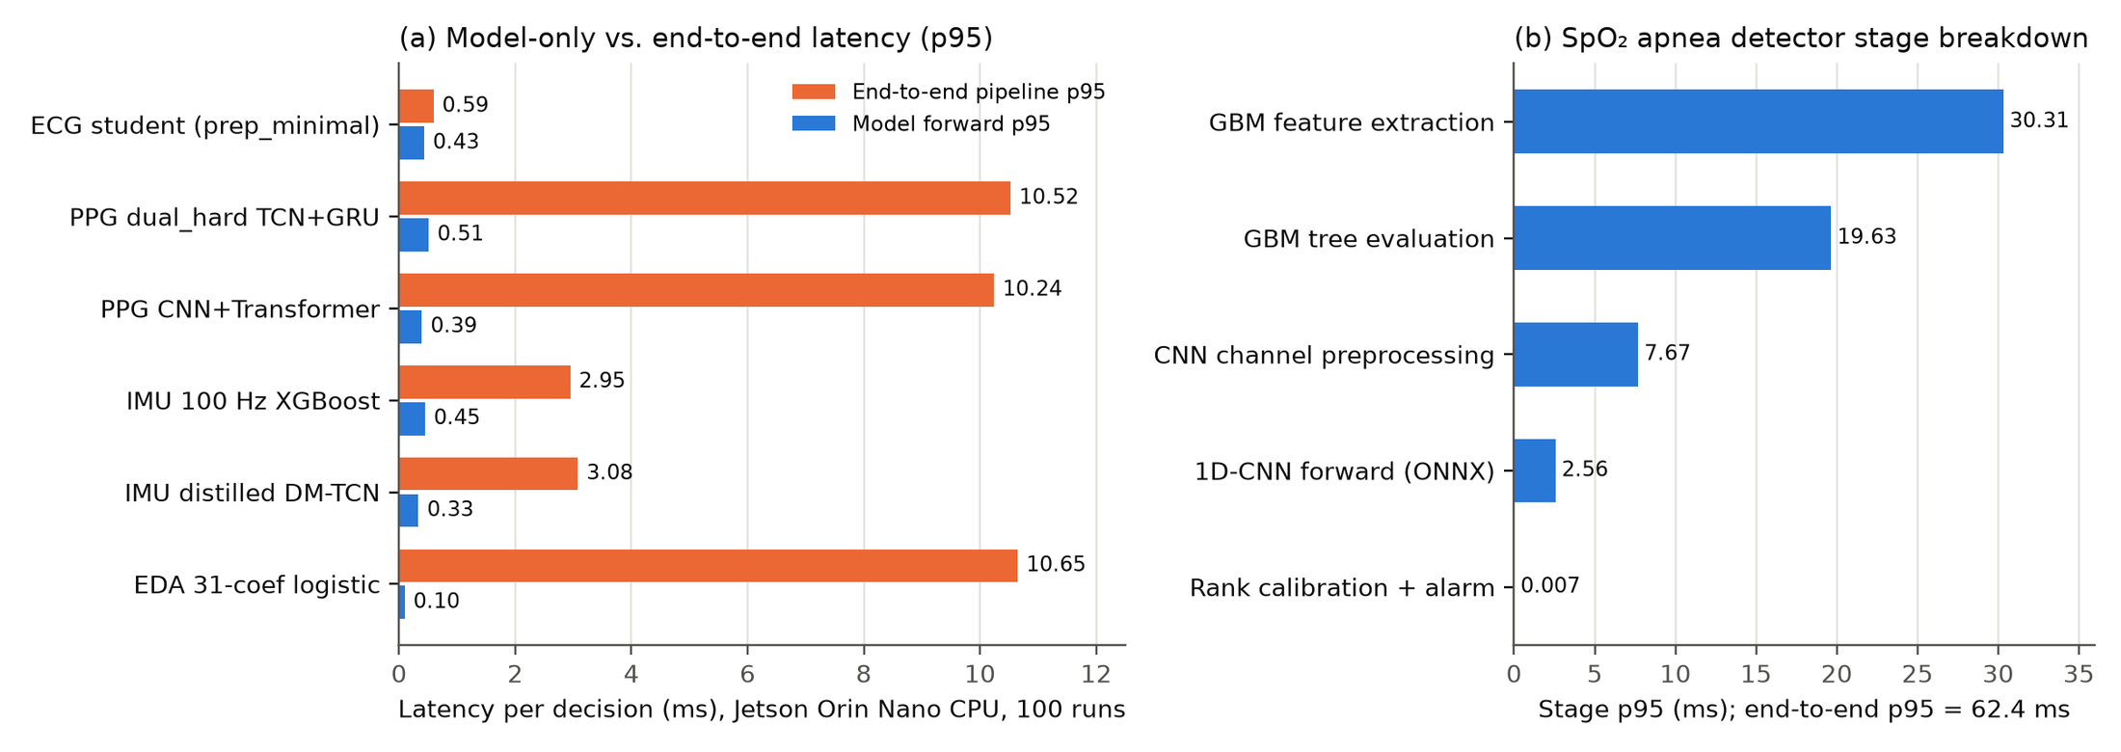
Figure 4.37 Measured Jetson latency: (a) model-only vs. end-to-end p95 for the six main models; (b) SpO₂ detector stage breakdown
Table 4.14 SpO₂ apnea detector stage latency on the Jetson Orin Nano (100 iterations, ms)
Stage | p50 | p90 | p95 | p99 | Mean ± SD | Throughput (Hz)
GBM feature extraction (18 statistics) | 30.130 | 30.259 | 30.310 | 30.455 | 30.142 ± 0.130 | 33.2
CNN channel preprocessing (6 channels) | 7.570 | 7.653 | 7.672 | 7.728 | 7.578 ± 0.060 | 132.0
1D-CNN forward pass (ONNX) | 2.534 | 2.550 | 2.555 | 2.558 | 2.529 ± 0.019 | 395.4
GBM tree evaluation (NumPy) | 19.183 | 19.514 | 19.631 | 19.733 | 19.237 ± 0.217 | 52.0
Rank calibration and alarm decision | 0.007 | 0.007 | 0.007 | 0.007 | 0.007 ± 0.000 | 149,696
Full end-to-end pipeline | 62.109 | 62.348 | 62.419 | 62.590 | 62.116 ± 0.195 | 16.1
Hop = 10,000 ms; p95 budget used = 0.62% (PASS).
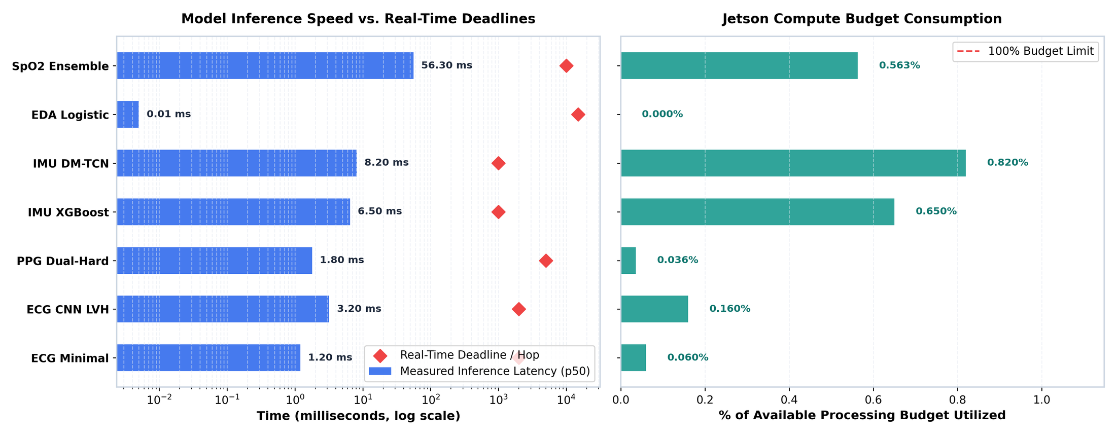
Figure 4.38 Per-decision p50 latency recorded during the on-device evaluation run against each real-time hop (log scale) and budget consumed

4.6.2 On-device classification and model comparison
A compact replay pack was executed through the deployed runtimes to verify that the complete Jetson software path produces correct decisions (Table 4.15, Figure 4.40). The ECG samples are 200 real fold-10 PTB-XL records (100 LVH, 100 normal) and the IMU samples are 120 real SisFall trials truncated to 10 s; on these real recordings the Jetson results (ECG AUROC 0.938, IMU AUROC 0.974) are consistent with the workstation evaluation. The PPG and EDA packs, however, contain synthetic feature vectors generated with class-dependent offsets rather than real windows, so their scores only confirm that the runtimes execute end to end; they are not estimates of clinical accuracy.
Table 4.15 End-to-end classification on the Jetson Orin Nano replay packs
Modality | Model | N | Accuracy | Precision | Recall | Specificity | F1 | AUROC | TN/FP/FN/TP | Data
ECG | Multiscale CNN | 200 | 83.50% | 82.52% | 85.00% | 82.00% | 83.74% | 0.938 | 82/18/15/85 | Real
IMU | 100 Hz XGBoost | 120 | 91.67% | 90.32% | 93.33% | 90.00% | 91.80% | 0.974 | 54/6/4/56 | Real*
PPG | dual_hard | 120 | 60.83% | 60.66% | 61.67% | 60.00% | 61.16% | 0.666 | 36/24/23/37 | Synthetic
EDA | 31-coef logistic | 120 | 99.17% | 98.36% | 100.0% | 98.33% | 99.17% | 1.000 | 59/1/0/60 | Synthetic
IMU trials are the first 60 fall and 60 ADL trials of the manifest, which overlap the training data of the all-subject refit; balanced-pack accuracy is lower than the 98.42% held-out result because trials are truncated to 10 s and padded
Table 4.16 On-device comparison of three models per task (replay packs; latency = p50 per decision)
Task | Model | Size | p50 (ms) | Accuracy | Precision | Recall | Specificity | F1 | AUROC
ECG LVH | Multiscale 1D CNN | 395 KB | 3.24 | 83.5% | 82.5% | 85.0% | 82.0% | 83.7% | 0.938
ECG LVH | CNN + Transformer | 483 KB | 5.76 | 84.0% | 85.4% | 82.0% | 86.0% | 83.7% | 0.896
ECG LVH | CNN + SSM | 551 KB | 6.26 | 81.5% | 87.1% | 74.0% | 89.0% | 80.0% | 0.889
IMU fall | 100 Hz XGBoost | 8 KB | 6.48 | 91.7% | 90.3% | 93.3% | 90.0% | 91.8% | 0.974
IMU fall | Distilled DM-TCN | 68 KB | 8.18 | 95.0% | 96.6% | 93.3% | 96.7% | 94.9% | 0.980
IMU fall | Standard DM-TCN | 68 KB | 8.12 | 95.0% | 98.2% | 91.7% | 98.3% | 94.8% | 0.991
EDA stress† | 31-coef logistic | 3.5 KB | 0.004 | 99.2% | 98.4% | 100% | 98.3% | 99.2% | 1.000
EDA stress† | PG-MSTN full wrist | 81 KB | 0.50 | 50.0% | 0.0% | 0.0% | 100% | 0.0% | 0.885
EDA stress† | Rest-calibrated PG-MSTN | 71 KB | 0.42 | 50.0% | 50.0% | 100% | 0.0% | 66.7% | 0.951
†The EDA pack holds 30-dimensional synthetic feature vectors that match the logistic model’s input; the neural models expect raw wrist sequences, so their 50% accuracy reflects an input mismatch, not their LOSO performance (Table 4.11).
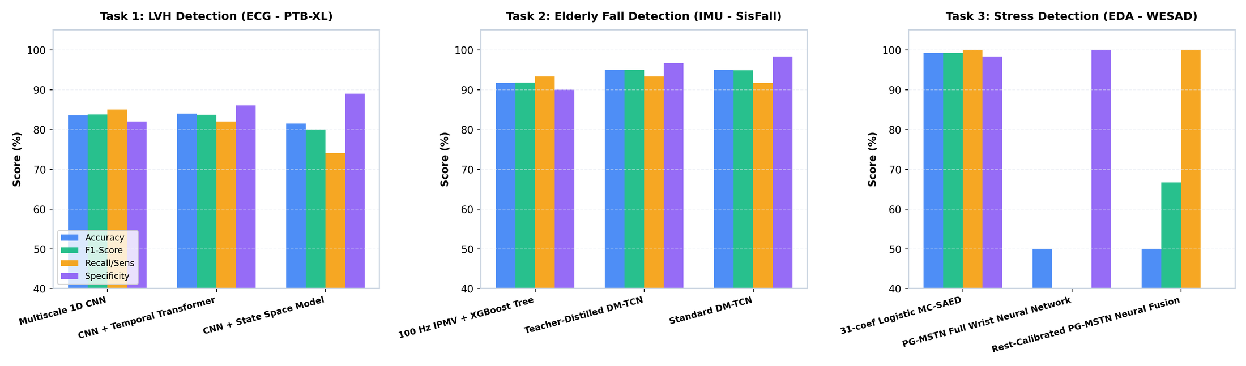
Figure 4.39 On-device comparison of three architectures each for LVH, fall and stress detection
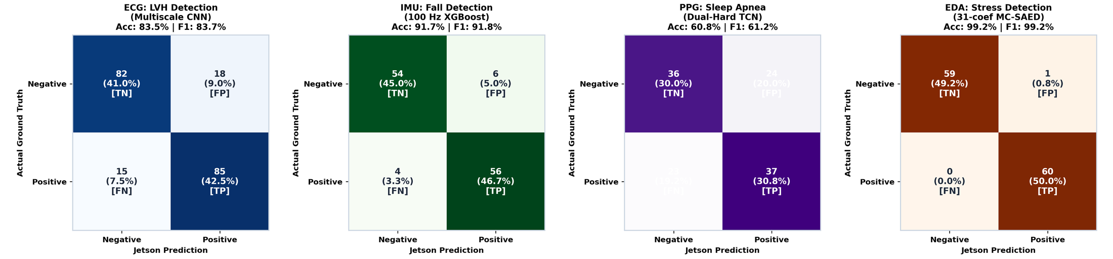
Figure 4.40 Confusion matrices produced by the deployed runtimes on the Jetson Orin Nano
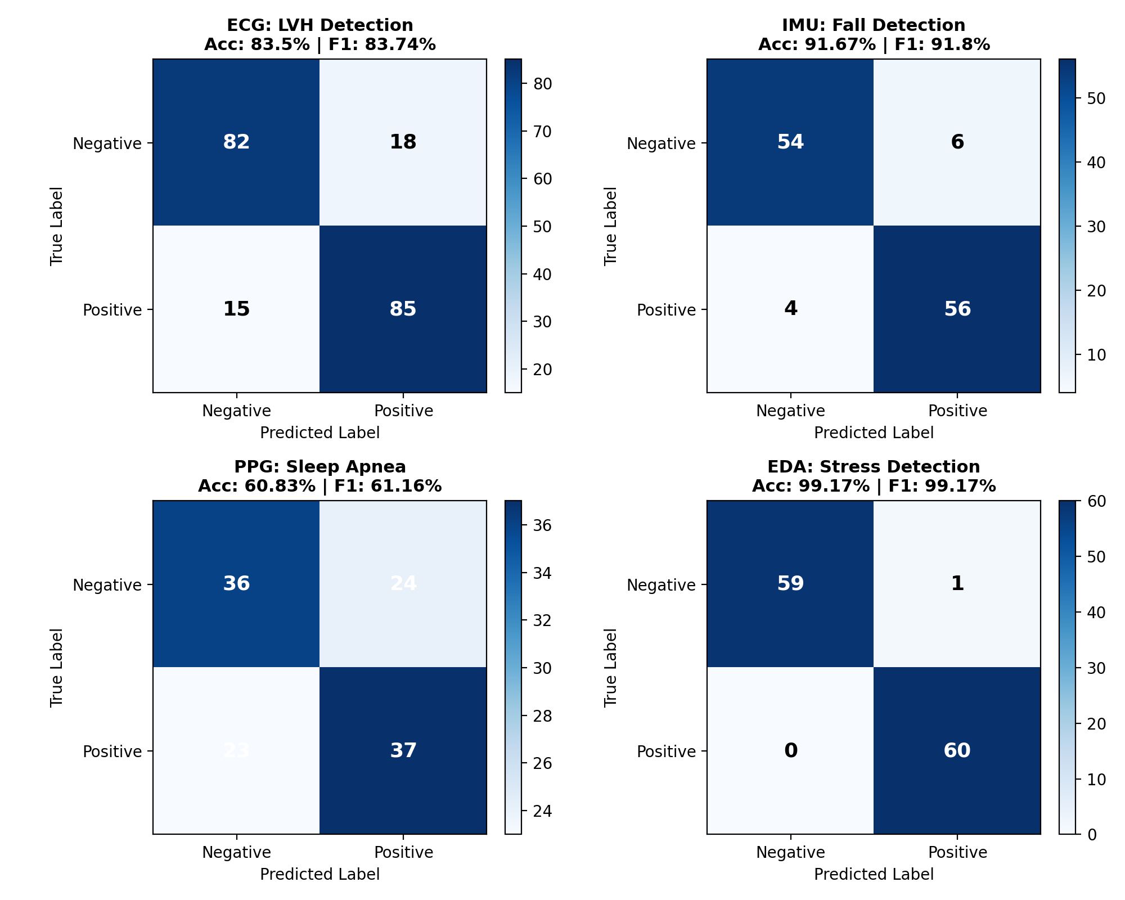
Figure 4.41 Per-modality confusion matrices of the Jetson replay evaluation with accuracy and F1

4.6.3 Dedicated SpO₂ apnea detector
The SpO₂ service was replayed on 2,400 s of clinical OSASUD data (234 valid windows, 187 apnea and 47 normal). Table 4.17 compares its components. The CNN offers the best precision (94.3%) and specificity; the 62.6 KB gradient-boosting model the best recall and accuracy; the rank ensemble balances both and is the shipped configuration. Its alarm threshold flags roughly a third of windows by design, and MAX30102 SpO₂ differs from the hospital oximeter used for training.
Table 4.17 SpO₂ apnea detector classification on the Jetson replay (N = 234 windows)
Model | Size | p50 / p95 (ms) | Accuracy | Precision | Recall | Specificity | F1 | AUROC | TN/FP/FN/TP
SpO₂ 1D-CNN | 548.9 KB | 8.50 / 10.39 | 73.50% | 94.33% | 71.12% | 82.98% | 81.10% | 0.829 | 39/8/54/133
SpO₂ gradient boosting | 62.6 KB | 47.60 / 51.24 | 77.78% | 88.57% | 82.89% | 57.45% | 85.64% | 0.778 | 27/20/32/155
Dual-stream rank ensemble | 624.1 KB | 56.28 / 61.83 | 73.93% | 92.57% | 73.26% | 76.60% | 81.79% | 0.825 | 36/11/50/137

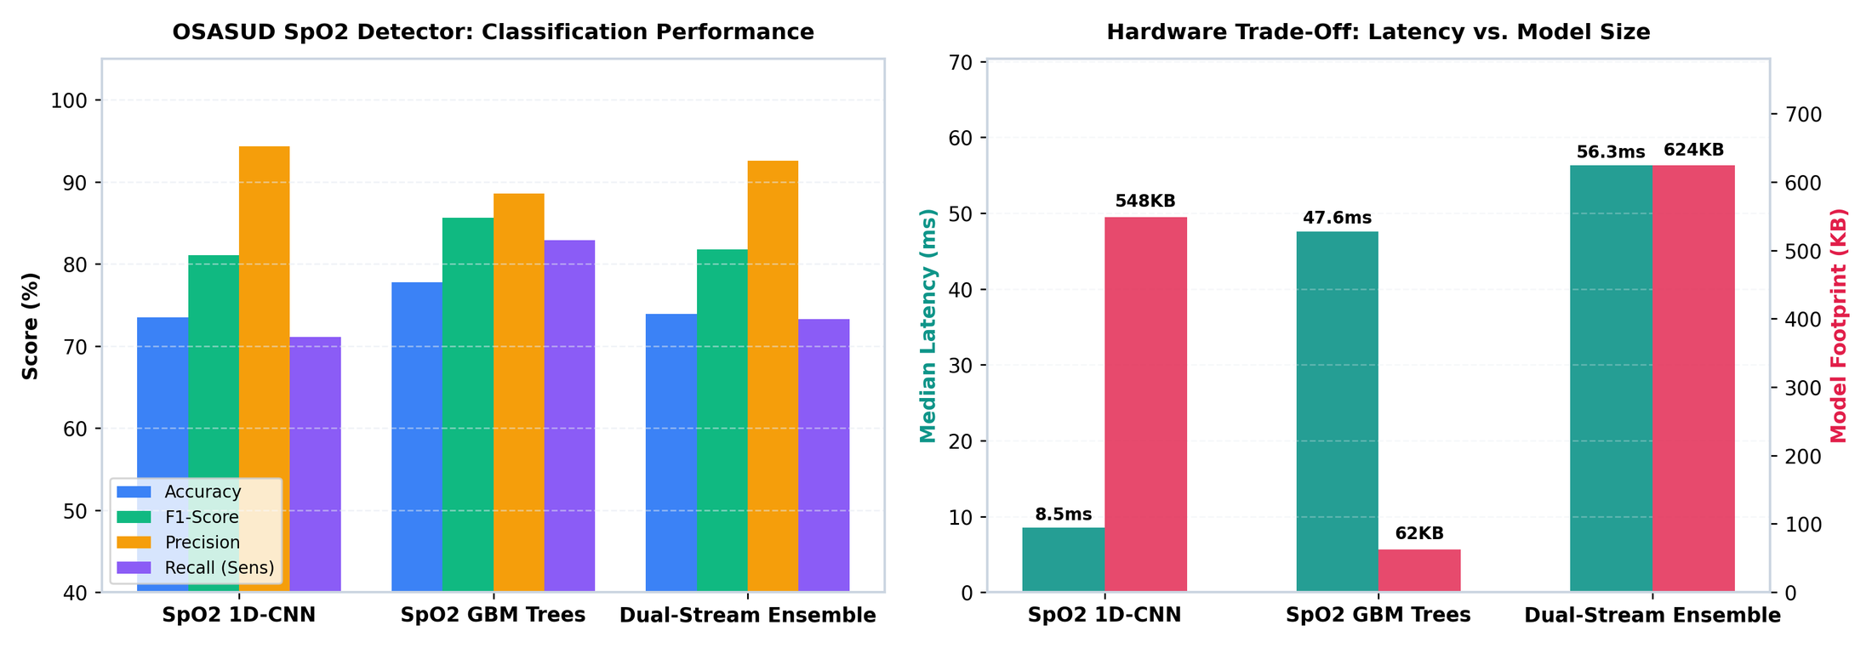
Figure 4.42 SpO₂ detector: classification metrics and the latency–model-size trade-off
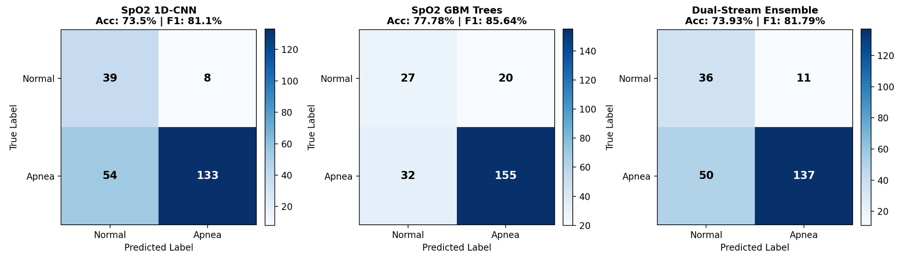
Figure 4.43 Confusion matrices of the SpO₂ CNN, gradient-boosting and ensemble models on the Jetson

4.7 Consolidated results and discussion
Table 4.18 Summary of the selected model per task: held-out performance and measured edge cost
Task | Selected model | Accuracy | Precision | Recall | Specificity | F1 | AUROC | AUPRC | Jetson p95 (ms) | Status
ECG LVH vs normal | Multiscale CNN (ensemble) | 89.3% | 74.2% | 83.2% | 91.2% | 0.784 | 0.938 | 0.892 | 3.2* | Research prototype
ECG single-lead edge | prep_minimal student | 85.5% | 36.8% | 51.5% | 89.5% | 0.429 | 0.804 | 0.437 | 0.59 | Research
PPG resp. events | Dual-rate TCN + GRU | 62.9% | 21.0% | 52.1% | 62.9% | 0.300 | 0.594 | 0.247 | 10.52 | Research only
IMU fall | 100 Hz IPMV + XGBoost | 98.4% | 97.3% | 98.8% | 98.2% | 0.980 | 0.999 | 0.998 | 2.95 | Prototype candidate
EDA stress | 31-coef logistic | 88.6% | 87.1% | 82.9% | 92.4% | 0.873† | 0.966 | 0.954 | 10.65 | Prototype candidate
SpO₂ apnea | Rank ensemble | 73.9% | 92.6% | 73.3% | 76.6% | 0.818 | 0.825 | — | 62.4 | Research
Model-only p50 from the on-device comparison run. †Mean participant macro F1. PPG accuracy and specificity are second-level values at the event-F1 threshold; PPG AUPRC is the mean patient AP
Compared with the literature, the results are strongest where the task is well posed for a wearable. The 0.938 AUROC for single-lead LVH versus normal approaches the 0.88 reported for 12-lead networks against echocardiography [21], although the endpoints differ (ECG statement vs. imaging). Fall detection reaches the 98–99% accuracy of recent embedded systems [13] without exploiting the SisFall duration cue, and with an explicit false-alarm rate. On WESAD, 0.873 macro F1 from wrist EDA and motion alone is comparable to the ≈88% wrist accuracy of the original benchmark [41] under a stricter LOSO protocol. Optical respiratory-event detection is the weakest link: second-level AUROC of about 0.59 shows that a single plethysmogram carries limited information about individual apnea seconds in stroke-unit patients, consistent with reviews that favour SpO₂ and multi-signal approaches [4]. The SpO₂ detector (AUROC 0.83) supports that conclusion. Across all tasks, edge cost is not the bottleneck; data and validation are.
CHAPTER 5

Conclusions and Future Scope of Study

5.1 Conclusions
This project built and evaluated an edge-deployable, four-signal physiological monitoring system for older adults. The main conclusions are:
- Physical-unit, single-lead ECG works for LVH patterns. A voltage-preserving multiscale CNN reached AUROC 0.933 ± 0.004 and 82.2% sensitivity at 90.8% specificity on the frozen PTB-XL test fold; the 12-lead teacher gap (+0.30 AP) quantifies what a single lead cannot see.
- Fall detection is ready for prospective testing. With the duration shortcut removed, an 8.2 KB XGBoost on IPMV features achieved 98.51% subject-balanced accuracy, AUROC 0.999 and 3.59 false alerts per hour, and witness distillation made a 5,846-parameter TCN reproducible across seeds (98.61%).
- Causal EDA processing matches acausal methods. MC-SAED matched cvxEDA at roughly 30× lower cost and enabled a 3.6 KB logistic model with 0.873 macro F1; rest calibration raised the neural fusion model to 0.899.
- Optical apnea detection needs more information. The best PPG model reached patient AP 0.247 against 0.160 and ≥ 51 false events per hour; it is retained only as a research output.
- The Jetson Orin Nano has ample headroom. All pipelines ran within 10.7 ms end to end on the CPU (≤ 0.31% of each hop), the SpO₂ service within 62.4 ms (0.62%), and every export reproduced its reference decisions exactly.

5.2 Limitations
- All performance figures come from public laboratory or hospital datasets; no physical BioAmp, MAX30102, MPU-9250 or GSR recordings with reference labels have yet been collected.
- Older adults are under-represented: WESAD participants were 24–35 years old, and only one older SisFall participant performed falls. SisFall falls are simulated.
- The ECG endpoint is a PTB-XL diagnostic statement, not echocardiographic LVH; OSASUD comes from a single stroke unit.
- Several neural follow-ups were designed after inspecting earlier results on the same cohorts and require confirmation on new data.
- The Jetson PPG and EDA replay packs use synthetic feature vectors; on-device accuracy for those modalities must be re-measured with real windows. Power consumption was not measured.

5.3 Future scope
- Hardware calibration and parity. Bench-calibrate each sensor (input-referred mV per count, optical channel and polarity, IMU gain and bias, EDA range and contact impedance) and verify that live streams reproduce dataset statistics.
- Prospective older-adult study. Collect counterbalanced, labelled recordings from older participants with reference devices (12-lead ECG/echocardiography, polysomnography, video-verified activities, stress protocols).
- Cross-modal confirmation and tiered alerts. Reduce alarm fatigue by confirming events across modalities, for example apnea with SpO₂ desaturation and heart-rate change, or a fall impact with post-fall immobility.
- GPU and quantised inference. Build TensorRT FP16/INT8 engines (scripts are provided) and measure power per decision to enable larger multi-lead or multi-sensor models.
- Integrated service. Package all modules as systemd services with local encrypted storage, BLE/Wi-Fi telemetry to a caregiver dashboard, and the data-minimisation and safety processes required for medical-device certification.

References
[1] World Health Organization, “Falls,” Fact sheet, Geneva, Apr. 2021. [Online]. Available: https://www.who.int/news-room/fact-sheets/detail/falls
[2] M. Sokolow and T. P. Lyon, “The ventricular complex in left ventricular hypertrophy as obtained by unipolar precordial and limb leads,” Am. Heart J., vol. 37, no. 2, pp. 161–186, 1949.
[3] P. N. Casale et al., “Electrocardiographic detection of left ventricular hypertrophy: Development and prospective validation of improved criteria,” J. Am. Coll. Cardiol., vol. 6, no. 3, pp. 572–580, 1985.
[4] F. Mendonça, S. S. Mostafa, A. G. Ravelo-García, F. Morgado-Dias, and T. Penzel, “A review of obstructive sleep apnea detection approaches,” IEEE J. Biomed. Health Inform., vol. 23, no. 2, pp. 825–837, 2019.
[5] R. B. Berry et al., “Rules for scoring respiratory events in sleep: Update of the 2007 AASM manual,” J. Clin. Sleep Med., vol. 8, no. 5, pp. 597–619, 2012.
[6] Y. S. Can, B. Arnrich, and C. Ersoy, “Stress detection in daily life scenarios using smart phones and wearable sensors: A survey,” J. Biomed. Inform., vol. 92, p. 103139, 2019.
[7] W. Shi, J. Cao, Q. Zhang, Y. Li, and L. Xu, “Edge computing: Vision and challenges,” IEEE Internet Things J., vol. 3, no. 5, pp. 637–646, 2016.
[8] M. Satyanarayanan, “The emergence of edge computing,” Computer, vol. 50, no. 1, pp. 30–39, 2017.
[9] “Real-time heartbeat classification on distributed edge devices: A performance and resource utilization study,” Sensors, vol. 25, no. 19, p. 6116, 2025, doi: 10.3390/s25196116.
[10] S. Kapoor and A. Narayanan, “Leakage and the reproducibility crisis in machine-learning-based science,” Patterns, vol. 4, no. 9, p. 100804, 2023.
[11] NVIDIA Corporation, “Jetson Orin Nano Super Developer Kit,” product documentation, Santa Clara, CA, USA, 2024. [Online]. Available: https://developer.nvidia.com/embedded/jetson-orin-nano-developer-kit
[12] ONNX Runtime developers, “ONNX Runtime: Cross-platform, high performance ML inferencing and training accelerator,” 2021. [Online]. Available: https://onnxruntime.ai
[13] S. Campanella, A. Alnasef, L. Falaschetti, A. Belli, P. Pierleoni, and L. Palma, “A novel embedded deep learning wearable sensor for fall detection,” IEEE Sensors J., vol. 24, no. 9, pp. 15219–15229, 2024, doi: 10.1109/JSEN.2024.3375603.
[14] M. Musci, D. De Martini, N. Blago, T. Facchinetti, and M. Piastra, “Online fall detection using recurrent neural networks on smart wearable devices,” IEEE Trans. Emerg. Topics Comput., vol. 9, no. 3, pp. 1276–1289, 2021, doi: 10.1109/TETC.2020.3027454.
[15] P. Wagner et al., “PTB-XL, a large publicly available electrocardiography dataset,” Sci. Data, vol. 7, no. 1, p. 154, 2020, doi: 10.1038/s41597-020-0495-6.
[16] A. L. Goldberger et al., “PhysioBank, PhysioToolkit, and PhysioNet: Components of a new research resource for complex physiologic signals,” Circulation, vol. 101, no. 23, pp. e215–e220, 2000.
[17] N. Strodthoff, P. Wagner, T. Schaeffter, and W. Samek, “Deep learning for ECG analysis: Benchmarks and insights from PTB-XL,” IEEE J. Biomed. Health Inform., vol. 25, no. 5, pp. 1519–1528, 2021, doi: 10.1109/JBHI.2020.3022989.
[18] A. Y. Hannun et al., “Cardiologist-level arrhythmia detection and classification in ambulatory electrocardiograms using a deep neural network,” Nat. Med., vol. 25, no. 1, pp. 65–69, 2019.
[19] A. H. Ribeiro et al., “Automatic diagnosis of the 12-lead ECG using a deep neural network,” Nat. Commun., vol. 11, p. 1760, 2020.
[20] S. Kiranyaz, T. Ince, and M. Gabbouj, “Real-time patient-specific ECG classification by 1-D convolutional neural networks,” IEEE Trans. Biomed. Eng., vol. 63, no. 3, pp. 664–675, 2016.
[21] J.-M. Kwon et al., “Comparing the performance of artificial intelligence and conventional diagnosis criteria for detecting left ventricular hypertrophy using electrocardiography,” Europace, vol. 22, no. 3, pp. 412–419, 2020, doi: 10.1093/europace/euz324.
[22] A. Taconné, V. D. A. Corino, and L. Mainardi, “An ECG-based model for left ventricular hypertrophy detection: A machine learning approach,” IEEE Open J. Eng. Med. Biol., vol. 6, pp. 219–226, 2025, doi: 10.1109/OJEMB.2024.3509379.
[23] G. Hinton, O. Vinyals, and J. Dean, “Distilling the knowledge in a neural network,” arXiv:1503.02531, 2015.
[24] D. Lopez-Paz, L. Bottou, B. Schölkopf, and V. Vapnik, “Unifying distillation and privileged information,” in Proc. Int. Conf. Learn. Represent. (ICLR), 2016.
[25] P. H. Charlton et al., “Breathing rate estimation from the electrocardiogram and photoplethysmogram: A review,” IEEE Rev. Biomed. Eng., vol. 11, pp. 2–20, 2018.
[26] W. Karlen, S. Raman, J. M. Ansermino, and G. A. Dumont, “Multiparameter respiratory rate estimation from the photoplethysmogram,” IEEE Trans. Biomed. Eng., vol. 60, no. 7, pp. 1946–1953, 2013.
[27] G. B. Papini et al., “Wearable monitoring of sleep-disordered breathing: Estimation of the apnea–hypopnea index using wrist-worn reflective photoplethysmography,” Sci. Rep., vol. 10, p. 13512, 2020.
[28] T. Choksatchawathi et al., “ApSense: Data-driven algorithm in PPG-based sleep apnea sensing,” IEEE Internet Things J., vol. 11, no. 20, pp. 33915–33926, 2024, doi: 10.1109/JIOT.2024.3433500.
[29] K. Kotzen, P. H. Charlton, S. Salabi, L. Amar, A. Landesberg, and J. A. Behar, “SleepPPG-Net: A deep learning algorithm for robust sleep staging from continuous photoplethysmography,” IEEE J. Biomed. Health Inform., vol. 27, no. 2, pp. 924–932, 2023.
[30] A. Bernardini, A. Brunello, G. L. Gigli, A. Montanari, and N. Saccomanno, “OSASUD: A dataset of stroke unit recordings for the detection of obstructive sleep apnea syndrome,” Sci. Data, vol. 9, p. 177, 2022.
[31] A. Sucerquia, J. D. López, and J. F. Vargas-Bonilla, “SisFall: A fall and movement dataset,” Sensors, vol. 17, no. 1, p. 198, 2017, doi: 10.3390/s17010198.
[32] R. Igual, C. Medrano, and I. Plaza, “Challenges, issues and trends in fall detection systems,” Biomed. Eng. Online, vol. 12, p. 66, 2013.
[33] E. Casilari, R. Lora-Rivera, and F. García-Lagos, “A study on the application of convolutional neural networks to fall detection evaluated with multiple public datasets,” Sensors, vol. 20, no. 5, p. 1466, 2020.
[34] S. Bai, J. Z. Kolter, and V. Koltun, “An empirical evaluation of generic convolutional and recurrent networks for sequence modeling,” arXiv:1803.01271, 2018.
[35] H. Ismail Fawaz et al., “InceptionTime: Finding AlexNet for time series classification,” Data Min. Knowl. Discov., vol. 34, no. 6, pp. 1936–1962, 2020.
[36] T. Chen and C. Guestrin, “XGBoost: A scalable tree boosting system,” in Proc. 22nd ACM SIGKDD Int. Conf. Knowl. Discov. Data Min., 2016, pp. 785–794.
[37] M. Benedek and C. Kaernbach, “A continuous measure of phasic electrodermal activity,” J. Neurosci. Methods, vol. 190, no. 1, pp. 80–91, 2010.
[38] A. Greco, G. Valenza, A. Lanata, E. P. Scilingo, and L. Citi, “cvxEDA: A convex optimization approach to electrodermal activity processing,” IEEE Trans. Biomed. Eng., vol. 63, no. 4, pp. 797–804, 2016, doi: 10.1109/TBME.2015.2474131.
[39] J. Choi, B. Ahmed, and R. Gutierrez-Osuna, “Development and evaluation of an ambulatory stress monitor based on wearable sensors,” IEEE Trans. Inf. Technol. Biomed., vol. 16, no. 2, pp. 279–286, 2012.
[40] M. Gjoreski, M. Luštrek, M. Gams, and H. Gjoreski, “Monitoring stress with a wrist device using context,” J. Biomed. Inform., vol. 73, pp. 159–170, 2017.
[41] P. Schmidt, A. Reiss, R. Duerichen, C. Marberger, and K. Van Laerhoven, “Introducing WESAD, a multimodal dataset for wearable stress and affect detection,” in Proc. 20th ACM Int. Conf. Multimodal Interact. (ICMI), 2018, pp. 400–408.
[42] A. Vaswani et al., “Attention is all you need,” in Proc. Adv. Neural Inf. Process. Syst. (NeurIPS), 2017, pp. 5998–6008.
[43] A. Gu, K. Goel, A. Gupta, and C. Ré, “On the parameterization and initialization of diagonal state space models,” in Proc. NeurIPS, 2022.
[44] A. Gu and T. Dao, “Mamba: Linear-time sequence modeling with selective state spaces,” arXiv:2312.00752, 2023.
[45] S. Varma and R. Simon, “Bias in error estimation when using cross-validation for model selection,” BMC Bioinformatics, vol. 7, p. 91, 2006.
[46] T. Saito and M. Rehmsmeier, “The precision-recall plot is more informative than the ROC plot when evaluating binary classifiers on imbalanced datasets,” PLoS ONE, vol. 10, no. 3, p. e0118432, 2015.
[47] C. Guo, G. Pleiss, Y. Sun, and K. Q. Weinberger, “On calibration of modern neural networks,” in Proc. Int. Conf. Mach. Learn. (ICML), 2017, pp. 1321–1330.
[48] J. Platt, “Probabilistic outputs for support vector machines and comparisons to regularized likelihood methods,” in Advances in Large Margin Classifiers. Cambridge, MA, USA: MIT Press, 1999, pp. 61–74.
[49] R. E. Crochiere and L. R. Rabiner, Multirate Digital Signal Processing. Englewood Cliffs, NJ, USA: Prentice-Hall, 1983.
[50] D. L. Donoho, “De-noising by soft-thresholding,” IEEE Trans. Inf. Theory, vol. 41, no. 3, pp. 613–627, 1995.
[51] S. G. Mallat, “A theory for multiresolution signal decomposition: The wavelet representation,” IEEE Trans. Pattern Anal. Mach. Intell., vol. 11, no. 7, pp. 674–693, 1989.
APPENDIX A

Supplementary Experimental Figures
This appendix collects the remaining stored result figures: the LVH-versus-rest task, ECG subgroup and preprocessing analyses, signal-level IMU and EDA diagnostics, and neural verification plots.

A.1 ECG: LVH versus all remaining ECGs and subgroup analyses
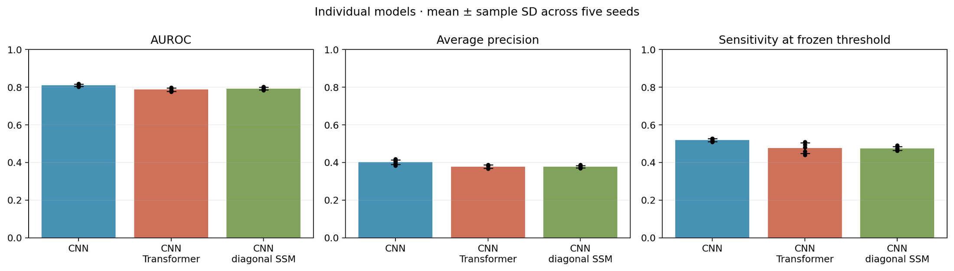
Figure A.1 AUROC, AUPRC and sensitivity of the three architectures (LVH vs. rest)
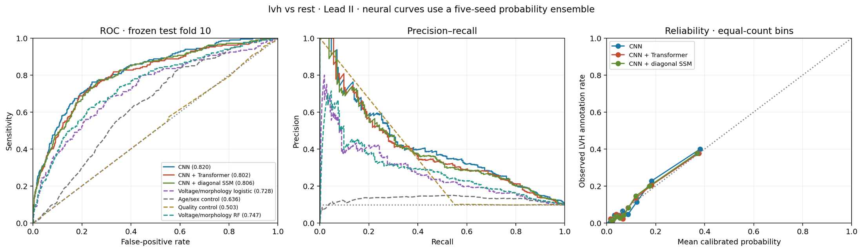
Figure A.2 ROC, precision–recall and reliability curves (LVH vs. rest)
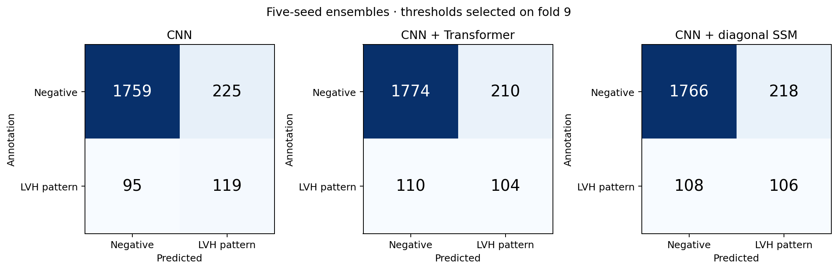
Figure A.3 Five-seed ensemble confusion matrices (LVH vs. rest)
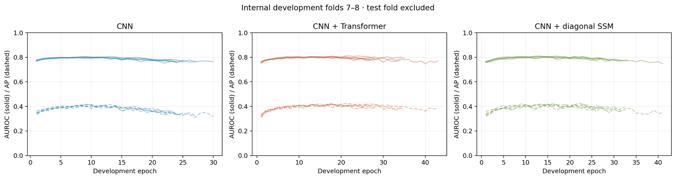
Figure A.4 Development AUROC and AP per epoch (LVH vs. rest)
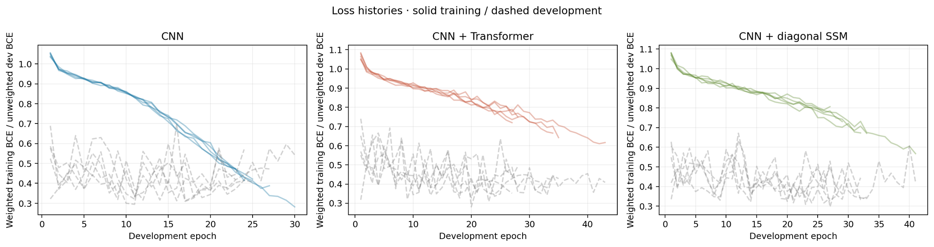
Figure A.5 Training and development loss histories (LVH vs. rest)
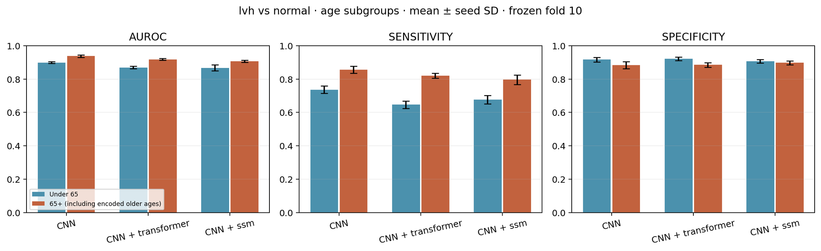
Figure A.6 Sensitivity and specificity by age group, < 65 vs. ≥ 65 years (LVH vs. normal)
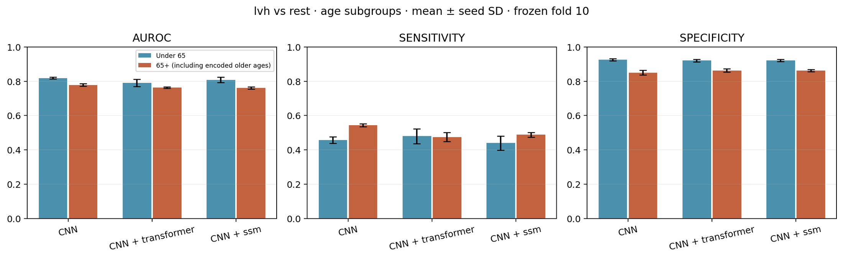
Figure A.7 Sensitivity and specificity by age group (LVH vs. rest)
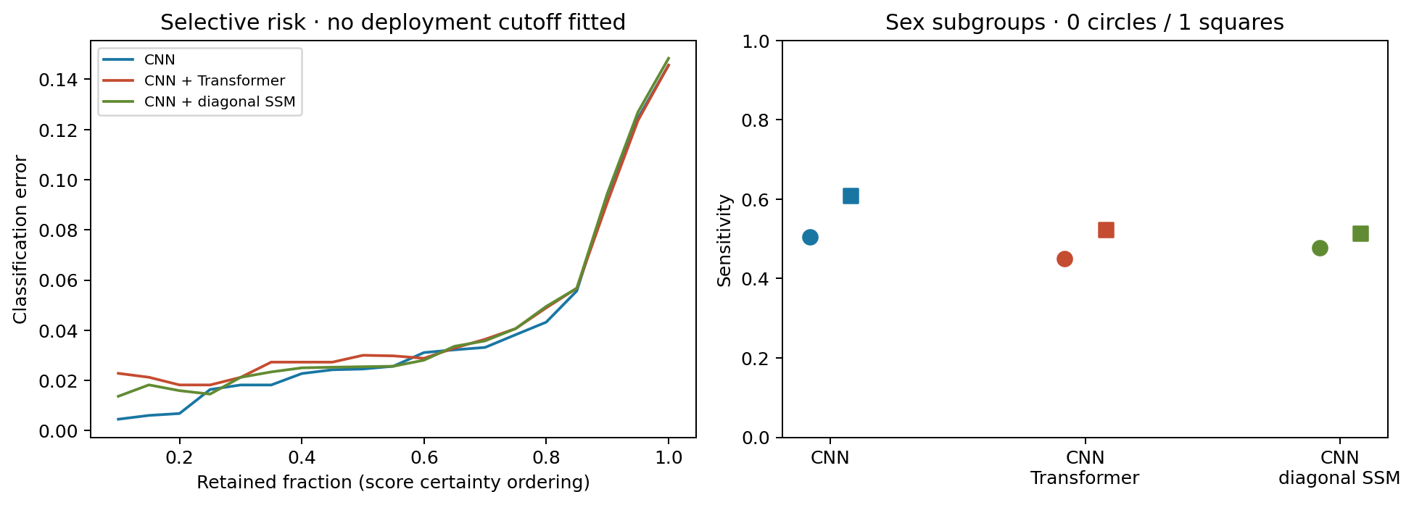  Figure A.8 Selective risk and sex subgroups (LVH vs. rest) | 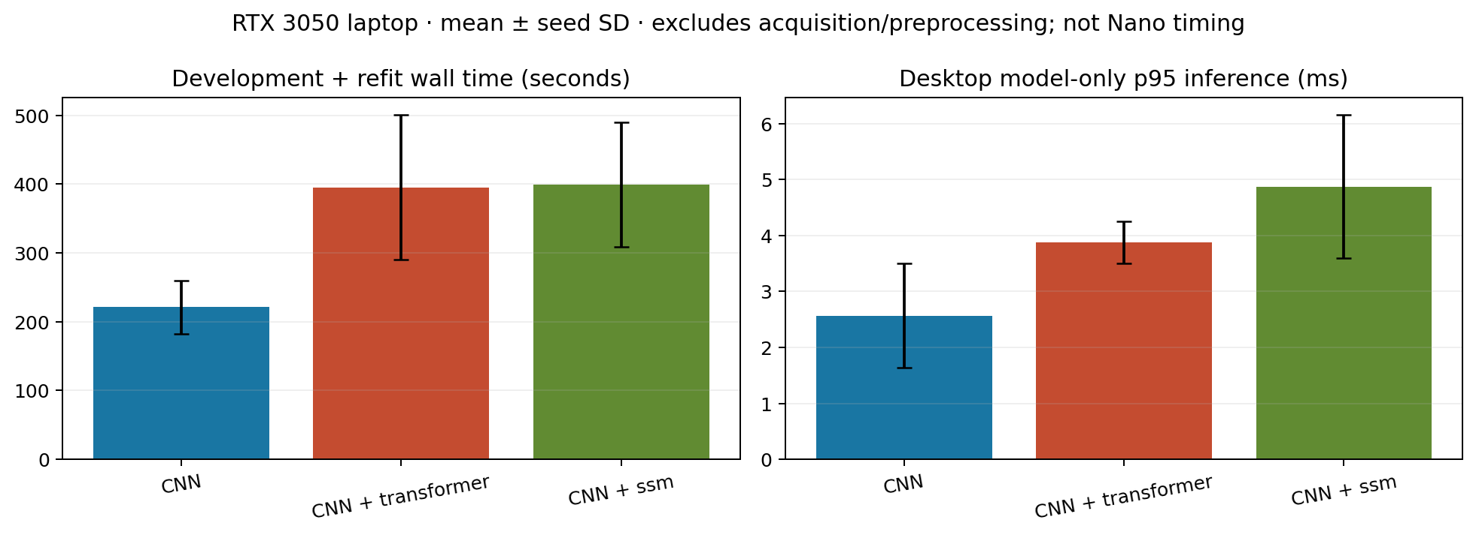  Figure A.9 Training time and desktop inference (LVH vs. rest)

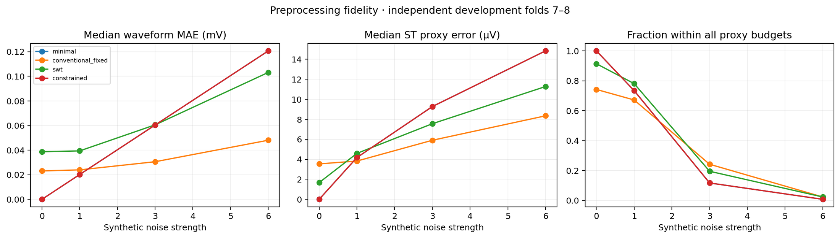
Figure A.10 Preprocessing fidelity under synthetic noise: waveform MAE, ST-proxy error and fraction within budgets

A.2 IMU signal diagnostics
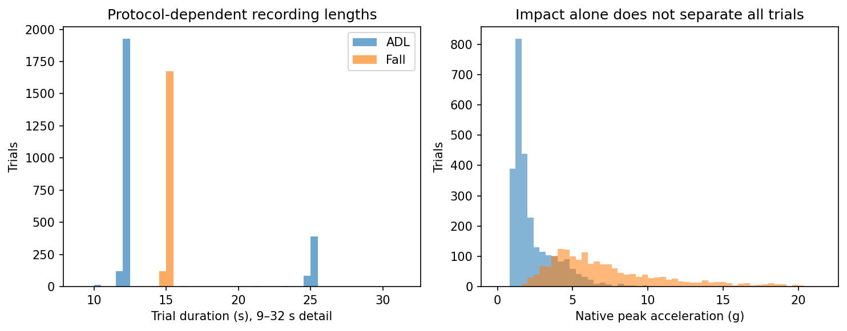  Figure A.11 SisFall recording durations and impact distribution (the duration cue) | 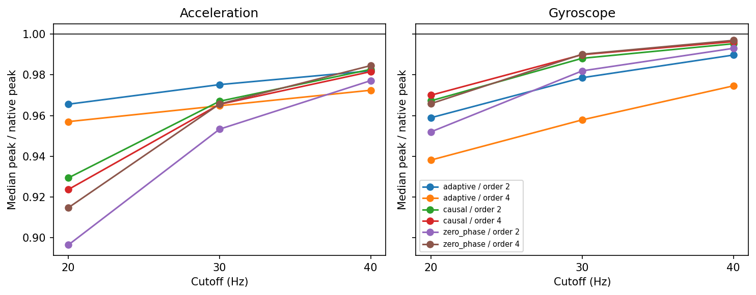  Figure A.12 Impact-peak retention of fixed and adaptive filters

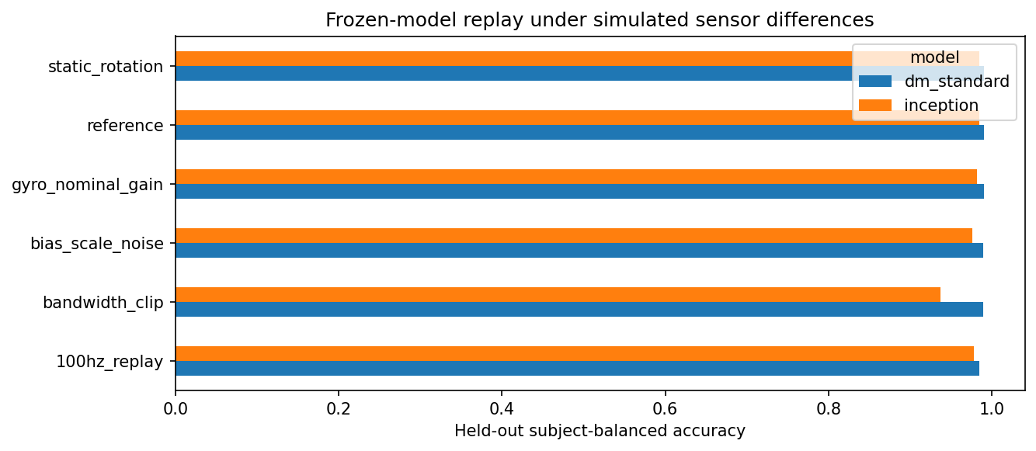
Figure A.13 Sensor-transfer stress tests of the neural comparators

A.3 EDA protocol, decomposition and verification
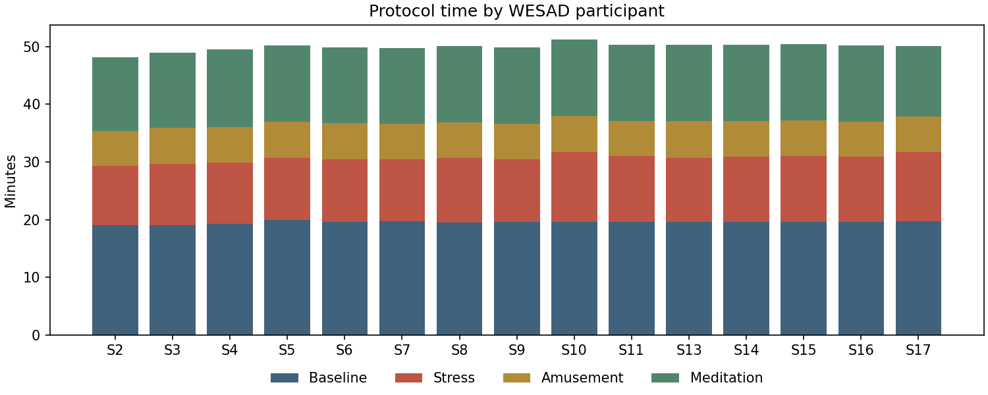
Figure A.14 Protocol time per WESAD participant by condition
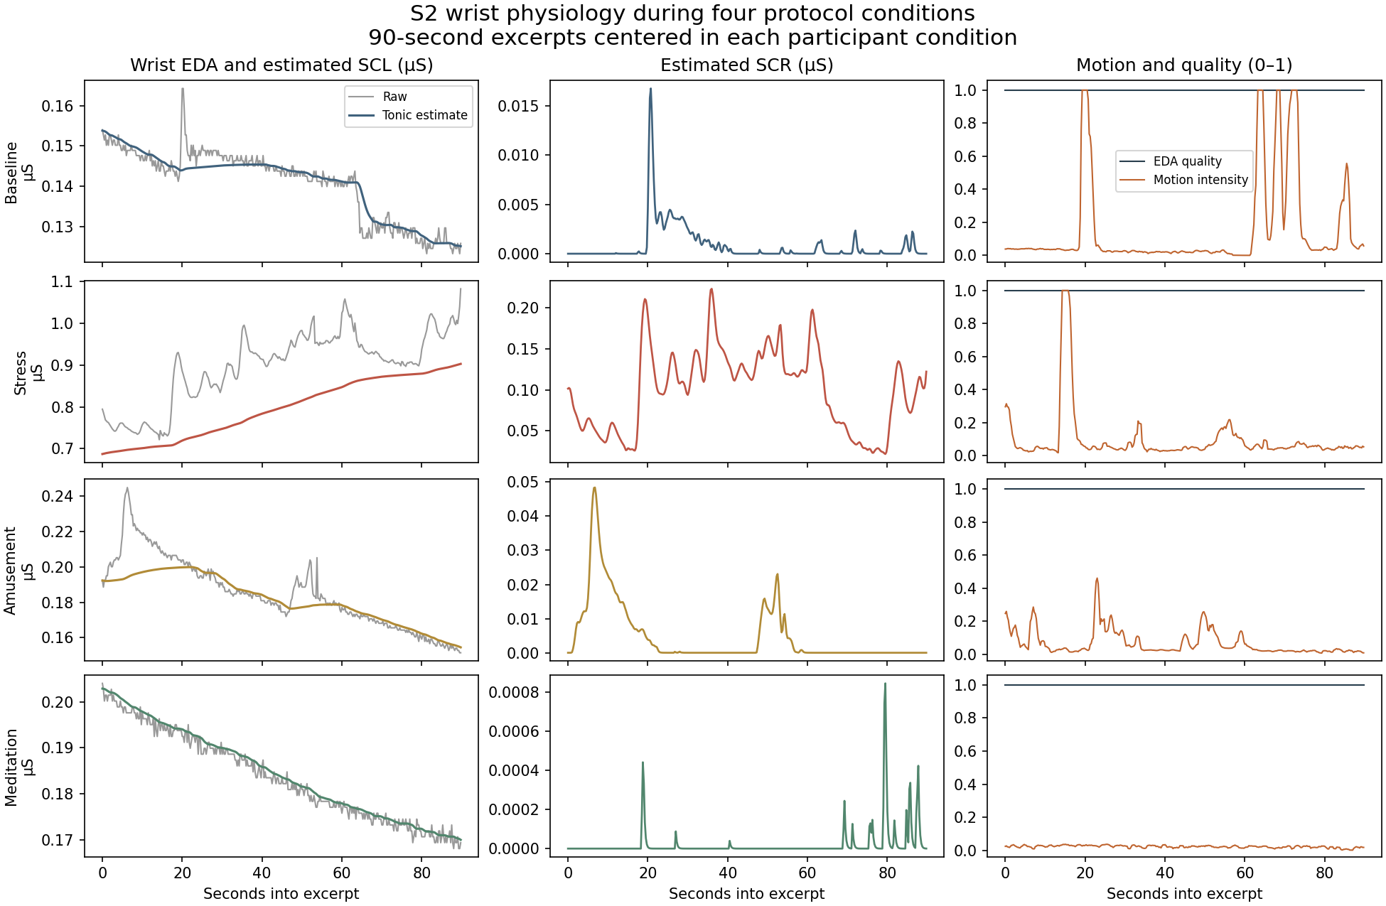
Figure A.15 MC-SAED tonic and phasic components across baseline, stress, amusement and meditation
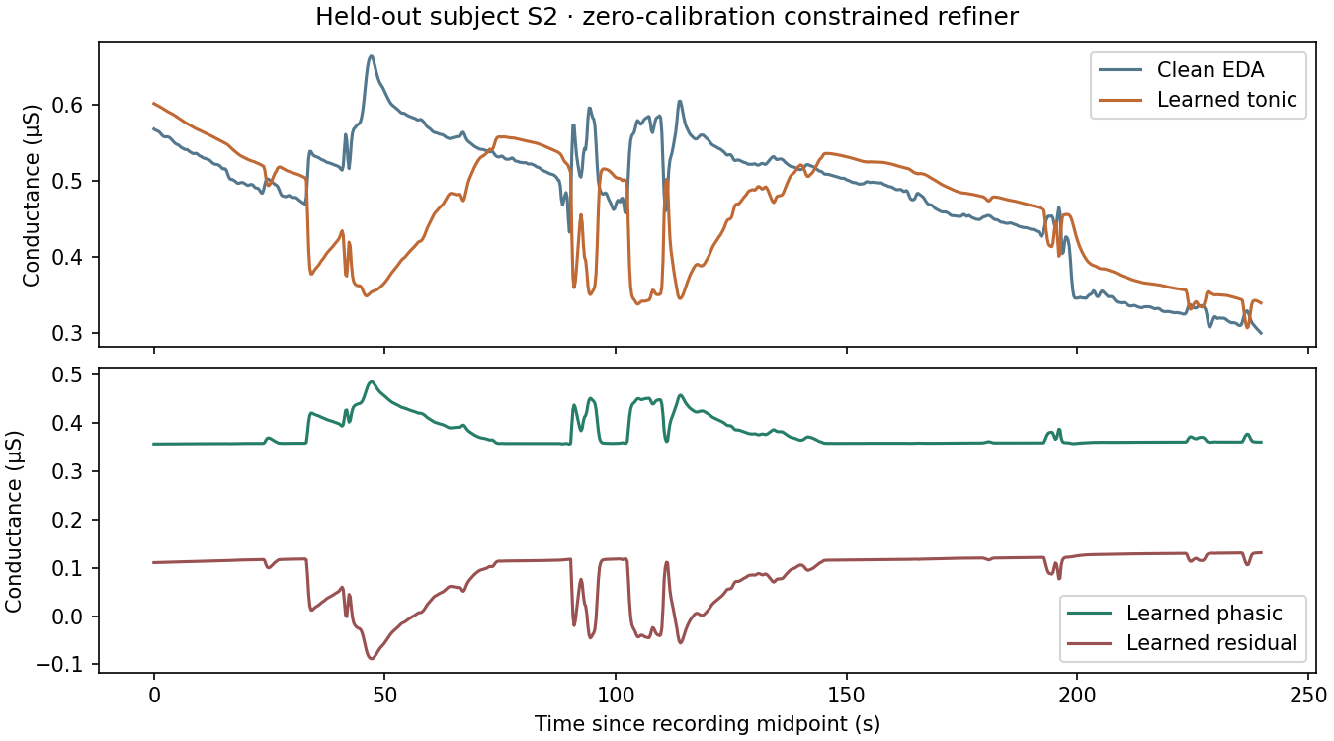  Figure A.16 Learned tonic/phasic decomposition of a held-out subject | 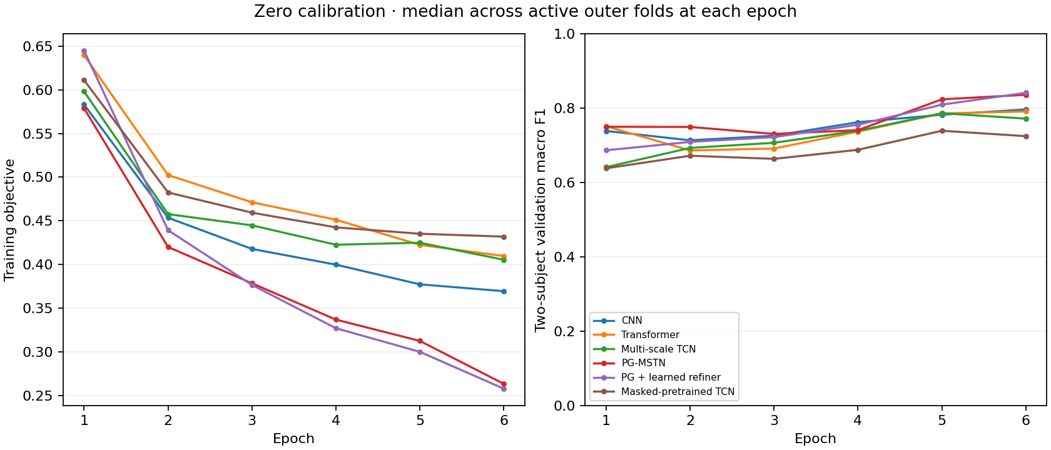  Figure A.17 Training objective and validation macro F1 per epoch

APPENDIX B

Reproducibility and Deployment Record

B.1 Verification records
Every reported number can be regenerated from local datasets with the module runbooks. Verification scripts re-hash source files, reconstruct scalers and splits, and replay saved checkpoints.
Table B.1 Verification records and replay parity
Module | Result directory | Independent unit | Verification outcome
ECG | research/results/20261105_lvh_comparison, lvh_distill_v1 | Patient (official folds) | Source rehash; ONNX parity on 59 raw records
PPG | research/results/osasud_v1, osasud_binary_dual_rate_v1 | Patient (5 folds) | 55 + 20 checkpoints replayed; max logit Δ 2×10⁻⁶
IMU | research/results/sisfall_v1 | Participant group | 385 fold evaluations; tree export Δ ≤ 1.44×10⁻⁶
EDA | research/results/wesad_loso_v1 | Participant (LOSO) | 1,140 neural + 1,035 classical checkpoints replayed
Jetson | jetson_results/ | Model bundle | Golden vectors: max Δ ≤ 9.5×10⁻⁷, 0 decision changes

B.2 Hardware contracts and deployment checklist
- BioAmp Lead II. RA negative, LL positive, RL reference; counts converted to input-referred mV before the 360 Hz polyphase resampler; 10 s window, 2 s hop; zero missing samples tolerated.
- MAX30102. 100 Hz red/IR FIFO over I²C; one channel per model; Haar shrinkage per completed second; 90 s history with validity mask; restart on gaps.
- Waist MPU-9250. ±16 g and ±2000 °/s, converted to g and °/s; fixed 2 s windows (40 tokens) with 1 s hop; five-second refractory alert logic.
- Wrist EDA. 4 Hz conductance in µS (0–100 µS), 32 Hz accelerometer; optional 120 s resting capture before calibrated scoring.
- Jetson services. deploy/jetson/run_all_benchmarks.sh reproduces the latency tables; deploy/bhanu_jetson/apnea-detector.service starts the SpO₂ detector at boot; build_tensorrt_engines.sh compiles FP16 engines.

