**VICKY VICKY**  
[vicky.vicky@fau.de](mailto:vicky.vicky@fau.de)  
ze45comu (23231674)  
MSc. in AI  
  
**Report**

**Parameters Chosen for all the experiments (due to low computational power):**  
Number of Cluster: 32  
Max Descriptors: 500000

Just for the better error handling and simplicity this code is in **two different files** (skeleton_bonus.py and skeleton_multi.py).

**Task (E): Compare the result of given descriptors and newly calculated SIFT descriptors.**

|  |  |  |  |  |
| --- | --- | --- | --- | --- |
| **DATA** | Given Descriptors | | Bonus Descriptors | |
| Descriptors Selected | 470776 | | 488415 | |
| Evaluate Test Encodings | Top 1: 0.8075 | mAP: 0.606705 | Top 1: 0.8027 | mAP: 0.605158 |
| Evaluate Train Encodings | Top 1: 0.8637 | mAP: 0.782805 | Top 1: 0.8680 | mAP: 0.786352 |
| Evaluate after ESVM | Top 1: 0.8797 | mAP: 0.734852 | Top 1: 0.8863 | mAP: 0.745487 |

Normal Descriptors Results:

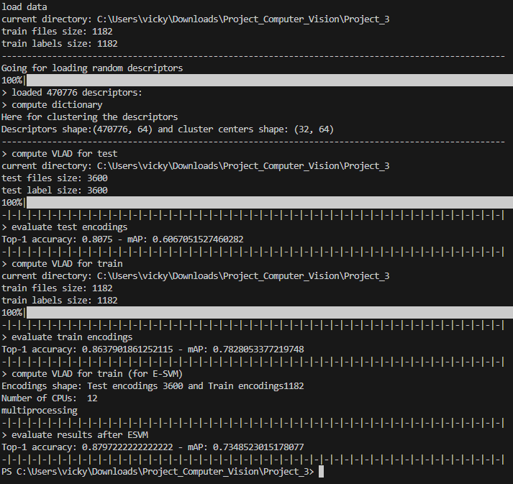

Bonus Descriptors Results:

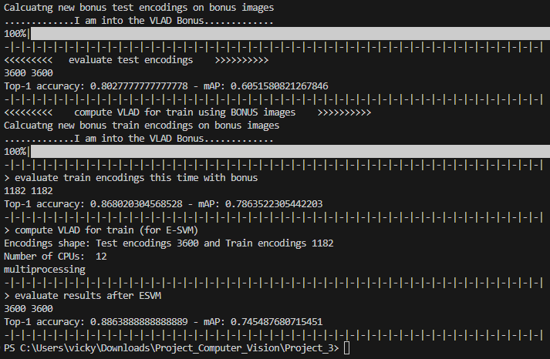

**Task (F): Compare the effect of GMP with and without Exemplar Classifier.**

|  |  |  |
| --- | --- | --- |
| **DATA** | **WITH GMP** | |
| Descriptors Selected | 470766 | |
| Evaluate Test Encodings | Top 1: 0.8077 | mAP: 0.606853 |
| Evaluate Train Encodings (No ESVM) | Top 1: 0.8646 | mAP: 0.783950 |
| Evaluate after ESVM | Top 1: 0.8802 | mAP: 0.735668 |

Effect of GMP on results:

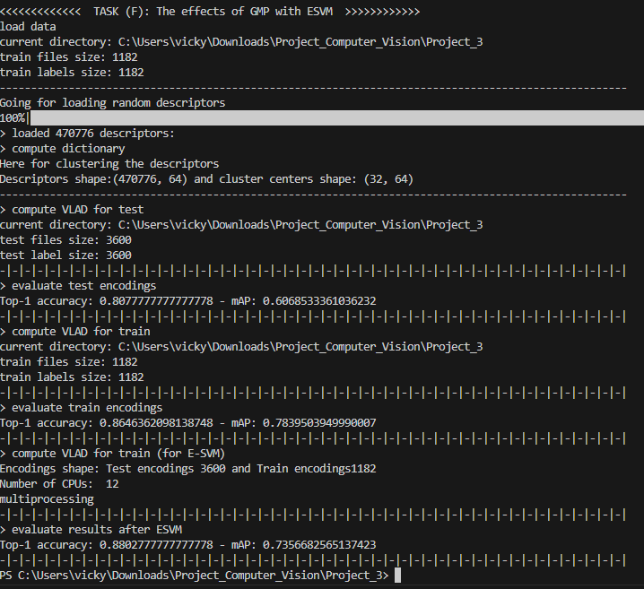

**Task (G): Compare the effect of Multi-VLAD with VLAD.**

|  |  |  |  |  |
| --- | --- | --- | --- | --- |
| **DATA** | **Normal VLAD** | | **MULTI-VLAD with PCA** | |
| Descriptors Selected | 470766 | | 466916 | |
| Evaluate Test Encodings | Top 1: 0.8077 | mAP: 0.606853 | Top 1: 0.8055 | mAP: 0.603413 |
| Evaluate Train Encodings (No ESVM) | Top 1: 0.8646 | mAP: 0.783950 | Top 1: 0.8663 | mAP: 0.784507 |
| Evaluate after ESVM | Top 1: 0.8802 | mAP: 0.735668 | Top 1: 0.7216 | mAP: 0.520197 |

Multi-VLAD Results:

