**Educational Organisation Using ServiceNow**

**Project Report**

**Team ID : NM2025TMID13064**

**Team Size : 4**

**Team Leader : Vignesh.S**

**Team Members : Ravidhasan B, S.Abinaya, Dharun D**

# **Table of Contents**

1. **Step 1: Setting Up ServiceNow Instance**
2. **Step 2: Creating An Update Set**
3. **Step 3: Creating Tables**
4. **Step 4: Form Layout**
5. **Step 5: Form Design**
6. **Step 6: Number Maintenance**
7. **Step 7: Creating Process Flow for Admission Table**
8. **Step 8: Client Scripts**

# Step 1: Setting Up ServiceNow Instance

* Sign up for a developer account on the ServiceNow Developer site (https://developer.servicenow.com).
* Navigate to the 'Personal Developer Instance' section.
* Request Instance and fill out the required details.
* Log in to your ServiceNow instance using the provided credentials.

# Step 2: Creating An Update Set

* Navigate to All >> Local update sets.
* Click on 'New', enter the details (Name: Educational Organisation ), and make it Current.

# Step 3: Creating Tables

* Salesforce Table: Create with required columns and configurations (Admin Number, Grade choices, etc.).
* Admission Table: Extend Salesforce table, add fields and choices (Admin Status, Pincode, etc.).
* Student Progress Table: Create fields and add module to Salesforce menu.

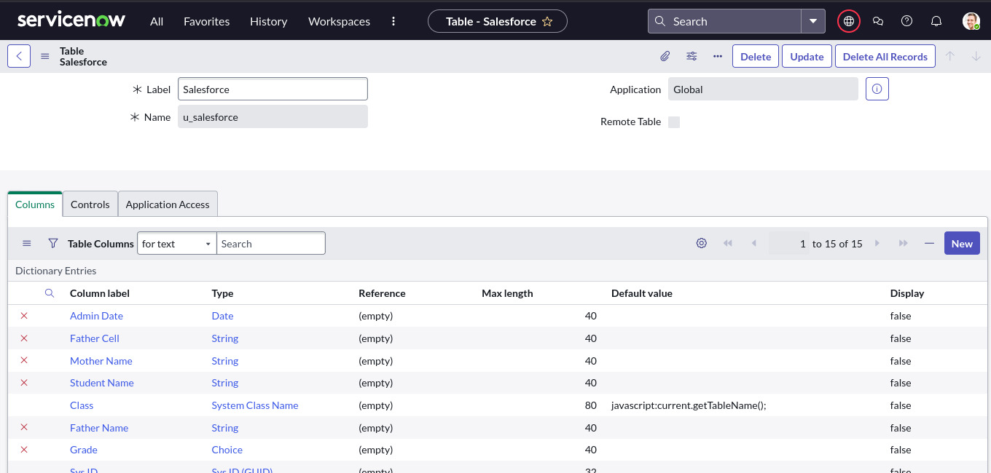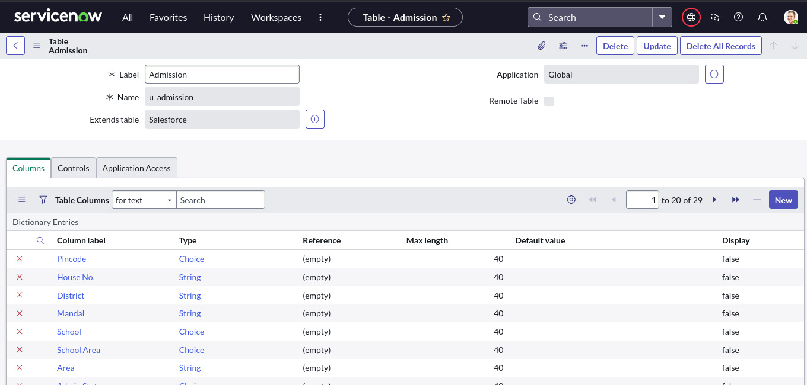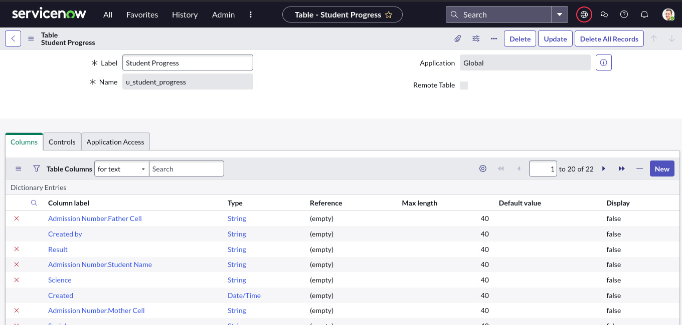

# Step 4: Form Layout

* Configure Table form for Student Progress Table.
* Add Admission Number fields to the layout.

# Step 5: Form Design

* Create a form design for a Salesforce table using drag and drop.
* Repeat process for Admission and Student Progress Tables.

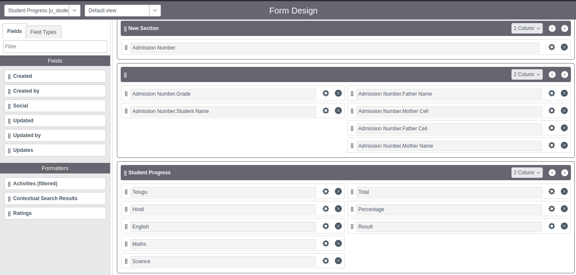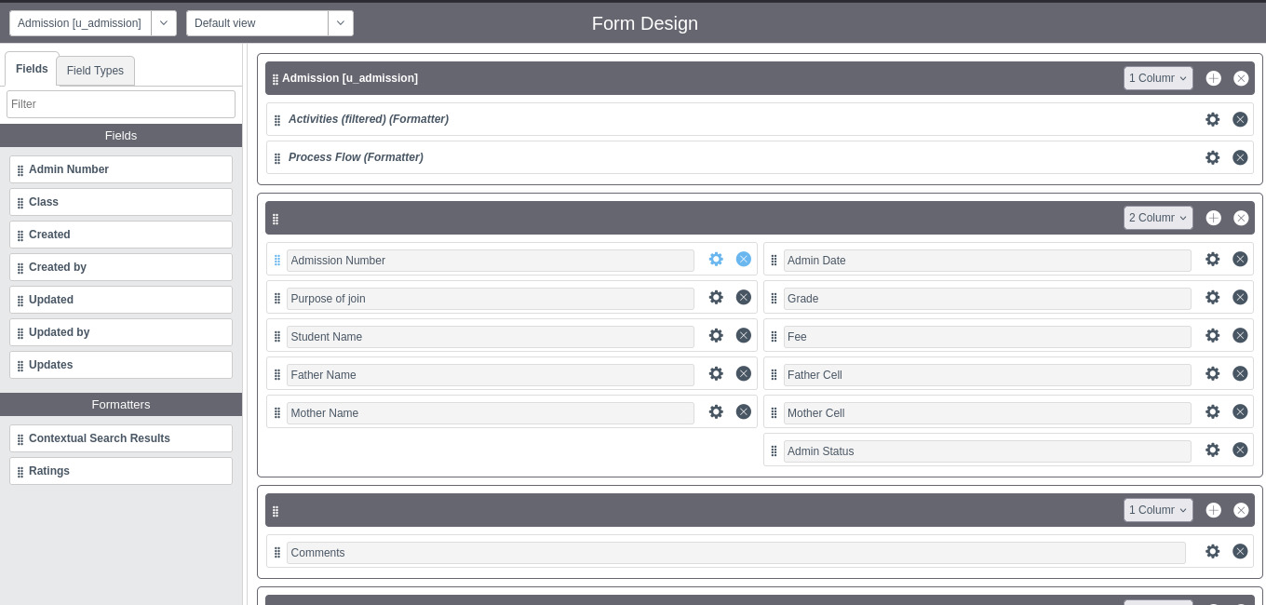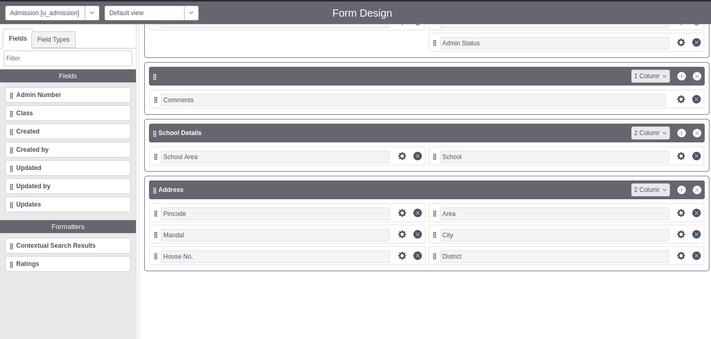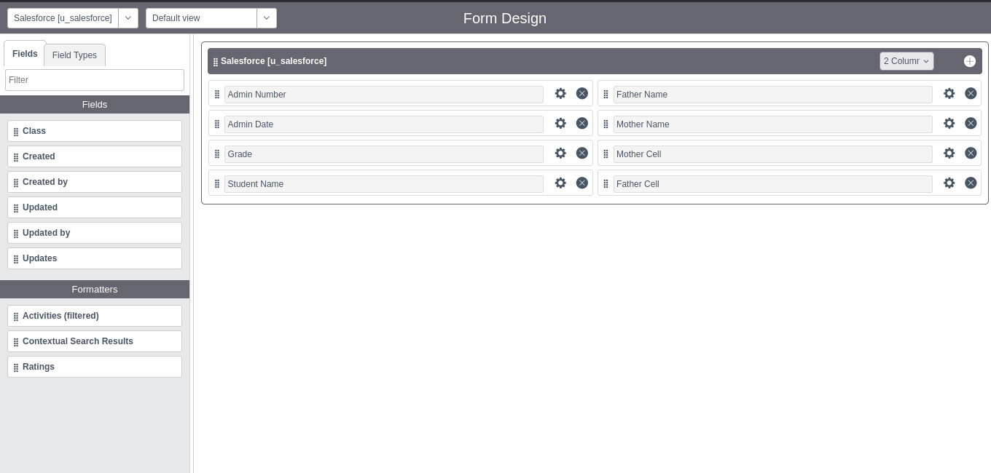

# Step 6: Number Maintenance

* Navigate to All >> Number Maintenance >> New.
* Fill Table Name: “**salesforce**” and Prefix : **SAL.**
* Submit

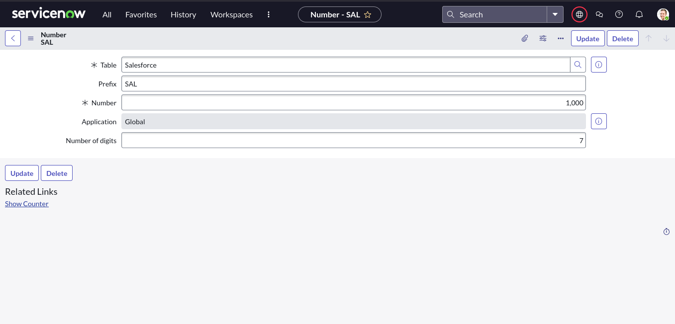

# Step 7: Creating Process Flow for Admission Table

* Navigate to All >> Process Flow >> New.
* Define process flow: New >> InProgress >> Joined >> Rejected >> Rejoined >> Closed >> Cancelled.

**The Result:**

# Step 8: Client Scripts

* Admission Table: Auto populate, Pincode Update scripts.
* Student Progress Table: Disable Fields, Total Update, Result, Percentage scripts.

# Results

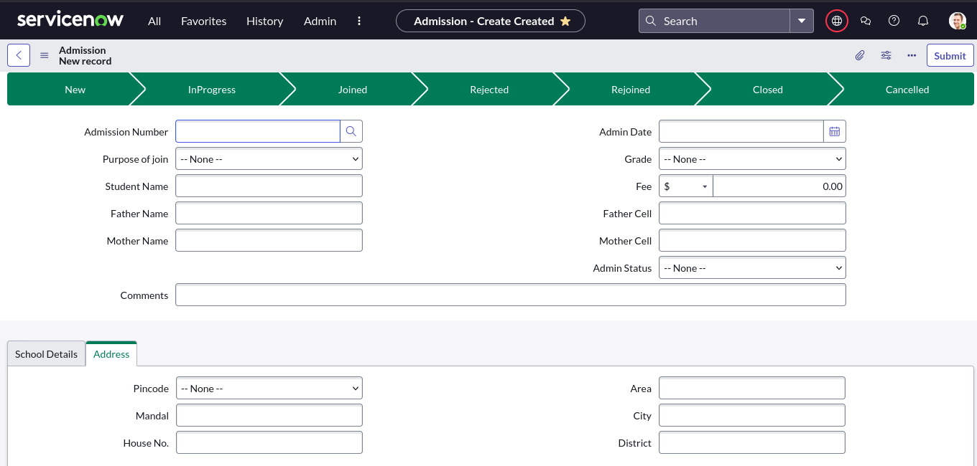**Admission:**

**salesforce:**

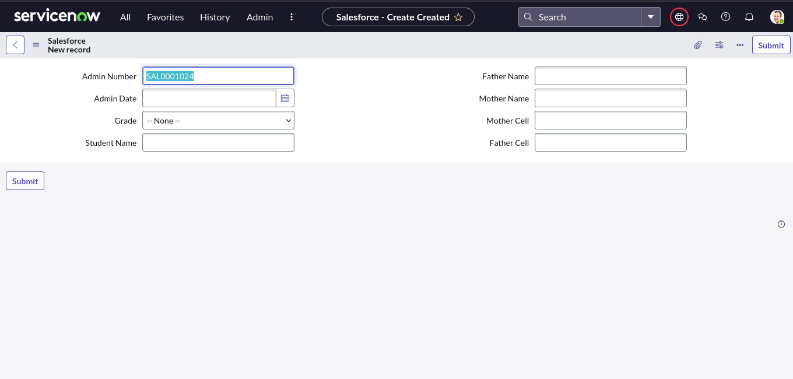

**Student Progress:**

# 

# Conclusion

This project demonstrates how to set up and configure an Educational Organisation system using ServiceNow. It covers the creation of instances, update sets, tables, form layouts, form designs, number maintenance, process flows, and client scripts. With this structured approach, the system enables smooth handling of educational records, admissions, and student progress tracking efficiently.