VIGNESH LAKSHMINARAYANAN

A0150251X| E00015233@U.NUS.EDU

DESIGN OF TEMPERATURE CONTROLLER FOR BAKE/CHILL PLATE SYSTEM IN SEMICONDUCTOR MANUFACTURING PROCESS

SEGMENT-D:SPECIAL TOPICS IN AUTOMATION AND CONTROL

# Table of Contents

[Table of Contents 2](#_Toc434236745)

[INTRODUCTION 3](#_Toc434236746)

[4](#_Toc434236747)

[PROBLEM STATEMENT 4](#_Toc434236748)

[BACKGROUND 5](#_Toc434236749)

[6](#_Toc434236750)

[PID CONTROLLER 6](#_Toc434236751)

[Proportional Control: 6](#_Toc434236752)

[Integral Control: 6](#_Toc434236753)

[Derivative Control: 6](#_Toc434236754)

[STATE SPACE MODEL OF A BAKE PLATE SYSTEM 7](#_Toc434236755)

[METHODOLOGY 7](#_Toc434236756)

[RESULTS AND CONCLUSIONS 9](#_Toc434236757)

[MATLAB CODE 9](#_Toc434236758)

[SIMULINK BLOCK DIAGRAM 12](#_Toc434236759)

[Case 1: When Initial Conditions are same for Center and Edge Zones 13](#_Toc434236760)

[PI PARAMETERS 13](#_Toc434236761)

[Initial Temperature Conditions 13](#_Toc434236762)

[PLATE TEMPERATURE PLOT 13](#_Toc434236763)

[Wafer Temperature 14](#_Toc434236764)

[Control Signal 14](#_Toc434236765)

[CONCLUSION CASE 1 15](#_Toc434236766)

[Case 2: When Initial Conditions are different for Center and Edge Zones 15](#_Toc434236767)

[Initial Temperature Conditions 15](#_Toc434236768)

[PLATE TEMPERATURE PLOT 15](#_Toc434236769)

[Wafer Temperature Plot 16](#_Toc434236770)

[Wafer Temperature – Zoomed In View 16](#_Toc434236771)

[Control Signal 17](#_Toc434236772)

[CONCLUSION CASE 2 17](#_Toc434236773)

[Case 3: Temperature Non-Uniformity across wafer 18](#_Toc434236774)

[Case 4: How to deal with steady state error in wafer temperature 18](#_Toc434236775)

[Plate Temperature Plot 19](#_Toc434236776)

[Wafer Temperature Plot 19](#_Toc434236777)

[Control Signal 20](#_Toc434236778)

[REFERENCES 21](#_Toc434236779)

# 

# INTRODUCTION

In the current era we know that innovation is happening is so fast that we cannot even imagine. A major contributor to this is the development of semiconductors for various applications. Integrated Circuits (ICs) or chips has now become a part of our everyday life. According to Moore’s law the transistors on a chip will double roughly every 2 years (See Fig.2). Semiconductor device fabrication or semiconductor manufacturing methods yields the development of these chips and are of great importance. A typical semiconductor manufacturing process involves multiple steps that serves in building components with necessary electrical structure. A proper component development will make sure the rapid switching and transferring signals within the electrical structure embedded in the component enhancing its computational purposes. Insulation in these components is also a process of high importance as these separate the conducting areas in these devices. The main 2 processes that involves with semiconductor manufacturing are:

1. Front-End Processes: Deals with the production of ICs on the wafer
2. Back-End Processes: Deals with the wire bonding and the packaging of the ICs

Photolithography and chemical processing is the main 2 phenomenon used in the semiconductor manufacturing process. The ICs are developed on a wafer which is a semiconducting material. In most of the cases Silicon is used other than in some specialized applications where some compound semiconductors are used. The following are the key steps involved in a typical semiconductor manufacturing process:

* Deposition- Process of growing an insulating layer on the Silicon substrate. It alters the electrical characteristics of the wafer by baking impurities into it.
* Photolithography – Involves the use of a very precise “mask” using which the photoresist applied across the wafer is exposed like a emulsion on film. On developing the pattern on the mask hardens into the wafer.
* Etching- Removes areas not covered by the hardened photoresist using a plasma that reacts to the wafer material
* Ion implantation- Changes the electrical characteristics of the wafer by infusing the wafer with various dopants.
* Chemical Mechanical Polishing (CMP)- Produces a planar wafer surface for subsequent processing

A typical IC will consist of many such steps during its development. The Fig.1 will give a complete overview on the semiconductor manufacturing steps:

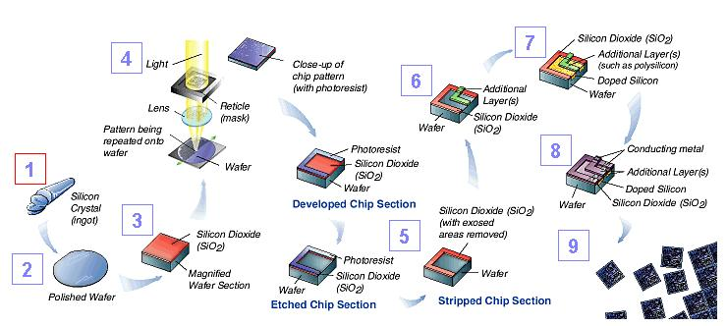

Fig.1 Semiconductor Manufacturing Steps

# 

Fig.2 Moore’s Law

# PROBLEM STATEMENT

The most common and critical part of the photoresist processing in microlithography sequence is the baking of the semiconductor substrate. With stringent specifications, a major and most important issue arises in controlling the temperature uniformity. The requirements for the post exposure bake step calls for controlling the temperature within at temperatures between and . This is also the most temperature sensitive step. The representative post exposure bake latitude for critical dimension (CD) variation for the deep ultraviolet resist, which is commercially available is around . The importance of proper bake-plate operation is huge when it comes to CD control.

Wafer warpage is something very critical that can affect a device performance, reliability and linewidth or CD control. It can lead to non-uniformity in temperature distribution across the wafer. For e.g. warpage results temperature variation across the wafer during baking. In such a case the spatial variation in CD will be subsequently high. In case of larger wafers, the maximum allowable warpage is low and this can post a huge problem. For e.g. Maximum warpage for a wafer from center to edge is around

This report aims in modelling a controller for minimizing the temperature uniformity across the wafer during the entire bake operation. The characteristics of a typical bake operation are:

* Time taken for a typical bake operation = 2 Minutes
* Steady-state wafer temperature =
* Overshoot of wafer temperature <

# BACKGROUND

In a typical microlithography process, thermal processing of the wafer is a common and required step. The substrate or the wafer is placed above a bake/chill plate in order to heat it. In a normal process the wafer should be heated from room temperature to . In order to achieve this the bake plate temperature should be held at constant temperature. This poses a challenge as when we drop the wafer over the bake plate it tends to reduce the bake plate temperature initially. Using a feedback control we can rectify this issue. Even then we will find that not enough time is given for the bake plate to reach back to its initial temperature and this causes a problem since the wafer will also be not able to reach the actual temperature of . The heated bake plate has a higher thermal mass and a temperature sensor placed near the surface of the bake plate provides the feedback to the controller. Note that in actual conditions we will only be able to measure the bake plate temperature and no the wafer temperature. An air gap of always exist between the bake plate and the wafer in order to minimize the contamination. Usually a PID control is implemented into the closed loop system.

In the modern time the bake and chill operations are performed using the same setup by just varying the bake plate temperature rather than the conventional method of having 2 separate setups for implementing the same. With all such new innovations coming into the process, the percentage of the problems have increased. Some of the critical ones are:

1. Maintain temperature uniformity across the wafer
2. Prevent wafer warpage which is caused by the above

A normal wafer warpage condition is shown in Fig.3. The main reason behind the temperature non-uniformity is the temperature varying from the center to the edges. The major challenge of controlling the temperature uniformity is that if the variance of the temperature is too high then wafer starts warping and will result in a wastage of wafers. In such a situation it is better to divide or discretize the bake plate into N zones and make use of N different sensors in order to measure the bake plate temperature across the N zones and thereby ensure a uniformity of the temperature all along the bake plate. The discretization the bake plate into N zones is as shown in the Fig.4

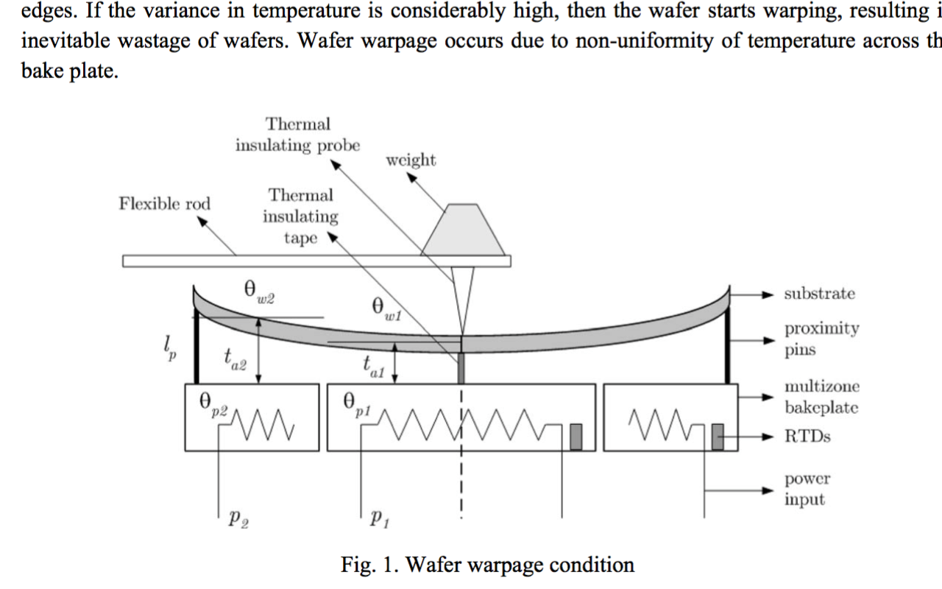

Fig.3 Wafer Warpage Condition

## ../../../../../Desktop/Screen%20Shot%202015-11-01%20at%202.44.1

Fig.4 Discretization of Bake/Chill plate into N zones

## PID CONTROLLER

A PID is controller or the Proportional-Integral-Derivative controller is the most commonly used control in a feedback mechanism in industrial systems. A typical control mechanism of a PID control is as shown below

Sensor

Input

Output

Process

PID Controller

u(t)

e(t)

y(t)

From the above diagram, let

* e(t) be the error signal output which is given as input to the PID controller
* u(t) be the output or the control signal from the PID controller to the actuator
* y(t) be the output

The output produced by each of these Proportional, Derivative and Integral control corresponds to their functionality. The following describes the functional part of each of the control and how the output u(t) changes with respect to the input e(t):

### Proportional Control:

It produces an output value that is proportional to the current error value.

u1(t)=Kpe(t); Kp is the proportional gain

### Integral Control:

Here the output is proportional to both the magnitude and duration of the error

u2(t)=Ki\*Integral(e(t)) ; time varying from 0 to time t, Ki is the integral gain

### Derivative Control:

Output determines the slope of the error over time and multiplies this rate of change by the derivative gain

u3(t)=Kd\*(de(t)/dt) ; Kd is the derivative gain

Now from the above the PID controller output u(t) will be the sum of the individual output of each control,

🡺 u(t)= Kpe(t)+ Ki\*Integral(e(t))+ Kd\*(de(t)/dt); Kp, Ki, Kd are the tuning parameters

Summarizing this into the closed loop control system:

Proportional

Process

Kd\*(de(t)/dt)

Input

e(t)

Ki\*Integral(e(t))

u(t)

y(t)

Output

Kpe(t)

Integral

Derivative

Sensor

## STATE SPACE MODEL OF A BAKE PLATE SYSTEM

A typical bake plate system resolved into the state space format is given by:

A detail description on how we arrive at the state space format of the system and the how each of the matrices are populated is given in [1].

# METHODOLOGY

In this report we will consider a Silicon wafer or substrate is put on to the bake plate for baking it to . In our case we will discretize the system into 5 zones and check the uniformity of temperature across these 5 zones. We will use a PI controller as the control feedback mechanism in the closed loop system. In our case, we will make use of MATLAB and Simulink in implementing the model system and check the temperature uniformity based on that.

The following is the simple design model of the closed loop system:

Sensor

PI Controller

Output

Input

Process

e(t)

u(t)

y(t)

Note the following things:

* Only bake plate temperature is available for measuring and not the wafer temperature
* Thus the feedback to the system is only the bake plate temperature and not the wafer temperature
* Since the bake plate is discretized into 5 zones we will have sensors for measuring each of the zone and corresponding PI control is implemented for the same
* The output coming out of the system will have each of the 5 zone bake plate temperature and wafer temperature.

A typical algorithm for the whole process is shown in the flowchart below:

Inputs to the plant

Set output of controller as input to the plant

Output Matches the Reference?

Yes

Continue Heating

Plant Output to Controller

NO

Yes

Temperature greater than the Reference?

Heating Process

Chilling Process

# RESULTS AND CONCLUSIONS

The proposed approach needed a basic model of the bake plate system to be designed with required parameters such as

* No of Zones
* Plate Thickness
* Wafer Thickness
* Zone Thickness
* Air gap

These parameters can be obtained from the handbooks that are available. In our case we made use of the readily available MATLAB function ibcmodelt.m which consisted the state space model of the system. Since we are designed the whole feedback system, we converted this function file into a normal MATLAB file which on processing gives the following:

* Matrices A, B, C, D of the State Space Model
* Initial Temperature condition of both bake plate and Wafer plate
* PID Tuning Parameters

A PI controller is designed as the control feedback mechanism for the current model. This section will review and conclude the results for the following cases:

1. Case 1: When Initial Conditions are same for Center and Edge Zones
2. Case 2: When Initial Conditions are different for Center and Edge Zones
3. Case 3: Temperature Non-Uniformity across wafer
4. Case 4: How to deal with steady state error in wafer temperature

The MATLAB code, Simulink Block diagram and the Tuning Parameters of the PI controller in tabulated form is also described in this section. The usual baking time period of 2 minutes is taken as the total time for all the plots.

## MATLAB CODE

The following is the MATLAB code simulated to give out:

* Matrices A, B, C, D of the State Space Model
* Initial Temperature condition of both bake plate and Wafer plate
* PID Tuning Parameters

%% Designing the STATE SPACE MODEL OF THE BAKE PLATE SYSTEM

N = 5; % number of zones

% The total number of states is 2N, the first N states are the plate temperature

% while the next N states are the wafer temperature

D = 0.3; % 300mm

tp = 1.778e-3; % plate thickness

ta = 125e-6; % airgap (6mils)

tw = 0.8636e-3;% wafer thickness

dr = D/2/N; % zone thickness

ta = 125e-6\*ones(1,N);

Aps=zeros(N,N);

Apz=zeros(N,N);

Aws=zeros(N,N);

Vp=zeros(N,N);

Vw=zeros(N,N);

for i=1:N,

Aps(i) = 2\*pi\*i\*dr\*tp;

Apz(i) = pi\*(i\*i - (i-1)\*(i-1))\*dr\*dr;

Aws(i) = 2\*pi\*i\*dr\*tw;

Vp(i) = Apz(i)\*tp;

Vw(i) = Apz(i)\*tw;

end;

%Thermophysical Properties

% rho - density

% Cp - specific heat

% k - thermal conductivity

% Silicon

rho\_si = 2330;

Cp\_si = 790;

k\_si = 99;

% Aluminum

rho\_al = 2700;

Cp\_al = 896;

k\_al = 167;

% Quatz

rho\_q = 2800;

Cp\_q = 833;

% Air gap

k\_a = 0.03;

ka = k\_a;

rho\_a = 1.1;

Cp\_a = 1000;

V\_a = 10;

h = 10;

%Plate (aluminum)

kp = k\_al;

Cpp = Cp\_al;

rhop = rho\_al;

%Wafer (silicon)

kw = k\_si;

Cpw = Cp\_si;

rhow = rho\_si;

%Modeling

%Resistance and Capacitance

Rpr=ones(1,N);

Rwr=ones(1,N);

Ra=ones(1,N);

Rwz=ones(1,N);

Cp=ones(1,N);

Cw=ones(1,N);

for i=1:N-1,

Rpr(i) = log((i+1/2)/(i-1/2))/(2\*pi\*kp\*tp);

Rwr(i) = log((i+1/2)/(i-1/2))/(2\*pi\*kw\*tw);

end;

for i=1:N,

Ra(i) = ta(i)/(ka\*Apz(i));

Rwz(i) = 1/(h\*Apz(i));

end;

Rpr(N) = 1/(h\*Aps(N));

Rwr(N) = 1/(h\*Aws(N));

for i=1:N,

Cp(i) = rhop\*Cpp\*Vp(i);

Cw(i) = rhow\*Cpw\*Vw(i);

end;

%Energy Balance Equations

% In state-space format

% define A and B matrix here, C assumed to be I (all states available)

% A = |App Apw|

% |Awp Aww|

App = zeros(N,N); %note that App is tridiagonial

App(1,1) = -(1/Rpr(1) + 1/Ra(1))/Cp(1);

for i=2:N,

App(i,i) = -(1/Rpr(i) + 1/Rpr(i-1) + 1/Ra(i))/Cp(i);

App(i,i-1) = (1/Rpr(i-1))/Cp(i);

end;

for i=1:N-1,

App(i,i+1) = (1/Rpr(i))/Cp(i);

end;

Apw = diag(1./(Ra.\*Cp)); % will be different if the airgap is varying

Awp = diag(1./(Ra.\*Cw));

Aww = zeros(N,N); %note that Aww is tridiagonial

Aww(1,1) = -(1/Rwr(1) + 1/Ra(1) + 1/Rwz(1))/Cw(1);

for i=2:N,

Aww(i,i) = -(1/Rwr(i) + 1/Rwr(i-1) + 1/Ra(i) + 1/Rwz(i))/Cw(i);

Aww(i,i-1) = (1/Rwr(i-1))/Cw(i);

end;

for i=1:N-1,

Aww(i,i+1) = (1/Rwr(i))/Cw(i);

end;

temp=ones(1,N);

for i=1:N,

temp(i)=Apz(i)/Cp(i);

end;

Bpp = diag(temp);

Bww = zeros(N,N);

%Combining everything

A = [App Apw;Awp Aww];

B = [Bpp;Bww];

C = eye(2\*N);

D = [zeros(N,N);zeros(N,N)];

sys = ss(A,B,C,D);

%% Initial Temperature Conditions

T=[90 90 90 90 90 30 30 30 30 30];

T=T';

%% PI Tuning Values for Each Zones

% Zone 1

Kp1=4811;

Ki1=915.3;

% Zone 2

Kp2=4811;

Ki2=915.3;

% Zone 3

Kp3=4811;

Ki3=915.3;

% Zone 4

Kp4=4811;

Ki4=915.3;

% Zone 5

Kp5=4811;

Ki5=915.3;

%% //////////////////////END OF THE MATLAB CODE////////////////////// %%

In the above consider that the PI tuning parameters give for each zone is same considering the initial conditions of all the zone is same. In case of different initial conditions, in order to have the same transient response we will have to tune the parameters accordingly.

## SIMULINK BLOCK DIAGRAM

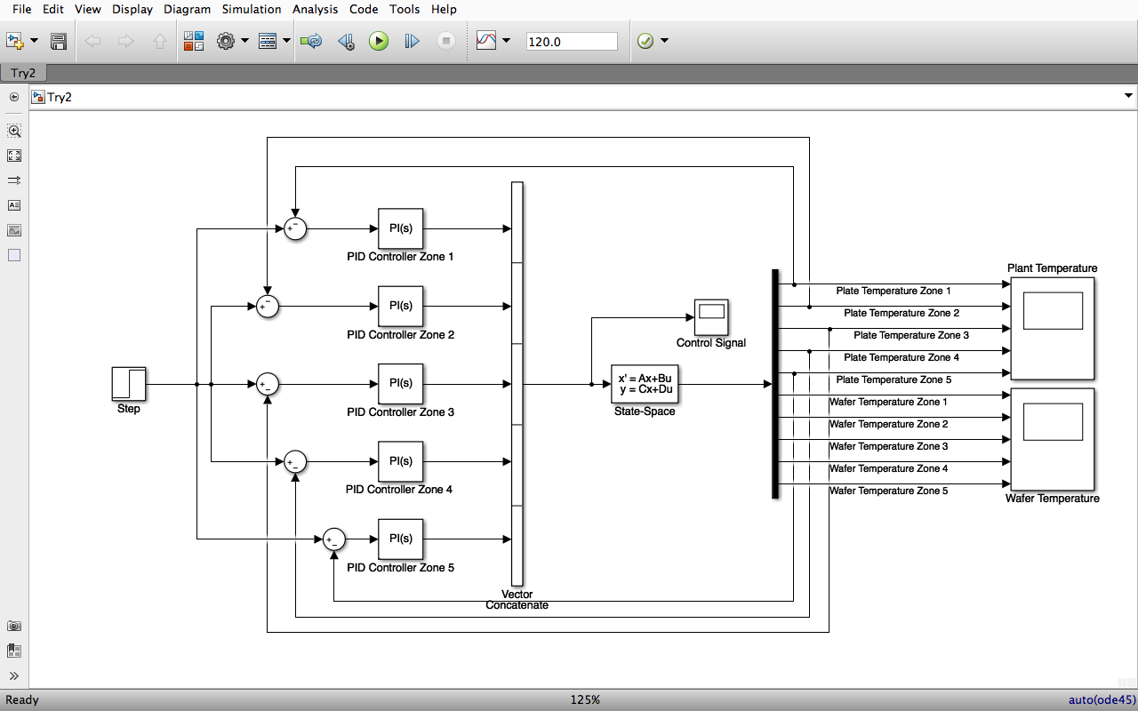

The Simulink block diagram shown above gives the complete model of the closed loop system that is designed to minimize the temperature non-uniformity during the baking process of the wafer.

## Case 1: When Initial Conditions are same for Center and Edge Zones

### PI PARAMETERS

|  |  |  |
| --- | --- | --- |
| ZONES | Kp | Ki |
| Zone 1 | 4811 | 915.3 |
| Zone 2 | 4811 | 915.3 |
| Zone 3 | 4811 | 915.3 |
| Zone 4 | 4811 | 915.3 |
| Zone 5 | 4811 | 915.3 |

### Initial Temperature Conditions

|  |  |  |
| --- | --- | --- |
| ZONES | Plate Temperature –Tp in | Wafer Temperature –Tw in |
| Zone 1 | 90 | 30 |
| Zone 2 | 90 | 30 |
| Zone 3 | 90 | 30 |
| Zone 4 | 90 | 30 |
| Zone 5 | 90 | 30 |

### PLATE TEMPERATURE PLOT

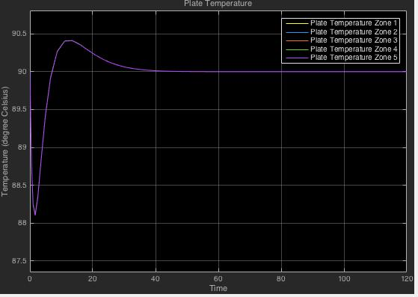

### WT_1.jpgWafer Temperature

### CS_1.jpgControl Signal

### CONCLUSION CASE 1

From the above plots we can see the following:

* Wafer temperature even though it settles with almost no overshoot but has a steady state error of almost
* The overshoot of the plate response is under and this is fine enough
* Here you can see in both the figures the plots of all the Zones overlap with each other since the initial conditions are same

## Case 2: When Initial Conditions are different for Center and Edge Zones

In this case we will provide different initial conditions to center and edge zones and see the resulting plots. Consider Zone 1,2 and 3 as the Center Zone and 4,5 as the Edge Zones. The Tuning Parameters remain the same.

### Initial Temperature Conditions

|  |  |  |
| --- | --- | --- |
| ZONES | Plate Temperature –Tp in | Wafer Temperature –Tw in |
| Zone 1 | 90 | 30 |
| Zone 2 | 90 | 30 |
| Zone 3 | 90 | 30 |
| Zone 4 | 88 | 30 |
| Zone 5 | 88 | 30 |

### PT_2.jpgPLATE TEMPERATURE PLOT

### WT_2.jpgWafer Temperature Plot

### Wafer Temperature – Zoomed In View

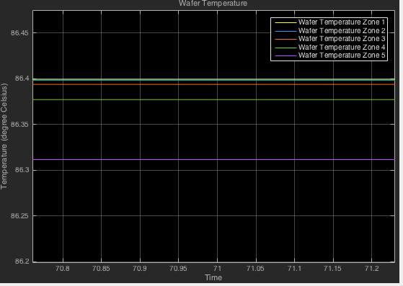

### Control Signal

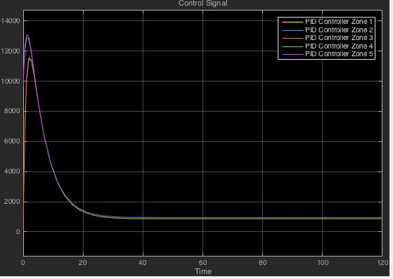

### CONCLUSION CASE 2

From the above plots we can see the following:

* On changing the initial conditions as the temperature variation from centre to edge zones we see the wafer temperature non uniformity
* Also there is change in the transient response of the plate and control signals
* 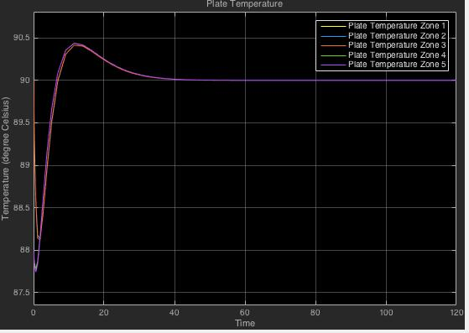Changing the tuning parameters of the PI controller can help in rectifying this (as shown below)

## Case 3: Temperature Non-Uniformity across wafer

In figure given below we can see that there exist still a non uniformity between the different zones of the wafer. We could only minimize it and cannot completely reduce it.



## Case 4: How to deal with steady state error in wafer temperature

We saw that even if the wafer temperature was achieving a steady state there still exist a error from the targeted temperature to be attained. This steady state error posse a major problem. Here since the steady state error is a constant we can rectify this by changing the reference input by adding the constant error with it.



Reference Input

Here the steady state error is about . So we increased the reference input to from The below plots shows the response of plate temperature, wafer temperature and control signal after changing the reference input.

### Plate Temperature Plot

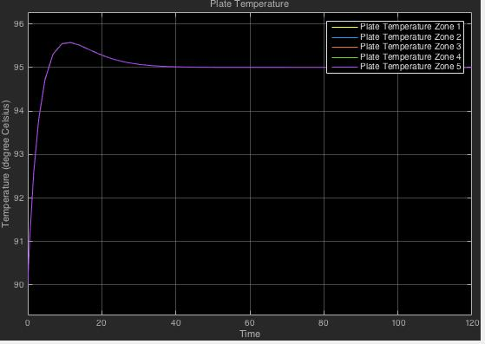

### Wafer Temperature Plot

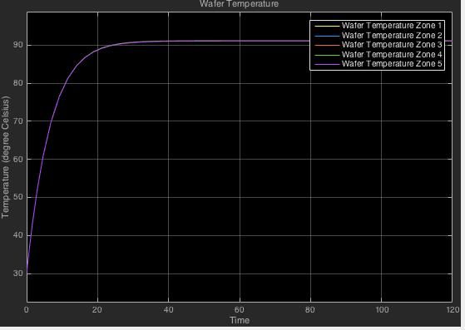

### CS_3.jpgControl Signal

# REFERENCES

1. Arthur Tay, Weng Khuen Ho, Ni Hu,” Estimation of wafer warpage profile during thermal processing in microlithography”, Review of scientific instruments 76, 075111, 2005.
2. D.P. DeWitt, T.C. Niemoeller, Chris A. Mack, Gil Yetter, “Thermal design methodology of hot and chill plates for photolithography”, 432 ISPIE Vol. 2196.
3. Ge Yang, Tao Yang, “A Study of Computational Verb PID Controllers: Structures and Designs”, IJCC, Vol. 7, NO. 3, SEPTEMBER 2009.
4. K. V. Ling, W. K. Ho, B. F. Wu, Andreas Lo, H. Yan, “Multiplexed MPC for Multizone Thermal Processing in Semiconductor Manufacturing”, 1063-6536© 2009 IEEE.
5. Hui-Tong Chua, Arthur Tay, Yuheng Wang*,* Xiaodong Wu*, “*A heater plate assisted integrated bake/chill system for photoresist processing”, Proc. of SPIE Vol. 6519 65193H-2.
6. Lee, J. Y., “ Simulations On A Heater Plate Assisted Bake/Chill System For Photoresist Processing”, *Department of Electrical and Computer Engineering, Faculty of Engineering, National University of Singapore.*
7. Arthur Tay, Hui-Tong Chua, Yuheng Wang, Geng Yang, “Control of Semiconductor Substrate Temperature Uniformity during Photoresist Processing in Lithography”, Proceedings of the 7th Asian Control Conference, Hong Kong, China, August 27-29,2009
8. [www.mathworks.com](http://www.mathworks.com)
9. [www.wikipedia.org](http://www.wikipedia.org)