INTI INTERNATIONAL UNIVERSITY
NET4207 CROSS PLATFORM MOBILE APPS DEVELOPMENT
ASSIGNMENT (30%): GROUP FLUTTER UI PROTOTYPE
CHECKPOINT 1: CODED FLUTTER PROTOTYPE
MT ALCHEMY CORPORATE PLATFORM (KAEDAE EVENT MANAGEMENT)
Item | Details
Programme | BCSI (Bachelor in Computer Science)
Session | Aug 2026
Lecturer | Mr Richard Tham
Hand-out date | 9 September 2026
Due date | 14 October 2026

Group members
No. | Name | Student ID | Section
1 | [Enter name] | [Enter ID] | [Section]
2 | [Enter name] | [Enter ID] | [Section]
3 | [Enter name] | [Enter ID] | [Section]

1. INTRODUCTION AND BRAND UNDERSTANDING

1.1 ABOUT MT ALCHEMY
MT Alchemy, operated by Kaedae Event Management, is a people development consultancy that works with individuals, teams and organisations. Its specialist focus areas are Emotional Intelligence, Leadership Development, Team Engagement, Workplace Well-being, CSR and ESG, and Customised Programmes. Its approach is human-centred: the consultancy does not only run activities, it aims to shift mindsets, behaviours and team culture.

1.2 PROBLEM STATEMENT
MT Alchemy needs a professional, human-centred digital presence that clearly communicates its brand, services and expertise, and that turns visitors into enquiries, learners and corporate clients. The long-term platform consists of four modules: a corporate website, a Learning Management System (LMS), an e-commerce store and role-based user portals. This assignment is Checkpoint 1: a coded Flutter prototype that demonstrates the proposed structure and key screens, without any backend integration.

1.3 TARGET USERS
User group | What they need from the platform
Visitors | Learn about MT Alchemy, explore services and courses, browse products and register.
Individual users | Create an account, purchase and take courses, complete assessments, track progress, receive certificates and buy products.
Corporate / employer users | Create an organisation account, purchase programmes, manage employees, assign courses, monitor progress and view reports.
MT Alchemy administrators and trainers | Manage users, organisations, courses, materials, assessments, products, orders and reports.

1.4 SCOPE OF THIS PROTOTYPE
The prototype was built with Flutter (Material 3) and demonstrates representative screens from the public website, the LMS, the store and the corporate area. It uses dummy data only. Firebase, real payments and real authentication are outside the scope of Checkpoint 1 and are planned for the final project. The employer dashboard and the admin portal are planned for the final project; the corporate module is represented in this checkpoint by the Corporate Learning enquiry form.

1.5 VISUAL DIRECTION
The visual identity follows the colours requested by the employer: Deep Blue (#172A4D) for trust and professionalism, Soft Yellow (#F4D35E) for warmth and highlights, and Purple (#7657A6) for creativity and growth. All colours, typography and component styles are centralised in one theme file (lib/theme/app_theme.dart), so every screen stays consistent.

2. SCAFFOLD STRUCTURE AND NAVIGATION

2.1 USE OF SCAFFOLD
Every screen is built on a Scaffold with an AppBar and a structured body. In total there are 17 Scaffold widgets across the 16 screen files (the Cart screen file contains both the Cart and the Checkout screens). The home screen additionally uses a bottom NavigationBar on narrow screens and a top navigation menu on wide screens.
return Scaffold(
backgroundColor: AppTheme.background,
appBar: AppBar(title: const Text('MT Alchemy Store')),
body: SafeArea(child: SingleChildScrollView(...)),
);
// lib/screens/store_screen.dart

2.2 SCREENS IMPLEMENTED
Area | Screen | File
Public website | Home | home_screen.dart
Public website | About | about_screen.dart
Public website | Services | services_screen.dart
Public website | Insights | insights_screen.dart
Public website | Contact (form) | contact_screen.dart
Authentication | Login (form) | login_screen.dart
Authentication | Register (form) | register_screen.dart
LMS | Courses (Upskilling) | courses_screen.dart
LMS | Course Detail | course_detail_screen.dart
LMS | Course Player | course_player_screen.dart
LMS | Assessment | assessment_screen.dart
LMS | Certificate | certificate_screen.dart
Store | Store | store_screen.dart
Store | Product Detail | product_detail_screen.dart
Store | Cart and Checkout (form) | cart_screen.dart
Corporate | Corporate Learning enquiry (form) | corporate_screen.dart

2.3 NAVIGATION
Navigation uses Flutter’s Navigator (36 Navigator calls across the screens). At a window width of 900 pixels or more, the home screen shows a top menu: About, Services, Learn, Develop, Store, Insights, Contact and Sign in / Register. Below 900 pixels it switches to a bottom navigation bar (Home, Learn, Store, Insights, More). Screens are also linked through call-to-action buttons, for example Services to Corporate Learning, Course Detail to Course Player, and Cart to Checkout.
[Insert screenshot: Home (desktop) and Home (mobile layout)] Figure 1 should show both layouts.
Figure 1: Home screen with top navigation (desktop) and bottom navigation (mobile)

3. CONTAINER LAYOUT AND UI DESIGN

3.1 USE OF CONTAINER
The prototype uses Container extensively (88 Container and AnimatedContainer usages across screens and reusable widgets) for grouping content, spacing, sizing, decoration and visual identity. The main purposes are listed below.
- Grouping and cards: product cards, course cards, order summary and information panels use Container with padding, rounded corners and borders.
- Background decoration: hero banners and call-to-action panels use BoxDecoration with Deep Blue backgrounds and rounded corners.
- Sizing and spacing: fixed icon tiles (62 by 62) and padded content areas keep layouts consistent.
- Badges and highlights: category tags and status pills use small Containers with Soft Yellow or Purple tints.
Container(
padding: const EdgeInsets.all(20),
decoration: BoxDecoration(
color: Colors.white,
borderRadius: BorderRadius.circular(22),
border: Border.all(color: const Color(0xFFE4E0E9)),
),
child: ...,
)
// lib/widgets/product_card.dart

3.2 RESPONSIVE LAYOUT
The layouts adapt to the screen width with LayoutBuilder and MediaQuery. For example, the Store grid shows three columns at 850 pixels or wider, two columns from 540 pixels, and one column on narrow screens, and the home screen switches between desktop and mobile navigation at 900 pixels.
[Insert screenshots: Courses and Store screens showing the card layouts]
Figure 2: Container-based card layouts (Courses and Store)

4. FORM WIDGET AND INPUT DESIGN

4.1 FORMS IMPLEMENTED
The prototype contains five forms. Each uses a Form widget with a GlobalKey, TextFormField inputs and validators that run when the user submits.
Form | Fields | Validation
Login | Email, password | Required fields; valid email format
Register | Full name, email, password, confirm password | Required fields; valid email; password of at least 8 characters; passwords must match
Contact | Full name, email, subject, message | Required fields; valid email
Corporate enquiry | Organisation name, contact person, work email, number of employees | Required fields; valid email; employee count must be a number
Checkout | Customer and delivery details | Required fields; valid email

4.2 VALIDATION EXAMPLE
TextFormField(
controller: _emailController,
keyboardType: TextInputType.emailAddress,
validator: (value) {
if (value == null || value.trim().isEmpty) {
return 'Please enter your email address';
}
if (!RegExp(r'^[^@\s]+@[^@\s]+\.[^@\s]+$')
.hasMatch(value.trim())) {
return 'Please enter a valid email address';
}
return null;
},
)
// lib/screens/login_screen.dart

When validation succeeds, the prototype shows a confirmation (for example a demo dialog) and states that no data is sent to a backend. The form design follows the theme: outlined fields with icons, clear labels and consistent spacing. A reusable AppButton widget is used for the submit buttons of the Contact and Corporate enquiry forms.
[Insert screenshots: Register form with validation errors; Contact form; Checkout form]
Figure 3: Forms with validation messages

5. INFORMATION ARCHITECTURE AND USER JOURNEYS

5.1 SITEMAP AND NAVIGATION STRUCTURE
The proposed top-level navigation is Home, About, Services, Upskilling, Store, Insights, Contact, Login / Register and Cart. In the prototype, Upskilling is presented as Learn / Develop in the navigation and opens the Courses screen. Figure 4 (next page) shows the sitemap. Solid boxes are implemented in the prototype; dashed boxes (Employer Dashboard and Admin Portal) are planned for the final project.

5.1 SITEMAP (CONTINUED)
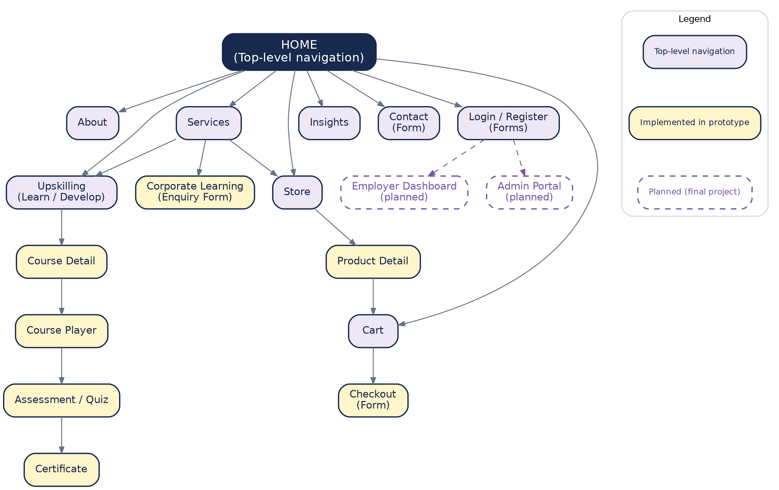
Figure 4: MT Alchemy sitemap and navigation structure

5.2 USER JOURNEYS
Three key journeys are documented and reflected in the prototype. Journeys A and B are fully clickable in the prototype. Journey C (Employer) is documented here; the corporate enquiry form is implemented and the employer dashboard steps are planned for the final project.

JOURNEY A: INDIVIDUAL LEARNING
Visitor, Register, Login, Browse Courses, Course Detail, Enrol, Course Player, Assessment, Certificate.
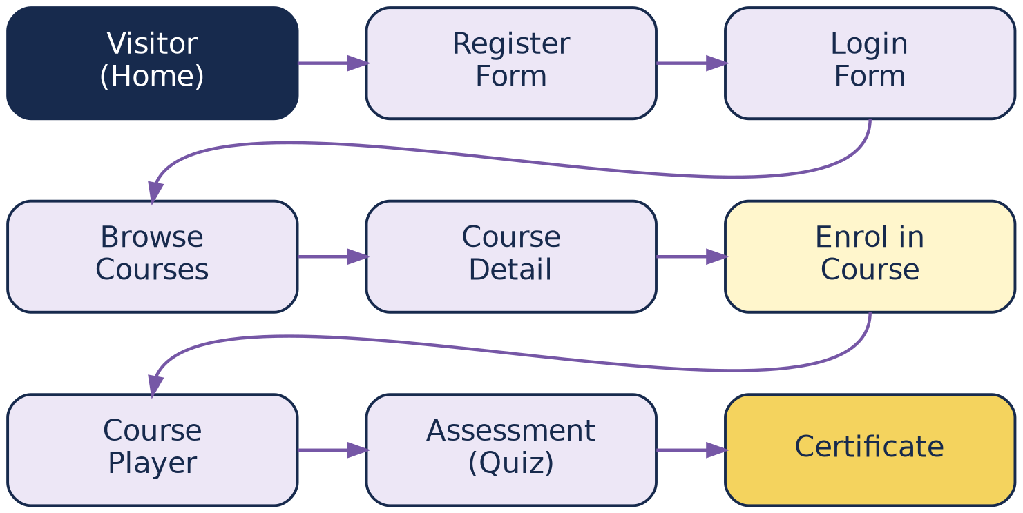
Figure 5: Journey A, Individual Learning

JOURNEY B: DIGITAL PRODUCT
Visitor, Store, Search / Filter, Product Detail, Add to Cart, Cart, Checkout, Order Confirmation. Payment is simulated in the prototype.
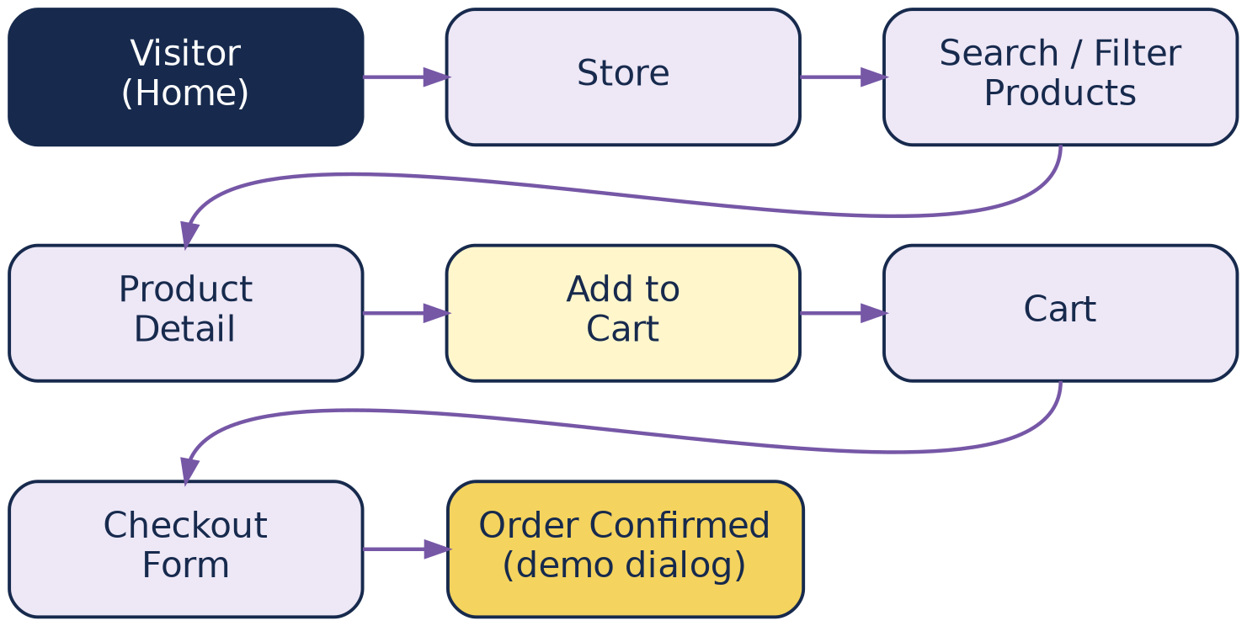
Figure 6: Journey B, Digital / Physical Product Purchase

JOURNEY C: EMPLOYER
Employer, Corporate Learning enquiry, Register Organisation, Add Employees, Assign Course, View Progress. Dashed boxes are planned for the final project.
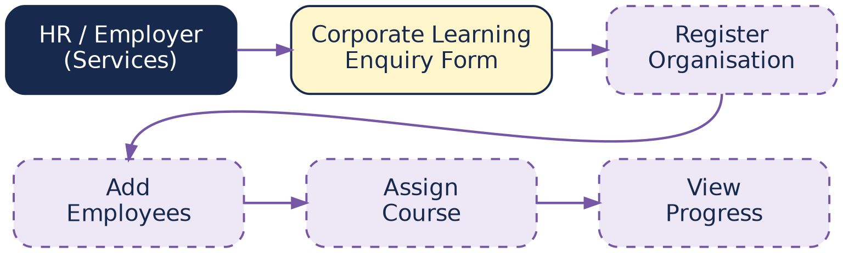
Figure 7: Journey C, Employer

6. PROTOTYPE QUALITY AND DOCUMENTATION

6.1 CODE ORGANISATION
The project follows a simple, readable structure: lib/main.dart (entry point), lib/theme/app_theme.dart (design system), lib/screens (one file per screen) and lib/widgets (reusable widgets). Reusable widgets reduce duplicated code and keep the styling consistent:
- AppButton: primary action button used by the Contact and Corporate enquiry forms.
- CourseCard: course tile with image, category badge, title, description and module count (Courses screen).
- ProductCard: product tile with icon, category, name, description and price (Store screen).

6.2 HOW TO RUN
flutter pub get
flutter run -d chrome

6.3 PROTOTYPE EVIDENCE
Screenshots of the running prototype are provided in Appendix A. The Scaffold, Container and Form usage is explained in Sections 2, 3 and 4.

6.4 DATABASE ER DIAGRAM DRAFT
An initial entity-relationship design was prepared for the final project. It covers 24 entities in three domains: Users and Organisations, Learning (LMS), and Store and Commerce. Figure 8 gives the overview; Figures 9 to 11 show each domain with primary keys (PK) and foreign keys (FK). No backend is implemented at this checkpoint.
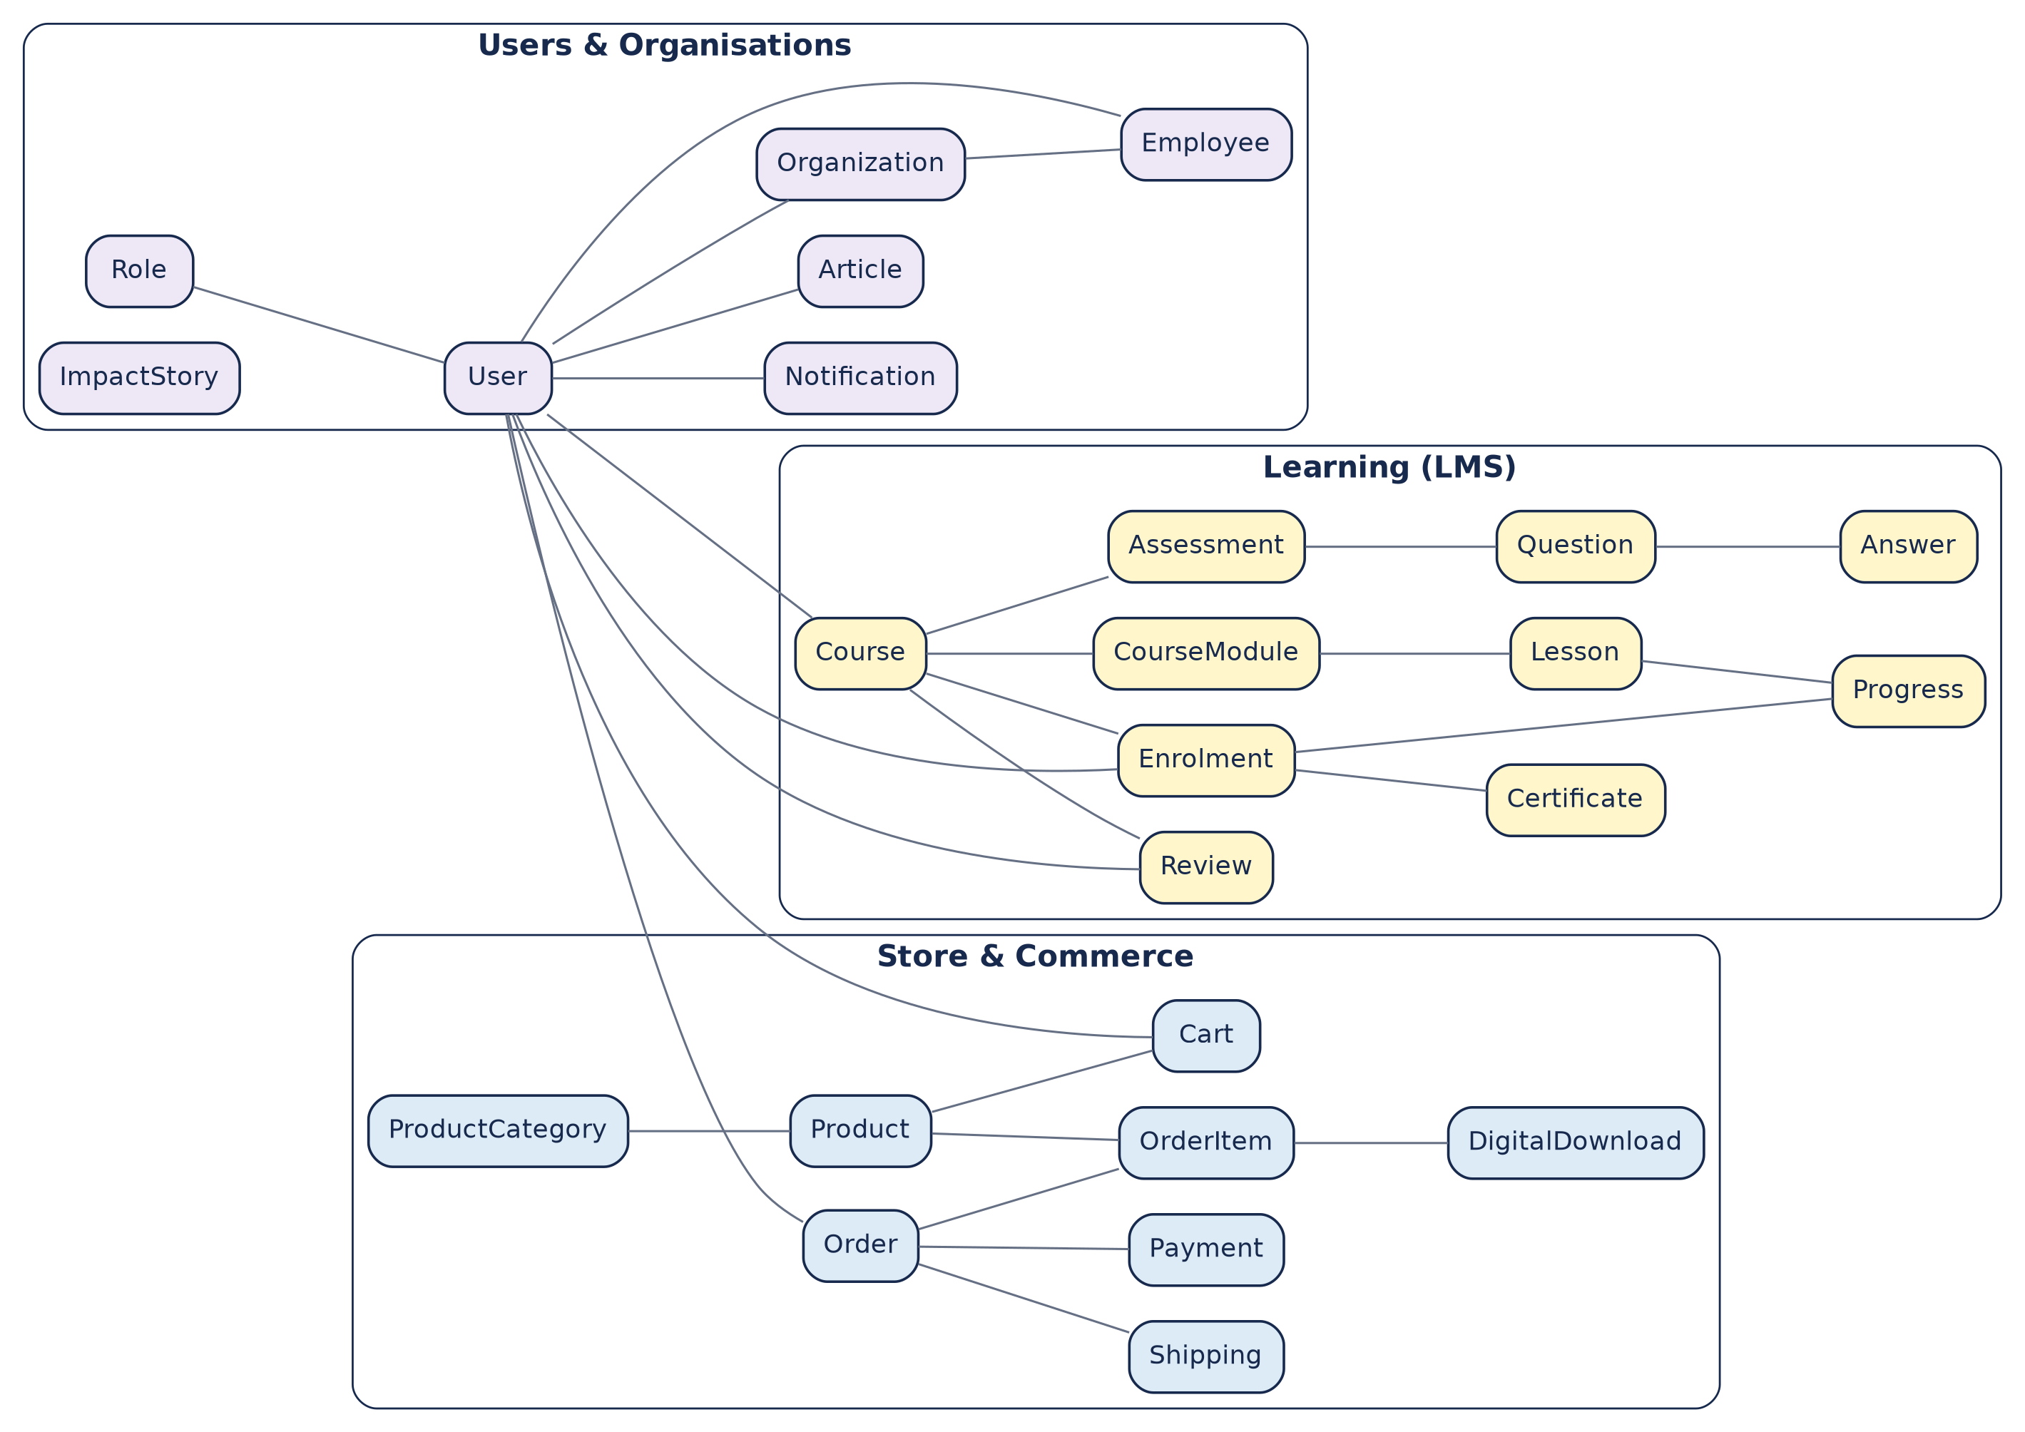
Figure 8: ER diagram overview (24 entities in three domains)

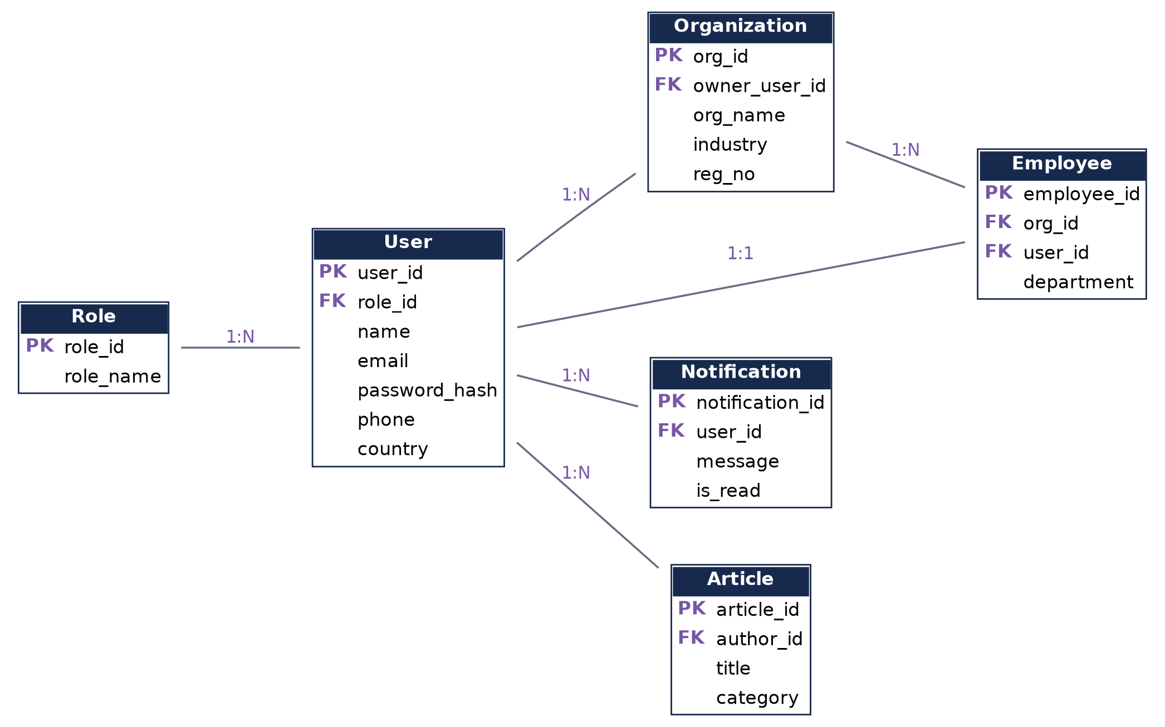
Figure 9: ER diagram, Users and Organisations

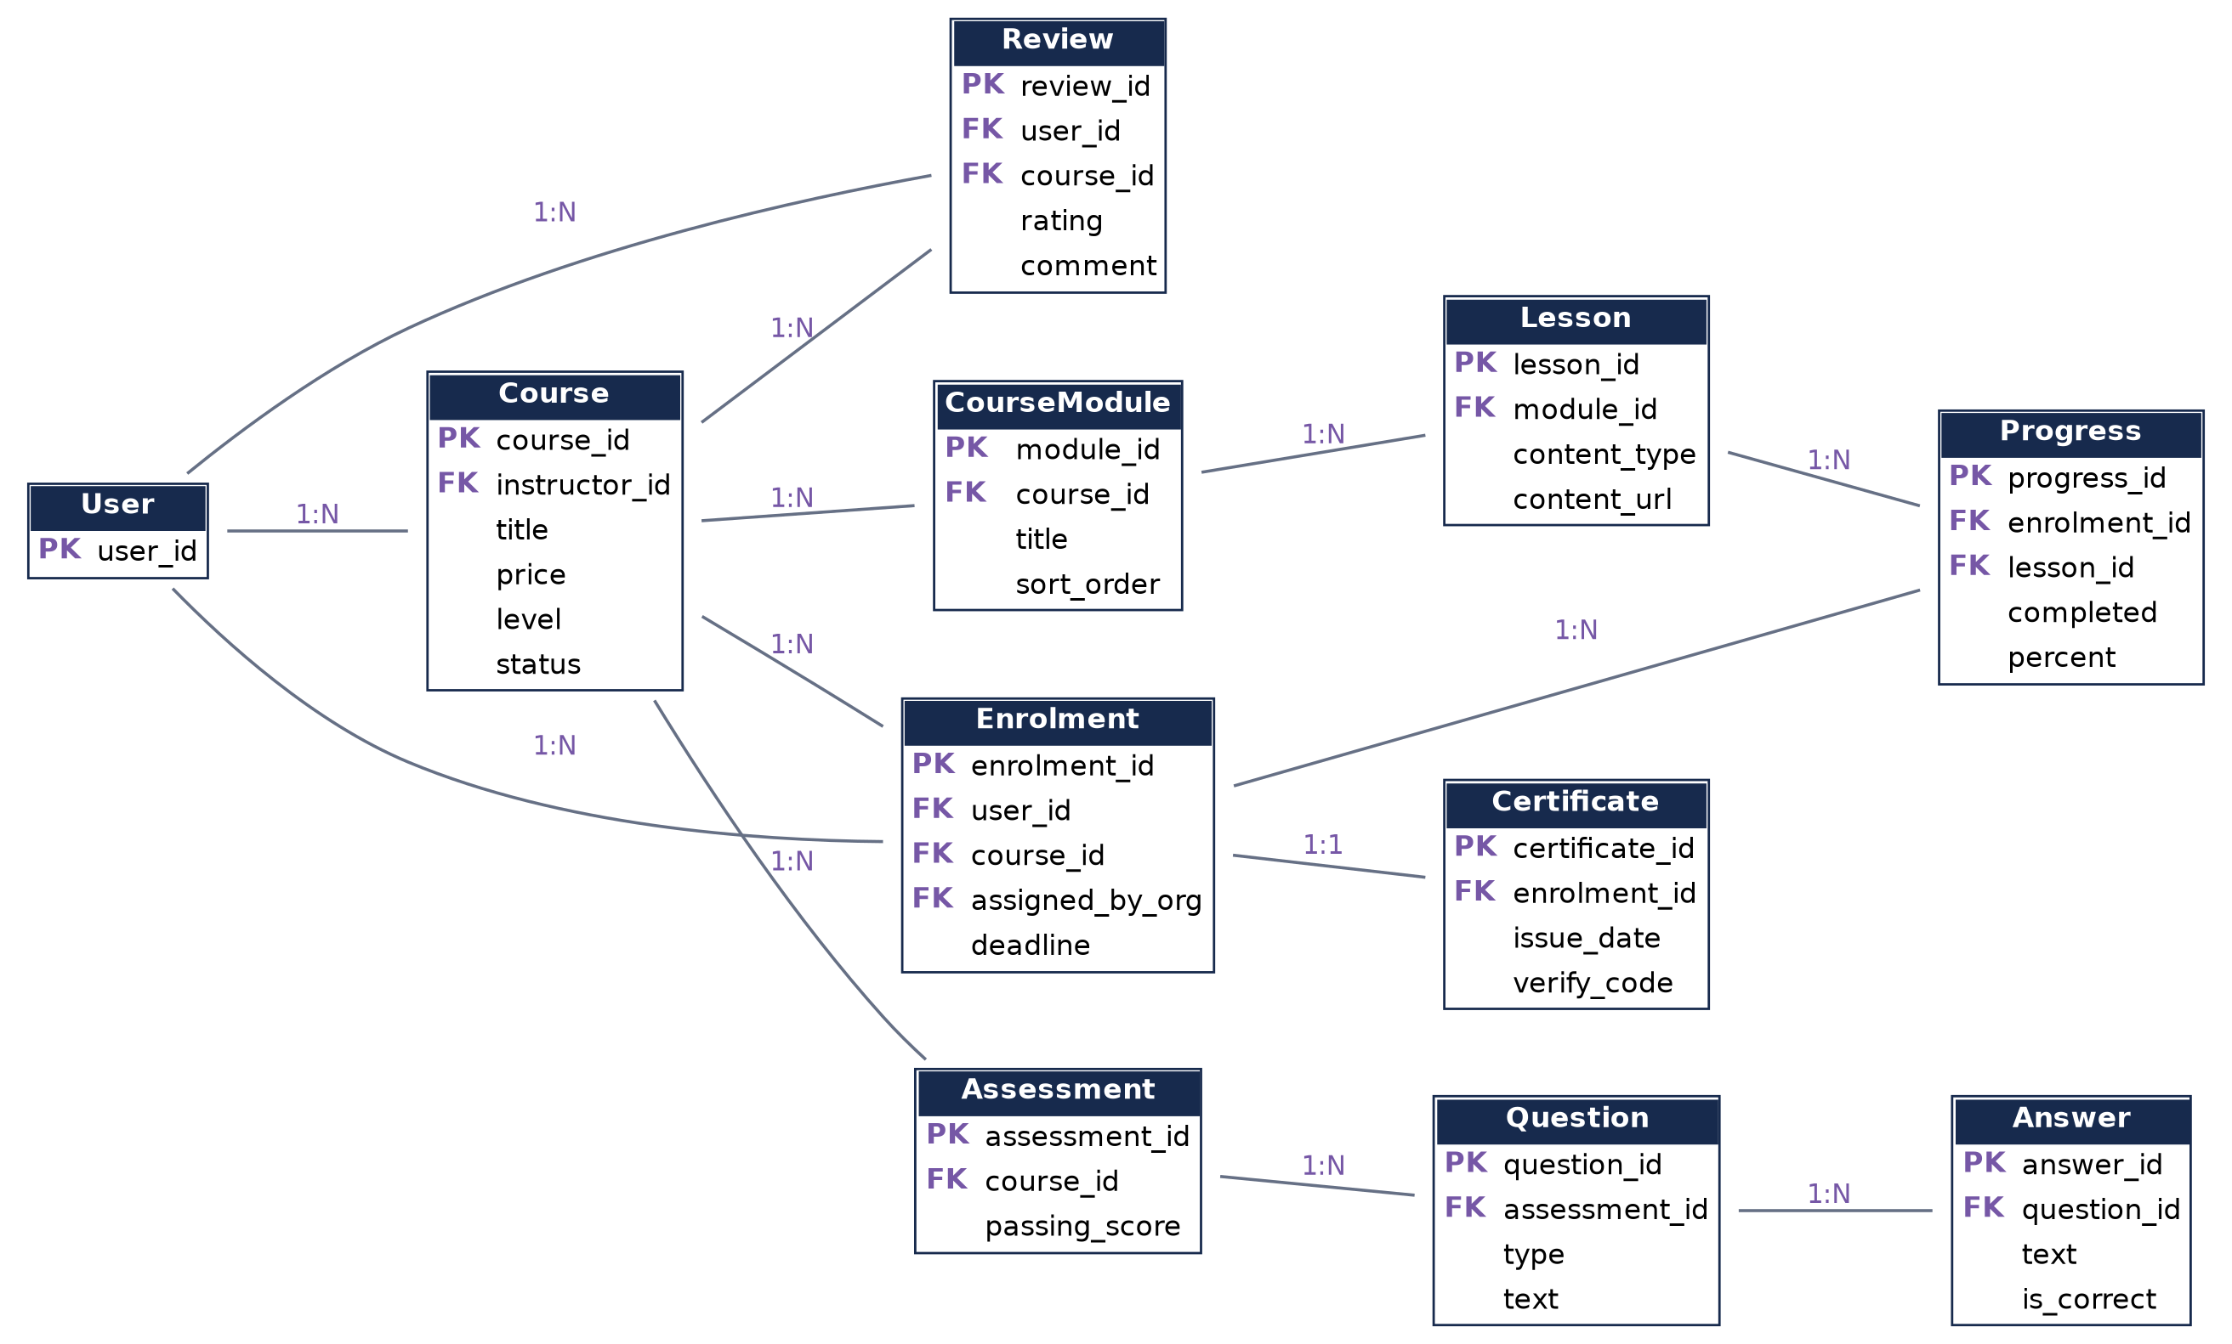
Figure 10: ER diagram, Learning (LMS)

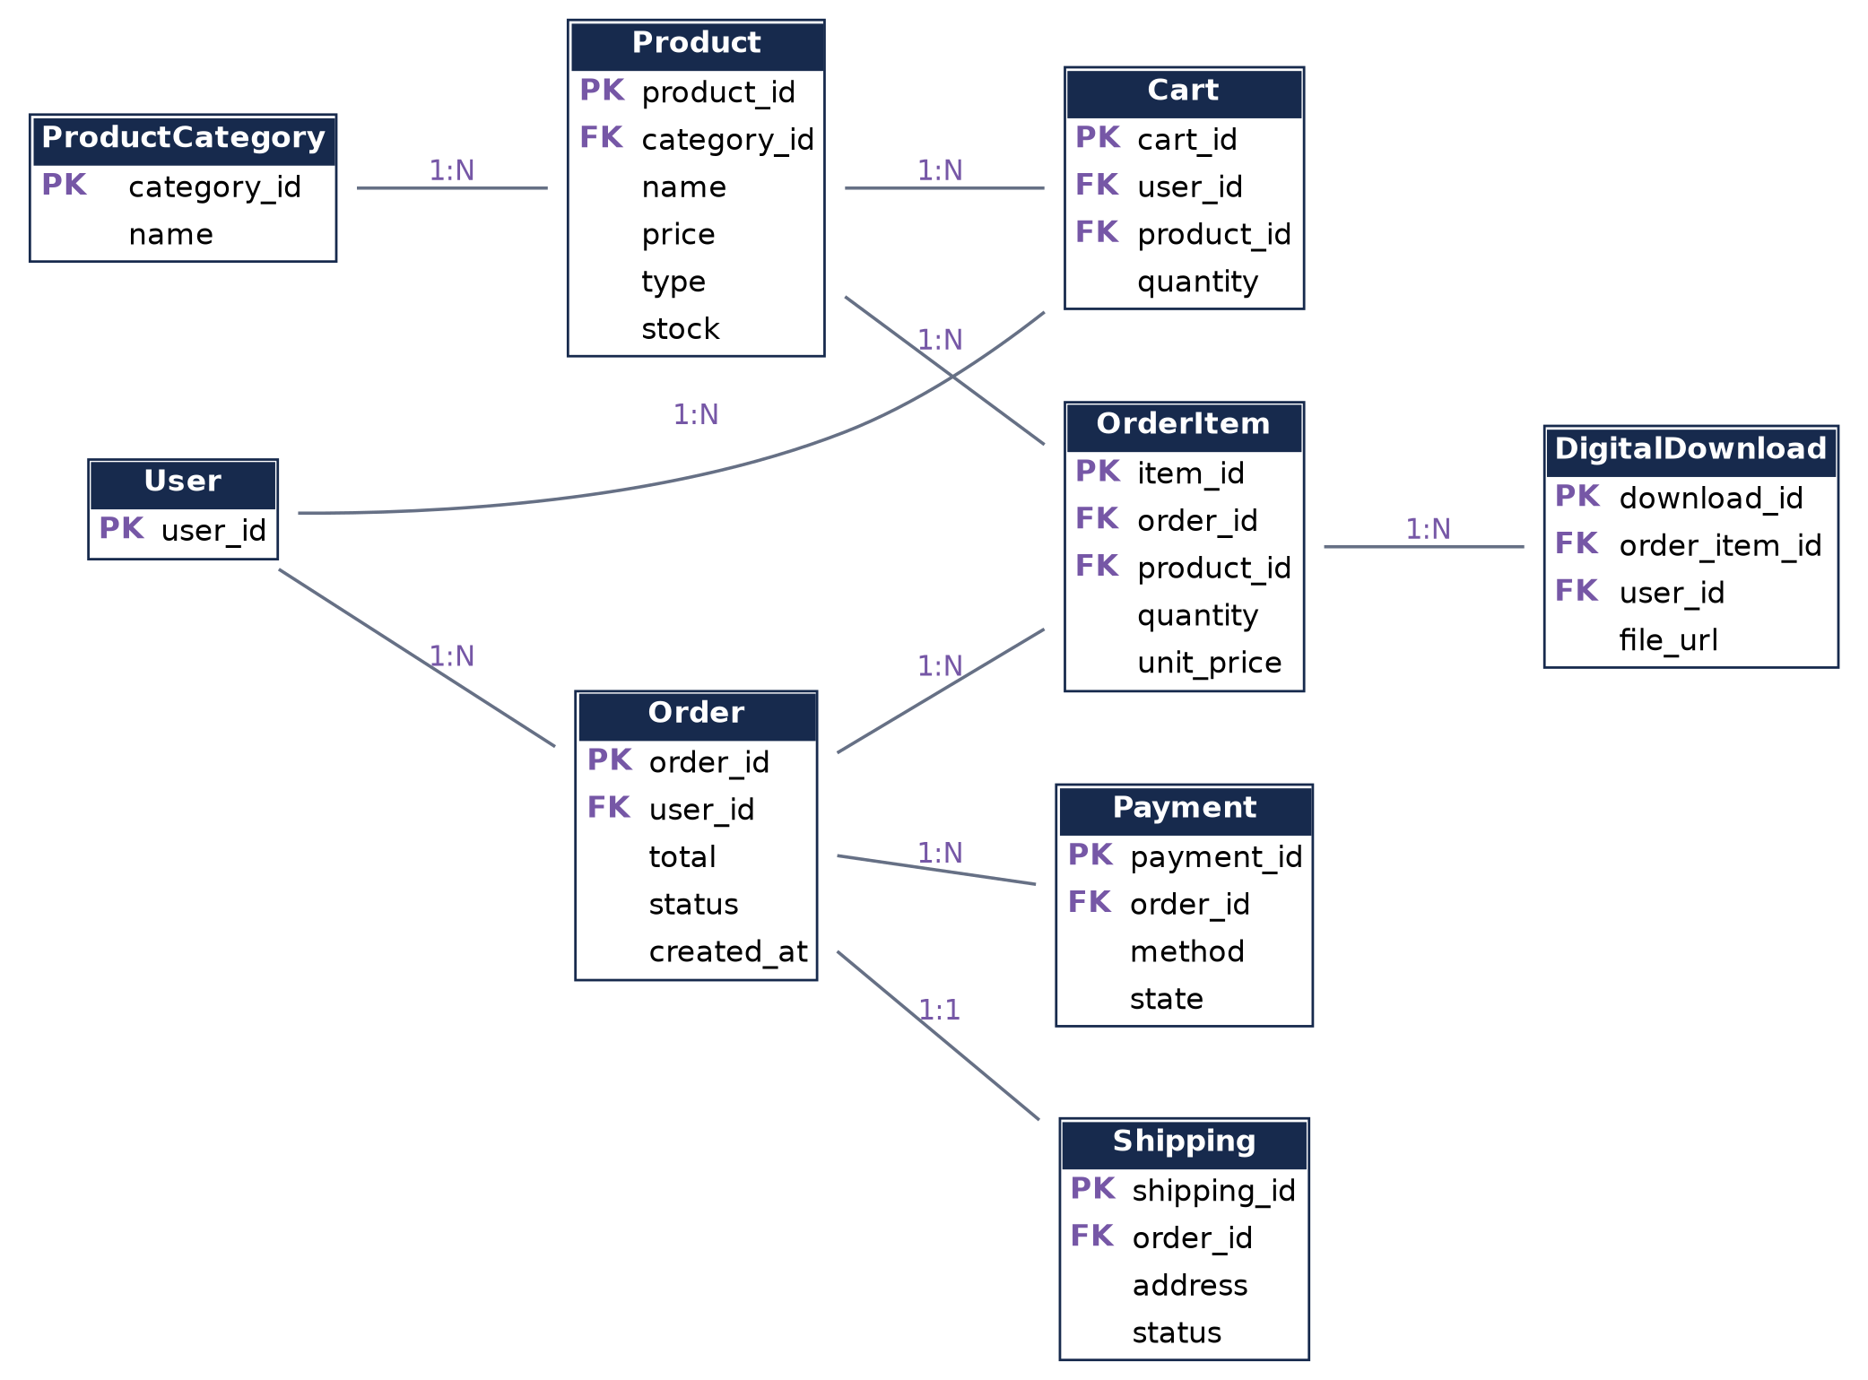
Figure 11: ER diagram, Store and Commerce

7. CONCLUSION
The prototype demonstrates the proposed MT Alchemy platform structure with a consistent Deep Blue, Soft Yellow and Purple visual identity. It uses Scaffold for the screen structure, Container for layout and decoration, and Form with validation for user input, and it connects representative screens from the public website, the LMS, the store and the corporate area. The sitemap, journeys and ER diagram provide the foundation for the final project, which will add Firebase, real authentication, payments, and the employer and admin portals.

REFERENCES

WEBSITE REFERENCES
Flutter. (n.d.). Flutter documentation. https://docs.flutter.dev
Flutter. (n.d.). Scaffold class. Flutter API documentation. https://api.flutter.dev/flutter/material/Scaffold-class.html
Flutter. (n.d.). Container class. Flutter API documentation. https://api.flutter.dev/flutter/widgets/Container-class.html
Flutter. (n.d.). Form class. Flutter API documentation. https://api.flutter.dev/flutter/widgets/Form-class.html
Dart. (n.d.). Dart documentation. https://dart.dev/guides
[Add any other websites you actually used, e.g. MT Alchemy materials, and check the access dates required by your referencing style.]

BOOK REFERENCES
[Add the books you actually used. If you used none, state “No book references were used”. Do not list books you did not read.]

APPENDIX A: SCREENSHOTS OF THE RUNNING PROTOTYPE
[Insert screenshots of the running app here. Suggested list: Home (desktop and mobile), About, Services, Courses, Course Detail, Course Player, Assessment, Certificate, Store, Product Detail, Cart, Checkout, Login, Register (with errors), Contact, Corporate enquiry, Insights.]

APPENDIX B: TURNITIN REPORT
[Insert the Turnitin similarity report here. Requirement: total similarity under 20% and each individual source under 3%. Run the check on the final report before submission.]

