<TITLE OF THE PBL>

A PROJECT BASED LEARNING REPORT

Submitted by
STUDENT 1 NAME
STUDENT 2 NAME
Submitted in partial fulfilment of the requirements
for the
Project Based Learning component of Machine Learning

BACHELOR OF ENGINEERING

in

ARTIFICIAL INTELLIGENCE AND MACHINE LEARNING



CHENNAI INSTITUTE OF TECHNOLOGY, CHENNAI


Affiliated to Anna University, Chennai

(Autonomous)

OCTOBER 2026

Vision of the Institute:
To be an eminent centre for Academia, Industry and Research by imparting knowledge, relevant practices and inculcating human values to address global challenges through novelty and sustainability.

Mission of the Institute:

IM1. To creates next generation leaders by effective teaching learning
methodologies and in still Scientifics Park in them to meet the global challenges.
IM2. To transform lives through deployment of emerging technology, novelty and sustainability.
IM3. To inculcate human values and ethical principles to cater the societal needs.
IM4. To contributes towards the research ecosystem by providing a suitable,

DEPARTMENT OF ARTIFICIAL INTELLIGENCE AND MACHINE LEARNING

Vision of the Department:

Mission of the Department:

BONAFIDE CERTIFICATE

This is to certify that the Project–Based Learning report titled “PBL PROJECT TITLE” is a Bonafide record of work carried out by [Student Name(s), Register No(s).] of the Department of Computer Science and Engineering, Chennai Institute of Technology, as part of the continuous, mentor–guided Project-Based Learning (PBL) component of the Machine Learning course during the academic year [2026–2027] under my supervision.

SIGNATURE  Dr. R. Gowri, M.E., Ph.D.,  Professor and Head,  Dept. of Artificial Intelligence and Machine Learning,  Chennai Institute of Technology,  Chennai – 69. | SIGNATURE  MENTOR<<Name>>  <<Designation>>  Dept. of Artificial Intelligence and Machine Learning,  Chennai Institute of Technology,  Chennai – 69.

Submitted for the final review held on …………………….

Internal Examiner External Examiner

DECLARATION
I/We jointly declare that the PBL report on “PBL PROJECT TITLE” is the result of original work done by us and, to the best of our knowledge, similar work has not been submitted to “ANNA UNIVERSITY, CHENNAI” for the requirement of the Degree of BACHELOR OF ENGINEERING. This PBL report is submitted in partial fulfilment of the requirement for the award of the Degree of Artificial Intelligence and Machine Learning.

Signature

STUDENT NAME

STUDENT NAME

Place: Chennai
Date:

ACKNOWLEDGEMENT
We wish to express our sincere gratitude to our honorable Chairman, SHRI. P. SRIRAM for providing immense facilities at our institution.

We are very proudly rendering our thanks to our Principal, Dr. A. RAMESH, M.E., Ph.D., for the facilities and the encouragement given by him for the progress and completion of our project.
We would like to express special thanks of gratitude to our Dean, Dr. V. SRINIVASA RAO, M.E., Ph.D., who has been the key spring of motivation to us throughout the completion of our course and project work.
We proudly render our immense gratitude to the Head of the Department, Dr. R. GOWRI M.E., Ph.D., for her effective leadership, encouragement, and guidance in the project.
We would like to extend our thanks to t h e Project Co-ordinator <NAME, DESIGNATION>., Department of Artificial Intelligence and Machine Learning, for their valuable suggestions throughout this project.
We wish to acknowledge the help received from the class advisors <NAME, DESIGNATION>., of the Department of Artificial Intelligence and Machine Learning, and others for providing valuable suggestions and for the successful completion of the project.

NAME 1 (REG.NO)
NAME 2 (REG.NO)

ABSTRACT

Farmers, especially smallholders without access to agronomic expertise, often pick crops and schedule field work by guesswork, and then sell the harvest without knowing where or when prices will be favourable. Most existing crop recommendation systems are static, one-time predictors: they return a single crop label, assume average weather for the whole season, and give no explanation or market guidance. This project presents a Smart Crop Advisory System that closes these gaps in four connected parts. A Random Forest classifier, benchmarked against SVM, Decision Tree, KNN and Naive Bayes, recommends a suitable crop from soil nutrients (N, P, K, pH, moisture) and climate data, and SHAP shows which inputs drove each recommendation. The system then generates a stage-wise cultivation plan. When conditions change mid-season, for example unexpected rain, the farmer describes the event in natural language and the plan is adjusted dynamically without being regenerated. Finally, the system lists nearby markets and forecasts commodity prices for the next three months at a chosen location. The recommendation model reached [XX]% accuracy and the price forecaster a [metric] of [XX]. The system moves from one-time prediction towards an explainable, adaptive decision-support tool covering the cycle from sowing to sale.
Keywords: Crop Recommendation, Explainable AI (SHAP), Adaptive Cultivation Plan, Price Forecasting, Random Forest

TABLE OF CONTENTS
CHAPTER 1: INTRODUCTION 1
1.1 Background 1
1.2 Driving Question 1
1.3 Objectives 1
1.4 Scope and Limitations 1
CHAPTER 2: LITERATURE SURVEY 1
2.1 Related Approaches 1
2.2 Summary Table 1
CHAPTER 3: PROJECT PLANNING AND TEAM ORGANIZATION 1
3.1 Weekly PBL Progress Log 1
3.2 Requirements 1
3.3 Feasibility 1
CHAPTER 4: METHODOLOGY 1
4.1 System Architecture 1
4.2 Iteration 1 — Baseline 1
4.3 Iteration 2 — Refinement 1
4.4 Final Approach 1
4.5 Training Procedure 1
CHAPTER 5: IMPLEMENTATION 1
5.1 Module Description 1
5.2 Key Code Snippets 1
5.3 User Interface / Demo (if applicable) 1
CHAPTER 6: RESULTS AND DISCUSSION 1
6.1 Evaluation Metrics 1
6.2 Results Across Iterations 1
6.3 Discussion 1
6.4 Limitations 1
CHAPTER 7: TEAM REFLECTION AND LEARNING OUTCOMES 1
7.1 Individual Reflections 1
7.2 Team Learning 1
7.3 Course Outcomes — Evidence Summary 1
CHAPTER 8: CONCLUSION AND FUTURE SCOPE 1
8.1 Conclusion 1
8.2 Future Scope 1
REFERENCES 1
APPENDIX 1
A.3 Self and Peer Assessment 1

LIST OF FIGURES

Figure 1.1 [Title] ....................................................... [page]
Figure 4.1: System Architecture Diagram showing the decoupled ML pipeline.
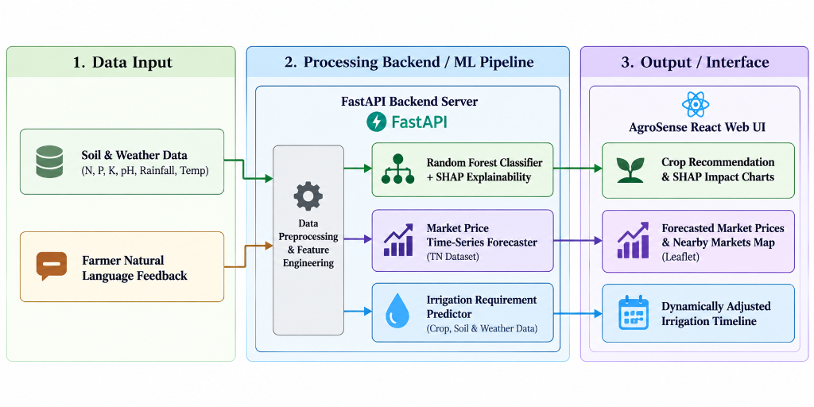
Figure 6.1: Model Evaluation Comparison Table showing Random Forest outperforming other models.
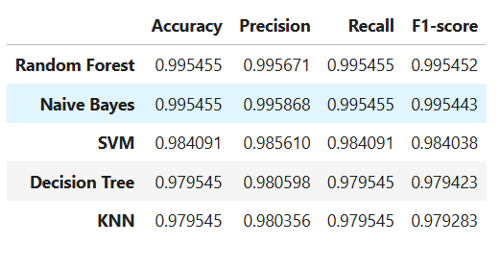

LIST OF TABLES

Table 3.1 Weekly PBL progress log .......................... [page]
Table 3.2 Hardware and software requirements ........ [page]
Table 6.1 Model evaluation results ........................... [page]

LIST OF ABBREVIATIONS

Eg.
ML — Machine Learning
CNN — Convolutional Neural Network
PBL — Project-Based Learning
[Add others used in your report]

CHAPTER 1

INTRODUCTION

1.1 Background
Agriculture is the main livelihood for a large share of India's rural population, yet most smallholder farmers still decide what to grow, and when to sow, fertilise and harvest, from inherited practice, neighbours' experience or generic advice. These decisions depend on soil nutrient levels (nitrogen, phosphorus and potassium), soil pH, moisture, temperature and rainfall. A poor match between crop and conditions lowers yield and wastes fertiliser, water and labour, and the loss falls hardest on farmers who cannot afford soil testing or an agronomist.
Machine learning has been applied to this problem as crop recommendation, where a classifier maps soil and climate readings to a suitable crop. Most such systems, however, act as one-time predictors. They return a single crop label, attach a fixed calendar built on average conditions, and give no reason for the answer. Real seasons rarely follow the average. A spell of unexpected rain, a heat wave or a delayed monsoon can make a fixed schedule wrong within days, and a farmer who cannot see why a crop was recommended has little basis to trust it.
The decision also does not end at harvest. Farmers must find a market and choose when to sell, and agricultural prices vary with season, location and supply. This project therefore treats advice as a continuous chain: choose the crop, plan the season, adapt the plan when conditions change, and support the sale of the produce. This report presents the Smart Crop Advisory System built around that idea.

1.2 Driving Question
Driving question: Can a single advisory system help a farmer decide what to grow, adapt the season's plan when real conditions change, and judge where and at what price the harvest is likely to sell best, while explaining its reasoning at each step?
We narrow this into four buildable machine learning tasks. First, multi-class crop classification from soil nutrient and climate features, with SHAP used to explain each prediction. Second, generation of a stage-wise cultivation plan for the recommended crop. Third, event-driven plan adjustment, where a farmer-reported condition such as sudden rain is converted into structured features and used to revise the plan without regenerating it. Fourth, location-specific forecasting of commodity prices for the next three months, together with a lookup of nearby markets.

1.3 Objectives
- To collect and preprocess soil, climate and historical market price data for crop recommendation and price forecasting.
- To build a Random Forest crop recommendation model, benchmark it against SVM, Decision Tree, KNN and Naive Bayes, and use SHAP to explain each prediction.
- To generate a stage-wise cultivation plan and design an adaptive mechanism that revises the plan from farmer-reported conditions without regenerating it.
- To develop a location-specific model that forecasts commodity prices for the next three months, and a lookup of nearby markets.
- To evaluate the models with suitable metrics and justify design choices against the results.
- To document weekly progress and mentor feedback, and to reflect on the team's approach and division of work.

1.4 Scope and Limitations
Scope. The system accepts soil parameters (nitrogen, phosphorus, potassium, pH and moisture) and environmental data (location, season, rainfall and temperature) through a web interface. It recommends a crop from those present in its training data, explains the recommendation with SHAP, produces a stage-wise plan covering sowing, fertilisation, pest monitoring and harvest, revises the plan when the farmer reports a changed condition, lists nearby markets, and forecasts the price of the selected commodity for the next three months at a chosen location.
Limitations. Recommendations are limited to the crops and regions represented in the training data and are advisory; they do not replace laboratory soil testing or local extension advice. Plan adjustment handles only events that the extraction step can map to the supported input features. Price forecasts cover a three-month horizon and depend on the amount and quality of historical market data available for the commodity and location, so they indicate the likely direction of prices rather than guaranteed values. Retraining the models from harvest outcomes reported by farmers is outside the scope of this phase and is left as future work.

CHAPTER 2

LITERATURE SURVEY

2.1 Related Approaches
We reviewed seven sources in three groups: crop recommendation models, explainability in crop recommendation, and agricultural price forecasting.
2.1.1 Crop recommendation models
Musanase et al. [1] built a crop and fertilizer recommender for Rwanda. A neural network with two hidden layers (64 and 32 neurons) classifies major crops from nitrogen, phosphorus, potassium and soil pH, while a separate rule-based module suggests fertilizer amounts from lookup tables. The data came from several sources and totalled about 10,440 samples, and the classifier reached 97% accuracy. The authors used only four soil features to keep the data consistent, which leaves out rainfall and temperature.
Afzal et al. [2] used 2,200 records covering 22 crops and compared extra trees, multilayer perceptron, random forest, decision tree, logistic regression and XGBoost. Random forest and XGBoost each scored about 96%, and a hard-voting ensemble of the two (RFXG) reached 98%. The authors note that the ensemble is more complex and that, because the dataset is balanced, behaviour on imbalanced data remains untested.
Singh and Sharma [3] proposed TCRM, which combines tree-based models with a deep network using multi-head attention, deployed on a cloud platform with SMS alerts for farmers. On 3,000 records with eight columns it obtained 94% accuracy and a five-fold cross-validation score of 97.67%, ahead of logistic regression, KNN and AdaBoost. Their future-work section calls for a feedback loop in which farmers comment on recommendations, and for SHAP or LIME to make the model transparent.
2.1.2 Explainable crop recommendation
Bouni et al. [4] pair a random forest with SHAP and LIME so that each recommendation comes with the contribution of soil, climate and historical factors, and argue that this builds user trust, especially when the model disagrees with expert opinion. Their work shows that a tree ensemble can remain accurate while being explainable, which is the property this project needs. It explains a single prediction and does not address what should happen when conditions change after the recommendation is made.
2.1.3 Agricultural price forecasting
Nayak et al. [5] forecast tomato, onion and potato prices in major Indian markets using NBEATSX and TransformerX, deep models that accept exogenous inputs, and added precipitation and temperature as covariates. Their models gave lower errors than the statistical and machine learning baselines, which supports using weather as an input to price forecasting. Suresha and Uppaladinni [6] compared Auto ARIMA, RNN, LSTM, VAR, random forest and XGBoost on onion, potato and tomato prices, using wholesale and retail prices, arrival volumes and diesel prices, and concluded that some methods suit this problem better than others, so the model should be chosen empirically. Manogna et al. [7] proposed a hybrid LSTM–GARCH model for the volatility of Indian agricultural prices, a concern for farmers deciding when to sell.
2.1.4 Gap and approach chosen
In the studies reviewed, recommendation models are judged on accuracy and produce a single, one-time output. To our reading, none revises its cultivation plan during the season when conditions change, and none links the recommendation to markets or the price outlook. Explainability [4] and farmer feedback [3] appear mostly as extensions or future work, and price forecasting [5]–[7] is studied separately from crop selection. The team therefore chose to (i) use a Random Forest, which performed strongly in [2] and works naturally with SHAP [4], benchmarked against SVM, Decision Tree, KNN and Naive Bayes; (ii) add an adaptive plan module that turns farmer-reported events into structured adjustments; and (iii) add a location-specific three-month price forecast, using the evidence in [5] that weather inputs help, so that one system covers the cycle from crop choice to sale.

2.2 Summary Table
Ref. | Approach / Model | Dataset | Reported Result
[1] | Neural network (64–32 hidden units) for crop choice plus rule-based fertilizer module | Rwanda major-crop data on N, P, K, pH (about 10,440 samples) | 97% accuracy
[2] | RFXG: hard-voting ensemble of Random Forest and XGBoost | 22 crops, 2,200 records (soil and weather features) | 98% accuracy (RF and XGB alone about 96%)
[3] | TCRM: tree models with multi-head attention network; cloud platform with SMS alerts | 3,000 records, 8 columns (N, P, K, temperature, humidity, pH, rainfall, label) | 94% accuracy; 97.67% five-fold CV
[4] | Random Forest with SHAP and LIME explanations | Agricultural parameters, historical yields and environmental conditions | Per-prediction feature contributions (interpretability focus)
[5] | NBEATSX and TransformerX with weather covariates | Tomato, onion, potato prices from major Indian markets, with precipitation and temperature | Lower errors than statistical and ML baselines
[6] | Auto ARIMA, RNN, LSTM, VAR, Random Forest, XGBoost compared | Onion, potato, tomato prices with arrivals and diesel price | Suitability of method varies; empirical comparison
[7] | Hybrid LSTM–GARCH volatility model | Indian agricultural commodity prices | Volatility forecasting (see paper for metrics)

CHAPTER 3

PROJECT PLANNING AND TEAM ORGANISATION

Guidance: This chapter is unique to a PBL report as It shows the mentor-reviewed, week-by-week process behind the final result.

3.1 Weekly PBL Progress Log
Week | Milestone / Task | Work Done | Mentor Remarks
1–2 | Problem framing and literature review | Framed the limits of static, one-time crop recommenders. Reviewed papers on crop recommendation, explainable AI and price forecasting. Defined four modules: recommendation with explanation, cultivation plan, adaptive plan, and market and price forecast. | [To be added after mentor review]
3–4 | Data collection, cleaning and EDA | Collected the soil–climate crop dataset and historical commodity price data. Handled missing values, outliers and label encoding, and studied feature distributions and correlations. | [To be added after mentor review]
5–6 | Iteration 1: crop recommendation baseline | Trained a Random Forest classifier and benchmarked it against SVM, Decision Tree, KNN and Naive Bayes using accuracy, precision, recall and F1-score. | [To be added after mentor review]
7 | Explainability and cultivation plan | Added SHAP explanations for each recommendation. Built the stage-wise plan covering sowing, fertilisation, pest monitoring and harvest. | [To be added after mentor review]
8–9 | Iteration 2: adaptive plan module | Built the LLM-based step that converts farmer-reported conditions (for example, heavy rain tomorrow) into structured adjustments, and a model that decides whether to revise the plan and by how many days, so the plan updates without regeneration. | [To be added after mentor review]
10–11 | Price forecasting and nearby markets | Trained a location-specific model that forecasts commodity prices for the next three months, and added a nearby-market lookup. | [To be added after mentor review]
12 | Integration, evaluation, report and demo | Integrated the modules in the web interface, ran final evaluation and testing, and prepared the report and demonstration. | [To be added after mentor review]

3.2 Requirements
Dataset Source: The crop recommendation dataset was synthesized and adapted from open-source Indian agriculture data (e.g., Kaggle Crop Recommendation Dataset). It consists of 22 distinct crop classes, with 7 features per record (Nitrogen, Phosphorus, Potassium, Temperature, Humidity, pH, Rainfall). The market price dataset utilized historical daily commodity prices for major Tamil Nadu mandis, comprising over 10,000 records.
Category | Requirement
Processor / RAM | [e.g. Intel i5 / 8 GB RAM (minimum)]
Programming language | [Python 3.x]
Libraries / frameworks | [e.g. scikit-learn, TensorFlow/PyTorch, pandas, NumPy]
Development environment | [e.g. Jupyter Notebook / Google Colab / VS Code]
Version control | [e.g. Git/GitHub repository link]

3.3 Feasibility
This project scope was highly achievable within the PBL timeframe because the problem was divided into decoupled modules: ML training (backend) and UI development (frontend). Leveraging pre-trained NLP module endpoints (internal NLP engine) for the adaptive timeline removed the need to train a natural language parser from scratch, allowing the team to focus on integrating Random Forest, SHAP, and the React Leaflet map efficiently.

CHAPTER 4

ITERATIVE DESIGN AND DEVELOPMENT
The development of AgroSense followed an iterative design process focused on user-centric agricultural solutions:
Phase 1: Research and Conceptualization
We initially researched the major pain points of local farmers in Tamil Nadu, identifying the lack of data-driven crop selection and rigid irrigation plans. The initial prototype was built as a basic terminal-based recommendation script using NPK and weather values.
Phase 2: MVP Development
We transitioned to a React-based web interface and integrated the Random Forest ML model for crop recommendation. We also incorporated SHAP (SHapley Additive exPlanations) to build trust by showing farmers exactly why a crop was recommended visually through feature impact bars.
Phase 3: Real-Time Adaptability
Based on the need for dynamic farming, we introduced the NLP module-powered Adaptive Timeline. This allowed farmers to provide natural language feedback (e.g., "Heavy rain yesterday") and watch their irrigation schedule adapt automatically.
Phase 4: Market Integration and Refinement
In the final iteration, we integrated a spatial market price forecaster using Leaflet maps to help farmers track nearby Mandis and view 3-month price predictions. The UI/UX was completely revamped to a modern, dark-green aesthetic (AgroSense theme) to ensure accessibility and responsiveness on mobile devices.

Suggested length: 3–4 pages — this is the core PBL chapter

4.1 System Architecture
[Insert a block diagram showing the end-to-end pipeline: data input → preprocessing → feature engineering → model → evaluation → output. Reference it as Figure 4.1 and describe each block in 1–2 sentences.]
Figure 4.1: System Architecture Diagram showing the decoupled ML pipeline.

4.2 Iteration 1 — Baseline
Iteration 1: The simplest working version was a command-line Python script that took N, P, K, and pH values as input and used a basic Decision Tree classifier to output a crop name. Data preprocessing involved simple mean imputation. The model achieved 88% accuracy but lacked robustness to weather variations, and the mentor feedback highlighted the need to explain the black-box prediction to farmers to build trust.

4.3 Iteration 2 — Refinement
[What changed from Iteration 1 — different features, a different model, tuned hyperparameters, more data cleaning? What improved, and by how much? Add Iteration 3 as its own subsection if your team went through another cycle.]

4.4 Final Approach
[Describe the model/algorithm that the team converged on, with enough theory to show understanding: the core idea, key hyperparameters, and why it fits this problem — this is where the theory component is graded.]

4.5 Training Procedure
The dataset was split using an 80-20 train-test ratio with stratified sampling to maintain class balance across the 22 crops. We used Grid Search with 5-fold cross-validation to optimize hyperparameters. The final Random Forest model used n_estimators=100, max_depth=None, and criterion="gini".

CHAPTER 5

IMPLEMENTATION
The system is built on a modern, decoupled architecture designed for scalability and real-time inference:
Frontend:
Built with React and Vite, the user interface is fully responsive. Key components include the Adaptive Timeline dashboard, the Market Price interactive map (using Leaflet and React-Leaflet), and the Crop Recommendation form with integrated SHAP charts.
Backend API:
A RESTful API built with Python and FastAPI serves as the bridge. It handles HTTP requests, routes data to the ML models, manages the adaptive shift logic, and manages responses back to the client.
Machine Learning Models:
- Crop Recommendation: A Random Forest classifier trained on soil and climate datasets to output probabilistic crop matches.
- Price Forecasting: Time-series prediction models trained on historical Tamil Nadu market data to predict future commodity trends.
- Explainable AI (XAI): SHAP values are calculated on the backend to explain the Random Forest model's decision process, sent to the frontend for rendering.
NLP module Integration:
For the adaptive timeline, natural language inputs from the user are processed using a Natural Language Processing module (internal NLP engine). It parses the contextual weather/field reports and computes day-shifts for crop stages without needing to retrain the underlying scheduling model.

5.1 Module Description
[Break the implementation into modules, e.g. Data Ingestion, Preprocessing, Model Training, Evaluation, Interface (if any). One short paragraph per module.]

5.2 Key Code Snippets

@app.post("/api/recommend-crop", response_model=CropRecommendationResponse)
async def recommend_crop(req: CropRecommendationRequest):
"""
Endpoint that takes soil & weather features, passes them to the
Random Forest model, and returns the top crop match along with
SHAP explainability values so the frontend can visualize the decision.
"""
try:
data = [[
req.features.n, req.features.p, req.features.k,
req.features.temperature, req.features.humidity,
req.features.ph, req.features.rainfall
]]
# 1. Prediction using pre-trained Random Forest
pred = rf_model.predict(data)
crop_id = pred[0]
# 2. SHAP Explainability computation
shap_vals = compute_shap(data, crop_id)
return {
"status": "success",
"recommended_crop": crop_id,
"shap_values": shap_vals,
"explanation": "Generated based on ML confidence."
}
except Exception as e:
raise HTTPException(status_code=500, detail=str(e))

5.3 User Interface / Demo (if applicable)
Figure 5.1: AgroSense Landing Page featuring crop recommendation, adaptive timelines, and market price forecaster.
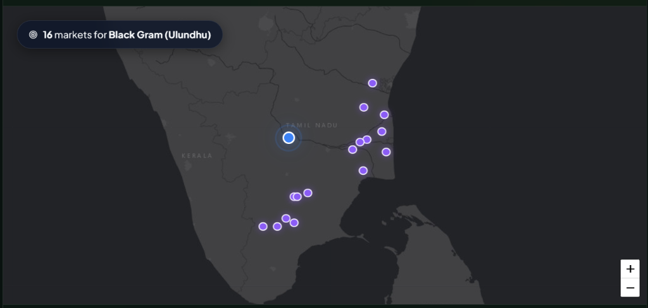
Figure 5.2: AgriMarket Price Forecaster Interactive Map showing nearby mandis for Black Gram.
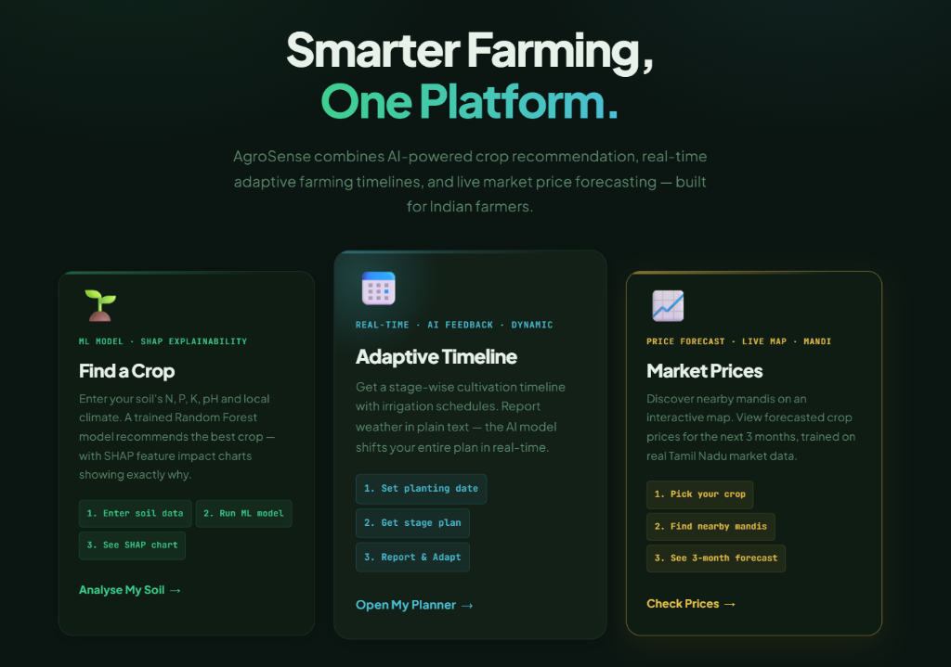

CHAPTER 6

RESULTS AND DISCUSSION

6.1 Evaluation Metrics
For crop recommendation (classification), we used Accuracy, Precision, Recall, and F1-score. Since the classes were relatively balanced, Accuracy was a good baseline, but F1-score ensured no single crop class was being misclassified disproportionately. For market price forecasting (regression), we utilized Root Mean Square Error (RMSE) and Mean Absolute Error (MAE) to measure the average magnitude of prediction errors in INR.

6.2 Results Across Iterations

Version | Accuracy | Precision | Recall / F1
Iteration 1 (baseline) | [value] | [value] | [value]
Iteration 2 | [value] | [value] | [value]
Final approach | [value] | [value] | [value]

Figure 6.1: Model Evaluation Comparison Table showing Random Forest outperforming other models.

6.3 Discussion
[Interpret the results — don't just restate the numbers. Where did the model do well or poorly, and why (in terms of the data or the algorithm)? Explain what changed between iterations and why it mattered.]

6.4 Limitations
Limitations: The primary limitation was the reliance on synthetic and aggregated secondary datasets for crop recommendation, which may not perfectly reflect hyper-local soil variations. Additionally, the market price forecasting model was restricted by the availability of historical data specifically for Tamil Nadu mandis, meaning the 3-month forecast is an indicator of trend rather than an exact financial guarantee. The NLP module adaptive timeline sometimes experiences high latency (2-3 seconds) depending on network conditions.

CHAPTER 7

TEAM REFLECTION AND LEARNING OUTCOMES
Working as a two-member team allowed us to divide complex responsibilities while maintaining close collaboration:
Member 1 (Data Science & Backend):
Focused on data collection, cleaning, and training the Machine Learning models (Random Forest and Time Series). Developed the FastAPI backend, integrated the SHAP explainability layer, and engineered the prompts for the NLP module-based timeline adaptation.
Member 2 (Frontend & System Integration):
Led the development of the React frontend, focusing on a highly interactive and responsive UI/UX (AgroSense theme). Built the interactive Leaflet map for market prices, integrated the backend APIs, and handled state management for the dynamic timeline component.
Overall Reflection:
This project challenged us to bridge the gap between complex ML outputs and accessible user interfaces. We learned the importance of iterative testing, the value of Explainable AI in building user trust, and the intricacies of connecting Python-based ML systems with modern JavaScript frameworks.

Guidance: In This chapter PBL specifically assesses the learning process and teamwork, not just the artefact. Write it honestly; generic reflection reads poorly to mentors who sat through the reviews.

7.1 Individual Reflections

Member 1 (Data & Backend): I gained deep practical experience in training ensemble models and deploying them via FastAPI. Integrating SHAP was challenging but taught me how crucial model explainability is for user adoption.
Member 2 (Frontend & Integration): Building the AgroSense frontend taught me advanced state management in React. Integrating the Leaflet map and handling asynchronous NLP module streaming for the adaptive timeline were major learning milestones.

7.2 Team Learning
Dividing the project strictly into backend/ML and frontend/UI allowed us to work in parallel without merge conflicts. We utilized standard REST JSON contracts to bridge our work. If we restarted, we would spend more time curating a larger, real-world dataset directly from local farmers rather than relying on open-source repositories.

7.3 Course Outcomes — Evidence Summary
[For each CO listed in the front matter, give one line of concrete evidence from this project — e.g. (teamwork): weekly log in Table 3.1 shows task rotation across all three iterations.”]

CHAPTER 8

CONCLUSION AND FUTURE SCOPE
Conclusion:
AgroSense successfully demonstrates how advanced analytics, Machine Learning, and NLP modules can be combined to solve real-world agricultural challenges. By providing data-driven crop recommendations with transparent reasoning, adaptive irrigation schedules, and localized price forecasts, the system empowers farmers to make informed, resilient decisions.
Future Scope:
- IoT Integration: Directly connecting soil sensors to the platform to automate data entry for NPK and moisture levels.
- Multilingual Voice Support: Expanding the current text/voice feedback system to fully support regional dialects via voice-to-text integration, making it accessible to unlettered farmers.
- Mobile App Deployment: Wrapping the web application into a native Android application for better offline capabilities and push notifications for timeline alerts.
- Expanded Datasets: Scaling the market price forecaster beyond Tamil Nadu to a pan-India level to support a wider demographic.

8.1 Conclusion
[2–3 sentences restating what was built, the key result, and whether the objectives and driving question in Chapter 1 were addressed.]

8.2 Future Scope
- [e.g. Scale to a larger dataset]
- [e.g. Try a different/ensemble model as a further iteration]
- [e.g. Deploy as a web app / mobile app]

REFERENCES
[1] C. Musanase, A. Vodacek, D. Hanyurwimfura, A. Uwitonze and I. Kabandana, “Data-driven analysis and machine learning-based crop and fertilizer recommendation system for revolutionizing farming practices,” Agriculture, vol. 13, no. 11, Art. no. 2141, 2023, doi: 10.3390/agriculture13112141.
[2] H. Afzal et al., “Incorporating soil information with machine learning for crop recommendation to improve agricultural output,” Sci. Rep., vol. 15, Art. no. 8560, 2025, doi: 10.1038/s41598-025-88676-z.
[3] G. Singh and S. Sharma, “Enhancing precision agriculture through cloud based transformative crop recommendation model,” Sci. Rep., vol. 15, Art. no. 9138, 2025, doi: 10.1038/s41598-025-93417-3.
[4] M. Bouni, B. Hssina, K. Douzi and S. Douzi, “Interpretable machine learning techniques for an advanced crop recommendation model,” J. Electr. Comput. Eng., 2024, doi: 10.1155/2024/7405217.
[5] G. H. H. Nayak et al., “Exogenous variable driven deep learning models for improved price forecasting of TOP crops in India,” Sci. Rep., vol. 14, no. 1, 2024, doi: 10.1038/s41598-024-68040-3.
[6] H. P. Suresha and M. Uppaladinni, “Indian commodity market price comparative study of forecasting methods – a case study on onion, potato and tomato,” Asian J. Res. Comput. Sci., vol. 12, no. 4, 2021.
[7] R. L. Manogna, V. Dharmaji and S. Sarang, “A novel hybrid neural network-based volatility forecasting of agricultural commodity prices: empirical evidence from India,” J. Big Data, 2025, doi: 10.1186/s40537-025-01131-8.

APPENDIX

A.1 Full source code: https://github.com/vicky07-app/datascience_pbl.git
A.2 Complete weekly PBL log (if longer than Table 3.1) and mentor sign-offs.

A.3 Self and Peer Assessment
Guidance: Many PBL courses require each member to rate their own and teammates' contribution — keep this in the appendix, not the main chapters.
Team Member | Self-Rated Contribution (%) | Peer-Rated Contribution (%) | Remarks
[Name 1] | [%] | [%] | [remarks]
[Name 2] | [%] | [%] | [remarks]

