BLUE-GREEN DEPLOYMENT

**Step 1:** Map Blue route To Green App

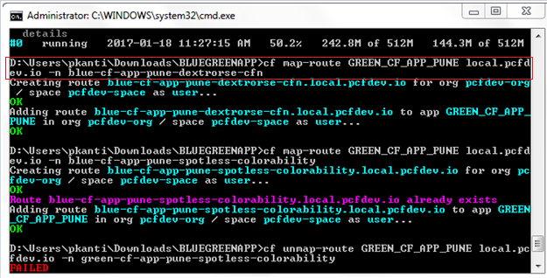

**Step 2:** UnMap Green route From green app

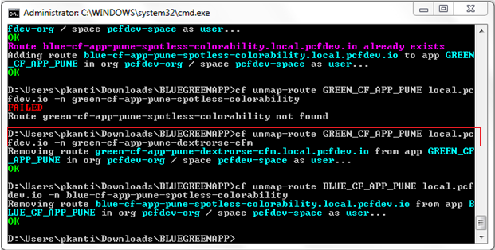

**Step 3:** See the result Mapping blue route to green app in below screen

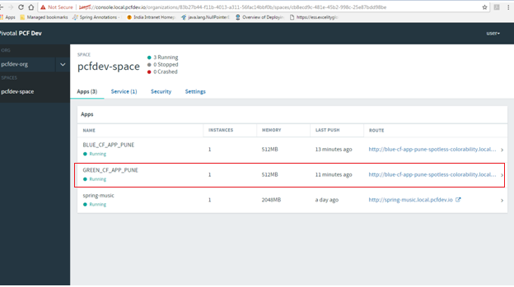

**Step 4:** UnMap Blue Route From Blue App

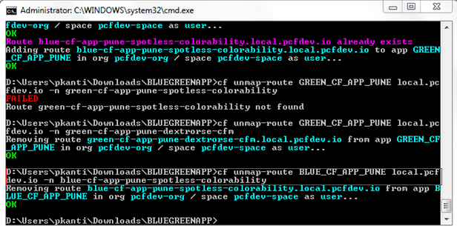

**Step 5:** See the result in below screen of unmapping the blue route from blue app.

Route has been removed because of unmapped the route.

