PCF:
IMP : Read before exam(https://www.examslocal.com , http://it.psionline.com/exam-faqs/pivotal-faq.
The exam itself is a computer-based exam. The exam software first gives you some general
instructions: how to navigate, how to mark a question, and so forth - please read it carefully.
Once you have agreed that you want to start, you have 90 minutes to answer 50 multiplechoice
questions. You must answer 38 questions correctly (76%) in order to pass the exam.
Basic exam technique applies: read each question carefully and answer the question that was asked not what you thought was asked.
)

TOPIC 1: Cloud Foundry Overview

What are the things you need to manage in IAAS ?

Applications, Data, runtime, Middleware.

What are the things you need to manage in platform (Cloud foundry)?

Applications, Data.

What are theexamples of Infrastucture as a service in cloud?

AWS, vSphere, Openstack

What are three levels a cloud foundry installation acomplishes?
- 1. BOSH creates and deploys virtual machines (VMs) on top of a physical computing infrastructure, and deploys and runs Cloud Foundry on top of this cloud. To configure the deployment, BOSH follows a manifest document.
2. The CF Cloud Controller runs the apps and other processes on the cloud’s VMs, balancing demand and managing app lifecycles.
- The router routes incoming traffic from the world to the VMs that are running the apps that the traffic demands, usually working with a customer-provided load balancer.

What are two types of VM cloud foundry designate?

-> The component VMs that constitute the platform’s infrastructure, and the host VMs that host apps for the outside world.

(NOTE: To store large binary files, such as droplets, CF maintains an internal or external blobstore. To store and share temporary information, such as internal component states, CF uses MySQL, Consul, and etcd.)

How Cf componenets communicate?

-> Cloud Foundry components communicate with each other by posting messages internally using http and https protocols, and by sending NATS messages to each other directly.
(Note: The Loggregator system aggregates this information in a structured, usable form, the Firehose. You can use all of the output of the Firehose, or direct the output to specific uses, such as monitoring system internals or analyzing user behavior, by applying nozzles.)
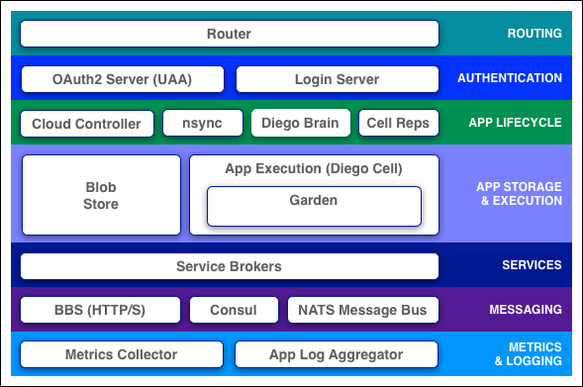
Router:
Note: The router periodically queries the Diego Bulletin Board System (BBS) to determine which cells and containers each application currently runs on. Using this information, the router recomputes new routing tables based on the IP addresses of each cell virtual machine (VM) and the host-side port numbers for the cell’s containers.

7. to push an application whom do you target?
-> Cloud Controller which maintain records of orgs, spaces, user roles, services =>The Cloud Controller then directs the Diego Brain through the CC-Bridge to coordinate individual Diego cells to stage and run applications.
Orgs, Spaces, Roles, and Permissions :
Orgs : By default, an org has the status of active. An admin can set the status of an org to suspended for various reasons such as failure to provide payment or misuse. When an org is suspended, users cannot perform certain activities within the org, such as push apps, modify spaces, or bind services
8. Every application and service is scoped to a ? = >. SPACE
9. . This role has read-only access to all Cloud Controller API resources except for secrets such as environment variables.?
=>Global Auditor
(Note: Org Auditors view but cannot edit user information and org quota usage information.Space Managers are managers or other users who administer a space within an org.Space Developers are application developers or other users who manage applications and services in a space.)

# nsync, BBS, and Cell Reps:
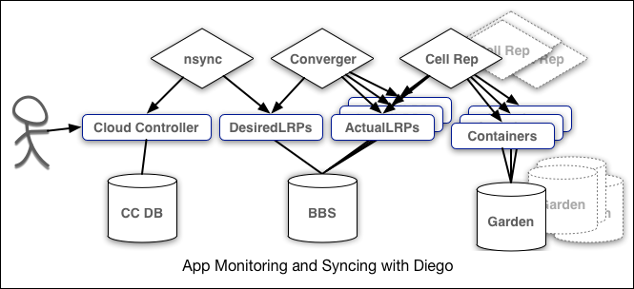

IMP: Here is how the components work together:
- nsync receives a message from the Cloud Controller when the user scales an app. It writes the number of instances into a DesiredLRP structure in the Diego BBS database.
- BBS uses its convergence process to monitor the DesiredLRP and ActualLRP values. It launches or kills application instances as appropriate to ensure the ActualLRP count matches the DesiredLRP count.
- Cell Rep monitors the containers and provides the ActualLRP value.

10..What are the conetent blobstore include ?
- Application code packages
- Buildpacks
- Droplets
11. Each application VM has a ……..that executes application start and stop actions locally, manages the VM’s containers, and reports app status and other data to the BBS and Loggregator.?
=> Diego Cell
(Note: )
Consul and BBS
Cloud Foundry component VMs communicate with each other internally through HTTP and HTTPS protocols, sharing temporary messages and data stored in two locations:
- A Consul server stores longer-lived control data, such as component IP addresses and distributed locks that prevent components from duplicating actions.
- Diego’s Bulletin Board System (BBS) stores more frequently updated and disposable data such as cell and application status, unallocated work, and heartbeat messages. The BBS stores data in MySQL, using the Go MySQL Driver.
The route-emitter component uses the NATS protocol to broadcast the latest routing tables to the routers. In pre-Diego CF architecture, the NATS Message Bus carried all internal component communications.

