Logging, Scaling and High Availability

Q 1. How do you access application logs?
- Cf logs app_name –recent
Q 2 What are the components of the Loggregator system?
- A) What is loggregator ?
- Loggregator is next generation system for aggregating and streaming logs and metrics from oll of the user apps and system components in cloud foundry deployment
B) Who can an access the Loggregator Firehose, the combined stream of logs from all apps, and the metrics data from Cloud Foundry components.?
=> Operator and Adminstrator
C) The component that listen to the firehose for specific events, metrics and stream this data to external services is ?
=>Nozzle
D) where the Nozzle operator can deploy ?
=> FIREHOSE
E) Which component uses for communication between Metron agent and Dropler ?
=> gRPC (In gRPC a client application can directly call methods on a server application on a different machine as if it was a local object, making it easier for you to create distributed applications and services. As in many RPC systems, gRPC is based around the idea of defining a service, specifying the methods that can be called remotely with their parameters and return types. On the server side, the server implements this interface and runs a gRPC server to handle client calls. On the client side, the client has a stub (referred to as just a client in some languages) that provides the same methods as the server.)
F) What is Source ?
=> Source are logging agents that runs on cloud foundry component.
G)What is the Purpose of Metron ?
=> They Co-located with sources. Collects the logs and forward them to Dropler server.
H) What Dropler Does ?
=> Dropler gathers logs from Metron agents and store in to temp. buffer after forward them to traffic controller.
I)What is the objective of Traffic controller || Who handles the client request of logs ?
=> Traf. Controller handles client request of logs . Gatherd and collects all messages form Dropler server and provide external apis and message transaltion. Exposes the Firhouse.
j) What is Firehose ?
=> Firehose is a websocket endpoint which stream all the event data coming from cloud foundry deployment.
## Logs from system components such as Cloud Controller are not included in the firehose and are typically accessed via rsyslog configuration.
## . The Traffic Controller serves the Firehose over WebSocket at the /firehose endpoint. The events coming out of the Firehose are formatted as protobuf messages conforming to the dropsonde protocol.
The address of the traffic controller can be discovered by hitting the /info endpoint on the API and getting the value of the doppler_logging_endpoint.
the Firehose carries both logs and metrics, which differ as follows:
k) How will I get logs of cloudcontroller ?
=> by accessed via rsyslog configuration
L) How to discovered the address of trafficcontroller ?
=> by hitting the /info endpoint
M) What is difference between Metron and Logs ?
- => Metrics : 1.Report a measurement from or status of a VM at its timestamp time
2.Follow dropsonde or statsd protocol
3.Can route to a monitoring platform to trigger alerts
Logs
1. Report events detected, actions taken, errors, or any other messages the operator or developer wanted to generate
2.Follow the syslog standard
3.Are not used to trigger alerts
N)Which of the following is used for Triggered alerts?
=> Metrics
o)Who Follows syslog standers ?
=>Logs
P)who report am measurement from or status of VP at its timestamp time?
=>Metrics
N) What is Nozzles ?
=> Nozzles is the program which consume data from Loggregator Firehose.
Nozzles can be configured to select, buffer, and transform data, and forward it to other applications and services.
- E.g : The Datadog nozzle publishes metrics coming from the Firehose to Datadog.

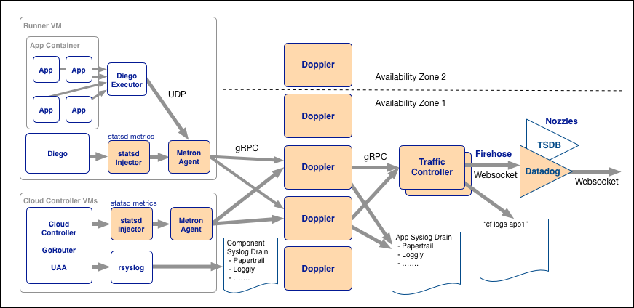

Q 3. What are the four levels of high-availability provided by PCF?
- This section describes how to configure system components to ensure high availability. You accomplish this by scaling component VMs and locating them in multiple Availability Zones (AZs), so that their redundancy and distribution minimizes downtime during ongoing operation, product updates, and platform upgrades.
- Scaling component VMs means changing the number of VM instances dedicated to running a functional component of the system. Scaling usually means increasing this number, while scaling down or scaling back means decreasing it.
- 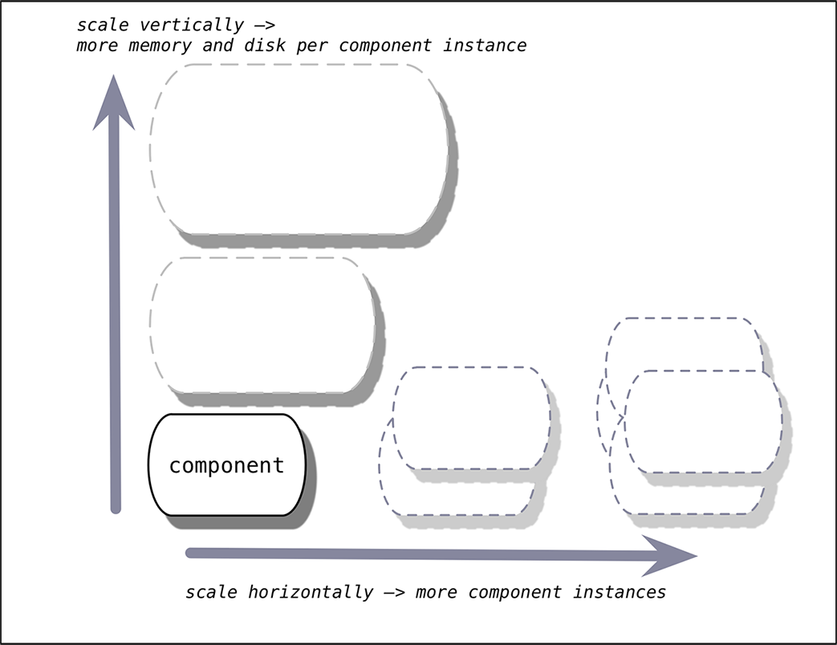
- Scaling Vertically
- Vertically scaling an application changes the disk space limit or memory limit that Cloud Foundry applies to all instances of the application.
- Use cf scale APP -k DISK to change the disk space limit applied to all instances of your application. DISK must be an integer followed by either an M, for megabytes, or G, for gigabytes.
- $ cf scale myApp -k 512M

cf scale APP -m MEMORY to change the memory limit applied to all instances of your application.
FIRST LEVEL :
First off, there is no voodoo magic here, you are going to have to deploy multiple instances of your application. Then Pivotal CF has the notion of availability zones* and these must be sensibly defined, for example, one availability zone (AZ) is defined for one vCenter resource pool, and another AZ defined for a second resource pool. Finally, you configure your Pivotal CF deployment so that the DEAs (the nodes on which your application instances run) are created across the availability zones. When application instances are then deployed, Pivotal CF will distribute them evenly across the availability zones. You lose one AZ and you still have instances up and serving traffic. That’s one level.

SECOND LEVEL :
Of course, if you lose application instances for any reason, a bug in the app, an AZ goes down, etc. you’ll want the system to compensate, restarting new instances so that we keep the capacity we are aiming for. This is where the elastic runtime health manager comes in. The health manager is constantly keeping tabs on the state of the system, in particular, how many instances of each application are running across all of the DEAs. When it detects a discrepancy between the actual state of the app instances in the cloud and the desired state, as known by the cloud controller, it advises the cloud controller of the difference and the cloud controller will initiate the deployment of new application instances. That’s another level.
THIRD LEVEL
here are all of these things that are working in concert to keep your application instances up and running–the DEAs, cloud controller, health manager and so on. You might then ask, “what happens if one of these pieces of software stops working? If the health manager isn’t there, what will compensate for app instance failures?” The answer is that there is another level that is keeping an eye on the health manager (and all of the other components). The processes running on the virtual machines (i.e. the health manager) are monitored, so that if a process dies it will automatically be restarted, whether the restart is successful or not, it will tell the BOSH agent about the failure. Recall that the BOSH agent is there to communicate with Operations Manager and in this case it will relay this failure information to the Operations Manager Health Monitor (not to be confused with the Health Manager of the Elastic Runtime discussed above)–we’ll abbreviate it OMHM. The OMHM will take this alert and pass it through a list of responders that do things things like send emails, page administrators and display alerts in operations dashboards. There’s a good chance that monit will already have recovered the process, but we also want there to be an opportunity for a human to respond. That’s another level.

FOURTH LEVEL:
Of course, the BOSH agent on a VM can only communicate back to the Ops Manager if the VM is there, so let’s talk about what happens when a VM disappears. By “disappear” I mean that the BOSH agent is not functional; the VM could be there, but Ops Manager no longer knows what it is up to so for all intents and purposes it’s “gone”. How does Ops Manager know? One of the things that a BOSH agent is responsible for is sending out heartbeat messages and by default it does so every 60 seconds. The OMHM is constantly listening for those heartbeats and when it finds that one is missing it will itself produce and alert and pass that through the list of responders. Just as described above, this could result in emails, pages and operations dashboard alerts, but in this case there is one more responder that kicks in – the “resurrector”. The resurrector will communicate with the IaaS over which Pivotal CF is running and will ask that the failed VM be replaced. Of course it will be replaced with a VM running the appropriate part of the Elastic Runtime–i.e., a health manager or DEA, etc. That’s right, Ops Manager will restart failed cluster components. That is the fourth level.

FOUR LEVEL ARES:
- Availability Zones.
- Health management for app instances.
- Monitored processes.
- Health management for virtual machines.
REFER LINK :https://www.slideshare.net/Pivotal/tue-1205-lightningtalk4davisnew

Q 4. What is the difference between scaling up and scaling out?
- Scaling up => Verticale scaling i.e increasing memory or disk space
- Scaling out = > means Horizantal Scaling i.e increasing instances of app.
- REF: http://kaminario.com/company/blog/scale-vs-scale-architecture-hardly-dilemma-kaminario/
Configuring the Autoscaler
You can set the absolute maximum and minimum number of instances for your app, as well as the CPU thresholds for an app that trigger the autoscaling service.
Set Instance Counts
The Instances values specify the absolute minimum and maximum number of instances autoscaling can set for an application.
- Min: Default value: 2. The minimum number of instances to which autoscaling can scale your app. Autoscaling never scales your application below this number of instances.
- Max: Default value: 5. The maximum number of instances to which autoscaling can scale your app. Autoscaling never scales your application above this number of instances.
Note: Min and Max cannot be set to less than 1. Min must be less than or equal to Max.

